**Name: Reymel Mislang**

Year and Section: III – F3  
Selected Content Management System: Invoice Ninja

1. **Brief Description of the Organization**

**Organization Name**: TransactLog Store  
**Business Owner**: Imelda Mislang  
**Address**: Laguna Naujan Oriental Mindoro  
**Year Established**: 2008  
**Services/Products:**TransactLog Store is a local mini store that provides essential everyday goods and services to the community. The store offers a wide variety of products, including food, household items, and personal necessities, catering to the needs of local customers.

In addition to its range of products, the store also offers basic financial services such as bill payments and mobile reloading, making it a convenient one-stop shop for customers. The business uses Invoice Ninja as its content management system (CMS) to track invoices, payments, expenses, and outstanding balances, ensuring smooth and organized operations.



**II. Current Business Processes**  
TransactLog Store handles a variety of transactions related to both product sales and basic financial services. Below are the steps for the typical transactions inside the store:

1. **Product Purchase:**
   * **Step 1:** The customer selects products from the store's available inventory.
   * **Step 2:** The items are scanned or manually entered into the POS system.
   * **Step 3:** The system calculates the total price, and the customer is provided with a payment option (cash, credit card, mobile payment).
   * **Step 4:** The customer pays, and the system generates an invoice for the sale.
   * **Step 5:** The transaction is recorded in the store’s **Invoice Ninja** CMS, updating inventory and the sales log.

**III. Content Management System**  
The content management system used by TransactLog Store is **Invoice Ninja**. This CMS was chosen for its efficiency in handling financial transactions and its ability to manage various elements of the store's operations, such as:

* **Invoicing:** Automatically generates and tracks invoices for each transaction.
* **Expense Management:** Tracks store expenses, including inventory purchases, operational costs, and utilities.
* **Payment Processing:** Accepts multiple forms of payment and integrates seamlessly with other financial platforms.
* **Inventory Management:** Keeps track of products sold, reordering needs, and stock levels.
* **Customer Management:** Stores customer information for repeat transactions and billing purposes.

**Justification for Choosing Invoice Ninja:**

* **Cost-Effective:** Invoice Ninja offers a free version with robust features and scalable paid plans, making it suitable for a growing small business like TransactLog Store.
* **User-Friendly:** Its interface is simple and easy to learn, reducing the training time for employees.
* **Comprehensive Features:** It offers a wide range of features, from invoicing to expense tracking, all integrated into one platform.
* **Cloud-Based:** This enables the store owner to access data from any location, providing flexibility in managing the business remotely.

**IV. Expected Output**  
The target output for this project is an efficient and organized mini store that utilizes **Invoice Ninja** to streamline its operations. Below are the key functionalities expected from the CMS implementation:

1. **Seamless Transaction Management:**
   * Integration of the CMS into the POS system will enable real-time transaction recording.
   * Automated generation of invoices and receipts for each transaction.
2. **Inventory Tracking:**
   * Real-time updates on inventory, with automatic notifications for stock replenishment.
   * Accurate reporting on sold products, allowing for better demand forecasting.
3. **Expense Management:**
   * The system will allow for detailed tracking of operational expenses, including utilities, rent, and inventory purchases.
4. **Customer and Sales Data Insights:**
   * Comprehensive reporting tools for sales performance, helping the store make informed decisions on product offerings.
   * Customer database management to facilitate loyalty programs and repeat transactions.

**Flowchart of System Workflow:**

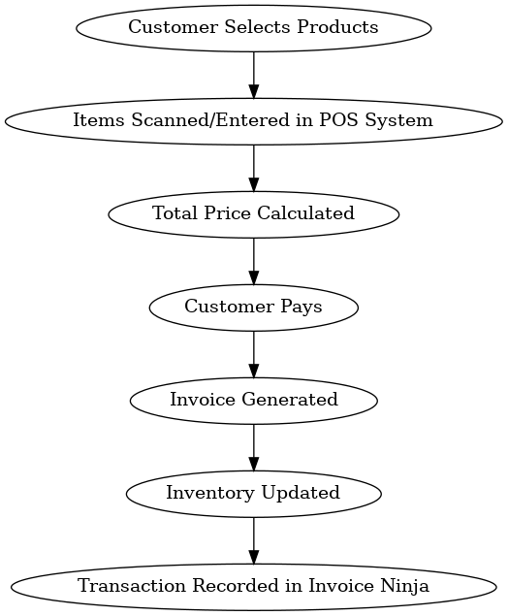

The workflow revolves around the **Invoice Ninja** content management system (CMS), which is integrated with the store’s **Point of Sale (POS)** system. Here's a textual explanation of the likely flow of the system:

1. **Customer Product Selection**:
   * The customer selects the products they wish to purchase from the store.
2. **Product Input**:
   * The items are either scanned or manually inputted into the POS system.
3. **Total Calculation**:
   * The POS system calculates the total price based on the inputted items and taxes.
4. **Payment Processing**:
   * The system offers multiple payment options like cash, credit card, or mobile payment.
5. **Invoice Generation**:
   * Once payment is processed, the system generates an invoice for the transaction.
6. **Transaction Recording**:
   * The transaction is recorded in **Invoice Ninja**, updating both the sales log and inventory levels.
7. **Expense Tracking**:
   * Inventory purchases and other store expenses are also logged into Invoice Ninja for expense management.
8. **Customer Data Management**:
   * Customer information is stored for repeat transactions and billing purposes.

**System Architecture:**

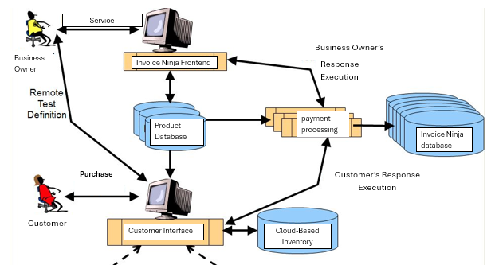

The diagram represents the system architecture of TransactLog Store, showcasing the integration of various components within its operations. It illustrates how the **Invoice Ninja CMS** interacts with the **Product Database**, **Payment Processing**, and **Cloud-Based Inventory** to facilitate efficient management of transactions. The system allows the **Business Owner** to access and control business operations through the **Invoice Ninja Frontend**, while customers use the **Customer Interface** to select and purchase products. The **Product Database** updates inventory levels in real-time, and **Payment Processing** ensures secure handling of transactions, which are then recorded in the **Invoice Ninja Database**. This interconnected structure streamlines the workflow, providing a comprehensive overview of sales, inventory, and financial data.