Lung surgery is surgery done to repair or remove lung tissue. You will have [general anaesthesia](https://medlineplus.gov/ency/article/007410.htm) before surgery. You will be asleep and unable to feel pain. Two common ways to do surgery on your lungs are thoracotomy and video-assisted thoracoscopic surgery (VATS). There are many common lung surgeries, including:

* Biopsy of an unknown growth in or around the lung
* Lobectomy, to remove one or more lobes of a lung
* Pneumonectomy, to remove a lung
* Surgery to prevent the build-up or return of fluid to the chest (pleurodesis)
* Surgery to remove an infection in the chest cavity i. e. empyema (decortication)
* Surgery to remove blood in the chest cavity, particularly after trauma
* Surgery to remove small balloon-like tissues (blebs) that cause lung collapse ([pneumothorax](https://medlineplus.gov/ency/article/000087.htm))
* Wedge resection, to remove part of a lobe in a lung
* Lung transplant.

A thoracotomy is a surgical cut that a surgeon makes to open the chest wall. VATS is the minimally invasive form of the same.

**CONDITIONS THAT REQUIRE LUNG SURGERY**

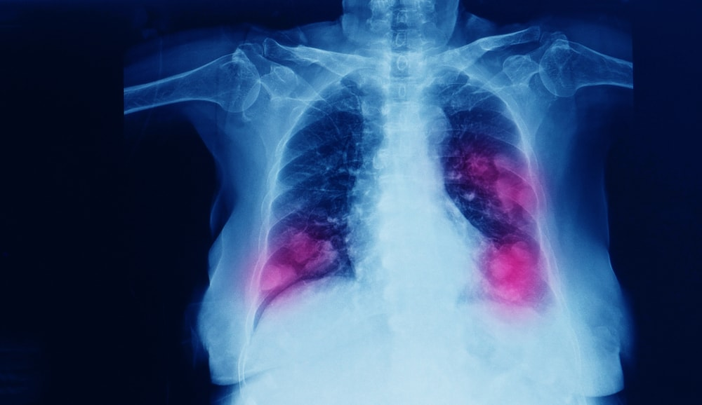

Conditions that require lung surgery are severe and will be performed by a highly trained lung surgeon to avoid any complications. The tissue is more fragile, and the infections or growth removed by the lung surgery procedure should not cause further damage to the organ. The surgery is performed for any of these pathologies if recovery through medication is not possible:

**Bronchiectasis:** Involves recurring infections in the bronchial regions. It may cause scarring or thickening of the bronchial wall and may reach a point of severity where the condition is no longer treatable by drug therapy. This condition causes patients to be highly fatigued, have bad breath, extreme coughing and cause eventual weight loss. Cystic fibrosis can also be an underlying cause of the condition. If the patient stops responding to antibiotics, a lung operation to remove the abnormalities or to drain the blockage regularly is suggested as a corrective measure.

**Interstitial lung disease:** Scarring of the lung tissue can cause extreme difficulty in breathing and may have underlying factors such as asbestosis, pneumonitis, connective tissue disorders or idiopathic pulmonary fibrosis. Lung surgery, and sometimes a complete lung transplant, is suggested by doctors in case the fibrosis is untreatable by breathing techniques or antibiotics.

**Lung cancer:** Cancerous tumours would require a biopsy to be performed, necessitating an initial lung surgery. In case the tumour is ascertained to be treatable by radiation therapy, a further lung surgery procedure may be avoided. However, a lung operation may be determined to be the best way forward for patients whose cancer has progressed beyond the initial stages. A pulmonology specialist can guide you to the most effective options in case of such a condition.

**Lung nodules:** These are benign growths on the lung tissue, which may not always require surgery. A lung operation will be recommended by doctors in case the nodule is found to be blocking airways and hampering the quality of patient life. The lung surgery success rate in case of such a procedure is relatively quite high and sees a patient living a more active life if the underlying cause of the nodule growth is addressed.

**Blebs:** They are small cavities where the air is trapped between the lung surface and its outer covering, and a rupture in a bleb can cause the lung to collapse in severe cases. In some patients, pulmonary blebs may form close together and fuse to create a "bulla". A lung surgery procedure to remove blebs or bullae helps prevent further complications and is done after administration of [general anaesthesia](https://www.narayanahealth.org/specialities/anaesthesia-critical-care).

**Collapsed lung:** It is a condition caused most often due to trauma resulting from a penetrating wound such as a fractured rib, a knife or bullet wound, and in rare cases, cigarette or drug abuse, or lung disease. The pneumothorax or lung collapse may be treated by a lung specialist without open surgery, in some instances, inserting a needle to remove air pressure and a chest tube. More critical cases involve lung operation and prevent immediate death in cases of extreme trauma. Pneumothorax may be a simple or tension pneumothorax, and the latter is immediately life-threatening and will require [emergency care](https://www.narayanahealth.org/specialities/emergency-medicine), often involving lung surgery.

**Emphysema:** The lung contains tiny air sacs called alveoli that help in inhalation and exhalation. Emphysema means that the alveoli are damaged and will weaken the lungs, causing a lack of sufficient oxygen and rapid breathing. It can occur without apparent symptoms, but if shortness of breath with unexplained fatigue is felt, it is best to consult a lung specialist who might suggest a type of lung surgery. Considering that lung surgery risks have reduced considerably in the last decade with precision instruments and robotic thoracotomy becoming more common, a lung operation help rid patients from a chronic condition like emphysema and provide a higher quality of life

**Empyema:** The thoracic cavity is filled with infectious fluid which causes the capacity of the lungs to reduce or increase the work of breathing.

**Our team of expert surgeons takes care of all lung related diseases and provides utmost care and all kinds of surgeries related to lung pathologies.**

