SpeechLens: Finding Where Speech Delivery Changes—and Why
Hear Beyond the Words
Technical Documentation | Multimodal AI Hackathon 2026 | Track C: Contrastive Speech Analytics & Temporal Flaw Grounding.
Submitted by ;
Siddhi Kaulage- Team Leader
Username: @siddhi24kaulage
Riddhi Kaulage- Team Member
Username: ridz-k-official
1. The Problem.
While a speech recording could be perceived as sounding good as a whole, there might still be some local issues related to delivery, such as unclear articulation, abnormal speech rate, long pauses, and fluency disruptions. Such local patterns appear at certain moments but could go unnoticed if the recording was considered as a whole during analysis.
The problem consists in the need to determine which patterns could be important for further analysis, to define their exact temporal positions in the recording, and to provide measurable evidence to support the findings. To achieve these aims, it is necessary to analyse not only acoustic properties of the speech but also its transcription and timing information.
1.1. Design Principle
An aggregate speech score may give an overview, but it may not be an indication of how the delivery changes from start to finish. SpeechLens addresses this limitation through the evaluation of observable acoustic and temporal attributes, such as energy, pitch, rate of speech, pause duration, and word timing.
- Temporal localisation: Each candidate finding should be associated with a timestamped segment, allowing the user to locate and replay the relevant part of the recording instead of reviewing the entire audio.
- Timestamp-based evidence: Word timings and pause intervals help identify where a potential variation occurs. For example, in one analysed recording, a gap of approximately 2.221 seconds between the words “our” and “century” was flagged for review. This identifies a specific interval for inspection; the gap alone does not establish that the speaker made an error.
- Acoustic feature analysis: Measurements such as energy, pitch, speaking rate, and pause duration help describe what changes within a segment. For instance, a long pause combined with the surrounding transcript may warrant reviewing fluency, while the pause duration alone cannot establish hesitation.
- Reference-based comparison: Where reference recordings are available, the observed features can be compared with reference patterns to identify potential differences in delivery. Such differences require contextual interpretation because pauses, speaking rate, and vocal characteristics naturally vary between speakers.
- Evidence-linked feedback: By connecting a candidate finding with its timestamp, acoustic measurements, and transcript context, SpeechLens helps users replay the relevant segment and understand why it was flagged. This provides a more targeted basis for reviewing delivery than an overall score alone.
1.2. The SpeechLens Approach
SpeechLens analyses speech through two complementary pipelines: an audio feature analysis pipeline and a transcript and timing analysis pipeline. The audio pipeline extracts measurable acoustic features, including energy, pitch, spectral characteristics, and pause patterns. The transcript pipeline provides recognised words and available word-level timing information.
The outputs of these two pipelines are analysed together to identify candidate variations in speech delivery and associate them with specific segments of the recording. Where reference recordings are available, the observed patterns can also be compared with reference characteristics. Each candidate finding can be inspected using its timestamp, acoustic measurements, and transcript context.
Rather than automatically treating every detected variation as an error, SpeechLens supports targeted inspection and evidence-based review. This allows users to examine the relevant segment and interpret the findings in the context of the recording and the speaker's natural delivery style.
2. System Architecture and Data Pipeline
SpeechLens processes uploaded audio through two parallel analysis branches. The audio-analysis branch extracts acoustic and timing measurements and uses a reference-based Isolation Forest to flag unusual intervals. The transcription branch uses pretrained faster-whisper small.en to generate text, word-level timestamps and recognition-confidence estimates. Evidence from both branches is combined to present timestamped findings in the dashboard for user review.
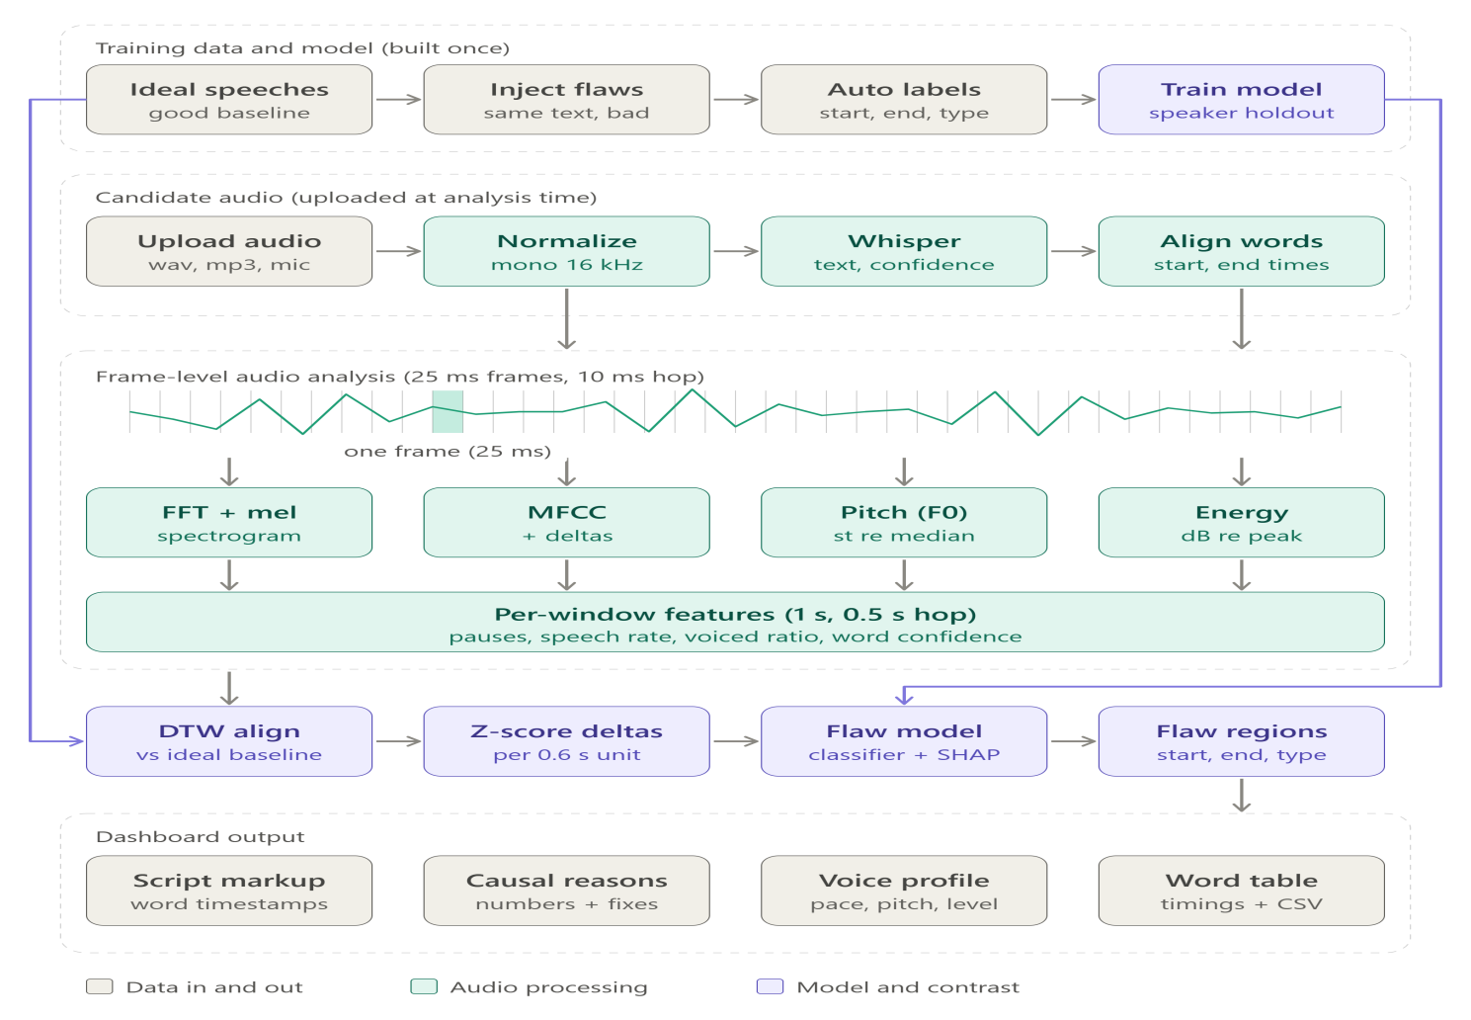

2.1Dataset Reference And Selection
There is natural variability between different speakers in the way in which they deliver their speech. Some speakers will be able to incorporate well-timed pauses into their speeches, thus making them sound natural and easy to understand, while others may demonstrate clearer articulation and vocal delivery. Choosing just one recording as an optimal baseline might lead to overlooking such distinctions and classifying a good speaking technique as a problem.
To avoid this problem, 14 audio recordings have been chosen as good reference samples for SpeechLens. Instead of basing the evaluation on just one sample, multiple references provide a broader basis for examining the acoustic and temporal properties of speech delivery, including pitch, energy, speaking rate, articulation, and pausing.
The goal of SpeechLens is to find potential variations that warrant closer inspection. Therefore, candidate variations are analysed using acoustic features, temporal data, and transcript information, recognising that there are many ways in which good speech can be delivered.

2.2 Audio Preprocessing and Parallel Analysis
SpeechLens analyses audio recordings using two complementary pipelines: the audio feature analysis pipeline, which extracts measurable acoustic properties, and the transcript and timing analysis pipeline, which provides recognised words and available timing information.
Together, these pipelines provide acoustic and textual evidence to help identify candidate variations in speech delivery for further review.

2.3. Acoustic Features Extraction
Acoustic feature extraction is an important step in SpeechLens that converts speech audio into measurable characteristics to analyse how a person speaks. We extract acoustic features such as sound energy, pitch, tone variation, frequency characteristics, and pauses to understand changes in speech delivery.
The main acoustic features considered in SpeechLens include:
- Sound Energy: Measures the intensity of the audio signal and helps identify variations in vocal loudness.
- Pitch: Represents how high or low the voice sounds and helps examine pitch variations during speech.
- Tone Variation: Describes changes in vocal delivery and intonation across an utterance.
- Frequency and Spectral Features: Capture characteristics of the sound signal that help describe variations in speech acoustics.
- Speech Rate: Examines how quickly words are delivered within a given time interval.
- Pause Duration: Measures silent or low-activity intervals that may indicate pauses between words or phrases.
- MFCC Features: Provide a compact representation of the speech signal's spectral characteristics for acoustic analysis and model input.
- RMS Energy: Measures the average amplitude of the audio signal over a given interval. It helps identify variations in signal intensity and low-energy regions that may correspond to pauses or quieter speech.
These features provide complementary information about speech delivery. By analysing them alongside transcript and timing information, SpeechLens identifies candidate variations in speech delivery for further inspection.

2.4 Frame-Level and Audio-Level Analysis
During acoustic feature extraction, SpeechLens analyses speech at two complementary levels: audio-level analysis and frame-level analysis. Audio-level analysis provides an overall summary of the recording, while frame-level analysis examines smaller portions of the audio to identify changes over time.
Both levels help SpeechLens understand the general characteristics of speech and locate potential variations in delivery. The extracted features, such as RMS energy, pitch, and spectral characteristics, can be examined at these levels to support further analysis.

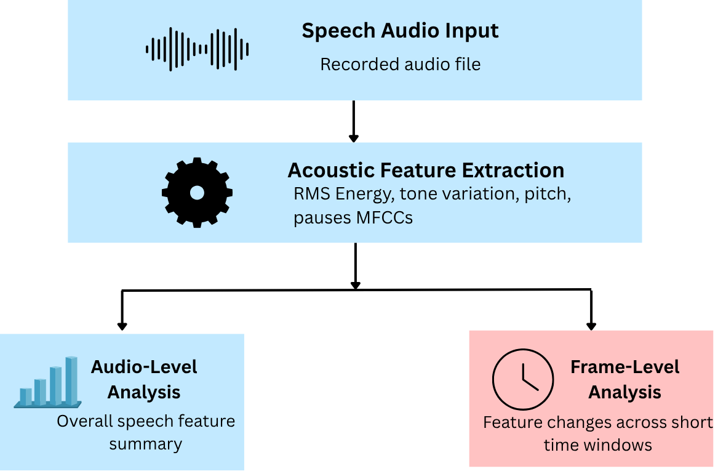

Suitable Example: Frame-Level Analysis
Consider a 10-second speech recording in which the speaker pauses briefly at around the 5-second mark.
Without frame-level analysis: SpeechLens examines the recording as a whole and obtains overall measurements, such as average energy. These measurements may not clearly show exactly where the pause occurs.
With frame-level analysis: SpeechLens divides the recording into short time windows and examines the acoustic features in each window. A drop in energy around the 5-second mark may help identify a segment for closer inspection.
Why SpeechLens uses it: Frame-level analysis helps locate when potential changes in speech delivery occur, allowing users to replay and review specific segments rather than searching through the entire recording. However, a drop in energy alone does not confirm a pause or a speech flaw; the segment requires further review.

3. Transcript Alignment and Temporal Grounding
SpeechLens combines speech transcription, timing information, and acoustic analysis to identify where potential variations in speech delivery occur. Acoustic features help describe how the voice changes, while transcript and timing information help locate these changes within the recording.
The purpose of temporal grounding is to identify the specific portion of audio that may require further inspection. Instead of simply reporting a potential delivery issue, SpeechLens aims to connect the finding to a timestamp, supporting evidence, and the corresponding audio segment.

3.1. Speech Transcription and Word-Level Timing
SpeechLens uses Whisper for speech-to-text transcription, converting spoken audio into recognised text. Timing information is used to associate words with their approximate positions in the recording.
Word-level timing helps determine when a word begins and ends. This information can support the analysis of word duration, gaps between words, and pauses within speech.
For example, if a word is followed by an unusually long gap before the next word begins, that interval can be identified for further inspection. However, the gap may represent a natural pause, breathing, punctuation, or a timing estimation error rather than a speech flaw.

3.2. Pause and Inter-Word Gap Analysis
Pauses and gaps between words can provide useful evidence when examining speech fluency and delivery. SpeechLens uses available timing information to identify intervals that may warrant closer attention.
For example, in one analysed recording, a gap of approximately 2.221 seconds between the words “our” and “century” was flagged for review. This measurement helps locate the relevant portion of the recording so that the user can listen to it directly.
A long gap does not automatically indicate hesitation. Speakers may pause intentionally for emphasis, take a breath, or separate ideas. Therefore, pause duration should be interpreted alongside the surrounding transcript and audio rather than treated as proof of an error.

3.3. Identifying and Explaining Candidate Findings
SpeechLens associates potential delivery variations with specific portions of the recording. These candidate findings may be supported by information such as:
- Temporal evidence: The start and end times of the segment being reviewed.
- Acoustic evidence: Observed changes in energy, pitch, speaking rate, or spectral characteristics, where available.
- Transcript context: The words spoken before, during, and after the selected segment.
- Candidate category: The type of delivery variation that the analysis suggests may require attention.
Combining these sources of information provides more context than relying on a single measurement. For example, a long pause together with a disruption in the surrounding speech may justify reviewing fluency. The final interpretation should still consider the original audio and the speaker's natural delivery style.

3.4. Connecting Findings to the Audio Timeline
The timestamped findings help users move from an analysis result to the relevant portion of the original recording. Through the SpeechLens interface, users can inspect candidate segments, review the associated evidence, and replay the audio to understand what occurred.
The review process follows four main steps:
- Locate: Find the timestamp associated with a candidate finding.
- Inspect: Review the available acoustic measurements and transcript context.
- Replay: Listen to the relevant audio segment.
- Interpret: Determine whether the observed pattern may indicate a delivery issue, a natural variation, or a limitation in the analysis.
This process makes the findings easier to understand and gives users an opportunity to evaluate the evidence instead of automatically accepting every prediction.

3.5. Importance of Temporal Grounding
Temporal grounding is important because speech delivery can change throughout a recording. An overall score may summarise a speaker's performance, but it does not necessarily reveal when a particular variation occurred.
By connecting candidate findings to timestamps, acoustic evidence, and transcript context, SpeechLens helps users review specific moments in their recordings. This makes feedback more targeted and actionable while recognising that automated analysis can make mistakes.

4. Machine Learning and Analysis Components
SpeechLens uses three distinct components for transcription, reference-based analysis, and experimental classification. Each component serves a different purpose, and their outputs should not be interpreted as interchangeable.
4.1. Speech Transcription
The application employs faster-whisper small.en, which is a pretrained speech recognition model for the English language, to generate a transcription of the recording file submitted by the user. It returns a transcription, word-level time stamps and confidence of recognition.
The model was used in a pretrained version without being fine-tuned on the SpeechLens dataset. The output of the model helps to get the transcript and timings for inspection of speech fragments and their correlation with the results of analysis.
Transcriptions and time estimates might be inaccurate, therefore they should be considered as helpful information for analysis.
4.2. Reference-Based Anomaly Detection
For the upload dashboard, SpeechLens applies Isolation Forest, which is an unsupervised anomaly detection technique, to detect intervals whose features do not match the reference pattern obtained based on the features of available reference recordings.
In this regard, the system analyzes both acoustic and timing features to find intervals that deviate from the patterns observed for the reference recordings. However, the deviations are simply flagged for review rather than being immediately marked as errors in the delivery.
Indeed, the deviation may be due to natural variation in the delivery, but it may also arise because of other reasons. Thus, an anomaly just shows a deviation that requires closer examination.
4.3. Audio-Flaw Classifier Experiment
SpeechLens also features an experimental machine-learning project for comparing classifiers of synthetic transformations of audio data. The classifiers used in the project were Logistic Regression, RBF Support Vector Machine (SVM), Random Forest, Extra Trees, and HistGradientBoosting.
The HistGradientBoosting classifier obtained around 72.8% out-of-fold accuracy of source-grouped prediction in the experiment.
This metric shows performance on synthetic audio-transformation labels used in the experiment. This is not an indicator that this model has 72.8% accuracy in predicting speech flaws in real life. This classifier is experimental and not used to generate results for the upload dashboard.
4.4. Signal-Processing-Based Metrics for the Dashboard
The dashboard also includes metrics describing the speech features like pitch, voice intensity, pauses, and speaking speed. The metrics are derived via signal processing techniques and heuristics rather than through the HistGradientBoosting classifier used in the experiment.
Such metrics serve as a source of description for the recording. For instance, the variation in speaking speed may be used to determine which part of the recording should be examined, whereas the measure of a pause will indicate an interval in the recording.
4.5. Interactions between the Components
The components play complementary parts in the SpeechLens processing flow:
faster-whisper small.en gives the transcribed text, timing per word, and confidence estimates for the recognition process.
Isolation Forest detects anomalous segments through comparisons of upload features against reference patterns and helps with anomaly detections on the current dashboard.
Signal-processing heuristics generate descriptive measures for the dashboard, including pitch, voice level, pauses, and speaking speed.
HistGradientBoosting is part of an independent experiment on classifier comparison and does not contribute to the results on the upload dashboard at this time.
This separation makes the system more understandable and clearly defines transcriptions, acoustic measurements, anomalies, and experiments.
Component | Role | Used in upload dashboard?
faster-whisper small.en | Transcription and word timing | Yes
Isolation Forest | Reference-based anomaly detection | Yes
Signal-processing heuristics | Pitch, voice level, pauses and pace | Yes
HistGradientBoosting | Experimental synthetic-label classification | No
5. Model Evaluation and Limitations
5.1 Experimental Classifier Comparison
Various machine learning algorithms were compared by their performance on artificial labels for audio transformations. The goal was to evaluate them experimentally.
Classifier | Accuracy
Histogram Gradient Boosting | 72.80%
Random Forest | 69.62%
Extra Trees | 66.94%
RBF SVM | 66.69%
Logistic Regression | 57.18%
The most accurate model was Histogram Gradient Boosting with an accuracy of 72.80%. Nonetheless, none of the models managed to achieve 80% accuracy. This data is limited to the synthetic labeling experiment and should not be taken as an accuracy measure for identifying natural speech mistakes.
Histogram Gradient Boosting is an experimental classifier and does not output any results on the upload dashboard yet.
5.2 Evaluation of Dashboard Components
The dashboard includes components for transcription, reference-based anomaly detection, and acoustic measurements. They differ in terms of their evaluation status.
Transcription component: The pre-trained faster-whisper small.en model performs transcription of English speech uploaded by users, including word-level timestamps and transcription recognition confidence. This component was not fine-tuned on the project dataset. No verified test labels are provided for measuring the transcription accuracy of this model in the context of this project.
Reference-based anomaly detection component: The Isolation Forest algorithm performs comparison of acoustic and timing features of an uploaded speech recording with learned patterns in available reference recordings and highlights unusual intervals for review. No verified test labels are provided for measuring the accuracy of this detection process.
Acoustic measurements: Dashboard metrics like pitch, voice level, pauses, and pace are computed through signal processing heuristics. These measurements characterize observable properties without confirming a speech flaw independently.
Transcription confidence is not the same as transcription accuracy. Similarly, an unusual interval detected with the use of the Isolation Forest algorithm is a pattern different from references, not a speech flaw.

5.3 Limitations and Interpretation
The current evaluation offers an early comparative analysis of the classifiers but does not prove their performance on the naturally occurring speech flaws. The synthetic modifications could differ from those in real life, while the experimental classifier is different from the one that is applied for generating the dashboard outputs.
A long pause, a low voice level, a strange pitch or a different speaking speed can happen due to various reasons such as breathing, stress, microphone effects or unique speaking manner. Thus, the SpeechLens provides its findings as something for further consideration along with timestamps and proof.
The independent review of the recordings and their labeling would be required to perform a reliable measurement of the transcription performance, anomaly detection performance and the speech flaw detection.

6. Formulas Used in Audio Analysis
This section presents standard signal-processing formulas relevant to SpeechLens. These formulas explain the measurements discussed in the project; their inclusion does not imply that every calculation is implemented in the current system.

6.1 Audio Duration
The duration of an audio recording is determined by its number of samples and its sampling rate.
$$Formula:$$
$$[ \\ T=\backslash frac\left\{N\right\}\left\{f_{s}\right\} \\ ]$$

Where:
- (T) = audio duration in seconds
- (N) = total number of audio samples
- (fs) = sampling rate in samples per second

6.2 Root Mean Square (RMS) Energy
RMS measures the effective amplitude of an audio signal over a selected window. It can help identify relative changes in voice level and signal energy. However, low RMS alone does not confirm mumbling.
Formula:
$$[ \\ \backslash operatorname\left\{RMS\right\}= \\ \sqrt{\left\{\backslash frac\left\{1\right\}\left\{N\right\}\sum_{\left\{n=1\right\}}^{\left\{N\right\}x_{n}^{2}}{}\right\}} \\ ]$$
Where:
- (x_n) = audio sample at index (n)
- (N) = number of samples in the selected window

6.3 Pause Duration
Pause duration represents the time interval between the detected start and end of a pause. The detected boundaries depend on the silence-detection method being used.
Formula:
$$[ \\ D_{\left\{\backslash text\left\{pause\right\}\right\}}=t_{\left\{\backslash text\left\{end\right\}\right\}}-t_{\left\{\backslash text\left\{start\right\}\right\}} \\ ]$$
Where:
- (D_{\text{pause}}) = pause duration in seconds
- (t_{\text{start}}) = pause start time
- (t_{\text{end}}) = pause end time
A threshold-based detector may flag a candidate pause when the signal remains below a configured energy threshold for a minimum duration. A detected pause is not necessarily a hesitation or speech flaw.

6.4 Relative Change from a Baseline
Relative change compares a measurement from a recording with a corresponding baseline measurement. It can be used to describe differences in speaking rate or other comparable features.
Formula:
$$[ \\ Δ_{\left\{\%\right\}}= \\ \backslash frac\left\{M_{\left\{\backslash text\left\{recording\right\}\right\}}-M_{\left\{\backslash text\left\{baseline\right\}\right\}}\right\} \\ \left\{M_{\left\{\backslash text\left\{baseline\right\}\right\}}\right\}\backslash times100 \\ ]$$
Where:
- (\Delta_{%}) = relative percentage change
- (M_{\text{recording}}) = measurement from the analysed recording
- (M_{\text{baseline}}) = corresponding baseline measurement
This comparison is meaningful only when the measurements are comparable and the baseline value is nonzero.

6.5 Implementation and Testing Note
The existing pipeline passed seven unit tests, including a test using a synthetic pause with a known timestamp. These tests provide evidence that specific tested behaviours work as expected, but they do not establish that every speech-flaw category can be localised precisely or that all formulas listed above are implemented in the current code.

6. Conclusion and Future Improvements

7.1 Conclusion
SpeechLens, developed under the theme “Hear Beyond the Words,” aims to make speech-delivery analysis more transparent, interpretable, and time-specific. Instead of relying only on an overall assessment, the system helps users examine speech patterns at particular moments in a recording.
The current implementation combines pretrained speech transcription using faster-whisper small.en, word-level timestamps, reference-based anomaly detection using Isolation Forest, and signal-processing measurements such as pitch, voice level, pauses, and speaking pace. These components provide transcript context and measurable evidence that can help users identify unusual speech segments for further review.
The experimental comparison of machine-learning classifiers achieved a best source-grouped out-of-fold accuracy of 72.8% using HistGradientBoostingClassifier on synthetic-label data. This result is limited to that experiment and should not be interpreted as real-world accuracy for detecting natural speech flaws. The experimental classifier is not currently used to generate dashboard findings.
SpeechLens is therefore best viewed as an assistive analysis tool rather than a definitive evaluator. A long pause, low voice level, or unusual speaking rate does not necessarily indicate a flaw. By connecting candidate findings with timestamps and acoustic measurements, SpeechLens aims to help users review their delivery and make more informed improvements.

6.2 Future Improvements
SpeechLens can be extended in several ways to provide more personalised, interactive, and comprehensive speech feedback.
- Individualised Feedback: Compare a user's practice sessions over time to track speaking speed, pauses, delivery patterns, and recurring areas for improvement.
- Real-Time Training Mode: Introduce gentle, low-distraction prompts for potentially excessive pauses, rushed speech, and repeated hesitation patterns during practice.
- Multisensor Analysis: Explore combining speech analysis with visual cues, such as eye contact and body posture, to support interview and presentation practice.
- Expanded Language Support: Extend the system beyond English by integrating suitable language-specific transcription, alignment, and evaluation methods while accounting for accents and speech variation.
- Individual Vocal Signature and Drift: Establish a speaker-specific baseline and highlight meaningful changes in pace, intonation, and other vocal characteristics across sessions.
- Individual Filler-Word Analysis: Detect and track the frequency and timing of filler words such as “um,” “uh,” and “like,” helping users understand recurring speech habits.
These enhancements could evolve SpeechLens from a tool for locating unusual speech patterns into a personalised practice companion. Future development should prioritise validation using real speech recordings and independently reviewed annotations, ensuring that feedback is reliable, fair, and sensitive to individual speaking styles.
Closing Statement: SpeechLens turns speech analysis into actionable, personalised insights, helping every speaker understand their delivery and communicate with greater clarity and confidence.

