DAILY ACTIVITY TRACKER
Full Stack Web Application - Project Source Code Submission
Backend: Java | Spring Boot 3 | Spring Data JPA | MySQL / H2
Frontend: HTML5 | CSS3 | JavaScript ES6+ | Bootstrap 5

1. Database Schema
1. Database Schema
SQL DDL - categories and activities tables with seed data.
-- ==============================================================================
-- 1. EXTENSIONS
-- ==============================================================================
CREATE EXTENSION IF NOT EXISTS "uuid-ossp";

-- ==============================================================================
-- 2. CATEGORIES TABLE
-- ==============================================================================
CREATE TABLE IF NOT EXISTS categories (
category_id BIGSERIAL PRIMARY KEY,
name VARCHAR(50) NOT NULL UNIQUE,
color VARCHAR(7) DEFAULT '#0d6efd', -- Hex color for UI badges
description TEXT,
created_at TIMESTAMP WITH TIME ZONE DEFAULT CURRENT_TIMESTAMP NOT NULL
);

CREATE INDEX IF NOT EXISTS idx_categories_name ON categories(name);

-- Pre-seeded standard categories
INSERT INTO categories (name, color, description) VALUES
('Study', '#0d6efd', 'Academic studies, homework, revisions'),
('College', '#6f42c1', 'Lectures, labs, submissions, college events'),
('Exercise', '#198754', 'Gym, workouts, sports, running'),
('Personal', '#0dcaf0', 'Habits, chores, reading, errands'),
('Work', '#fd7e14', 'Part-time jobs, projects, internships'),
('Other', '#6c757d', 'Miscellaneous tasks')
ON CONFLICT (name) DO NOTHING;

-- ==============================================================================
-- 3. ACTIVITIES TABLE (Core Entity)
-- ==============================================================================
CREATE TABLE IF NOT EXISTS activities (
activity_id BIGSERIAL PRIMARY KEY,
title VARCHAR(150) NOT NULL,
description TEXT,
activity_date DATE NOT NULL,
start_time TIME,
end_time TIME,
priority VARCHAR(10) NOT NULL DEFAULT 'MEDIUM'
CHECK (priority IN ('LOW', 'MEDIUM', 'HIGH')),
status VARCHAR(15) NOT NULL DEFAULT 'PENDING'
CHECK (status IN ('PENDING', 'COMPLETED')),
category_id BIGINT REFERENCES categories(category_id) ON DELETE SET NULL,
notes TEXT,
created_at TIMESTAMP WITH TIME ZONE DEFAULT CURRENT_TIMESTAMP NOT NULL,
updated_at TIMESTAMP WITH TIME ZONE DEFAULT CURRENT_TIMESTAMP NOT NULL,
CONSTRAINT chk_time_window CHECK (start_time IS NULL OR end_time IS NULL OR start_time <= end_time)
);

-- Performance Indexes
CREATE INDEX IF NOT EXISTS idx_activities_date ON activities(activity_date);
CREATE INDEX IF NOT EXISTS idx_activities_status ON activities(status);
CREATE INDEX IF NOT EXISTS idx_activities_category ON activities(category_id);
CREATE INDEX IF NOT EXISTS idx_activities_date_status ON activities(activity_date, status);

-- Trigger to automatically update updated_at on record changes
CREATE OR REPLACE FUNCTION update_updated_at_column()
RETURNS TRIGGER AS $$
Application Screenshots
The following screenshots show the running Daily Activity Tracker application across all major views, along with the live database records.
Figure 1 - Manage Activities: Full list view with search bar, status/priority/category filters, edit and delete actions.
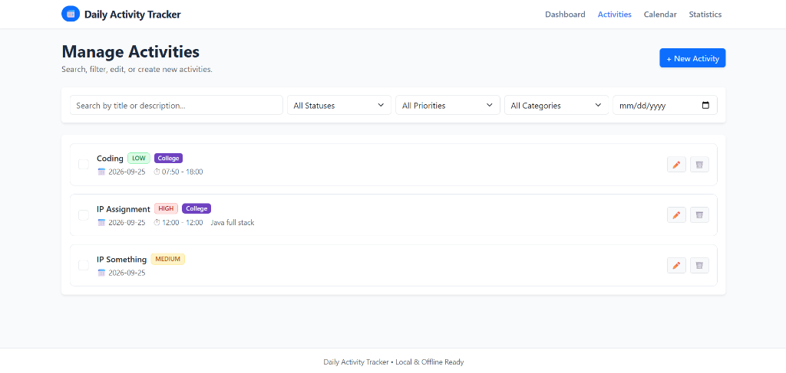
Figure 2 - Add Activity Modal: Create a task with title, description, date, start/end time, priority and category.
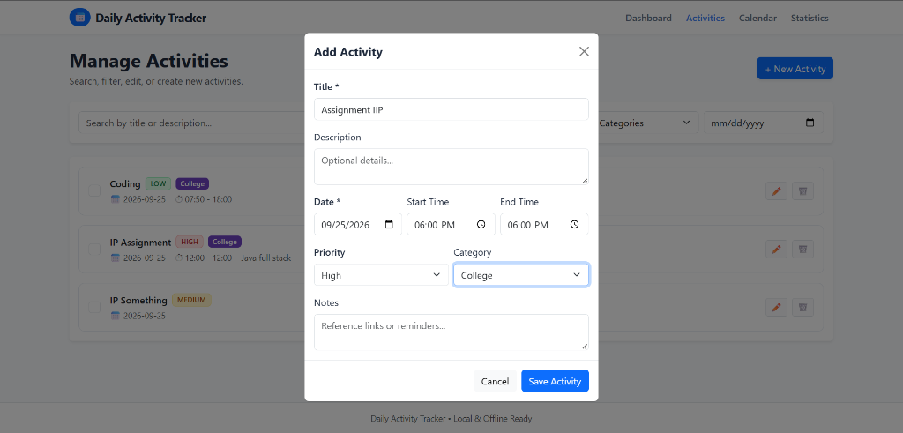
Figure 3 - Calendar View: Browse and inspect all activities scheduled by day with a monthly calendar grid.
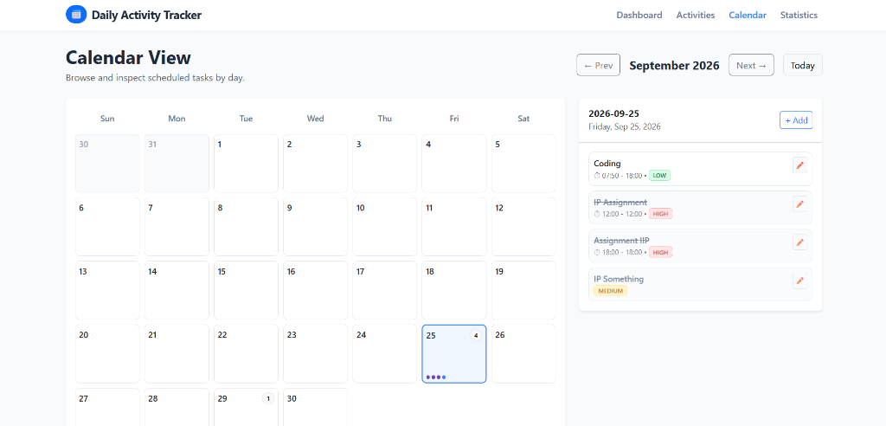
Figure 4 - Statistics & Analytics: Productivity metrics, category distribution, and priority breakdown charts.
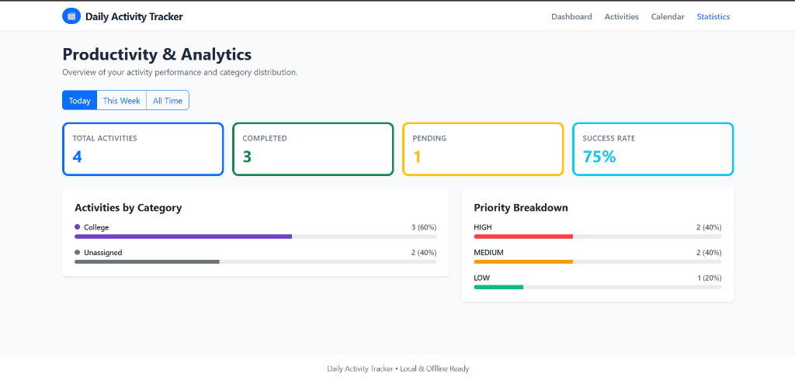
Figure 5 - Database (PostgreSQL / Supabase): Categories table showing category_id, color, description and name columns.
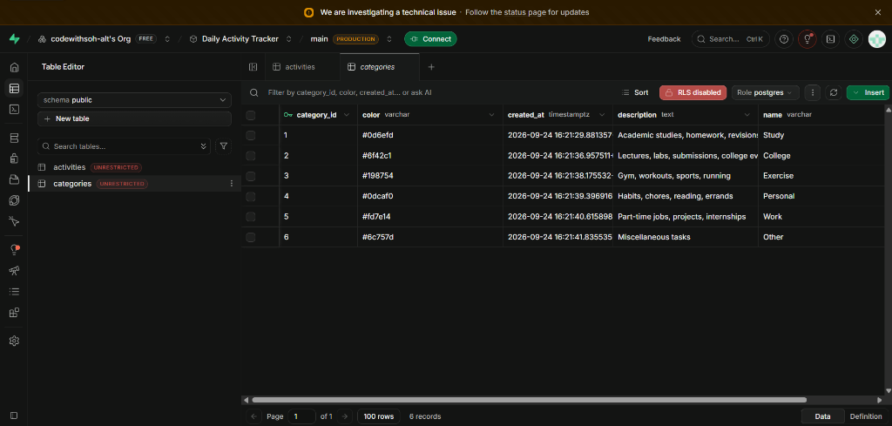

BEGIN
NEW.updated_at = CURRENT_TIMESTAMP;
RETURN NEW;
END;
$$ LANGUAGE plpgsql;

DROP TRIGGER IF EXISTS trigger_activities_updated_at ON activities;
CREATE TRIGGER trigger_activities_updated_at
BEFORE UPDATE ON activities
FOR EACH ROW
EXECUTE FUNCTION update_updated_at_column();

-- ==============================================================================
-- 4. RECURRING ACTIVITIES TABLE (Phase 3 Feature)
-- ==============================================================================
CREATE TABLE IF NOT EXISTS recurring_activities (
recurring_id BIGSERIAL PRIMARY KEY,
title VARCHAR(150) NOT NULL,
description TEXT,
start_time TIME,
end_time TIME,
priority VARCHAR(10) NOT NULL DEFAULT 'MEDIUM'
CHECK (priority IN ('LOW', 'MEDIUM', 'HIGH')),
category_id BIGINT REFERENCES categories(category_id) ON DELETE SET NULL,
frequency VARCHAR(20) NOT NULL DEFAULT 'DAILY'
CHECK (frequency IN ('DAILY', 'WEEKLY', 'MONTHLY')),
days_of_week VARCHAR(30), -- e.g. 'MON,WED,FRI'
start_date DATE NOT NULL,
end_date DATE,
active BOOLEAN NOT NULL DEFAULT TRUE,
created_at TIMESTAMP WITH TIME ZONE DEFAULT CURRENT_TIMESTAMP NOT NULL,
CONSTRAINT chk_recurring_dates CHECK (end_date IS NULL OR start_date <= end_date)
);

CREATE INDEX IF NOT EXISTS idx_recurring_active ON recurring_activities(active);

2. Backend Code (Java / Spring Boot)
2.1 Application Configuration
Datasource, JPA / Hibernate settings, and server port.
server.port=8080

# Supabase PostgreSQL Configuration (Project: evvkuhqkrvzvkmoxqqxn, Region: ap-southeast-2 Sydney)
# IPv4 Connection Pooler (Transaction mode on port 6543 with prepareThreshold=0 for PgBouncer)
spring.datasource.url=${DB_URL:jdbc:postgresql://aws-0-ap-southeast-2.pooler.supabase.com:6543/postgres?sslmode=require&prepareThreshold=0}
spring.datasource.username=${DB_USERNAME:postgres.evvkuhqkrvzvkmoxqqxn}
spring.datasource.password=soham77890#
spring.datasource.driver-class-name=org.postgresql.Driver

# JPA / Hibernate Configuration
spring.jpa.database-platform=org.hibernate.dialect.PostgreSQLDialect
spring.jpa.hibernate.ddl-auto=update
spring.jpa.show-sql=true
spring.jpa.properties.hibernate.format_sql=true

# Jackson Configuration
spring.jackson.date-format=yyyy-MM-dd
spring.jackson.time-zone=UTC

2.2 Main Application Class
Spring Boot entry point (@SpringBootApplication).
package com.activitytracker;

import org.springframework.boot.SpringApplication;
import org.springframework.boot.autoconfigure.SpringBootApplication;

@SpringBootApplication
public class ActivityTrackerApplication {

public static void main(String[] args) {
SpringApplication.run(ActivityTrackerApplication.class, args);
}
}

2.3a Model - Activity.java
JPA entity representing an activity record.
package com.activitytracker.model;

import jakarta.persistence.*;
import java.time.LocalDate;
import java.time.LocalTime;
import java.time.OffsetDateTime;

@Entity
@Table(name = "activities")
public class Activity {

@Id
@GeneratedValue(strategy = GenerationType.IDENTITY)
@Column(name = "activity_id")
private Long id;

@Column(nullable = false, length = 150)
private String title;

@Column(columnDefinition = "TEXT")
private String description;

@Column(name = "activity_date", nullable = false)
private LocalDate activityDate;

@Column(name = "start_time")
private LocalTime startTime;

@Column(name = "end_time")
private LocalTime endTime;

@Enumerated(EnumType.STRING)
@Column(nullable = false, length = 10)
private Priority priority = Priority.MEDIUM;

@Enumerated(EnumType.STRING)
@Column(nullable = false, length = 15)
private Status status = Status.PENDING;

@ManyToOne(fetch = FetchType.EAGER)
@JoinColumn(name = "category_id")
private Category category;

@Column(columnDefinition = "TEXT")
private String notes;

@Column(name = "created_at", nullable = false, updatable = false)
private OffsetDateTime createdAt;

@Column(name = "updated_at", nullable = false)
private OffsetDateTime updatedAt;

public Activity() {
}

@PrePersist
protected void onCreate() {
OffsetDateTime now = OffsetDateTime.now();
if (this.createdAt == null) {
this.createdAt = now;
}
if (this.updatedAt == null) {
this.updatedAt = now;
}
if (this.priority == null) {
this.priority = Priority.MEDIUM;
}
if (this.status == null) {
this.status = Status.PENDING;
}
}

@PreUpdate
protected void onUpdate() {
this.updatedAt = OffsetDateTime.now();
}

// Getters and Setters
public Long getId() {
return id;
}

public void setId(Long id) {
this.id = id;
}

public String getTitle() {
return title;
}

public void setTitle(String title) {
this.title = title;
}

public String getDescription() {
return description;
}

public void setDescription(String description) {
this.description = description;
}

public LocalDate getActivityDate() {
return activityDate;
}

public void setActivityDate(LocalDate activityDate) {
this.activityDate = activityDate;
}

public LocalTime getStartTime() {
return startTime;
}

public void setStartTime(LocalTime startTime) {
this.startTime = startTime;
}

public LocalTime getEndTime() {
return endTime;
}

public void setEndTime(LocalTime endTime) {
this.endTime = endTime;
}

public Priority getPriority() {
return priority;
}

public void setPriority(Priority priority) {
this.priority = priority;
}

public Status getStatus() {
return status;
}

public void setStatus(Status status) {
this.status = status;
}

public Category getCategory() {
return category;
}

public void setCategory(Category category) {
this.category = category;
}

public String getNotes() {
return notes;
}

public void setNotes(String notes) {
this.notes = notes;
}

public OffsetDateTime getCreatedAt() {
return createdAt;
}

public void setCreatedAt(OffsetDateTime createdAt) {
this.createdAt = createdAt;
}

public OffsetDateTime getUpdatedAt() {
return updatedAt;
}

public void setUpdatedAt(OffsetDateTime updatedAt) {
this.updatedAt = updatedAt;
}
}

2.3b Model - Category.java
JPA entity representing an activity category.
package com.activitytracker.model;

import jakarta.persistence.*;
import java.time.OffsetDateTime;

@Entity
@Table(name = "categories")
public class Category {

@Id
@GeneratedValue(strategy = GenerationType.IDENTITY)
@Column(name = "category_id")
private Long id;

@Column(nullable = false, unique = true, length = 50)
private String name;

@Column(length = 7)
private String color = "#0d6efd";

@Column(columnDefinition = "TEXT")
private String description;

@Column(name = "created_at", nullable = false, updatable = false)
private OffsetDateTime createdAt;

public Category() {
}

public Category(Long id, String name, String color, String description) {
this.id = id;
this.name = name;
this.color = color != null ? color : "#0d6efd";
this.description = description;
}

@PrePersist
protected void onCreate() {
if (this.createdAt == null) {
this.createdAt = OffsetDateTime.now();
}
if (this.color == null || this.color.isBlank()) {
this.color = "#0d6efd";
}
}

// Getters and Setters
public Long getId() {
return id;
}

public void setId(Long id) {
this.id = id;
}

public String getName() {
return name;
}

public void setName(String name) {
this.name = name;
}

public String getColor() {
return color;
}

public void setColor(String color) {
this.color = color;
}

public String getDescription() {
return description;
}

public void setDescription(String description) {
this.description = description;
}

public OffsetDateTime getCreatedAt() {
return createdAt;
}

public void setCreatedAt(OffsetDateTime createdAt) {
this.createdAt = createdAt;
}
}

2.4a Repository - ActivityRepository
Custom JPQL queries for filtering and statistics.
package com.activitytracker.repository;

import com.activitytracker.model.Activity;
import com.activitytracker.model.Priority;
import com.activitytracker.model.Status;
import org.springframework.data.jpa.repository.JpaRepository;
import org.springframework.data.jpa.repository.Query;
import org.springframework.data.repository.query.Param;
import org.springframework.stereotype.Repository;

import java.time.LocalDate;
import java.util.List;

@Repository
public interface ActivityRepository extends JpaRepository<Activity, Long> {

List<Activity> findByActivityDateOrderByStartTimeAsc(LocalDate activityDate);

List<Activity> findByActivityDateBetweenOrderByActivityDateAscStartTimeAsc(LocalDate startDate, LocalDate endDate);

List<Activity> findByStatus(Status status);

List<Activity> findByCategoryId(Long categoryId);

// Overdue items: date before today and status PENDING
@Query("SELECT a FROM Activity a WHERE a.activityDate < :today AND a.status = :status ORDER BY a.activityDate ASC, a.startTime ASC")
List<Activity> findOverdueActivities(@Param("today") LocalDate today, @Param("status") Status status);

long countByActivityDate(LocalDate activityDate);

long countByActivityDateAndStatus(LocalDate activityDate, Status status);

long countByActivityDateBetween(LocalDate startDate, LocalDate endDate);

long countByActivityDateBetweenAndStatus(LocalDate startDate, LocalDate endDate, Status status);

long countByStatus(Status status);

@Query("SELECT COUNT(a) FROM Activity a WHERE a.activityDate < :today AND a.status = :status")
long countOverdueActivities(@Param("today") LocalDate today, @Param("status") Status status);

@Query("SELECT a FROM Activity a WHERE " +
"(:date IS NULL OR a.activityDate = :date) AND " +
"(:status IS NULL OR a.status = :status) AND " +
"(:priority IS NULL OR a.priority = :priority) AND " +
"(:categoryId IS NULL OR a.category.id = :categoryId) AND " +
"(CAST(:search AS string) IS NULL OR LOWER(a.title) LIKE LOWER(CONCAT('%', CAST(:search AS string), '%')) OR LOWER(a.description) LIKE LOWER(CONCAT('%', CAST(:search AS string), '%'))) " +
"ORDER BY a.activityDate DESC, a.startTime ASC")
List<Activity> filterActivities(@Param("date") LocalDate date,
@Param("status") Status status,
@Param("priority") Priority priority,
@Param("categoryId") Long categoryId,
@Param("search") String search);
}

2.4b Repository - CategoryRepository
Spring Data JPA repository for categories.
package com.activitytracker.repository;

import com.activitytracker.model.Category;
import org.springframework.data.jpa.repository.JpaRepository;
import org.springframework.stereotype.Repository;

import java.util.Optional;

@Repository
public interface CategoryRepository extends JpaRepository<Category, Long> {
Optional<Category> findByNameIgnoreCase(String name);
boolean existsByNameIgnoreCase(String name);
}

2.5a Service - ActivityService.java
Business logic: CRUD, status toggle, dashboard stats.
package com.activitytracker.service;

import com.activitytracker.dto.ActivityRequestDTO;
import com.activitytracker.dto.ActivityResponseDTO;
import com.activitytracker.dto.DashboardStatsDTO;
import com.activitytracker.exception.BadRequestException;
import com.activitytracker.exception.ResourceNotFoundException;
import com.activitytracker.model.Activity;
import com.activitytracker.model.Category;
import com.activitytracker.model.Priority;
import com.activitytracker.model.Status;
import com.activitytracker.repository.ActivityRepository;
import com.activitytracker.repository.CategoryRepository;
import org.springframework.stereotype.Service;
import org.springframework.transaction.annotation.Transactional;

import java.time.LocalDate;
import java.util.List;
import java.util.stream.Collectors;

@Service
public class ActivityService {

private final ActivityRepository activityRepository;
private final CategoryRepository categoryRepository;
private final CategoryService categoryService;

public ActivityService(ActivityRepository activityRepository,
CategoryRepository categoryRepository,
CategoryService categoryService) {
this.activityRepository = activityRepository;
this.categoryRepository = categoryRepository;
this.categoryService = categoryService;
}

@Transactional(readOnly = true)
public List<ActivityResponseDTO> getActivities(LocalDate date, Status status, Priority priority, Long categoryId, String search) {
return activityRepository.filterActivities(date, status, priority, categoryId, search).stream()
.map(this::mapToResponseDTO)
.collect(Collectors.toList());
}

@Transactional(readOnly = true)
public ActivityResponseDTO getActivityById(Long id) {
Activity activity = activityRepository.findById(id)
.orElseThrow(() -> new ResourceNotFoundException("Activity not found with id: " + id));
return mapToResponseDTO(activity);
}

@Transactional(readOnly = true)
public List<ActivityResponseDTO> getActivitiesForDate(LocalDate date) {
return activityRepository.findByActivityDateOrderByStartTimeAsc(date).stream()
.map(this::mapToResponseDTO)
.collect(Collectors.toList());
}

@Transactional(readOnly = true)
public List<ActivityResponseDTO> getOverdueActivities() {
return activityRepository.findOverdueActivities(LocalDate.now(), Status.PENDING).stream()
.map(this::mapToResponseDTO)
.collect(Collectors.toList());
}

@Transactional
public ActivityResponseDTO createActivity(ActivityRequestDTO dto) {
validateTimeWindow(dto);

Activity activity = new Activity();
applyDtoToActivity(dto, activity);

Activity saved = activityRepository.save(activity);
return mapToResponseDTO(saved);
}

@Transactional
public ActivityResponseDTO updateActivity(Long id, ActivityRequestDTO dto) {
validateTimeWindow(dto);

Activity activity = activityRepository.findById(id)
.orElseThrow(() -> new ResourceNotFoundException("Activity not found with id: " + id));

applyDtoToActivity(dto, activity);

Activity updated = activityRepository.save(activity);
return mapToResponseDTO(updated);
}

@Transactional
public ActivityResponseDTO updateStatus(Long id, Status status) {
Activity activity = activityRepository.findById(id)
.orElseThrow(() -> new ResourceNotFoundException("Activity not found with id: " + id));
activity.setStatus(status);
Activity updated = activityRepository.save(activity);
return mapToResponseDTO(updated);
}

@Transactional
public void deleteActivity(Long id) {
if (!activityRepository.existsById(id)) {
throw new ResourceNotFoundException("Activity not found with id: " + id);
}
activityRepository.deleteById(id);
}

@Transactional(readOnly = true)
public DashboardStatsDTO getTodayStats() {
LocalDate today = LocalDate.now();
long total = activityRepository.countByActivityDate(today);
long completed = activityRepository.countByActivityDateAndStatus(today, Status.COMPLETED);
long pending = activityRepository.countByActivityDateAndStatus(today, Status.PENDING);
long overdue = activityRepository.countOverdueActivities(today, Status.PENDING);

double rate = (total > 0) ? Math.round(((double) completed / total) * 1000.0) / 10.0 : 0.0;
return new DashboardStatsDTO(total, completed, pending, rate, overdue);
}

@Transactional(readOnly = true)
public DashboardStatsDTO getRangeStats(LocalDate start, LocalDate end) {
long total = activityRepository.countByActivityDateBetween(start, end);
long completed = activityRepository.countByActivityDateBetweenAndStatus(start, end, Status.COMPLETED);
long pending = activityRepository.countByActivityDateBetweenAndStatus(start, end, Status.PENDING);
long overdue = activityRepository.countOverdueActivities(LocalDate.now(), Status.PENDING);

double rate = (total > 0) ? Math.round(((double) completed / total) * 1000.0) / 10.0 : 0.0;
return new DashboardStatsDTO(total, completed, pending, rate, overdue);
}

@Transactional(readOnly = true)
public DashboardStatsDTO getOverallStats() {
long total = activityRepository.count();
long completed = activityRepository.countByStatus(Status.COMPLETED);
long pending = activityRepository.countByStatus(Status.PENDING);
long overdue = activityRepository.countOverdueActivities(LocalDate.now(), Status.PENDING);

double rate = (total > 0) ? Math.round(((double) completed / total) * 1000.0) / 10.0 : 0.0;
return new DashboardStatsDTO(total, completed, pending, rate, overdue);
}

private void validateTimeWindow(ActivityRequestDTO dto) {
if (dto.getStartTime() != null && dto.getEndTime() != null) {
if (dto.getStartTime().isAfter(dto.getEndTime())) {
throw new BadRequestException("Start time (" + dto.getStartTime() + ") must not be after end time (" + dto.getEndTime() + ")");
}
}
}

private void applyDtoToActivity(ActivityRequestDTO dto, Activity activity) {
activity.setTitle(dto.getTitle().trim());
activity.setDescription(dto.getDescription());
activity.setActivityDate(dto.getActivityDate());
activity.setStartTime(dto.getStartTime());
activity.setEndTime(dto.getEndTime());
activity.setPriority(dto.getPriority() != null ? dto.getPriority() : Priority.MEDIUM);
activity.setStatus(dto.getStatus() != null ? dto.getStatus() : Status.PENDING);
activity.setNotes(dto.getNotes());

if (dto.getCategoryId() != null) {
Category category = categoryRepository.findById(dto.getCategoryId())
.orElseThrow(() -> new ResourceNotFoundException("Category not found with id: " + dto.getCategoryId()));
activity.setCategory(category);
} else {
activity.setCategory(null);
}
}

public ActivityResponseDTO mapToResponseDTO(Activity activity) {
if (activity == null) return null;
ActivityResponseDTO dto = new ActivityResponseDTO();
dto.setId(activity.getId());
dto.setTitle(activity.getTitle());
dto.setDescription(activity.getDescription());
dto.setActivityDate(activity.getActivityDate());
dto.setStartTime(activity.getStartTime());
dto.setEndTime(activity.getEndTime());
dto.setPriority(activity.getPriority());
dto.setStatus(activity.getStatus());
dto.setNotes(activity.getNotes());
dto.setCategory(categoryService.mapToDTO(activity.getCategory()));
dto.setCreatedAt(activity.getCreatedAt());
dto.setUpdatedAt(activity.getUpdatedAt());

// Overdue condition: activityDate is strictly before today and status is PENDING
boolean isOverdue = activity.getStatus() == Status.PENDING && activity.getActivityDate().isBefore(LocalDate.now());
dto.setOverdue(isOverdue);

return dto;
}
}

2.5b Service - CategoryService.java
Category CRUD and DTO mapping.
package com.activitytracker.service;

import com.activitytracker.dto.CategoryDTO;
import com.activitytracker.exception.BadRequestException;
import com.activitytracker.exception.ResourceNotFoundException;
import com.activitytracker.model.Category;
import com.activitytracker.repository.CategoryRepository;
import org.springframework.stereotype.Service;
import org.springframework.transaction.annotation.Transactional;

import java.util.List;
import java.util.stream.Collectors;

@Service
public class CategoryService {

private final CategoryRepository categoryRepository;

public CategoryService(CategoryRepository categoryRepository) {
this.categoryRepository = categoryRepository;
}

@Transactional(readOnly = true)
public List<CategoryDTO> getAllCategories() {
return categoryRepository.findAll().stream()
.map(this::mapToDTO)
.collect(Collectors.toList());
}

@Transactional(readOnly = true)
public CategoryDTO getCategoryById(Long id) {
Category category = categoryRepository.findById(id)
.orElseThrow(() -> new ResourceNotFoundException("Category not found with id: " + id));
return mapToDTO(category);
}

@Transactional
public CategoryDTO createCategory(CategoryDTO categoryDTO) {
if (categoryRepository.existsByNameIgnoreCase(categoryDTO.getName())) {
throw new BadRequestException("Category with name '" + categoryDTO.getName() + "' already exists");
}
Category category = new Category();
category.setName(categoryDTO.getName().trim());
category.setColor(categoryDTO.getColor() != null ? categoryDTO.getColor().trim() : "#0d6efd");
category.setDescription(categoryDTO.getDescription());

Category saved = categoryRepository.save(category);
return mapToDTO(saved);
}

@Transactional
public CategoryDTO updateCategory(Long id, CategoryDTO categoryDTO) {
Category category = categoryRepository.findById(id)
.orElseThrow(() -> new ResourceNotFoundException("Category not found with id: " + id));

// Check unique name if altered
categoryRepository.findByNameIgnoreCase(categoryDTO.getName().trim())
.ifPresent(existing -> {
if (!existing.getId().equals(id)) {
throw new BadRequestException("Category with name '" + categoryDTO.getName() + "' already exists");
}
});

category.setName(categoryDTO.getName().trim());
if (categoryDTO.getColor() != null && !categoryDTO.getColor().isBlank()) {
category.setColor(categoryDTO.getColor().trim());
}
category.setDescription(categoryDTO.getDescription());

Category updated = categoryRepository.save(category);
return mapToDTO(updated);
}

@Transactional
public void deleteCategory(Long id) {
if (!categoryRepository.existsById(id)) {
throw new ResourceNotFoundException("Category not found with id: " + id);
}
categoryRepository.deleteById(id);
}

public CategoryDTO mapToDTO(Category category) {
if (category == null) return null;
return new CategoryDTO(
category.getId(),
category.getName(),
category.getColor(),
category.getDescription()
);
}
}

2.6a Controller - ActivityController
REST endpoints: GET, POST, PUT, PATCH, DELETE for activities.
package com.activitytracker.controller;

import com.activitytracker.dto.ActivityRequestDTO;
import com.activitytracker.dto.ActivityResponseDTO;
import com.activitytracker.model.Priority;
import com.activitytracker.model.Status;
import com.activitytracker.service.ActivityService;
import jakarta.validation.Valid;
import org.springframework.format.annotation.DateTimeFormat;
import org.springframework.http.HttpStatus;
import org.springframework.http.ResponseEntity;
import org.springframework.web.bind.annotation.*;

import java.time.LocalDate;
import java.util.List;

@RestController
@RequestMapping("/api/activities")
public class ActivityController {

private final ActivityService activityService;

public ActivityController(ActivityService activityService) {
this.activityService = activityService;
}

@GetMapping
public ResponseEntity<List<ActivityResponseDTO>> getActivities(
@RequestParam(required = false) @DateTimeFormat(iso = DateTimeFormat.ISO.DATE) LocalDate date,
@RequestParam(required = false) Status status,
@RequestParam(required = false) Priority priority,
@RequestParam(required = false) Long categoryId,
@RequestParam(required = false) String search) {
return ResponseEntity.ok(activityService.getActivities(date, status, priority, categoryId, search));
}

@GetMapping("/{id}")
public ResponseEntity<ActivityResponseDTO> getActivityById(@PathVariable Long id) {
return ResponseEntity.ok(activityService.getActivityById(id));
}

@GetMapping("/today")
public ResponseEntity<List<ActivityResponseDTO>> getTodayActivities() {
return ResponseEntity.ok(activityService.getActivitiesForDate(LocalDate.now()));
}

@GetMapping("/date/{date}")
public ResponseEntity<List<ActivityResponseDTO>> getActivitiesByDate(
@PathVariable @DateTimeFormat(iso = DateTimeFormat.ISO.DATE) LocalDate date) {
return ResponseEntity.ok(activityService.getActivitiesForDate(date));
}

@GetMapping("/overdue")
public ResponseEntity<List<ActivityResponseDTO>> getOverdueActivities() {
return ResponseEntity.ok(activityService.getOverdueActivities());
}

@PostMapping
public ResponseEntity<ActivityResponseDTO> createActivity(@Valid @RequestBody ActivityRequestDTO dto) {
ActivityResponseDTO created = activityService.createActivity(dto);
return new ResponseEntity<>(created, HttpStatus.CREATED);
}

@PutMapping("/{id}")
public ResponseEntity<ActivityResponseDTO> updateActivity(
@PathVariable Long id,
@Valid @RequestBody ActivityRequestDTO dto) {
ActivityResponseDTO updated = activityService.updateActivity(id, dto);
return ResponseEntity.ok(updated);
}

@PatchMapping("/{id}/complete")
public ResponseEntity<ActivityResponseDTO> markAsCompleted(@PathVariable Long id) {
ActivityResponseDTO updated = activityService.updateStatus(id, Status.COMPLETED);
return ResponseEntity.ok(updated);
}

@PatchMapping("/{id}/pending")
public ResponseEntity<ActivityResponseDTO> markAsPending(@PathVariable Long id) {
ActivityResponseDTO updated = activityService.updateStatus(id, Status.PENDING);
return ResponseEntity.ok(updated);
}

@DeleteMapping("/{id}")
public ResponseEntity<Void> deleteActivity(@PathVariable Long id) {
activityService.deleteActivity(id);
return ResponseEntity.noContent().build();
}
}

2.6b Controller - CategoryController
REST endpoints for category management.
package com.activitytracker.controller;

import com.activitytracker.dto.CategoryDTO;
import com.activitytracker.service.CategoryService;
import jakarta.validation.Valid;
import org.springframework.http.HttpStatus;
import org.springframework.http.ResponseEntity;
import org.springframework.web.bind.annotation.*;

import java.util.List;

@RestController
@RequestMapping("/api/categories")
public class CategoryController {

private final CategoryService categoryService;

public CategoryController(CategoryService categoryService) {
this.categoryService = categoryService;
}

@GetMapping
public ResponseEntity<List<CategoryDTO>> getAllCategories() {
return ResponseEntity.ok(categoryService.getAllCategories());
}

@GetMapping("/{id}")
public ResponseEntity<CategoryDTO> getCategoryById(@PathVariable Long id) {
return ResponseEntity.ok(categoryService.getCategoryById(id));
}

@PostMapping
public ResponseEntity<CategoryDTO> createCategory(@Valid @RequestBody CategoryDTO categoryDTO) {
CategoryDTO created = categoryService.createCategory(categoryDTO);
return new ResponseEntity<>(created, HttpStatus.CREATED);
}

@PutMapping("/{id}")
public ResponseEntity<CategoryDTO> updateCategory(@PathVariable Long id, @Valid @RequestBody CategoryDTO categoryDTO) {
CategoryDTO updated = categoryService.updateCategory(id, categoryDTO);
return ResponseEntity.ok(updated);
}

@DeleteMapping("/{id}")
public ResponseEntity<Void> deleteCategory(@PathVariable Long id) {
categoryService.deleteCategory(id);
return ResponseEntity.noContent().build();
}
}

2.6c Controller - StatisticsController
REST endpoints for today / week / range statistics.
package com.activitytracker.controller;

import com.activitytracker.dto.DashboardStatsDTO;
import com.activitytracker.service.ActivityService;
import org.springframework.format.annotation.DateTimeFormat;
import org.springframework.http.ResponseEntity;
import org.springframework.web.bind.annotation.*;

import java.time.DayOfWeek;
import java.time.LocalDate;
import java.time.temporal.TemporalAdjusters;

@RestController
@RequestMapping("/api/statistics")
public class StatisticsController {

private final ActivityService activityService;

public StatisticsController(ActivityService activityService) {
this.activityService = activityService;
}

@GetMapping("/today")
public ResponseEntity<DashboardStatsDTO> getTodayStats() {
return ResponseEntity.ok(activityService.getTodayStats());
}

@GetMapping("/week")
public ResponseEntity<DashboardStatsDTO> getWeekStats() {
LocalDate today = LocalDate.now();
LocalDate startOfWeek = today.with(TemporalAdjusters.previousOrSame(DayOfWeek.MONDAY));
LocalDate endOfWeek = today.with(TemporalAdjusters.nextOrSame(DayOfWeek.SUNDAY));
return ResponseEntity.ok(activityService.getRangeStats(startOfWeek, endOfWeek));
}

@GetMapping("/overview")
public ResponseEntity<DashboardStatsDTO> getOverviewStats() {
return ResponseEntity.ok(activityService.getOverallStats());
}

@GetMapping("/range")
public ResponseEntity<DashboardStatsDTO> getCustomRangeStats(
@RequestParam @DateTimeFormat(iso = DateTimeFormat.ISO.DATE) LocalDate start,
@RequestParam @DateTimeFormat(iso = DateTimeFormat.ISO.DATE) LocalDate end) {
return ResponseEntity.ok(activityService.getRangeStats(start, end));
}
}

2.6d Exception - GlobalExceptionHandler
Centralised @RestControllerAdvice error handler.
package com.activitytracker.exception;

import org.springframework.http.HttpStatus;
import org.springframework.http.ResponseEntity;
import org.springframework.validation.FieldError;
import org.springframework.web.bind.MethodArgumentNotValidException;
import org.springframework.web.bind.annotation.ExceptionHandler;
import org.springframework.web.bind.annotation.RestControllerAdvice;

import java.time.OffsetDateTime;
import java.util.HashMap;
import java.util.Map;

@RestControllerAdvice
public class GlobalExceptionHandler {

@ExceptionHandler(ResourceNotFoundException.class)
public ResponseEntity<Map<String, Object>> handleNotFound(ResourceNotFoundException ex) {
Map<String, Object> body = new HashMap<>();
body.put("timestamp", OffsetDateTime.now());
body.put("status", HttpStatus.NOT_FOUND.value());
body.put("error", "Not Found");
body.put("message", ex.getMessage());
return new ResponseEntity<>(body, HttpStatus.NOT_FOUND);
}

@ExceptionHandler(BadRequestException.class)
public ResponseEntity<Map<String, Object>> handleBadRequest(BadRequestException ex) {
Map<String, Object> body = new HashMap<>();
body.put("timestamp", OffsetDateTime.now());
body.put("status", HttpStatus.BAD_REQUEST.value());
body.put("error", "Bad Request");
body.put("message", ex.getMessage());
return new ResponseEntity<>(body, HttpStatus.BAD_REQUEST);
}

@ExceptionHandler(MethodArgumentNotValidException.class)
public ResponseEntity<Map<String, Object>> handleValidationErrors(MethodArgumentNotValidException ex) {
Map<String, String> fieldErrors = new HashMap<>();
for (FieldError error : ex.getBindingResult().getFieldErrors()) {
fieldErrors.put(error.getField(), error.getDefaultMessage());
}

Map<String, Object> body = new HashMap<>();
body.put("timestamp", OffsetDateTime.now());
body.put("status", HttpStatus.BAD_REQUEST.value());
body.put("error", "Validation Failed");
body.put("validationErrors", fieldErrors);
return new ResponseEntity<>(body, HttpStatus.BAD_REQUEST);
}

@ExceptionHandler(IllegalArgumentException.class)
public ResponseEntity<Map<String, Object>> handleIllegalArgument(IllegalArgumentException ex) {
Map<String, Object> body = new HashMap<>();
body.put("timestamp", OffsetDateTime.now());
body.put("status", HttpStatus.BAD_REQUEST.value());
body.put("error", "Bad Request");
body.put("message", ex.getMessage());
return new ResponseEntity<>(body, HttpStatus.BAD_REQUEST);
}

@ExceptionHandler(Exception.class)
public ResponseEntity<Map<String, Object>> handleGeneralException(Exception ex) {
Map<String, Object> body = new HashMap<>();
body.put("timestamp", OffsetDateTime.now());
body.put("status", HttpStatus.INTERNAL_SERVER_ERROR.value());
body.put("error", "Internal Server Error");
body.put("message", ex.getMessage());
return new ResponseEntity<>(body, HttpStatus.INTERNAL_SERVER_ERROR);
}
}

3. Frontend Code (HTML / CSS / JavaScript)
3.1 Frontend - index.html (Dashboard)
Today stats cards, progress bar, overdue banner, activity list.
<!DOCTYPE html>
<html lang="en">
<head>
<meta charset="UTF-8">
<meta name="viewport" content="width=device-width, initial-scale=1.0">
<title>Dashboard — Daily Activity Tracker</title>
<link rel="stylesheet" href="css/bootstrap.min.css">
<link rel="stylesheet" href="css/style.css">
</head>
<body>
<!-- Navigation Bar -->
<nav class="navbar navbar-expand-lg navbar-custom sticky-top">
<div class="container">
<a class="navbar-brand d-flex align-items-center gap-2" href="index.html">
<span class="badge bg-primary rounded-pill p-2">📅</span>
<span>Daily Activity Tracker</span>
</a>
<button class="navbar-toggler" type="button" data-bs-toggle="collapse" data-bs-target="#navbarNav">
<span class="navbar-toggler-icon"></span>
</button>
<div class="collapse navbar-collapse" id="navbarNav">
<ul class="navbar-nav ms-auto gap-2">
<li class="nav-item"><a class="nav-link active" href="index.html">Dashboard</a></li>
<li class="nav-item"><a class="nav-link" href="activities.html">Activities</a></li>
<li class="nav-item"><a class="nav-link" href="calendar.html">Calendar</a></li>
<li class="nav-item"><a class="nav-link" href="statistics.html">Statistics</a></li>
</ul>
</div>
</div>
</nav>

<!-- Main Content -->
<main class="container my-4 flex-grow-1">
<!-- Header -->
<div class="d-flex flex-wrap justify-content-between align-items-center mb-4 gap-3">
<div>
<h2 class="fw-bold mb-1">Today's Overview</h2>
<p class="text-muted mb-0" id="current-date-display">Loading date...</p>
</div>
<div>
<a href="activities.html?action=new" class="btn btn-primary d-inline-flex align-items-center gap-2 shadow-sm">
<span>+ Add Activity</span>
</a>
</div>
</div>

<!-- Summary Metrics Cards -->
<div class="row g-3 mb-4">
<div class="col-sm-6 col-lg-3">
<div class="stat-card p-3 border-start border-4 border-primary">
<div class="stat-label">Total Today</div>
<div class="stat-value text-primary mt-1" id="stat-total">0</div>
</div>
</div>
<div class="col-sm-6 col-lg-3">
<div class="stat-card p-3 border-start border-4 border-success">
<div class="stat-label">Completed</div>
<div class="stat-value text-success mt-1" id="stat-completed">0</div>
</div>
</div>
<div class="col-sm-6 col-lg-3">
<div class="stat-card p-3 border-start border-4 border-warning">
<div class="stat-label">Pending</div>
<div class="stat-value text-warning mt-1" id="stat-pending">0</div>
</div>
</div>
<div class="col-sm-6 col-lg-3">
<div class="stat-card p-3 border-start border-4 border-danger">
<div class="stat-label">Overdue Tasks</div>
<div class="stat-value text-danger mt-1" id="stat-overdue">0</div>
</div>
</div>
</div>

<!-- Progress Bar -->
<div class="card border-0 shadow-sm mb-4">
<div class="card-body p-3">
<div class="d-flex justify-content-between align-items-center mb-2">
<span class="fw-semibold">Today's Completion Rate</span>
<span class="fw-bold text-primary" id="completion-rate-text">0%</span>
</div>
<div class="progress" style="height: 12px;">
<div id="completion-progress-bar" class="progress-bar bg-primary progress-bar-striped progress-bar-animated" role="progressbar" style="width: 0%"></div>
</div>
</div>
</div>

<!-- Overdue Alert Section -->
<div id="overdue-banner" class="alert alert-danger d-none shadow-sm mb-4 align-items-center justify-content-between" role="alert">
<div>
<strong id="overdue-count-alert">0 tasks</strong> are overdue from previous days.
</div>
<a href="activities.html?filter=overdue" class="btn btn-sm btn-outline-danger">Review Overdue</a>
</div>

<!-- Today's Activities List -->
<div class="card border-0 shadow-sm">
<div class="card-header bg-white py-3 d-flex justify-content-between align-items-center">
<h5 class="fw-bold mb-0">Scheduled for Today</h5>
<a href="activities.html" class="btn btn-sm btn-outline-secondary">View All</a>
</div>
<div class="card-body p-3">
<div id="today-activities-list" class="vstack gap-3">
<div class="text-center py-4 text-muted">Loading today's tasks...</div>
</div>
</div>
</div>
</main>

<footer class="bg-white border-top py-3 text-center text-muted small">
Daily Activity Tracker &bull; Local & Offline Ready
</footer>

<script src="js/bootstrap.bundle.min.js"></script>
<script src="js/api.js"></script>
<script src="js/dashboard.js"></script>
</body>
</html>

3.2 Frontend - activities.html
Activity list with search, filters, and create/edit modal.
<!DOCTYPE html>
<html lang="en">
<head>
<meta charset="UTF-8">
<meta name="viewport" content="width=device-width, initial-scale=1.0">
<title>Activities — Daily Activity Tracker</title>
<link rel="stylesheet" href="css/bootstrap.min.css">
<link rel="stylesheet" href="css/style.css">
</head>
<body>
<!-- Navigation Bar -->
<nav class="navbar navbar-expand-lg navbar-custom sticky-top">
<div class="container">
<a class="navbar-brand d-flex align-items-center gap-2" href="index.html">
<span class="badge bg-primary rounded-pill p-2">📅</span>
<span>Daily Activity Tracker</span>
</a>
<button class="navbar-toggler" type="button" data-bs-toggle="collapse" data-bs-target="#navbarNav">
<span class="navbar-toggler-icon"></span>
</button>
<div class="collapse navbar-collapse" id="navbarNav">
<ul class="navbar-nav ms-auto gap-2">
<li class="nav-item"><a class="nav-link" href="index.html">Dashboard</a></li>
<li class="nav-item"><a class="nav-link active" href="activities.html">Activities</a></li>
<li class="nav-item"><a class="nav-link" href="calendar.html">Calendar</a></li>
<li class="nav-item"><a class="nav-link" href="statistics.html">Statistics</a></li>
</ul>
</div>
</div>
</nav>

<!-- Main Content -->
<main class="container my-4 flex-grow-1">
<!-- Header -->
<div class="d-flex flex-wrap justify-content-between align-items-center mb-4 gap-3">
<div>
<h2 class="fw-bold mb-1">Manage Activities</h2>
<p class="text-muted mb-0">Search, filter, edit, or create new activities.</p>
</div>
<div>
<button class="btn btn-primary d-inline-flex align-items-center gap-2 shadow-sm" onclick="openCreateModal()">
<span>+ New Activity</span>
</button>
</div>
</div>

<!-- Filter & Search Toolbar -->
<div class="card border-0 shadow-sm mb-4">
<div class="card-body p-3">
<div class="row g-2">
<div class="col-md-4">
<input type="text" id="search-input" class="form-control" placeholder="Search by title or description...">
</div>
<div class="col-sm-6 col-md-2">
<select id="filter-status" class="form-select">
<option value="">All Statuses</option>
<option value="PENDING">Pending</option>
<option value="COMPLETED">Completed</option>
</select>
</div>
<div class="col-sm-6 col-md-2">
<select id="filter-priority" class="form-select">
<option value="">All Priorities</option>
<option value="HIGH">High</option>
<option value="MEDIUM">Medium</option>
<option value="LOW">Low</option>
</select>
</div>
<div class="col-sm-6 col-md-2">
<select id="filter-category" class="form-select">
<option value="">All Categories</option>
</select>
</div>
<div class="col-sm-6 col-md-2">
<input type="date" id="filter-date" class="form-control">
</div>
</div>
</div>
</div>

<!-- Activities List -->
<div class="card border-0 shadow-sm">
<div class="card-body p-3">
<div id="activities-list" class="vstack gap-3">
<div class="text-center py-5 text-muted">Loading activities...</div>
</div>
</div>
</div>
</main>

<!-- Activity Add / Edit Modal -->
<div class="modal fade" id="activityModal" tabindex="-1" aria-labelledby="activityModalLabel" aria-hidden="true">
<div class="modal-dialog modal-dialog-centered">
<div class="modal-content">
<form id="activityForm" onsubmit="saveActivity(event)">
<div class="modal-header">
<h5 class="modal-title fw-bold" id="activityModalLabel">Add Activity</h5>
<button type="button" class="btn-close" data-bs-dismiss="modal" aria-label="Close"></button>
</div>
<div class="modal-body vstack gap-3">
<input type="hidden" id="activity-id">

<div>
<label for="form-title" class="form-label fw-semibold">Title *</label>
<input type="text" class="form-control" id="form-title" required maxlength="150" placeholder="e.g., Complete Chapter 3 Assignment">
</div>

<div>
<label for="form-desc" class="form-label">Description</label>
<textarea class="form-control" id="form-desc" rows="2" placeholder="Optional details..."></textarea>
</div>

<div class="row g-2">
<div class="col-sm-4">
<label for="form-date" class="form-label fw-semibold">Date *</label>
<input type="date" class="form-control" id="form-date" required>
</div>
<div class="col-sm-4">
<label for="form-start-time" class="form-label">Start Time</label>
<input type="time" class="form-control" id="form-start-time">
</div>
<div class="col-sm-4">
<label for="form-end-time" class="form-label">End Time</label>
<input type="time" class="form-control" id="form-end-time">
</div>
</div>

<div class="row g-2">
<div class="col-sm-6">
<label for="form-priority" class="form-label fw-semibold">Priority</label>
<select class="form-select" id="form-priority">
<option value="LOW">Low</option>
<option value="MEDIUM" selected>Medium</option>
<option value="HIGH">High</option>
</select>
</div>
<div class="col-sm-6">
<label for="form-category" class="form-label">Category</label>
<select class="form-select" id="form-category">
<option value="">None / Unassigned</option>
</select>
</div>
</div>

<div>
<label for="form-notes" class="form-label">Notes</label>
<textarea class="form-control" id="form-notes" rows="2" placeholder="Reference links or reminders..."></textarea>
</div>
</div>
<div class="modal-footer">
<button type="button" class="btn btn-light" data-bs-dismiss="modal">Cancel</button>
<button type="submit" class="btn btn-primary" id="saveActivityBtn">Save Activity</button>
</div>
</form>
</div>
</div>
</div>

<footer class="bg-white border-top py-3 text-center text-muted small">
Daily Activity Tracker &bull; Local & Offline Ready
</footer>

<script src="js/bootstrap.bundle.min.js"></script>
<script src="js/api.js"></script>
<script src="js/activities.js"></script>
</body>
</html>

3.3 CSS - style.css
Custom styling: navbar, cards, badges, responsive layout.
:root {
--primary-color: #3b82f6;
--primary-hover: #2563eb;
--bg-color: #f8fafc;
--card-bg: #ffffff;
--text-main: #1e293b;
--text-muted: #64748b;
--border-color: #e2e8f0;
}

body {
background-color: var(--bg-color);
color: var(--text-main);
font-family: system-ui, -apple-system, BlinkMacSystemFont, 'Segoe UI', Roboto, Oxygen, Ubuntu, Cantarell, sans-serif;
min-height: 100vh;
display: flex;
flex-direction: column;
}

/* Navbar */
.navbar-custom {
background-color: #ffffff;
border-bottom: 1px solid var(--border-color);
box-shadow: 0 1px 3px rgba(0, 0, 0, 0.05);
}

.navbar-brand {
font-weight: 700;
color: #1e293b !important;
letter-spacing: -0.5px;
}

.nav-link {
font-weight: 500;
color: #64748b !important;
transition: color 0.2s ease;
}

.nav-link:hover, .nav-link.active {
color: var(--primary-color) !important;
}

/* Metric / Stat Cards */
.stat-card {
border: 1px solid var(--border-color);
border-radius: 12px;
background: #ffffff;
box-shadow: 0 1px 3px rgba(0,0,0,0.04);
transition: transform 0.2s ease, box-shadow 0.2s ease;
}

.stat-card:hover {
transform: translateY(-2px);
box-shadow: 0 4px 6px -1px rgba(0,0,0,0.08);
}

.stat-value {
font-size: 2rem;
font-weight: 700;
line-height: 1.2;
}

.stat-label {
font-size: 0.875rem;
font-weight: 600;
text-transform: uppercase;
letter-spacing: 0.05em;
color: var(--text-muted);
}

/* Activity Cards */
.activity-card {
background: #ffffff;
border: 1px solid var(--border-color);
border-radius: 10px;
transition: all 0.2s ease;
}

.activity-card:hover {
border-color: #cbd5e1;
box-shadow: 0 2px 4px rgba(0,0,0,0.04);
}

.activity-card.completed {
background-color: #f8fafc;
opacity: 0.85;
}

.activity-card.completed .activity-title {
text-decoration: line-through;
color: var(--text-muted);
}

.activity-card.overdue-border {
border-left: 4px solid #ef4444 !important;
}

/* Badges */
.badge-priority-HIGH {
background-color: #fee2e2;
color: #b91c1c;
font-weight: 600;
border: 1px solid #fca5a5;
}

.badge-priority-MEDIUM {
background-color: #fef3c7;
color: #b45309;
font-weight: 600;
border: 1px solid #fde68a;
}

.badge-priority-LOW {
background-color: #dcfce7;
color: #15803d;
font-weight: 600;
border: 1px solid #86efac;
}

.badge-category {
font-weight: 500;
padding: 0.35em 0.65em;
border-radius: 6px;
color: #ffffff;
}

/* Calendar Styles */
.calendar-grid {
display: grid;
grid-template-columns: repeat(7, 1fr);
gap: 8px;
}

.calendar-header-day {
text-align: center;
font-weight: 600;
color: var(--text-muted);
font-size: 0.875rem;
padding: 8px 0;
}

.calendar-cell {
aspect-ratio: 1.1;
border: 1px solid var(--border-color);
border-radius: 8px;
padding: 6px;
background: #ffffff;
cursor: pointer;
display: flex;
flex-direction: column;
justify-content: space-between;
transition: background-color 0.15s, border-color 0.15s;
}

.calendar-cell:hover {
background-color: #f1f5f9;
}

.calendar-cell.active-day {
border: 2px solid var(--primary-color);
background-color: #eff6ff;
}

.calendar-cell.other-month {
color: #94a3b8;
background-color: #f8fafc;
}

.calendar-cell .day-num {
font-size: 0.9rem;
font-weight: 600;
}

.calendar-cell .task-dot-container {
display: flex;
gap: 3px;
flex-wrap: wrap;
}

.task-dot {
width: 6px;
height: 6px;
border-radius: 50%;
background-color: var(--primary-color);
}

/* Alert Notification Toast/Banner */
#api-alert-container {
position: fixed;
top: 20px;
right: 20px;
z-index: 1060;
min-width: 320px;
}

3.4 JS - api.js
Centralised Fetch API wrapper + toast notifications.
// Use relative '/api' when hosted on Render/production, or fallback to localhost during local file testing
const BASE_URL = window.location.origin.startsWith('http')
? `${window.location.origin}/api`
: 'http://localhost:8080/api';

class ApiClient {
static async request(endpoint, options = {}) {
const url = `${BASE_URL}${endpoint}`;
const defaultHeaders = {
'Content-Type': 'application/json',
'Accept': 'application/json'
};

const config = {
...options,
headers: {
...defaultHeaders,
...(options.headers || {})
}
};

try {
const response = await fetch(url, config);

if (response.status === 204) {
return null;
}

const data = await response.json().catch(() => null);

if (!response.ok) {
const errorMsg = (data && (data.message || data.error)) || `HTTP ${response.status}: ${response.statusText}`;
throw new Error(errorMsg);
}

return data;
} catch (error) {
console.error(`API Error on ${options.method || 'GET'} ${endpoint}:`, error);
ApiClient.showToast(error.message || 'Network error occurred while contacting the server', 'danger');
throw error;
}
}

// --- Activities API ---
static async getActivities(params = {}) {
const searchParams = new URLSearchParams();
if (params.date) searchParams.append('date', params.date);
if (params.status) searchParams.append('status', params.status);
if (params.priority) searchParams.append('priority', params.priority);
if (params.categoryId) searchParams.append('categoryId', params.categoryId);
if (params.search) searchParams.append('search', params.search);

const query = searchParams.toString() ? `?${searchParams.toString()}` : '';
return await ApiClient.request(`/activities${query}`);
}

static async getTodayActivities() {
return await ApiClient.request('/activities/today');
}

static async getActivitiesByDate(dateStr) {
return await ApiClient.request(`/activities/date/${dateStr}`);
}

static async getOverdueActivities() {
return await ApiClient.request('/activities/overdue');
}

static async getActivityById(id) {
return await ApiClient.request(`/activities/${id}`);
}

static async createActivity(activityData) {
return await ApiClient.request('/activities', {
method: 'POST',
body: JSON.stringify(activityData)
});
}

static async updateActivity(id, activityData) {
return await ApiClient.request(`/activities/${id}`, {
method: 'PUT',
body: JSON.stringify(activityData)
});
}

static async markComplete(id) {
return await ApiClient.request(`/activities/${id}/complete`, {
method: 'PATCH'
});
}

static async markPending(id) {
return await ApiClient.request(`/activities/${id}/pending`, {
method: 'PATCH'
});
}

static async deleteActivity(id) {
return await ApiClient.request(`/activities/${id}`, {
method: 'DELETE'
});
}

// --- Categories API ---
static async getCategories() {
return await ApiClient.request('/categories');
}

static async createCategory(categoryData) {
return await ApiClient.request('/categories', {
method: 'POST',
body: JSON.stringify(categoryData)
});
}

// --- Statistics API ---
static async getTodayStats() {
return await ApiClient.request('/statistics/today');
}

static async getWeekStats() {
return await ApiClient.request('/statistics/week');
}

static async getOverviewStats() {
return await ApiClient.request('/statistics/overview');
}

static async getRangeStats(start, end) {
return await ApiClient.request(`/statistics/range?start=${start}&end=${end}`);
}

// --- UI Toast Helper ---
static showToast(message, type = 'info') {
let container = document.getElementById('api-alert-container');
if (!container) {
container = document.createElement('div');
container.id = 'api-alert-container';
document.body.appendChild(container);
}

const alert = document.createElement('div');
alert.className = `alert alert-${type} alert-dismissible fade show shadow-sm`;
alert.role = 'alert';
alert.innerHTML = `
<div>${message}</div>
<button type="button" class="btn-close" data-bs-dismiss="alert" aria-label="Close"></button>
`;
container.appendChild(alert);

setTimeout(() => {
alert.classList.remove('show');
setTimeout(() => alert.remove(), 250);
}, 4500);
}
}

3.5 JS - dashboard.js
Loads stats, today list, overdue banner, status toggle.
document.addEventListener('DOMContentLoaded', async () => {
displayTodayDate();
await loadDashboard();
});

function displayTodayDate() {
const dateElement = document.getElementById('current-date-display');
if (dateElement) {
const now = new Date();
const options = { weekday: 'long', year: 'numeric', month: 'long', day: 'numeric' };
dateElement.textContent = now.toLocaleDateString(undefined, options);
}
}

async function loadDashboard() {
try {
const [stats, activities, overdueActivities] = await Promise.allSettled([
ApiClient.getTodayStats(),
ApiClient.getTodayActivities(),
ApiClient.getOverdueActivities()
]);

if (stats.status === 'fulfilled' && stats.value) {
renderStats(stats.value);
}

if (activities.status === 'fulfilled' && Array.isArray(activities.value)) {
renderTodayActivities(activities.value);
}

if (overdueActivities.status === 'fulfilled' && Array.isArray(overdueActivities.value)) {
renderOverdueAlert(overdueActivities.value.length);
}
} catch (err) {
console.error('Failed to load dashboard data:', err);
}
}

function renderStats(stats) {
document.getElementById('stat-total').textContent = stats.total ?? 0;
document.getElementById('stat-completed').textContent = stats.completed ?? 0;
document.getElementById('stat-pending').textContent = stats.pending ?? 0;
document.getElementById('stat-overdue').textContent = stats.overdueCount ?? 0;

const rate = Math.round(stats.completionRate || 0);
document.getElementById('completion-rate-text').textContent = `${rate}%`;
const progressBar = document.getElementById('completion-progress-bar');
if (progressBar) {
progressBar.style.width = `${rate}%`;
progressBar.setAttribute('aria-valuenow', rate);
}
}

function renderOverdueAlert(count) {
const banner = document.getElementById('overdue-banner');
const countText = document.getElementById('overdue-count-alert');
if (!banner || !countText) return;

if (count > 0) {
countText.textContent = `${count} task${count > 1 ? 's' : ''}`;
banner.classList.remove('d-none');
banner.classList.add('d-flex');
} else {
banner.classList.add('d-none');
banner.classList.remove('d-flex');
}
}

function renderTodayActivities(activities) {
const container = document.getElementById('today-activities-list');
if (!container) return;

if (activities.length === 0) {
container.innerHTML = `
<div class="text-center py-5">
<p class="text-muted mb-2">No activities scheduled for today.</p>
<a href="activities.html?action=new" class="btn btn-sm btn-outline-primary">+ Add an Activity</a>
</div>
`;
return;
}

container.innerHTML = activities.map(activity => {
const isCompleted = activity.status === 'COMPLETED';
const timeFormatted = formatTimeWindow(activity.startTime, activity.endTime);
const categoryBadge = activity.category ? `
<span class="badge badge-category" style="background-color: ${activity.category.color || '#3b82f6'};">
${escapeHtml(activity.category.name)}
</span>
` : '';

return `
<div class="activity-card p-3 d-flex align-items-center justify-content-between gap-3 ${isCompleted ? 'completed' : ''} ${activity.overdue ? 'overdue-border' : ''}">
<div class="d-flex align-items-center gap-3 flex-grow-1">
<input type="checkbox" class="form-check-input mt-0 fs-5" style="cursor: pointer;"
${isCompleted ? 'checked' : ''}
onchange="toggleTaskStatus(${activity.id}, this.checked)">
<div>
<div class="d-flex align-items-center gap-2 flex-wrap mb-1">
<span class="fw-semibold activity-title fs-6">${escapeHtml(activity.title)}</span>
<span class="badge badge-priority-${activity.priority}">${activity.priority}</span>
${categoryBadge}
</div>
<div class="small text-muted d-flex align-items-center gap-3">
${timeFormatted ? `<span>⏱ ${timeFormatted}</span>` : ''}
${activity.description ? `<span>${escapeHtml(activity.description)}</span>` : ''}
</div>
</div>
</div>
<div class="d-flex align-items-center gap-2">
<a href="activities.html?edit=${activity.id}" class="btn btn-sm btn-light border" title="Edit">✏️</a>
</div>
</div>
`;
}).join('');
}

async function toggleTaskStatus(id, isChecked) {
try {
if (isChecked) {
await ApiClient.markComplete(id);
} else {
await ApiClient.markPending(id);
}
await loadDashboard();
} catch (err) {
console.error('Error toggling status:', err);
await loadDashboard();
}
}

function formatTimeWindow(start, end) {
if (!start && !end) return '';
if (start && !end) return `${start.slice(0, 5)}`;
return `${start.slice(0, 5)} - ${end.slice(0, 5)}`;
}

function escapeHtml(str) {
if (!str) return '';
return str.replace(/[&<>"']/g, match => ({
'&': '&amp;',
'<': '&lt;',
'>': '&gt;',
'"': '&quot;',
"'": '&#39;'
}[match]));
}

3.6 JS - activities.js
Filter/search, render, create/edit modal, save, delete.
let activityModalInstance = null;
let currentCategories = [];

document.addEventListener('DOMContentLoaded', async () => {
const modalEl = document.getElementById('activityModal');
if (modalEl && window.bootstrap) {
activityModalInstance = new bootstrap.Modal(modalEl);
}

setupEventListeners();
await loadCategories();
await handleUrlParams();
await loadActivities();
});

function setupEventListeners() {
const searchInput = document.getElementById('search-input');
const filterStatus = document.getElementById('filter-status');
const filterPriority = document.getElementById('filter-priority');
const filterCategory = document.getElementById('filter-category');
const filterDate = document.getElementById('filter-date');

let debounceTimer;
searchInput.addEventListener('input', () => {
clearTimeout(debounceTimer);
debounceTimer = setTimeout(loadActivities, 300);
});

filterStatus.addEventListener('change', loadActivities);
filterPriority.addEventListener('change', loadActivities);
filterCategory.addEventListener('change', loadActivities);
filterDate.addEventListener('change', loadActivities);
}

async function handleUrlParams() {
const urlParams = new URLSearchParams(window.location.search);
if (urlParams.get('action') === 'new') {
openCreateModal();
} else if (urlParams.get('edit')) {
const editId = urlParams.get('edit');
await openEditModal(editId);
} else if (urlParams.get('filter') === 'overdue') {
// For overdue filter, default search to pending and clear date
document.getElementById('filter-status').value = 'PENDING';
}
}

async function loadCategories() {
try {
currentCategories = await ApiClient.getCategories() || [];
populateCategoryDropdowns(currentCategories);
} catch (err) {
console.error('Failed to load categories:', err);
}
}

function populateCategoryDropdowns(categories) {
const filterSelect = document.getElementById('filter-category');
const formSelect = document.getElementById('form-category');

const filterOptions = categories.map(c => `<option value="${c.id}">${escapeHtml(c.name)}</option>`).join('');
filterSelect.innerHTML = `<option value="">All Categories</option>${filterOptions}`;

const formOptions = categories.map(c => `<option value="${c.id}">${escapeHtml(c.name)}</option>`).join('');
formSelect.innerHTML = `<option value="">None / Unassigned</option>${formOptions}`;
}

async function loadActivities() {
const container = document.getElementById('activities-list');
container.innerHTML = '<div class="text-center py-4 text-muted">Loading activities...</div>';

const params = {
search: document.getElementById('search-input').value.trim(),
status: document.getElementById('filter-status').value,
priority: document.getElementById('filter-priority').value,
categoryId: document.getElementById('filter-category').value,
date: document.getElementById('filter-date').value
};

try {
const activities = await ApiClient.getActivities(params) || [];
renderActivities(activities);
} catch (err) {
container.innerHTML = `<div class="alert alert-danger">Error loading activities: ${escapeHtml(err.message)}</div>`;
}
}

function renderActivities(activities) {
const container = document.getElementById('activities-list');

if (activities.length === 0) {
container.innerHTML = `
<div class="text-center py-5">
<p class="text-muted mb-2">No matching activities found.</p>
<button class="btn btn-sm btn-outline-primary" onclick="openCreateModal()">+ Create an Activity</button>
</div>
`;
return;
}

container.innerHTML = activities.map(activity => {
const isCompleted = activity.status === 'COMPLETED';
const timeFormatted = formatTimeWindow(activity.startTime, activity.endTime);
const categoryBadge = activity.category ? `
<span class="badge badge-category" style="background-color: ${activity.category.color || '#3b82f6'};">
${escapeHtml(activity.category.name)}
</span>
` : '';

return `
<div class="activity-card p-3 d-flex align-items-center justify-content-between gap-3 ${isCompleted ? 'completed' : ''} ${activity.overdue ? 'overdue-border' : ''}">
<div class="d-flex align-items-center gap-3 flex-grow-1">
<input type="checkbox" class="form-check-input mt-0 fs-5" style="cursor: pointer;"
${isCompleted ? 'checked' : ''}
onchange="toggleStatus(${activity.id}, this.checked)">
<div>
<div class="d-flex align-items-center gap-2 flex-wrap mb-1">
<span class="fw-semibold activity-title fs-6">${escapeHtml(activity.title)}</span>
<span class="badge badge-priority-${activity.priority}">${activity.priority}</span>
${categoryBadge}
${activity.overdue ? '<span class="badge bg-danger">Overdue</span>' : ''}
</div>
<div class="small text-muted d-flex align-items-center gap-3 flex-wrap">
<span>📅 ${activity.activityDate}</span>
${timeFormatted ? `<span>⏱ ${timeFormatted}</span>` : ''}
${activity.description ? `<span>${escapeHtml(activity.description)}</span>` : ''}
${activity.notes ? `<span class="text-secondary fst-italic">📝 ${escapeHtml(activity.notes)}</span>` : ''}
</div>
</div>
</div>
<div class="d-flex align-items-center gap-2">
<button class="btn btn-sm btn-light border" onclick="openEditModal(${activity.id})" title="Edit">✏️</button>
<button class="btn btn-sm btn-light border text-danger" onclick="deleteActivity(${activity.id})" title="Delete">🗑️</button>
</div>
</div>
`;
}).join('');
}

function openCreateModal() {
document.getElementById('activityModalLabel').textContent = 'Add Activity';
document.getElementById('activity-id').value = '';
document.getElementById('form-title').value = '';
document.getElementById('form-desc').value = '';
document.getElementById('form-date').value = new Date().toISOString().split('T')[0];
document.getElementById('form-start-time').value = '';
document.getElementById('form-end-time').value = '';
document.getElementById('form-priority').value = 'MEDIUM';
document.getElementById('form-category').value = '';
document.getElementById('form-notes').value = '';

if (activityModalInstance) {
activityModalInstance.show();
}
}

async function openEditModal(id) {
try {
const activity = await ApiClient.getActivityById(id);
if (!activity) return;

document.getElementById('activityModalLabel').textContent = 'Edit Activity';
document.getElementById('activity-id').value = activity.id;
document.getElementById('form-title').value = activity.title || '';
document.getElementById('form-desc').value = activity.description || '';
document.getElementById('form-date').value = activity.activityDate || '';
document.getElementById('form-start-time').value = activity.startTime ? activity.startTime.slice(0, 5) : '';
document.getElementById('form-end-time').value = activity.endTime ? activity.endTime.slice(0, 5) : '';
document.getElementById('form-priority').value = activity.priority || 'MEDIUM';
document.getElementById('form-category').value = activity.category ? activity.category.id : '';
document.getElementById('form-notes').value = activity.notes || '';

if (activityModalInstance) {
activityModalInstance.show();
}
} catch (err) {
console.error('Failed to fetch activity for editing:', err);
}
}

async function saveActivity(event) {
event.preventDefault();
const id = document.getElementById('activity-id').value;
const startTimeVal = document.getElementById('form-start-time').value;
const endTimeVal = document.getElementById('form-end-time').value;

const payload = {
title: document.getElementById('form-title').value.trim(),
description: document.getElementById('form-desc').value.trim(),
activityDate: document.getElementById('form-date').value,
startTime: startTimeVal ? `${startTimeVal}:00` : null,
endTime: endTimeVal ? `${endTimeVal}:00` : null,
priority: document.getElementById('form-priority').value,
categoryId: document.getElementById('form-category').value ? Number(document.getElementById('form-category').value) : null,
notes: document.getElementById('form-notes').value.trim()
};

try {
if (id) {
await ApiClient.updateActivity(id, payload);
ApiClient.showToast('Activity updated successfully', 'success');
} else {
await ApiClient.createActivity(payload);
ApiClient.showToast('Activity created successfully', 'success');
}

if (activityModalInstance) {
activityModalInstance.hide();
}
await loadActivities();
} catch (err) {
console.error('Failed to save activity:', err);
}
}

async function toggleStatus(id, isChecked) {
try {
if (isChecked) {
await ApiClient.markComplete(id);
} else {
await ApiClient.markPending(id);
}
await loadActivities();
} catch (err) {
console.error('Error toggling status:', err);
await loadActivities();
}
}

async function deleteActivity(id) {
if (!confirm('Are you sure you want to delete this activity?')) return;

try {
await ApiClient.deleteActivity(id);
ApiClient.showToast('Activity deleted', 'info');
await loadActivities();
} catch (err) {
console.error('Failed to delete activity:', err);
}
}

function formatTimeWindow(start, end) {
if (!start && !end) return '';
if (start && !end) return `${start.slice(0, 5)}`;
return `${start.slice(0, 5)} - ${end.slice(0, 5)}`;
}

function escapeHtml(str) {
if (!str) return '';
return str.replace(/[&<>"']/g, match => ({
'&': '&amp;',
'<': '&lt;',
'>': '&gt;',
'"': '&quot;',
"'": '&#39;'
}[match]));
}

