PUNJAB COLLEGE OF TECHNICAL
EDUCATION, LUDHIANA

[SUBJECT] PROJECT REPORT
ON
RK FASHIONS – Premium Designer Clothing
E-Commerce Website
SUBMITTED TO:  [Faculty Name]  ([Designation]) | SUBMITTED BY:  [Student Name]  Class: [Class]  Roll no. [Roll Number]

TABLE OF CONTENTS
Sr. No. | Particulars
1 | Acknowledgement
2 | Abstract
3 | Introduction
4 | Technology Stack
5 | Key Features
6 | Implementation
7 | Visual Results
8 | Deployment
9 | Conclusion & Future Scope
10 | Reference Links

ACKNOWLEDGEMENT
I wish to express my sincere gratitude to everyone who contributed to the successful completion of the RK FASHIONS e-commerce website project. This project gave me valuable practical experience in designing and building a complete, full-stack web application for a real-world business.
I am especially thankful to [Faculty Name] for the valuable guidance and support provided throughout the design and development of this project. Their feedback helped shape both the technical architecture and the user experience of the website.
I would also like to acknowledge Punjab College of Technical Education for providing the academic environment and resources that made this work possible.
Finally, I thank my family and friends for their constant support and encouragement.
[Student Name]
[Class] | Roll No. [Roll Number]
November 2026
ABSTRACT
This report presents the design and development of RK FASHIONS, a premium e-commerce website for an Indian designer clothing brand founded by designer Rohit Kumar. The brand works in two divisions: ready-to-wear outfits that customers can browse and buy, and bespoke (custom-made) clothing that is designed personally for each customer after a consultation.
The website is a full-stack application. The frontend is built with React, Vite, Tailwind CSS and Motion (Framer Motion) and follows a minimal luxury design system of ivory, champagne gold and deep black with elegant serif typography. The backend is built with Node.js and Express and stores products, customer accounts, orders, bespoke design enquiries, appointments and newsletter subscribers in a MongoDB database.
Key outcomes include a complete product catalogue for women and men with mega-menu navigation, search and advanced filters; premium product detail pages; a six-step Bespoke Studio form with inspiration-image uploads and measurements; and an appointment booking system that shows live slot availability, prevents double bookings at the database level and issues reference numbers; and secure customer accounts with checkout, Razorpay and cash-on-delivery payment, order history and order tracking. The site is fully responsive across desktop, tablet and mobile devices.

INTRODUCTION
Project Background
Designer fashion houses depend on a strong online presence that reflects the quality of their craft. Customers expect to explore collections through large, editorial photography, filter outfits by category, occasion, price, colour and size, and book personal consultations online. Customers looking for customised outfits also need a simple way to share their ideas, references and measurements with the designer before visiting.
RK FASHIONS needed a website that presents the brand as a genuine designer fashion house while supporting both of its business divisions — ready-to-wear and bespoke. The design was inspired by leading Indian designer websites such as Anita Dongre, Ritu Kumar and Manish Malhotra, while creating an original identity, logo and layout for RK FASHIONS.
Project Goals
- Build a premium, minimalist and fully responsive fashion e-commerce website with an original RK FASHIONS brand identity.
- Present complete women's and men's clothing categories and curated collections (Bridal, Groom, Wedding, Festive, Signature and more) with prices in Indian Rupees (₹).
- Provide search, advanced filters, sorting, wishlist and shopping bag functionality.
- Create “The Bespoke Studio”, a multi-step custom design enquiry that generates a reference number without promising an automatic price.
- Build an appointment booking system with available slots, double-booking prevention and reference IDs.
- Provide customer registration and login, a secure checkout with Indian payment options, order history and order tracking.
- Use a clean, modular and scalable architecture so that content can later be managed from an admin dashboard.

TECHNOLOGY STACK
Component | Technology | Description
Frontend Framework | React 19 + Vite | Component-based user interface with fast development builds and optimised production bundles.
Styling | Tailwind CSS v4 | Custom design tokens (ivory, beige, champagne gold, ink) and responsive utility classes.
Animation | Motion (Framer Motion) | Subtle page transitions, scroll reveals, mega menus, drawers and multi-step form transitions.
Routing | React Router 7 | Client-side routing for categories, collections, product pages and forms.
Backend | Node.js + Express 5 | REST API for products, accounts, orders, bespoke enquiries, appointments and newsletter.
Database | MongoDB + Mongoose | Stores products, users, orders, enquiries, appointments and subscribers with schema validation and indexes.
File Uploads | Multer + Cloudinary | Inspiration image uploads; stored on Cloudinary when configured, otherwise locally.
Email | Nodemailer (SMTP) | Confirmation emails for enquiries and appointments when SMTP is configured.
Security | Helmet, CORS, Rate Limiting | Secure HTTP headers, restricted origins and protection against form spam.
Authentication | JWT + bcryptjs | Secure sign-in with hashed passwords and an httpOnly session cookie.
Payments | Razorpay + Cash on Delivery | UPI, cards and net banking through Razorpay Checkout with server-side signature verification; optional cash on delivery.
KEY FEATURES
- Luxury header: announcement bar, centred RK FASHIONS logo, sticky navigation and elegant mega menus for Women, Men and Collections.
- Full-screen hero campaign: “THE ART OF ELEGANCE” with Explore Collection and Design Your Outfit buttons.
- Complete catalogue: 15 women's categories, 11 men's categories and 10 collections with editorial banners.
- Shopping experience: product search, filters (gender, category, occasion, price, colour, size) and sorting (newest, best sellers, price).
- Product pages: image gallery with zoom, colours, sizes, custom size option, size guide, fabric and craftsmanship details, Add to Bag, Buy Now, Wishlist, Request Customisation and similar products.
- The Bespoke Studio: six-step form for gender, category, garment, fabric, colour, embroidery, inspiration photos, measurements, consultation preference and contact details.
- Appointment booking: six consultation types, a date picker, live time-slot availability, double-booking prevention and reference IDs.
- Customer accounts: registration, sign-in, profile and saved address, password change, and a wishlist and bag that follow the customer across devices.
- Checkout: delivery address with Indian states and PIN-code validation, Razorpay online payment or cash on delivery, and server-side price and stock checks.
- Orders: order history in My Account, order detail with a Placed → In the Atelier → Shipped → Delivered progress bar, and public order tracking by order number and email.
- Honest system behaviour: confirmations appear only after the server saves the record; checkout never fakes a payment.
- Responsive and accessible: works on desktop, laptop, tablet, Android and iPhone; keyboard navigation, labels and reduced-motion support.

IMPLEMENTATION
1. Project Architecture
The project is divided into two applications. The client folder contains the React storefront, organised into pages (Home, Listing, Product, Bespoke, Appointment, About, Collections, Wishlist, Bag, Checkout, Account) and reusable components (Header, Footer, ProductCard, Modal, Field, Reveal and others). The server folder contains the Express API, organised into routes, Mongoose models, helper libraries and seed data. During development, Vite forwards all /api requests to the Express server.
2. Design System
A consistent design system is defined once in the Tailwind theme: an ivory background, warm beige sections, champagne gold accents and deep black typography. Cormorant Garamond is used for elegant serif headings and Jost for clean sans-serif body text. Reusable utilities such as btn-dark, eyebrow and field keep every page visually consistent.
3. Catalogue, Search and Filters
- Products are stored in MongoDB and seeded from a single editable data file containing 52 sample garments with prices, fabrics, colours, sizes and images.
- A single Listing page powers gender pages, category pages, collections, new arrivals, ready-to-wear and search results.
- Filters are stored in the URL query string, so filtered views can be bookmarked and shared.
- Wishlist and shopping bag are managed with React Context, saved in the browser for guests and synced to the customer's account after sign-in.
4. The Bespoke Studio
The bespoke enquiry is a six-step form with validation at each step. Inspiration images are previewed in the browser and sent as multipart form data. The server validates every field, stores images on Cloudinary (or locally), saves the enquiry with status “new”, and returns a reference number such as RKB-2611-GZ4V7. No price is calculated automatically — the designer reviews the brief and sends a quotation.
5. Appointment Booking
Studio hours, closed days and the booking window are configured on the server. When a customer chooses a date, the client requests that day's slots and the server marks booked times as unavailable. Each active booking stores a unique slot key (date + time) protected by a unique database index, so two customers can never book the same slot, even if they submit at the same moment. A conflicting request receives a clear “slot just booked” message and the slot list refreshes. Admin endpoints allow appointments to be accepted, rejected or rescheduled.
6. Customer Accounts and Checkout
Passwords are hashed with bcrypt and never stored in plain text. After sign-in, the server sets a signed JWT in an httpOnly cookie, so the session cannot be read by page scripts. When a guest signs in, the items in their browser bag and wishlist are merged into their account and every later change is saved to the server.
At checkout the client sends only product IDs, sizes and quantities. The server looks up the real prices and stock in the database, so prices cannot be changed in the browser. For online payment, the server creates a Razorpay order and confirms the order only after verifying Razorpay's HMAC-SHA256 signature. For cash on delivery the order is confirmed immediately. Stock is reduced with an atomic database update that fails if the item has sold out.
7. Order Tracking
Every order receives a number such as RKO-2611-3TDJK and keeps a timeline of status updates. The studio updates the status and courier tracking number through protected admin endpoints. Customers see the progress in My Account, and anyone with the order number and email address can check it on the public Track Your Order page.
8. Testing
- Successful bespoke enquiry submission returning a reference number.
- Successful appointment request; a second request for the same slot is rejected with HTTP 409.
- Server-side validation errors for invalid email addresses and phone numbers.
- Filters, add to bag, wishlist and mobile layout checked in the browser.
- Registration, sign-in, sign-out and wishlist restore from the account.
- Cash-on-delivery order placed end to end; stock reduced and bag cleared; status updates shown on the tracking page.

VISUAL RESULTS
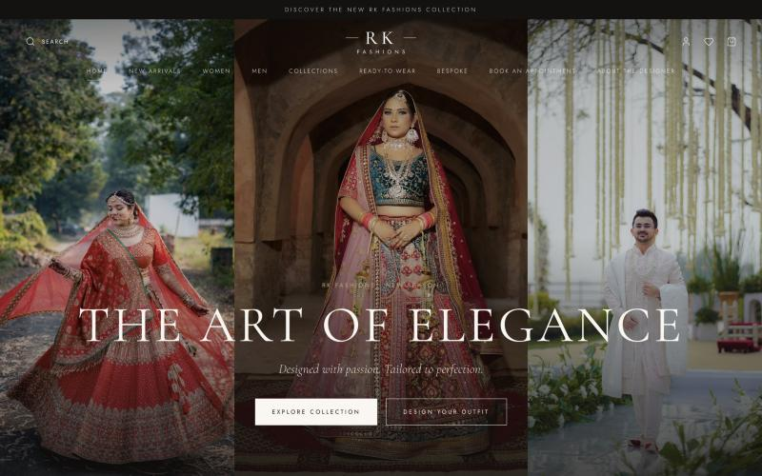
Figure 1: Home page (hero campaign section)
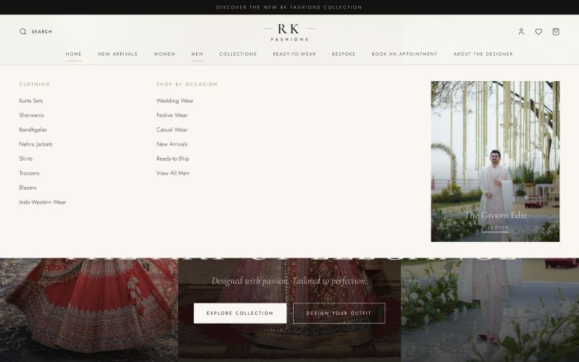
Figure 2: Mega menu navigation (Men)

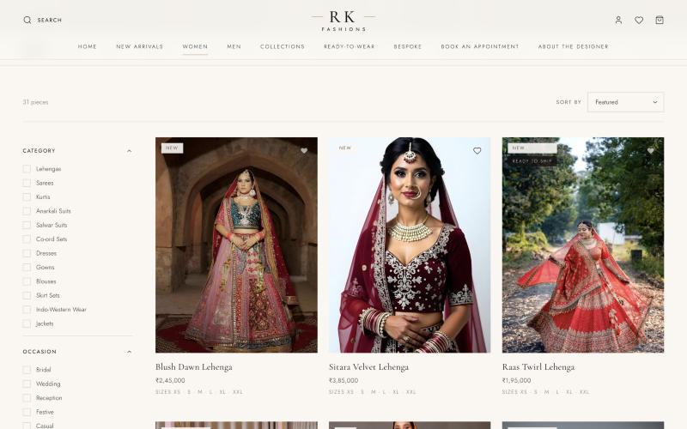
Figure 3: Women's collection with filters and product grid
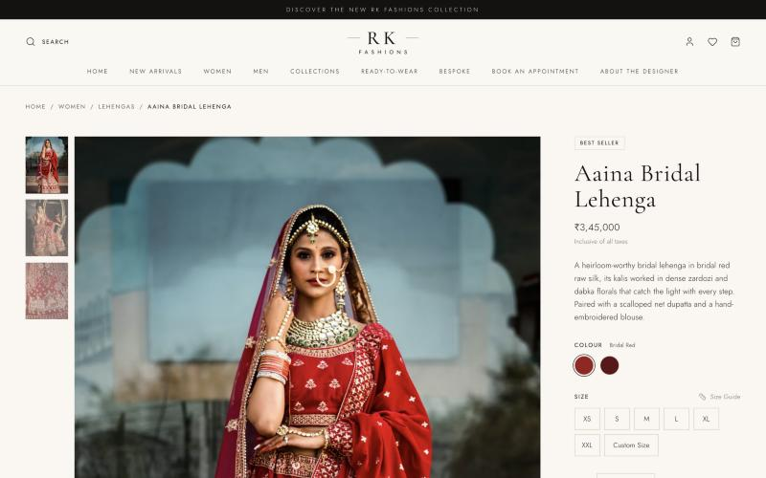
Figure 4: Product detail page

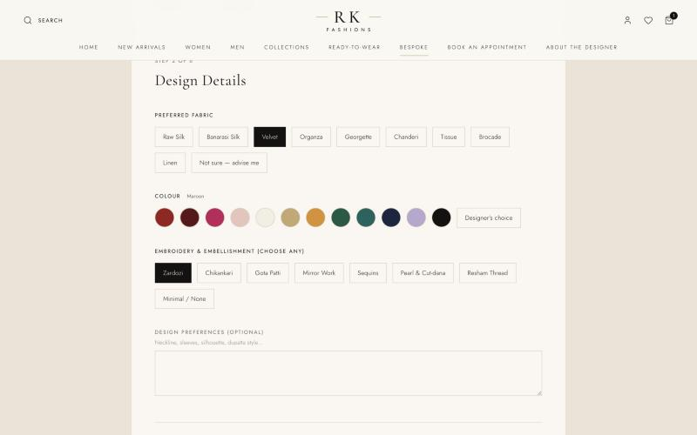
Figure 5: The Bespoke Studio – design details step
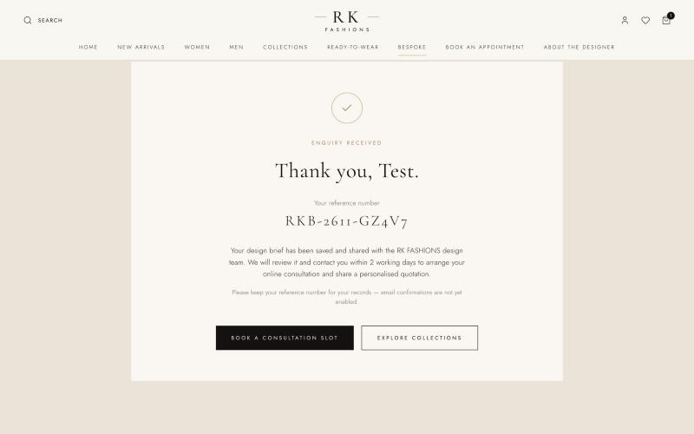
Figure 6: Bespoke enquiry confirmation with reference number

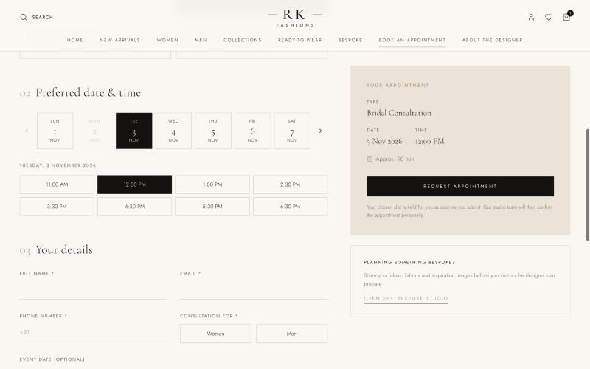
Figure 7: Appointment booking with available time slots
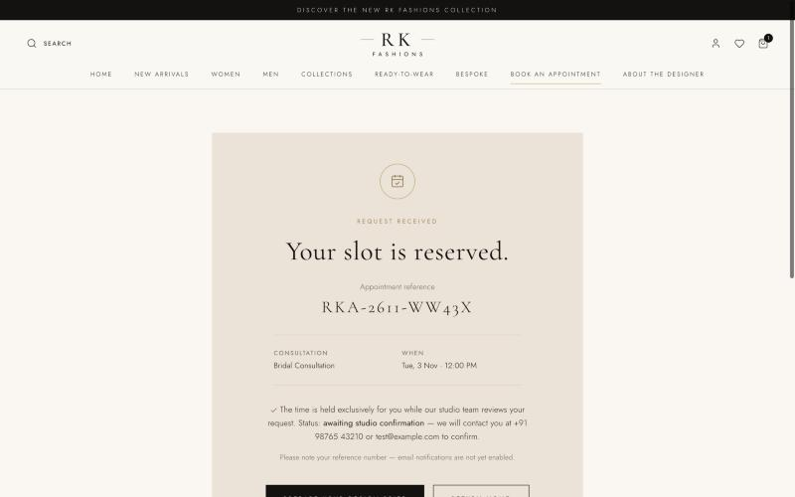
Figure 8: Appointment request confirmation

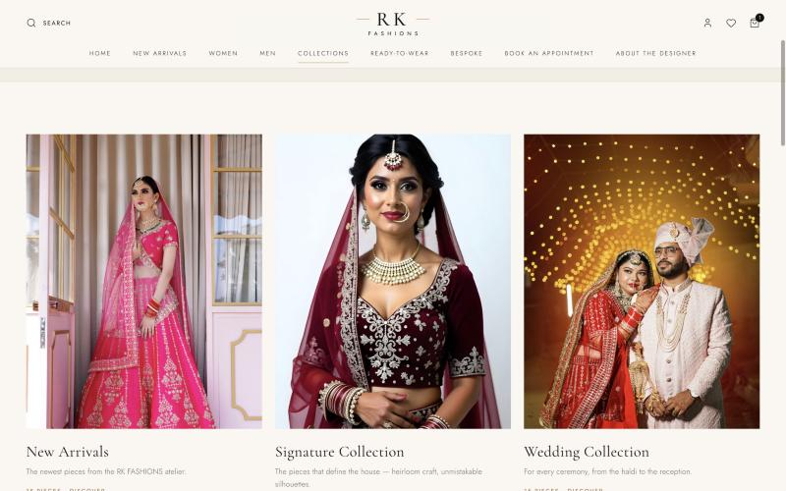
Figure 9: Collections page
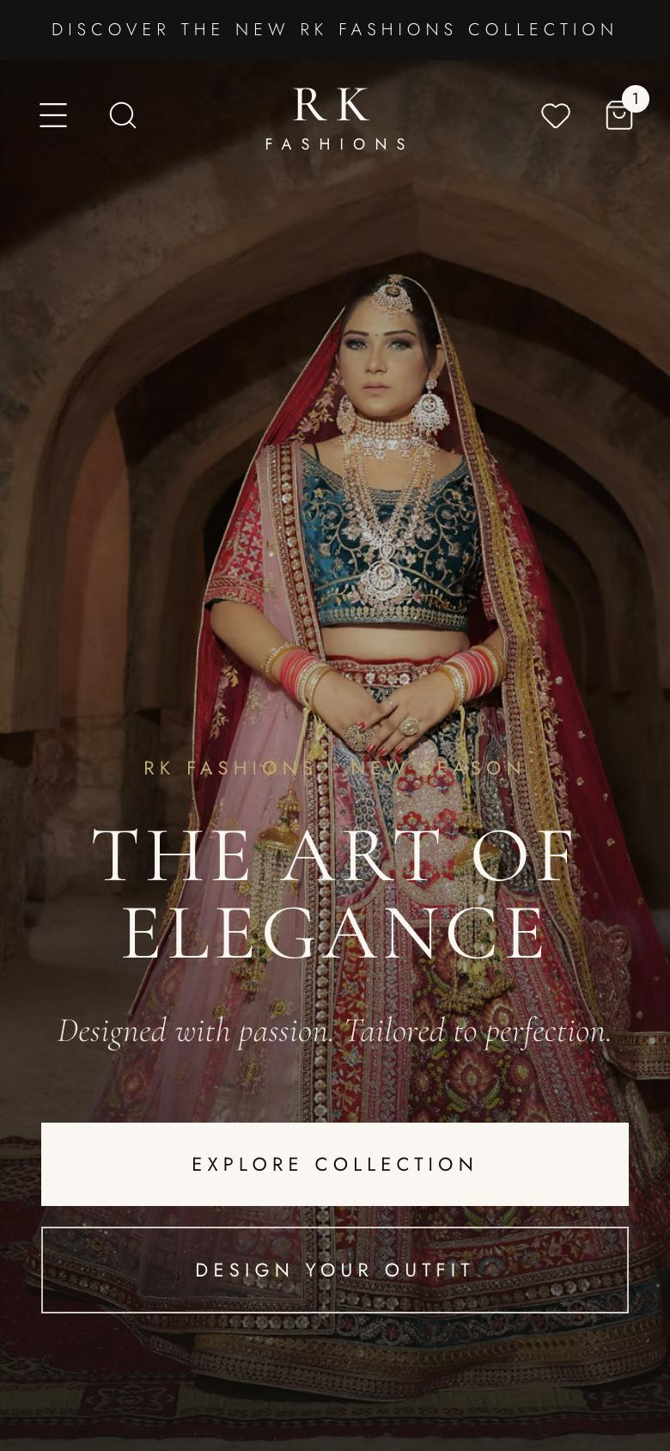
Figure 10: Mobile view of the home page

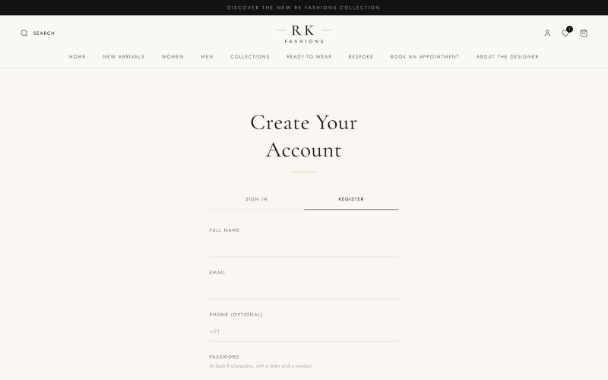
Figure 11: Customer registration page
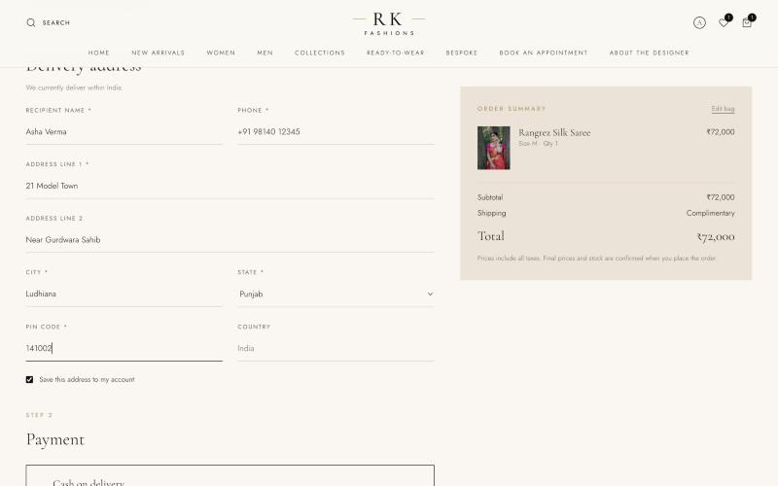
Figure 12: Checkout with delivery address and order summary

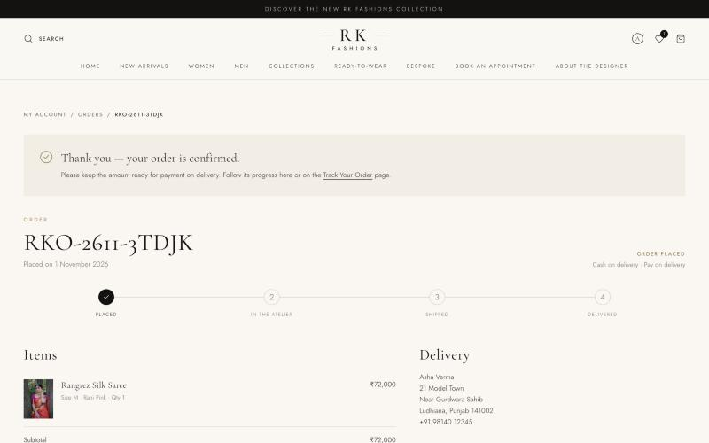
Figure 13: Order confirmation with progress tracker
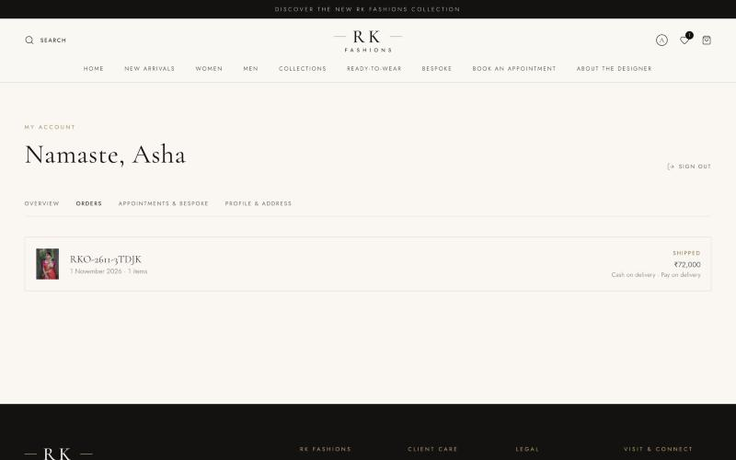
Figure 14: My Account – order history

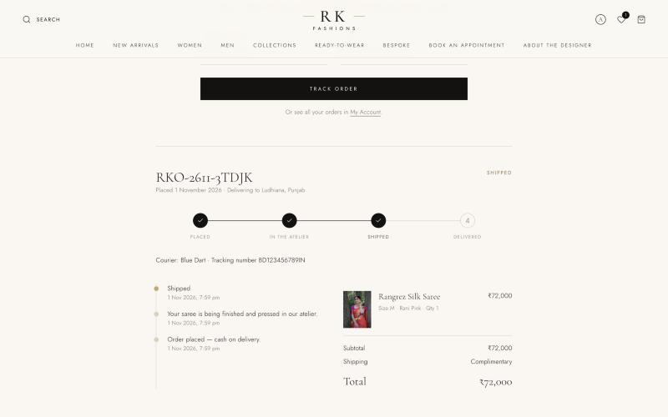
Figure 15: Public order tracking with courier details and timeline

DEPLOYMENT
The website currently runs in a local development environment. It is designed to be deployed as two services using the following steps:
- Create a free MongoDB Atlas cluster and copy its connection string.
- Deploy the server folder to a Node.js host such as Render or Railway, and set environment variables: MONGODB_URI, CLIENT_URL, JWT_SECRET, ADMIN_TOKEN, Razorpay keys and, optionally, SMTP and Cloudinary keys.
- Build the client with npm run build and deploy the dist folder to Vercel or Netlify, routing /api requests to the deployed server.
- Connect a custom domain for RK FASHIONS and enable HTTPS.
- Run locally: npm run install:all, then npm run dev, and open http://localhost:5173.
CONCLUSION & FUTURE SCOPE
The RK FASHIONS website meets its goals for the first two phases: it presents the brand as a premium Indian designer fashion house, supports both ready-to-wear shopping and bespoke design enquiries, provides a reliable appointment booking system, and lets customers create accounts, check out, and follow their orders through to delivery. Its modular architecture keeps all products and brand content editable and ready for an admin dashboard.
Future Scope
- Going live with Razorpay payments after account activation, with a payment webhook as a backup confirmation.
- Admin dashboard to manage products, images, inventory, orders, enquiries, appointments, slots, banners, testimonials and sales reports.
- Email and WhatsApp notifications for appointment confirmations and order updates.
- Replacing placeholder photographs with original RK FASHIONS campaign photography.
REFERENCE LINKS
- React documentation: https://react.dev
- Vite documentation: https://vite.dev
- Tailwind CSS documentation: https://tailwindcss.com/docs
- Motion (Framer Motion) documentation: https://motion.dev
- Express.js documentation: https://expressjs.com
- MongoDB and Mongoose documentation: https://www.mongodb.com/docs and https://mongoosejs.com
- Cloudinary documentation: https://cloudinary.com/documentation
- Nodemailer documentation: https://nodemailer.com
- Razorpay documentation: https://razorpay.com/docs
- Unsplash License (placeholder images): https://unsplash.com/license
- Design inspiration: https://www.anitadongre.com, https://ritukumar.com, https://manishmalhotra.in

