HYDRA
Full architecture, self-healing design, and operator brief
Sruthi Anuvalasetty · Ramachandra Nalam · 22 August 2026
Public dashboard: http://2.29.4.204:8080
Authors: Sruthi Anuvalasetty · Ramachandra Nalam
One sentence. HYDRA keeps an Amazon product catalog on screen. When a scrape fails, shoppers still see the last good catalog while the agent finds the failure class, tries a bounded repair, and only publishes again after the same quality check that failed now passes.

Contents
1. How to explain this to anyone
2. What I built
3. LinkedIn and submission copy
4. What the system does
5. High-level design
6. How self-healing works
7. Last-good catalog
8. Failure classes, primitives, and Amazon faults
9. Low-level design
10. Four-minute judge script
11. Scoreboard and talking points
12. Commands, invariants, and repository map

1. How to explain this to anyone
Imagine a store window that must never go empty. A clerk goes to Amazon, copies the shelf, and only then updates the window. If Amazon slams the door, shows an “are you human?” page, or sends a half-empty box, the window still shows yesterday’s products. Customers never see a blank page.
Then a supervisor asks a simple question: was the door locked, was the box empty, or was one item rotten? It tries a bounded fix. Wait and try again. Use a stronger fetch. Rebuild from the last good box. Set aside the rotten item. It does not invent a softer test so it can declare victory. It re-runs the same checklist: enough products, every item has an ID and a title, prices are not mostly missing.
If the problem would change the shape of the catalog — a column renamed — it stops and asks a human. If the same problem happens three times in an hour, it stops on purpose so it cannot burn money all night.
That is what “self-healing” means here. Detect the break. Classify it. Stay safe. Act. Prove the original check now passes.

2. What I built
This is a team hackathon. The generic agent — six failure classes, eight repair primitives, a DuckDB ledger — is HYDRA. My product work is what judges actually see.
I turned a source-agnostic healer into one story: Amazon catalog reliability. When someone asks what I built, the honest sentence is this. I made the catalog stay up, and I made the heal loop visible.
What I shipped | Why it matters
Amazon-only README and architecture diagrams | Judges see one story: the catalog stays up when the scrape breaks.
amazon_products contract and replay fixture | Bright Data dataset gd_l7q7dkf244hwjntr0. Required fields: asin, title. Quality floor: at least 5 products.
Public dashboard on port 8080; isolated live UI on 8081 | Break Amazon, then watch Detect → Classify → Guard → Act → Verify. Live cannot overwrite the judge page.
Last-good serving snapshot (data/hydra-live.json) | Raw Bright Data never writes the document the public page serves.
Port catalog import and control-plane entities | Writes hit a local ledger first. A Port login failure does not fail the pipeline.
Original factory invariants | Heal is triggered, not silent. Default mode is replay. Never promote a bad document.

The agent is the engine. The Amazon page is the proof. I own the proof.

3. LinkedIn and submission copy

LinkedIn (about 130 words)
Built HYDRA, a self-healing data agent for Amazon catalog reliability, for a zero-downtime hackathon with Ramachandra Nalam.
External data breaks quietly. HTTP 200 with empty or wrong products is how bad catalogs ship. HYDRA never puts a raw scrape on the page. It classifies the failure, applies one of eight reversible repairs, and only publishes after the same quality check passes. Schema changes wait for a human. Repeated identical failures open a circuit so the agent cannot burn budget overnight.
I productized the agent onto a public Amazon dashboard: last-good catalog, a Break control that injects eight real faults, and a visible Detect → Verify loop. Default mode is replay, so the demo does not depend on venue wifi.
Live: http://2.29.4.204:8080

Submission form (short)
HYDRA is a self-healing Amazon catalog agent. When the scrape breaks, the last-good catalog stays up. The agent detects the failure, classifies it (F1–F6), guards the repair, acts with one of eight primitives (P1–P8), and verifies using the same assertion that failed. No Port login. No SigNoz login. Open the dashboard, choose a fault, click Break Amazon, watch Detect → Classify → Guard → Act → Verify.
Dashboard: http://2.29.4.204:8080
Authors: Sruthi Anuvalasetty · Ramachandra Nalam

4. What the system does
HYDRA is pointed at one source for the demo: Amazon products. The catalog on the dashboard is real Amazon-shaped rows — ASIN, title, price, availability. Replay means we are not calling Bright Data on every tick, so the demo does not depend on venue wifi.
Piece | Value
Source | amazon_products
Contract | contracts/amazon_products.json
Replay fixture | fixtures/amazon_products.json
Bright Data dataset | gd_l7q7dkf244hwjntr0
Collection | hl_bbd9eb9a
Serving snapshot | data/hydra-live.json
Required fields | asin, title
Quality floor | at least 5 products
Default mode | HYDRA_MODE=replay

Operator action | What happens
scrape | Acquire → parse → validate → load. Promote only if assertions pass.
break --fault … | Arm one of eight runtime faults. No code edit.
heal | One detect-and-repair sweep.
Dashboard Break Amazon | Same as break plus the watch loop: scrape, hold last-good, then heal.
approve | Unlock a Tier 2 repair (schema change or failover).
reset-circuit | Close an open circuit after the agent gave up.
status | Source health plus MTTD, MTTA, MTTR, heal success.

Replay uses the fixture. You do not need a Bright Data key for the demo. Live calls the dataset API and is isolated on port 8081 so it cannot overwrite the judge page.

5. High-level design
Three planes. One invariant. The data plane acquires and quality-gates rows. The control plane classifies and repairs. The memory plane records what happened and can refuse a dangerous repair. The invariant: a raw scrape never becomes the serving document.

Data plane
Bright Data or the fixture → Acquire → Parse → Validate → Load DuckDB → hydra-live.json → dashboard. Validation is SQL assertions on the contract, not “HTTP 200 means success.” Quiet failures — too few rows, null prices — are first-class.

Control plane
Detect → Classify (F1–F6) → Propose a playbook → Guard → Act (P1–P8) → Verify → Learn. Sources are contracts (JSON). Failures are classes. Repairs are primitives. Adding a source is a JSON file, not a new handler. No Amazon-specific if-statements in the healer.

Memory and governance
DuckDB (hydra.duckdb) is the system of record: raw snapshots, runs, incidents, heal ledger. Port mirrors incidents and heals, best effort. Local ledger first. SigNoz is optional sight. OpenTelemetry export failures are swallowed after a three-second timeout.
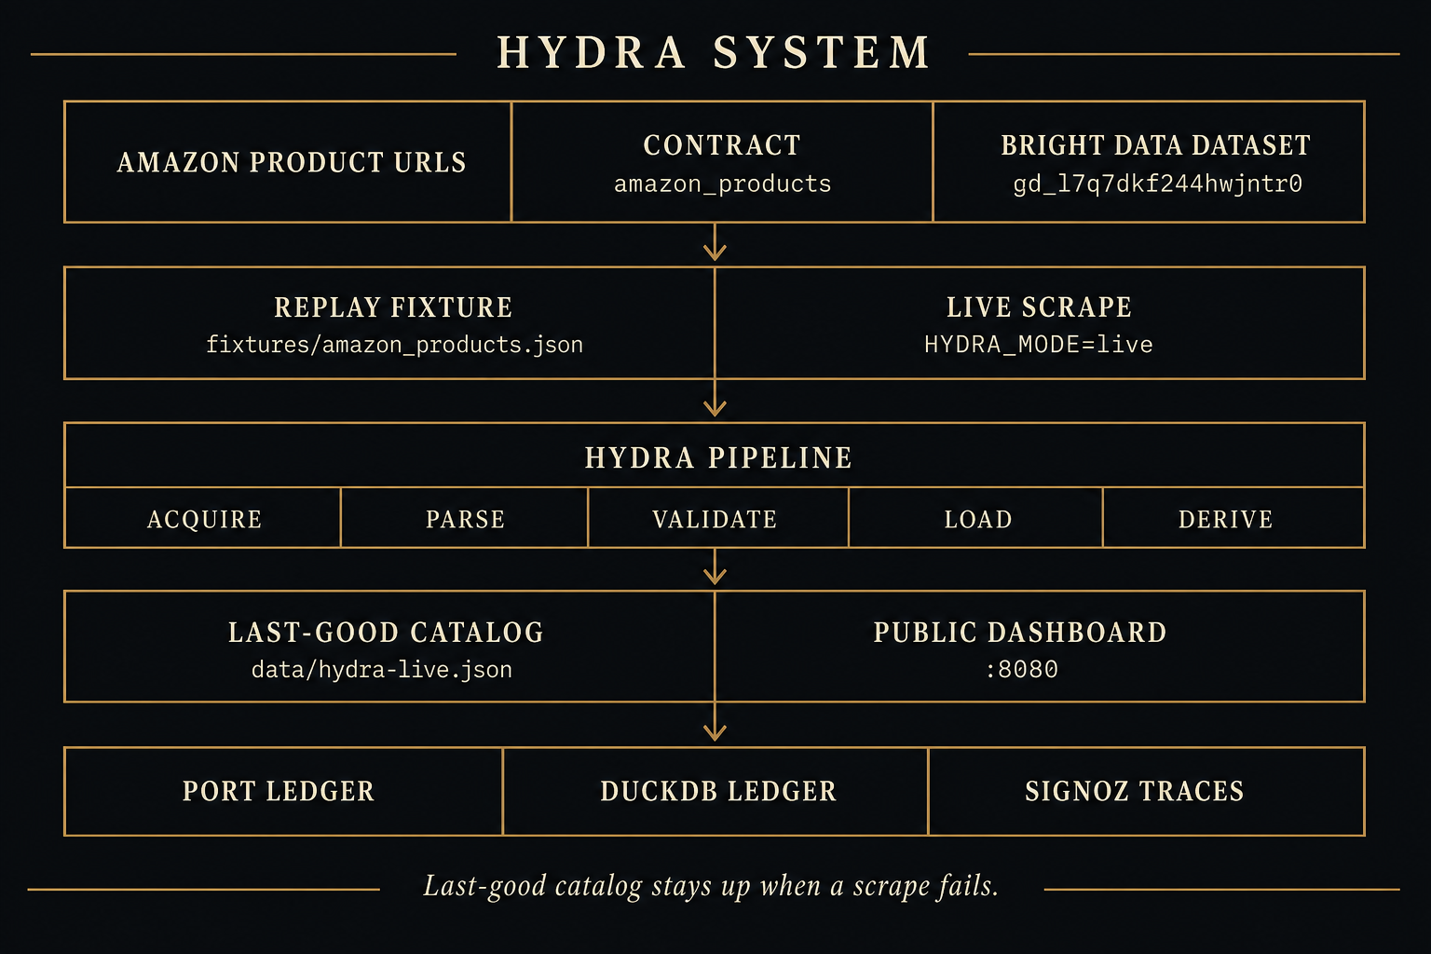
Figure 1. System architecture. Acquire, parse, validate, then promote. Raw scrape never writes the serving catalog.

6. How self-healing works
Heal is triggered, not silent. The dashboard watch loop scrapes, then heals only if that run failed. There is no silent auto-heal on a healthy feed. A repair is only a heal if the same assertion that failed, passes afterward.
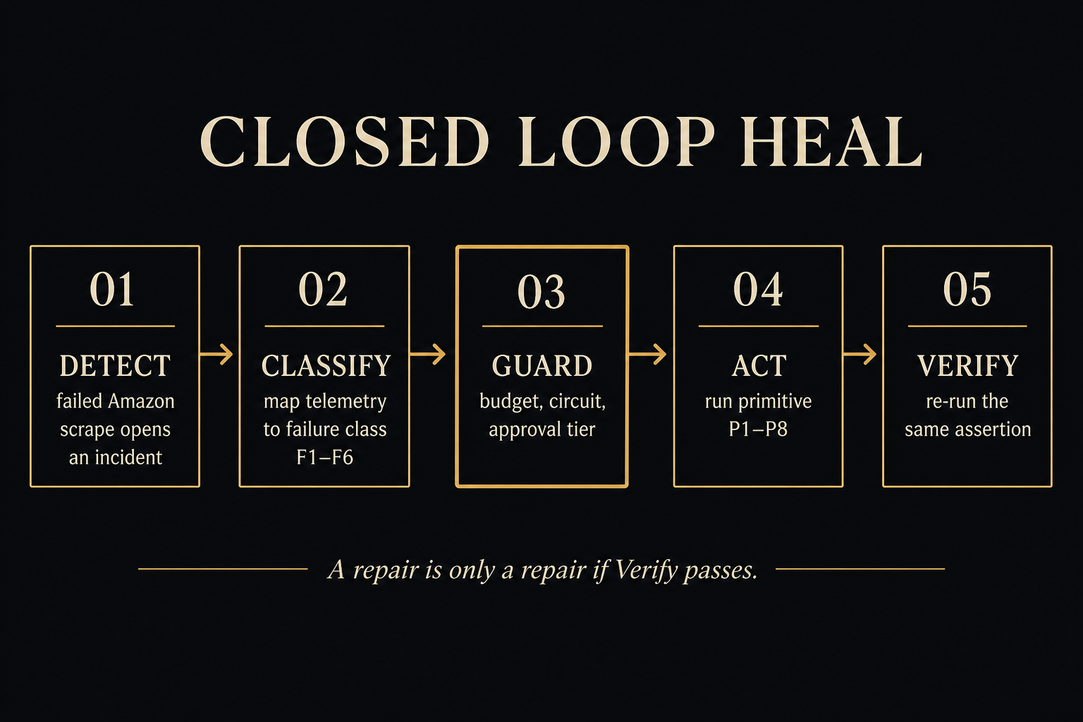
Figure 2. Closed-loop heal. Detect → Classify → Guard → Act → Verify. The same check that failed must pass.

Detect
Code: hydra/agent/detector.py. Three evidence sources, then one incident per source.
• Failed pipeline runs — 403, captcha, parse or load errors.
• Failed SQL assertions — row_count_floor, asin_not_null, and the rest of the contract.
• Freshness — no successful run inside the SLO (24 hours on Amazon).

Classify
Code: hydra/agent/classifier.py. First match wins. Inputs are telemetry, not “this is Amazon.”
If this is true | Class
No success inside the freshness SLO | F5 Freshness
Acquire error, HTTP ≥ 400, timeout, captcha, or empty body | F1 Acquisition
Zero rows, or fewer than half of last-good volume | F2 Structural drift
Schema errors | F3 Contract violation
Load error, poison, or conversion error | F6 Poison pill
Everything else — null flood, distribution | F4 Statistical anomaly

A fingerprint is a hash of class + source + stage + error + failed assertions. UUIDs and numbers are stripped so the same structural failure matches again. The same fingerprint three times in an hour is treated as structural, not transient.

Propose
Code: hydra/agent/proposer.py and playbooks.yaml. Each class has an ordered list of primitives. If this fingerprint healed before, that primitive is tried first. Every playbook ends in P8 — give up and open the circuit.
Loud 403 (F1): P6 backoff → P1 climb the ladder → P1 again → P7 failover → P8 stop.
Volume collapse (F2 / F4): P5 replay last-good raw → P1 stronger fetch → P2 resynthesize extractor → P8.

Guard
Code: hydra/agent/guard.py. This is the difference between a retry script and a system you can leave running. Before every primitive the guard checks:
Rule | Default
Circuit is open | Refuse until reset-circuit
Heal budget per source per hour | 5, then refuse
Same fingerprint in one hour | 3 times → force P8
Attempts on this incident | 4, then force P8
Primitive tier 2 or above | Ask a human before changing schema or failing over
Verification | Required. No verify, no success.

Act
Eight primitives. Each one operates on a contract and a failure record, never on a named source.
ID | What it does | Tier | Reversible
P6 | Wait, then retry | 0 | Yes
P1 | Advance one rung on the acquisition ladder (dataset → markdown → HTML) | 1 | Yes
P5 | Rebuild derived tables from the last-good raw snapshot. No re-fetch. | 0 | Yes
P2 | Infer a new extractor. Must reproduce known-good historical snapshots. | 1 | Yes
P4 | Drop bad rows to a dead-letter table. Commit the rest. | 1 | Yes
P3 | Additive schema or field aliases | 2 — ask first | Gated
P7 | Search for an alternate URL | 2 — ask first | Gated
P8 | Open the circuit and escalate to a human | 3 | Stop

P2 does not grade its own homework. A candidate extractor must replay historical snapshots that already have expected_rows. If it cannot reproduce them, it is discarded and the next primitive runs.

Verify
Code: hydra/agent/verifier.py. Re-run the same failing assertion IDs. No softer substitute check. If verify fails and the primitive was reversible, the contract patch is rolled back and the next primitive runs.
Heal success on the scoreboard is incidents healed divided by incidents finished. Backoff then a verified P1 is one healed incident, not two.

Learn
On verified success, DuckDB — and Port if configured — stores fingerprint → primitive. The next identical failure skips the wasted first steps. Measured effect: MTTR on a repeat failure drops by the cost of the primitives it skips.

7. Last-good catalog
Serving is split on purpose. The public page never reads Bright Data output. It reads data/hydra-live.json, which keeps products_good when products_now is bad.
1. Acquire writes raw to DuckDB raw_snapshot — content-hashed, append-only.
2. Parse and schema split good rows from bad rows.
3. Assertions run on the derived table (derived_amazon_products).
4. If the run is ok, products_good is updated. If not, the snapshot keeps the previous good list.
5. The dashboard reads hydra-live.json atomically — write a temp file, then replace.
So a 403 looks like this. The ribbon says BROKE. Cards are dimmed but still there. The loop walks Detect → Verify. The pill returns to Healthy.
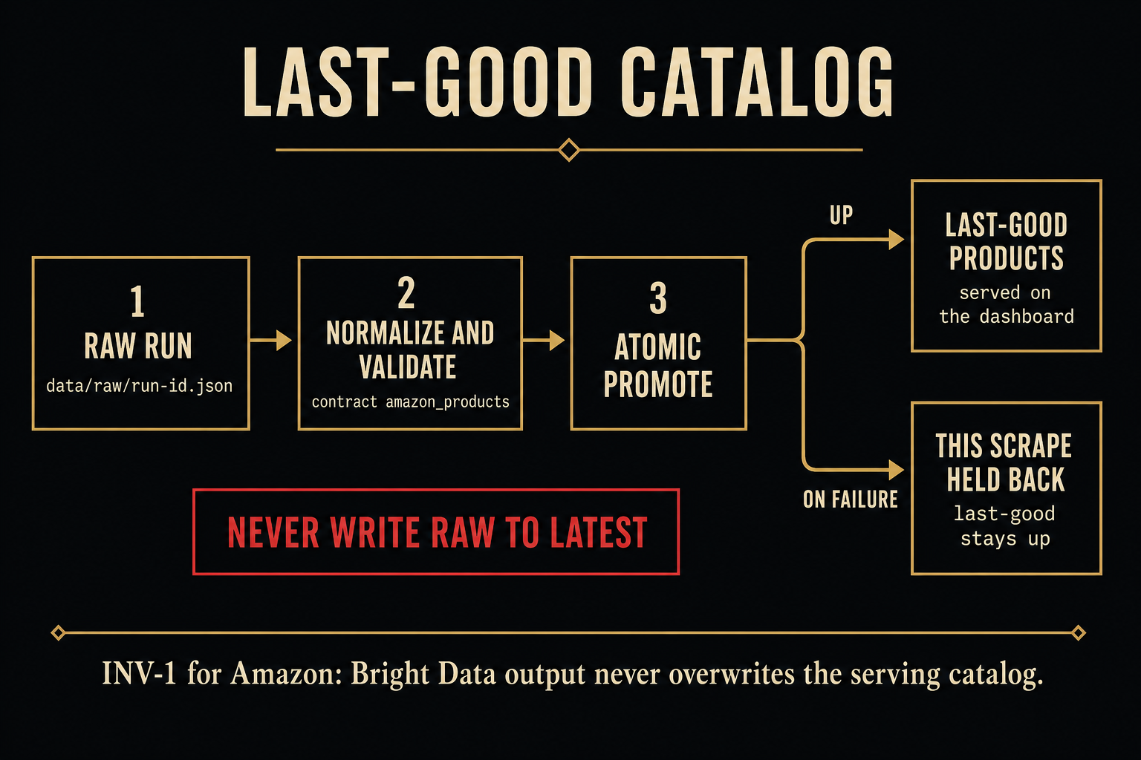
Figure 3. Last-good path. Fixture or Bright Data never overwrites the serving document.
Document | Role
fixtures/amazon_products.json | Replay source. No venue wifi required.
DuckDB raw_snapshot | Immutable raw payload and content hash.
DuckDB derived_amazon_products | Current parsed rows after validate.
data/hydra-live.json | Atomic serving snapshot for port 8080.
data/hydra-faults.json | Armed chaos flag shared with the watch loop.

8. Failure classes, primitives, and Amazon faults

Six failure classes
Class | Name | Signature | Typical repair
F1 | Acquisition | 403, timeout, captcha, empty body | P6 then P1
F2 | Structural drift | Fetch OK, zero or half the rows | P5 then P1 or P2
F3 | Contract violation | Rows exist, schema fails | P4 then P3 (Tier 2)
F4 | Statistical anomaly | Schema OK, distribution wrong | P5 then P1
F5 | Freshness | No success inside the SLO | P6 then P1
F6 | Poison pill | One row kills the batch | P4 quarantine

Eight Amazon faults the Break menu injects
Every fault is a runtime flag in data/hydra-faults.json. ChaosInjector.apply() mutates the payload — or raises 403 — after the fixture or live fetch. Loud faults apply only on the current rung unless marked permanent, so P1 can actually climb out.
Fault | What judges see | Class
Loud · HTTP 403 | Scrape blocked. Cards stay last-good. | F1
Loud · captcha wall | Human-check HTML, not products. | F1
Quiet · volume collapse | HTTP 200, too few products. | F2 / F4
Quiet · selector drift | Zero products extracted. | F2
Schema · price renamed | Price field gone. Guard asks. | F3
Schema · prices become n/a | Type errors. Bad rows held back. | F3
Quality · null flood | Most prices empty. | F4
Poison · one bad row | One product corrupts the batch. | F3 / F6

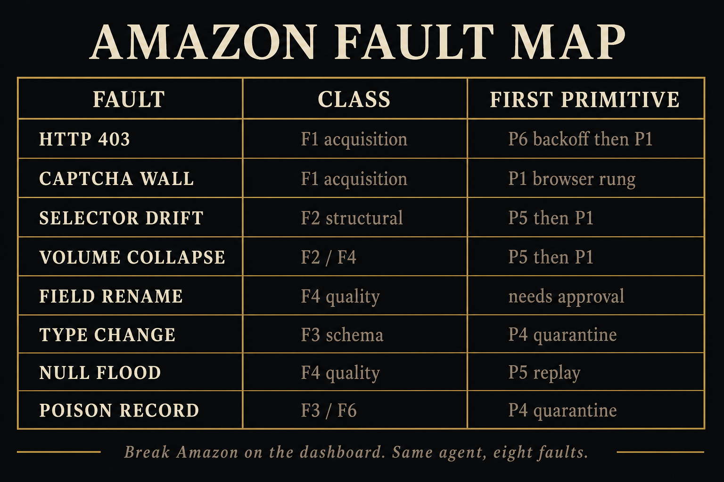
Figure 4. Amazon fault map. Same agent, same eight primitives, eight different breaks.

9. Low-level design
Composition root is HydraApp in hydra/factory.py. One lock serializes ingest and heal so the dashboard and the CLI cannot race.

The Amazon contract
contracts/amazon_products.json is the source, not Python. It declares how to acquire, how to extract, what the schema is, which SQL assertions must pass, and how far the agent may go without asking.
Acquisition ladder: scrape_dataset → fetch_markdown → fetch_html.
Extraction: json_records plus field aliases (price / final_price / current_price).
Schema: required asin and title; price and rating are optional numbers.
Assertions: at least 5 rows; ASIN and title not null; in-stock price null rate under 25 percent; no duplicate ASINs.
Healing: max autonomy tier 2, budget 5 per hour, all eight primitives allowed.

Watch loop
make hydra-dashboard starts the public UI with watch enabled. Every 3 seconds it ingests. On failure it holds 3.5 seconds so judges can see BROKE, then heals, then resets the acquisition rung so the next demo starts clean. prepare_demo raises the heal budget and can auto-approve Tier 2 so a live presentation does not freeze on Guard.

DuckDB tables
Table | Purpose
raw_snapshot | Append-only raw payload, hash, rung, expected_rows for P2.
pipeline_run | One ingest: status, rows in/out, error_type, trace_id.
assertion_result | Each SQL check, pass or fail, observed value.
dead_letter | Quarantined poison or schema rows.
incident | Opened on detect; closed healed, escalated, or blocked.
heal_ledger | One primitive attempt plus verification_passed.
heal_pattern | Fingerprint to successful primitive.
source_state | health, circuit_state, current_rung.
pending_approval | Tier 2 gate for schema change or failover.

Key files
Path | Owns
contracts/amazon_products.json | Acquisition ladder, schema, assertions.
playbooks.yaml | Failure class to ordered primitives.
capabilities.yaml | Logical tools to MCP names. No raw tool calls in business logic.
hydra/runtime/pipeline.py | Happy-path ingest and assertion SQL.
hydra/agent/loop.py | Closed heal loop.
hydra/chaos/faults.py | Eight runtime flags.
hydra/live_snapshot.py | Last-good snapshot and Detect/Classify/Guard/Act/Verify UI state.
hydra/dashboard.py | Public port 8080 and watch_tick heal.
hydra/dashboard_live.py | Isolated port 8081 so live cannot overwrite replay.
hydra/store.py | DuckDB schema, scoreboard, reliability metrics.

MCP capability layer
capabilities.yaml binds logical names to MCP tools. Business logic calls pool.invoke("fetch_markdown", …), never a raw tool name. If Bright Data renames a tool next month, you edit one YAML line. Replay mode never needs Port, SigNoz, or Bright Data to be reachable.

Relationship to the older factory
SPEC.md, bin/factory, and the Hacker News digest are still in the repository. That was the original Zero Downtime Factory. HYDRA sits beside it. HYDRA does not write data/latest.json. The public product is the Amazon dashboard. The factory invariants were reused: last-good stays up, heal is triggered, Port is ledger-first, OpenTelemetry failures are swallowed, default mode is replay.

10. Four-minute judge script
Rehearse this three times. One break at a time. Wait for Healthy before the next. Default mode is replay. You do not need a Bright Data key.

0:00 to 0:30 — The setup
Open http://2.29.4.204:8080. Names under the title are LinkedIn links. Catalog is healthy. Ten Amazon products. Dark / Light stays pinned at the bottom left.
Say: “This is a live Amazon catalog. The page is serving last-good data, not a raw scrape. I am about to break the scrape on purpose.”

0:30 to 1:15 — Loud 403
1. Open the Break dropdown. Choose Loud · HTTP 403.
2. Click Break Amazon.
3. Ribbon says BROKE. Cards stay on screen, dimmed. That is last-good. Nothing was promoted.
4. Loop walks Detect → Classify → Guard → Act → Verify. Pill returns to Healthy.
Say: “Detected as F1, acquisition failure. It backed off, then climbed the acquisition ladder. Two attempts, both recorded. Heal success counts this as one incident, not two.”

1:15 to 2:30 — Quiet volume collapse
Wait until Healthy. Then choose Quiet · volume collapse. Click Break Amazon.
Say: “This is the failure that actually costs money. The scrape returns HTTP 200. A naive pipeline would ship three products and call it success. The row-count assertion caught it.”
Point at the scoreboard. MTTD is how fast we noticed. MTTR is how fast the same checklist went green again.

2:30 to 3:15 — Schema rename, if you want Guard
Choose Schema · price renamed. Click Break Amazon.
Say: “Schema change. The agent is not allowed to do this alone. Tier 2 stops and asks. An agent that can change your schema at 3 a.m. without asking is not a feature.”
If the demo is in auto-approve mode for the presentation, say that out loud: “For stage timing we pre-approved Tier 2. In production this card waits for an owner.”

3:15 to 3:45 — The numbers
Hover any scoreboard tile. Read MTTD, MTTA, MTTR, heal success, false-heal rate, autonomy.
Say: “We track false heals, because an agent that claims success without verifying is worse than no agent.”

3:45 to 4:00 — Close
Say: “Same agent. Same eight primitives. The demo source is Amazon. The healer is not Amazon-specific. Adding a source is a JSON contract, not a pull request.”

If something goes wrong
If this happens | Do this
Loop freezes on Guard | Designed, not a hang. Click Reset circuit, then Break again.
Venue wifi dies | You are already on replay. Do not switch to live.
Live fetch is requested | Use port 8081 only. Do not touch 8080.
Same 403 repeats | Fingerprint escalation opened the circuit. Reset, then continue.
Everything breaks | This document plus the recorded fallback. Do not write code on stage.

11. Scoreboard and talking points
Metric | Definition | How to say it
MTTD | Detection time minus fault injection time | How fast we noticed.
MTTA | First heal attempt minus detection | How fast we started a repair.
MTTR | Resolution minus detection | How fast the original checklist went green.
Heal success | Incidents healed / incidents finished | Not every ladder step. One incident, one score.
False-heal rate | Marked success, then the same fingerprint fails again | We measure our own lies.
Autonomy | Verified heals with no human approver | Most classes do not need a person.

Sentences that land
“Retries are not healing. Healing is detect, classify, guard, act, and verify on the same assertion.”
“HTTP 200 with empty products is how bad catalogs ship. That is the quiet half.”
“The model does not get to grade its own homework.”
“Knowing when to quit is a design requirement, not a bug.”
“If it is not recorded in the ledger, it did not happen.”

12. Commands, invariants, and repository map

Commands
make hydra-test
make hydra-dashboard # replay UI on :8080
make hydra-dashboard-live # live UI on :8081
make hydra-amazon # live scrape, needs a key
python3 -m hydra scrape|break|heal|status|approve|reset-circuit|dashboard

Invariants — say these out loud
1. Last-good stays up. Raw Bright Data or CLI output is never written onto the serving catalog.
2. Heal is triggered. The dashboard watch loop heals after you break. There is no silent auto-heal on a healthy feed.
3. One Amazon contract. Do not create a second scraper for the demo.
4. Port writes hit the local ledger first. A Port login failure does not fail the pipeline.
5. OpenTelemetry failures are swallowed (3 second timeout, log once). The dashboard does not require SigNoz.
6. Default mode is replay. Live needs BRIGHTDATA_API_TOKEN or BRIGHTDATA_API_KEY.

Repository map
Path | What it is
contracts/amazon_products.json | Contract, assertions, ladder
fixtures/amazon_products.json | Replay catalog
hydra/dashboard.py | Public UI on port 8080
hydra/dashboard_live.py | Isolated live UI on port 8081
hydra/runtime/ | Acquire → parse → validate → load
hydra/agent/ | Detect, classify, guard, act, verify
hydra/chaos/ | The eight Amazon faults
hydra/primitives/ | P1 through P8
playbooks.yaml | Class to primitive order
HYDRA.md | Design contract for the agent
data/hydra-live.json | Serving snapshot (not committed)

30-second pitch
External data breaks constantly, quietly, and differently every time. Retries are not healing. HYDRA makes sources declarative and failures categorical. Repairs bind to classes, never to sources, so healing generalizes. The page never goes blank. The agent knows when to stop, asks before it changes your schema, and reports its own false-heal rate.

