SUBMISSION GUIDE:
- Create your Windows Forms App (.Net Framework)
- Take **screenshots** of the following:
  - GUI Design (your form)
    - LoginForm
    - SignupForm
    - Dashboard
    - DataEntryForm
  - Code (event handler)
  - Output (program running)
- Compile your outputs into ONE document:
  - Microsoft Word (.docx)
  - PDF file
- Include the following in your file:
  - Title of your system
  - Screenshot of GUI
  - Screenshot of code
  - Screenshot of output
  - Short explanation of your program
- File name format:
Lastname_Firstname_Section_Lab1
- Submit your file via:
  - MS Teams
- Submit on or before:
ˆ·ç·.·.·April 14, 2026

PART I – GUI DESIGN
- Create a simple system (choose one):
  - Student Information
- Identify at least three (5) inputs:
a. Username
b. Password
c. First Name
d. Last Name
e. Birthdate

- Screenshot your GUI layout using the Visual Studio:

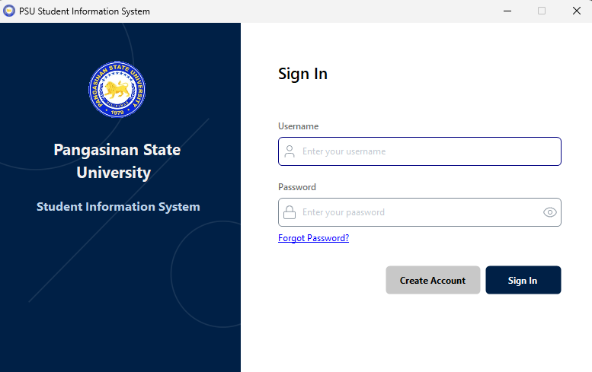
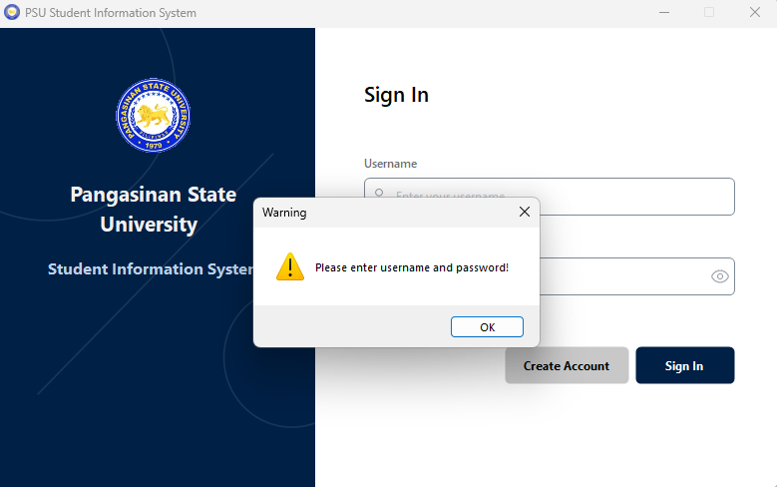

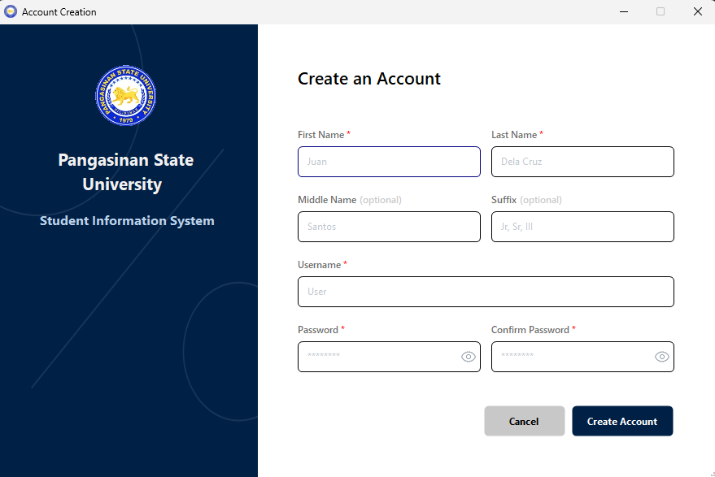
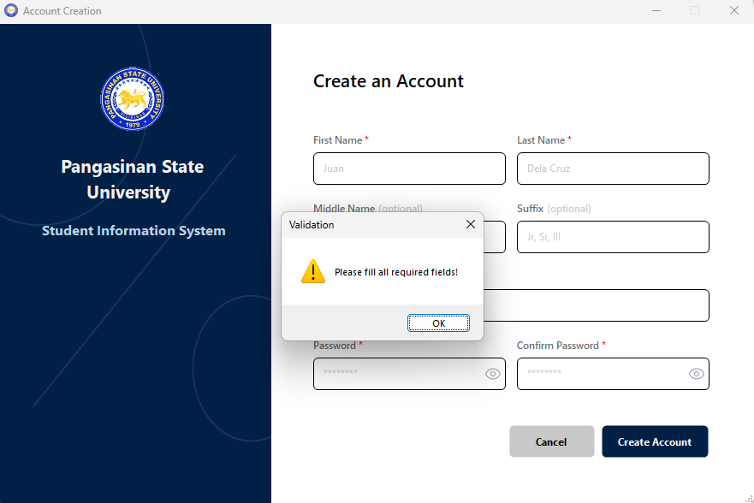

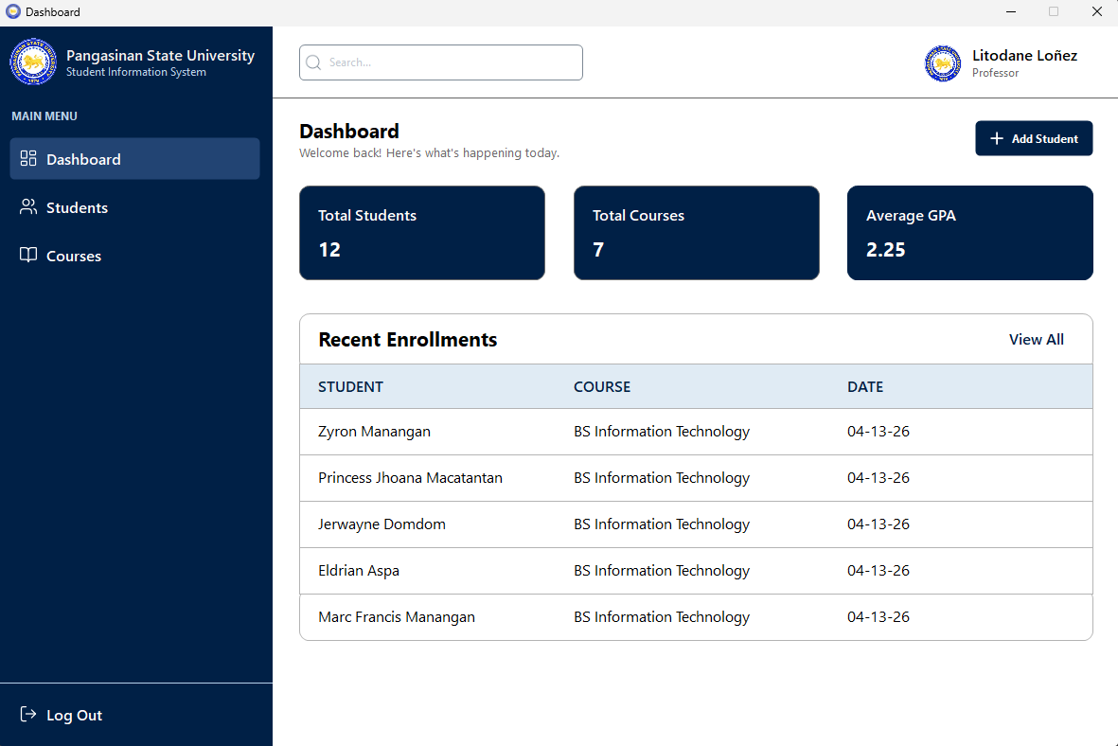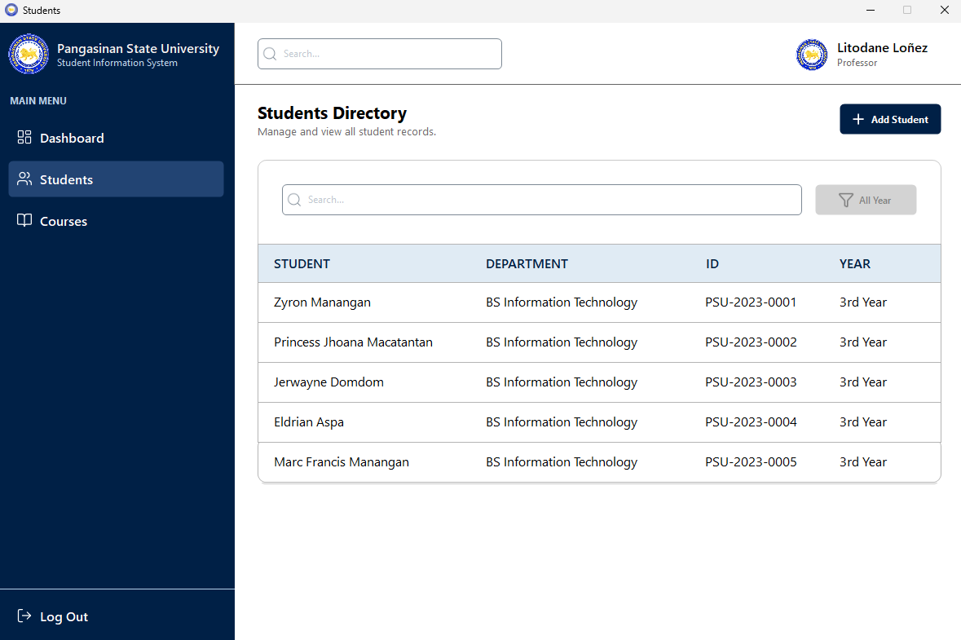

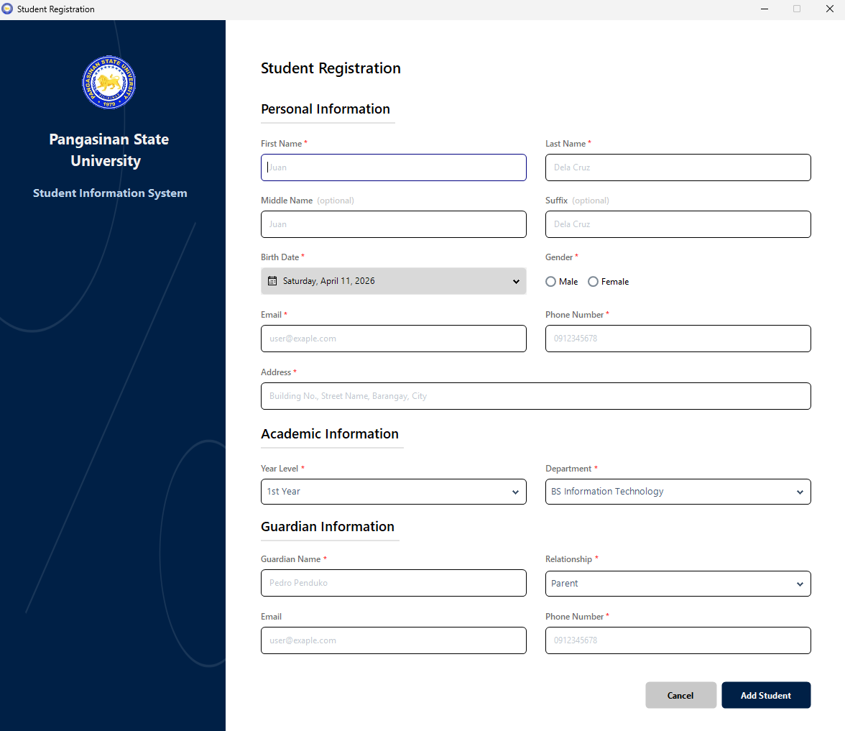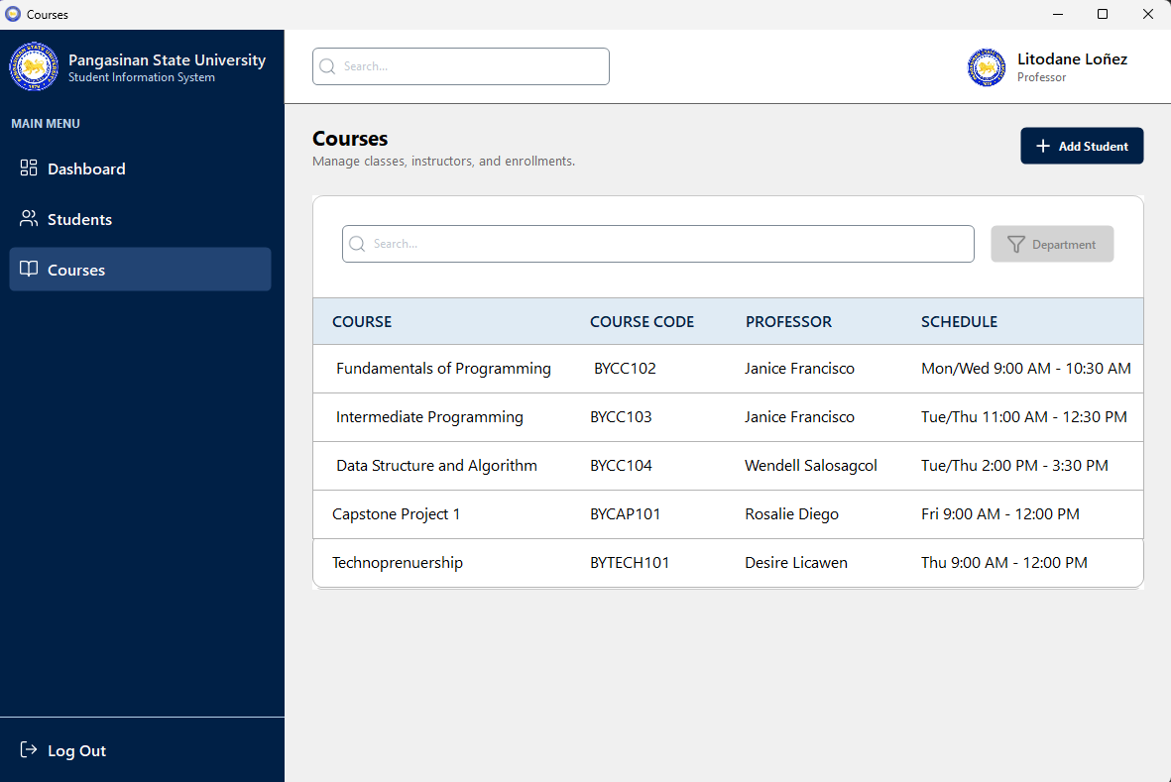
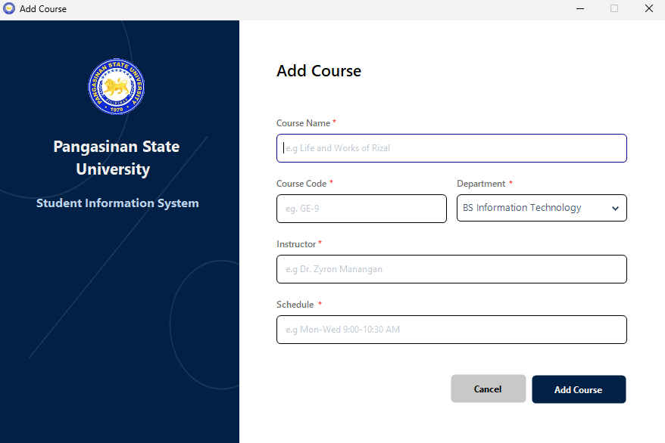

PART II – COMPONENTS
- List the components you used:
Component | Purpose
Label | Used to display non-editable text such as form titles, headers, and field descriptors like "Username" and "Password".
TextBox | Provides an input area for the user to enter alphanumeric data such as names and login credentials.
Button | Acts as a clickable control to trigger specific actions like "Sign In," "Create Account," or "Add Student".
PictureBox | Used to host and display image assets such as the university logo and interface icons.
DateTimePicker | Allows the user to select a specific date from a calendar dropdown for the birthdate field.
Panel | Serves as a container to group other controls and organize the layout for the sidebar and top navigation.

PART III – EVENT PLANNING
- What will happen when the button is clicked?
- When the Sign In button is clicked, the program will first perform a validation check to ensure that both the Username and Password text fields are not empty. If the user fails to provide credentials, the system will trigger a warning message box with the text "Please enter username and password!" to alert the user. If the fields are properly filled, the system will hide the Login form and display the Dashboard, which serves as the main navigation hub showing student statistics and recent enrollments. Additionally, when the Add Student button is clicked within the system, it will open the Student Registration form for data entry. The program will then monitor the required fields, displaying a validation prompt if any mandatory information is missing before allowing the record to be added.

PART IV – CODING TASK
- Write a simple event handler code:
private void btnSubmit_Click(object sender, EventArgs e)
{
if (string.IsNullOrWhiteSpace(txtUsername.Text) || string.IsNullOrWhiteSpace(txtPassword.Text))
{
MessageBox.Show("Please enter username and password!", "Warning", MessageBoxButtons.OK, MessageBoxIcon.Warning);
return;
}

MessageBox.Show("Login Successful!", "Success", MessageBoxButtons.OK, MessageBoxIcon.Information);
Dashboard dashboard = new Dashboard();
dashboard.Show();
this.Hide();}

- What will your program display when the button is clicked?
- If the username or password fields are empty, the program will display a Warning Message Box with the text "Please enter username and password!". If the fields are filled, it will show a Success message and then open the Dashboard form while hiding the login screen.
.

PART V: CHECKLIST
Check if you have completed the following:
- GUI is properly designed
- Controls are properly named (txtName, btnSubmit, etc.)
- Event handler is implemented
- Output is displayed correctly

PART VI – REFLECTION
- What did you learn from this activity?
- Through this laboratory activity, I learned how to navigate and utilize the environment of Visual Studio 2022 to create a functional Windows Forms Application. I realized that while the syntax and IDE are different from my previous experience with Java and Eclipse, the fundamental logic of event-driven programming remains similar. I also learned the importance of proper control naming and input validation to ensure a smooth user experience, especially when managing multiple forms like the Login, Dashboard, and Registration screens.

- What challenges did you encounter?
- I encountered was the adjustment period of using C# and Visual Studio 2022 for the first time. Navigating a new interface and learning the specific properties of C# components felt unfamiliar at the start. Additionally, implementing the logic for database simulation or form navigation required careful attention to detail to avoid errors. However, my prior experience in building a GWA Calculator using Java and Eclipse helped me understand how components like textboxes and buttons work, which made the transition more manageable.

RUBRIC (20 POINTS)
Criteria | 10 | 7 | 5 | 2
GUI Design | Clean and organized | Minor errors | Needs improvement | Poor layout
Component Use | Correct components | Minor mistakes | Some missing | Incorrect
Event Handling | Fully working | Minor issues | Partial | Not working
Code Quality | Clean and correct | Minor errors | Needs improvement | Incorrect

