Chapter 4

RESULTS AND DISCUSSION
This chapter presents, analyzes, and discusses the findings of the study based on the stated research objectives. The presentation of results follows the sequence of the objectives: the existing legislative management process; the problems encountered in the current process; the functional requirements of the intended users; and the usability evaluation of the developed Pangasinan Legislative Information System (PLIS) in terms of efficiency, affect, helpfulness, control and learnability.
Existing Legislative Management Process
Interviews with authorized personnel, direct observation of office procedures, and review of available legislative documents were conducted to describe the existing legislative management process of the Sangguniang Panlalawigan of Pangasinan. The findings focused on the receiving, recording, routing, tracking, committee referral, archiving, retrieval, reporting, and monitoring of legislative documents, including ordinances, resolutions, official communications, committee reports, and related records.
The analysis of the current process provides the basis for identifying how legislative documents move across the concerned offices, including the SP Secretary, Administrative personnel, Receiving personnel, Committee Affairs personnel, Plenary Affairs personnel, and Legislative Staff. It also establishes the workflow requirements that must be reflected in the development of PLIS. By documenting the existing procedures, the researchers were able to determine the points at which document processing, coordination, tracking, and records management may be improved through a centralized web-based legislative information system.
The findings from this section serve as the foundation for the succeeding discussions on the problems encountered in the current legislative management process, the required system features, and the usability evaluation of the developed PLIS.
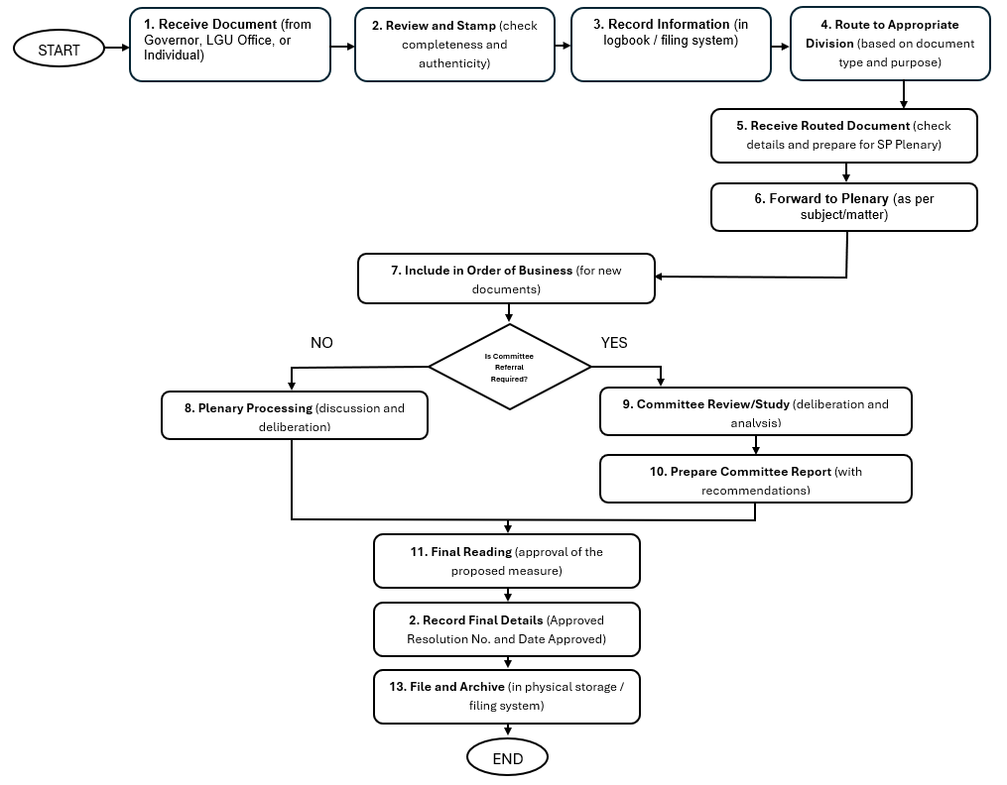

Figure 3. Flowchart of Existing Legislative Process
The flowchart presents the existing legislative document workflow of the Sangguniang Panlalawigan of Pangasinan, beginning with the receipt of documents from the Governor, local government offices, or individual parties. Upon receipt, the document is reviewed for completeness and authenticity and is stamped accordingly. The document information is then recorded in the existing logbook or filing system before it is routed to the appropriate division based on its type, subject, and purpose.
After routing, the concerned personnel receive and review the document before forwarding it to Plenary Affairs for appropriate processing. Newly received documents are included in the Order of Business. At this stage, a decision is made on whether committee referral is required. Documents that do not require committee referral proceed directly to plenary processing for discussion and deliberation. Documents that require committee action are referred to the appropriate committee for review, study, and analysis. The committee then prepares a report containing its findings and recommendations.
After plenary or committee processing, the document proceeds to the final legislative action. Depending on the outcome, the proposed measure may be approved, adopted, returned for further action, or referred to another office or committee. The final details, including the approved ordinance or resolution number and date, are then recorded. Finally, the completed document is filed and archived for future reference and retrieval.
The flowchart shows the sequence of activities, responsible offices, and decision points involved in legislative document processing. It also provides a basis for identifying possible areas for improvement, particularly in document routing, manual recording, committee referral, status monitoring, final-detail recording, and records archiving. These areas served as references in identifying the required features of the Pangasinan Legislative Information System, including document tracking, role-based access, committee workflow management, searchable records, and centralized archiving.
Table 3 Problems Encountered in the Existing Legislative Management Process
Problem Category | Identified Problem | Possible Effect on the Process
People | Manual follow-ups are needed to determine the current status of documents. | Delays in obtaining updates and coordinating with responsible personnel.
Process | Documents undergo several manual routing and endorsement steps. | Processing and document movement may take longer.
Technology | The existing process relies heavily on paper-based records and manual tracking. | Limited real-time visibility of document status and information.
Data and Records | Documents and records may be difficult to locate when needed. | Slower retrieval and verification of legislative records.
Access and Information | Personnel may need to coordinate with other offices to obtain updated document information. | Delayed responses and difficulty monitoring document progress.

Table 3 presents the problems encountered in the existing legislative management process. The findings show that the current workflow relies on manual follow-ups, paper-based records, and multiple routing and endorsement procedures. Personnel often need to coordinate with other offices to determine the current status, location, or action taken on a legislative document.
These concerns may result in delays in document processing, limited visibility of document status, slow retrieval of archived records, and difficulty in accessing updated legislative information. The identified problems highlight the need for a centralized system that can support document routing, status tracking, records archiving, retrieval, and controlled access to legislative information.
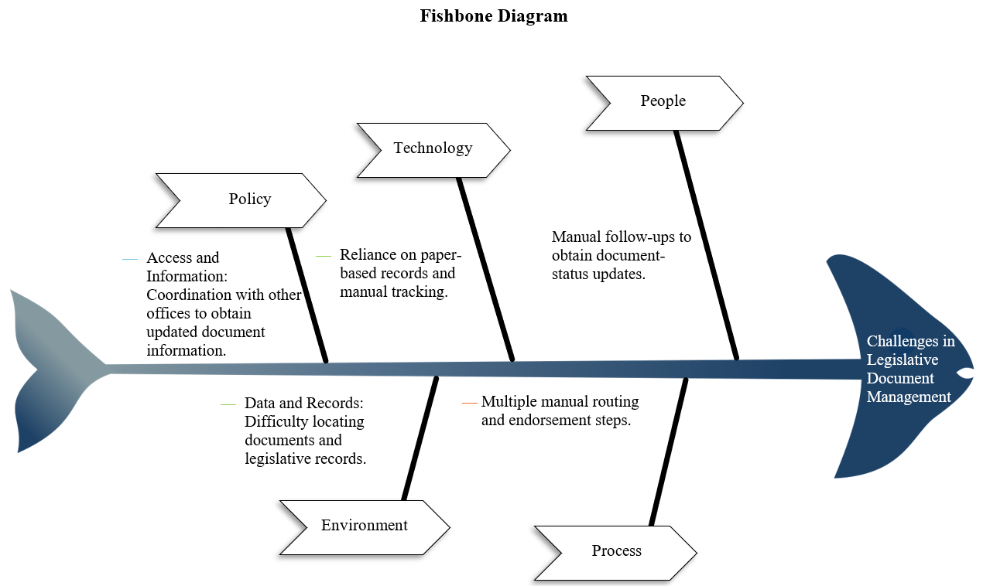
Figure 4. Fishbone Diagram of Existing Legislative Process
The Fishbone Diagram presents the possible causes of challenges in the existing legislative document management process of the Sangguniang Panlalawigan of Pangasinan. The “head” represents the central problem, while the “bones” organize the contributing factors into people, process, technology, data and records, and access and information. The diagram highlights reliance on manual follow-ups, multiple routing and endorsement steps, paper-based records, difficulty locating documents, and coordination with other offices to obtain updated information. These factors provide a basis for identifying PLIS features that support centralized records management, document routing, status tracking, and efficient retrieval.

Proposed Process in Legislative Document Management
The process of legislative document management plays a crucial role in ensuring the smooth operation of the Sangguniang Panlalawigan and the timely delivery of legislative services. This process involves the receiving, routing, tracking, monitoring, archiving, and retrieval of ordinances, resolutions, committee reports, and other legislative documents. By systematically recording and monitoring these documents, authorized personnel can easily determine the status of each document, reduce delays, and ensure that important legislative activities are properly documented and followed up.
At present, the recording and monitoring of legislative documents are mostly done through manual and semi-digital processes. Information is recorded in physical logbooks, folders, and spreadsheets, while communication is done through face-to-face coordination, phone calls, text messages, or online messaging applications. The current process goes through several stages, including document receiving, manual encoding, routing to concerned offices or committees, tracking of document status, consolidation of records, archiving, and retrieval of documents when needed.
Although the current process allows the Office of the Sangguniang Panlalawigan to continue its legislative functions, it presents challenges in terms of organization, accessibility, and efficiency. Manual recording and tracking may result in delayed document routing, misplaced records, difficulty in monitoring document status, and slow retrieval of archived files. As the volume of legislative documents continues to increase, there is a compelling opportunity to integrate a digital solution that can streamline the workflow, improve record management, and enhance the overall experience of the personnel in managing legislative documents.
Proposed Process in the Pangasinan Legislative Information System
To address these concerns, the proponents will develop the Pangasinan Legislative Information System (PLIS). The proposed system will digitize the process of receiving, routing, tracking, monitoring, archiving, and retrieving legislative documents. Through PLIS, authorized users will be able to encode and upload documents, assign documents to the appropriate office or committee, monitor their status in real time, generate reports, and retrieve archived records easily.
The proposed process will begin with the receiving and encoding of legislative documents. The system will then automatically route the documents to the concerned personnel or committee based on their assigned roles. Users will be able to track the progress of each document, receive notifications for pending actions, and generate reports whenever needed. Finally, completed documents will be archived in the system for secure storage and faster retrieval.
The proposed system will also provide role-based access to ensure that authorized users can perform tasks appropriate to their responsibilities. Documents requiring committee action will be referred to the concerned committee, while those requiring plenary action will be forwarded to the appropriate personnel for further processing. Updates on document status and actions taken will be recorded in the system, allowing users to review the progress and processing history of each document. These features aim to strengthen accountability and improve coordination among the offices involved in legislative document management.
This proposed process aims to reduce manual work, minimize document delays, improve accessibility of records, and provide a more organized and efficient way of managing legislative documents within the Sangguniang Panlalawigan of Pangasinan.
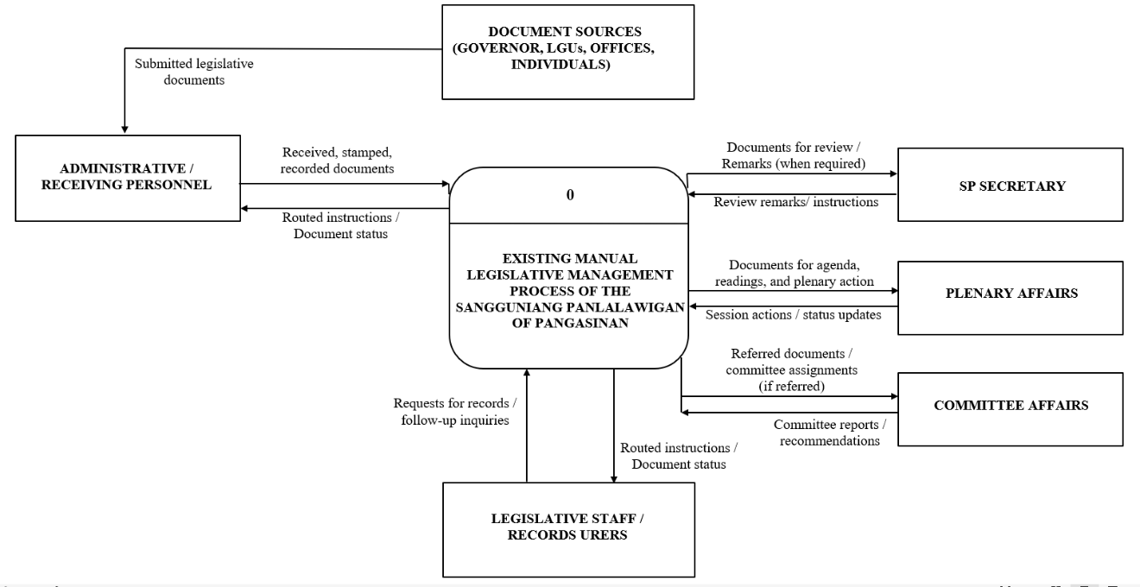

Figure 5. Context Data Flow Diagram of the Existing Legislative Management Process
Figure 5 illustrates the context data flow diagram of the existing manual legislative management process of the Sangguniang Panlalawigan of Pangasinan. The process begins when legislative documents from the Governor, local government units (LGUs), government offices, and individuals are submitted to Administrative or Receiving Personnel. These personnel receive, stamp, record, and initially process the documents before forwarding them to the appropriate offices for review and action. The SP Secretary provides review remarks or routing instruction when necessary, while the Plenary Affairs Division handles documents for agenda preparation, readings, and plenary action.
Documents requiring committee action are referred to the Committee Affairs Division for coordination of committee assignments, evaluation, and preparation of committee reports or recommendations. This referral applies only to documents requiring further examination by the concerned committees. Throughout the process, the personnel involved exchange document-status updates, instructions, and related information to coordinate the necessary actions.
Once the required actions are completed, finalized documents and their corresponding tracking records are filed and maintained for future reference and retrieval. Legislative Staff and other authorized records users may submit requests for records or inquire about document status. Overall, the diagram shows the exchange of legislative documents and information among the participating offices and users, with document handling, routing, monitoring, and retrieval carried out through manual procedures and personnel coordination.

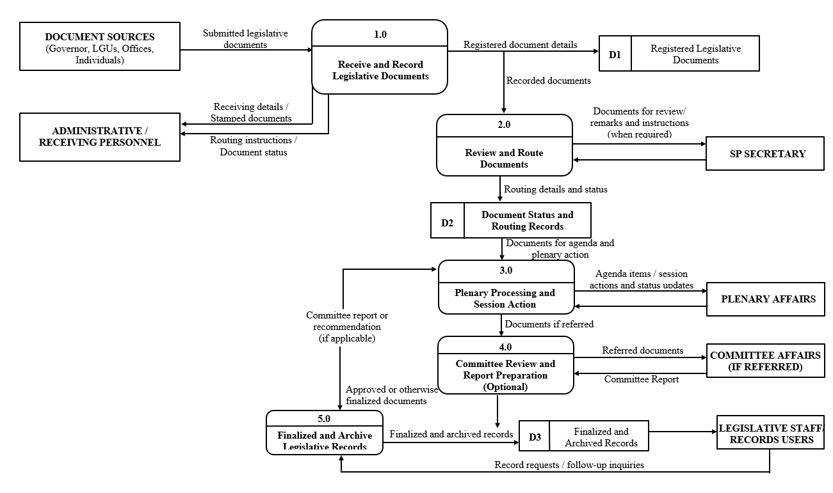

Figure 6. Top-Level Data Flow Diagram of the Existing Manual Legislative Management Process of the Sangguniang Panlalawigan of Pangasinan
Figure 5 illustrates the major processes and data flows within the existing manual legislative management process of the Sangguniang Panlalawigan of Pangasinan. It shows how legislative documents and related information are exchanged among document sources, Administrative or Receiving Personnel, the SP Secretary, the Plenary Affairs Division, the Committee Affairs Division, and Legislative Staff. The diagram consists of five major processes: receiving and recording legislative documents, reviewing and routing documents, plenary processing and session action, committee review and report preparation when required, and finalizing and archiving legislative records.
The process begins when documents from the Governor, local government units (LGUs), government offices, and individuals are submitted to Administrative or Receiving Personnel for receiving, stamping, and recording. The recorded documents are then reviewed and routed to the appropriate offices, with the SP Secretary providing remarks or instructions when necessary. Documents requiring agenda preparation, readings, and plenary action are forwarded to the Plenary Affairs Division for the corresponding processing and recording of session actions.
When committee action is required, the documents are referred to the Committee Affairs Division for coordination of committee assignments, review, and preparation of reports or recommendations. The resulting committee reports are forwarded for the appropriate subsequent action. Committee referral is conditional and does not apply to every document. Throughout these processes, the concerned personnel exchange documents, routing instructions, and status updates through manual coordination.
After the required reviews and legislative actions are completed, finalized documents and their corresponding records are filed and archived for future reference. Legislative Staff and other authorized records users may submit document requests or status inquiries, which are addressed using the available records and coordination with the concerned offices. Overall, the diagram presents how legislative documents and related information move through the major processes of the existing manual system, from initial receipt to final filing and retrieval.

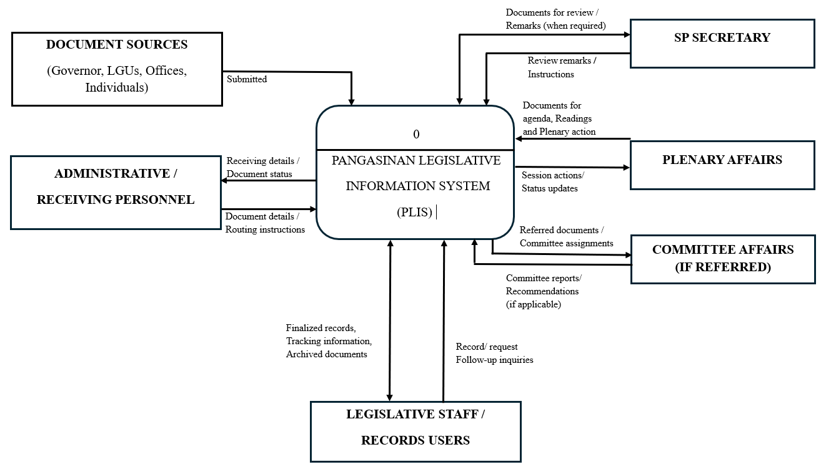

Figure 7. Context Data Flow Diagram of the Pangasinan Legislative Information System (PLIS)
Figure 7 illustrates the exchange of legislative documents and information between PLIS and its external entities: Document Sources, Administrative or Receiving Personnel, the SP Secretary, Plenary Affairs, Committee Affairs, and Legislative Staff or Records Users. The diagram shows the submission of documents, recording of document details, exchange of review remarks and instructions, plenary processing, and committee referral when required. It also presents the exchange of finalized records, tracking information, record requests, and follow-up inquiries, showing how PLIS supports the coordination and management of legislative documents.
Figure 8 illustrates the main processes and data flows on the Administrative/Receiving side of the Pangasinan Legislative Information System (PLIS). It shows how Administrative or Receiving Personnel register incoming documents, enter document details, and route records to the appropriate offices. The diagram also presents the generation of tracking numbers and the storage, retrieval, and updating of document information. These processes support document traceability, status monitoring, and organized digital recordkeeping.
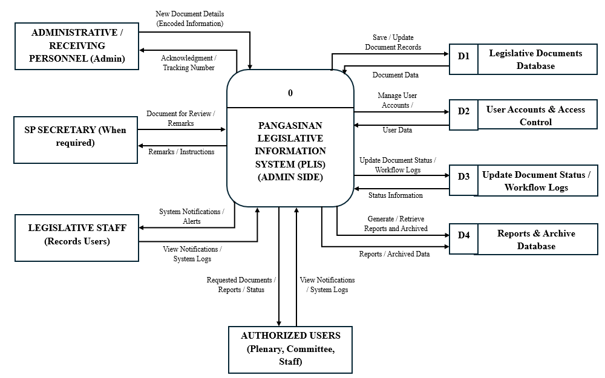

Figure 8. Top-Level Data Flow Diagram of the Pangasinan Legislative Information System (PLIS) – Admin Side

Figure 9 illustrates the main processes and data flows of PLIS and their interactions with Administrative or Receiving Personnel, the SP Secretary, Plenary Affairs Personnel, Committee Affairs Personnel, and Legislative Staff. It shows how legislative documents and related information move through registration, review and routing, plenary processing, committee review when required, and finalization and archiving. The diagram also presents the exchange of instructions, status updates, committee reports, and record requests, showing how the system supports coordinated document processing and centralized legislative records management within the Sangguniang Panlalawigan of Pangasinan.
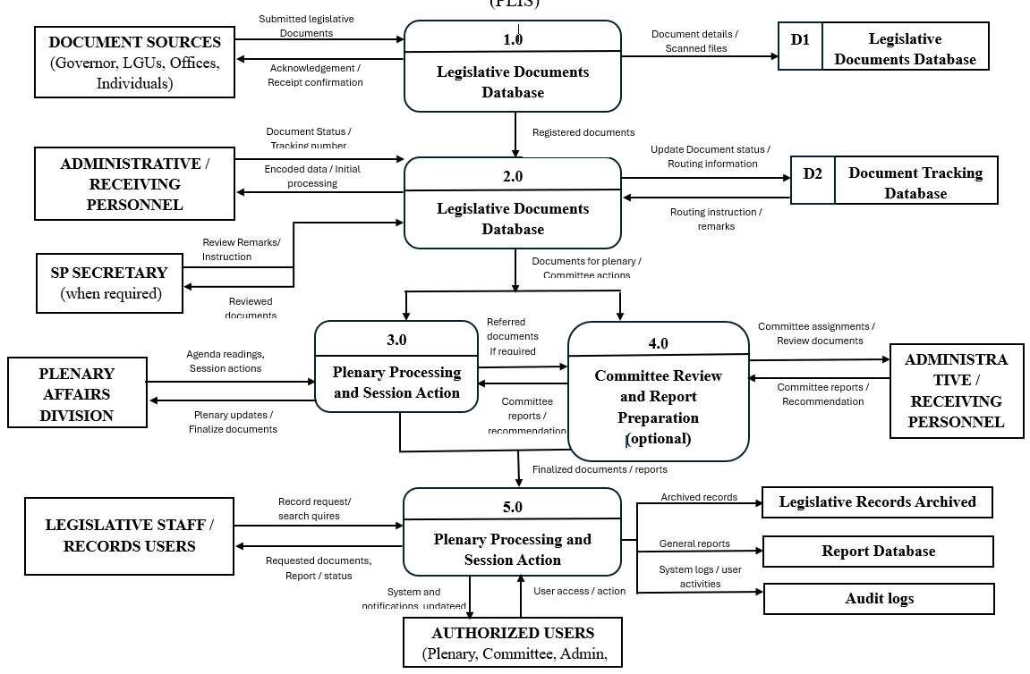

Figure 9. Top-Level Data Flow Diagram of the Pangasinan Legislative
Information System (PLIS)

Features of the Developed System
This section presents the core features of the Pangasinan Legislative Information System (PLIS), highlighting its main functionalities designed to support legislative document management within the Sangguniang Panlalawigan of Pangasinan. The PLIS Features Table outlines the system’s essential components, including user management, role-based access control, document receiving and registration, tracking number generation, document routing, status monitoring, plenary and committee affairs management, report generation, and document archiving and retrieval. Each feature is described to show how it contributes to the system’s goal of providing an organized, secure, and accessible digital platform for managing legislative documents. The system is also designed to assist Administrative or Receiving Personnel, the SP Secretary, Plenary Affairs Personnel, Committee Affairs Personnel, and Legislative Staff in reducing manual work, coordinating document-related tasks, and monitoring the progress of legislative transactions.

Table 4. Features of the Developed System
PLIS Features | Description
Dashboard Overview | Provides an overview of legislative documents and their processing statuses, allowing authorized users to monitor pending, ongoing, and completed transactions.
User Management | Allows the administrator to create, update, and manage user accounts according to assigned roles and responsibilities.
Role-Based Access Control | Restricts access to system functions and legislative records based on the roles and permissions assigned to authorized users.
Document Receiving and Registration | Enables Administrative or Receiving Personnel to record incoming legislative documents, encode relevant details, and register documents for processing.
Tracking Number Generation | Generates a unique tracking number for each registered document to support identification and monitoring throughout the legislative workflow.
Document Routing | Allows authorized personnel to forward legislative documents to the appropriate office or division for review, processing, and further action.
Document Status Monitoring | Displays the recorded processing status of legislative documents, helping authorized users monitor progress and identify pending actions.
Document Processing | Supports the recording and updating of document details, actions taken, and processing statuses for document types included in the system’s approved scope.
Plenary Affairs and Session Record Management | Supports agenda preparation and the recording of readings, session actions, and legislative decisions associated with documents processed by the system.
Committee Affairs Management | Supports the recording of committee assignments, reports, and recommendations for documents referred for committee action.
Communication Management | Allows authorized personnel to record, route, and monitor official communications and their corresponding actions or remarks.
Document Review and Remarks | Enables authorized personnel to record review remarks, routing instructions, and other document-related actions when required.
Report Generation | Generates reports using recorded document information and processing statuses to support monitoring and legislative recordkeeping.
Document Archiving | Stores finalized legislative documents and related records in an organized digital repository for future reference.
Search and Retrieval | Allows authorized users to locate and retrieve legislative records using available search fields, such as tracking number, document type, and date.
Document Attachment Management | Enables authorized personnel to upload and maintain digital copies of legislative documents and supporting files.
System Activity Logging | Records user activities and changes to system information to support accountability and traceability.

The Pangasinan Legislative Information System (PLIS) is designed to require authorized personnel to log in before accessing legislative records and system functions. The system provides distinct access permissions for the Administrator, Administrative or Receiving Personnel, the SP Secretary, Plenary Affairs Personnel, Committee Affairs Personnel, and Legislative Staff. Each user category will have access to functions appropriate to its assigned responsibilities. The Administrator will manage user accounts and access permissions, while other authorized personnel will handle document receiving, routing, review, plenary processing, committee-related activities, and records management according to their designated roles.
The User Access and Privileges Table defines the roles and permissions assigned to each user category within PLIS. It identifies which users can perform actions such as managing user accounts, registering documents, routing records, monitoring document status, uploading attachments, generating reports, and retrieving archived documents. This role-based access structure is intended to restrict unauthorized access, clarify personnel responsibilities, and improve coordination among the offices involved in legislative document management within the Sangguniang Panlalawigan of Pangasinan.

Table 5. User Access and Privileges Table
PRIVILEGES | Super Admin | Administrative/  Receiving Personnel | SP Secretary | Plenary Affairs  Personnel | Committee Affairs Personnel | Legislative Staff
1. Log In to the system | / | / | / | / | / | /
2. Manage User Accounts and Access Permissions | /
3. View Dashboard Overview | / | / | / | / | / | /
4. Register Incoming Documents and Generate Tracking Numbers |  | /
5. Route Documents |  | / | / | / | /
6. Monitor Document Status | / | / | / | / | / | /
7. Record Review Remarks and Instructions |  |  | /
8. Manage Plenary and Session Records |  |  |  | /
9. Manage Committee Referrals, Reports, and Recommendations |  |  |  |  | /
10. Record and Monitor Official Communications |  | /
11. Generate Reports |  | / | / | / | / | /
12. Generate Reports |  | / | / | / | /
13. Archive Finalized Documents |  | / |  | /
14. Search and Retrieve Authorized Records | / | / | / | / | / | /
15. View System Activity Logs | /

The proponents identified the key features of the Pangasinan Legislative Information System (PLIS) based on the legislative workflow and the responsibilities of its intended users. The system is designed to simplify the receiving, routing, tracking, processing, archiving, and retrieval of legislative documents while providing access appropriate to each user’s role. The Super Admin manages user accounts, access permissions, and system activity logs; Administrative or Receiving Personnel register and initially route incoming documents; and the SP Secretary provides review remarks and instructions when required. Plenary Affairs Personnel manage session-related records and legislative actions, while Committee Affairs Personnel handle committee referrals, reports, and recommendations. Legislative Staff access authorized records, monitor document status, and upload supporting files where permitted. This role-based structure aims to clarify responsibilities, improve coordination, and support organized and accessible legislative record management within the Sangguniang Panlalawigan of Pangasinan.
Figure 10. Use Case Diagram of the Pangasinan Legislative Information System (PLIS)
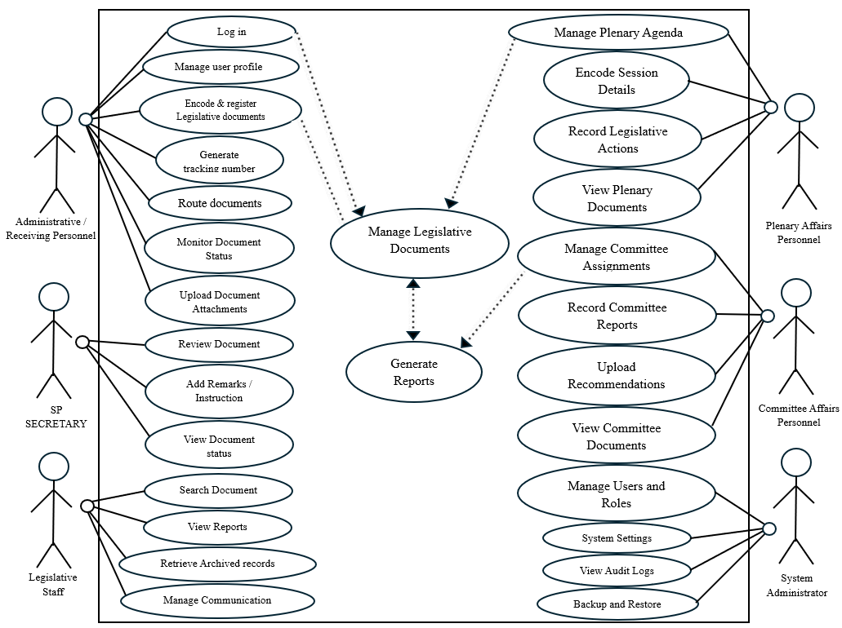

Figure 10 presents the Use Case Diagram of the Pangasinan Legislative Information System (PLIS), illustrating the interactions between the system and its primary users: the Super Admin, Administrative or Receiving Personnel, SP Secretary, Plenary Affairs Personnel, Committee Affairs Personnel, and Legislative Staff. The diagram outlines the system’s main functions, including user account and access management, document registration, tracking number generation, document routing and status monitoring, plenary and session record management, committee referral and report management, report generation, and document archiving and retrieval. It shows how each user accesses these functions according to their assigned roles and permissions to support coordinated legislative document processing and records management.
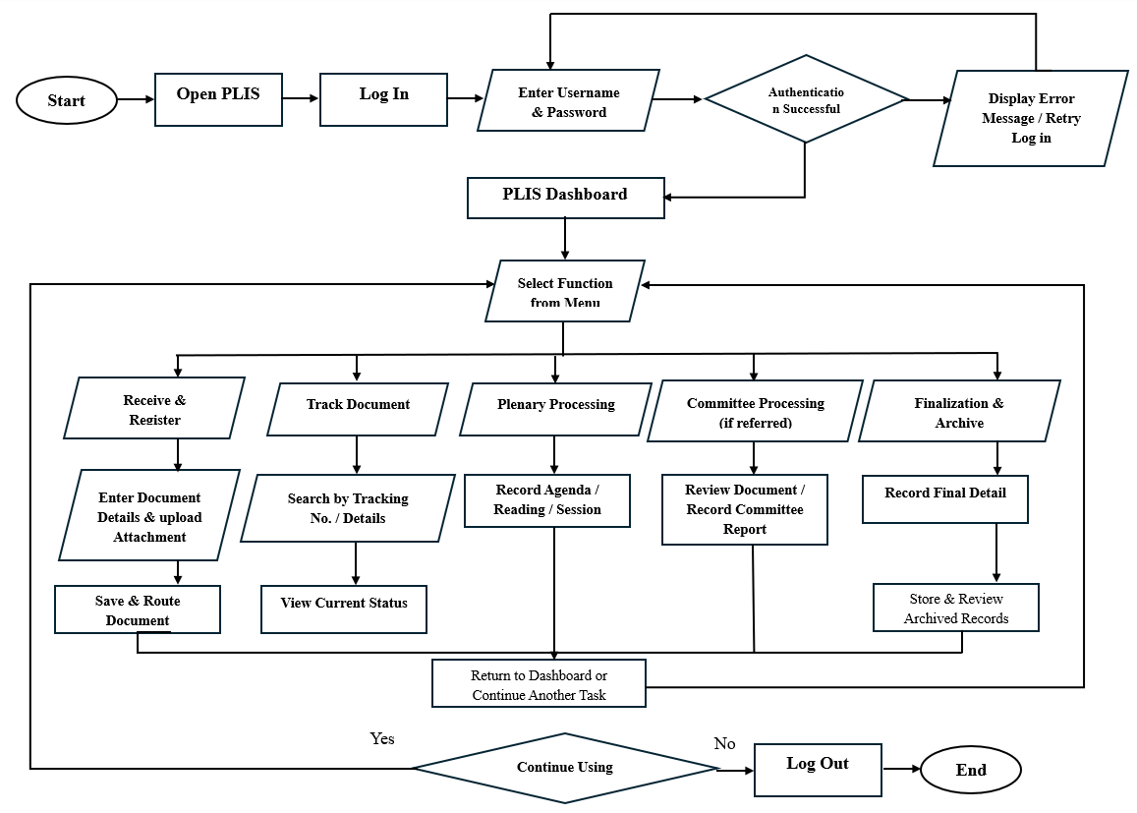

Figure 11. Flowchart Diagram of the Pangasinan Legislative Information System (PLIS)
Figure 11 illustrates the operational flow of the Pangasinan Legislative Information System (PLIS), beginning with user authentication. Authorized users enter their username and password, which the system verifies before granting access. If the credentials are valid, the user is directed to the Dashboard, where legislative document summaries and processing statuses are displayed. Otherwise, the user is prompted to re-enter the correct credentials.
From the Dashboard, users access the functions available to their assigned roles, including Document Receiving and Registration, Document Tracking and Processing, Plenary Processing, Committee Processing, and Records Archiving. Administrative or Receiving Personnel enter document details, upload supporting files, and save and route documents to the appropriate office. Upon successful saving and routing, the system generates an administrative tracking number for identifying and monitoring each document.
Through Document Tracking and Processing, authorized users can search for documents using their tracking numbers and view their recorded statuses. Documents requiring plenary action proceed to Plenary Processing, where authorized personnel record agenda details, readings, and session actions. When committee review is required, documents are referred to Committee Affairs Personnel for coordination of committee evaluation and the recording of reports or recommendations. This referral is conditional and applies only to documents requiring committee action.
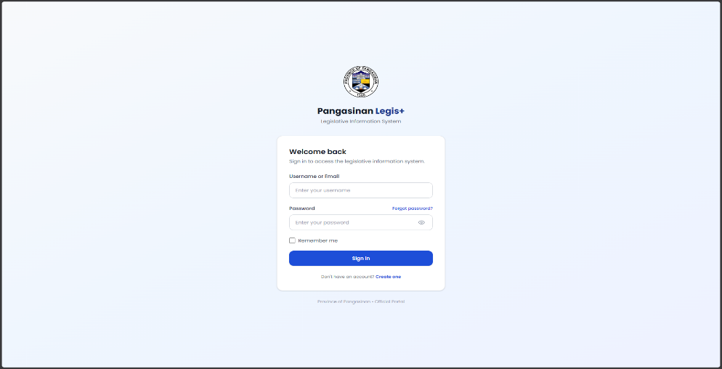
After the required processing and legislative actions are completed, finalized documents and their corresponding records are archived for future reference and retrieval. Authorized users can search for and access these records according to their permissions. Users may then return to the Dashboard to perform additional tasks or log out to end their session. Overall, the flowchart shows how PLIS integrates document receiving, routing, tracking, processing, and archiving into a centralized platform intended to improve traceability, coordination, and legislative records management.

Plate 1: Log In Page
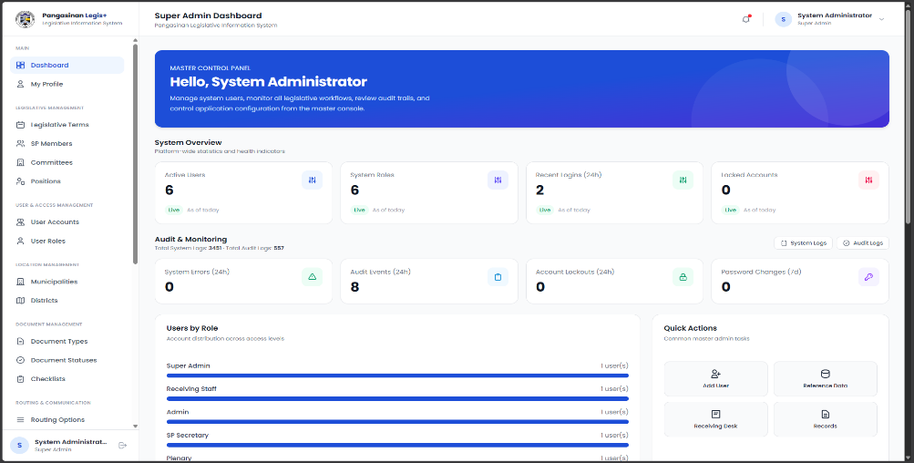
Plate 1 shows the Log In page of the Pangasinan Legislative Information System (PLIS), where authorized users enter their registered username and password to access the platform. After successful authentication, users can access modules and functions according to their assigned roles and permissions. These may include document receiving and registration, routing and status tracking, plenary processing, committee referral management, and archived-record retrieval.

Plate 2: Super Administrator Dashboard Page
Plate 2 displays the System Administrator Dashboard of the Pangasinan Legislative Information System (PLIS), which serves as the primary interface for system configuration and administrative management. Through the navigation menu, the System Administrator can access modules for legislative terms, SP members, committees, positions, user accounts, user roles, document types, document statuses, routing options, and other system settings. These functions help ensure accurate and consistent system information, control user access, and configure the settings needed to support legislative document management.
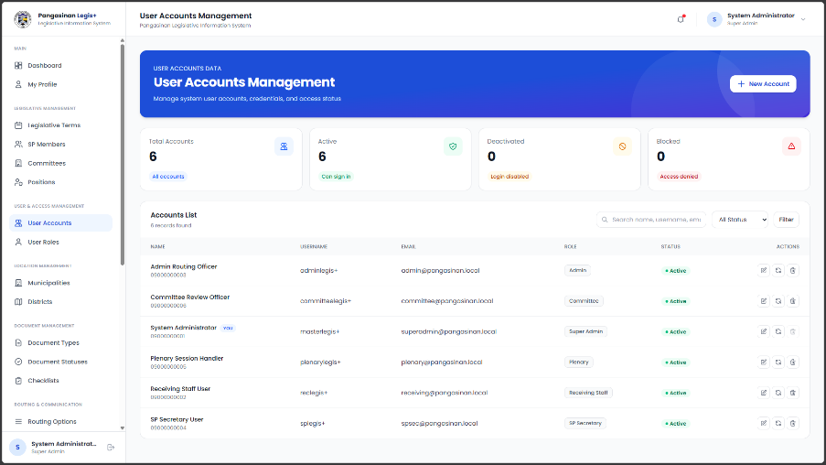

Plate 3: User Account Management Page (SuperAdmin)
Plate 3 shows the User Account Management module of the Pangasinan Legislative Information System (PLIS). Through this module, the Superadmin can create new user accounts, view existing account information, update account details, and manage registered accounts of authorized personnel. The Superadmin can also assign user roles and access permissions to ensure that each user can access only the modules and functions relevant to their responsibilities. These actions support controlled system access, organized user information, and the security of legislative records.

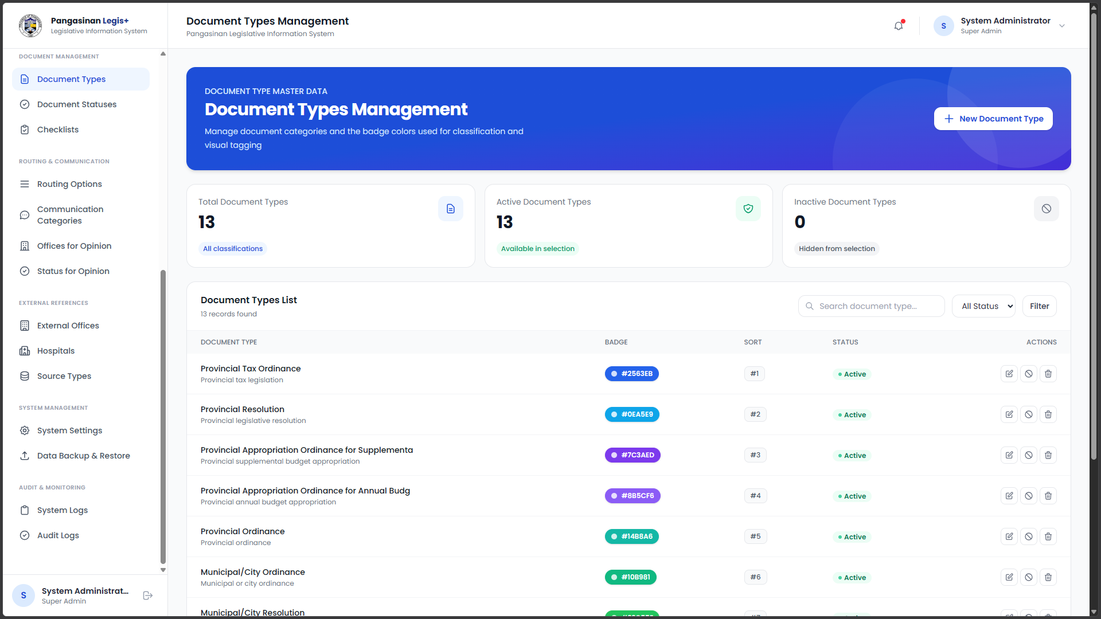
Plate 4: Document Types Page (SuperAdmin)
Plate 4 displays the Document Types Management module of the Pangasinan Legislative Information System (PLIS). This module enables the Superadmin to manage the categories of legislative documents used within the system by adding, viewing, updating, and maintaining document types. These categories ensure that documents are properly classified during registration, routing, processing, and archiving. By standardizing document types, PLIS promotes consistent recordkeeping and organized legislative document management within the Sangguniang Panlalawigan of Pangasinan.
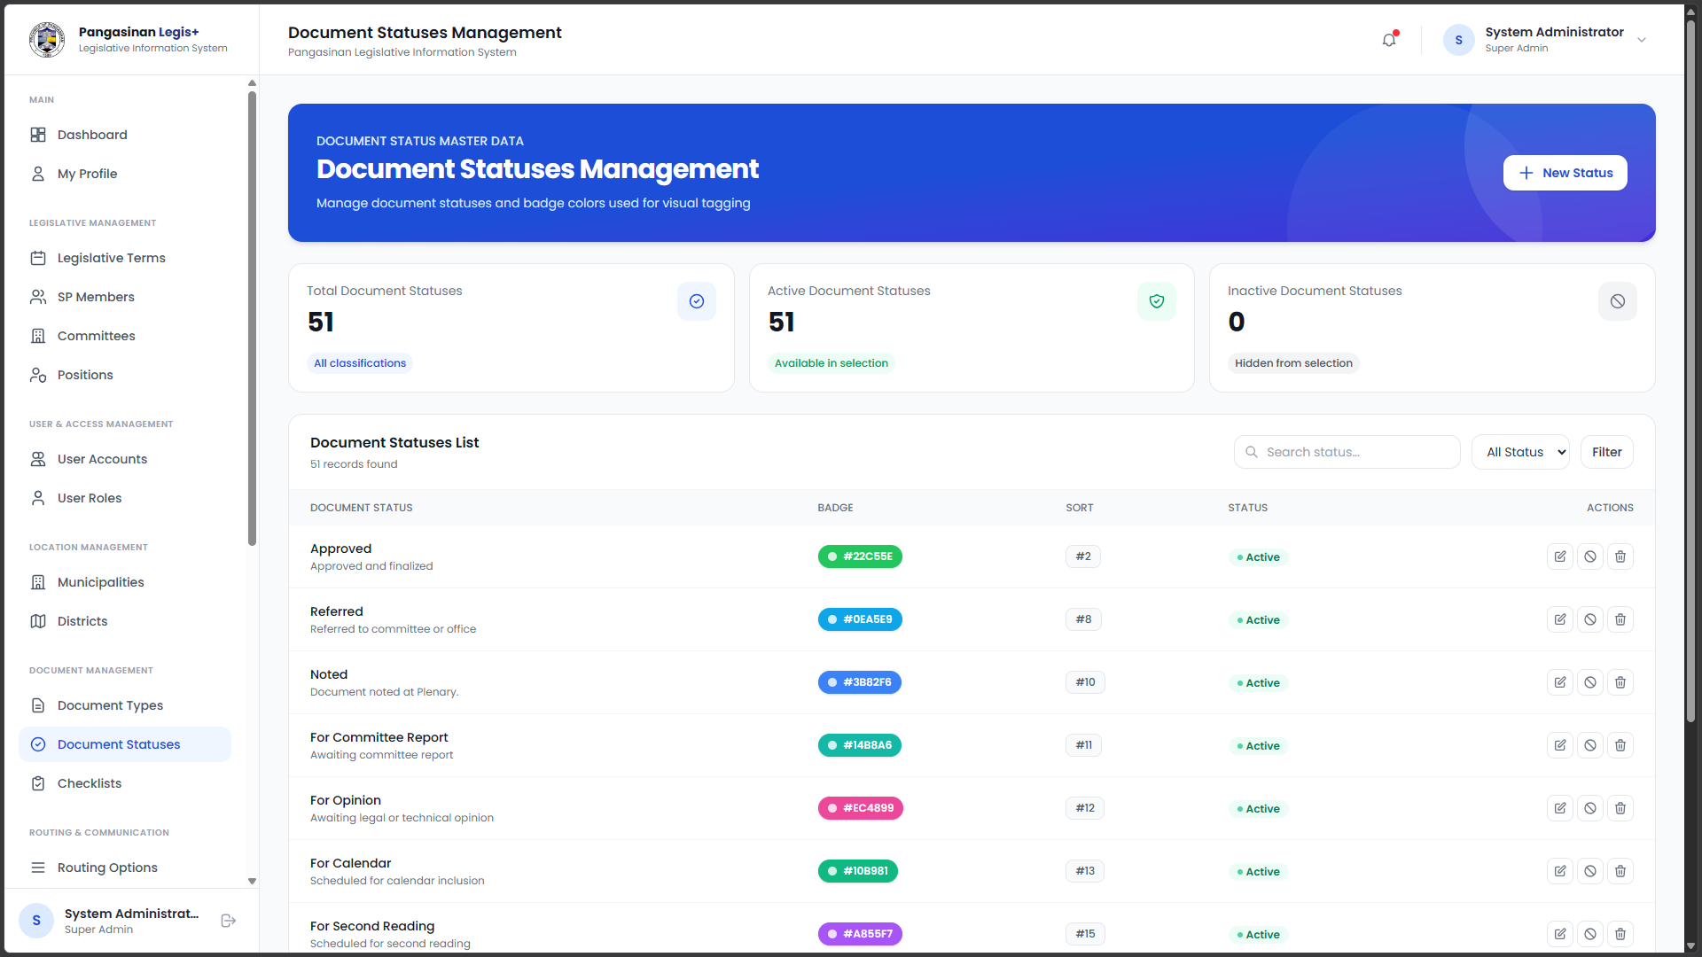
Plate 5: Document Statuses Management Page (SuperAdmin)
Plate 5 shows the Document Statuses Management module of PLIS, where the Superadmin can add, view, update, and manage the statuses used to track legislative documents. These statuses support accurate monitoring of each document throughout registration, routing, processing, and archiving.
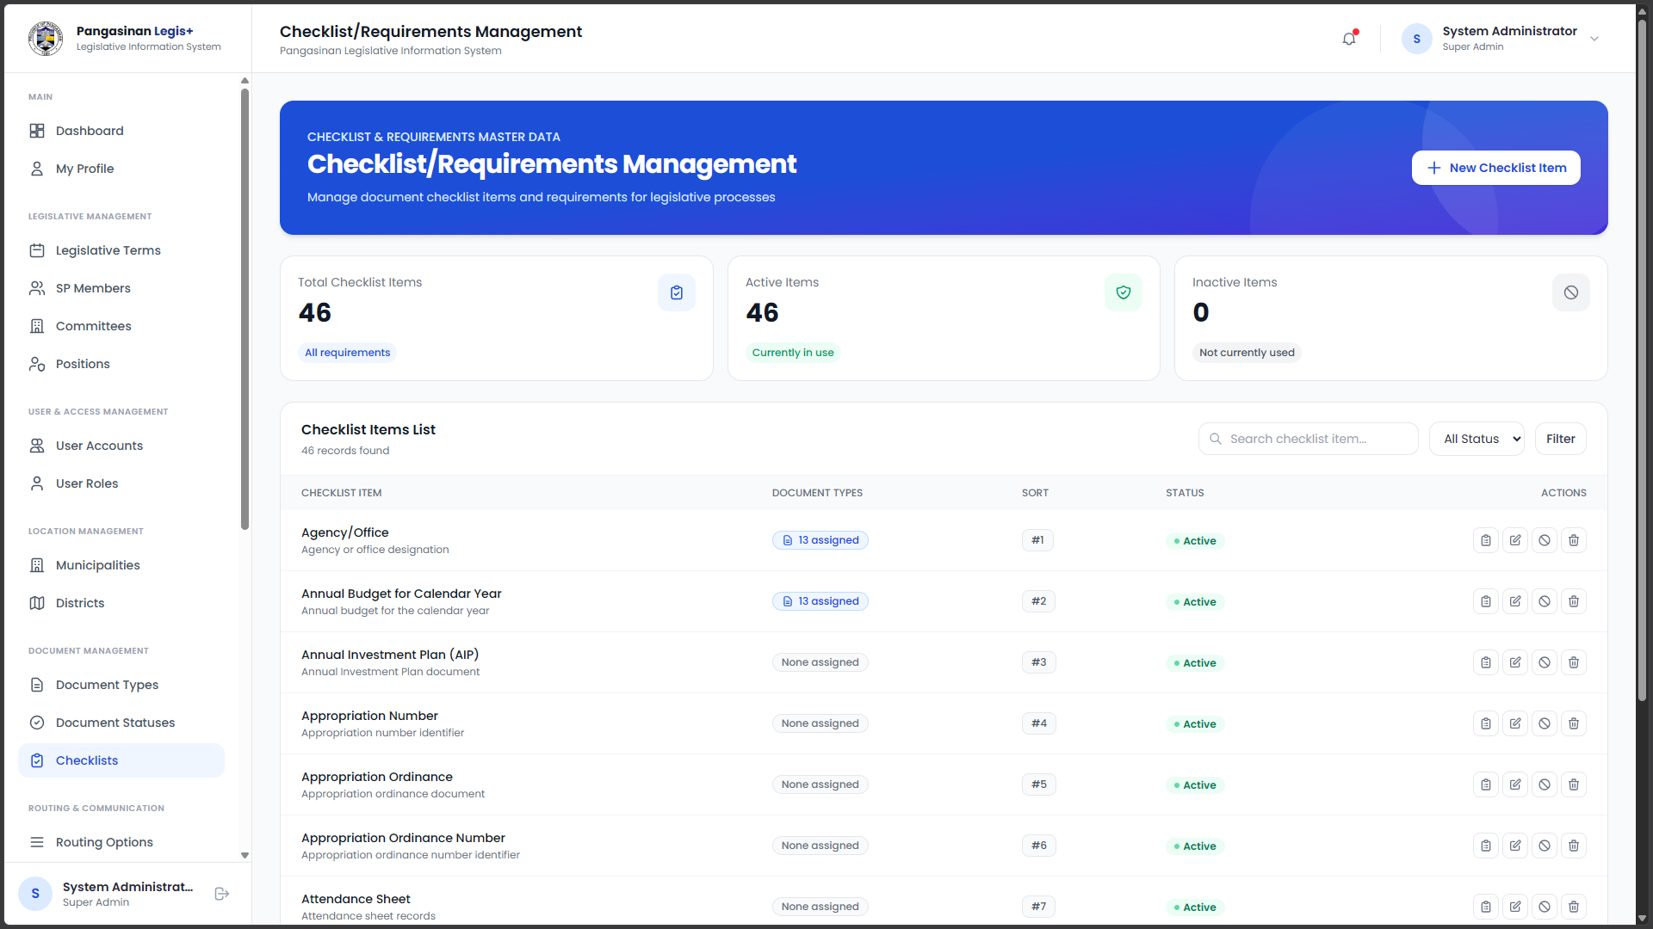
Plate 6: Checklist/Requirements Management Page (SuperAdmin)
Plate 6 shows the Checklist/Requirements Management module of PLIS, where the Superadmin can add, view, update, and manage the requirements or checklist items needed for legislative documents. Through this module, the Superadmin can define the specific documents or supporting materials required for each type of legislative transaction. This feature helps ensure that submitted documents are complete and contain the necessary requirements before they proceed to routing and processing. By maintaining a standardized checklist, PLIS supports accurate document evaluation, reduces incomplete submissions, and promotes organized legislative document management within the Sangguniang Panlalawigan of Pangasinan.
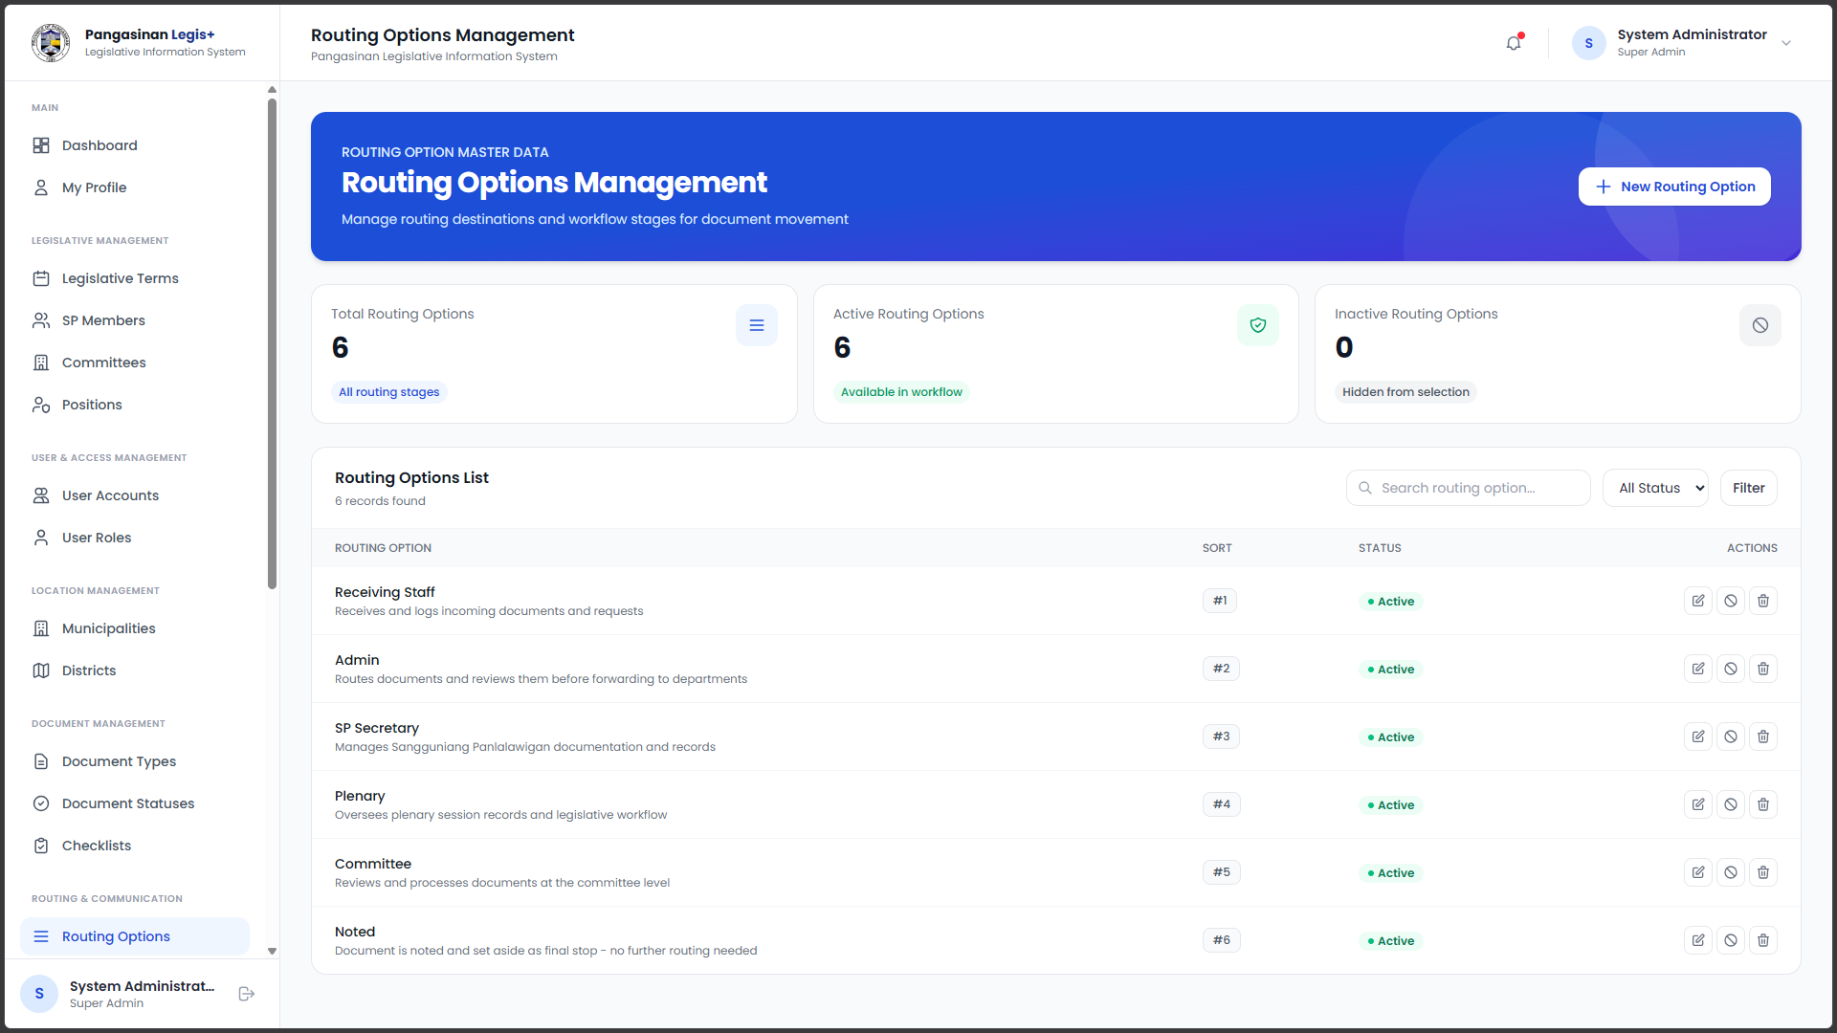
Plate 6: Routing Options Management Page (SuperAdmin)
Plate 6 shows the Routing Options Management module of PLIS, where the Superadmin can add, view, update, and manage the routing paths used for legislative documents. This feature helps ensure that documents are properly directed to the appropriate offices or personnel for review, processing, and approval.

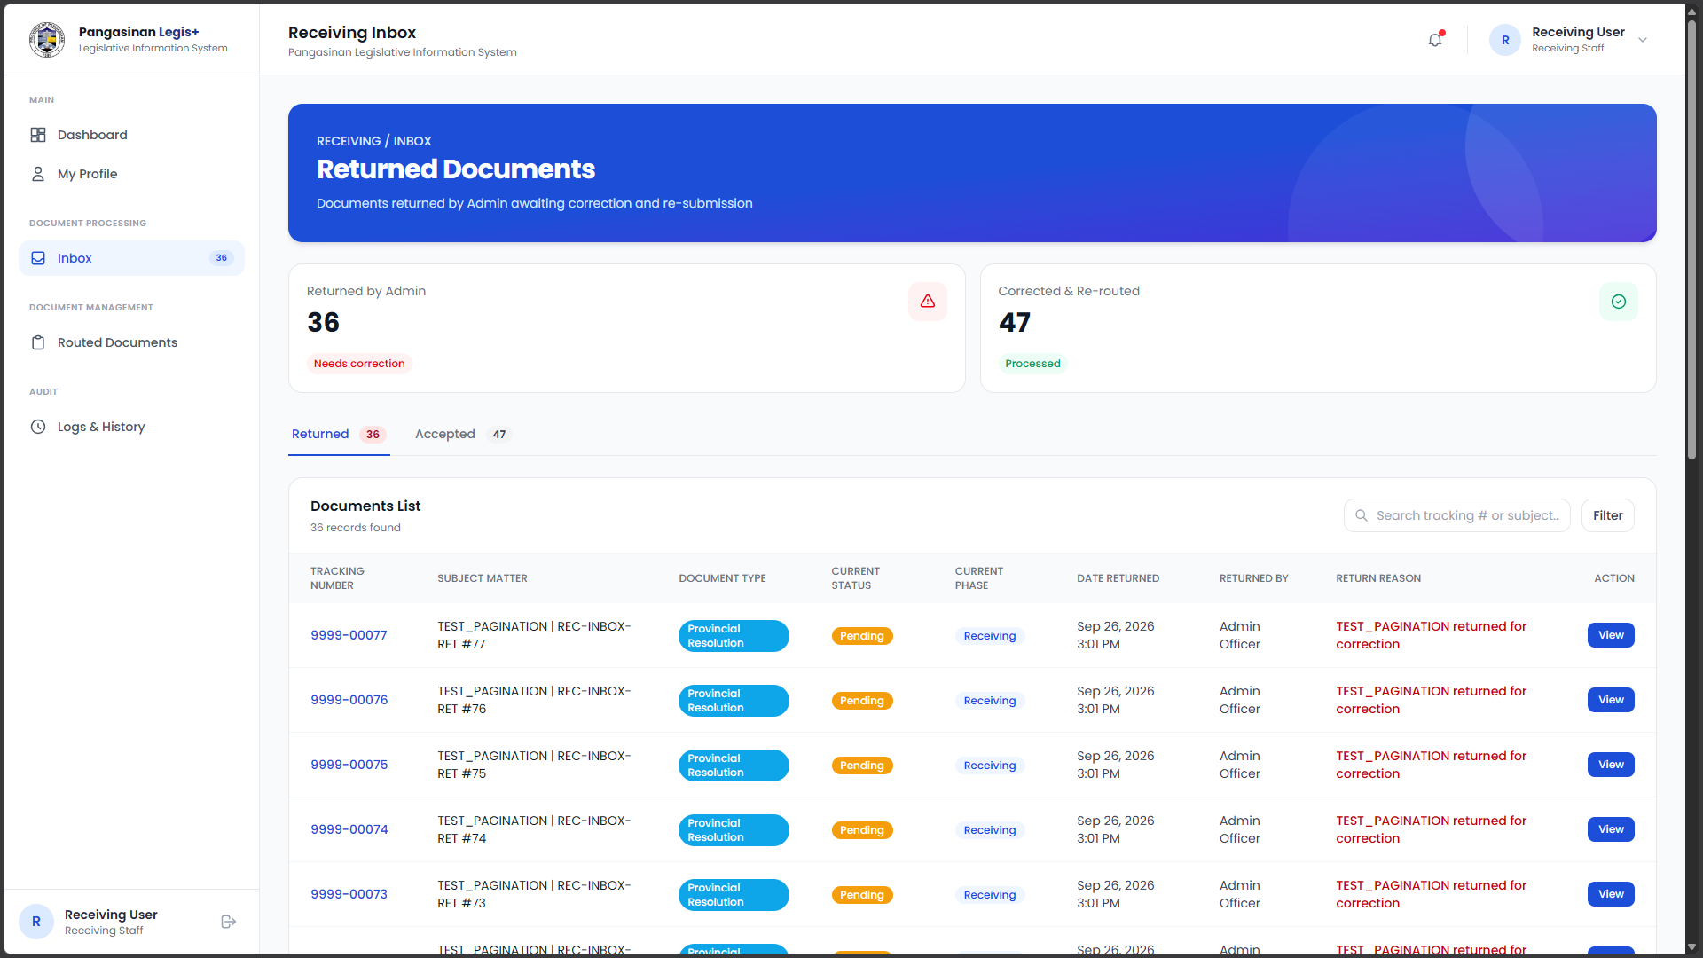
Plate 7: Inbox Page (Receiving)
Plate 7 presents the Inbox page of the Receiving module of the Pangasinan Legislative Information System (PLIS). This page allows authorized Receiving Personnel to view and manage incoming legislative documents submitted to the Sangguniang Panlalawigan of Pangasinan. It serves as a centralized interface for accessing received documents and reviewing their available details before proceeding with the appropriate receiving and routing processes. Through this page, personnel can monitor incoming documents and identify records that require further processing. This feature helps organize document intake, supports systematic handling of legislative records, and improves the traceability of documents within the system.
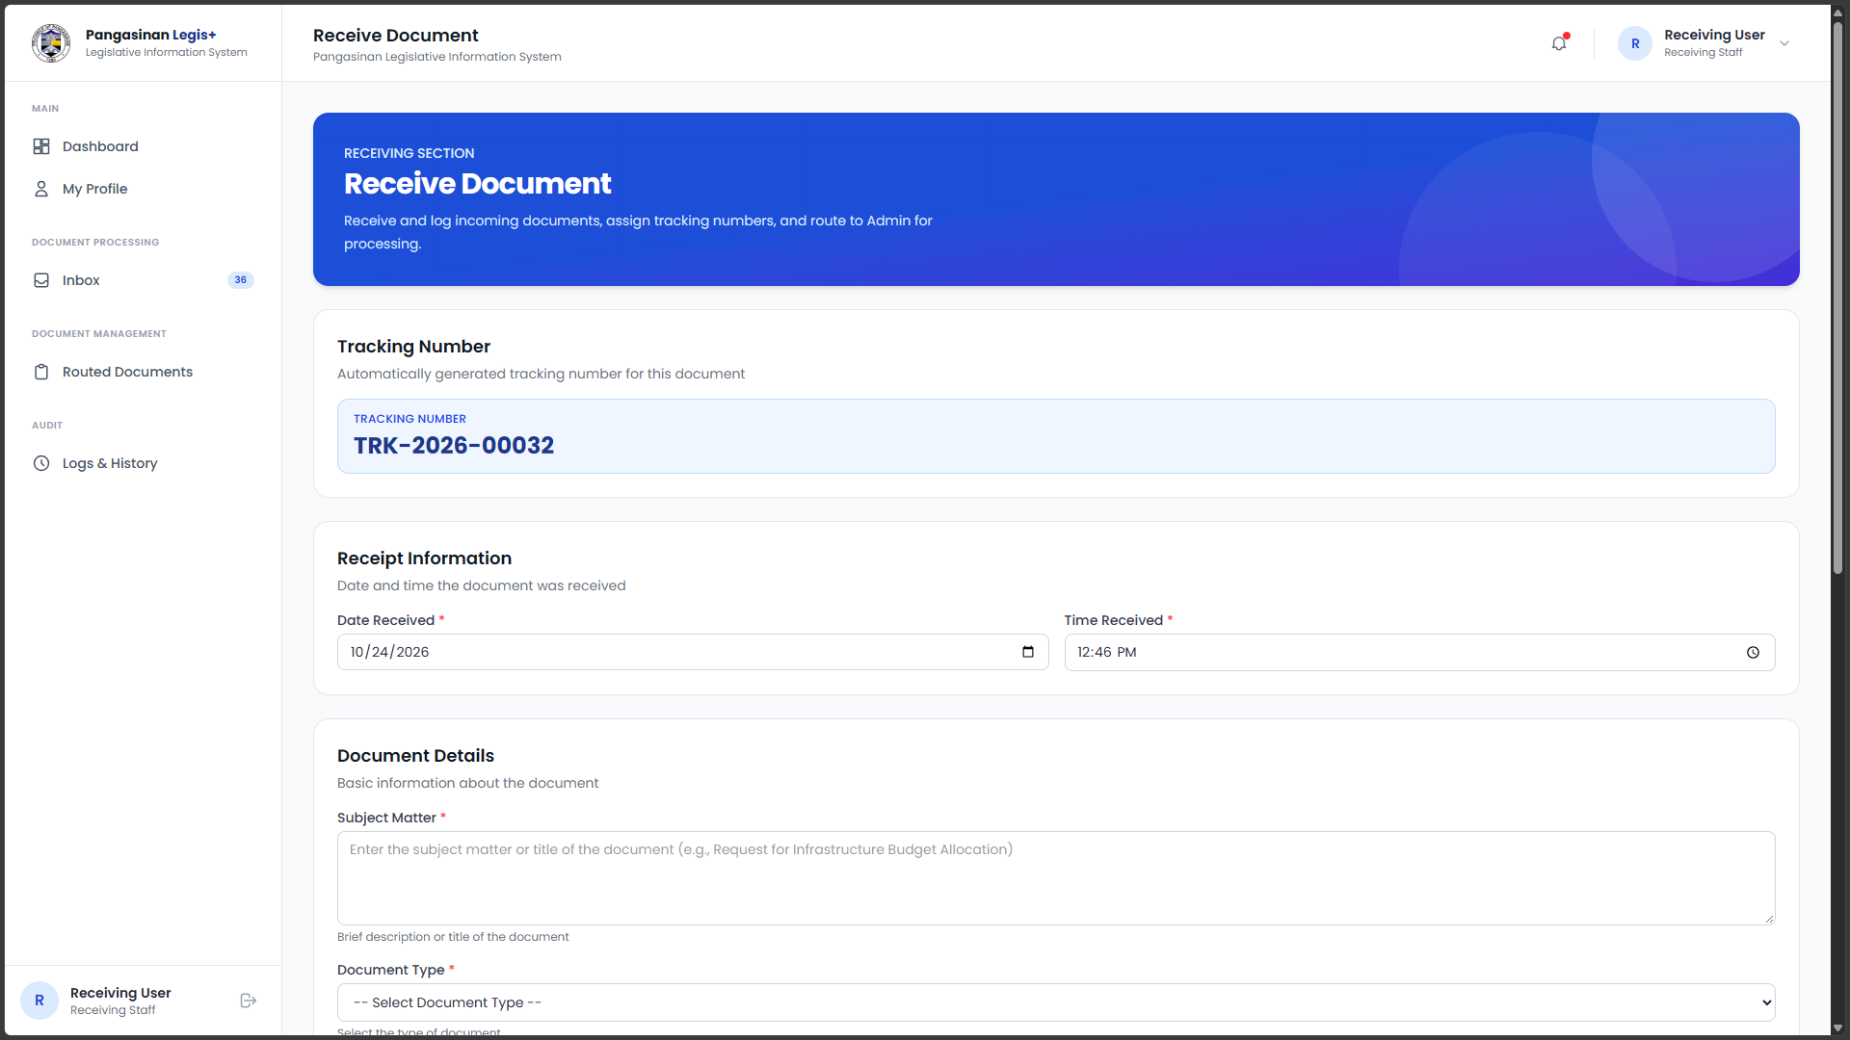
Plate 8: Receive Document Page (Receiving)
Plate 8 shows the Receive Document module of PLIS, where authorized users can record newly received legislative documents, enter document details, and upload necessary attachments. This feature helps ensure that documents are properly recorded and prepared for routing to the appropriate division.
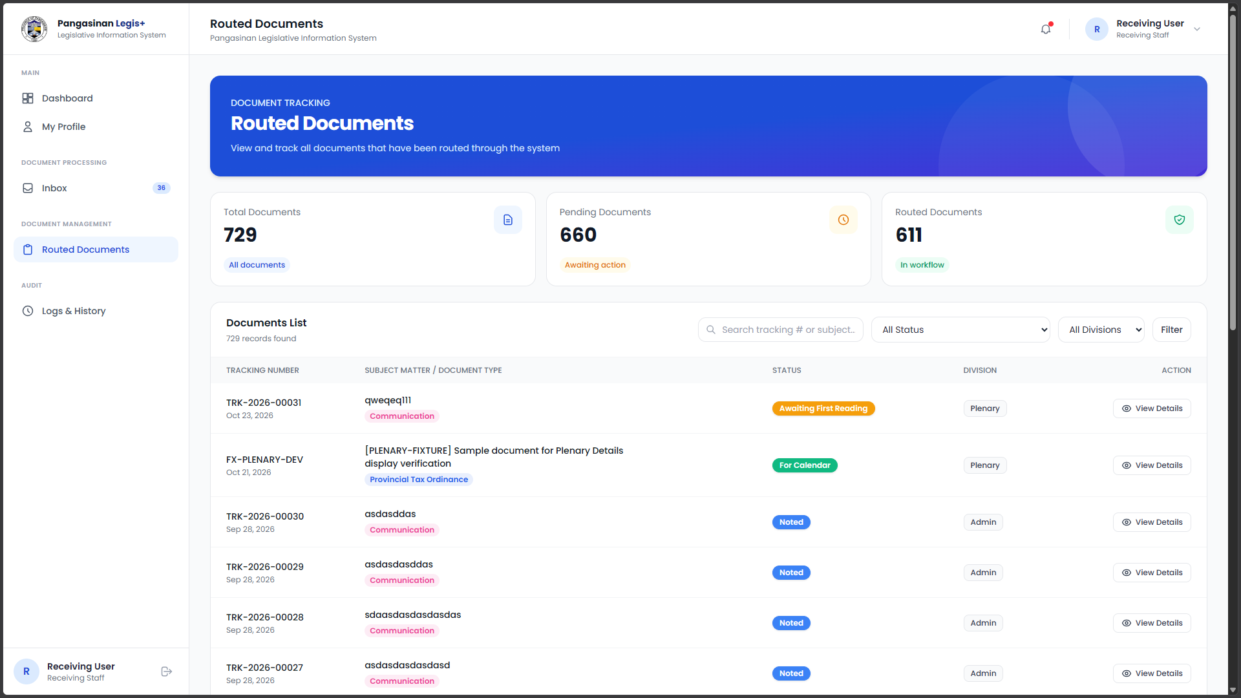
Plate 9: Routed Document Page (Receiving)
Plate 9 shows the Routed Document module of PLIS, where users can view and monitor documents that have been routed to the appropriate divisions for processing. This feature helps track document movement and ensures proper coordination between offices.
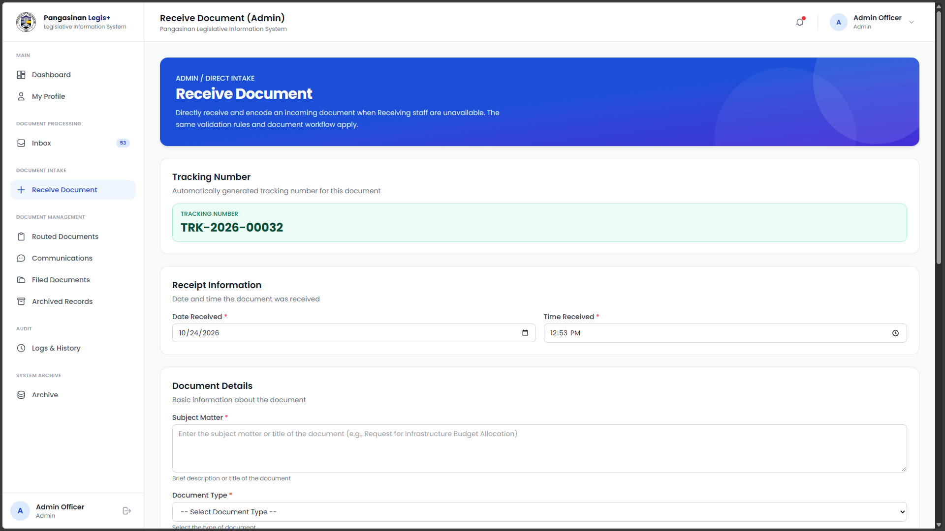
Plate 10: Received Document Page (Admin)
Plate 10 shows the Received Document module of PLIS, where users can view and manage documents that have been received by the designated division. This feature helps monitor document receipt and ensures that each document is properly recorded for further processing.
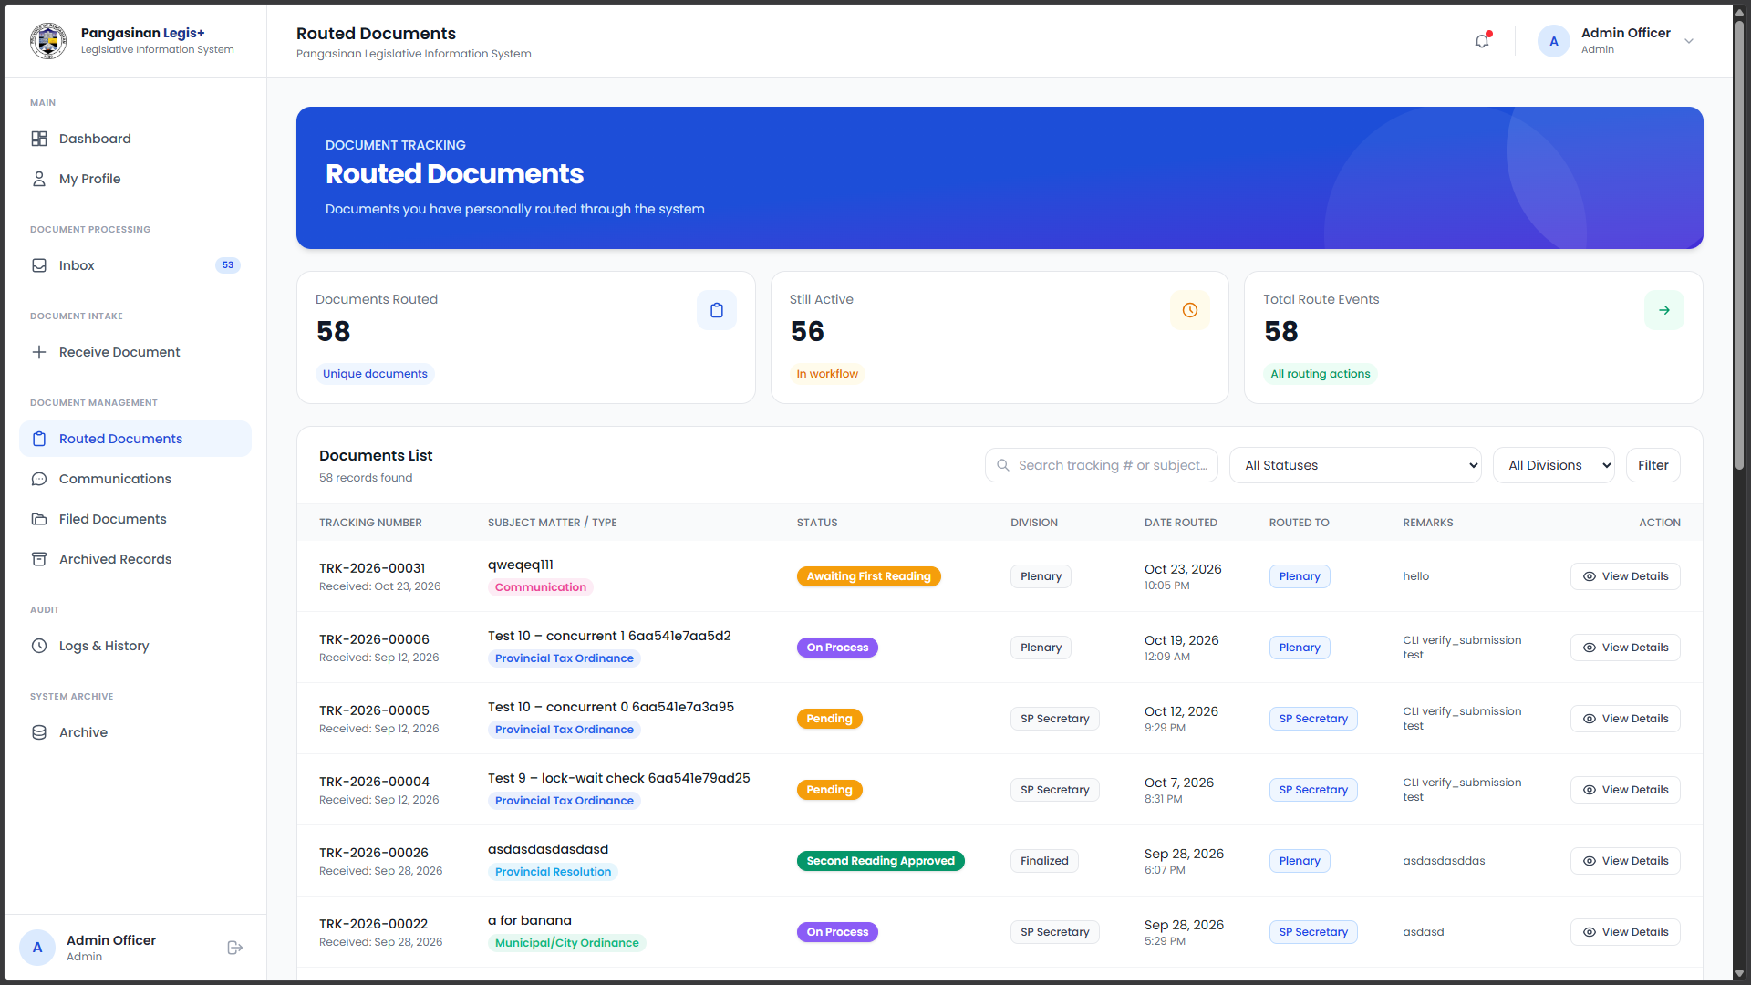
Plate 11: Routed Document Page (Admin)
Plate 11 shows the Routed Document module of PLIS, where the Admin can view and monitor documents routed to the appropriate divisions. This feature helps track document movement and ensures proper routing for further processing.
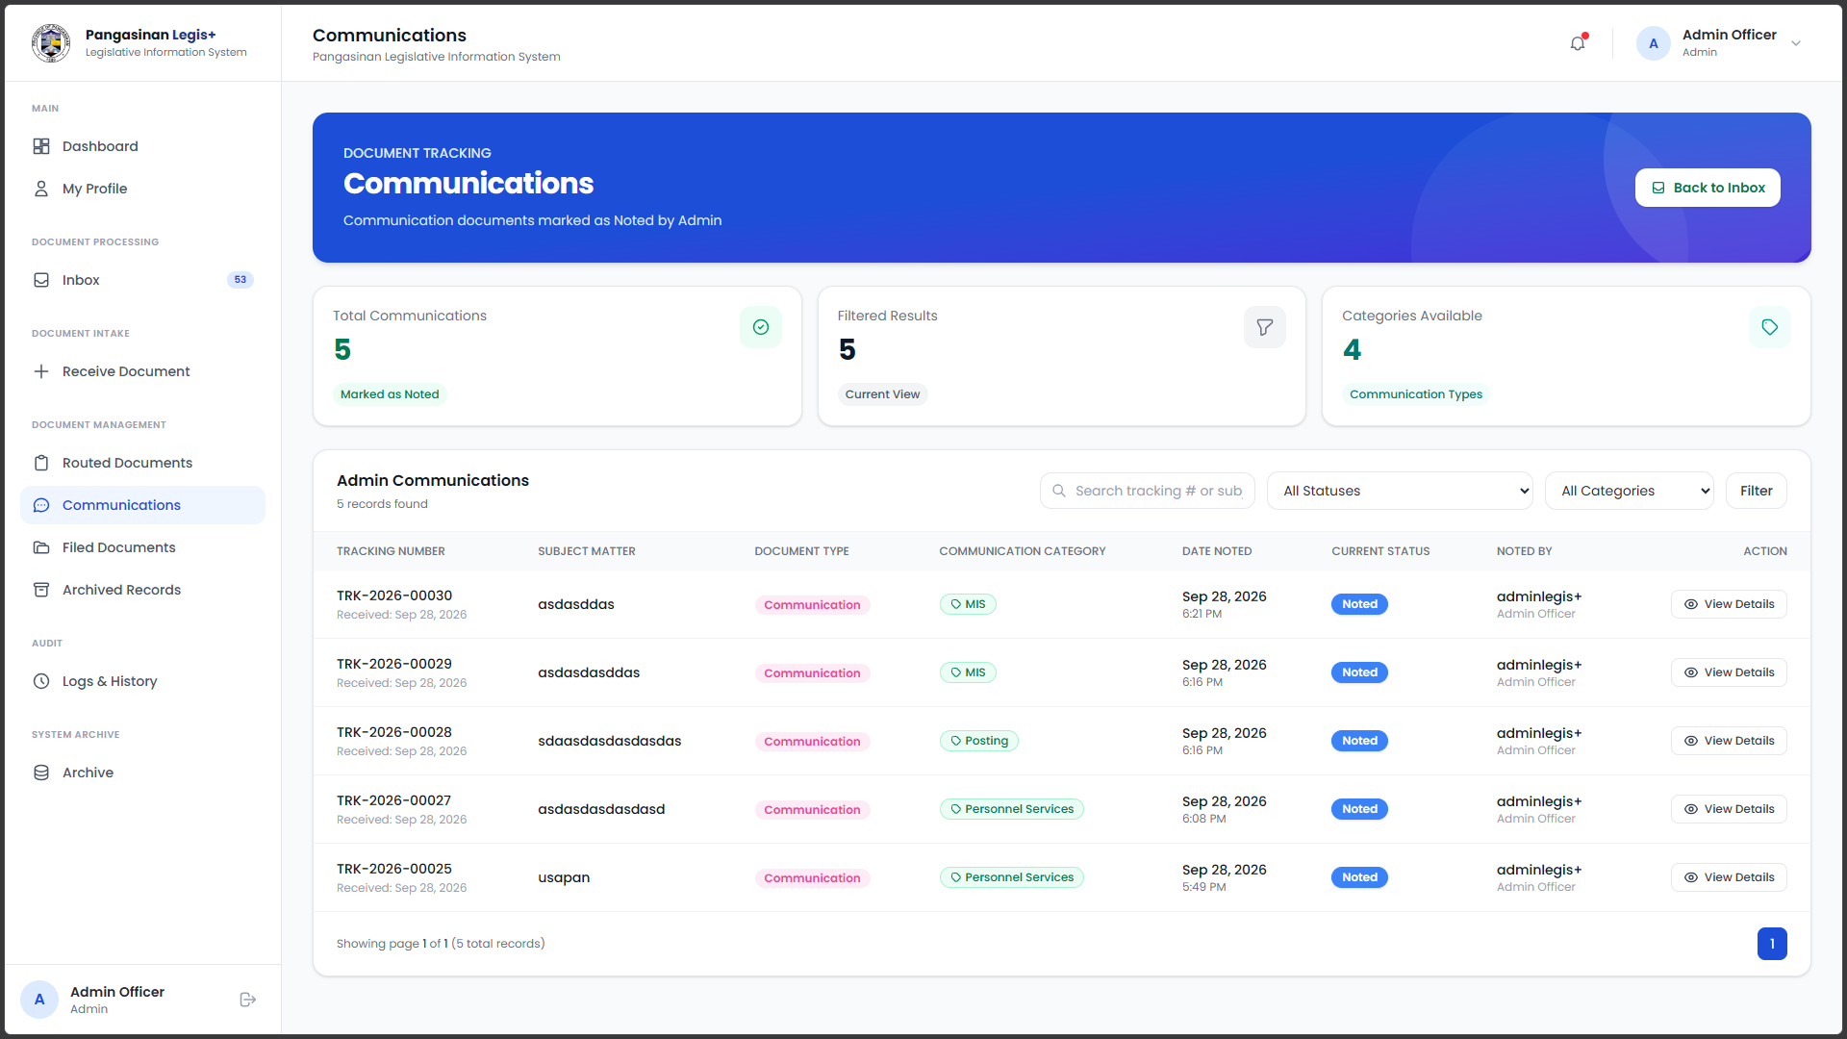
Plate 12: Communication Page (Admin)
Plate 12 shows the Communication Page module of PLIS, where the Admin can record and manage incoming communications, including their date and subject matter. This feature helps ensure that communications are properly documented and tracked for processing.
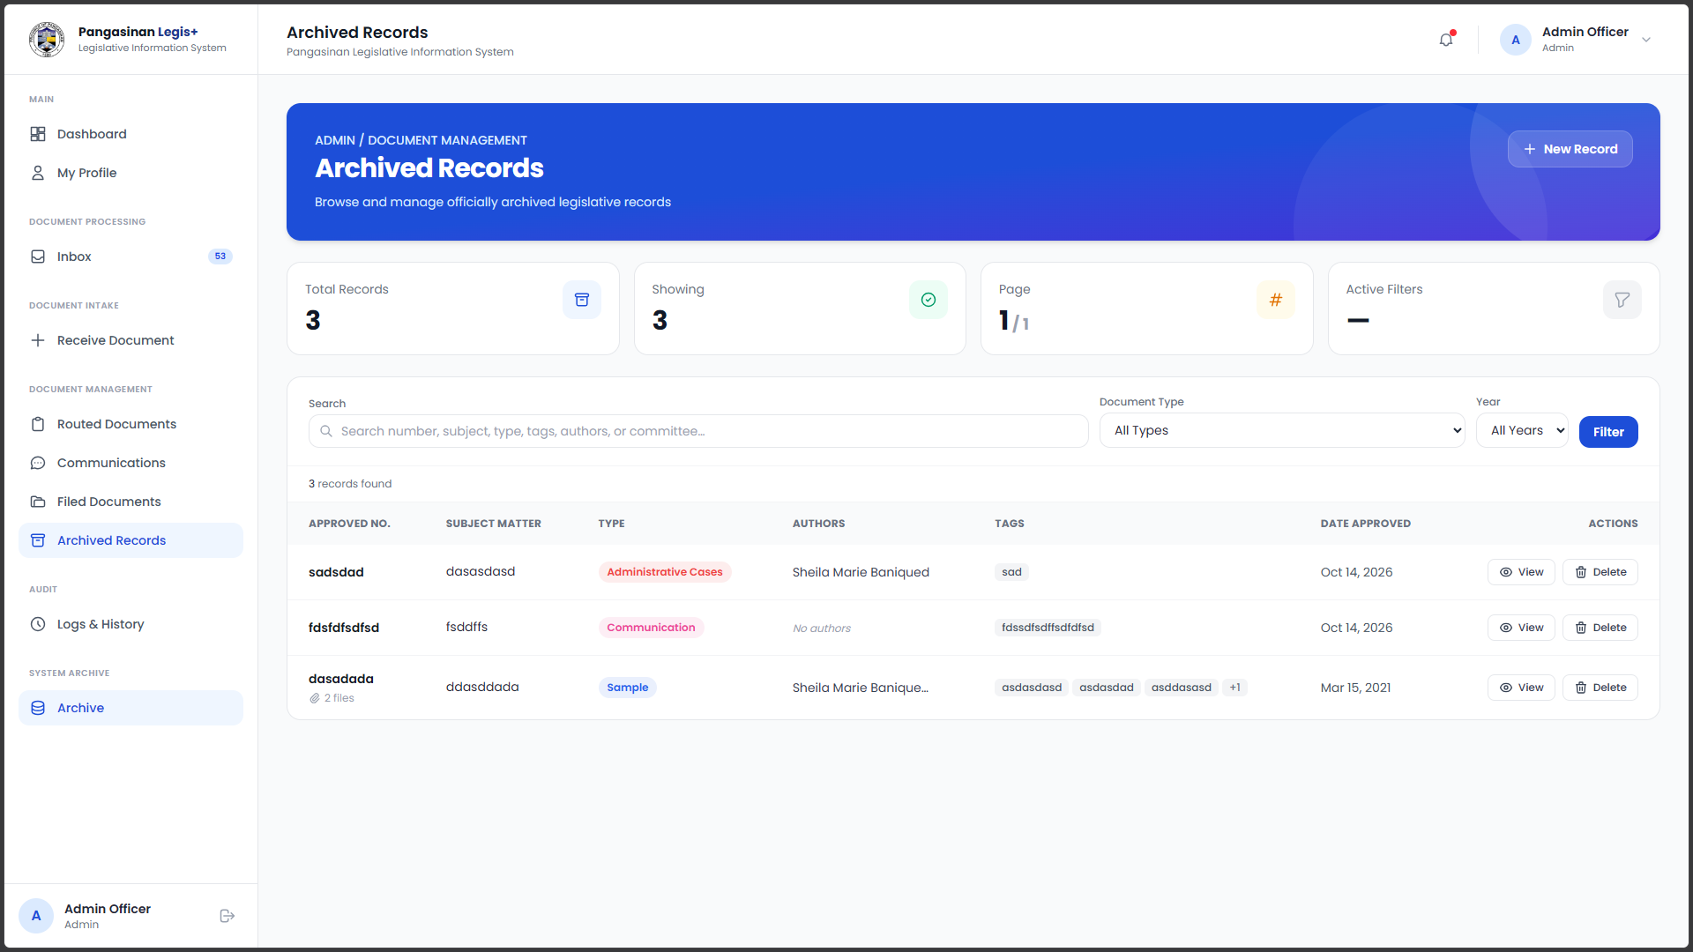
Plate 13: Archived Records Page (Admin)
Plate 13 shows the Archived Records module of PLIS, where the Admin can view and access previously processed documents and records. This feature helps maintain organized records for future reference and retrieval.
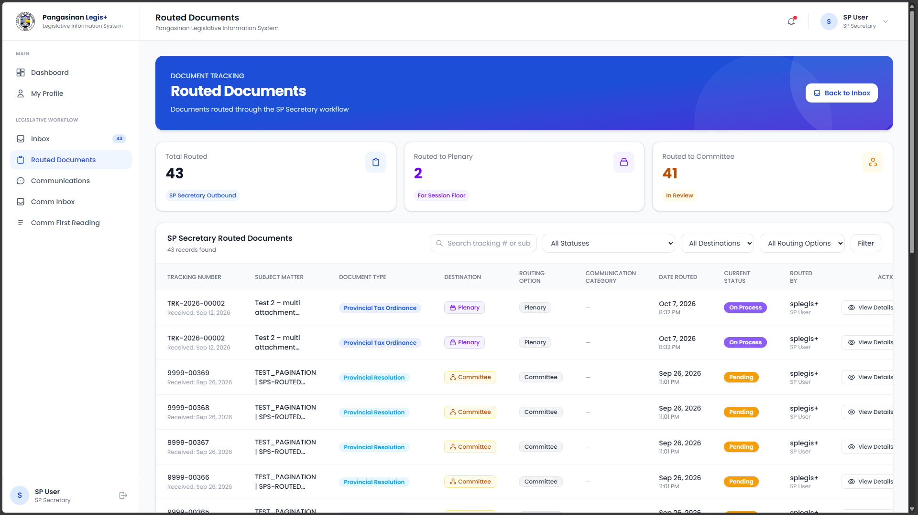
Plate 14: Routed Documents Page (SP Secretary)
Plate 14 shows the Routed Documents module of PLIS, where the SP Secretary can view documents routed for review and provide remarks when necessary. This feature helps facilitate document monitoring and coordination within the legislative process.

Plate 15: Routed Documents Page (SP Secretary)
Plate 15 shows the Routed Documents module of PLIS, where the SP Secretary can monitor documents routed to the division and check their current status. This feature helps ensure proper tracking and handling of legislative documents.
The Proposed Implementation Plan
The Pangasinan Legislative Information System is a web-based tracking platform designed to monitor the complete lifecycle of legislative documents, including ordinances, resolutions, and official communications. The system was developed using PHP and JavaScript for server-side and client-side logic, Tailwind CSS for the user interface, and MySQL for the database management system.
The implementation of the proposed system will require a range of resources, including hardware, software, and personnel. A web server will be needed to host the system and ensure continuous accessibility for end users.
Hardware and Software Requirements
To successfully develop the Pangasinan Legislative Information System, both hardware and software components that meet specific performance standards are required.
Table 6. Minimum Hardware Requirements for System Development
Component | Minimum Requirement | Recommended Requirement
Processor | Intel Core i3/Ryzen 3 | Intel Core i5 or AMD Ryzen 5 or higher
RAM | 8 GB | 16 GB or higher
Storage | 256 GB SSD, with sufficient free space for development tools and project files | 512 GB NVMe SSD or higher
Graphics | Integrated Graphics | Dedicated GPU
Display | 1366 × 768 resolution | 1920 × 1080 resolution or higher
Network Connectivity | Ethernet or Wi-Fi | Stable Ethernet or Wi-Fi connection

Table 6 outlines the minimum and recommended hardware specifications for developing and testing the Pangasinan Legislative Information System (PLIS). It covers the processor, memory, storage, graphics, display, and network connectivity required to support development activities and system operations. The minimum specifications provide the basic capacity for writing code, managing databases, and conducting local tests, while the recommended specifications offer greater resources for smoother multitasking and better development performance. As PLIS is a web-based application, reliable network connectivity is also important for accessing the system once it is deployed.
Table 7. Minimum Software Requirements for System Development
Component | Specification
Operating System | Windows 10/11
Source Code Editor | Visual Studio Code
Server-Side Programming Language | PHP
Client-Side Programming Language | JavaScript
CSS Framework | Tailwind CSS
Database Management System | MySQL 8.0
Database Administration Tool | phpMyAdmin 5.2.1
Local Development Environment | Laragon 8.0.0

Table 7 outlines the software tools and technologies used to develop and test the Pangasinan Legislative Information System (PLIS). These components provide the environment needed to build, run, and evaluate the web-based application. Windows 10/11 serves as the operating system, while Visual Studio Code is used to write, edit, and organize the source code. PHP and JavaScript support the application’s functionality, and Tailwind CSS is used to style the user interface. MySQL stores and manages system data, phpMyAdmin supports database administration, and Laragon provides the local development environment for running and testing the application.

Viability of the Project
This section presents the Cost-Benefit Analysis (CBA) to determine the viability of the Pangasinan Legislative Information System (PLIS) by comparing the estimated capital costs required for its development with the projected financial and operational benefits it can provide to the Sangguniang Panlalawigan of Pangasinan. The analysis considers the costs of hardware, software, system development, and other resources needed to develop, test, and implement the system.
Table x. Capital Costs for Development
Component | Description | Cost (PHP)
Hardware | PC Workstation (AMD Ryzen 5 5600G, 24GB RAM, 256GB SSD), Lenovo ThinkPad X1 Carbon (6th Gen, Intel Core i5-8350U, 16GB RAM, 256GB SSD), and Lenovo ThinkPad X1 Carbon (7th Gen, Intel Core i5-7300U, 8GB RAM, 256GB storage) | ₱ 80,000
Software | Open-source technologies and development tools (PHP, JavaScript, Tailwind CSS, MySQL 8.0, Visual Studio Code, phpMyAdmin 5.2.1, and Laragon 8.0.0) | ₱ 0
System Development | System analysis, design, coding, testing, debugging, and documentation | ₱ 20,000
Miscellaneous | Printing of documents, internet subscription, electricity consumption during testing, and other related expenses | ₱ 5,000
Total Costs |  | ₱ 81,500

Table X shows the capital costs needed for the development of the Pangasinan Legislative Information System (PLIS). The expenses cover the hardware, software, system development, and other resources required for the development, testing, and implementation of the system. The major expense is hardware. The total capital investment for the project is ₱81,500 to support the successful development of the project.
Table 9: Annual Operating Costs
Expense | Price |  | Annual cost
Server hosting | ₱350/month |  | ₱4,200
Utilities (internet. electricity) | ₱900/month |  | ₱10,800
System Maintenance | ₱600/month |  | ₱7,200
Total Cost |  |  | ₱22,200

Table 9 presents the annual operating costs of the Pangasinan Legislative Information System (PLIS). These expenses cover internet connectivity, electricity, server hosting, and system maintenance required for the continuous operation of the system. In total, the annual operating cost amounts to ₱22,200.
Table 10: Projected Annual Income
Revenue Source | Price | Units | Annual income
PLIS System Package | ₱120,000 | 1 | ₱120,000
Annual Maintenance and Technical Support | ₱12,000 | 1 | ₱12,000
Total projected income |  |  | ₱132,000

Table 10 shows the projected annual income of the PLIS system. It is based on the proposed system package and annual maintenance and technical support fees offered to the Provincial Government of Pangasinan. The total expected earnings for the year amount to ₱132,000.

The ROI is computed using the standard financial formula:
ROI = $\frac{ Projected Income - Operating Cost}{Initial Investment}$ x 100
ROI = $\frac{ 132,000 - 22,300}{81,,500}$ x 100
ROI= 1.3472×100
ROI= 134.72%
This ROI calculation reflects the projected profitability of the PLIS system relative to its initial investment. By subtracting the annual operating cost from the projected annual income and comparing the result to the initial investment, the project achieved an ROI of 134.72%. This indicates that the proposed system has the potential to generate returns that exceed its initial development and operating costs, suggesting that PLIS is financially viable based on the estimated expenses and projected income.
The findings of this study are supported by existing literature, which highlights the importance of electronic records management systems in improving administrative efficiency, document accessibility, and organizational workflow. Libadia et al. (2025) demonstrated that a web-based Electronic Records Management System developed for the Office of Senior Citizens Affairs in the Philippines improved record management through centralized storage, organized information processing, efficient retrieval, and controlled access. Similarly, Rizabal Chavesta and Sinche Martinez (2024) emphasized that electronic document management systems contribute to organizational efficiency by facilitating access to important information, streamlining workflows, and reducing administrative costs. Furthermore, Aguado-Riveros et al. (2026) found a positive relationship between administrative simplification and document management practices in local government, highlighting the importance of organized document processes in strengthening institutional efficiency and accountability. These studies were selected because they provide relevant evidence on the benefits of digital records management and workflow improvement, which directly align with the objectives and expected outcomes of the proposed PLIS.
Table 11. Technical Feasibility Matrix
Category | Requirement | Availability
Hardware | Desktop computer (AMD Ryzen 5 5600G, 24GB RAM, 256GB SSD) | Available
 | Lenovo ThinkPad X1 Carbon (6th Gen, Intel Core i5, 16GB RAM, 256GB SSD) | Available
 | Lenovo ThinkPad X1 Carbon (7th Gen, Intel Core i5, 8GB RAM, 256GB storage) | Available
 | Stable power supply | Available
Software | Windows 10/11 Operating System | Available
 | PHP and JavaScript | Available
 | Tailwind CSS | Available
 | MySQL 8.0 Database Management System | Available
 | Visual Studio Code | Available
 | phpMyAdmin 5.2.1 | Available
 | Laragon 8.0.0 | Available
Infrastructure | Existing internet connection at the Provincial Capitol | Available
 | Local network connectivity | Available
 | Secure server for database storage | Available
Technical Skills | Knowledge of PHP, JavaScript, and Tailwind CSS for system development | Available
 | Ability to maintain database & logs Database management using MySQL and phpMyAdmin | Available
 | System troubleshooting, testing, and maintenance | Available
 | Ability to manage legislative records and document workflows | Available

Table 11 outlines the summary of the technical feasibility assessment, which includes the required hardware, software, infrastructure, and technical skills necessary for the implementation of PLIS. Most of the listed requirements are available, while some infrastructure requirements, such as local network connectivity and database backup resources, still need to be verified. This indicates that PLIS can be implemented using the available resources with minimal additional requirements, confirming its technical feasibility.

Usability Testing of the Developed System
The usability testing of the Pangasinan Legislative Information System (PLIS) will evaluate how easily its intended users can perform legislative document management tasks. Participants will perform activities appropriate to their assigned roles, such as document registration, routing, status monitoring, document processing, and records retrieval. After testing, they will complete the evaluation questionnaire identified in the study’s methodology. The responses and any separately collected comments will be analyzed to identify the system’s strengths and areas for improvement.
Profile of the Testers
The usability testing will involve authorized personnel of the Sangguniang Panlalawigan of Pangasinan, including the office of the SP Secretary, Administrative Personnel, Receiving Personnel, Plenary Affairs Personnel, Committee Affairs Personnel, and Legislative Staff. The participants will evaluate the system based on tasks relevant to their responsibilities. Table 6 will present the distribution of the actual testers by user group.

Table 6 Profile of Respondents in terms Respondent Category
Respondent Category | Frequency | Percentage
Office of the SP Secretary | 2 | 6.90%
Administrative Personnel | 3 | 10.34%
Receiving Personnel | 2 | 6.90%
Plenary Affairs Personnel | 3 | 10.34%
Committee Affairs Personnel | 3 | 10.34%
Legislative Staff | 16 | 55.17%
Total | 29 | 100%

There is a total population of twenty-nine (29) respondents who participated, in which 2 or 6.90% were from the Office of the SP Secretary, 3 or 10.34% were Administrative Personnel, 2 or 6.90% were Receiving Personnel, 3 or 10.34% were Plenary Affairs Personnel, 3 or 10.34% were Committee Affairs Personnel, and 16 or 55.17% were Legislative Staff.
Table 7. Computation Procedure for SUS Scores
Steps | Procedure
1 | For odd-numbered items (1,3,5,7,9), subtract 1 from the user’s response.
2 | For even-numbered items (2, 4, 6, 8, 10), subtract the user’s response from 5.
3 | Add the adjusted scores from all 10 items to obtain a raw score ranging from 0–40.
4 | Multiply raw score by 2.5 to convert it to final SUS score on a 0-100 scale

The SUS consists of 10 statements rated on a five-point Likert scale, ranging from 1 (Strongly Disagree) to 5 (Strongly Agree). SUS scores will be computed using the standard procedure outlined in Table 12. After data collection, the average SUS score will be calculated separately for security personnel and MIS staff. These scores will then be interpreted using established SUS benchmarks, with scores above 68 indicating above-average usability and scores approaching 100 suggesting excellent usability.
The interpretation will follow the adjective-rating framework attributed to Bangor, Kortum, and Miller (2008). Under the specified classification, scores of 85–100 represent “Excellent Usability,” scores of 70–84 indicate “Good Usability,” scores of 50–69 are classified as “Marginally Acceptable,” and scores below 50 indicate “Poor Usability.”
Table 8 Usability Assessment in terms of efficiency
Questions | Mean | Descriptive Equivalent
- The system responds quickly when I enter information or perform actions. | 4.93 | Strongly Agree
- It is easy to perform the tasks I need using the system. | 4.48 | Strongly Agree
- The system is a great help in managing and processing legislative documents. | 4.55 | Strongly Agree
- It provides useful features that support my assigned tasks and responsibilities. | 4.72 | Strongly Agree
- The system performs its functions consistently. | 4.41 | Strongly Agree
- It processes document transactions and retrieves information quickly. | 4.34 | Strongly Agree
- The system provides features that address the needs of its intended users. | 4.55 | Strongly Agree
- It operates reliably without unexpectedly stopping or encountering interruptions. | 4.52 | Strongly Agree
- I can accomplish most tasks without frequently asking for assistance. | 4.59 | Strongly Agree
- It is easy to navigate from one section or function to another when performing tasks. | 4.59 | Strongly Agree
Average Weighted Mean | 4.57 | Strongly Agree

According to Hussain et al. (2024), efficiency concerns the resources used to achieve results when interacting with a system. In their study, efficiency was evaluated using task completion time, emphasizing the time users need to accomplish specific activities. This highlights the importance of designing systems that support timely task completion.
Table 8 presents the efficiency result of the Pangasinan Legislative Information System (PLIS), with an overall mean of 4.57, interpreted as Strongly Agree under the proposed five-point interpretation scale. These findings indicate that the system demonstrates a very high level of efficiency, enabling users to complete tasks in a timely and efficient manner.

Table 9. Usability Assessment in terms of learnability
Questions | Mean | Descriptive Equivalent
- Learning to operate the system is initially easy. | 4.83 | Strongly Agree
- It is easy to learn the commands and functions. | 4.69 | Strongly Agree
- Learning how to use new functions is easy. | 4.52 | Strongly Agree
- There is not much information to read before I can start using the system. | 4.48 | Strongly Agree
- The organization of menus and information is logical and easy to understand. | 4.38 | Strongly Agree
- The commands and options guide me through the proper steps when performing tasks. | 4.62 | Strongly Agree
Average Weighted Mean | 4.59 | Strongly Agree

According to Forsey et al. (2024), learnability concerns the time required for users to learn how to operate a system, and interface design can influence the training needed to achieve competence. This highlights the importance of presenting system functions in a way that helps users understand and become familiar with their tasks.
Table 9 presents the learnability assessment of the Pangasinan Legislative Information System (PLIS), with an overall mean of 4.59, interpreted as Strongly Agree. A rating of Strongly Agree indicate that respondents perceived the system as easy to learn, particularly in understanding its menus, navigating its features, and performing tasks relevant to their responsibilities.

Table 10. Usability Assessment in terms of affect
Questions | Mean | Descriptive Equivalent
- I know what steps to follow when using the system to perform my tasks. | 4.66 | Strongly Agree
- I am satisfied with my experience in using the system. | 4.41 | Strongly Agree
- I would like to use the system regularly in performing my assigned tasks. | 4.41 | Strongly Agree
- Using the system does not cause me frustration when performing my tasks. | 4.34 | Strongly Agree
- I would recommend the system to other personnel involved in legislative document management. | 4.41 | Strongly Agree
Average Weighted Mean | 4.45 | Strongly Agree

According to Forsey et al. (2024), interface design can influence how users learn to operate a system and the training required to achieve competence. This provides relevant context for the item concerning whether users understand what to do next, although it does not directly define affect or establish user satisfaction.
Table 10 presents the illustrative affect assessment of the Pangasinan Legislative Information System (PLIS), with an overall mean of 4.45, interpreted as Strongly Agree. These findings indicate that the system demonstrates the user attitudes toward the system, particularly satisfaction, willingness to use it regularly, and willingness to recommend it to others.

Table 11. Usability Assessment in terms of helpfulness
Questions | Mean | Descriptive Equivalent
- The instructions, labels, and prompts provided are helpful in performing my tasks. | 4.59 | Strongly Agree
- The information presented is clear and easy to understand. | 4.55 | Strongly Agree
- There is sufficient information on the screen whenever I need it. | 4.48 | Strongly Agree
- The error messages and notifications help me identify and correct mistakes. | 4.38 | Strongly Agree
- I am confident in using the different functions and features. | 4.28 | Strongly Agree
Average Weighted Mean | 4.46 | Strongly Agree

According to Arifin et al. (2025), helpfulness refers to the degree to which a system provides clear instructions, guidance, and support that assist users in completing their tasks. In the context of PLIS, helpfulness reflects the extent to which users perceive the system as useful in performing legislative document management activities.
Table 11 presents the illustrative helpfulness assessment of the Pangasinan Legislative Information System (PLIS), with an overall mean of 4.46, interpreted as Strongly Agree. These findings indicate that the respondents perceived PLIS as helpful in carrying out their assigned tasks, particularly in accessing legislative records, monitoring document status, and performing document-related functions. The result suggests that the system provides clear guidance and useful features that support a more organized and efficient legislative document management process.
Table 12. Usability Assessment in terms of control
Questions | Mean | Descriptive Equivalent
1. The system operates properly without unexpectedly stopping while I perform different tasks. | 4.79 | Strongly Agree
- It provides familiar commands and operations that make it easy to complete tasks. | 4.66 | Strongly Agree
- I can perform tasks without experiencing unexpected interruptions. | 4.34 | Strongly Agree
- Tasks can be completed in a straightforward and organized manner. | 4.34 | Strongly Agree
- Fewer steps are required to complete tasks using the system. | 4.48 | Strongly Agree
- It is easy to learn how to use the different functions. | 4.59 | Strongly Agree
Average Weighted Mean | 4.53 | Strongly Agree

According to Hussain et al. (2024), control refers to the user’s ability to direct, manage, and interact with a system according to their assigned tasks and preferences. In the context of PLIS, control reflects the extent to which users feel they can navigate the system, access authorized functions, and manage legislative documents effectively.
Table 12 presents the illustrative control assessment of the Pangasinan Legislative Information System (PLIS), with an overall mean of 4.53, interpreted as Strongly Agree. These findings indicate that the respondents perceived PLIS as providing sufficient control over system functions and document-related activities. The result suggests that authorized users can effectively navigate the system, access the modules relevant to their responsibilities, and manage legislative records in a controlled and organized manner.
Table 13. Overall Usability Assessment for PLIS
Items | Mean | Descriptive Equivalent | Descriptive Interpretation
1. Efficiency | 4.57 | Strongly Agree | Usable
2. Learnability | 4.59 | Strongly Agree | Usable
3. Affect | 4.45 | Strongly Agree | Usable
4. Helpfulness | 4.46 | Strongly Agree | Usable
5. Control | 4.53 | Strongly Agree | Usable
Average Weighted Mean | 4.52 | Strongly Agree | Usable

The overall usability assessment of the developed Pangasinan Legislative Information System (PLIS) obtained an average weighted mean of 4.757, with a descriptive equivalent of Strongly Agree and a descriptive interpretation of Usable. This result suggests that the respondents positively evaluated the system in terms of efficiency, affect, helpfulness, control and learnability. The high ratings indicate that the system is perceived to support the efficient processing and monitoring of legislative documents, is easy to learn and navigate, and provides a positive user experience. These findings suggest that PLIS meets the usability expectations reflected in the respondents’ assessments.

