May 29, 2026
Sent Via E-Mail Only: collins.elaine@ace.aaa.com

Attn.: Elaine Collins
Interinsurance Exchange of the Automobile Club
P.O. Box 25210
Santa Ana, CA 92799

Re: Our Client: Patrick Donahue
Claim Number: 017204635
Your Insured: Carol Bush
Date of Loss: June 6, 2025

TIME-LIMITED POLICY LIMITS DEMAND
PURSUANT TO CODE OF CIVIL PROCEDURE § 999
EXPIRES AT 12 P.M. PST ON JUNE 29, 2026

Dear Ms. Collins:

As you are aware, our office represents Patrick Donahue (“Mr. Donahue”) for his personal injury claim arising out of the above-referenced incident, and Mr. Donahue has authorized our firm to make this offer for settlement. As such, this letter constitutes a formal demand for the damages that were directly incurred upon Mr. Donahue by Larry L. Lawhorn’s (“Mr. Lawhorn”) negligence.

We do not provide Social Security numbers pre-suit. Social Security numbers are protected under the attorney-client privilege and privacy rights of the United States Constitution. However, upon your timely request, I will provide you with a completed CMS form.

LIABILITY

On June 6, 2025, at approximately 4:20 PM, Mr. Donahue was in the far-right lane preparing to merge onto the on-ramp from Highway 67 to Highway 8 East in El Cajon, California. Traffic conditions required vehicles to stop while waiting to merge, and Mr. Donahue brought his vehicle to a complete stop. Mr. Donahue was properly restrained with his seatbelt and following all applicable traffic conditions when Mr. Lawhorn, operating a 2013 Ford, failed to stop his vehicle and rear-ended Mr. Donahue. The Interinsurance Exchange of the Automobile Club has accepted 100% liability for this incident, confirming that Mr. Lawhorn was completely at fault for this rear-end collision.

///
///
///

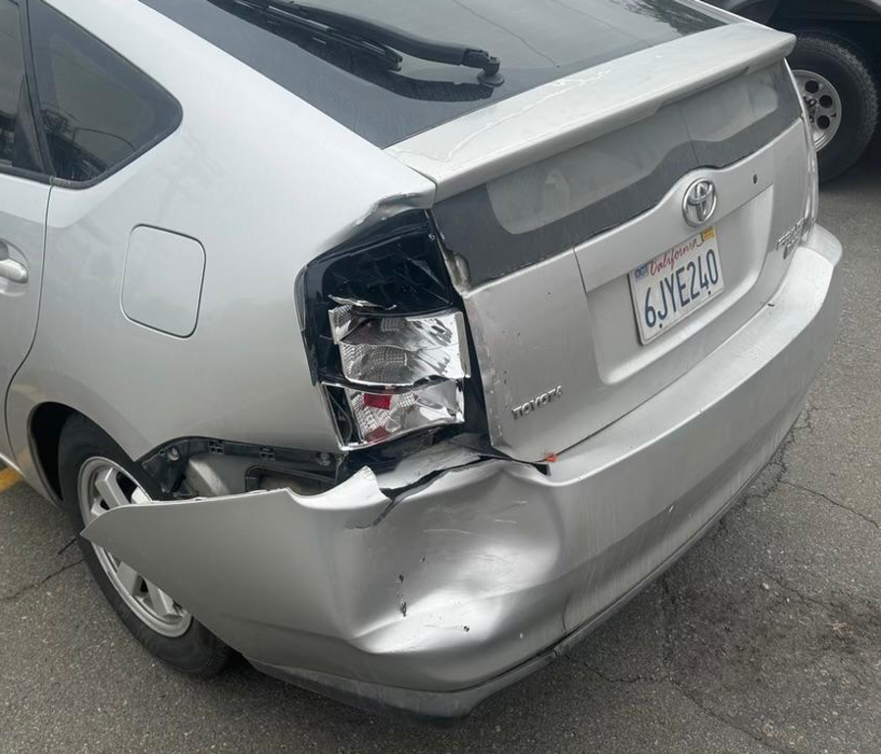
Photograph 1: Mr. Donahue’s Prius with major rear damages after the accident.

MR. DONAHUE’S DAMAGES

As a direct result of your insured’s negligence, Mr. Donahue’s diagnosed conditions resulting from this collision include sprain of the ligaments of the cervical spine, strain of the muscle, fascia, and tendon at the neck level, sprain of the ligaments of the thoracic spine, sprain of the lumbar spine and pelvis, muscle spasm, bilateral low back pain with right-sided sciatica, right-sided thoracic pain, neck pain, myalgia, and lumbar facet joint pain. Dr. Ankush Kumar Bansal, M.D., of Coastal Pain and Spinal Diagnostics, assessed Mr. Donahue’s neck pain as consistent with cervical myofascial strain, cervical facet joint sprain on the right, cervical ligamentous sprain, and possible cervical disc injuries with posterior protrusion causing cervical radiculitis. Dr. Bansal further assessed Mr. Donahue’s right-sided mid back pain as consistent with thoracic myofascial strain, ligamentous sprain, and facet joint capsular sprain on the right, as well as a possible thoracic disc injury. His lower back pain radiating to the right buttock was assessed as consistent with lumbar myofascial strain, ligamentous sprain, and facet joint capsular sprain bilaterally, and possible lumbar disc injury with posterior protrusion causing right-sided lumbar radiculitis.

Following the accident, Mr. Donahue initiated chiropractic care with Dr. Michael P. Kelly, D.C., at Santee Chiropractic Clinic, receiving treatment from June 9, 2025, through July 9, 2025, for a total of 12 visits. Dr. Kelly’s examination on June 9, 2025, revealed restricted cervical and thoracolumbar range of motion, bilateral posterior cervical muscle spasm, lumbar paraspinal muscle spasm, and a positive Spurling’s test on the left. Mr. Donahue’s treatment at Santee Chiropractic included spinal manipulation, electrical muscle stimulation, therapeutic ultrasound, and bilateral orthotics.

Due to persistent symptoms, Mr. Donahue was evaluated by Dr. Bansal at Coastal Pain and Spinal Diagnostics on February 17, 2026. At that evaluation, Dr. Bansal documented that Mr. Donahue continued to experience right-sided mid back pain radiating to his right low back and right buttock, as well as neck soreness with restricted range of motion. Physical examination revealed mild straightening of the cervical lordosis, forward head posture, tenderness along the medial scapular border on the right, restricted cervical rotation, a limited Spurling’s test, loss of lumbar lordosis, tenderness of the right lumbar paraspinal muscles at L1-L3, limited lumbar flexion and extension, facet loading positive bilaterally, and a positive straight leg raise on the right for buttock pain. Dr. Bansal ordered MRI studies of the lumbar and thoracic spine, referred Mr. Donahue to physical therapy, and prescribed conservative pain management measures.

Mr. Donahue underwent MRI imaging of both the lumbar and thoracic spine at MAX MRI Radiology on March 25, 2026. The thoracic spine MRI revealed straightening of the normal thoracic kyphosis associated with underlying muscle spasm, strain or sprain, and musculoligamentous or disc injury in the setting of a whiplash injury; a left paracentral disc protrusion at T4-T5 measuring 6 x 3 mm with flattening of the left ventral cord and moderate left paracentral canal stenosis (AP dimension 7 mm); central disc protrusions at T5-T6 and T6-T7 each measuring 5 x 3 mm with indentation of the ventral cord and mild canal stenosis (AP dimension 9-10 mm); posterior annular bulges at T10-T11 and T11-T12 measuring 3 mm with mild canal stenosis; and a right paracentral broad-based subligamentous disc extrusion at T12-L1 measuring 5 x 6 x 3 mm with indentation and effacement of the right ventral thecal sac. Dr. Voci also noted disc bulges and extrusions in the mid to lower cervical spine and recommended a dedicated cervical spine MRI for further evaluation.

The lumbar spine MRI revealed mild to moderate dextroscoliosis centered in the mid lumbar spine; a broad-based subligamentous disc extrusion at L5-S1 measuring 9 x 10 x 5 mm with significant crowding and effacement of the descending S1 nerve roots and 4-5 mm retrolisthesis of L5 on S1; a biforaminal subligamentous disc extrusion at L4-L5 most significant at the left foramina measuring 10 x 4 mm with a probability of impingement of the exiting left nerve root and moderate to severe left and moderate right foraminal compromise; a bilobed posterior annular bulge at L3-L4 of 3 mm with moderate foraminal compromise and crowding of the exiting nerve roots; and a broad-based subligamentous disc extrusion at L2-L3 measuring 7 x 4 mm with moderate foraminal compromise and mild to moderate canal stenosis. Dr. Voci noted that the spinal curvature changes were associated with underlying muscle spasm, strain or sprain, and musculoligamentous or disc injury in the setting of a possible whiplash injury.

At his follow-up appointment with Dr. Bansal on April 16, 2026, Mr. Donahue continued to present with mid and low back pain on the right side, neck pain on the right, and radiating pain to the right buttock. Dr. Bansal updated his assessment to reflect the MRI findings, noting that the multilevel lumbar disc herniations and bulges, most notably at L4-5 and L5-S1, were contributing to axial discogenic pain and lumbar radicular pain due to narrowing of the subarticular space and neuroforamen. Dr. Bansal determined that Mr. Donahue had tried and failed conservative treatment options and was experiencing persistent pain that was debilitating and affecting his function and quality of life.

Based on his evaluation, Dr. Bansal recommended a right lumbar medial branch block targeting the L4-5 and L5-S1 facets with fluoroscopic guidance for diagnostic evaluation of facet-mediated pain. The estimated cost of this procedure is $5,000.00 to $6,000.00 if performed at a clinic location, and $6,000.00 to $8,000.00 if performed at the surgery center in Carlsbad. Additionally, a physical therapy referral has been placed, and a dedicated MRI of the cervical spine has been ordered to further evaluate the cervical pathology identified on the thoracic MRI. Therefore, at least $50,000.00 should be reserved for Mr. Donahue’s future medical care, with additional costs for physical therapy and cervical imaging still to be determined.

Current Medical Expenses:

- Santee Chiropractic Clinic: $2,739.00
- San Diego Chiropractic And Massage Center: Pending Bill
- Coastal Pain and Spinal Diagnostics: $2,386.58
- MAX MRI Radiology: $3,500.00

Total Medical Expenses to Date: $8,625.58

Future Medical Expenses: $50,000.00

General Damages: $100,000.00
PAIN, SUFFERING, AND INCONVENIENCE
Mr. Donahue’s claim cannot be evaluated on the physical injuries alone, because under California law he is entitled to general (non-economic) damages for the pain, suffering, emotional anguish, and inconvenience the Collision caused. (Cal. Civ. Code §1431.2(b)(2)). This collision has caused great harm to our client and has disrupted his ability to be able to go about his pre-collision life, despite his attempts to seek continued medical care.

Mr. Donahue works as an RV technician, a physically demanding occupation that requires him to work underneath recreational vehicles to perform his duties. As a direct result of the injuries sustained in this collision, Mr. Donahue has experienced significant difficulty performing the core functions of his job. He has reported that it is hard to lay down and then get back up, a movement integral to his work as an RV technician. Dr. Bansal documented that Mr. Donahue’s pain is aggravated by working, bending, walking, and standing for prolonged periods of time, all of which are essential components of his daily occupational demands. The pain is only alleviated with rest, forcing Mr. Donahue to constantly manage the conflict between the physical requirements of his work and the persistent limitations caused by his injuries.

Beyond the occupational impact, this collision has affected virtually every aspect of Mr. Donahue’s daily activities. At his initial pain management evaluation in February 2026, nearly eight months after the accident, Dr. Bansal documented that Mr. Donahue experienced mild pain when sitting at rest that became severe with any movement. By his April 2026 follow-up, he continued to experience an intermittent aching and discomforting sensation that worsened in the afternoon, with standing, walking, and over-exertion. Despite undergoing 12 sessions of chiropractic care, two pain management evaluations, and MRI imaging, Mr. Donahue continues to experience multilevel spinal disc herniations and persistent pain that, in Dr. Bansal’s assessment, is debilitating and affecting his function and quality of life. The ongoing nature of Mr. Donahue’s injuries and the need for additional interventional treatment, including the recommended lumbar medial branch block and physical therapy, underscore the profound and lasting impact this collision has had on his life.

DEMAND FOR SETTLEMENT

Based upon the above, Mr. Donahue hereby offers to accept all applicable bodily injury policy limits in full and final settlement of his claims arising out of this collision.

This offer is subject to you complying with the following express terms and conditions:

- If you are claiming that a statutory lien has been perfected against our client’s recovery, you
must provide written proof to our satisfaction that such lien has been legally perfected. No “lien claimant” may be included as a payee on settlement funds, unless we give you written permission to do so before expiration of this offer.

- The settlement checks or drafts must be made payable to only our client, Stalwart Law
Group and no other person or entity, unless we give you written permission to do otherwise before expiration of this offer.

- This offer expires unless it is accepted in writing on or before June 29, 2026,
at 12:00 p.m. PST. Acceptance requires your full and complete compliance with this demand and requires that we receive at our office, located at 1327 N. Broadway Santa Ana, CA 92706, all of the documentation including but not limited to:

A) The settlement draft, made payable to our client and Stalwart Law Group;

B) A certified copy of all declaration pages for each and every operative policy that
affords coverage, or may afford coverage, for your insured(s) for this incident, certifying
these represent all such policies. If there is insurance other than yours, you must
immediately inform our office in writing with the details, place the other carrier(s) on
notice, and coordinate their compliance with this demand;

C) A compliant release that:

(1) Only releases your settling insured(s), their heirs, successors, assigns,
executors, and administrators, and not third-parties or other persons, entities, or
parties, including any insurance carrier or attorneys.

(2) Cannot contain any terms inconsistent with or that disclaim our client’s
reliance upon any representations made by you or your insured(s), including
those made in any declaration provided herein.

(3) Does not require our firm or any member of our firm to indemnify or hold
harmless you, your principal, any insured, your attorneys, or any person or
entity for any claim, statutory or otherwise, made against you, your
insured(s), or your attorneys concerning this incident. Neither our firm nor
any member of our firm will be required to sign the release unless we give
you written permission to include such provision before expiration of this offer.

(4) Does not require our client to agree to indemnify or hold harmless you, your
insured(s), or their carriers or attorneys for any claims arising out of this
settlement other than for statutory liens that have been legally perfected
against you or your insured(s) for medical services and bills arising only out
of the incident, unless we give you written permission to include such
provision before expiration of this offer. If you timely request, our client will
provide you with the appropriate Medicare Compliance documents, if
applicable.

D) A declaration signed by all your named insured(s), vehicle driver, and vehicle owner(s),
under penalty of perjury and based upon their personal knowledge:

(1) That identifies all applicable insurance that affords coverage for this incident.
This includes liability, UM, UIM, Medpay, PIP, or any other insurance.

(2) That states there is no other insurance other than those identified herein that
afford coverage to your insured(s) for this incident.

(3) That states your insured(s) were not acting within the course and scope of
employment, agency, joint venture; was not participating in a business activity
at the time of the incident, and not an errand for another at the time of the
incident; was not logged into any “ride share” application, and was not
operating a motor vehicle that was a “company car” or that its use was not
“incidental” to or a “required use” for any job duties at the time of the incident.

(4) The declaration must include the following language: “if any representation
made within the declaration is false or untrue, I acknowledge that
claimants reserve the right to rescind this settlement, file suit for damages
and not be barred by any applicable statute of limitations.”

A purported “acceptance” that does not comply with the precise terms and conditions set forth herein will deemed a rejection of this offer.

Best,

Faby Rivera, Esq.
STALWART LAW GROUP, APC

