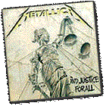
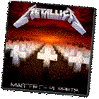


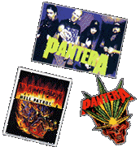
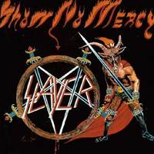
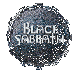

Guitarist seeking like-minded individuals to form local Heavy Metal band. Band will have a lead guitarist, rhythm guitar, bass guitar, drums, and vocalists. Must be versatile, (i.e.: can sing and play instrument, can play drums, bass, and rhythm, etc.). Must have own equipment. Will play many different styles of music including some blues, country, classic rock, 50’s, classical, and standards. However, will primarily play in the styles of METALLICA (Old and New), BLACK SABBATH, MEGADETH, PANTERA, SLAYER, and in general old-school thrash and speed-metal. Ability to play songs by Bush, Slipknot, Coal Chamber, Orgy, Pappa Roach and other new-metal bands are definitely a plus.

We will start out playing covers and will ease into creating originals. Only SERIOUS musicians need to call. (No, that doesn’t mean you need a degree, it means you are willing to practice assigned songs and be on time, etc.) If interested, call 266-8520 anytime – just leave a voice-mail message.

August 19, 2000

