Codebook

Table of Contents

knitr::opts_chunk$set(  
 warning = TRUE, # show warnings during codebook generation  
 message = TRUE, # show messages during codebook generation  
 error = TRUE, # do not interrupt codebook generation in case of errors,  
 # usually better for debugging  
 echo = TRUE # show R code  
)  
ggplot2::theme_set(ggplot2::theme_bw())

Now, we’re preparing our data for the codebook.

library(codebook)  
UCI_HAR_dataset <- read.table("output.txt",header = TRUE)  
# to import an SPSS file from the same folder uncomment and edit the line below  
# codebook_data <- rio::import("mydata.sav")  
# for Stata  
# codebook_data <- rio::import("mydata.dta")  
# for CSV  
# codebook_data <- rio::import("mydata.csv")  
  
# omit the following lines, if your missing values are already properly labelled  
UCI_HAR_dataset <- detect_missing(UCI_HAR_dataset,  
 only_labelled = TRUE, # only labelled values are autodetected as  
 # missing  
 negative_values_are_missing = FALSE, # negative values are missing values  
 ninety_nine_problems = TRUE, # 99/999 are missing values, if they  
 # are more than 5 MAD from the median  
 )  
  
# If you are not using formr, the codebook package needs to guess which items  
# form a scale. The following line finds item aggregates with names like this:  
# scale = scale_1 + scale_2R + scale_3R  
# identifying these aggregates allows the codebook function to  
# automatically compute reliabilities.  
# However, it will not reverse items automatically.  
UCI_HAR_dataset <- detect_scales(codebook_data)

## Error in detect_scales(codebook_data): object 'codebook_data' not found

Create codebook

codebook(UCI_HAR_dataset)

## No missing values.

### Metadata

#### Description

**Dataset name**: UCI_HAR_dataset

The dataset has N=180 rows and 88 columns. 180 rows have no missing values on any column.

Metadata for search engines

* **Date published**: 2020-09-18

|  |
| --- |
| x |
| activity |
| subjects |
| TimeBodyAccelerometer.mean…X |
| TimeBodyAccelerometer.mean…Y |
| TimeBodyAccelerometer.mean…Z |
| TimeGravityAccelerometer.mean…X |
| TimeGravityAccelerometer.mean…Y |
| TimeGravityAccelerometer.mean…Z |
| TimeBodyAccelerometerJerk.mean…X |
| TimeBodyAccelerometerJerk.mean…Y |
| TimeBodyAccelerometerJerk.mean…Z |
| TimeBodyGyroscope.mean…X |
| TimeBodyGyroscope.mean…Y |
| TimeBodyGyroscope.mean…Z |
| TimeBodyGyroscopeJerk.mean…X |
| TimeBodyGyroscopeJerk.mean…Y |
| TimeBodyGyroscopeJerk.mean…Z |
| TimeBodyAccelerometerMagnitude.mean.. |
| TimeGravityAccelerometerMagnitude.mean.. |
| TimeBodyAccelerometerJerkMagnitude.mean.. |
| TimeBodyGyroscopeMagnitude.mean.. |
| TimeBodyGyroscopeJerkMagnitude.mean.. |
| FrequencyBodyAccelerometer.mean…X |
| FrequencyBodyAccelerometer.mean…Y |
| FrequencyBodyAccelerometer.mean…Z |
| FrequencyBodyAccelerometer.meanFreq…X |
| FrequencyBodyAccelerometer.meanFreq…Y |
| FrequencyBodyAccelerometer.meanFreq…Z |
| FrequencyBodyAccelerometerJerk.mean…X |
| FrequencyBodyAccelerometerJerk.mean…Y |
| FrequencyBodyAccelerometerJerk.mean…Z |
| FrequencyBodyAccelerometerJerk.meanFreq…X |
| FrequencyBodyAccelerometerJerk.meanFreq…Y |
| FrequencyBodyAccelerometerJerk.meanFreq…Z |
| FrequencyBodyGyroscope.mean…X |
| FrequencyBodyGyroscope.mean…Y |
| FrequencyBodyGyroscope.mean…Z |
| FrequencyBodyGyroscope.meanFreq…X |
| FrequencyBodyGyroscope.meanFreq…Y |
| FrequencyBodyGyroscope.meanFreq…Z |
| FrequencyBodyAccelerometerMagnitude.mean.. |
| FrequencyBodyAccelerometerMagnitude.meanFreq.. |
| FrequencyBodyAccelerometerJerkMagnitude.mean.. |
| FrequencyBodyAccelerometerJerkMagnitude.meanFreq.. |
| FrequencyBodyGyroscopeMagnitude.mean.. |
| FrequencyBodyGyroscopeMagnitude.meanFreq.. |
| FrequencyBodyGyroscopeJerkMagnitude.mean.. |
| FrequencyBodyGyroscopeJerkMagnitude.meanFreq.. |
| Angle.TimeBodyAccelerometerMean.Gravity. |
| Angle.TimeBodyAccelerometerJerkMean..GravityMean. |
| Angle.TimeBodyGyroscopeMean.GravityMean. |
| Angle.TimeBodyGyroscopeJerkMean.GravityMean. |
| Angle.X.GravityMean. |
| Angle.Y.GravityMean. |
| Angle.Z.GravityMean. |
| TimeBodyAccelerometer.std…X |
| TimeBodyAccelerometer.std…Y |
| TimeBodyAccelerometer.std…Z |
| TimeGravityAccelerometer.std…X |
| TimeGravityAccelerometer.std…Y |
| TimeGravityAccelerometer.std…Z |
| TimeBodyAccelerometerJerk.std…X |
| TimeBodyAccelerometerJerk.std…Y |
| TimeBodyAccelerometerJerk.std…Z |
| TimeBodyGyroscope.std…X |
| TimeBodyGyroscope.std…Y |
| TimeBodyGyroscope.std…Z |
| TimeBodyGyroscopeJerk.std…X |
| TimeBodyGyroscopeJerk.std…Y |
| TimeBodyGyroscopeJerk.std…Z |
| TimeBodyAccelerometerMagnitude.std.. |
| TimeGravityAccelerometerMagnitude.std.. |
| TimeBodyAccelerometerJerkMagnitude.std.. |
| TimeBodyGyroscopeMagnitude.std.. |
| TimeBodyGyroscopeJerkMagnitude.std.. |
| FrequencyBodyAccelerometer.std…X |
| FrequencyBodyAccelerometer.std…Y |
| FrequencyBodyAccelerometer.std…Z |
| FrequencyBodyAccelerometerJerk.std…X |
| FrequencyBodyAccelerometerJerk.std…Y |
| FrequencyBodyAccelerometerJerk.std…Z |
| FrequencyBodyGyroscope.std…X |
| FrequencyBodyGyroscope.std…Y |
| FrequencyBodyGyroscope.std…Z |
| FrequencyBodyAccelerometerMagnitude.std.. |
| FrequencyBodyAccelerometerJerkMagnitude.std.. |
| FrequencyBodyGyroscopeMagnitude.std.. |
| FrequencyBodyGyroscopeJerkMagnitude.std.. |

#Variables

### activity

#### Distribution

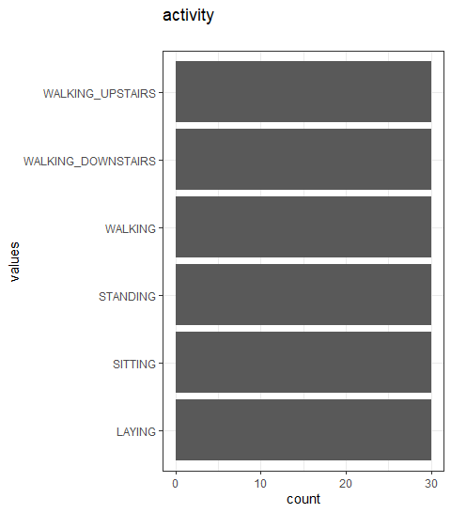

Distribution of values for activity

0 missing values.

#### Summary statistics

|  |  |  |  |  |  |  |  |  |  |
| --- | --- | --- | --- | --- | --- | --- | --- | --- | --- |
| name | data_type | n_missing | complete_rate | n_unique | empty | min | max | whitespace | label |
| activity | character | 0 | 1 | 6 | 0 | 6 | 18 | 0 | NA |

### subjects

#### Distribution

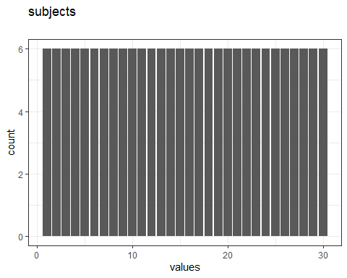

Distribution of values for subjects

0 missing values.

#### Summary statistics

|  |  |  |  |  |  |  |  |  |  |  |
| --- | --- | --- | --- | --- | --- | --- | --- | --- | --- | --- |
| name | data_type | n_missing | complete_rate | min | median | max | mean | sd | hist | label |
| subjects | numeric | 0 | 1 | 1 | 16 | 30 | 15.5 | 8.679585 | <U+2587><U+2587><U+2587><U+2587><U+2587> | NA |

### TimeBodyAccelerometer.mean…X

#### Distribution

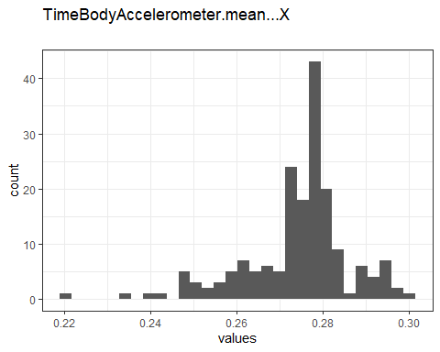

Distribution of values for TimeBodyAccelerometer.mean…X

0 missing values.

#### Summary statistics

|  |  |  |  |  |  |  |  |  |  |  |
| --- | --- | --- | --- | --- | --- | --- | --- | --- | --- | --- |
| name | data_type | n_missing | complete_rate | min | median | max | mean | sd | hist | label |
| TimeBodyAccelerometer.mean…X | numeric | 0 | 1 | 0.22 | 0.28 | 0.3 | 0.2743027 | 0.0121646 | <U+2581><U+2581><U+2582><U+2587><U+2582> | NA |

### TimeBodyAccelerometer.mean…Y

#### Distribution

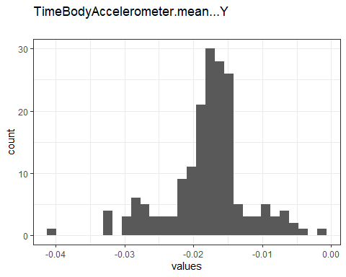

Distribution of values for TimeBodyAccelerometer.mean…Y

0 missing values.

#### Summary statistics

|  |  |  |  |  |  |  |  |  |  |  |
| --- | --- | --- | --- | --- | --- | --- | --- | --- | --- | --- |
| name | data_type | n_missing | complete_rate | min | median | max | mean | sd | hist | label |
| TimeBodyAccelerometer.mean…Y | numeric | 0 | 1 | -0.041 | -0.017 | -0.0013 | -0.0178755 | 0.0057712 | <U+2581><U+2582><U+2587><U+2587><U+2581> | NA |

### TimeBodyAccelerometer.mean…Z

#### Distribution

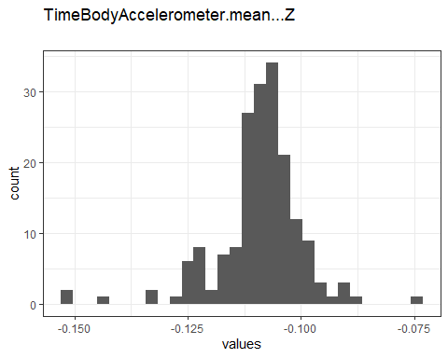

Distribution of values for TimeBodyAccelerometer.mean…Z

0 missing values.

#### Summary statistics

|  |  |  |  |  |  |  |  |  |  |  |
| --- | --- | --- | --- | --- | --- | --- | --- | --- | --- | --- |
| name | data_type | n_missing | complete_rate | min | median | max | mean | sd | hist | label |
| TimeBodyAccelerometer.mean…Z | numeric | 0 | 1 | -0.15 | -0.11 | -0.075 | -0.1091638 | 0.009582 | <U+2581><U+2581><U+2587><U+2585><U+2581> | NA |

### TimeGravityAccelerometer.mean…X

#### Distribution

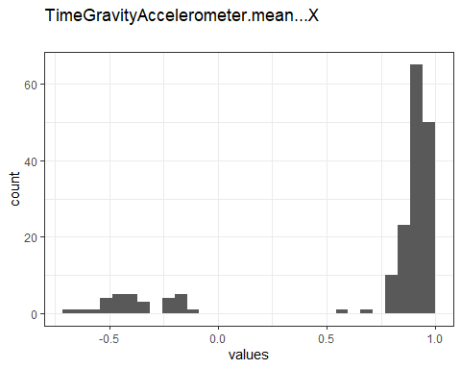

Distribution of values for TimeGravityAccelerometer.mean…X

0 missing values.

#### Summary statistics

|  |  |  |  |  |  |  |  |  |  |  |
| --- | --- | --- | --- | --- | --- | --- | --- | --- | --- | --- |
| name | data_type | n_missing | complete_rate | min | median | max | mean | sd | hist | label |
| TimeGravityAccelerometer.mean…X | numeric | 0 | 1 | -0.68 | 0.92 | 0.97 | 0.6974775 | 0.4872534 | <U+2581><U+2581><U+2581><U+2581><U+2587> | NA |

### TimeGravityAccelerometer.mean…Y

#### Distribution

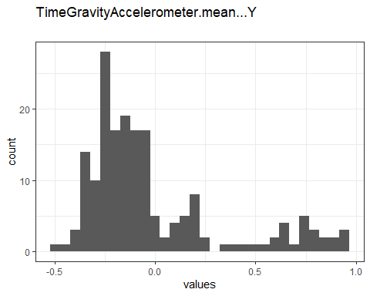

Distribution of values for TimeGravityAccelerometer.mean…Y

0 missing values.

#### Summary statistics

|  |  |  |  |  |  |  |  |  |  |  |
| --- | --- | --- | --- | --- | --- | --- | --- | --- | --- | --- |
| name | data_type | n_missing | complete_rate | min | median | max | mean | sd | hist | label |
| TimeGravityAccelerometer.mean…Y | numeric | 0 | 1 | -0.48 | -0.13 | 0.96 | -0.0162128 | 0.3452376 | <U+2587><U+2587><U+2582><U+2581><U+2582> | NA |

### TimeGravityAccelerometer.mean…Z

#### Distribution

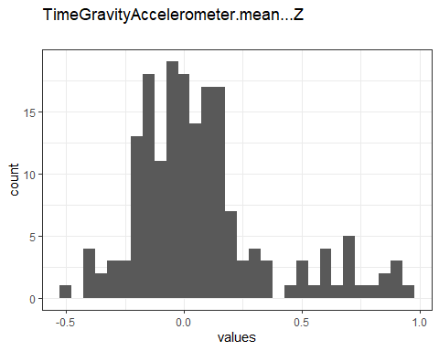

Distribution of values for TimeGravityAccelerometer.mean…Z

0 missing values.

#### Summary statistics

|  |  |  |  |  |  |  |  |  |  |  |
| --- | --- | --- | --- | --- | --- | --- | --- | --- | --- | --- |
| name | data_type | n_missing | complete_rate | min | median | max | mean | sd | hist | label |
| TimeGravityAccelerometer.mean…Z | numeric | 0 | 1 | -0.5 | 0.024 | 0.96 | 0.0741279 | 0.2887919 | <U+2582><U+2587><U+2583><U+2581><U+2581> | NA |

### TimeBodyAccelerometerJerk.mean…X

#### Distribution

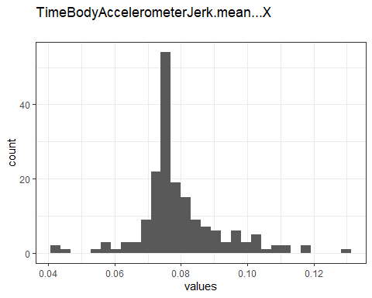

Distribution of values for TimeBodyAccelerometerJerk.mean…X

0 missing values.

#### Summary statistics

|  |  |  |  |  |  |  |  |  |  |  |
| --- | --- | --- | --- | --- | --- | --- | --- | --- | --- | --- |
| name | data_type | n_missing | complete_rate | min | median | max | mean | sd | hist | label |
| TimeBodyAccelerometerJerk.mean…X | numeric | 0 | 1 | 0.043 | 0.076 | 0.13 | 0.0794736 | 0.012588 | <U+2581><U+2587><U+2583><U+2582><U+2581> | NA |

### TimeBodyAccelerometerJerk.mean…Y

#### Distribution

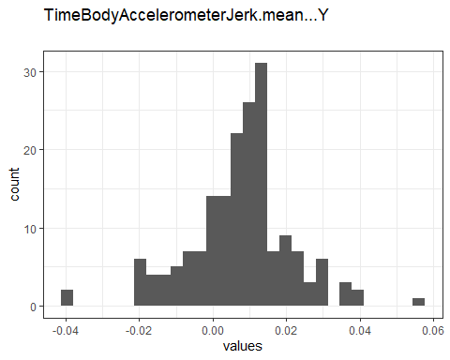

Distribution of values for TimeBodyAccelerometerJerk.mean…Y

0 missing values.

#### Summary statistics

|  |  |  |  |  |  |  |  |  |  |  |
| --- | --- | --- | --- | --- | --- | --- | --- | --- | --- | --- |
| name | data_type | n_missing | complete_rate | min | median | max | mean | sd | hist | label |
| TimeBodyAccelerometerJerk.mean…Y | numeric | 0 | 1 | -0.039 | 0.0095 | 0.057 | 0.0075652 | 0.0135764 | <U+2581><U+2583><U+2587><U+2582><U+2581> | NA |

### TimeBodyAccelerometerJerk.mean…Z

#### Distribution

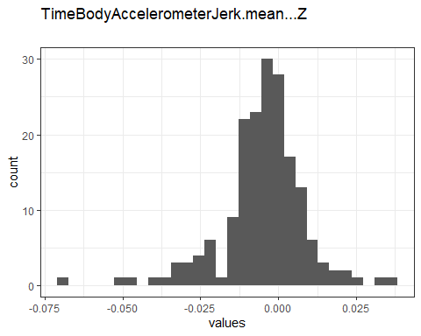

Distribution of values for TimeBodyAccelerometerJerk.mean…Z

0 missing values.

#### Summary statistics

|  |  |  |  |  |  |  |  |  |  |  |
| --- | --- | --- | --- | --- | --- | --- | --- | --- | --- | --- |
| name | data_type | n_missing | complete_rate | min | median | max | mean | sd | hist | label |
| TimeBodyAccelerometerJerk.mean…Z | numeric | 0 | 1 | -0.067 | -0.0039 | 0.038 | -0.0049534 | 0.0134621 | <U+2581><U+2581><U+2587><U+2587><U+2581> | NA |

### TimeBodyGyroscope.mean…X

#### Distribution

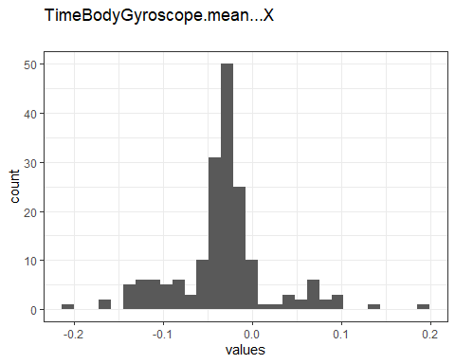

Distribution of values for TimeBodyGyroscope.mean…X

0 missing values.

#### Summary statistics

|  |  |  |  |  |  |  |  |  |  |  |
| --- | --- | --- | --- | --- | --- | --- | --- | --- | --- | --- |
| name | data_type | n_missing | complete_rate | min | median | max | mean | sd | hist | label |
| TimeBodyGyroscope.mean…X | numeric | 0 | 1 | -0.21 | -0.029 | 0.19 | -0.0324372 | 0.0540518 | <U+2581><U+2582><U+2587><U+2581><U+2581> | NA |

### TimeBodyGyroscope.mean…Y

#### Distribution

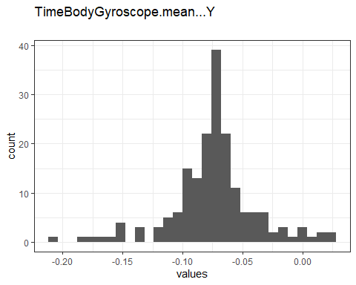

Distribution of values for TimeBodyGyroscope.mean…Y

0 missing values.

#### Summary statistics

|  |  |  |  |  |  |  |  |  |  |  |
| --- | --- | --- | --- | --- | --- | --- | --- | --- | --- | --- |
| name | data_type | n_missing | complete_rate | min | median | max | mean | sd | hist | label |
| TimeBodyGyroscope.mean…Y | numeric | 0 | 1 | -0.2 | -0.073 | 0.027 | -0.0742596 | 0.0355415 | <U+2581><U+2581><U+2587><U+2583><U+2581> | NA |

### TimeBodyGyroscope.mean…Z

#### Distribution

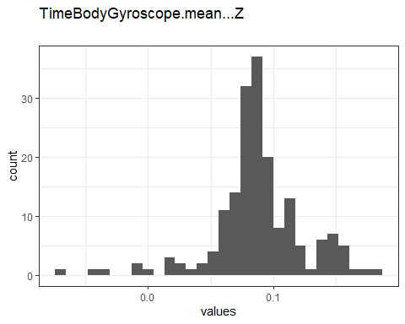

Distribution of values for TimeBodyGyroscope.mean…Z

0 missing values.

#### Summary statistics

|  |  |  |  |  |  |  |  |  |  |  |
| --- | --- | --- | --- | --- | --- | --- | --- | --- | --- | --- |
| name | data_type | n_missing | complete_rate | min | median | max | mean | sd | hist | label |
| TimeBodyGyroscope.mean…Z | numeric | 0 | 1 | -0.072 | 0.085 | 0.18 | 0.0874446 | 0.0362125 | <U+2581><U+2581><U+2583><U+2587><U+2582> | NA |

### TimeBodyGyroscopeJerk.mean…X

#### Distribution

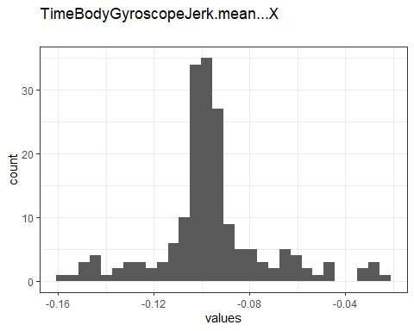

Distribution of values for TimeBodyGyroscopeJerk.mean…X

0 missing values.

#### Summary statistics

|  |  |  |  |  |  |  |  |  |  |  |
| --- | --- | --- | --- | --- | --- | --- | --- | --- | --- | --- |
| name | data_type | n_missing | complete_rate | min | median | max | mean | sd | hist | label |
| TimeBodyGyroscopeJerk.mean…X | numeric | 0 | 1 | -0.16 | -0.099 | -0.022 | -0.0960568 | 0.0233458 | <U+2581><U+2582><U+2587><U+2581><U+2581> | NA |

### TimeBodyGyroscopeJerk.mean…Y

#### Distribution

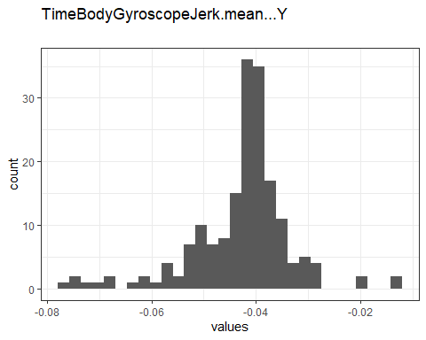

Distribution of values for TimeBodyGyroscopeJerk.mean…Y

0 missing values.

#### Summary statistics

|  |  |  |  |  |  |  |  |  |  |  |
| --- | --- | --- | --- | --- | --- | --- | --- | --- | --- | --- |
| name | data_type | n_missing | complete_rate | min | median | max | mean | sd | hist | label |
| TimeBodyGyroscopeJerk.mean…Y | numeric | 0 | 1 | -0.077 | -0.041 | -0.013 | -0.0426928 | 0.009532 | <U+2581><U+2582><U+2587><U+2583><U+2581> | NA |

### TimeBodyGyroscopeJerk.mean…Z

#### Distribution

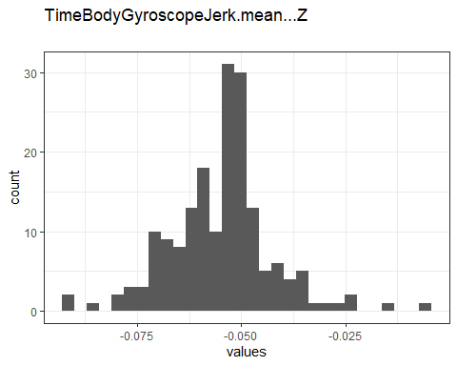

Distribution of values for TimeBodyGyroscopeJerk.mean…Z

0 missing values.

#### Summary statistics

|  |  |  |  |  |  |  |  |  |  |  |
| --- | --- | --- | --- | --- | --- | --- | --- | --- | --- | --- |
| name | data_type | n_missing | complete_rate | min | median | max | mean | sd | hist | label |
| TimeBodyGyroscopeJerk.mean…Z | numeric | 0 | 1 | -0.092 | -0.053 | -0.0069 | -0.0548019 | 0.012347 | <U+2581><U+2585><U+2587><U+2581><U+2581> | NA |

### TimeBodyAccelerometerMagnitude.mean..

#### Distribution

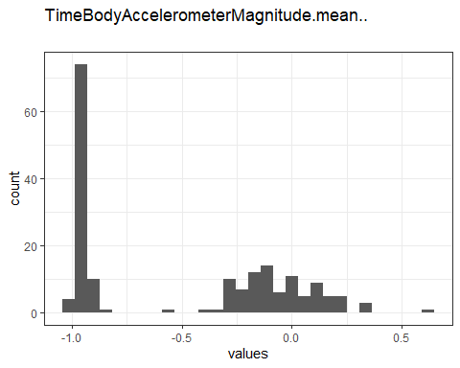

Distribution of values for TimeBodyAccelerometerMagnitude.mean..

0 missing values.

#### Summary statistics

|  |  |  |  |  |  |  |  |  |  |  |
| --- | --- | --- | --- | --- | --- | --- | --- | --- | --- | --- |
| name | data_type | n_missing | complete_rate | min | median | max | mean | sd | hist | label |
| TimeBodyAccelerometerMagnitude.mean.. | numeric | 0 | 1 | -0.99 | -0.48 | 0.64 | -0.4972897 | 0.4728834 | <U+2587><U+2581><U+2585><U+2583><U+2581> | NA |

### TimeGravityAccelerometerMagnitude.mean..

#### Distribution

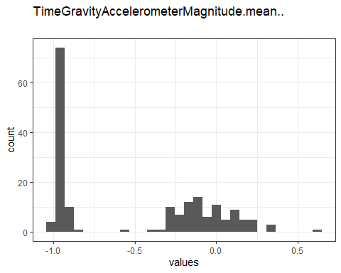

Distribution of values for TimeGravityAccelerometerMagnitude.mean..

0 missing values.

#### Summary statistics

|  |  |  |  |  |  |  |  |  |  |  |
| --- | --- | --- | --- | --- | --- | --- | --- | --- | --- | --- |
| name | data_type | n_missing | complete_rate | min | median | max | mean | sd | hist | label |
| TimeGravityAccelerometerMagnitude.mean.. | numeric | 0 | 1 | -0.99 | -0.48 | 0.64 | -0.4972897 | 0.4728834 | <U+2587><U+2581><U+2585><U+2583><U+2581> | NA |

### TimeBodyAccelerometerJerkMagnitude.mean..

#### Distribution

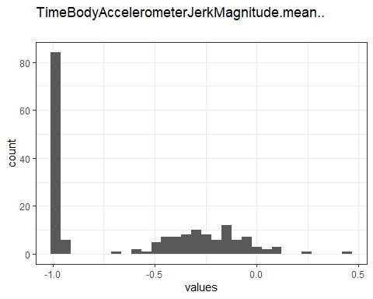

Distribution of values for TimeBodyAccelerometerJerkMagnitude.mean..

0 missing values.

#### Summary statistics

|  |  |  |  |  |  |  |  |  |  |  |
| --- | --- | --- | --- | --- | --- | --- | --- | --- | --- | --- |
| name | data_type | n_missing | complete_rate | min | median | max | mean | sd | hist | label |
| TimeBodyAccelerometerJerkMagnitude.mean.. | numeric | 0 | 1 | -0.99 | -0.82 | 0.43 | -0.6079296 | 0.3965272 | <U+2587><U+2582><U+2585><U+2582><U+2581> | NA |

### TimeBodyGyroscopeMagnitude.mean..

#### Distribution

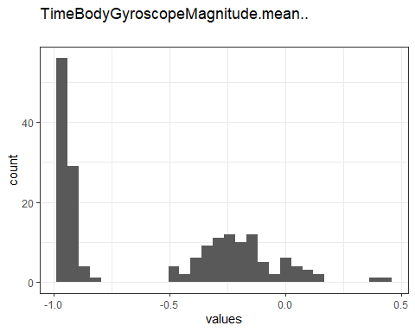

Distribution of values for TimeBodyGyroscopeMagnitude.mean..

0 missing values.

#### Summary statistics

|  |  |  |  |  |  |  |  |  |  |  |
| --- | --- | --- | --- | --- | --- | --- | --- | --- | --- | --- |
| name | data_type | n_missing | complete_rate | min | median | max | mean | sd | hist | label |
| TimeBodyGyroscopeMagnitude.mean.. | numeric | 0 | 1 | -0.98 | -0.66 | 0.42 | -0.5651631 | 0.3977338 | <U+2587><U+2581><U+2585><U+2582><U+2581> | NA |

### TimeBodyGyroscopeJerkMagnitude.mean..

#### Distribution

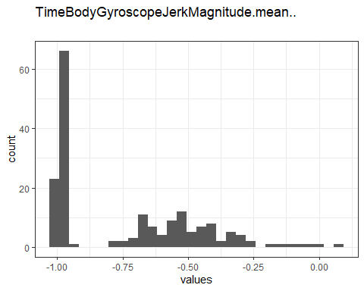

Distribution of values for TimeBodyGyroscopeJerkMagnitude.mean..

0 missing values.

#### Summary statistics

|  |  |  |  |  |  |  |  |  |  |  |
| --- | --- | --- | --- | --- | --- | --- | --- | --- | --- | --- |
| name | data_type | n_missing | complete_rate | min | median | max | mean | sd | hist | label |
| TimeBodyGyroscopeJerkMagnitude.mean.. | numeric | 0 | 1 | -1 | -0.86 | 0.088 | -0.7363693 | 0.2767541 | <U+2587><U+2583><U+2583><U+2581><U+2581> | NA |

### FrequencyBodyAccelerometer.mean…X

#### Distribution

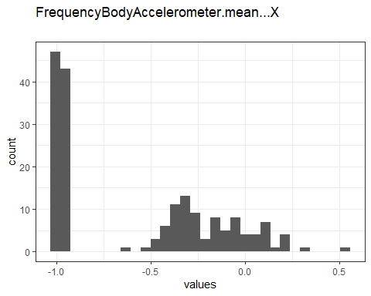

Distribution of values for FrequencyBodyAccelerometer.mean…X

0 missing values.

#### Summary statistics

|  |  |  |  |  |  |  |  |  |  |  |
| --- | --- | --- | --- | --- | --- | --- | --- | --- | --- | --- |
| name | data_type | n_missing | complete_rate | min | median | max | mean | sd | hist | label |
| FrequencyBodyAccelerometer.mean…X | numeric | 0 | 1 | -1 | -0.77 | 0.54 | -0.5758 | 0.4300214 | <U+2587><U+2581><U+2583><U+2582><U+2581> | NA |

### FrequencyBodyAccelerometer.mean…Y

#### Distribution

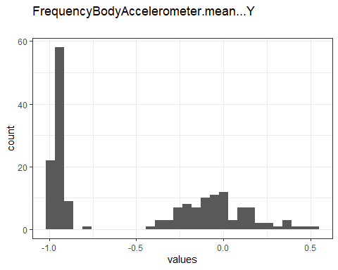

Distribution of values for FrequencyBodyAccelerometer.mean…Y

0 missing values.

#### Summary statistics

|  |  |  |  |  |  |  |  |  |  |  |
| --- | --- | --- | --- | --- | --- | --- | --- | --- | --- | --- |
| name | data_type | n_missing | complete_rate | min | median | max | mean | sd | hist | label |
| FrequencyBodyAccelerometer.mean…Y | numeric | 0 | 1 | -0.99 | -0.59 | 0.52 | -0.4887327 | 0.4806496 | <U+2587><U+2581><U+2583><U+2583><U+2581> | NA |

### FrequencyBodyAccelerometer.mean…Z

#### Distribution

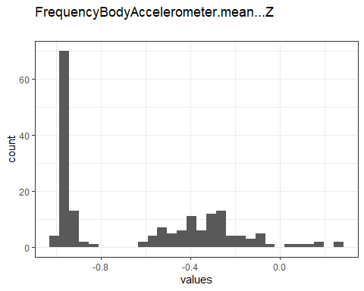

Distribution of values for FrequencyBodyAccelerometer.mean…Z

0 missing values.

#### Summary statistics

|  |  |  |  |  |  |  |  |  |  |  |
| --- | --- | --- | --- | --- | --- | --- | --- | --- | --- | --- |
| name | data_type | n_missing | complete_rate | min | median | max | mean | sd | hist | label |
| FrequencyBodyAccelerometer.mean…Z | numeric | 0 | 1 | -0.99 | -0.72 | 0.28 | -0.6297388 | 0.3556469 | <U+2587><U+2582><U+2585><U+2581><U+2581> | NA |

### FrequencyBodyAccelerometer.meanFreq…X

#### Distribution

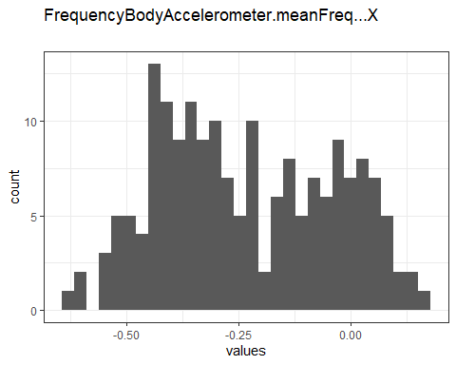

Distribution of values for FrequencyBodyAccelerometer.meanFreq…X

0 missing values.

#### Summary statistics

|  |  |  |  |  |  |  |  |  |  |  |
| --- | --- | --- | --- | --- | --- | --- | --- | --- | --- | --- |
| name | data_type | n_missing | complete_rate | min | median | max | mean | sd | hist | label |
| FrequencyBodyAccelerometer.meanFreq…X | numeric | 0 | 1 | -0.64 | -0.26 | 0.16 | -0.2322661 | 0.1935684 | <U+2582><U+2587><U+2586><U+2586><U+2583> | NA |

### FrequencyBodyAccelerometer.meanFreq…Y

#### Distribution

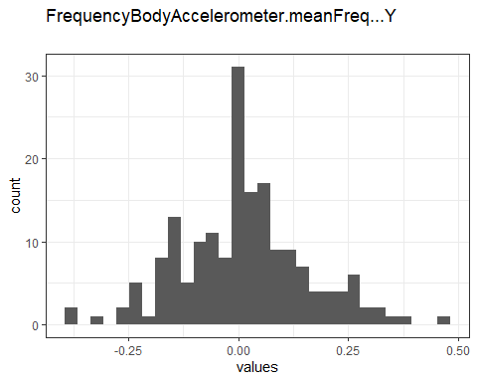

Distribution of values for FrequencyBodyAccelerometer.meanFreq…Y

0 missing values.

#### Summary statistics

|  |  |  |  |  |  |  |  |  |  |  |
| --- | --- | --- | --- | --- | --- | --- | --- | --- | --- | --- |
| name | data_type | n_missing | complete_rate | min | median | max | mean | sd | hist | label |
| FrequencyBodyAccelerometer.meanFreq…Y | numeric | 0 | 1 | -0.38 | 0.0079 | 0.47 | 0.0115289 | 0.1447051 | <U+2581><U+2585><U+2587><U+2582><U+2581> | NA |

### FrequencyBodyAccelerometer.meanFreq…Z

#### Distribution

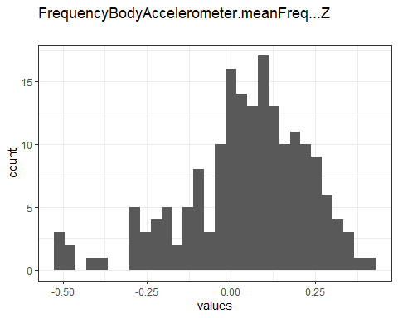

Distribution of values for FrequencyBodyAccelerometer.meanFreq…Z

0 missing values.

#### Summary statistics

|  |  |  |  |  |  |  |  |  |  |  |
| --- | --- | --- | --- | --- | --- | --- | --- | --- | --- | --- |
| name | data_type | n_missing | complete_rate | min | median | max | mean | sd | hist | label |
| FrequencyBodyAccelerometer.meanFreq…Z | numeric | 0 | 1 | -0.52 | 0.066 | 0.4 | 0.0437174 | 0.1850113 | <U+2581><U+2582><U+2586><U+2587><U+2583> | NA |

### FrequencyBodyAccelerometerJerk.mean…X

#### Distribution

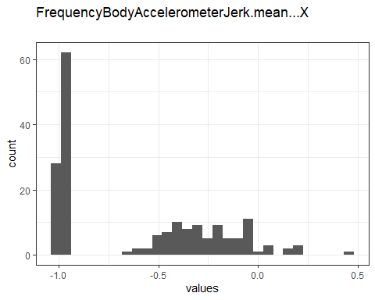

Distribution of values for FrequencyBodyAccelerometerJerk.mean…X

0 missing values.

#### Summary statistics

|  |  |  |  |  |  |  |  |  |  |  |
| --- | --- | --- | --- | --- | --- | --- | --- | --- | --- | --- |
| name | data_type | n_missing | complete_rate | min | median | max | mean | sd | hist | label |
| FrequencyBodyAccelerometerJerk.mean…X | numeric | 0 | 1 | -0.99 | -0.81 | 0.47 | -0.6139282 | 0.3982896 | <U+2587><U+2582><U+2583><U+2582><U+2581> | NA |

### FrequencyBodyAccelerometerJerk.mean…Y

#### Distribution

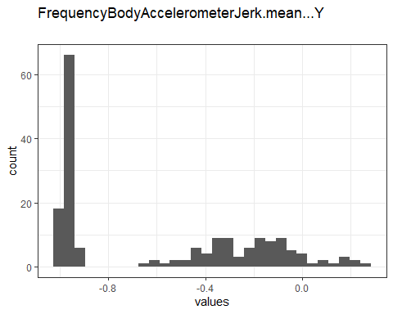

Distribution of values for FrequencyBodyAccelerometerJerk.mean…Y

0 missing values.

#### Summary statistics

|  |  |  |  |  |  |  |  |  |  |  |
| --- | --- | --- | --- | --- | --- | --- | --- | --- | --- | --- |
| name | data_type | n_missing | complete_rate | min | median | max | mean | sd | hist | label |
| FrequencyBodyAccelerometerJerk.mean…Y | numeric | 0 | 1 | -0.99 | -0.78 | 0.28 | -0.5881631 | 0.4077491 | <U+2587><U+2581><U+2583><U+2583><U+2581> | NA |

### FrequencyBodyAccelerometerJerk.mean…Z

#### Distribution

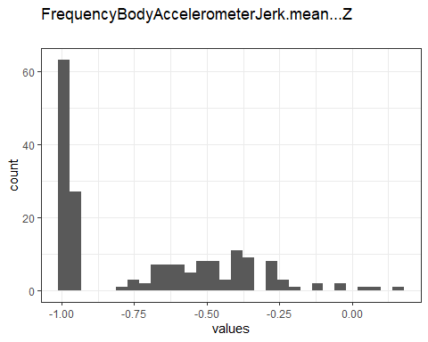

Distribution of values for FrequencyBodyAccelerometerJerk.mean…Z

0 missing values.

#### Summary statistics

|  |  |  |  |  |  |  |  |  |  |  |
| --- | --- | --- | --- | --- | --- | --- | --- | --- | --- | --- |
| name | data_type | n_missing | complete_rate | min | median | max | mean | sd | hist | label |
| FrequencyBodyAccelerometerJerk.mean…Z | numeric | 0 | 1 | -0.99 | -0.87 | 0.16 | -0.7143585 | 0.2970225 | <U+2587><U+2582><U+2583><U+2581><U+2581> | NA |

### FrequencyBodyAccelerometerJerk.meanFreq…X

#### Distribution

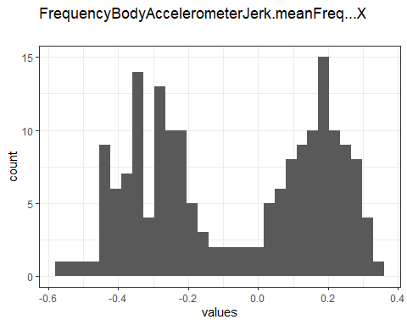

Distribution of values for FrequencyBodyAccelerometerJerk.meanFreq…X

0 missing values.

#### Summary statistics

|  |  |  |  |  |  |  |  |  |  |  |
| --- | --- | --- | --- | --- | --- | --- | --- | --- | --- | --- |
| name | data_type | n_missing | complete_rate | min | median | max | mean | sd | hist | label |
| FrequencyBodyAccelerometerJerk.meanFreq…X | numeric | 0 | 1 | -0.58 | -0.061 | 0.33 | -0.0691018 | 0.2541022 | <U+2582><U+2587><U+2582><U+2585><U+2587> | NA |

### FrequencyBodyAccelerometerJerk.meanFreq…Y

#### Distribution

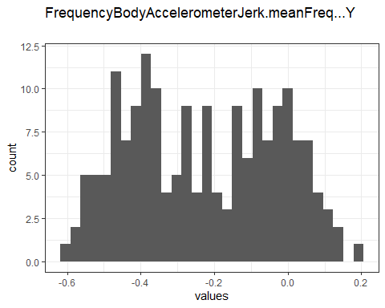

Distribution of values for FrequencyBodyAccelerometerJerk.meanFreq…Y

0 missing values.

#### Summary statistics

|  |  |  |  |  |  |  |  |  |  |  |
| --- | --- | --- | --- | --- | --- | --- | --- | --- | --- | --- |
| name | data_type | n_missing | complete_rate | min | median | max | mean | sd | hist | label |
| FrequencyBodyAccelerometerJerk.meanFreq…Y | numeric | 0 | 1 | -0.6 | -0.23 | 0.2 | -0.2281021 | 0.1998647 | <U+2585><U+2587><U+2586><U+2587><U+2583> | NA |

### FrequencyBodyAccelerometerJerk.meanFreq…Z

#### Distribution

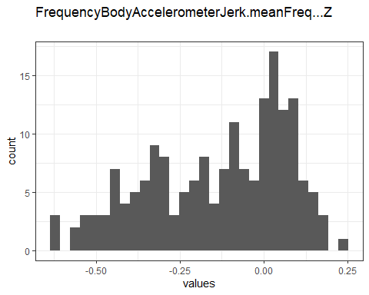

Distribution of values for FrequencyBodyAccelerometerJerk.meanFreq…Z

0 missing values.

#### Summary statistics

|  |  |  |  |  |  |  |  |  |  |  |
| --- | --- | --- | --- | --- | --- | --- | --- | --- | --- | --- |
| name | data_type | n_missing | complete_rate | min | median | max | mean | sd | hist | label |
| FrequencyBodyAccelerometerJerk.meanFreq…Z | numeric | 0 | 1 | -0.63 | -0.092 | 0.23 | -0.1376023 | 0.2078722 | <U+2582><U+2585><U+2583><U+2587><U+2585> | NA |

### FrequencyBodyGyroscope.mean…X

#### Distribution

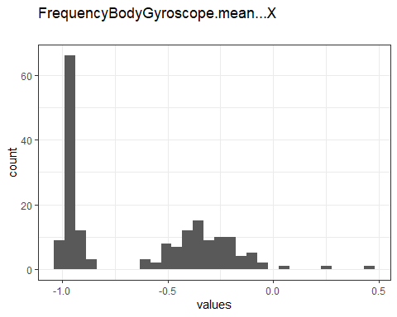

Distribution of values for FrequencyBodyGyroscope.mean…X

0 missing values.

#### Summary statistics

|  |  |  |  |  |  |  |  |  |  |  |
| --- | --- | --- | --- | --- | --- | --- | --- | --- | --- | --- |
| name | data_type | n_missing | complete_rate | min | median | max | mean | sd | hist | label |
| FrequencyBodyGyroscope.mean…X | numeric | 0 | 1 | -0.99 | -0.73 | 0.47 | -0.6367396 | 0.3467628 | <U+2587><U+2582><U+2585><U+2581><U+2581> | NA |

### FrequencyBodyGyroscope.mean…Y

#### Distribution

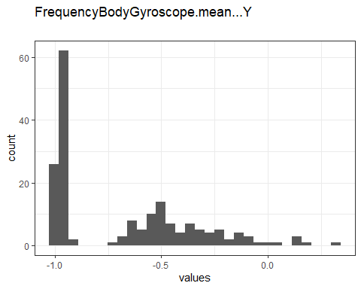

Distribution of values for FrequencyBodyGyroscope.mean…Y

0 missing values.

#### Summary statistics

|  |  |  |  |  |  |  |  |  |  |  |
| --- | --- | --- | --- | --- | --- | --- | --- | --- | --- | --- |
| name | data_type | n_missing | complete_rate | min | median | max | mean | sd | hist | label |
| FrequencyBodyGyroscope.mean…Y | numeric | 0 | 1 | -0.99 | -0.81 | 0.33 | -0.6766868 | 0.3319182 | <U+2587><U+2583><U+2583><U+2581><U+2581> | NA |

### FrequencyBodyGyroscope.mean…Z

#### Distribution

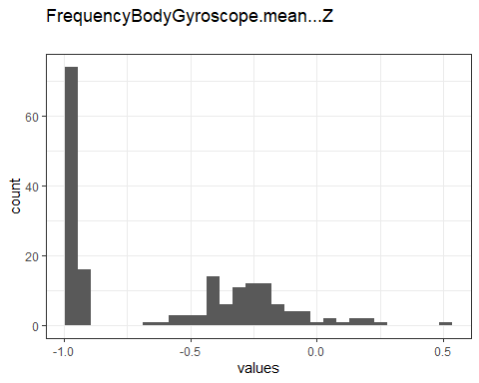

Distribution of values for FrequencyBodyGyroscope.mean…Z

0 missing values.

#### Summary statistics

|  |  |  |  |  |  |  |  |  |  |  |
| --- | --- | --- | --- | --- | --- | --- | --- | --- | --- | --- |
| name | data_type | n_missing | complete_rate | min | median | max | mean | sd | hist | label |
| FrequencyBodyGyroscope.mean…Z | numeric | 0 | 1 | -0.99 | -0.79 | 0.49 | -0.6043912 | 0.3842603 | <U+2587><U+2582><U+2585><U+2581><U+2581> | NA |

### FrequencyBodyGyroscope.meanFreq…X

#### Distribution

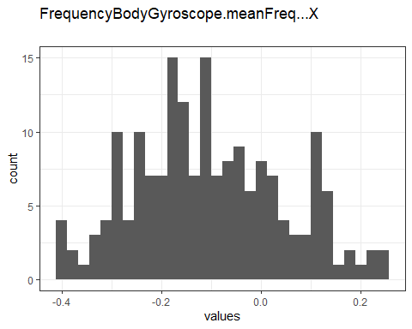

Distribution of values for FrequencyBodyGyroscope.meanFreq…X

0 missing values.

#### Summary statistics

|  |  |  |  |  |  |  |  |  |  |  |
| --- | --- | --- | --- | --- | --- | --- | --- | --- | --- | --- |
| name | data_type | n_missing | complete_rate | min | median | max | mean | sd | hist | label |
| FrequencyBodyGyroscope.meanFreq…X | numeric | 0 | 1 | -0.4 | -0.12 | 0.25 | -0.104551 | 0.1480975 | <U+2583><U+2587><U+2587><U+2585><U+2582> | NA |

### FrequencyBodyGyroscope.meanFreq…Y

#### Distribution

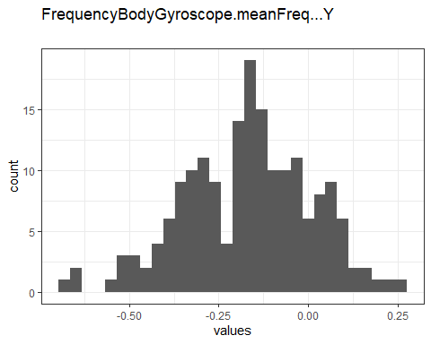

Distribution of values for FrequencyBodyGyroscope.meanFreq…Y

0 missing values.

#### Summary statistics

|  |  |  |  |  |  |  |  |  |  |  |
| --- | --- | --- | --- | --- | --- | --- | --- | --- | --- | --- |
| name | data_type | n_missing | complete_rate | min | median | max | mean | sd | hist | label |
| FrequencyBodyGyroscope.meanFreq…Y | numeric | 0 | 1 | -0.67 | -0.16 | 0.27 | -0.1674075 | 0.1788011 | <U+2581><U+2585><U+2587><U+2586><U+2582> | NA |

### FrequencyBodyGyroscope.meanFreq…Z

#### Distribution

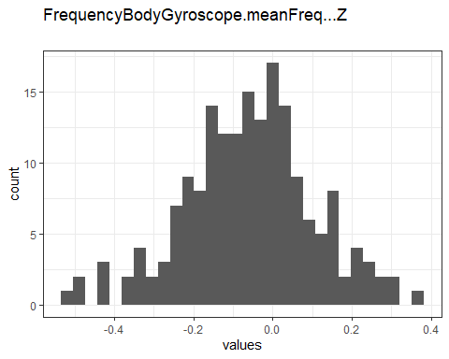

Distribution of values for FrequencyBodyGyroscope.meanFreq…Z

0 missing values.

#### Summary statistics

|  |  |  |  |  |  |  |  |  |  |  |
| --- | --- | --- | --- | --- | --- | --- | --- | --- | --- | --- |
| name | data_type | n_missing | complete_rate | min | median | max | mean | sd | hist | label |
| FrequencyBodyGyroscope.meanFreq…Z | numeric | 0 | 1 | -0.51 | -0.051 | 0.38 | -0.0571809 | 0.1652298 | <U+2581><U+2583><U+2587><U+2583><U+2581> | NA |

### FrequencyBodyAccelerometerMagnitude.mean..

#### Distribution

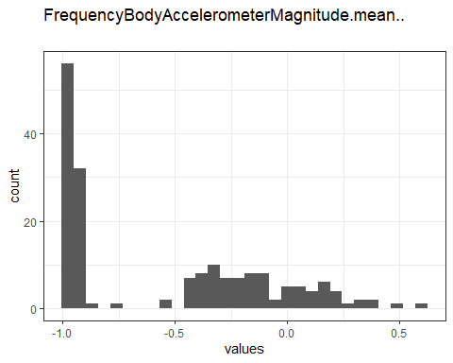

Distribution of values for FrequencyBodyAccelerometerMagnitude.mean..

0 missing values.

#### Summary statistics

|  |  |  |  |  |  |  |  |  |  |  |
| --- | --- | --- | --- | --- | --- | --- | --- | --- | --- | --- |
| name | data_type | n_missing | complete_rate | min | median | max | mean | sd | hist | label |
| FrequencyBodyAccelerometerMagnitude.mean.. | numeric | 0 | 1 | -0.99 | -0.67 | 0.59 | -0.5365167 | 0.4516451 | <U+2587><U+2582><U+2583><U+2582><U+2581> | NA |

### FrequencyBodyAccelerometerMagnitude.meanFreq..

#### Distribution

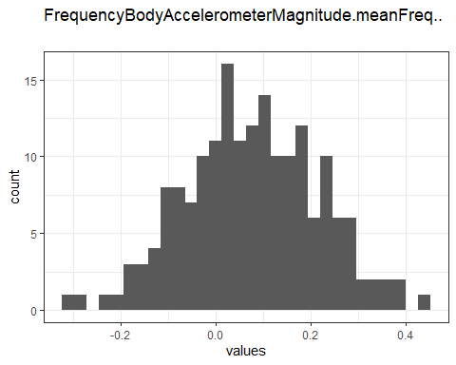

Distribution of values for FrequencyBodyAccelerometerMagnitude.meanFreq..

0 missing values.

#### Summary statistics

|  |  |  |  |  |  |  |  |  |  |  |
| --- | --- | --- | --- | --- | --- | --- | --- | --- | --- | --- |
| name | data_type | n_missing | complete_rate | min | median | max | mean | sd | hist | label |
| FrequencyBodyAccelerometerMagnitude.meanFreq.. | numeric | 0 | 1 | -0.31 | 0.081 | 0.44 | 0.0761282 | 0.1404479 | <U+2581><U+2585><U+2587><U+2585><U+2581> | NA |

### FrequencyBodyAccelerometerJerkMagnitude.mean..

#### Distribution

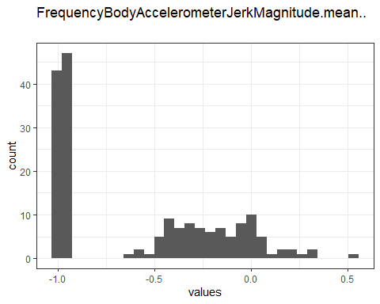

Distribution of values for FrequencyBodyAccelerometerJerkMagnitude.mean..

0 missing values.

#### Summary statistics

|  |  |  |  |  |  |  |  |  |  |  |
| --- | --- | --- | --- | --- | --- | --- | --- | --- | --- | --- |
| name | data_type | n_missing | complete_rate | min | median | max | mean | sd | hist | label |
| FrequencyBodyAccelerometerJerkMagnitude.mean.. | numeric | 0 | 1 | -0.99 | -0.79 | 0.54 | -0.5756175 | 0.4312321 | <U+2587><U+2582><U+2583><U+2582><U+2581> | NA |

### FrequencyBodyAccelerometerJerkMagnitude.meanFreq..

#### Distribution

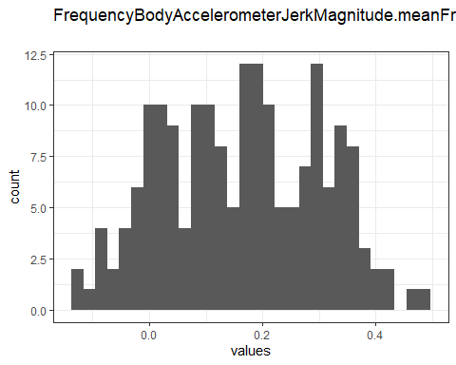

Distribution of values for FrequencyBodyAccelerometerJerkMagnitude.meanFreq..

0 missing values.

#### Summary statistics

|  |  |  |  |  |  |  |  |  |  |  |
| --- | --- | --- | --- | --- | --- | --- | --- | --- | --- | --- |
| name | data_type | n_missing | complete_rate | min | median | max | mean | sd | hist | label |
| FrequencyBodyAccelerometerJerkMagnitude.meanFreq.. | numeric | 0 | 1 | -0.13 | 0.17 | 0.49 | 0.1625459 | 0.13783 | <U+2583><U+2587><U+2587><U+2587><U+2582> | NA |

### FrequencyBodyGyroscopeMagnitude.mean..

#### Distribution

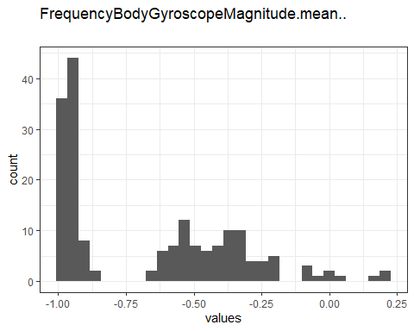

Distribution of values for FrequencyBodyGyroscopeMagnitude.mean..

0 missing values.

#### Summary statistics

|  |  |  |  |  |  |  |  |  |  |  |
| --- | --- | --- | --- | --- | --- | --- | --- | --- | --- | --- |
| name | data_type | n_missing | complete_rate | min | median | max | mean | sd | hist | label |
| FrequencyBodyGyroscopeMagnitude.mean.. | numeric | 0 | 1 | -0.99 | -0.77 | 0.2 | -0.6670991 | 0.3181183 | <U+2587><U+2582><U+2583><U+2581><U+2581> | NA |

### FrequencyBodyGyroscopeMagnitude.meanFreq..

#### Distribution

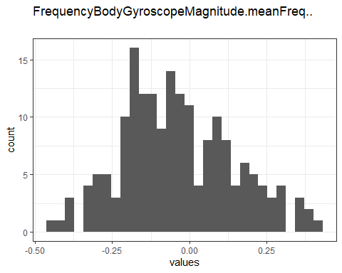

Distribution of values for FrequencyBodyGyroscopeMagnitude.meanFreq..

0 missing values.

#### Summary statistics

|  |  |  |  |  |  |  |  |  |  |  |
| --- | --- | --- | --- | --- | --- | --- | --- | --- | --- | --- |
| name | data_type | n_missing | complete_rate | min | median | max | mean | sd | hist | label |
| FrequencyBodyGyroscopeMagnitude.meanFreq.. | numeric | 0 | 1 | -0.46 | -0.054 | 0.41 | -0.0360322 | 0.1807351 | <U+2582><U+2587><U+2587><U+2585><U+2582> | NA |

### FrequencyBodyGyroscopeJerkMagnitude.mean..

#### Distribution

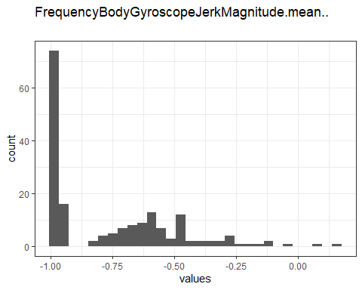

Distribution of values for FrequencyBodyGyroscopeJerkMagnitude.mean..

0 missing values.

#### Summary statistics

|  |  |  |  |  |  |  |  |  |  |  |
| --- | --- | --- | --- | --- | --- | --- | --- | --- | --- | --- |
| name | data_type | n_missing | complete_rate | min | median | max | mean | sd | hist | label |
| FrequencyBodyGyroscopeJerkMagnitude.mean.. | numeric | 0 | 1 | -1 | -0.88 | 0.15 | -0.7563853 | 0.2628722 | <U+2587><U+2585><U+2582><U+2581><U+2581> | NA |

### FrequencyBodyGyroscopeJerkMagnitude.meanFreq..

#### Distribution

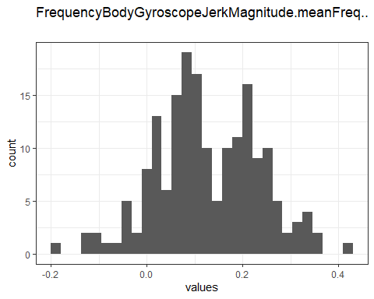

Distribution of values for FrequencyBodyGyroscopeJerkMagnitude.meanFreq..

0 missing values.

#### Summary statistics

|  |  |  |  |  |  |  |  |  |  |  |
| --- | --- | --- | --- | --- | --- | --- | --- | --- | --- | --- |
| name | data_type | n_missing | complete_rate | min | median | max | mean | sd | hist | label |
| FrequencyBodyGyroscopeJerkMagnitude.meanFreq.. | numeric | 0 | 1 | -0.18 | 0.11 | 0.43 | 0.1259225 | 0.1083232 | <U+2581><U+2585><U+2587><U+2586><U+2581> | NA |

### Angle.TimeBodyAccelerometerMean.Gravity.

#### Distribution

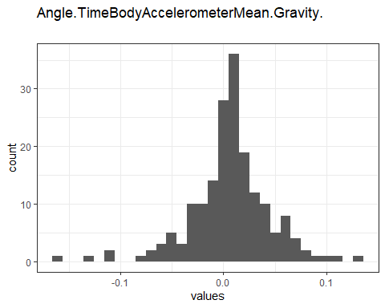

Distribution of values for Angle.TimeBodyAccelerometerMean.Gravity.

0 missing values.

#### Summary statistics

|  |  |  |  |  |  |  |  |  |  |  |
| --- | --- | --- | --- | --- | --- | --- | --- | --- | --- | --- |
| name | data_type | n_missing | complete_rate | min | median | max | mean | sd | hist | label |
| Angle.TimeBodyAccelerometerMean.Gravity. | numeric | 0 | 1 | -0.16 | 0.0079 | 0.13 | 0.0065557 | 0.0396044 | <U+2581><U+2581><U+2587><U+2587><U+2581> | NA |

### Angle.TimeBodyAccelerometerJerkMean..GravityMean.

#### Distribution

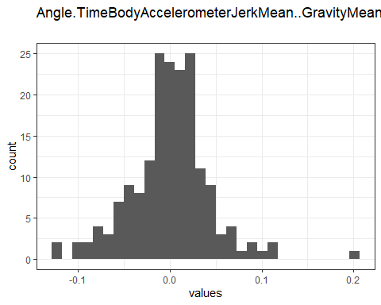

Distribution of values for Angle.TimeBodyAccelerometerJerkMean..GravityMean.

0 missing values.

#### Summary statistics

|  |  |  |  |  |  |  |  |  |  |  |
| --- | --- | --- | --- | --- | --- | --- | --- | --- | --- | --- |
| name | data_type | n_missing | complete_rate | min | median | max | mean | sd | hist | label |
| Angle.TimeBodyAccelerometerJerkMean..GravityMean. | numeric | 0 | 1 | -0.12 | 0.0031 | 0.2 | 0.0006439 | 0.0427632 | <U+2582><U+2587><U+2586><U+2581><U+2581> | NA |

### Angle.TimeBodyGyroscopeMean.GravityMean.

#### Distribution

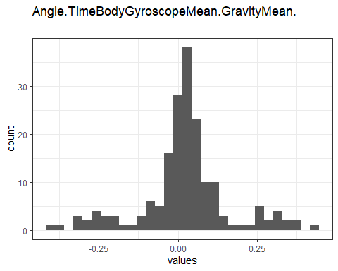

Distribution of values for Angle.TimeBodyGyroscopeMean.GravityMean.

0 missing values.

#### Summary statistics

|  |  |  |  |  |  |  |  |  |  |  |
| --- | --- | --- | --- | --- | --- | --- | --- | --- | --- | --- |
| name | data_type | n_missing | complete_rate | min | median | max | mean | sd | hist | label |
| Angle.TimeBodyGyroscopeMean.GravityMean. | numeric | 0 | 1 | -0.39 | 0.021 | 0.44 | 0.0219317 | 0.1401276 | <U+2581><U+2581><U+2587><U+2581><U+2581> | NA |

### Angle.TimeBodyGyroscopeJerkMean.GravityMean.

#### Distribution

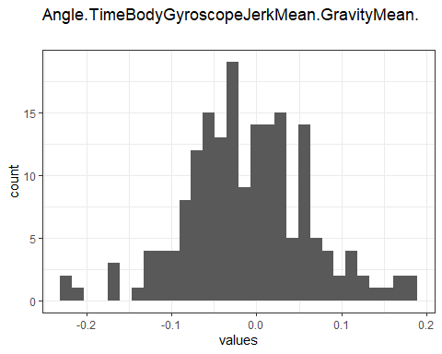

Distribution of values for Angle.TimeBodyGyroscopeJerkMean.GravityMean.

0 missing values.

#### Summary statistics

|  |  |  |  |  |  |  |  |  |  |  |
| --- | --- | --- | --- | --- | --- | --- | --- | --- | --- | --- |
| name | data_type | n_missing | complete_rate | min | median | max | mean | sd | hist | label |
| Angle.TimeBodyGyroscopeJerkMean.GravityMean. | numeric | 0 | 1 | -0.22 | -0.016 | 0.18 | -0.0113732 | 0.0729629 | <U+2581><U+2583><U+2587><U+2585><U+2581> | NA |

### Angle.X.GravityMean.

#### Distribution

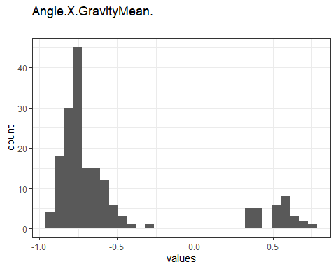

Distribution of values for Angle.X.GravityMean.

0 missing values.

#### Summary statistics

|  |  |  |  |  |  |  |  |  |  |  |
| --- | --- | --- | --- | --- | --- | --- | --- | --- | --- | --- |
| name | data_type | n_missing | complete_rate | min | median | max | mean | sd | hist | label |
| Angle.X.GravityMean. | numeric | 0 | 1 | -0.95 | -0.74 | 0.74 | -0.5243065 | 0.481228 | <U+2587><U+2582><U+2581><U+2581><U+2582> | NA |

### Angle.Y.GravityMean.

#### Distribution

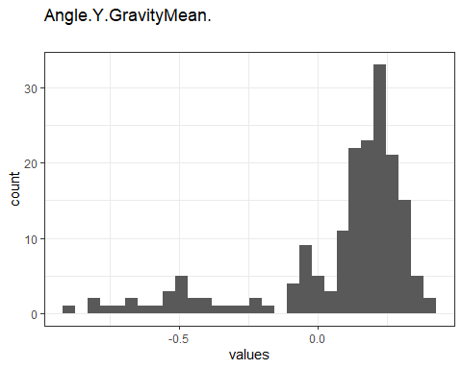

Distribution of values for Angle.Y.GravityMean.

0 missing values.

#### Summary statistics

|  |  |  |  |  |  |  |  |  |  |  |
| --- | --- | --- | --- | --- | --- | --- | --- | --- | --- | --- |
| name | data_type | n_missing | complete_rate | min | median | max | mean | sd | hist | label |
| Angle.Y.GravityMean. | numeric | 0 | 1 | -0.87 | 0.17 | 0.42 | 0.0786534 | 0.2784784 | <U+2581><U+2581><U+2581><U+2585><U+2587> | NA |

### Angle.Z.GravityMean.

#### Distribution

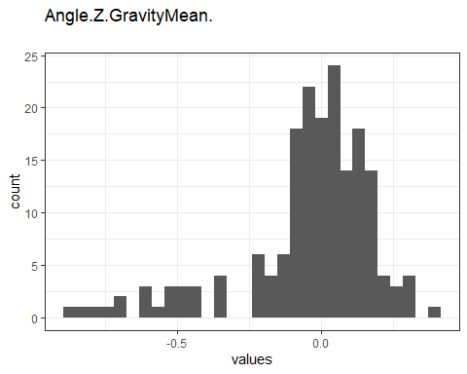

Distribution of values for Angle.Z.GravityMean.

0 missing values.

#### Summary statistics

|  |  |  |  |  |  |  |  |  |  |  |
| --- | --- | --- | --- | --- | --- | --- | --- | --- | --- | --- |
| name | data_type | n_missing | complete_rate | min | median | max | mean | sd | hist | label |
| Angle.Z.GravityMean. | numeric | 0 | 1 | -0.87 | 0.0051 | 0.39 | -0.0404362 | 0.2308332 | <U+2581><U+2581><U+2581><U+2587><U+2582> | NA |

### TimeBodyAccelerometer.std…X

#### Distribution

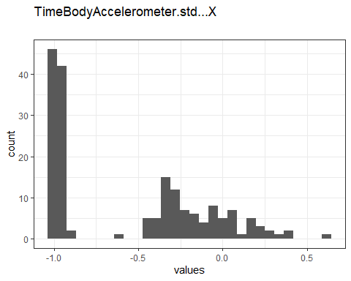

Distribution of values for TimeBodyAccelerometer.std…X

0 missing values.

#### Summary statistics

|  |  |  |  |  |  |  |  |  |  |  |
| --- | --- | --- | --- | --- | --- | --- | --- | --- | --- | --- |
| name | data_type | n_missing | complete_rate | min | median | max | mean | sd | hist | label |
| TimeBodyAccelerometer.std…X | numeric | 0 | 1 | -1 | -0.75 | 0.63 | -0.5576901 | 0.4516911 | <U+2587><U+2582><U+2585><U+2582><U+2581> | NA |

### TimeBodyAccelerometer.std…Y

#### Distribution

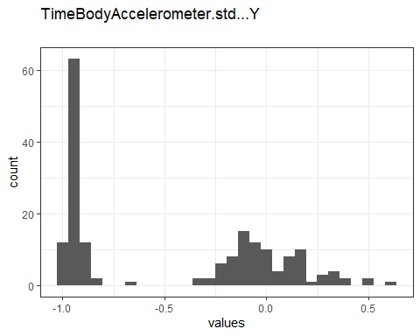

Distribution of values for TimeBodyAccelerometer.std…Y

0 missing values.

#### Summary statistics

|  |  |  |  |  |  |  |  |  |  |  |
| --- | --- | --- | --- | --- | --- | --- | --- | --- | --- | --- |
| name | data_type | n_missing | complete_rate | min | median | max | mean | sd | hist | label |
| TimeBodyAccelerometer.std…Y | numeric | 0 | 1 | -0.99 | -0.51 | 0.62 | -0.4604626 | 0.496565 | <U+2587><U+2581><U+2585><U+2583><U+2581> | NA |

### TimeBodyAccelerometer.std…Z

#### Distribution

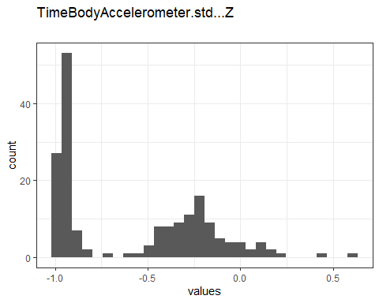

Distribution of values for TimeBodyAccelerometer.std…Z

0 missing values.

#### Summary statistics

|  |  |  |  |  |  |  |  |  |  |  |
| --- | --- | --- | --- | --- | --- | --- | --- | --- | --- | --- |
| name | data_type | n_missing | complete_rate | min | median | max | mean | sd | hist | label |
| TimeBodyAccelerometer.std…Z | numeric | 0 | 1 | -0.99 | -0.65 | 0.61 | -0.5755602 | 0.3955439 | <U+2587><U+2582><U+2585><U+2581><U+2581> | NA |

### TimeGravityAccelerometer.std…X

#### Distribution

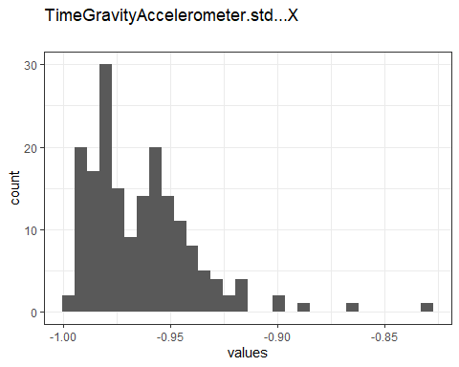

Distribution of values for TimeGravityAccelerometer.std…X

0 missing values.

#### Summary statistics

|  |  |  |  |  |  |  |  |  |  |  |
| --- | --- | --- | --- | --- | --- | --- | --- | --- | --- | --- |
| name | data_type | n_missing | complete_rate | min | median | max | mean | sd | hist | label |
| TimeGravityAccelerometer.std…X | numeric | 0 | 1 | -1 | -0.97 | -0.83 | -0.9637525 | 0.0250344 | <U+2587><U+2586><U+2581><U+2581><U+2581> | NA |

### TimeGravityAccelerometer.std…Y

#### Distribution

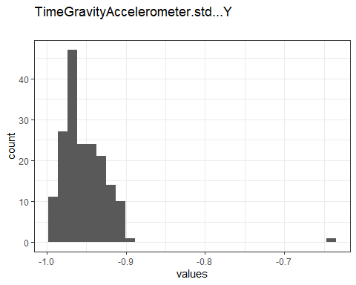

Distribution of values for TimeGravityAccelerometer.std…Y

0 missing values.

#### Summary statistics

|  |  |  |  |  |  |  |  |  |  |  |
| --- | --- | --- | --- | --- | --- | --- | --- | --- | --- | --- |
| name | data_type | n_missing | complete_rate | min | median | max | mean | sd | hist | label |
| TimeGravityAccelerometer.std…Y | numeric | 0 | 1 | -0.99 | -0.96 | -0.64 | -0.9524296 | 0.0326557 | <U+2587><U+2581><U+2581><U+2581><U+2581> | NA |

### TimeGravityAccelerometer.std…Z

#### Distribution

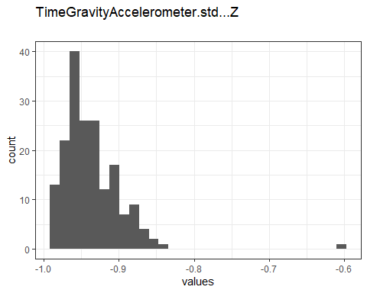

Distribution of values for TimeGravityAccelerometer.std…Z

0 missing values.

#### Summary statistics

|  |  |  |  |  |  |  |  |  |  |  |
| --- | --- | --- | --- | --- | --- | --- | --- | --- | --- | --- |
| name | data_type | n_missing | complete_rate | min | median | max | mean | sd | hist | label |
| TimeGravityAccelerometer.std…Z | numeric | 0 | 1 | -0.99 | -0.95 | -0.61 | -0.936401 | 0.0402912 | <U+2587><U+2582><U+2581><U+2581><U+2581> | NA |

### TimeBodyAccelerometerJerk.std…X

#### Distribution

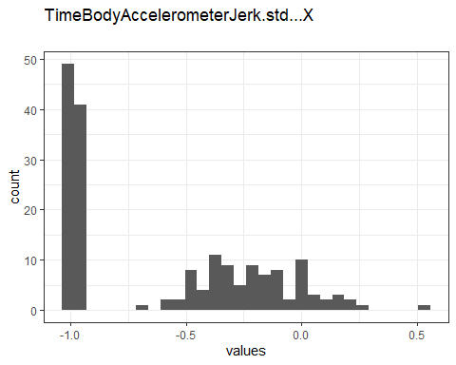

Distribution of values for TimeBodyAccelerometerJerk.std…X

0 missing values.

#### Summary statistics

|  |  |  |  |  |  |  |  |  |  |  |
| --- | --- | --- | --- | --- | --- | --- | --- | --- | --- | --- |
| name | data_type | n_missing | complete_rate | min | median | max | mean | sd | hist | label |
| TimeBodyAccelerometerJerk.std…X | numeric | 0 | 1 | -0.99 | -0.81 | 0.54 | -0.5949467 | 0.4175865 | <U+2587><U+2582><U+2585><U+2582><U+2581> | NA |

### TimeBodyAccelerometerJerk.std…Y

#### Distribution

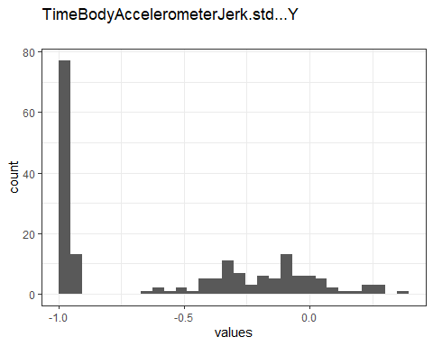

Distribution of values for TimeBodyAccelerometerJerk.std…Y

0 missing values.

#### Summary statistics

|  |  |  |  |  |  |  |  |  |  |  |
| --- | --- | --- | --- | --- | --- | --- | --- | --- | --- | --- |
| name | data_type | n_missing | complete_rate | min | median | max | mean | sd | hist | label |
| TimeBodyAccelerometerJerk.std…Y | numeric | 0 | 1 | -0.99 | -0.78 | 0.36 | -0.5654147 | 0.4330871 | <U+2587><U+2581><U+2583><U+2583><U+2581> | NA |

### TimeBodyAccelerometerJerk.std…Z

#### Distribution

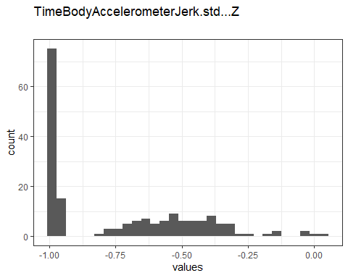

Distribution of values for TimeBodyAccelerometerJerk.std…Z

0 missing values.

#### Summary statistics

|  |  |  |  |  |  |  |  |  |  |  |
| --- | --- | --- | --- | --- | --- | --- | --- | --- | --- | --- |
| name | data_type | n_missing | complete_rate | min | median | max | mean | sd | hist | label |
| TimeBodyAccelerometerJerk.std…Z | numeric | 0 | 1 | -0.99 | -0.88 | 0.031 | -0.7359577 | 0.2768479 | <U+2587><U+2582><U+2583><U+2581><U+2581> | NA |

### TimeBodyGyroscope.std…X

#### Distribution

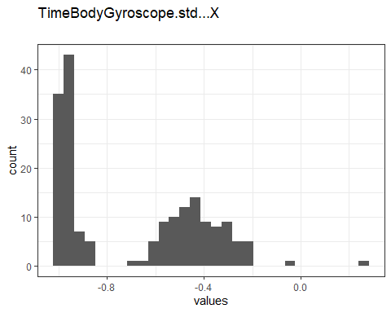

Distribution of values for TimeBodyGyroscope.std…X

0 missing values.

#### Summary statistics

|  |  |  |  |  |  |  |  |  |  |  |
| --- | --- | --- | --- | --- | --- | --- | --- | --- | --- | --- |
| name | data_type | n_missing | complete_rate | min | median | max | mean | sd | hist | label |
| TimeBodyGyroscope.std…X | numeric | 0 | 1 | -0.99 | -0.79 | 0.27 | -0.6916399 | 0.2910189 | <U+2587><U+2583><U+2585><U+2581><U+2581> | NA |

### TimeBodyGyroscope.std…Y

#### Distribution

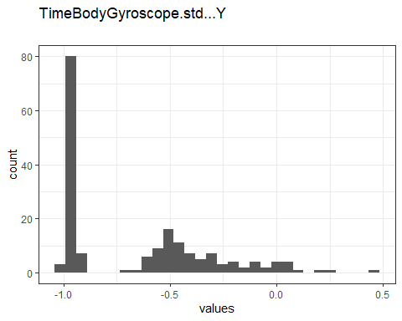

Distribution of values for TimeBodyGyroscope.std…Y

0 missing values.

#### Summary statistics

|  |  |  |  |  |  |  |  |  |  |  |
| --- | --- | --- | --- | --- | --- | --- | --- | --- | --- | --- |
| name | data_type | n_missing | complete_rate | min | median | max | mean | sd | hist | label |
| TimeBodyGyroscope.std…Y | numeric | 0 | 1 | -0.99 | -0.8 | 0.48 | -0.653302 | 0.3520252 | <U+2587><U+2585><U+2582><U+2581><U+2581> | NA |

### TimeBodyGyroscope.std…Z

#### Distribution

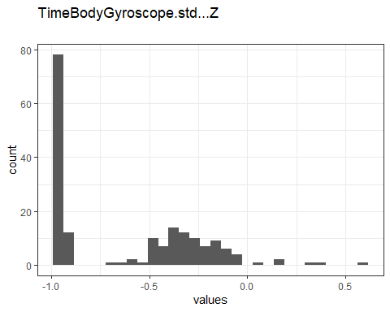

Distribution of values for TimeBodyGyroscope.std…Z

0 missing values.

#### Summary statistics

|  |  |  |  |  |  |  |  |  |  |  |
| --- | --- | --- | --- | --- | --- | --- | --- | --- | --- | --- |
| name | data_type | n_missing | complete_rate | min | median | max | mean | sd | hist | label |
| TimeBodyGyroscope.std…Z | numeric | 0 | 1 | -0.99 | -0.8 | 0.56 | -0.6164353 | 0.3730264 | <U+2587><U+2582><U+2585><U+2581><U+2581> | NA |

### TimeBodyGyroscopeJerk.std…X

#### Distribution

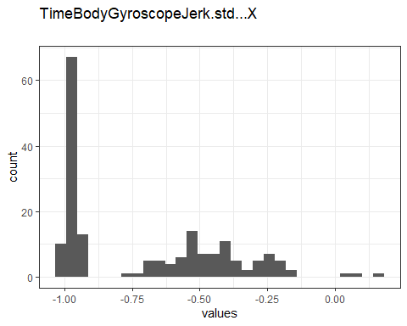

Distribution of values for TimeBodyGyroscopeJerk.std…X

0 missing values.

#### Summary statistics

|  |  |  |  |  |  |  |  |  |  |  |
| --- | --- | --- | --- | --- | --- | --- | --- | --- | --- | --- |
| name | data_type | n_missing | complete_rate | min | median | max | mean | sd | hist | label |
| TimeBodyGyroscopeJerk.std…X | numeric | 0 | 1 | -1 | -0.84 | 0.18 | -0.7036327 | 0.3008361 | <U+2587><U+2582><U+2583><U+2582><U+2581> | NA |

### TimeBodyGyroscopeJerk.std…Y

#### Distribution

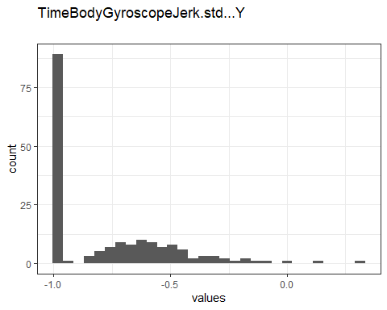

Distribution of values for TimeBodyGyroscopeJerk.std…Y

0 missing values.

#### Summary statistics

|  |  |  |  |  |  |  |  |  |  |  |
| --- | --- | --- | --- | --- | --- | --- | --- | --- | --- | --- |
| name | data_type | n_missing | complete_rate | min | median | max | mean | sd | hist | label |
| TimeBodyGyroscopeJerk.std…Y | numeric | 0 | 1 | -1 | -0.89 | 0.3 | -0.7635518 | 0.2672885 | <U+2587><U+2583><U+2582><U+2581><U+2581> | NA |

### TimeBodyGyroscopeJerk.std…Z

#### Distribution

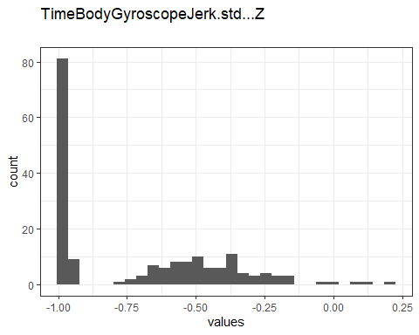

Distribution of values for TimeBodyGyroscopeJerk.std…Z

0 missing values.

#### Summary statistics

|  |  |  |  |  |  |  |  |  |  |  |
| --- | --- | --- | --- | --- | --- | --- | --- | --- | --- | --- |
| name | data_type | n_missing | complete_rate | min | median | max | mean | sd | hist | label |
| TimeBodyGyroscopeJerk.std…Z | numeric | 0 | 1 | -1 | -0.86 | 0.19 | -0.7095592 | 0.3045394 | <U+2587><U+2583><U+2583><U+2581><U+2581> | NA |

### TimeBodyAccelerometerMagnitude.std..

#### Distribution

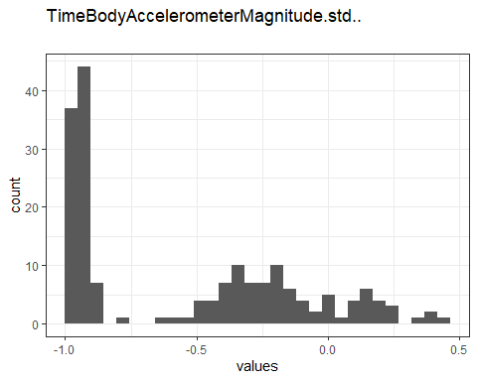

Distribution of values for TimeBodyAccelerometerMagnitude.std..

0 missing values.

#### Summary statistics

|  |  |  |  |  |  |  |  |  |  |  |
| --- | --- | --- | --- | --- | --- | --- | --- | --- | --- | --- |
| name | data_type | n_missing | complete_rate | min | median | max | mean | sd | hist | label |
| TimeBodyAccelerometerMagnitude.std.. | numeric | 0 | 1 | -0.99 | -0.61 | 0.43 | -0.5439087 | 0.4310448 | <U+2587><U+2581><U+2585><U+2582><U+2581> | NA |

### TimeGravityAccelerometerMagnitude.std..

#### Distribution

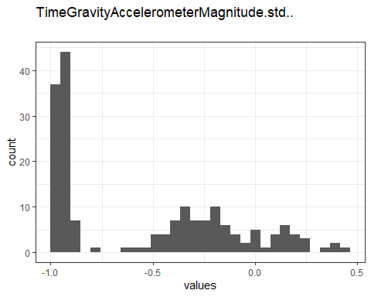

Distribution of values for TimeGravityAccelerometerMagnitude.std..

0 missing values.

#### Summary statistics

|  |  |  |  |  |  |  |  |  |  |  |
| --- | --- | --- | --- | --- | --- | --- | --- | --- | --- | --- |
| name | data_type | n_missing | complete_rate | min | median | max | mean | sd | hist | label |
| TimeGravityAccelerometerMagnitude.std.. | numeric | 0 | 1 | -0.99 | -0.61 | 0.43 | -0.5439087 | 0.4310448 | <U+2587><U+2581><U+2585><U+2582><U+2581> | NA |

### TimeBodyAccelerometerJerkMagnitude.std..

#### Distribution

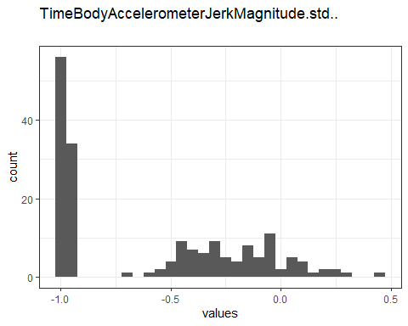

Distribution of values for TimeBodyAccelerometerJerkMagnitude.std..

0 missing values.

#### Summary statistics

|  |  |  |  |  |  |  |  |  |  |  |
| --- | --- | --- | --- | --- | --- | --- | --- | --- | --- | --- |
| name | data_type | n_missing | complete_rate | min | median | max | mean | sd | hist | label |
| TimeBodyAccelerometerJerkMagnitude.std.. | numeric | 0 | 1 | -0.99 | -0.8 | 0.45 | -0.5841756 | 0.4227953 | <U+2587><U+2582><U+2583><U+2582><U+2581> | NA |

### TimeBodyGyroscopeMagnitude.std..

#### Distribution

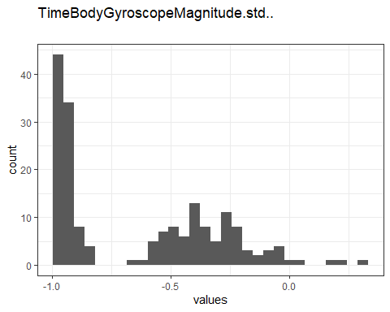

Distribution of values for TimeBodyGyroscopeMagnitude.std..

0 missing values.

#### Summary statistics

|  |  |  |  |  |  |  |  |  |  |  |
| --- | --- | --- | --- | --- | --- | --- | --- | --- | --- | --- |
| name | data_type | n_missing | complete_rate | min | median | max | mean | sd | hist | label |
| TimeBodyGyroscopeMagnitude.std.. | numeric | 0 | 1 | -0.98 | -0.74 | 0.3 | -0.6303947 | 0.3368827 | <U+2587><U+2582><U+2585><U+2582><U+2581> | NA |

### TimeBodyGyroscopeJerkMagnitude.std..

#### Distribution

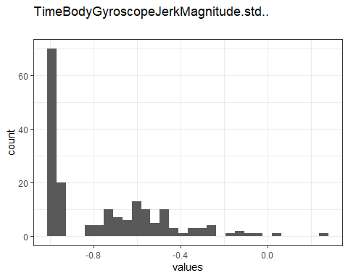

Distribution of values for TimeBodyGyroscopeJerkMagnitude.std..

0 missing values.

#### Summary statistics

|  |  |  |  |  |  |  |  |  |  |  |
| --- | --- | --- | --- | --- | --- | --- | --- | --- | --- | --- |
| name | data_type | n_missing | complete_rate | min | median | max | mean | sd | hist | label |
| TimeBodyGyroscopeJerkMagnitude.std.. | numeric | 0 | 1 | -1 | -0.88 | 0.25 | -0.7550152 | 0.2655057 | <U+2587><U+2583><U+2582><U+2581><U+2581> | NA |

### FrequencyBodyAccelerometer.std…X

#### Distribution

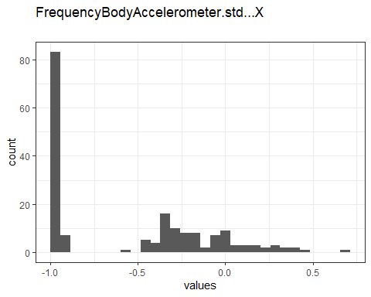

Distribution of values for FrequencyBodyAccelerometer.std…X

0 missing values.

#### Summary statistics

|  |  |  |  |  |  |  |  |  |  |  |
| --- | --- | --- | --- | --- | --- | --- | --- | --- | --- | --- |
| name | data_type | n_missing | complete_rate | min | median | max | mean | sd | hist | label |
| FrequencyBodyAccelerometer.std…X | numeric | 0 | 1 | -1 | -0.75 | 0.66 | -0.5522011 | 0.4600233 | <U+2587><U+2582><U+2585><U+2582><U+2581> | NA |

### FrequencyBodyAccelerometer.std…Y

#### Distribution

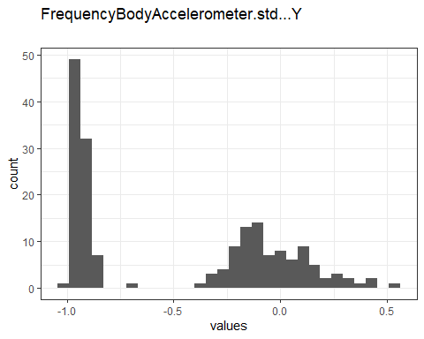

Distribution of values for FrequencyBodyAccelerometer.std…Y

0 missing values.

#### Summary statistics

|  |  |  |  |  |  |  |  |  |  |  |
| --- | --- | --- | --- | --- | --- | --- | --- | --- | --- | --- |
| name | data_type | n_missing | complete_rate | min | median | max | mean | sd | hist | label |
| FrequencyBodyAccelerometer.std…Y | numeric | 0 | 1 | -0.99 | -0.51 | 0.56 | -0.4814787 | 0.4740277 | <U+2587><U+2581><U+2585><U+2583><U+2581> | NA |

### FrequencyBodyAccelerometer.std…Z

#### Distribution

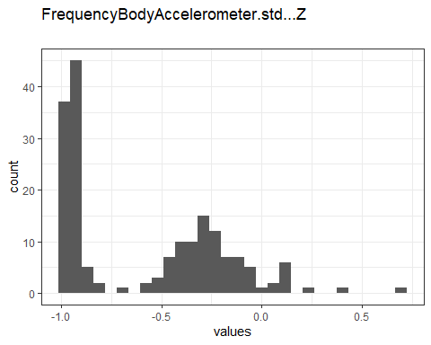

Distribution of values for FrequencyBodyAccelerometer.std…Z

0 missing values.

#### Summary statistics

|  |  |  |  |  |  |  |  |  |  |  |
| --- | --- | --- | --- | --- | --- | --- | --- | --- | --- | --- |
| name | data_type | n_missing | complete_rate | min | median | max | mean | sd | hist | label |
| FrequencyBodyAccelerometer.std…Z | numeric | 0 | 1 | -0.99 | -0.64 | 0.69 | -0.5823614 | 0.3880902 | <U+2587><U+2583><U+2585><U+2581><U+2581> | NA |

### FrequencyBodyAccelerometerJerk.std…X

#### Distribution

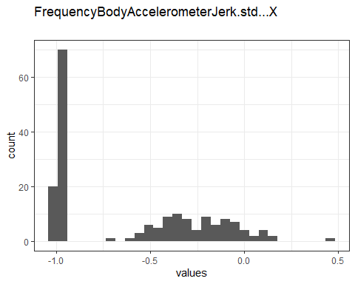

Distribution of values for FrequencyBodyAccelerometerJerk.std…X

0 missing values.

#### Summary statistics

|  |  |  |  |  |  |  |  |  |  |  |
| --- | --- | --- | --- | --- | --- | --- | --- | --- | --- | --- |
| name | data_type | n_missing | complete_rate | min | median | max | mean | sd | hist | label |
| FrequencyBodyAccelerometerJerk.std…X | numeric | 0 | 1 | -1 | -0.83 | 0.48 | -0.6121033 | 0.4004506 | <U+2587><U+2582><U+2583><U+2582><U+2581> | NA |

### FrequencyBodyAccelerometerJerk.std…Y

#### Distribution

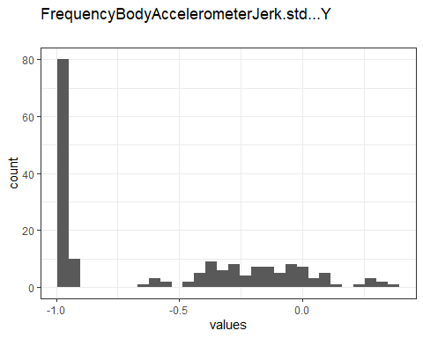

Distribution of values for FrequencyBodyAccelerometerJerk.std…Y

0 missing values.

#### Summary statistics

|  |  |  |  |  |  |  |  |  |  |  |
| --- | --- | --- | --- | --- | --- | --- | --- | --- | --- | --- |
| name | data_type | n_missing | complete_rate | min | median | max | mean | sd | hist | label |
| FrequencyBodyAccelerometerJerk.std…Y | numeric | 0 | 1 | -0.99 | -0.79 | 0.35 | -0.570731 | 0.4319873 | <U+2587><U+2581><U+2583><U+2583><U+2581> | NA |

### FrequencyBodyAccelerometerJerk.std…Z

#### Distribution

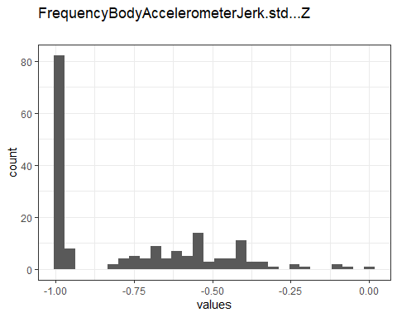

Distribution of values for FrequencyBodyAccelerometerJerk.std…Z

0 missing values.

#### Summary statistics

|  |  |  |  |  |  |  |  |  |  |  |
| --- | --- | --- | --- | --- | --- | --- | --- | --- | --- | --- |
| name | data_type | n_missing | complete_rate | min | median | max | mean | sd | hist | label |
| FrequencyBodyAccelerometerJerk.std…Z | numeric | 0 | 1 | -0.99 | -0.9 | -0.0062 | -0.7564894 | 0.2570577 | <U+2587><U+2583><U+2583><U+2581><U+2581> | NA |

### FrequencyBodyGyroscope.std…X

#### Distribution

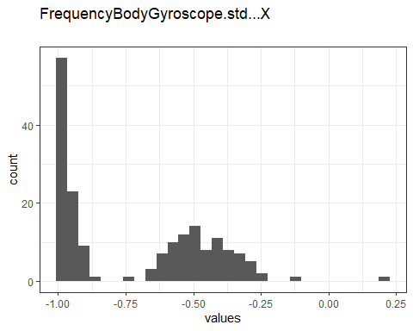

Distribution of values for FrequencyBodyGyroscope.std…X

0 missing values.

#### Summary statistics

|  |  |  |  |  |  |  |  |  |  |  |
| --- | --- | --- | --- | --- | --- | --- | --- | --- | --- | --- |
| name | data_type | n_missing | complete_rate | min | median | max | mean | sd | hist | label |
| FrequencyBodyGyroscope.std…X | numeric | 0 | 1 | -0.99 | -0.81 | 0.2 | -0.7110357 | 0.272789 | <U+2587><U+2582><U+2585><U+2581><U+2581> | NA |

### FrequencyBodyGyroscope.std…Y

#### Distribution

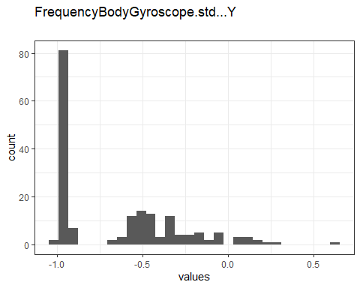

Distribution of values for FrequencyBodyGyroscope.std…Y

0 missing values.

#### Summary statistics

|  |  |  |  |  |  |  |  |  |  |  |
| --- | --- | --- | --- | --- | --- | --- | --- | --- | --- | --- |
| name | data_type | n_missing | complete_rate | min | median | max | mean | sd | hist | label |
| FrequencyBodyGyroscope.std…Y | numeric | 0 | 1 | -0.99 | -0.8 | 0.65 | -0.6454334 | 0.3634445 | <U+2587><U+2585><U+2582><U+2581><U+2581> | NA |

### FrequencyBodyGyroscope.std…Z

#### Distribution

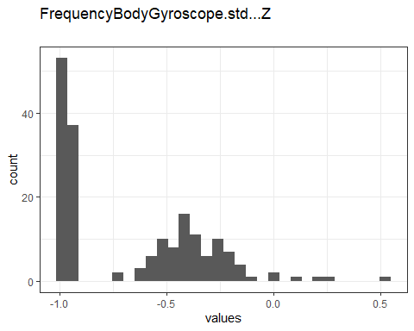

Distribution of values for FrequencyBodyGyroscope.std…Z

0 missing values.

#### Summary statistics

|  |  |  |  |  |  |  |  |  |  |  |
| --- | --- | --- | --- | --- | --- | --- | --- | --- | --- | --- |
| name | data_type | n_missing | complete_rate | min | median | max | mean | sd | hist | label |
| FrequencyBodyGyroscope.std…Z | numeric | 0 | 1 | -0.99 | -0.82 | 0.52 | -0.6577466 | 0.3362014 | <U+2587><U+2583><U+2583><U+2581><U+2581> | NA |

### FrequencyBodyAccelerometerMagnitude.std..

#### Distribution

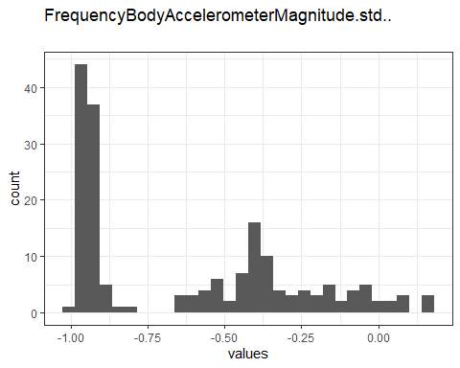

Distribution of values for FrequencyBodyAccelerometerMagnitude.std..

0 missing values.

#### Summary statistics

|  |  |  |  |  |  |  |  |  |  |  |
| --- | --- | --- | --- | --- | --- | --- | --- | --- | --- | --- |
| name | data_type | n_missing | complete_rate | min | median | max | mean | sd | hist | label |
| FrequencyBodyAccelerometerMagnitude.std.. | numeric | 0 | 1 | -0.99 | -0.65 | 0.18 | -0.6209633 | 0.3529148 | <U+2587><U+2581><U+2583><U+2582><U+2581> | NA |

### FrequencyBodyAccelerometerJerkMagnitude.std..

#### Distribution

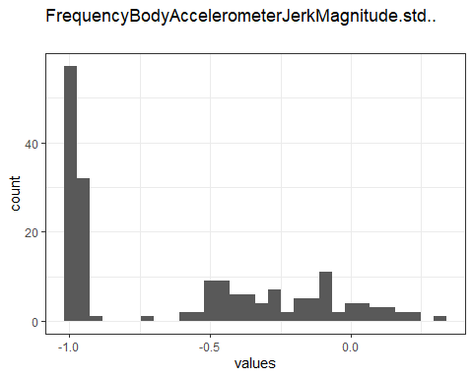

Distribution of values for FrequencyBodyAccelerometerJerkMagnitude.std..

0 missing values.

#### Summary statistics

|  |  |  |  |  |  |  |  |  |  |  |
| --- | --- | --- | --- | --- | --- | --- | --- | --- | --- | --- |
| name | data_type | n_missing | complete_rate | min | median | max | mean | sd | hist | label |
| FrequencyBodyAccelerometerJerkMagnitude.std.. | numeric | 0 | 1 | -0.99 | -0.81 | 0.32 | -0.5991609 | 0.4086668 | <U+2587><U+2581><U+2583><U+2582><U+2581> | NA |

### FrequencyBodyGyroscopeMagnitude.std..

#### Distribution

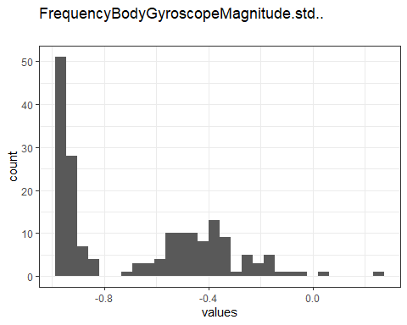

Distribution of values for FrequencyBodyGyroscopeMagnitude.std..

0 missing values.

#### Summary statistics

|  |  |  |  |  |  |  |  |  |  |  |
| --- | --- | --- | --- | --- | --- | --- | --- | --- | --- | --- |
| name | data_type | n_missing | complete_rate | min | median | max | mean | sd | hist | label |
| FrequencyBodyGyroscopeMagnitude.std.. | numeric | 0 | 1 | -0.98 | -0.77 | 0.24 | -0.6723223 | 0.2931842 | <U+2587><U+2582><U+2585><U+2581><U+2581> | NA |

### FrequencyBodyGyroscopeJerkMagnitude.std..

#### Distribution

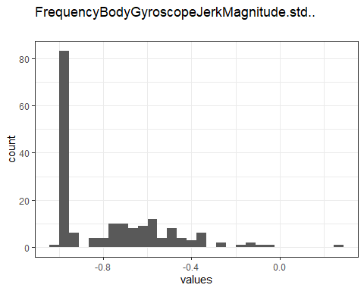

Distribution of values for FrequencyBodyGyroscopeJerkMagnitude.std..

0 missing values.

#### Summary statistics

|  |  |  |  |  |  |  |  |  |  |  |
| --- | --- | --- | --- | --- | --- | --- | --- | --- | --- | --- |
| name | data_type | n_missing | complete_rate | min | median | max | mean | sd | hist | label |
| FrequencyBodyGyroscopeJerkMagnitude.std.. | numeric | 0 | 1 | -1 | -0.89 | 0.29 | -0.7715171 | 0.2504248 | <U+2587><U+2583><U+2581><U+2581><U+2581> | NA |

## Missingness report

## Codebook table

|  |  |  |  |  |  |  |  |  |  |  |  |  |  |
| --- | --- | --- | --- | --- | --- | --- | --- | --- | --- | --- | --- | --- | --- |
| name | data_type | n_missing | complete_rate | n_unique | empty | min | median | max | mean | sd | whitespace | hist | label |
| activity | character | 0 | 1 | 6 | 0 | 6 | NA | 18 | NA | NA | 0 | NA | NA |
| subjects | numeric | 0 | 1 | NA | NA | 1.000 | 15.5000 | 30.0000 | 15.5000000 | 8.6795850 | NA | <U+2587><U+2587><U+2587><U+2587><U+2587> | NA |
| TimeBodyAccelerometer.mean…X | numeric | 0 | 1 | NA | NA | 0.222 | 0.2770 | 0.3015 | 0.2743027 | 0.0121646 | NA | <U+2581><U+2581><U+2582><U+2587><U+2582> | NA |
| TimeBodyAccelerometer.mean…Y | numeric | 0 | 1 | NA | NA | -0.041 | -0.0173 | -0.0013 | -0.0178755 | 0.0057712 | NA | <U+2581><U+2582><U+2587><U+2587><U+2581> | NA |
| TimeBodyAccelerometer.mean…Z | numeric | 0 | 1 | NA | NA | -0.153 | -0.1082 | -0.0754 | -0.1091638 | 0.0095820 | NA | <U+2581><U+2581><U+2587><U+2585><U+2581> | NA |
| TimeGravityAccelerometer.mean…X | numeric | 0 | 1 | NA | NA | -0.680 | 0.9208 | 0.9745 | 0.6974775 | 0.4872534 | NA | <U+2581><U+2581><U+2581><U+2581><U+2587> | NA |
| TimeGravityAccelerometer.mean…Y | numeric | 0 | 1 | NA | NA | -0.480 | -0.1278 | 0.9566 | -0.0162128 | 0.3452376 | NA | <U+2587><U+2587><U+2582><U+2581><U+2582> | NA |
| TimeGravityAccelerometer.mean…Z | numeric | 0 | 1 | NA | NA | -0.495 | 0.0238 | 0.9579 | 0.0741279 | 0.2887919 | NA | <U+2582><U+2587><U+2583><U+2581><U+2581> | NA |
| TimeBodyAccelerometerJerk.mean…X | numeric | 0 | 1 | NA | NA | 0.043 | 0.0764 | 0.1302 | 0.0794736 | 0.0125880 | NA | <U+2581><U+2587><U+2583><U+2582><U+2581> | NA |
| TimeBodyAccelerometerJerk.mean…Y | numeric | 0 | 1 | NA | NA | -0.039 | 0.0095 | 0.0568 | 0.0075652 | 0.0135764 | NA | <U+2581><U+2583><U+2587><U+2582><U+2581> | NA |
| TimeBodyAccelerometerJerk.mean…Z | numeric | 0 | 1 | NA | NA | -0.067 | -0.0039 | 0.0381 | -0.0049534 | 0.0134621 | NA | <U+2581><U+2581><U+2587><U+2587><U+2581> | NA |
| TimeBodyGyroscope.mean…X | numeric | 0 | 1 | NA | NA | -0.206 | -0.0287 | 0.1927 | -0.0324372 | 0.0540518 | NA | <U+2581><U+2582><U+2587><U+2581><U+2581> | NA |
| TimeBodyGyroscope.mean…Y | numeric | 0 | 1 | NA | NA | -0.204 | -0.0732 | 0.0275 | -0.0742596 | 0.0355415 | NA | <U+2581><U+2581><U+2587><U+2583><U+2581> | NA |
| TimeBodyGyroscope.mean…Z | numeric | 0 | 1 | NA | NA | -0.072 | 0.0851 | 0.1791 | 0.0874446 | 0.0362125 | NA | <U+2581><U+2581><U+2583><U+2587><U+2582> | NA |
| TimeBodyGyroscopeJerk.mean…X | numeric | 0 | 1 | NA | NA | -0.157 | -0.0987 | -0.0221 | -0.0960568 | 0.0233458 | NA | <U+2581><U+2582><U+2587><U+2581><U+2581> | NA |
| TimeBodyGyroscopeJerk.mean…Y | numeric | 0 | 1 | NA | NA | -0.077 | -0.0411 | -0.0132 | -0.0426928 | 0.0095320 | NA | <U+2581><U+2582><U+2587><U+2583><U+2581> | NA |
| TimeBodyGyroscopeJerk.mean…Z | numeric | 0 | 1 | NA | NA | -0.092 | -0.0534 | -0.0069 | -0.0548019 | 0.0123470 | NA | <U+2581><U+2585><U+2587><U+2581><U+2581> | NA |
| TimeBodyAccelerometerMagnitude.mean.. | numeric | 0 | 1 | NA | NA | -0.986 | -0.4829 | 0.6446 | -0.4972897 | 0.4728834 | NA | <U+2587><U+2581><U+2585><U+2583><U+2581> | NA |
| TimeGravityAccelerometerMagnitude.mean.. | numeric | 0 | 1 | NA | NA | -0.986 | -0.4829 | 0.6446 | -0.4972897 | 0.4728834 | NA | <U+2587><U+2581><U+2585><U+2583><U+2581> | NA |
| TimeBodyAccelerometerJerkMagnitude.mean.. | numeric | 0 | 1 | NA | NA | -0.993 | -0.8168 | 0.4345 | -0.6079296 | 0.3965272 | NA | <U+2587><U+2582><U+2585><U+2582><U+2581> | NA |
| TimeBodyGyroscopeMagnitude.mean.. | numeric | 0 | 1 | NA | NA | -0.981 | -0.6551 | 0.4180 | -0.5651631 | 0.3977338 | NA | <U+2587><U+2581><U+2585><U+2582><U+2581> | NA |
| TimeBodyGyroscopeJerkMagnitude.mean.. | numeric | 0 | 1 | NA | NA | -0.997 | -0.8648 | 0.0876 | -0.7363693 | 0.2767541 | NA | <U+2587><U+2583><U+2583><U+2581><U+2581> | NA |
| FrequencyBodyAccelerometer.mean…X | numeric | 0 | 1 | NA | NA | -0.995 | -0.7691 | 0.5370 | -0.5758000 | 0.4300214 | NA | <U+2587><U+2581><U+2583><U+2582><U+2581> | NA |
| FrequencyBodyAccelerometer.mean…Y | numeric | 0 | 1 | NA | NA | -0.989 | -0.5950 | 0.5242 | -0.4887327 | 0.4806496 | NA | <U+2587><U+2581><U+2583><U+2583><U+2581> | NA |
| FrequencyBodyAccelerometer.mean…Z | numeric | 0 | 1 | NA | NA | -0.989 | -0.7236 | 0.2807 | -0.6297388 | 0.3556469 | NA | <U+2587><U+2582><U+2585><U+2581><U+2581> | NA |
| FrequencyBodyAccelerometer.meanFreq…X | numeric | 0 | 1 | NA | NA | -0.636 | -0.2573 | 0.1591 | -0.2322661 | 0.1935684 | NA | <U+2582><U+2587><U+2586><U+2586><U+2583> | NA |
| FrequencyBodyAccelerometer.meanFreq…Y | numeric | 0 | 1 | NA | NA | -0.380 | 0.0079 | 0.4665 | 0.0115289 | 0.1447051 | NA | <U+2581><U+2585><U+2587><U+2582><U+2581> | NA |
| FrequencyBodyAccelerometer.meanFreq…Z | numeric | 0 | 1 | NA | NA | -0.520 | 0.0658 | 0.4025 | 0.0437174 | 0.1850113 | NA | <U+2581><U+2582><U+2586><U+2587><U+2583> | NA |
| FrequencyBodyAccelerometerJerk.mean…X | numeric | 0 | 1 | NA | NA | -0.995 | -0.8126 | 0.4743 | -0.6139282 | 0.3982896 | NA | <U+2587><U+2582><U+2583><U+2582><U+2581> | NA |
| FrequencyBodyAccelerometerJerk.mean…Y | numeric | 0 | 1 | NA | NA | -0.989 | -0.7817 | 0.2767 | -0.5881631 | 0.4077491 | NA | <U+2587><U+2581><U+2583><U+2583><U+2581> | NA |
| FrequencyBodyAccelerometerJerk.mean…Z | numeric | 0 | 1 | NA | NA | -0.992 | -0.8707 | 0.1578 | -0.7143585 | 0.2970225 | NA | <U+2587><U+2582><U+2583><U+2581><U+2581> | NA |
| FrequencyBodyAccelerometerJerk.meanFreq…X | numeric | 0 | 1 | NA | NA | -0.576 | -0.0609 | 0.3314 | -0.0691018 | 0.2541022 | NA | <U+2582><U+2587><U+2582><U+2585><U+2587> | NA |
| FrequencyBodyAccelerometerJerk.meanFreq…Y | numeric | 0 | 1 | NA | NA | -0.602 | -0.2321 | 0.1957 | -0.2281021 | 0.1998647 | NA | <U+2585><U+2587><U+2586><U+2587><U+2583> | NA |
| FrequencyBodyAccelerometerJerk.meanFreq…Z | numeric | 0 | 1 | NA | NA | -0.628 | -0.0919 | 0.2301 | -0.1376023 | 0.2078722 | NA | <U+2582><U+2585><U+2583><U+2587><U+2585> | NA |
| FrequencyBodyGyroscope.mean…X | numeric | 0 | 1 | NA | NA | -0.993 | -0.7300 | 0.4750 | -0.6367396 | 0.3467628 | NA | <U+2587><U+2582><U+2585><U+2581><U+2581> | NA |
| FrequencyBodyGyroscope.mean…Y | numeric | 0 | 1 | NA | NA | -0.994 | -0.8141 | 0.3288 | -0.6766868 | 0.3319182 | NA | <U+2587><U+2583><U+2583><U+2581><U+2581> | NA |
| FrequencyBodyGyroscope.mean…Z | numeric | 0 | 1 | NA | NA | -0.986 | -0.7909 | 0.4924 | -0.6043912 | 0.3842603 | NA | <U+2587><U+2582><U+2585><U+2581><U+2581> | NA |
| FrequencyBodyGyroscope.meanFreq…X | numeric | 0 | 1 | NA | NA | -0.396 | -0.1155 | 0.2492 | -0.1045510 | 0.1480975 | NA | <U+2583><U+2587><U+2587><U+2585><U+2582> | NA |
| FrequencyBodyGyroscope.meanFreq…Y | numeric | 0 | 1 | NA | NA | -0.667 | -0.1579 | 0.2731 | -0.1674075 | 0.1788011 | NA | <U+2581><U+2585><U+2587><U+2586><U+2582> | NA |
| FrequencyBodyGyroscope.meanFreq…Z | numeric | 0 | 1 | NA | NA | -0.507 | -0.0508 | 0.3771 | -0.0571809 | 0.1652298 | NA | <U+2581><U+2583><U+2587><U+2583><U+2581> | NA |
| FrequencyBodyAccelerometerMagnitude.mean.. | numeric | 0 | 1 | NA | NA | -0.987 | -0.6703 | 0.5866 | -0.5365167 | 0.4516451 | NA | <U+2587><U+2582><U+2583><U+2582><U+2581> | NA |
| FrequencyBodyAccelerometerMagnitude.meanFreq.. | numeric | 0 | 1 | NA | NA | -0.312 | 0.0813 | 0.4358 | 0.0761282 | 0.1404479 | NA | <U+2581><U+2585><U+2587><U+2585><U+2581> | NA |
| FrequencyBodyAccelerometerJerkMagnitude.mean.. | numeric | 0 | 1 | NA | NA | -0.994 | -0.7940 | 0.5384 | -0.5756175 | 0.4312321 | NA | <U+2587><U+2582><U+2583><U+2582><U+2581> | NA |
| FrequencyBodyAccelerometerJerkMagnitude.meanFreq.. | numeric | 0 | 1 | NA | NA | -0.125 | 0.1720 | 0.4881 | 0.1625459 | 0.1378300 | NA | <U+2583><U+2587><U+2587><U+2587><U+2582> | NA |
| FrequencyBodyGyroscopeMagnitude.mean.. | numeric | 0 | 1 | NA | NA | -0.987 | -0.7657 | 0.2040 | -0.6670991 | 0.3181183 | NA | <U+2587><U+2582><U+2583><U+2581><U+2581> | NA |
| FrequencyBodyGyroscopeMagnitude.meanFreq.. | numeric | 0 | 1 | NA | NA | -0.457 | -0.0535 | 0.4095 | -0.0360322 | 0.1807351 | NA | <U+2582><U+2587><U+2587><U+2585><U+2582> | NA |
| FrequencyBodyGyroscopeJerkMagnitude.mean.. | numeric | 0 | 1 | NA | NA | -0.998 | -0.8779 | 0.1466 | -0.7563853 | 0.2628722 | NA | <U+2587><U+2585><U+2582><U+2581><U+2581> | NA |
| FrequencyBodyGyroscopeJerkMagnitude.meanFreq.. | numeric | 0 | 1 | NA | NA | -0.183 | 0.1116 | 0.4263 | 0.1259225 | 0.1083232 | NA | <U+2581><U+2585><U+2587><U+2586><U+2581> | NA |
| Angle.TimeBodyAccelerometerMean.Gravity. | numeric | 0 | 1 | NA | NA | -0.163 | 0.0079 | 0.1292 | 0.0065557 | 0.0396044 | NA | <U+2581><U+2581><U+2587><U+2587><U+2581> | NA |
| Angle.TimeBodyAccelerometerJerkMean..GravityMean. | numeric | 0 | 1 | NA | NA | -0.121 | 0.0031 | 0.2033 | 0.0006439 | 0.0427632 | NA | <U+2582><U+2587><U+2586><U+2581><U+2581> | NA |
| Angle.TimeBodyGyroscopeMean.GravityMean. | numeric | 0 | 1 | NA | NA | -0.389 | 0.0209 | 0.4441 | 0.0219317 | 0.1401276 | NA | <U+2581><U+2581><U+2587><U+2581><U+2581> | NA |
| Angle.TimeBodyGyroscopeJerkMean.GravityMean. | numeric | 0 | 1 | NA | NA | -0.224 | -0.0160 | 0.1824 | -0.0113732 | 0.0729629 | NA | <U+2581><U+2583><U+2587><U+2585><U+2581> | NA |
| Angle.X.GravityMean. | numeric | 0 | 1 | NA | NA | -0.947 | -0.7377 | 0.7378 | -0.5243065 | 0.4812280 | NA | <U+2587><U+2582><U+2581><U+2581><U+2582> | NA |
| Angle.Y.GravityMean. | numeric | 0 | 1 | NA | NA | -0.875 | 0.1714 | 0.4248 | 0.0786534 | 0.2784784 | NA | <U+2581><U+2581><U+2581><U+2585><U+2587> | NA |
| Angle.Z.GravityMean. | numeric | 0 | 1 | NA | NA | -0.874 | 0.0051 | 0.3904 | -0.0404362 | 0.2308332 | NA | <U+2581><U+2581><U+2581><U+2587><U+2582> | NA |
| TimeBodyAccelerometer.std…X | numeric | 0 | 1 | NA | NA | -0.996 | -0.7526 | 0.6269 | -0.5576901 | 0.4516911 | NA | <U+2587><U+2582><U+2585><U+2582><U+2581> | NA |
| TimeBodyAccelerometer.std…Y | numeric | 0 | 1 | NA | NA | -0.990 | -0.5090 | 0.6169 | -0.4604626 | 0.4965650 | NA | <U+2587><U+2581><U+2585><U+2583><U+2581> | NA |
| TimeBodyAccelerometer.std…Z | numeric | 0 | 1 | NA | NA | -0.988 | -0.6518 | 0.6090 | -0.5755602 | 0.3955439 | NA | <U+2587><U+2582><U+2585><U+2581><U+2581> | NA |
| TimeGravityAccelerometer.std…X | numeric | 0 | 1 | NA | NA | -0.997 | -0.9695 | -0.8296 | -0.9637525 | 0.0250344 | NA | <U+2587><U+2586><U+2581><U+2581><U+2581> | NA |
| TimeGravityAccelerometer.std…Y | numeric | 0 | 1 | NA | NA | -0.994 | -0.9590 | -0.6436 | -0.9524296 | 0.0326557 | NA | <U+2587><U+2581><U+2581><U+2581><U+2581> | NA |
| TimeGravityAccelerometer.std…Z | numeric | 0 | 1 | NA | NA | -0.991 | -0.9450 | -0.6102 | -0.9364010 | 0.0402912 | NA | <U+2587><U+2582><U+2581><U+2581><U+2581> | NA |
| TimeBodyAccelerometerJerk.std…X | numeric | 0 | 1 | NA | NA | -0.995 | -0.8104 | 0.5443 | -0.5949467 | 0.4175865 | NA | <U+2587><U+2582><U+2585><U+2582><U+2581> | NA |
| TimeBodyAccelerometerJerk.std…Y | numeric | 0 | 1 | NA | NA | -0.990 | -0.7756 | 0.3553 | -0.5654147 | 0.4330871 | NA | <U+2587><U+2581><U+2583><U+2583><U+2581> | NA |
| TimeBodyAccelerometerJerk.std…Z | numeric | 0 | 1 | NA | NA | -0.993 | -0.8837 | 0.0310 | -0.7359577 | 0.2768479 | NA | <U+2587><U+2582><U+2583><U+2581><U+2581> | NA |
| TimeBodyGyroscope.std…X | numeric | 0 | 1 | NA | NA | -0.994 | -0.7890 | 0.2677 | -0.6916399 | 0.2910189 | NA | <U+2587><U+2583><U+2585><U+2581><U+2581> | NA |
| TimeBodyGyroscope.std…Y | numeric | 0 | 1 | NA | NA | -0.994 | -0.8017 | 0.4765 | -0.6533020 | 0.3520252 | NA | <U+2587><U+2585><U+2582><U+2581><U+2581> | NA |
| TimeBodyGyroscope.std…Z | numeric | 0 | 1 | NA | NA | -0.986 | -0.8010 | 0.5649 | -0.6164353 | 0.3730264 | NA | <U+2587><U+2582><U+2585><U+2581><U+2581> | NA |
| TimeBodyGyroscopeJerk.std…X | numeric | 0 | 1 | NA | NA | -0.997 | -0.8396 | 0.1791 | -0.7036327 | 0.3008361 | NA | <U+2587><U+2582><U+2583><U+2582><U+2581> | NA |
| TimeBodyGyroscopeJerk.std…Y | numeric | 0 | 1 | NA | NA | -0.997 | -0.8942 | 0.2959 | -0.7635518 | 0.2672885 | NA | <U+2587><U+2583><U+2582><U+2581><U+2581> | NA |
| TimeBodyGyroscopeJerk.std…Z | numeric | 0 | 1 | NA | NA | -0.995 | -0.8610 | 0.1932 | -0.7095592 | 0.3045394 | NA | <U+2587><U+2583><U+2583><U+2581><U+2581> | NA |
| TimeBodyAccelerometerMagnitude.std.. | numeric | 0 | 1 | NA | NA | -0.986 | -0.6074 | 0.4284 | -0.5439087 | 0.4310448 | NA | <U+2587><U+2581><U+2585><U+2582><U+2581> | NA |
| TimeGravityAccelerometerMagnitude.std.. | numeric | 0 | 1 | NA | NA | -0.986 | -0.6074 | 0.4284 | -0.5439087 | 0.4310448 | NA | <U+2587><U+2581><U+2585><U+2582><U+2581> | NA |
| TimeBodyAccelerometerJerkMagnitude.std.. | numeric | 0 | 1 | NA | NA | -0.995 | -0.8014 | 0.4506 | -0.5841756 | 0.4227953 | NA | <U+2587><U+2582><U+2583><U+2582><U+2581> | NA |
| TimeBodyGyroscopeMagnitude.std.. | numeric | 0 | 1 | NA | NA | -0.981 | -0.7420 | 0.3000 | -0.6303947 | 0.3368827 | NA | <U+2587><U+2582><U+2585><U+2582><U+2581> | NA |
| TimeBodyGyroscopeJerkMagnitude.std.. | numeric | 0 | 1 | NA | NA | -0.998 | -0.8809 | 0.2502 | -0.7550152 | 0.2655057 | NA | <U+2587><U+2583><U+2582><U+2581><U+2581> | NA |
| FrequencyBodyAccelerometer.std…X | numeric | 0 | 1 | NA | NA | -0.997 | -0.7470 | 0.6585 | -0.5522011 | 0.4600233 | NA | <U+2587><U+2582><U+2585><U+2582><U+2581> | NA |
| FrequencyBodyAccelerometer.std…Y | numeric | 0 | 1 | NA | NA | -0.991 | -0.5134 | 0.5602 | -0.4814787 | 0.4740277 | NA | <U+2587><U+2581><U+2585><U+2583><U+2581> | NA |
| FrequencyBodyAccelerometer.std…Z | numeric | 0 | 1 | NA | NA | -0.987 | -0.6441 | 0.6871 | -0.5823614 | 0.3880902 | NA | <U+2587><U+2583><U+2585><U+2581><U+2581> | NA |
| FrequencyBodyAccelerometerJerk.std…X | numeric | 0 | 1 | NA | NA | -0.995 | -0.8254 | 0.4768 | -0.6121033 | 0.4004506 | NA | <U+2587><U+2582><U+2583><U+2582><U+2581> | NA |
| FrequencyBodyAccelerometerJerk.std…Y | numeric | 0 | 1 | NA | NA | -0.990 | -0.7852 | 0.3498 | -0.5707310 | 0.4319873 | NA | <U+2587><U+2581><U+2583><U+2583><U+2581> | NA |
| FrequencyBodyAccelerometerJerk.std…Z | numeric | 0 | 1 | NA | NA | -0.993 | -0.8951 | -0.0062 | -0.7564894 | 0.2570577 | NA | <U+2587><U+2583><U+2583><U+2581><U+2581> | NA |
| FrequencyBodyGyroscope.std…X | numeric | 0 | 1 | NA | NA | -0.995 | -0.8086 | 0.1966 | -0.7110357 | 0.2727890 | NA | <U+2587><U+2582><U+2585><U+2581><U+2581> | NA |
| FrequencyBodyGyroscope.std…Y | numeric | 0 | 1 | NA | NA | -0.994 | -0.7964 | 0.6462 | -0.6454334 | 0.3634445 | NA | <U+2587><U+2585><U+2582><U+2581><U+2581> | NA |
| FrequencyBodyGyroscope.std…Z | numeric | 0 | 1 | NA | NA | -0.987 | -0.8224 | 0.5225 | -0.6577466 | 0.3362014 | NA | <U+2587><U+2583><U+2583><U+2581><U+2581> | NA |
| FrequencyBodyAccelerometerMagnitude.std.. | numeric | 0 | 1 | NA | NA | -0.988 | -0.6513 | 0.1787 | -0.6209633 | 0.3529148 | NA | <U+2587><U+2581><U+2583><U+2582><U+2581> | NA |
| FrequencyBodyAccelerometerJerkMagnitude.std.. | numeric | 0 | 1 | NA | NA | -0.994 | -0.8126 | 0.3163 | -0.5991609 | 0.4086668 | NA | <U+2587><U+2581><U+2583><U+2582><U+2581> | NA |
| FrequencyBodyGyroscopeMagnitude.std.. | numeric | 0 | 1 | NA | NA | -0.981 | -0.7727 | 0.2367 | -0.6723223 | 0.2931842 | NA | <U+2587><U+2582><U+2585><U+2581><U+2581> | NA |
| FrequencyBodyGyroscopeJerkMagnitude.std.. | numeric | 0 | 1 | NA | NA | -0.998 | -0.8941 | 0.2878 | -0.7715171 | 0.2504248 | NA | <U+2587><U+2583><U+2581><U+2581><U+2581> | NA |

JSON-LD metadata The following JSON-LD can be found by search engines, if you share this codebook publicly on the web.

{  
 "name": "UCI_HAR_dataset",  
 "datePublished": "2020-09-18",  
 "description": "The dataset has N=180 rows and 88 columns.\n180 rows have no missing values on any column.\n\n\n## Table of variables\nThis table contains variable names, labels, and number of missing values.\nSee the complete codebook for more.\n\n[truncated]\n\n### Note\nThis dataset was automatically described using the [codebook R package](https://rubenarslan.github.io/codebook/) (version 0.9.2).",  
 "keywords": ["activity", "subjects", "TimeBodyAccelerometer.mean...X", "TimeBodyAccelerometer.mean...Y", "TimeBodyAccelerometer.mean...Z", "TimeGravityAccelerometer.mean...X", "TimeGravityAccelerometer.mean...Y", "TimeGravityAccelerometer.mean...Z", "TimeBodyAccelerometerJerk.mean...X", "TimeBodyAccelerometerJerk.mean...Y", "TimeBodyAccelerometerJerk.mean...Z", "TimeBodyGyroscope.mean...X", "TimeBodyGyroscope.mean...Y", "TimeBodyGyroscope.mean...Z", "TimeBodyGyroscopeJerk.mean...X", "TimeBodyGyroscopeJerk.mean...Y", "TimeBodyGyroscopeJerk.mean...Z", "TimeBodyAccelerometerMagnitude.mean..", "TimeGravityAccelerometerMagnitude.mean..", "TimeBodyAccelerometerJerkMagnitude.mean..", "TimeBodyGyroscopeMagnitude.mean..", "TimeBodyGyroscopeJerkMagnitude.mean..", "FrequencyBodyAccelerometer.mean...X", "FrequencyBodyAccelerometer.mean...Y", "FrequencyBodyAccelerometer.mean...Z", "FrequencyBodyAccelerometer.meanFreq...X", "FrequencyBodyAccelerometer.meanFreq...Y", "FrequencyBodyAccelerometer.meanFreq...Z", "FrequencyBodyAccelerometerJerk.mean...X", "FrequencyBodyAccelerometerJerk.mean...Y", "FrequencyBodyAccelerometerJerk.mean...Z", "FrequencyBodyAccelerometerJerk.meanFreq...X", "FrequencyBodyAccelerometerJerk.meanFreq...Y", "FrequencyBodyAccelerometerJerk.meanFreq...Z", "FrequencyBodyGyroscope.mean...X", "FrequencyBodyGyroscope.mean...Y", "FrequencyBodyGyroscope.mean...Z", "FrequencyBodyGyroscope.meanFreq...X", "FrequencyBodyGyroscope.meanFreq...Y", "FrequencyBodyGyroscope.meanFreq...Z", "FrequencyBodyAccelerometerMagnitude.mean..", "FrequencyBodyAccelerometerMagnitude.meanFreq..", "FrequencyBodyAccelerometerJerkMagnitude.mean..", "FrequencyBodyAccelerometerJerkMagnitude.meanFreq..", "FrequencyBodyGyroscopeMagnitude.mean..", "FrequencyBodyGyroscopeMagnitude.meanFreq..", "FrequencyBodyGyroscopeJerkMagnitude.mean..", "FrequencyBodyGyroscopeJerkMagnitude.meanFreq..", "Angle.TimeBodyAccelerometerMean.Gravity.", "Angle.TimeBodyAccelerometerJerkMean..GravityMean.", "Angle.TimeBodyGyroscopeMean.GravityMean.", "Angle.TimeBodyGyroscopeJerkMean.GravityMean.", "Angle.X.GravityMean.", "Angle.Y.GravityMean.", "Angle.Z.GravityMean.", "TimeBodyAccelerometer.std...X", "TimeBodyAccelerometer.std...Y", "TimeBodyAccelerometer.std...Z", "TimeGravityAccelerometer.std...X", "TimeGravityAccelerometer.std...Y", "TimeGravityAccelerometer.std...Z", "TimeBodyAccelerometerJerk.std...X", "TimeBodyAccelerometerJerk.std...Y", "TimeBodyAccelerometerJerk.std...Z", "TimeBodyGyroscope.std...X", "TimeBodyGyroscope.std...Y", "TimeBodyGyroscope.std...Z", "TimeBodyGyroscopeJerk.std...X", "TimeBodyGyroscopeJerk.std...Y", "TimeBodyGyroscopeJerk.std...Z", "TimeBodyAccelerometerMagnitude.std..", "TimeGravityAccelerometerMagnitude.std..", "TimeBodyAccelerometerJerkMagnitude.std..", "TimeBodyGyroscopeMagnitude.std..", "TimeBodyGyroscopeJerkMagnitude.std..", "FrequencyBodyAccelerometer.std...X", "FrequencyBodyAccelerometer.std...Y", "FrequencyBodyAccelerometer.std...Z", "FrequencyBodyAccelerometerJerk.std...X", "FrequencyBodyAccelerometerJerk.std...Y", "FrequencyBodyAccelerometerJerk.std...Z", "FrequencyBodyGyroscope.std...X", "FrequencyBodyGyroscope.std...Y", "FrequencyBodyGyroscope.std...Z", "FrequencyBodyAccelerometerMagnitude.std..", "FrequencyBodyAccelerometerJerkMagnitude.std..", "FrequencyBodyGyroscopeMagnitude.std..", "FrequencyBodyGyroscopeJerkMagnitude.std.."],  
 "@context": "http://schema.org/",  
 "@type": "Dataset",  
 "variableMeasured": [  
 {  
 "name": "activity",  
 "@type": "propertyValue"  
 },  
 {  
 "name": "subjects",  
 "@type": "propertyValue"  
 },  
 {  
 "name": "TimeBodyAccelerometer.mean...X",  
 "@type": "propertyValue"  
 },  
 {  
 "name": "TimeBodyAccelerometer.mean...Y",  
 "@type": "propertyValue"  
 },  
 {  
 "name": "TimeBodyAccelerometer.mean...Z",  
 "@type": "propertyValue"  
 },  
 {  
 "name": "TimeGravityAccelerometer.mean...X",  
 "@type": "propertyValue"  
 },  
 {  
 "name": "TimeGravityAccelerometer.mean...Y",  
 "@type": "propertyValue"  
 },  
 {  
 "name": "TimeGravityAccelerometer.mean...Z",  
 "@type": "propertyValue"  
 },  
 {  
 "name": "TimeBodyAccelerometerJerk.mean...X",  
 "@type": "propertyValue"  
 },  
 {  
 "name": "TimeBodyAccelerometerJerk.mean...Y",  
 "@type": "propertyValue"  
 },  
 {  
 "name": "TimeBodyAccelerometerJerk.mean...Z",  
 "@type": "propertyValue"  
 },  
 {  
 "name": "TimeBodyGyroscope.mean...X",  
 "@type": "propertyValue"  
 },  
 {  
 "name": "TimeBodyGyroscope.mean...Y",  
 "@type": "propertyValue"  
 },  
 {  
 "name": "TimeBodyGyroscope.mean...Z",  
 "@type": "propertyValue"  
 },  
 {  
 "name": "TimeBodyGyroscopeJerk.mean...X",  
 "@type": "propertyValue"  
 },  
 {  
 "name": "TimeBodyGyroscopeJerk.mean...Y",  
 "@type": "propertyValue"  
 },  
 {  
 "name": "TimeBodyGyroscopeJerk.mean...Z",  
 "@type": "propertyValue"  
 },  
 {  
 "name": "TimeBodyAccelerometerMagnitude.mean..",  
 "@type": "propertyValue"  
 },  
 {  
 "name": "TimeGravityAccelerometerMagnitude.mean..",  
 "@type": "propertyValue"  
 },  
 {  
 "name": "TimeBodyAccelerometerJerkMagnitude.mean..",  
 "@type": "propertyValue"  
 },  
 {  
 "name": "TimeBodyGyroscopeMagnitude.mean..",  
 "@type": "propertyValue"  
 },  
 {  
 "name": "TimeBodyGyroscopeJerkMagnitude.mean..",  
 "@type": "propertyValue"  
 },  
 {  
 "name": "FrequencyBodyAccelerometer.mean...X",  
 "@type": "propertyValue"  
 },  
 {  
 "name": "FrequencyBodyAccelerometer.mean...Y",  
 "@type": "propertyValue"  
 },  
 {  
 "name": "FrequencyBodyAccelerometer.mean...Z",  
 "@type": "propertyValue"  
 },  
 {  
 "name": "FrequencyBodyAccelerometer.meanFreq...X",  
 "@type": "propertyValue"  
 },  
 {  
 "name": "FrequencyBodyAccelerometer.meanFreq...Y",  
 "@type": "propertyValue"  
 },  
 {  
 "name": "FrequencyBodyAccelerometer.meanFreq...Z",  
 "@type": "propertyValue"  
 },  
 {  
 "name": "FrequencyBodyAccelerometerJerk.mean...X",  
 "@type": "propertyValue"  
 },  
 {  
 "name": "FrequencyBodyAccelerometerJerk.mean...Y",  
 "@type": "propertyValue"  
 },  
 {  
 "name": "FrequencyBodyAccelerometerJerk.mean...Z",  
 "@type": "propertyValue"  
 },  
 {  
 "name": "FrequencyBodyAccelerometerJerk.meanFreq...X",  
 "@type": "propertyValue"  
 },  
 {  
 "name": "FrequencyBodyAccelerometerJerk.meanFreq...Y",  
 "@type": "propertyValue"  
 },  
 {  
 "name": "FrequencyBodyAccelerometerJerk.meanFreq...Z",  
 "@type": "propertyValue"  
 },  
 {  
 "name": "FrequencyBodyGyroscope.mean...X",  
 "@type": "propertyValue"  
 },  
 {  
 "name": "FrequencyBodyGyroscope.mean...Y",  
 "@type": "propertyValue"  
 },  
 {  
 "name": "FrequencyBodyGyroscope.mean...Z",  
 "@type": "propertyValue"  
 },  
 {  
 "name": "FrequencyBodyGyroscope.meanFreq...X",  
 "@type": "propertyValue"  
 },  
 {  
 "name": "FrequencyBodyGyroscope.meanFreq...Y",  
 "@type": "propertyValue"  
 },  
 {  
 "name": "FrequencyBodyGyroscope.meanFreq...Z",  
 "@type": "propertyValue"  
 },  
 {  
 "name": "FrequencyBodyAccelerometerMagnitude.mean..",  
 "@type": "propertyValue"  
 },  
 {  
 "name": "FrequencyBodyAccelerometerMagnitude.meanFreq..",  
 "@type": "propertyValue"  
 },  
 {  
 "name": "FrequencyBodyAccelerometerJerkMagnitude.mean..",  
 "@type": "propertyValue"  
 },  
 {  
 "name": "FrequencyBodyAccelerometerJerkMagnitude.meanFreq..",  
 "@type": "propertyValue"  
 },  
 {  
 "name": "FrequencyBodyGyroscopeMagnitude.mean..",  
 "@type": "propertyValue"  
 },  
 {  
 "name": "FrequencyBodyGyroscopeMagnitude.meanFreq..",  
 "@type": "propertyValue"  
 },  
 {  
 "name": "FrequencyBodyGyroscopeJerkMagnitude.mean..",  
 "@type": "propertyValue"  
 },  
 {  
 "name": "FrequencyBodyGyroscopeJerkMagnitude.meanFreq..",  
 "@type": "propertyValue"  
 },  
 {  
 "name": "Angle.TimeBodyAccelerometerMean.Gravity.",  
 "@type": "propertyValue"  
 },  
 {  
 "name": "Angle.TimeBodyAccelerometerJerkMean..GravityMean.",  
 "@type": "propertyValue"  
 },  
 {  
 "name": "Angle.TimeBodyGyroscopeMean.GravityMean.",  
 "@type": "propertyValue"  
 },  
 {  
 "name": "Angle.TimeBodyGyroscopeJerkMean.GravityMean.",  
 "@type": "propertyValue"  
 },  
 {  
 "name": "Angle.X.GravityMean.",  
 "@type": "propertyValue"  
 },  
 {  
 "name": "Angle.Y.GravityMean.",  
 "@type": "propertyValue"  
 },  
 {  
 "name": "Angle.Z.GravityMean.",  
 "@type": "propertyValue"  
 },  
 {  
 "name": "TimeBodyAccelerometer.std...X",  
 "@type": "propertyValue"  
 },  
 {  
 "name": "TimeBodyAccelerometer.std...Y",  
 "@type": "propertyValue"  
 },  
 {  
 "name": "TimeBodyAccelerometer.std...Z",  
 "@type": "propertyValue"  
 },  
 {  
 "name": "TimeGravityAccelerometer.std...X",  
 "@type": "propertyValue"  
 },  
 {  
 "name": "TimeGravityAccelerometer.std...Y",  
 "@type": "propertyValue"  
 },  
 {  
 "name": "TimeGravityAccelerometer.std...Z",  
 "@type": "propertyValue"  
 },  
 {  
 "name": "TimeBodyAccelerometerJerk.std...X",  
 "@type": "propertyValue"  
 },  
 {  
 "name": "TimeBodyAccelerometerJerk.std...Y",  
 "@type": "propertyValue"  
 },  
 {  
 "name": "TimeBodyAccelerometerJerk.std...Z",  
 "@type": "propertyValue"  
 },  
 {  
 "name": "TimeBodyGyroscope.std...X",  
 "@type": "propertyValue"  
 },  
 {  
 "name": "TimeBodyGyroscope.std...Y",  
 "@type": "propertyValue"  
 },  
 {  
 "name": "TimeBodyGyroscope.std...Z",  
 "@type": "propertyValue"  
 },  
 {  
 "name": "TimeBodyGyroscopeJerk.std...X",  
 "@type": "propertyValue"  
 },  
 {  
 "name": "TimeBodyGyroscopeJerk.std...Y",  
 "@type": "propertyValue"  
 },  
 {  
 "name": "TimeBodyGyroscopeJerk.std...Z",  
 "@type": "propertyValue"  
 },  
 {  
 "name": "TimeBodyAccelerometerMagnitude.std..",  
 "@type": "propertyValue"  
 },  
 {  
 "name": "TimeGravityAccelerometerMagnitude.std..",  
 "@type": "propertyValue"  
 },  
 {  
 "name": "TimeBodyAccelerometerJerkMagnitude.std..",  
 "@type": "propertyValue"  
 },  
 {  
 "name": "TimeBodyGyroscopeMagnitude.std..",  
 "@type": "propertyValue"  
 },  
 {  
 "name": "TimeBodyGyroscopeJerkMagnitude.std..",  
 "@type": "propertyValue"  
 },  
 {  
 "name": "FrequencyBodyAccelerometer.std...X",  
 "@type": "propertyValue"  
 },  
 {  
 "name": "FrequencyBodyAccelerometer.std...Y",  
 "@type": "propertyValue"  
 },  
 {  
 "name": "FrequencyBodyAccelerometer.std...Z",  
 "@type": "propertyValue"  
 },  
 {  
 "name": "FrequencyBodyAccelerometerJerk.std...X",  
 "@type": "propertyValue"  
 },  
 {  
 "name": "FrequencyBodyAccelerometerJerk.std...Y",  
 "@type": "propertyValue"  
 },  
 {  
 "name": "FrequencyBodyAccelerometerJerk.std...Z",  
 "@type": "propertyValue"  
 },  
 {  
 "name": "FrequencyBodyGyroscope.std...X",  
 "@type": "propertyValue"  
 },  
 {  
 "name": "FrequencyBodyGyroscope.std...Y",  
 "@type": "propertyValue"  
 },  
 {  
 "name": "FrequencyBodyGyroscope.std...Z",  
 "@type": "propertyValue"  
 },  
 {  
 "name": "FrequencyBodyAccelerometerMagnitude.std..",  
 "@type": "propertyValue"  
 },  
 {  
 "name": "FrequencyBodyAccelerometerJerkMagnitude.std..",  
 "@type": "propertyValue"  
 },  
 {  
 "name": "FrequencyBodyGyroscopeMagnitude.std..",  
 "@type": "propertyValue"  
 },  
 {  
 "name": "FrequencyBodyGyroscopeJerkMagnitude.std..",  
 "@type": "propertyValue"  
 }  
 ]  
}`