LABORATORY EXERCISE 5

ADMIN, TEACHER, AND STUDENT DASHBOARDS

Learning Objectives
By the end of this laboratory exercise, students should be able to:
- Differentiate user roles and implement role-based access control (RBAC).
- Create distinct, role-specific dashboards within a single application.
- Develop dynamic navigation bars that change based on user role.
- Utilize CodeIgniter's Session library to manage user state and permissions across pages.
- Apply Bootstrap components and layout techniques to create informative and user-friendly dashboard interfaces.
- Implement authorization checks to restrict access to specific functionalities.
Prerequisite student experiences and knowledge
Before starting this exercise, students should have:
- Completed Laboratory Exercise 4 (User Authentication).
- A functioning login/registration system with a `users` table containing a `role` field.
- Understanding of CodeIgniter controllers, views, and session management.
- Basic proficiency in HTML, PHP, and Bootstrap grid system & components.
- Ability to write simple SQL queries and use the CodeIgniter Model.
Background
Most real-world applications serve different types of users, each with unique privileges and needs. A Learning Management System (LMS) is a prime example, typically involving Administrators (manage system, users, courses), Teachers (create content, manage grades), and Students (view courses, submit work).
This exercise focuses on building upon the authentication system from Lab 4. After a user logs in, they must be redirected to a dashboard tailored to their role. The application must also protect these dashboards, ensuring users cannot access areas reserved for other roles, a concept known as Role-Based Access Control (RBAC).
Materials/Resources
- Personal Computer with Internet Access
- XAMPP/WAMP/LAMP server installed
- CodeIgniter Framework (latest version)
- Visual Studio Code or any code editor
- Git and GitHub Account
- Web Browser (Chrome, Firefox, etc.)
- Pass the user's role and relevant data to the view.
Step 4: Create a Unified Dashboard View with Conditional Content
- Create or modify the dashboard view at app/Views/auth/dashboard.php.
- Use PHP conditional statements to display different content based on the user's role.
Step 5: Create a Dynamic Navigation Bar
- Modify your header template (app/Views/templates/header.php) to include role-specific navigation items accessible from anywhere in the application.
Step 6: Configure RoutesLaboratory Activity
Step 1: Project Setup
- Open your existing ITE311-LASTNAME CodeIgniter project.
- Ensure your database has a users table with a role column: admin, teacher, student.
  - If not, create a new migration to alter the table.
- Verify that the login process from Lab 4 correctly stores the user's role in the session data.
- Open your previously created CodeIgniter project ITE311-LASTNAME.
- Ensure your local server and database are running.
- Open a terminal/command prompt in your project root.

Step 2: Modify the Login Process for Unified Dashboard
- Navigate to your Auth.php controller.
- Locate the login() method where user credentials are verified.
- After a successful login, redirect everyone to a generic dashboard and implement a conditional check on the user's role from the session.

Step 3: Enhance the Dashboard Method in the Auth Controller
- In your Auth.php controller, locate the dashboard() method.
- Enhance this method to:
- Perform authorization check (ensure user is logged in).
- Fetch role-specific data from the database.

- Ensure your app/Config/Routes.php has the correct route for the dashboard:
  - $routes->get('/dashboard', 'Auth::dashboard');
Step 7: Test the Application Thoroughly
- Register or manually create users in your database with different roles (admin, teacher, student).
- Log in with each user and verify:
- All users are redirected to the same dashboard URL.
- The dashboard displays different content based on the user's role.
- The navigation bar shows appropriate menu items for each role.
- Users can only see and access functionality intended for their role.
- Test the logout functionality and access control.
Step 8: Push to GitHub
- Commit your changes with a descriptive message.
  - At least five commits and it should be 4 days before submission are required to identify the progress of version control of the code or syntax.
  - Commit: "ROLE BASE Implementation"
- Push the changes to your GitHub repository.
Step 9: Vulnerable Checking
- Secure the students login and registration process so there is no vulnerability in the login procedures.
Output / Results
- Screenshot 1: The user's table shows users with different roles.
- Screenshot 2: When logged in as an admin, the dashboard view shows admin-specific content.
- Screenshot 3: When logged in as a teacher, the dashboard view shows teacher-specific content.
- Screenshot 4: When logged in as a student, the dashboard view shows student-specific content.
- Screenshot 5: The navigation bar displays different menu items for admin vs student users.
- Screenshot 6: The GitHub repository shows the latest commits.
QUESTIONS:
- Authorization vs. Authentication: Based on your implementation, explain the difference between authentication from Lab 4 and authorization from Lab 5. Where in your code did you implement authorization How does the dashboard view determine which content to display? Explain the role of the session variable in this process.
In Lab 4, we implemented authentication, which is all about verifying who the user is. This happens during login, where the system checks the email and password against the database and then creates a session for the user. That session stores important details like the user’s name and role. In Lab 5, we added authorization, which is about deciding what the user is allowed to do. Even though all users go to the same dashboard URL, the system looks at the role stored in the session to determine what content to display. For example, admins see management tools, teachers see class features, and students see their own course information. The session variable is the key here it acts like an ID card that tells the system which parts of the dashboard a user can access.
If we wanted to add a new user role, what changes would be required in the current implementation to support this new role?
To add a new role, like a “Parent” or “Registrar,” we’d just need to update the users table in the database, adjust the controller logic to handle the new role, and add a section in the dashboard.
Output / Results
Screenshot 1:
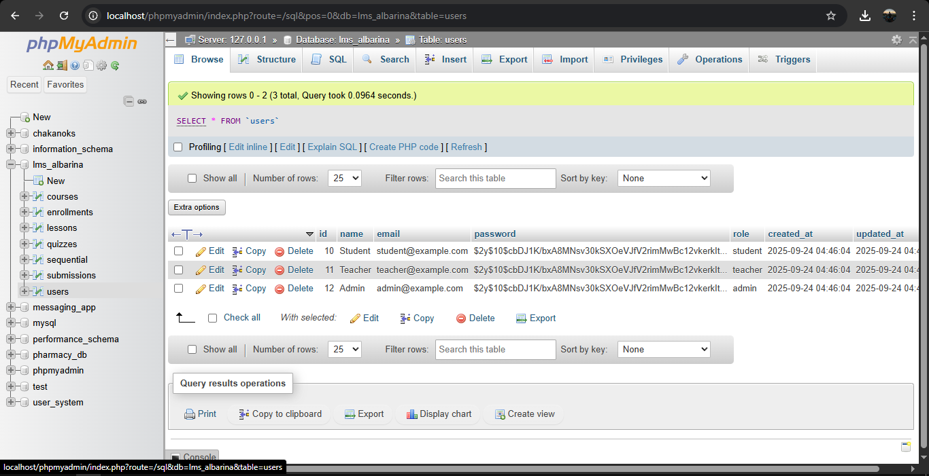
Screenshot 2:
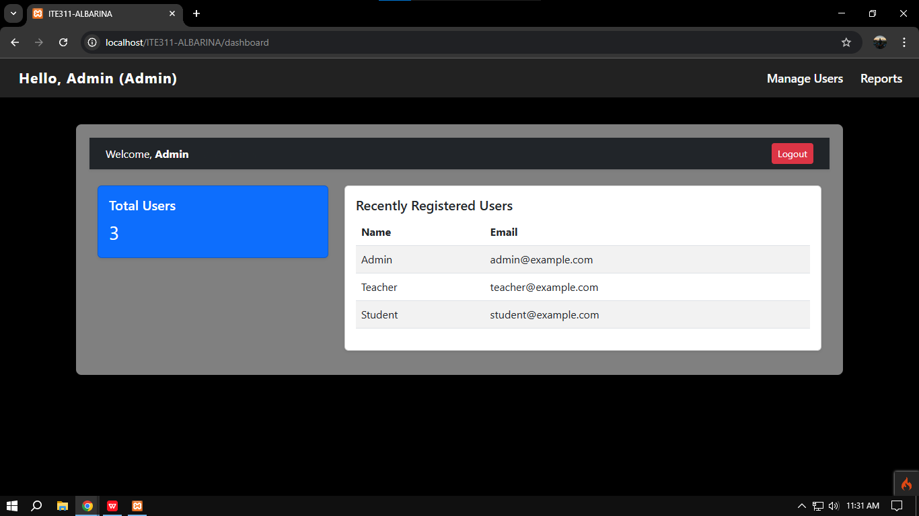
Screenshot 3:
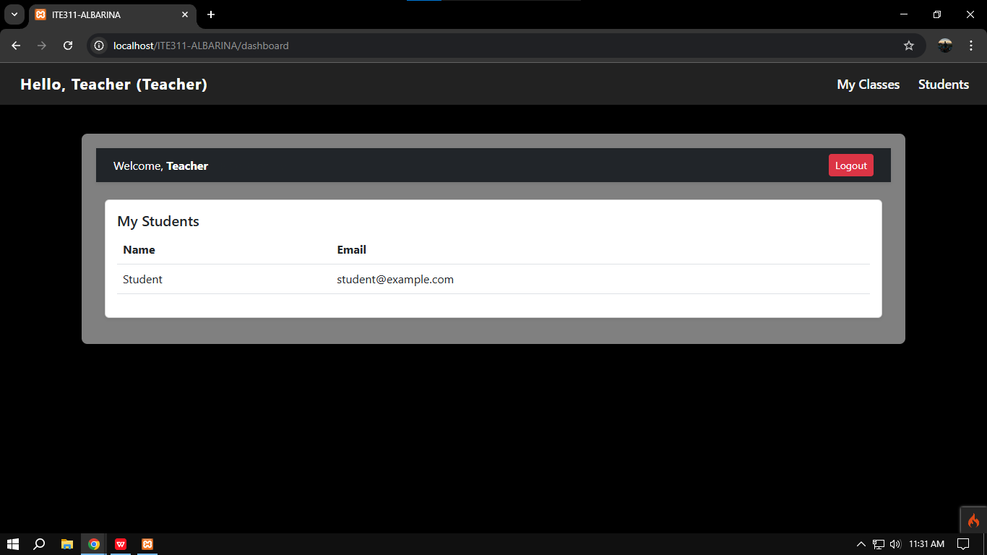
Screenshot 4:
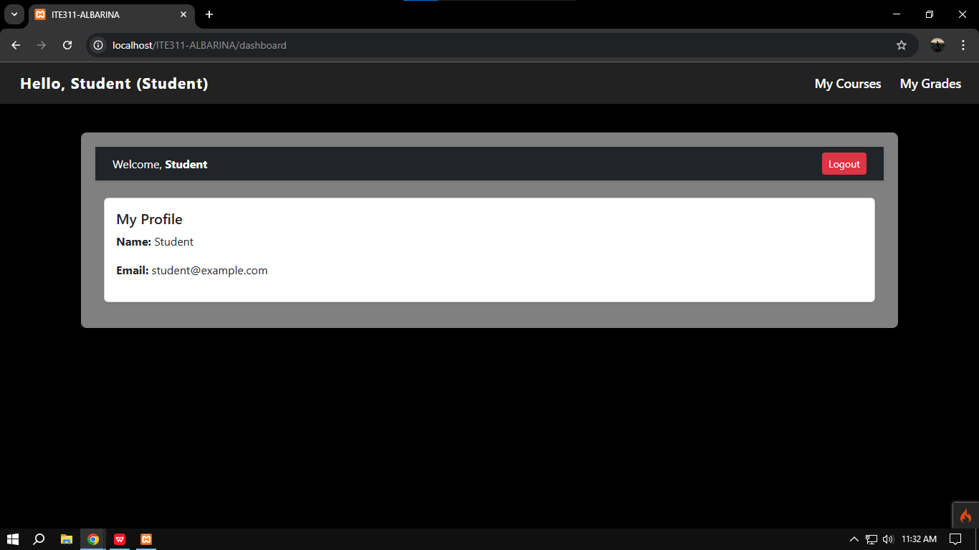
Screenshot 5:
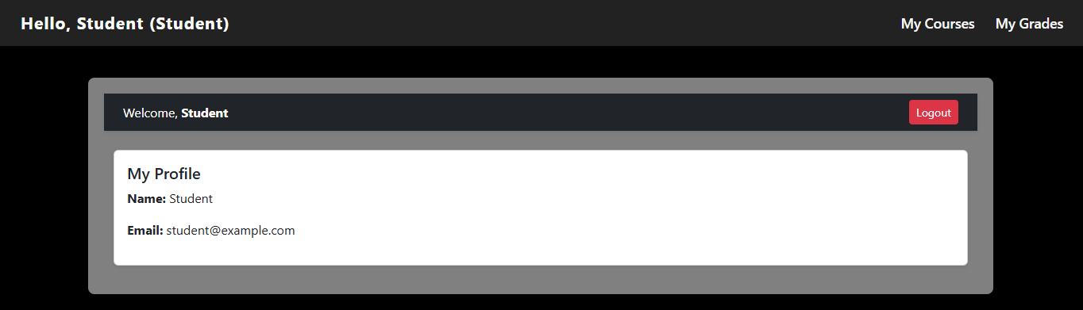
Vs
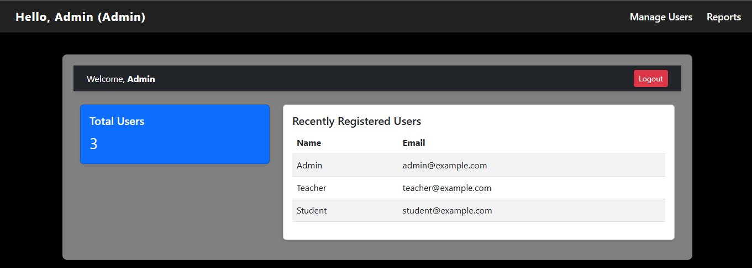
Screenshot 6:
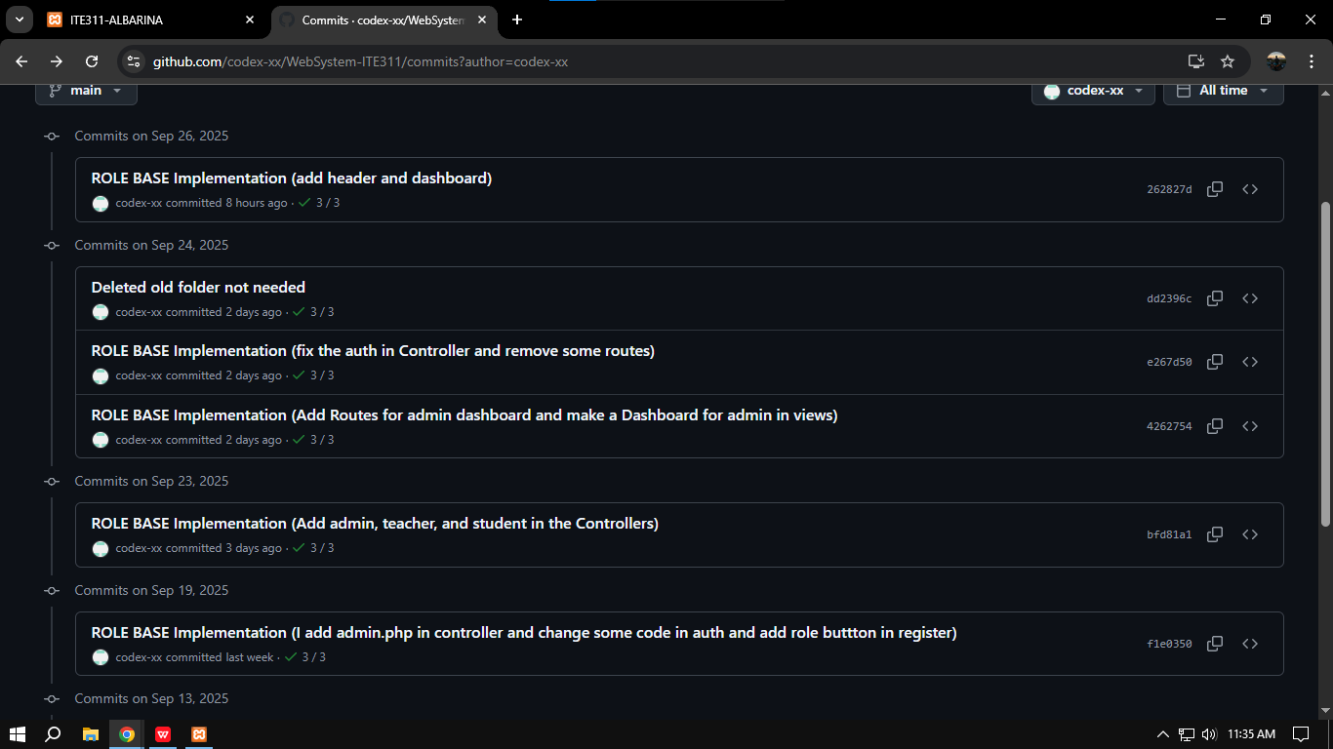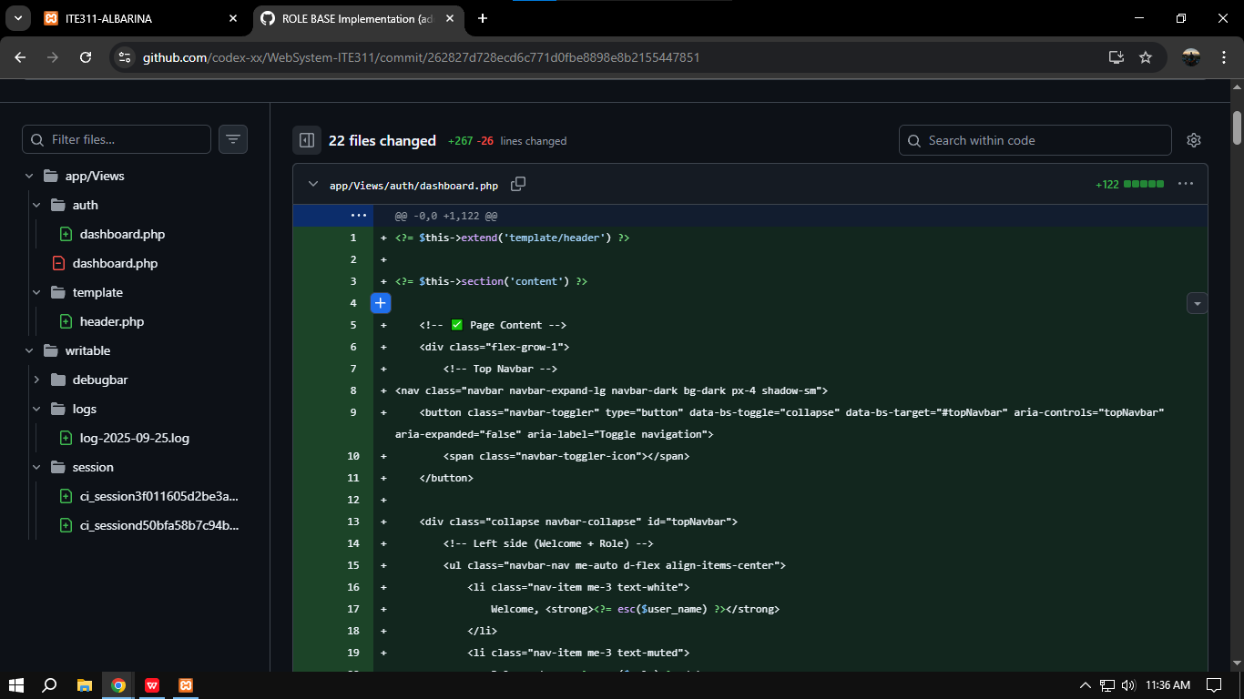

Conclusion
Authentication makes sure the right person is logging in, while authorization makes sure they only see what they’re supposed to. The session role variable ties everything together by controlling access and the dashboard experience.

