# LABORATORY EXERCISE 6

# COURSE ENROLLMENT SYSTEM

**Learning Objectives**

By the end of this laboratory exercise, students should be able to:

* Design and create a new database table to manage relationships between users and courses.
* Implement server-side logic for handling course enrollments.
* Display user-specific data (enrolled courses) in a dashboard.
* Utilize jQuery and AJAX to create a dynamic, seamless user experience without page reloads.
* Understand and implement basic foreign key relationships in a web application.

**Prerequisite student experiences and knowledge**

Before starting this exercise, students should have:

* Completed Laboratory Exercise 5 (Admin and Student Dashboards).
* A solid understanding of the MVC architecture in CodeIgniter.
* Proficiency in writing database queries using CodeIgniter's Query Builder.
* Basic knowledge of SQL relationships (one-to-many).
* Familiarity with jQuery syntax and the concept of AJAX.
* Ability to create and style front-end components with Bootstrap.

**Background**

A core feature of any Learning Management System (LMS) is the ability for students to enroll in available courses. This involves creating a relationship between the **users** table (students) and the **courses** table. This relationship is typically stored in a pivot table. To enhance user experience, the enrollment process should be dynamic, allowing students to join courses without refreshing the page. This is achieved using jQuery AJAX to send a request to the server in the background, providing immediate feedback to the user.

**Materials/Resources**

* **Personal Computer with Internet Access**
* **XAMPP/WAMP/LAMP server installed**
* **CodeIgniter Framework (latest version)**
* **Visual Studio Code or any code editor**
* **Git and GitHub Account**
* **Web Browser (Chrome, Firefox, etc.)**

**Laboratory Activity**

**Step 1: Create a Database Migration for the Enrollments Table**

1. Create a new migration file for the **enrollments** table.

Run: php spark make:migration CreateEnrollmentsTable

1. Open the newly created file in app/Database/Migrations/.
2. In the up() method, define the table with the following fields:
   * id (primary key, auto-increment)
   * user_id (int, foreign key to **users** table)
   * course_id (int, foreign key to **courses** table)
   * enrollment_date (datetime)
3. In the down() method, define how to drop the table.
4. Run the migration: php spark migrate.

**Step 2: Create the Enrollment Model**

1. Navigate to app/Models/ and create a file named EnrollmentModel.php.
2. Create a model class with methods to:

* enrollUser($data): Insert a new enrollment record.
* getUserEnrollments($user_id): Fetch all courses a user is enrolled in.
* isAlreadyEnrolled($user_id, $course_id): Check if a user is already enrolled in a specific course to prevent duplicates.

**Step 3: Modify the Course Controller**

1. Open your Course.php controller (or create it if it doesn't exist).
2. Add a new method, enroll(), to handle the AJAX request.

* This method should:
* Check if the user is logged in.
* Receive the **course_id** from the POST request.
* Check if the user is already enrolled.
* If not, insert the new enrollment record with the current timestamp.
* Return a JSON response indicating success or failure.

**Step 4: Update Student Dashboard View**

1. Open/Check the student dashboard view file.
2. Create a section to **Display Enrolled Courses**. Use a Bootstrap list group or cards to iterate over and display the courses returned by **EnrollmentModel::getUserEnrollments()**.
3. Create another section for **Available Courses**. Display a list of courses with an **Enroll** button next to each.

**Step 5: Implement AJAX Enrollment**

1. In the **Available Courses** section of the dashboard, add a **data_course_id** attribute to each **Enroll** button containing the specific course ID.
2. Include the jQuery library in your view if it's not already included.
3. Write a jQuery script that:

* Listens for a click on the **Enroll** button.
* Prevents the default form submission behavior.
* Uses **$.post()** to send the **course_id** to the /course/enroll URL.
* On a successful response from the server:
* Displays a Bootstrap alert message.
* Hides or disables the **Enroll** button for that course.
* Updates the **Enrolled Courses** list dynamically without reloading the page.

**Step 6: Configure Routes**

1. Update app/Config/Routes.php to include a route for the enrollment action.

**$routes->post('/course/enroll', 'Course::enroll');**

**Step 7: Test the Application Thoroughly**

1. Log in as a student.
2. Navigate to the student dashboard.
3. Click the **Enroll** button on an available course and verify:

* The page does not reload.
* A success message appears.
* The button becomes disabled or disappears.
* The course appears in the **Enrolled Courses** list.

**Step 8: Push to GitHub**

1. Commit your changes with a descriptive message.
2. Push your changes to your GitHub repository.

**Step 9: Vulnerable Checking**

1. Test for Authorization Bypass
   * Log out of the application and attempt to directly access the enrollment endpoint via Postman or browser console by sending a POST request to /course/enroll with a course_id parameter.
   * Verify that the server returns an unauthorized error instead of processing the enrollment.
2. Test for SQL Injection
   * While logged in, use browser developer tools to modify the AJAX request and change the course_id value to 1 OR 1=1.
   * Check if the application properly validates the input and prevents SQL injection attacks.
3. Test for CSRF (Cross-Site Request Forgery)
   * Check if your enrollment form includes CSRF protection tokens.
   * Verify that CodeIgniter's CSRF protection is enabled in app/Config/Security.php.
   * Attempt to make an enrollment request without a valid CSRF token and confirm it is rejected.
4. Test for Data Tampering
   * As a student, try to enroll another user in a course by modifying the user ID in the request.
   * Verify that the server-side code uses the logged-in user's session ID rather than trusting client-supplied user IDs.
5. Test for Input Validation
   * Attempt to enroll in non-existent courses by sending invalid course_id values.
   * Verify that the application properly validates that the course exists before creating an enrollment.

Output / Results

* Screenshot of your database's **enrollments** table structure (phpMyAdmin or equivalent).
* A screenshot of the student dashboard showing the **Available** and **Enrolled Courses** sections is attached.
* A screenshot of the browser's developer tools (Network tab) shows the successful AJAX POST request and response when enrolling in a course.
* A screenshot of the GitHub repository with the latest commit for this exercise.

**QUESTIONS:**

1. What is the purpose of the **enrollments** table? Why is it necessary, instead of just adding a **course_id** column to the **users** table?

The enrollments table functions as a junction table, sometimes referred to as a join or associative table, in a many-to-many relationship between users and courses. Many users may be enrolled in each course, and a single user may enroll in more than one course. This table is necessary for this setup. This type of link would not be supported by merely adding a course_id column to the users table. Each user could only sign up for one course if the course_id was in the users table. For any real-world learning environment, this would be extremely restrictive and unfeasible. In a similar vein, the presence of a user_id in the courses table would suggest that each course is associated with a single user.

1. Explain the role of the **isAlreadyEnrolled()** method in the Model. What potential issue does it prevent?

The isAlreadyEnrolled() function must be used to preserve user experience and data integrity. This technique, which typically resides in the application's Model layer, determines whether a user is already enrolled in a particular course before permitting them to re-enroll. To ensure that each user can only enroll once per course, the system calls isAlreadyEnrolled() before adding a new enrollment record. By doing this, redundancy is eliminated and the possibility of bugs in other areas of the application is reduced. The enrollments table would be significantly more likely to contain duplicate entries without it.

1. Describe the client-side and server-side steps when students click the **Enroll** button until they receive confirmation.

When a student clicks the Enroll button, the client side sends a request to the server with the user's and course's details. A loading indicator may appear while the request is processed. On the server side, the system checks if the user is logged in. Then, it uses the isAlreadyEnrolled() method to see if the user is already registered. If they are, an error message is created. If not, a new enrollment entry is added. The server then sends a response back. The client refreshes the UI and shows a success message or notifies the user if they are already enrolled. This process ensures a smooth, accurate, and duplicate-free enrollment experience.

**Output / Results**

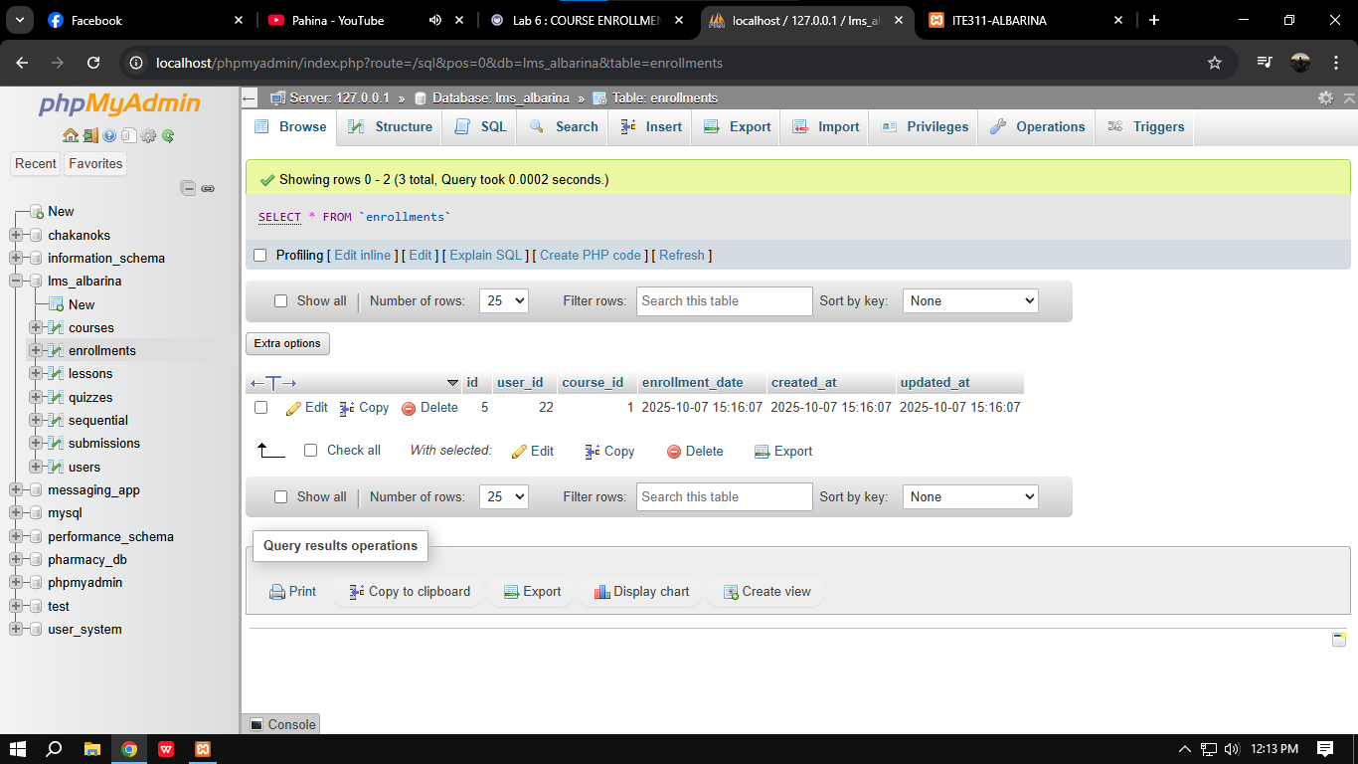

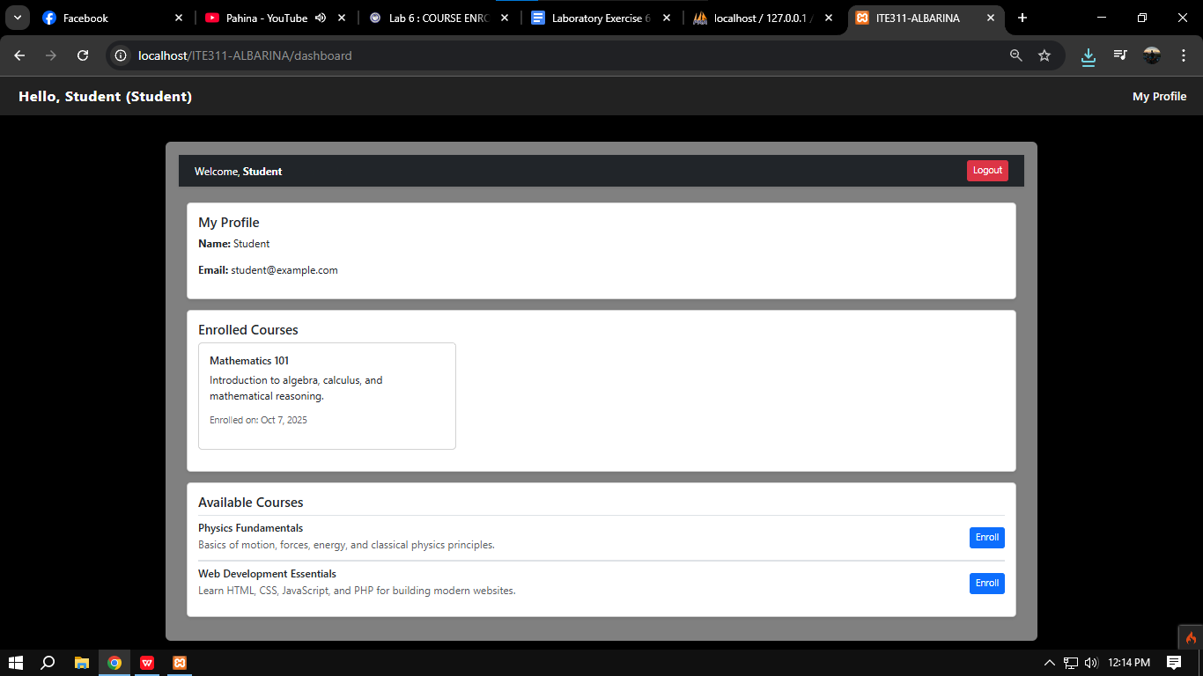

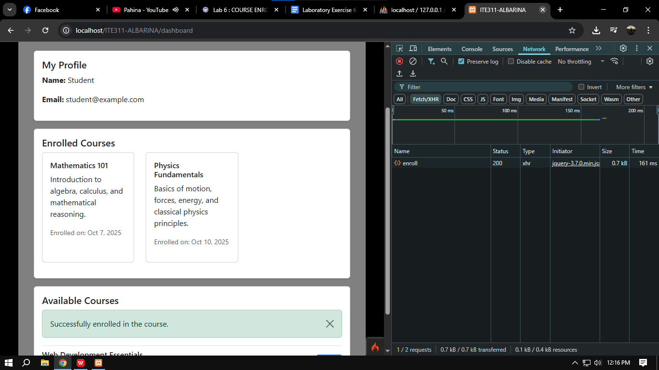

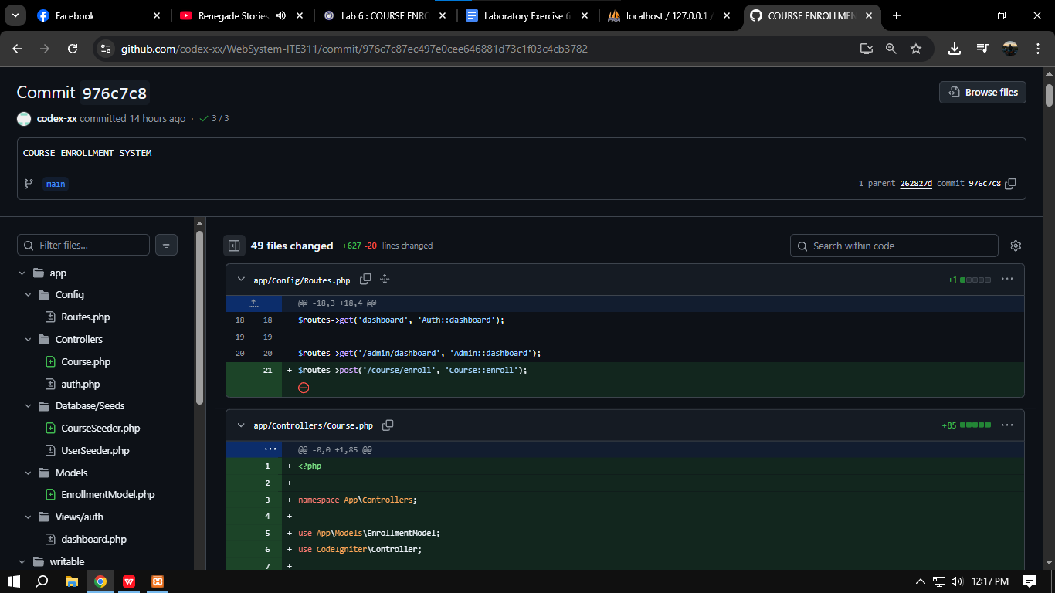

**Conclusion**

The enrollments table is an important part of the database setup for any educational platform. It offers a flexible and scalable method to manage user-course interactions. By removing unnecessary operations, the isAlreadyEnrolled() method improves the user experience and keeps data secure. Emphasizing security, responsiveness, and user-centered design, the process from clicking the Enroll button to receiving the final confirmation shows how crucial effective client-server communication is. Together, these components make a reliable and scalable enrollment system.