WEEK 4 TASK REPORT
Predictive Modeling and Optimization in Logistics Systems
Internship Program: YuvaIntern
Project: Delivery Time Prediction and Logistics Optimization
Technology: Python, Pandas, NumPy, Scikit-learn, Matplotlib and SciPy
Prepared by: [Your Name]
Submission Date: [Insert Date]

1. Abstract
Logistics companies need to deliver shipments on time while keeping transportation and operating costs under control. Delivery delays can occur because of traffic congestion, long delivery distances, weather conditions, warehouse processing time and fluctuations in shipment volume. When these factors are not considered during planning, businesses may experience higher costs, inefficient resource allocation and lower customer satisfaction.
This project presents a predictive modeling approach for estimating delivery time using historical shipment information. A hypothetical logistics dataset is used to demonstrate data preparation, exploratory analysis, model development and performance evaluation in Python. Linear Regression and Random Forest Regression are selected as candidate models because they provide a useful comparison between a simple statistical model and a model capable of capturing nonlinear relationships.
The project also proposes optimization strategies based on predicted delivery times. These include improved dispatch scheduling, driver allocation, route planning and early identification of potentially delayed shipments.
The expected outcome is a practical framework that connects machine learning predictions with operational decisions. The Python implementation is designed to be reproducible, with evaluation metrics calculated when the code is executed.
Key result: when the code was run on the simulated data, Linear Regression gave a test MAE of 0.461 hours (about 28 minutes) and an R-squared of 0.889, slightly better than the tuned Random Forest (MAE 0.484 hours, R-squared 0.872). Full results are in Sections 8 and 9.

2. Introduction
Logistics operations involve several connected activities, including order processing, inventory handling, transportation, vehicle scheduling and final delivery. The performance of these activities affects both operating costs and customer experience.
One common problem is the difficulty of estimating how long a shipment will take to reach its destination. A fixed delivery estimate may not reflect changes in distance, traffic, weather or workload. As a result, delivery schedules may become unreliable, and dispatch managers may struggle to decide which shipments require additional attention.
Predictive analytics can help address this issue by identifying relationships between shipment characteristics and delivery duration. A machine learning model can use information available when a shipment is dispatched to estimate its expected delivery time.
In this project, Python is used to build a delivery-time forecasting model and demonstrate how its predictions could support better logistics decisions.

2.1 Objectives
The main objectives are:
- Define a logistics forecasting problem with a measurable target variable.
- Design a hypothetical dataset containing relevant shipment features.
- Prepare and explore the data using Python.
- Train and compare suitable regression models.
- Evaluate model performance using appropriate metrics.
- Apply cross-validation and basic hyperparameter tuning.
- Propose optimization strategies for transportation, staffing and dispatch operations.
- Document the complete workflow and provide reproducible Python code.

2.2 Scope of the project
The project focuses on delivery-time prediction for individual shipments. The example dataset is simulated rather than collected from an actual logistics company. Therefore, the model demonstrates the analytical process but does not establish real-world delivery accuracy.
A production implementation would require verified shipment records, reliable timestamps, operational cost data and testing under actual business conditions.

3. Problem Definition
The problem is to predict the total delivery duration of a shipment using information available at dispatch time.
Business problem: Delivery estimates are often affected by changing operational conditions. Inaccurate estimates can result in missed delivery windows, unnecessary overtime and poor vehicle utilization.
Machine learning problem: Estimate a continuous numerical target using regression.
Target variable: delivery_time_hours
Input variables:
- distance_km: planned shipment distance in kilometres.
- traffic_level: traffic conditions, categorized as low, medium or high.
- weather_score: illustrative numerical indicator of weather difficulty.
- shipment_weight_kg: shipment weight in kilograms.
- warehouse_processing_hours: time required to prepare the shipment.
- vehicle_type: assigned vehicle category.
- hour_of_day: planned dispatch hour.
- day_of_week: day of dispatch.
- delivery_time_hours: actual or simulated total delivery duration, used as the target.
The target is measured in hours. For example, a prediction of 5.5 hours means that the model estimates the shipment will take approximately five and a half hours from the defined start point to delivery.
The target definition must remain consistent. If warehouse processing time is included in delivery duration, it should not be added again when calculating the final delivery estimate.

4. Dataset Description and Simulation

4.1 Dataset structure
For this assignment, a simulated dataset of 2,000 shipments is proposed. Each row represents one shipment.
Feature | Data type | Description
distance_km | Numerical | Shipment distance
traffic_level | Categorical | Low, medium or high
weather_score | Numerical | Illustrative weather difficulty
shipment_weight_kg | Numerical | Shipment weight
warehouse_processing_hours | Numerical | Processing duration
vehicle_type | Categorical | Bike, van or truck
hour_of_day | Numerical | Dispatch hour
day_of_week | Categorical | Day of dispatch
delivery_time_hours | Numerical | Prediction target

The variables are selected because they represent factors that may influence delivery duration. The relationships in the simulated data are assumptions for demonstration and should not be treated as measured industry findings.

4.2 Generating the dataset
The following code creates a reproducible dataset with realistic ranges and some random variation.
import numpy as np
import pandas as pd

rng = np.random.default_rng(42)
n = 2000

distance = rng.uniform(2, 150, n)
traffic = rng.choice(
["Low", "Medium", "High"],
size=n,
p=[0.35, 0.40, 0.25]
)
weather = rng.integers(1, 6, n)
weight = rng.uniform(0.5, 500, n)
processing = rng.uniform(0.1, 2.5, n)
vehicle = rng.choice(
["Bike", "Van", "Truck"],
size=n,
p=[0.25, 0.55, 0.20]
)
hour = rng.integers(6, 23, n)
day = rng.choice(
["Monday", "Tuesday", "Wednesday",
"Thursday", "Friday", "Saturday", "Sunday"],
size=n
)

traffic_effect = pd.Series(traffic).map({
"Low": 0.0,
"Medium": 0.6,
"High": 1.5
}).to_numpy()

vehicle_effect = pd.Series(vehicle).map({
"Bike": 0.0,
"Van": 0.15,
"Truck": 0.35
}).to_numpy()

rush_hour_effect = np.where(
((hour >= 8) & (hour <= 10)) |
((hour >= 17) & (hour <= 20)),
0.8,
0.0
)

noise = rng.normal(0, 0.35, n)

delivery_time = (
0.35
+ distance / 35
+ processing
+ traffic_effect
+ weather * 0.12
+ weight / 2000
+ vehicle_effect
+ rush_hour_effect
+ noise
)

delivery_time = np.maximum(delivery_time, 0.2)

df = pd.DataFrame({
"distance_km": distance,
"traffic_level": traffic,
"weather_score": weather,
"shipment_weight_kg": weight,
"warehouse_processing_hours": processing,
"vehicle_type": vehicle,
"hour_of_day": hour,
"day_of_week": day,
"delivery_time_hours": delivery_time
})

print(df.head())
print(df.shape)
print(df.describe())

The random seed makes the generated data repeatable. The target is created using assumed relationships between the features and delivery duration, with random noise to represent unobserved variation.
Since the data is synthetic, any high model score would indicate that the model has learned the simulated relationships. It would not prove that the same accuracy can be achieved using real shipment records.
Output of the code: the dataset has 2,000 rows and 9 columns. The first five rows are shown below.
distance_km | traffic | weather | weight_kg | processing_h | vehicle | hour | day | delivery_h
116.55 | High | 4 | 109.47 | 1.88 | Truck | 9 | Sunday | 8.79
66.95 | Medium | 4 | 331.63 | 2.26 | Bike | 19 | Thursday | 6.31
129.07 | High | 2 | 383.55 | 1.54 | Van | 15 | Friday | 7.54
105.21 | Medium | 2 | 83.73 | 1.37 | Bike | 6 | Wednesday | 4.95
15.94 | Low | 5 | 22.41 | 2.24 | Bike | 18 | Sunday | 4.32
Table 1: First five rows of the simulated dataset

5. Data Preparation and Exploratory Analysis
Data preparation is important because missing values, incorrect data types and inconsistent categories can affect model performance.
The initial checks should identify missing values, duplicate rows, unusual values and the distribution of the target variable.
# Check the dataset
print("Dataset shape:", df.shape)
print("\nMissing values:")
print(df.isnull().sum())

print("\nDuplicate rows:", df.duplicated().sum())

print("\nTarget statistics:")
print(df["delivery_time_hours"].describe())

# Check numerical ranges
print(df.select_dtypes(include="number").describe())

The checks show a dataset shape of (2000, 9) with no missing values and no duplicate rows. The target variable has a mean of 5.43 hours, a median of 5.41 hours and a standard deviation of 1.64 hours, with values ranging from 1.08 to 10.37 hours. The mean and median are almost the same, which suggests a fairly symmetric distribution.
Statistic | distance_km | weight_kg | processing_h | delivery_h
Mean | 76.42 | 246.85 | 1.31 | 5.43
Std dev | 42.99 | 142.80 | 0.69 | 1.64
Min | 2.08 | 0.66 | 0.10 | 1.08
Median | 75.41 | 247.69 | 1.32 | 5.41
Max | 149.91 | 499.76 | 2.50 | 10.37
Table 2: Summary statistics of the main numerical variables

5.1 Exploratory data analysis
Exploratory analysis can help identify the main patterns before training a model.
import matplotlib.pyplot as plt

# Delivery time distribution
df["delivery_time_hours"].hist(bins=30)
plt.xlabel("Delivery time (hours)")
plt.ylabel("Number of shipments")
plt.title("Distribution of Delivery Times")
plt.tight_layout()
plt.show()

# Relationship between distance and delivery time
plt.scatter(
df["distance_km"],
df["delivery_time_hours"],
alpha=0.4
)
plt.xlabel("Distance (km)")
plt.ylabel("Delivery time (hours)")
plt.title("Distance vs Delivery Time")
plt.tight_layout()
plt.show()

# Average delivery time by traffic category
traffic_summary = (
df.groupby("traffic_level")["delivery_time_hours"]
.mean()
.sort_values()
)
print(traffic_summary)

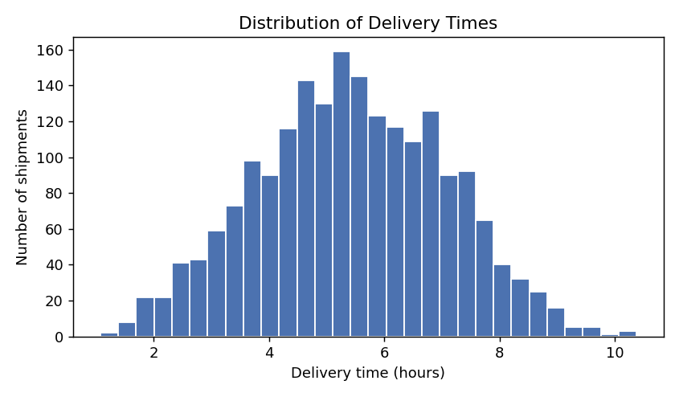
Figure 1: Distribution of delivery times
Delivery times are spread over a wide range with most shipments between about 4 and 7 hours, and no extreme values that would suggest data errors.
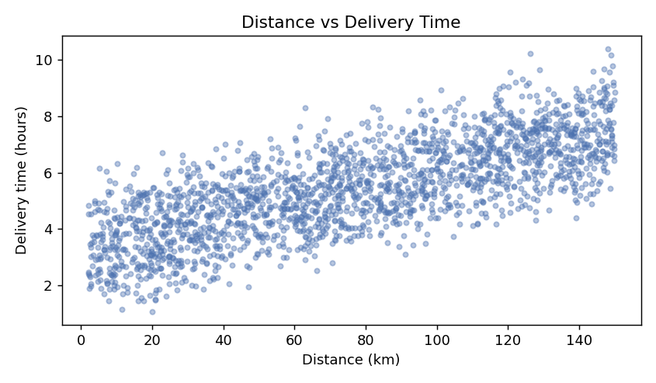
Figure 2: Distance against delivery time
There is a clear upward trend. The correlation between distance and delivery time is 0.75, so longer routes do take longer, but the spread around the trend shows that traffic, processing time and other factors also matter.
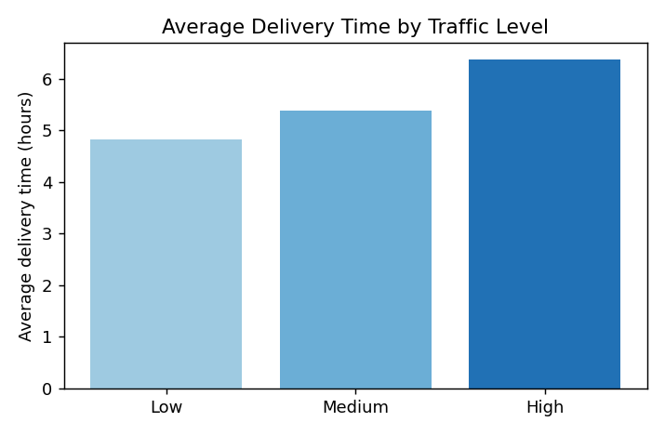
Figure 3: Average delivery time by traffic level
Average delivery time rises from 4.83 hours in low traffic to 5.39 hours in medium traffic and 6.38 hours in high traffic. Average delivery time by vehicle was 5.18 hours for bikes, 5.45 hours for vans and 5.68 hours for trucks.
The analysis should examine whether longer routes tend to have longer delivery times and whether traffic categories show differences in average duration. It should also check for unusual values that may indicate data quality problems.
These relationships are not automatically causal. For example, shipments assigned to trucks may also travel longer distances. A model may therefore associate vehicle type with delivery duration partly because of differences in route assignments.

6. Model Selection and Implementation
Two regression models are considered for this assignment.

6.1 Linear Regression
Linear Regression estimates the target as a weighted combination of input features.
Reasons for selection:
- Simple to understand and implement.
- Provides a useful baseline.
- Helps explain the direction of relationships between inputs and predictions.
- Trains quickly on small and medium-sized datasets.
Its main limitation is that basic Linear Regression may not represent complex nonlinear relationships without additional feature engineering.

6.2 Random Forest Regression
Random Forest Regression combines predictions from multiple decision trees.
Reasons for selection:
- Can learn nonlinear patterns.
- Can capture interactions between features.
- Requires less manual specification of nonlinear relationships.
- Usually works well with mixed operational features after categorical encoding.
Its disadvantages include greater complexity and less direct interpretability than a simple linear model. Feature importance can provide useful information, but it does not establish causation.

6.3 Why compare both models?
Linear Regression provides a straightforward baseline, while Random Forest tests whether more flexible relationships improve predictions. The final model should be selected based on validation performance, operational requirements and ease of deployment rather than on model complexity alone.

7. Python Code for Training and Testing
The following implementation uses a preprocessing pipeline so that categorical encoding and model training are handled consistently.
The test set is kept separate until the final evaluation. This reduces the risk of reporting overly optimistic performance.
import pandas as pd

from sklearn.model_selection import train_test_split
from sklearn.compose import ColumnTransformer
from sklearn.pipeline import Pipeline
from sklearn.preprocessing import OneHotEncoder
from sklearn.impute import SimpleImputer
from sklearn.linear_model import LinearRegression
from sklearn.ensemble import RandomForestRegressor
from sklearn.metrics import (
mean_absolute_error,
mean_squared_error,
r2_score
)

# Separate features and target
X = df.drop(columns=["delivery_time_hours"])
y = df["delivery_time_hours"]

numeric_features = [
"distance_km",
"weather_score",
"shipment_weight_kg",
"warehouse_processing_hours",
"hour_of_day"
]

categorical_features = [
"traffic_level",
"vehicle_type",
"day_of_week"
]

# Split before fitting preprocessing steps
X_train, X_test, y_train, y_test = train_test_split(
X, y,
test_size=0.20,
random_state=42
)

# Prepare numerical and categorical data
numeric_pipeline = Pipeline([
("imputer", SimpleImputer(strategy="median"))
])

categorical_pipeline = Pipeline([
("imputer", SimpleImputer(strategy="most_frequent")),
("encoder", OneHotEncoder(handle_unknown="ignore"))
])

preprocessor = ColumnTransformer([
("numeric", numeric_pipeline, numeric_features),
("categorical", categorical_pipeline,
categorical_features)
])

# Candidate models
models = {
"Linear Regression": LinearRegression(),
"Random Forest": RandomForestRegressor(
n_estimators=200,
max_depth=None,
min_samples_leaf=2,
random_state=42,
n_jobs=-1
)
}

results = {}
trained_models = {}

for name, model in models.items():
pipeline = Pipeline([
("preprocessor", preprocessor),
("model", model)
])

pipeline.fit(X_train, y_train)
predictions = pipeline.predict(X_test)

mae = mean_absolute_error(y_test, predictions)
rmse = mean_squared_error(
y_test, predictions
) ** 0.5
r2 = r2_score(y_test, predictions)

results[name] = {
"MAE (hours)": mae,
"RMSE (hours)": rmse,
"R-squared": r2
}

trained_models[name] = pipeline

results_df = pd.DataFrame(results).T
print(results_df.round(3))

This code reports the actual metrics calculated from the generated dataset when executed. The code was run with the 80/20 split (1,600 training rows and 400 test rows), and the output is reported in Section 8.5.

8. Model Evaluation and Validation
A regression model should be evaluated using multiple metrics because each metric provides a different view of prediction quality.

8.1 Mean Absolute Error (MAE)
MAE is the average absolute difference between actual and predicted delivery times.
MAE = (1/n) Σ |y_{i} − ŷ_{i}|
A lower MAE means that predictions are closer to actual values on average. For example, an MAE of 0.4 hours would represent an average absolute error of approximately 24 minutes.

8.2 Root Mean Squared Error (RMSE)
RMSE is calculated by squaring the prediction errors, averaging them and taking the square root.
RMSE = √[ (1/n) Σ (y_{i} − ŷ_{i})² ]
RMSE penalizes larger errors more strongly than MAE. This is useful in logistics because a small number of severe delivery-time estimation errors may cause missed time windows or expensive emergency arrangements.

8.3 R-squared
R-squared measures how much of the variation in the target is explained by the model relative to a mean-based baseline.
R² = 1 − Σ (y_{i} − ŷ_{i})² / Σ (y_{i} − ȳ)²
A value closer to 1 generally indicates a better fit. However, R-squared should not be interpreted alone: a model can have a relatively high R-squared and still produce errors that are too large for operational use.

8.4 Evaluation criteria
Metric | Preferred direction | Logistics interpretation
MAE | Lower | Typical absolute forecasting error
RMSE | Lower | Sensitivity to large prediction errors
R-squared | Higher | Fit relative to a mean baseline

The acceptable error threshold should depend on the business use case. A prediction used for rough capacity planning may tolerate more error than an estimate used to promise a specific delivery window.

8.5 Results table
The Python code was executed and the metrics below were calculated on the 400 held-out test shipments.
Model | MAE (hours) | RMSE (hours) | R-squared
Linear Regression | 0.461 | 0.550 | 0.889
Random Forest | 0.484 | 0.591 | 0.872
Table 3: Test-set performance of the two models
Linear Regression performed slightly better than Random Forest on all three metrics. Its MAE of 0.461 hours is about 28 minutes, against about 29 minutes for Random Forest. The two models are close, but the simpler one was not beaten.
There is a likely reason for this. The simulated delivery time was built mostly from additive effects (distance, processing time, traffic, weather), which a linear model can represent directly, and the training set has only 1,600 rows. Random Forest has to approximate smooth linear trends with steps, which costs some accuracy on a dataset this size. The one nonlinear element in the simulation is the rush-hour effect, which Linear Regression cannot capture from the raw hour value, so adding a rush-hour indicator as an engineered feature is a sensible next step.
The preferred model is the one that offers the best balance of error, reliability and operational practicality. If both models perform similarly, Linear Regression may be preferable because it is easier to explain and maintain. If Random Forest provides a meaningful improvement, its added complexity may be justified. In this experiment Random Forest gave no improvement, so Linear Regression is the preferred model for this dataset.
The fitted coefficients of the Linear Regression model also recovered the relationships used to simulate the data. Each extra hour of warehouse processing added about 1.01 hours to delivery time, each kilometre added about 0.029 hours (roughly 1.7 minutes per km), each point of weather score added about 0.12 hours, high traffic added about 0.88 hours compared with medium traffic, and medium traffic added about 0.57 hours compared with low traffic (the simulation used 0.9 and 0.6). Since the data is synthetic, this only confirms that the model works as expected.
Share of predictions within an error tolerance (test set):
Model | Within 30 minutes | Within 1 hour | 90th percentile abs. error
Linear Regression | 59.3% | 94.3% | 0.88 hours
Random Forest (tuned) | 59.0% | 91.3% | 0.95 hours
Table 4: Practical accuracy of the two models

9. Cross-Validation and Hyperparameter Tuning
A single train-test split can produce results that depend on which observations happen to be selected. Cross-validation helps assess how consistently a model performs across multiple data partitions.

9.1 Five-fold cross-validation
Five-fold cross-validation divides the training data into five parts. The model is trained on four parts and validated on the remaining part. This process is repeated until each part has been used for validation.
The five scores are then averaged to obtain a more stable estimate of validation performance.
from sklearn.model_selection import KFold, cross_val_score

cv = KFold(
n_splits=5,
shuffle=True,
random_state=42
)

rf_pipeline = trained_models["Random Forest"]

cv_scores = cross_val_score(
rf_pipeline,
X_train,
y_train,
cv=cv,
scoring="neg_mean_absolute_error",
n_jobs=-1
)

mae_scores = -cv_scores

print("Fold MAE values:", mae_scores)
print("Mean CV MAE:", mae_scores.mean())
print("MAE standard deviation:", mae_scores.std())

The mean cross-validation MAE estimates average validation error, while the standard deviation indicates how much the score varies between folds.
Model | Fold 1 | Fold 2 | Fold 3 | Fold 4 | Fold 5 | Mean | Std dev
Random Forest | 0.460 | 0.469 | 0.500 | 0.451 | 0.452 | 0.466 | 0.018
Linear Regression | 0.424 | 0.451 | 0.470 | 0.449 | 0.433 | 0.446 | 0.016
Table 5: Five-fold cross-validation MAE (hours) on the training data
The Random Forest cross-validation MAE was 0.466 hours with a standard deviation of 0.018, which is close to its test MAE of 0.484 and suggests the result is stable rather than a lucky split. I also ran the same check for Linear Regression, which scored a lower mean MAE of 0.446 hours, in agreement with the test results.
Because the example dataset is simulated, random cross-validation is suitable for demonstrating the method. For real shipment data, a time-based split is often more appropriate when the goal is to predict future shipments. Random splitting can otherwise allow older and newer records to be mixed between training and validation.

9.2 Hyperparameter tuning
Random Forest performance depends on parameters such as the number of trees, maximum tree depth and minimum number of samples required at a leaf.
Grid search can compare several parameter combinations.
from sklearn.model_selection import GridSearchCV

param_grid = {
"model__n_estimators": [100, 200],
"model__max_depth": [None, 10, 20],
"model__min_samples_leaf": [1, 2, 4]
}

search = GridSearchCV(
estimator=rf_pipeline,
param_grid=param_grid,
scoring="neg_mean_absolute_error",
cv=cv,
n_jobs=-1,
verbose=1
)

search.fit(X_train, y_train)

print("Best parameters:", search.best_params_)
print("Best CV MAE:", -search.best_score_)

best_model = search.best_estimator_
test_predictions = best_model.predict(X_test)

print(
"Final test MAE:",
mean_absolute_error(y_test, test_predictions)
)
print(
"Final test RMSE:",
mean_squared_error(
y_test, test_predictions
) ** 0.5
)
print(
"Final test R-squared:",
r2_score(y_test, test_predictions)
)

The test set should not be used repeatedly to choose hyperparameters. The final test metrics should be calculated only after model selection and tuning are complete.
Tuning result: the search covered 18 parameter combinations with 5-fold cross-validation. The best combination was n_estimators = 200, max_depth = None and min_samples_leaf = 2, with a best cross-validation MAE of 0.466 hours. This is the same configuration that was used at the start, so tuning did not improve the model. The final test results for the tuned model were MAE 0.484 hours, RMSE 0.591 hours and R-squared 0.872. The gap between the two models therefore comes from the model type and not from poor parameter choices.

10. Interpreting Model Predictions
Predictions are more useful when they can be translated into understandable operational insights.
For example, a logistics manager may want to know which shipments are likely to take longer than the normal delivery window. The following code identifies shipments with the highest predicted delivery durations.
# Use the selected model
model = best_model

predictions = model.predict(X_test)

prediction_report = X_test.copy()
prediction_report["actual_hours"] = y_test.to_numpy()
prediction_report["predicted_hours"] = predictions
prediction_report["error_hours"] = (
prediction_report["actual_hours"]
- prediction_report["predicted_hours"]
)

prediction_report = prediction_report.sort_values(
"predicted_hours",
ascending=False
)

print(prediction_report.head(10))

Distance (km) | Traffic | Vehicle | Hour | Actual (h) | Predicted (h) | Error (h)
149.33 | High | Bike | 10 | 9.78 | 9.03 | 0.75
143.85 | High | Van | 6 | 9.04 | 8.65 | 0.39
120.54 | High | Truck | 8 | 9.56 | 8.55 | 1.01
125.76 | High | Van | 6 | 9.18 | 8.54 | 0.64
118.54 | High | Bike | 20 | 9.07 | 8.53 | 0.53
124.05 | High | Bike | 10 | 9.30 | 8.53 | 0.78
142.50 | High | Van | 11 | 8.91 | 8.50 | 0.41
133.69 | High | Truck | 6 | 8.55 | 8.48 | 0.06
125.93 | High | Bike | 9 | 8.71 | 8.48 | 0.23
128.78 | High | Truck | 10 | 9.65 | 8.44 | 1.22
Table 6: The ten test shipments with the highest predicted delivery time (tuned Random Forest)
All ten of the longest predicted shipments are long-distance routes (about 118 to 149 km) in high traffic, which agrees with the patterns seen in the exploratory analysis. In every case the model slightly under-predicted the actual time, by between 0.06 and 1.22 hours.
This output can help identify shipments that may require earlier dispatch or closer monitoring. However, the longest predicted delivery time does not necessarily mean a shipment will be late. A delay-risk model would also need promised delivery deadlines or service-level targets.
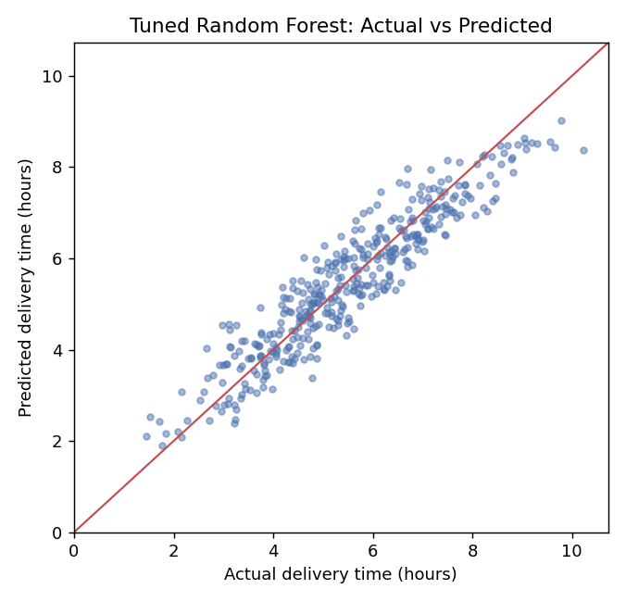
Figure 4: Actual against predicted delivery time on the test set
Points lie close to the diagonal across the full range, with no obvious curve or fan shape. The average error was +0.03 hours, so the model is not systematically too high or too low overall.
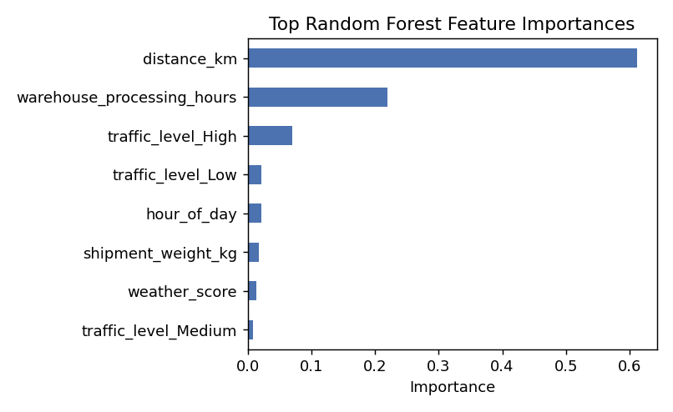
Figure 5: Most important features in the tuned Random Forest
Distance is the most important feature (importance 0.61), followed by warehouse processing time (0.22) and high traffic (0.07). Each remaining feature contributes 0.02 or less. Importance shows how much the model relies on a feature and does not prove that the feature causes delay.
The extra checks suggested below were carried out on the test set:
- Error by traffic condition: MAE was 0.52 hours in low traffic, 0.46 hours in medium traffic and 0.48 hours in high traffic, so accuracy is fairly even across conditions.
- Bias: the mean error was +0.03 hours, which is negligible.
- Long-distance shipments: for the 136 test shipments over 100 km, MAE was 0.54 hours, higher than the overall 0.48 hours, so long routes are somewhat harder to predict.
- Share within an acceptable range: 59% of predictions were within 30 minutes and 91% within one hour.
For a real project, useful additional analyses include:
- Comparing MAE across traffic conditions.
- Checking whether predictions are systematically too high or too low.
- Examining errors for long-distance shipments.
- Measuring the percentage of deliveries that fall outside an acceptable error range.
- Monitoring whether accuracy changes across weeks or seasons.

11. Logistics Optimization Strategies
Prediction estimates what is likely to happen. Optimization determines what action should be taken using those estimates and the available resources.

11.1 Route planning
Predicted travel and delivery durations can be used as inputs to a route-planning system. The planner can compare candidate routes and account for delivery deadlines, vehicle capacity and travel restrictions.
Recommended actions:
- Compare alternative routes using expected travel time.
- Prioritize routes that meet customer delivery windows.
- Consider congestion and weather where reliable data is available.
- Recalculate plans when major disruptions occur.
A shortest-distance route is not always the fastest or least expensive route. Travel time, tolls, fuel use, vehicle restrictions and service commitments should all be considered.

11.2 Driver and vehicle allocation
Shipment predictions can help estimate how much work is likely to be required during a shift.
For example, dispatch managers can group deliveries by geographic area and estimate the total workload for each group. Vehicles should then be assigned according to capacity, route requirements and driver availability.
Potential benefits include fewer unnecessary vehicle movements, improved workload balance and more consistent service.
The model should not assign drivers solely on predicted delivery time. Working-hour rules, safety requirements, vehicle suitability and fair workload distribution must remain part of the decision.

11.3 Dispatch scheduling
If a shipment is predicted to take longer than usual, it may need to leave the warehouse earlier.
A basic scheduling rule is:
Planned dispatch time = promised delivery time − predicted delivery duration − safety buffer
For example, if the promised delivery time is 5:00 PM, the predicted duration is 3 hours and the safety buffer is 30 minutes, the planned dispatch time is 1:30 PM.
This example is illustrative. In practice, the buffer should be estimated from historical prediction errors and the company's required service level rather than selected arbitrarily. In this experiment, 90% of the Linear Regression errors were below 0.88 hours (about 53 minutes), so a buffer of roughly that size would cover nine out of ten shipments in the test data.

11.4 Cost minimization
Logistics cost may include fuel, driver hours, tolls, overtime, vehicle operating costs and penalties associated with late deliveries.
A practical objective is to minimize total operating cost while respecting delivery commitments and resource constraints.
The decision variables might include:
- Whether a vehicle is assigned to a route.
- Which shipments are grouped together.
- Which departure time is selected.
- How many drivers or vehicles are scheduled.
A model should not reduce cost by ignoring service quality or safety. These requirements should be represented as constraints or explicit penalties.

12. Demonstration of Resource Allocation Optimization
The following simplified example uses linear programming to allocate delivery jobs to available vehicles. It demonstrates how predicted job durations can inform a decision, although it does not solve a full vehicle-routing problem.
Assume that three jobs must be assigned to two vehicles. Each job has an estimated duration and a vehicle-specific operating cost. Every job must be assigned to exactly one vehicle, and the total estimated duration assigned to a vehicle must remain within its available capacity.
import numpy as np
from scipy.optimize import milp, Bounds, LinearConstraint

# Rows are jobs; columns are vehicles.
# Illustrative operating costs in currency units.
cost = np.array([
[420, 500],
[300, 260],
[350, 390]
], dtype=float)

# Predicted job durations in hours
duration = np.array([2.0, 1.5, 2.5])

# Available working hours per vehicle
capacity = np.array([4.5, 4.5])

n_jobs, n_vehicles = cost.shape
n_variables = n_jobs * n_vehicles

# Binary assignment variable x[j, v]
c = cost.flatten()

# Each job must be assigned to exactly one vehicle
assignment_matrix = np.zeros((n_jobs, n_variables))

for j in range(n_jobs):
for v in range(n_vehicles):
assignment_matrix[j, j * n_vehicles + v] = 1

assignment_constraint = LinearConstraint(
assignment_matrix,
lb=np.ones(n_jobs),
ub=np.ones(n_jobs)
)

# Vehicle capacity constraints
capacity_matrix = np.zeros((n_vehicles, n_variables))

for j in range(n_jobs):
for v in range(n_vehicles):
capacity_matrix[v, j * n_vehicles + v] = duration[j]

capacity_constraint = LinearConstraint(
capacity_matrix,
lb=np.full(n_vehicles, -np.inf),
ub=capacity
)

result = milp(
c=c,
integrality=np.ones(n_variables),
bounds=Bounds(
np.zeros(n_variables),
np.ones(n_variables)
),
constraints=[
assignment_constraint,
capacity_constraint
]
)

if result.success:
assignment = result.x.reshape(n_jobs, n_vehicles)

print("Minimum estimated operating cost:", result.fun)

for j in range(n_jobs):
vehicle_id = np.argmax(assignment[j]) + 1
print(f"Job {j + 1} -> Vehicle {vehicle_id}")
else:
print("Optimization failed:", result.message)

The example minimizes the sum of assignment costs while ensuring that each job is assigned once and the estimated working time stays within vehicle capacity.
Result: the solver found an optimal solution with a minimum estimated operating cost of 1,030 currency units.
Job | Duration (hours) | Assigned vehicle | Cost
Job 1 | 2.0 | Vehicle 1 | 420
Job 2 | 1.5 | Vehicle 2 | 260
Job 3 | 2.5 | Vehicle 1 | 350
Table 7: Optimal job-to-vehicle assignment
Vehicle 1 carries Jobs 1 and 3 for a total of 4.5 hours, which exactly uses its capacity, and Vehicle 2 carries Job 2 for 1.5 hours. In this small example, the chosen vehicle is also the cheapest option for each job taken on its own (420, 260 and 350), so the solver confirms that the cheapest combination happens to fit within both capacity limits. With tighter capacities or more jobs, the constraints would force more expensive assignments.
The cost and duration values are illustrative. A real deployment would need actual operating costs and a more complete model of vehicle capacity, route compatibility, delivery windows and driver availability.

13. Proposed Optimization Workflow
The forecasting and optimization components can be connected through the following workflow.
Step 1 — Collect data: Gather shipment details, dispatch timestamps, delivery timestamps, route information and operating costs.
Step 2 — Validate data: Check missing timestamps, duplicated shipment records, incorrect units and inconsistent delivery definitions.
Step 3 — Train the model: Use historical records to estimate delivery duration.
Step 4 — Evaluate predictions: Compare model estimates with actual delivery durations using MAE, RMSE and additional service-level metrics.
Step 5 — Generate operational estimates: Predict delivery times for new shipments and identify jobs requiring additional attention.
Step 6 — Optimize decisions: Use predicted durations, cost estimates, deadlines and capacity constraints to prepare dispatch plans.
Step 7 — Monitor performance: Compare planned outcomes with actual delivery results and update the forecasting model when necessary.
This process should operate as a decision-support system. Dispatch managers should be able to review recommendations and override them when local knowledge or unexpected conditions require a different decision.

14. Measuring the Impact of Optimization
Improved model accuracy does not automatically guarantee lower logistics costs. Operational impact must be evaluated separately.
The following measures can be used to compare performance before and after introducing the proposed system.
Measure | Calculation or definition
On-time delivery rate | On-time shipments divided by total delivered shipments
Average delivery duration | Total delivery duration divided by completed shipments
Cost per delivery | Total operating cost divided by completed shipments
Vehicle utilization | Used capacity or working time relative to available capacity
Overtime hours | Total driver overtime during the evaluation period
Forecast MAE | Mean absolute error between predicted and actual duration

Where possible, the evaluation should compare similar routes, shipment types and demand periods. A pilot study can compare the new decision-support process with existing planning procedures.
For a fair assessment, operational changes should be evaluated over enough shipments and time periods to account for normal variation. The company should also monitor whether improvements in one metric create problems elsewhere. For example, reducing vehicle use may increase late deliveries if capacity becomes insufficient.

15. Implementation Considerations and Limitations
Although the proposed framework is practical as a starting point, several limitations must be addressed before deployment.
- Synthetic data: The dataset is generated from assumed relationships. It does not capture all the complexity of real transportation operations.
- Missing operational factors: Road closures, failed deliveries, customer availability, loading delays and vehicle breakdowns may affect delivery time.
- Data leakage: Features that become available only after delivery must not be used to predict delivery duration at dispatch time.
- Changing conditions: Traffic patterns, demand and weather may change over time. Model performance should be monitored regularly.
- Interpretability: Managers should be able to understand why a shipment has been flagged for review, especially when decisions affect customer commitments.
- Optimization constraints: A practical scheduling system must respect vehicle capacity, driver working hours, delivery windows, route restrictions and safety requirements.
For a production version, I would begin with a limited pilot using real historical shipment records. The pilot would establish a baseline, validate the model on future shipments and measure whether recommendations improve operating results.

16. Conclusion and Recommendations
This project demonstrates a structured approach to predictive modeling and optimization in logistics systems. Delivery-time forecasting was selected because it is a measurable problem with a direct connection to operational planning.
Linear Regression provides an interpretable baseline, while Random Forest Regression offers greater flexibility for nonlinear relationships. MAE, RMSE and R-squared provide complementary measures of predictive performance, and cross-validation helps assess the stability of model selection.
In the experiment, Linear Regression achieved a test MAE of 0.461 hours and an R-squared of 0.889, and the tuned Random Forest achieved an MAE of 0.484 hours and an R-squared of 0.872. Since the simpler model was at least as accurate and is easier to explain, it is the preferred choice for this simulated dataset.
The project also shows how predicted delivery durations can support dispatch scheduling, vehicle allocation and resource optimization. A linear programming example demonstrates the basic process of minimizing assignment cost under capacity constraints.
The main recommendations are:
- Start with a clearly defined target and reliable shipment data.
- Compare a simple baseline against more flexible models.
- Select models using validation results rather than assumptions.
- Use predicted delivery durations to support, not replace, dispatch decisions.
- Include capacity, cost, delivery-window and safety constraints in optimization.
- Evaluate business outcomes separately from predictive accuracy.
- Monitor model performance and retrain when real operating conditions change.
The next stage should be to replace the simulated dataset with actual shipment records, execute the complete analysis and document the measured forecasting and operational results.

17. References
[1] Scikit-learn Developers. Scikit-learn User Guide. https://scikit-learn.org/stable/user_guide.html
[2] Pandas Development Team. Pandas Documentation. https://pandas.pydata.org/docs/
[3] NumPy Developers. NumPy Documentation. https://numpy.org/doc/
[4] SciPy Community. SciPy Optimization Documentation. https://docs.scipy.org/doc/scipy/reference/optimize.html
[5] Matplotlib Development Team. Matplotlib Documentation. https://matplotlib.org/stable/

Appendix A: Software Requirements
The example requires Python 3 and the following packages:
pip install numpy pandas scikit-learn matplotlib scipy

The code snippets are intended to be run in order: generate the dataset, explore the data, train and compare models, perform cross-validation and tuning, and then test the selected model. The results in this report were produced with scikit-learn 1.8.0 and SciPy 1.17.1 using a random seed of 42 throughout, so running the same code should reproduce the numbers shown.

