LOGIC PUZZLE ARENA
USER FLOW DIAGRAM

Browser-Based Multi-Puzzle Brain Training Web Application
Academic Project — Software Engineering
Project Milestone: User Flow Diagram
Submission Deadline: 04 September
Submitted by: Anjali Mishra — 22515000024
Under the guidance of: Mr. Gautam Mukherjee
Department of Computer Science and Engineering
GLA University
Document Version 1.0

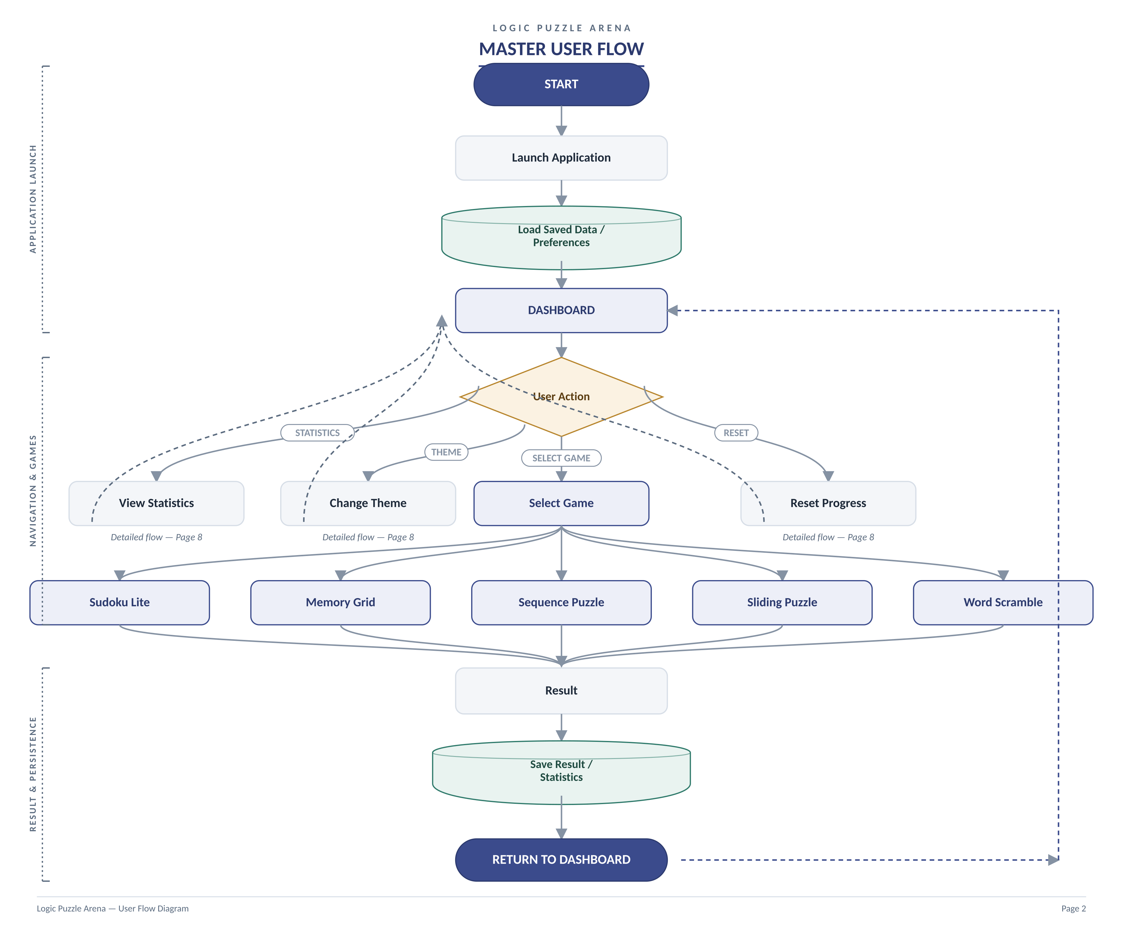

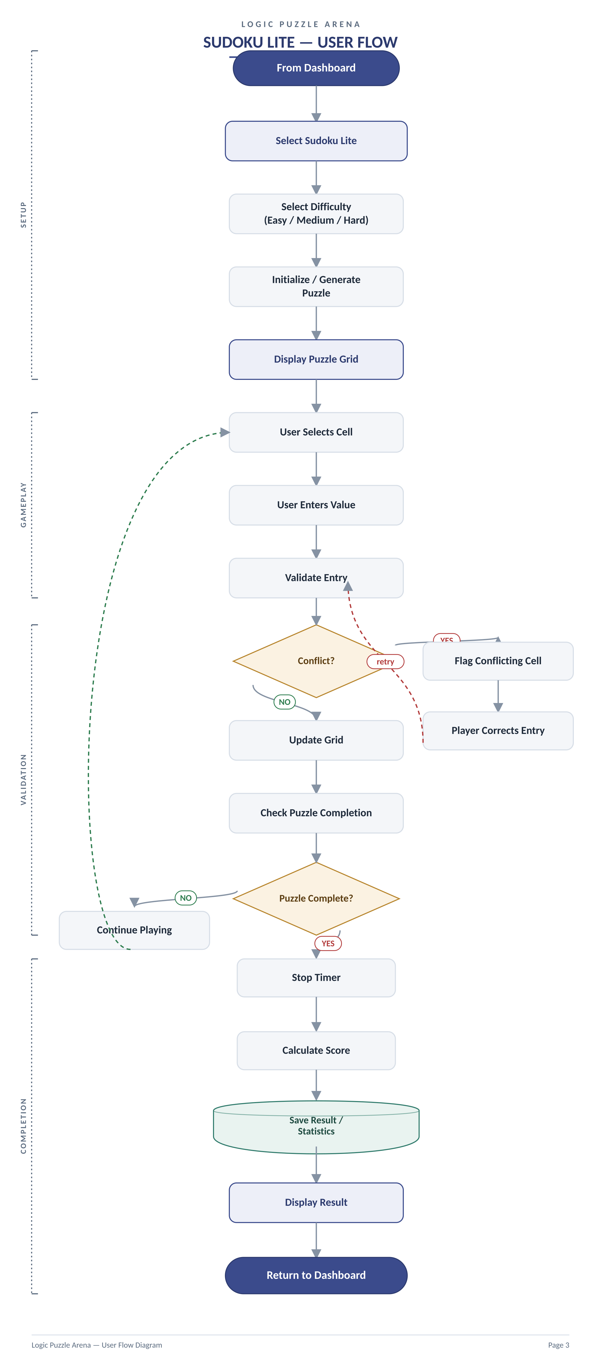

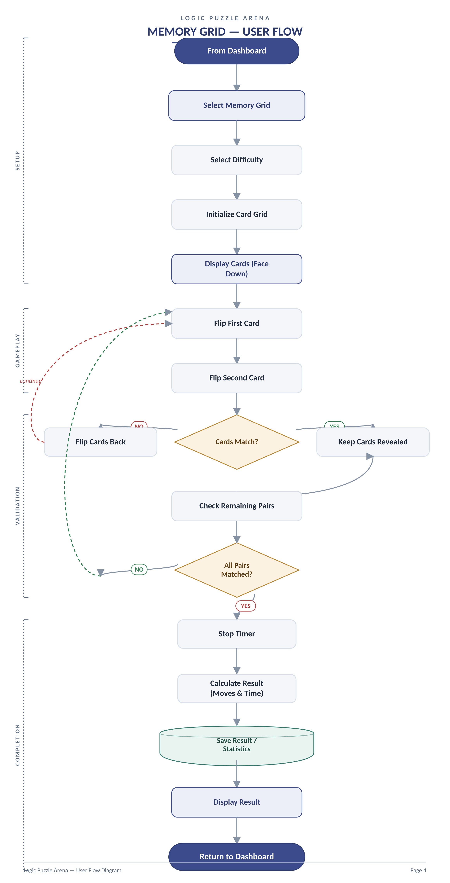

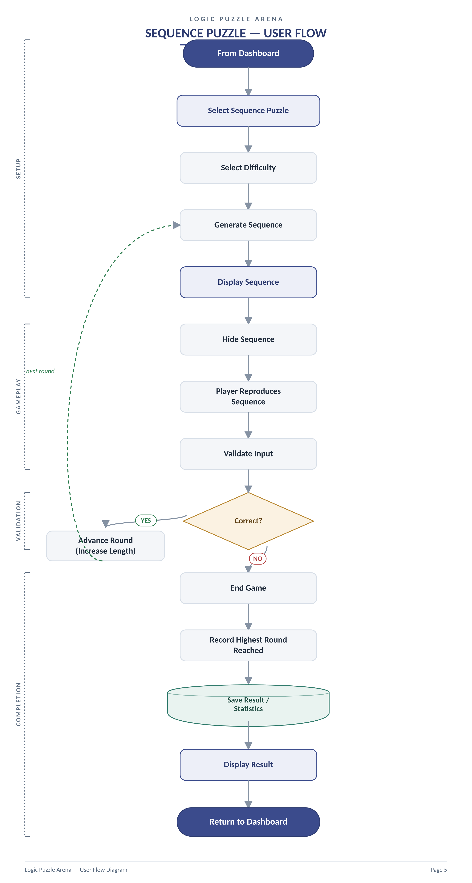

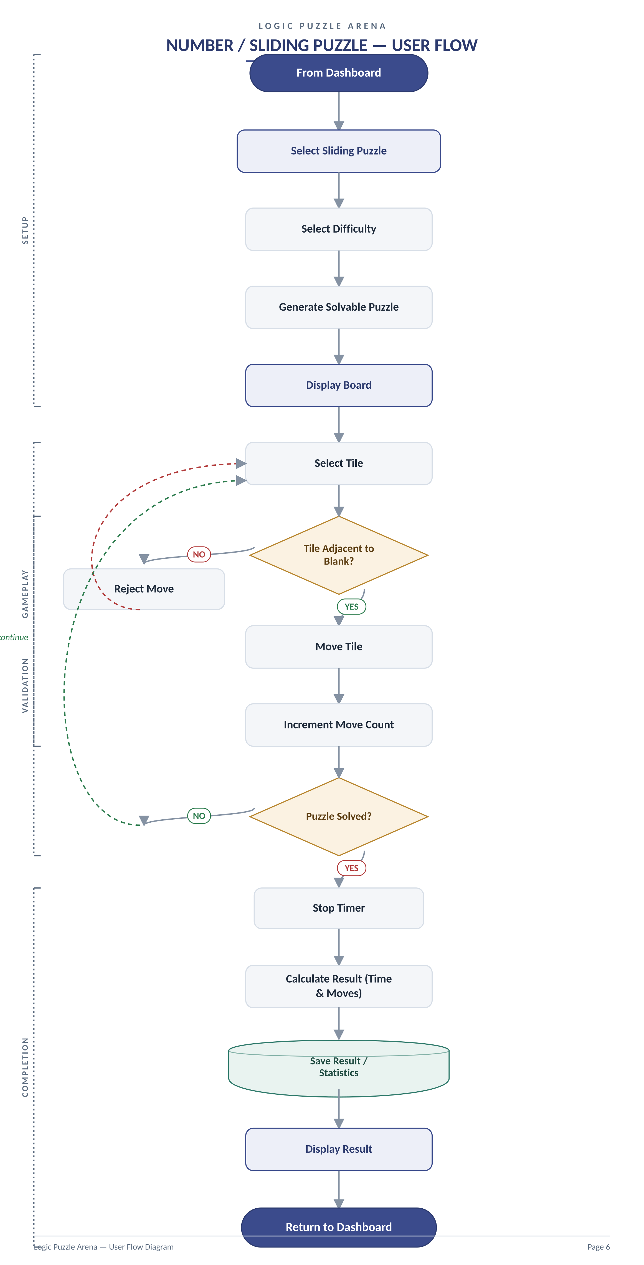

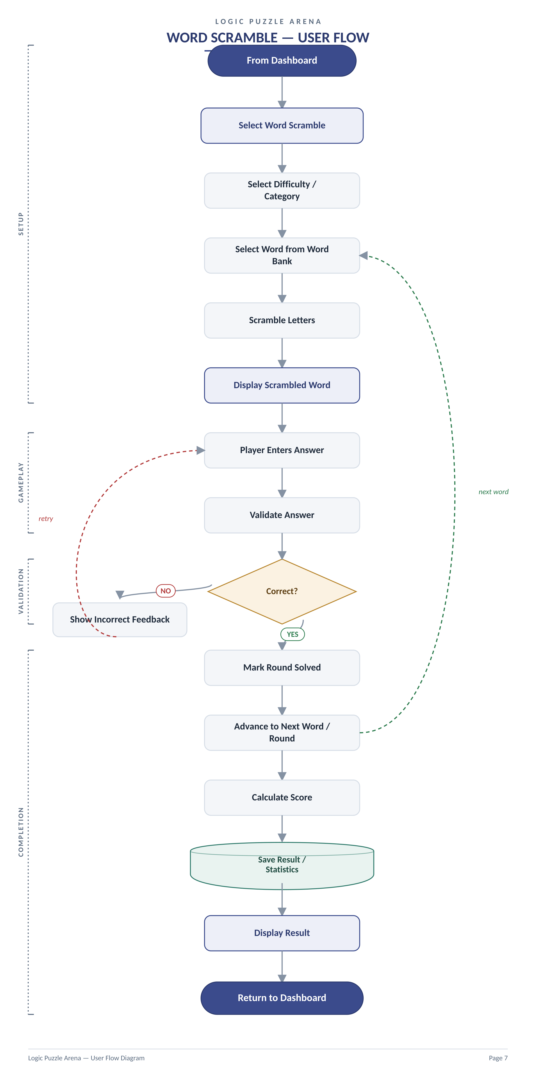

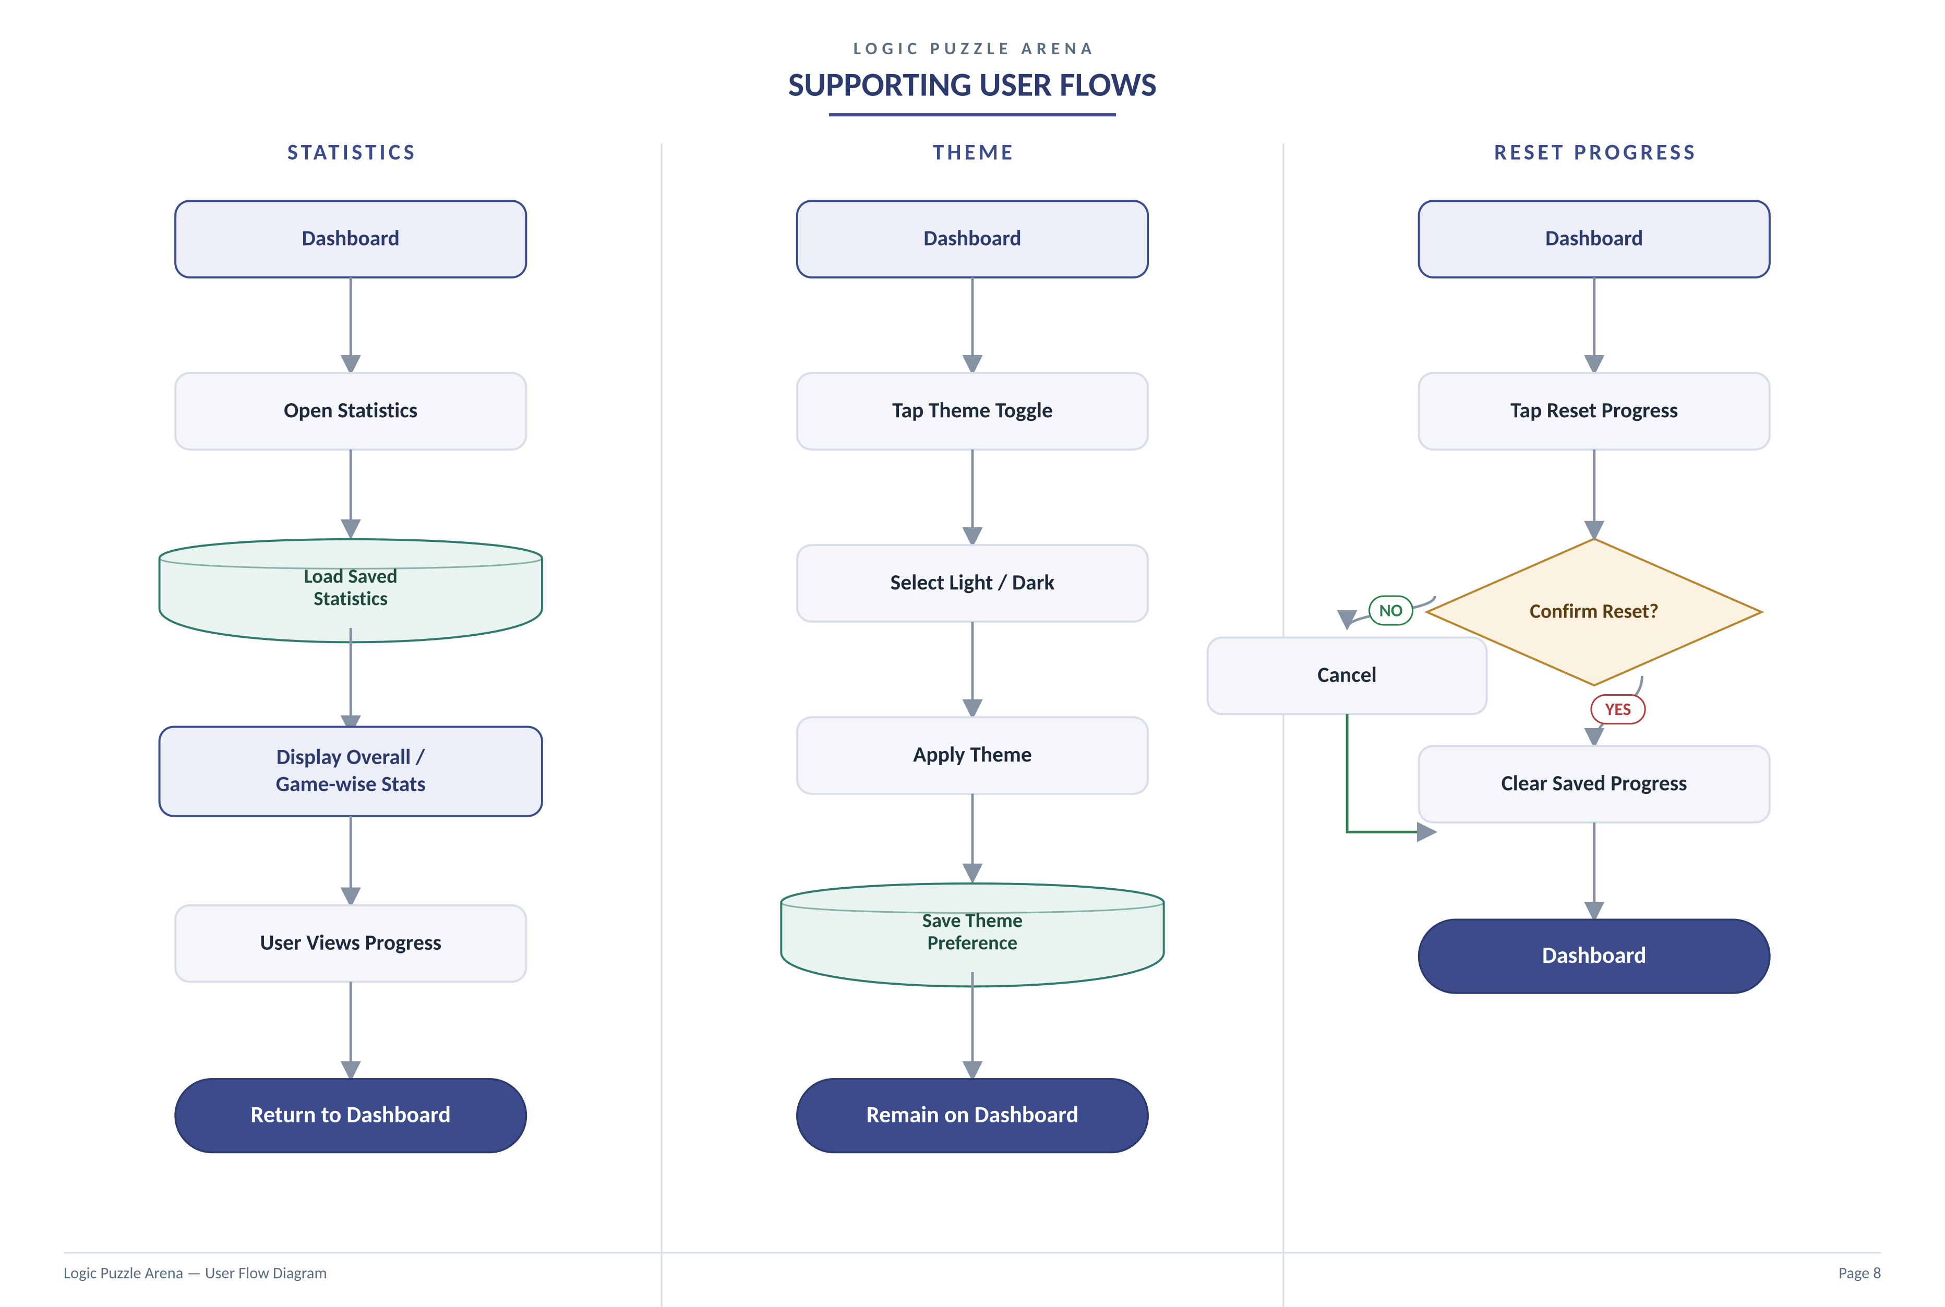

LOGIC PUZZLE ARENA
Requirement Traceability & Notes
The table below maps each functional module and its requirement IDs (as defined in the Software Requirements Specification) to the page of this document where its user flow is represented. This section exists for evaluator cross-reference only; the flow diagrams themselves intentionally omit requirement IDs to keep the visual flow uncluttered.
Module | Requirement IDs | Represented In
Home Dashboard | FR-DASH-01 – FR-DASH-02 | Page 2 — Master User Flow
Sudoku Lite | FR-SUD-01 – FR-SUD-05 | Page 3 — Sudoku Lite Flow
Memory Grid | FR-MEM-01 – FR-MEM-05 | Page 4 — Memory Grid Flow
Sequence Puzzle | FR-SEQ-01 – FR-SEQ-05 | Page 5 — Sequence Puzzle Flow
Sliding Puzzle | FR-SLD-01 – FR-SLD-05 | Page 6 — Sliding Puzzle Flow
Word Scramble | FR-WRD-01 – FR-WRD-05 | Page 7 — Word Scramble Flow
Score & Progress Tracking | FR-SCORE-01 – FR-SCORE-04 | Pages 2–8 — Completion & Reset flows
Notes
• All flows return to the Dashboard, which is the single central navigation point of the application.
• Local Storage is the only persistence mechanism used in the current phase — no backend, database, or account system is involved.
• Difficulty selection, validation logic, and completion/result handling are shown per game since each module has independent rules; scoring and storage follow a shared pattern across all five games.

