**Hands on:**

* Design the page using HTML5.
* Validate first name (only alphabets), last name (only alphabets), contact number(10 digits) and email-id.
* Make sure all the fields are required.
* Once user submits the page, the new page should open saying “Welcome User”. Try http method as get and post also

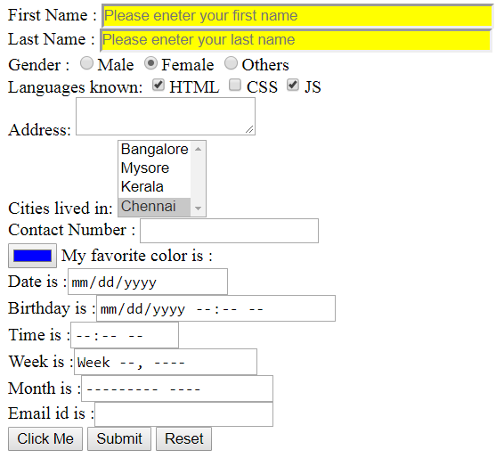

**Use Case:**

1. Design SC Website using HTML
2. Enhance Web page sing BootStrap