**Hands-on**

1. Create an array of Strings which contains the values like [“sTandarD”,”CharTered”,”banK”] then replace the array values with corresponding Uppercase values only. [“STANDARD”,”CHARTERED”,”BANK”]
2. Create an array of strings and display its values in list format in browser.
3. Take input from the name text box and validate to check if it contains only alphabets or not. If it does not contain, display the error message next to the text box “please enter only alphabets”.

**Use Case:**

1. Create the page using Bootstrap. After entering the valid values, once user clicks on Add Customer button, create the customer object and display in tabular format.

Validate the fields name (alphabets allowed), email id ( valid email id), contact no( only 10 digits and first digit should be 7-9) and account type should be selected.

Whenever user inserts invalid value, show the error message next to text box for ex please enter only alphabets

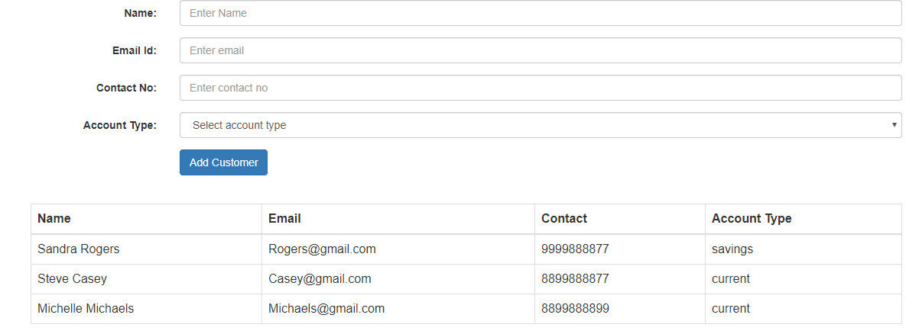

1. Add testimonial page to sc website by collecting the data from the user and add it to the testimonials dynamically with edit and delete Operation using JavaScript.

Testimonials

Name

Your Name

Enter your Message

Message

Submit

Ritu

It has been a positive experience with personable banking service in a timely manner.

Edit | Delete