JalSuraksha
Software Requirement Specifications (SRS)
Version 1.0

Project Work Phase-I (EAI753)
Specialisation: Data Science, 4th Year
BACHELOR OF TECHNOLOGY (CSE)

PROJECT GUIDE:  Dr. Ajay Rastogi | SUBMITTED BY:  Mohd Shami (TCA2366017)  Aman Khan (TCA2366003)  Firoj (TCA2366010)

October, 2026



COLLEGE OF COMPUTING SCIENCES & INFORMATION TECHNOLOGY
TEERTHANKER MAHAVEER UNIVERSITY, MORADABAD

Revision History
Author/ Changes made by | Date | Reason For Changes | Version
JalSuraksha Team | 29-10-26 | initial draft | 1.0 draft
JalSuraksha Team |  | baseline following changes after inspection | 1.0 approved

Approved by:
Project Guide Name: Dr. Ajay Rastogi

Signature:

Table of Contents

1 Introduction 4
1.1 Purpose 4
1.2 Scope of the Work 5
1.2.1 1.2.1 In-Scope Requirements: 5
1.2.2 1.2.2 Out-of-Scope Boundaries: 5
1.3 Definitions, Acronyms, and Abbreviations 6
1.4 References 7
2 Overall Description 8
2.1 Product Perspective 8
2.2 Product Functions 8
2.3 User Characteristics 9
2.4 General Constraints 9
2.5 Assumptions and Dependencies 10
3 Specific Requirements 11
3.1 Groundwater Level Forecasting 11
3.1.1 Description 11
3.1.2 Inputs 11
3.1.3 Processing 11
3.1.4 Outputs 11
3.1.5 Error Handling 12
3.1.6 Test Cases for Groundwater Level Forecasting 12
3.2 Recommendation of Recharge Interventions 12
3.2.1 Description 12
3.2.2 Inputs 13
3.2.3 Processing 13
3.2.4 Outputs 13
3.2.5 Error Handling 13
3.2.6 Test Cases for Recommendation of Recharge Interventions 14
3.3 Design Constraints 14
3.3.1 Table D.1: DISTRICT Table (Entity: Administrative Assessment Units) 19
3.3.2 Table D.2: LOCATION Table (Entity: Spatial Monitoring Points) 19
3.3.3 Table D.3: SENSOR Table (Entity: Edge IoT Telemetry Hardware) 20
3.3.4 Table D.4: MEASUREMENT Table (Entity: Hydrological Time-Series & Water Quality) 20
3.3.5 Table D.5: PREDICTION Table (Entity: Machine Learning Forecast Records) 21
3.3.6 Table D.6: RECOMMENDATION Table (Entity: Recharge & Conservation Interventions) 21
3.3.7 Table D.7: USER Table (Entity: System Authentication & Roles) 22

Appendix A: Data Flow Diagram (DFD)
Appendix B: Entity-Relationship Diagram (ERD)
Appendix C: Use-Case Diagram (UCD)
Appendix D: Data Dictionary (DD)
Appendix E: Screen Shots



Introduction
The JalSuraksha (HydroRaksh) platform is an artificial intelligence-driven groundwater intelligence and decision-support system engineered to address India's critical groundwater depletion and aquifer management challenges. Across India, approximately 245 billion cubic meters (m³) of groundwater are withdrawn annually, resulting in more than 17% of all assessment units being categorized as Over-Exploited. With 63% of irrigated cropland and 85% of rural drinking water supplies dependent on stressed subsurface aquifers, compounded by increasing rainfall variability, sparse monitoring infrastructure, and widespread chemical contamination (fluoride, arsenic, and nitrate), there is an urgent imperative for an automated, data-driven intelligence platform. JalSuraksha ingests, validates, and harmonizes multi-source hydrological datasets from the Central Ground Water Board (CGWB), India Meteorological Department (IMD), India Water Resources Information System (India-WRIS), and the Central Water Commission (CWC), alongside localized edge IoT telemetry. The system employs machine learning predictive pipelines (Ridge Regression, Gradient Boosting, Random Forest) with SHAP explainability, combined with a Hydro-Geological Collaborative Filtering (HG-CF) recommendation engine, to provide predictive foresight, risk categorization, and targeted recharge intervention advisories across 36 States/Union Territories and over 700 districts. This Software Requirements Specification (SRS) establishes the foundational functional, non-functional, interface, and architectural requirements governing the design, implementation, and rigorous verification of the JalSuraksha platform.

Purpose
The purpose of this Software Requirements Specification (SRS) document is to establish a rigorous, comprehensive, and verifiable technical baseline for the engineering, deployment, and testing of the JalSuraksha (HydroRaksh) platform. It delineates all functional workflows, system inputs and outputs, analytical pipelines, user roles, design constraints, and interface specifications required to construct the platform.
The intended audience for this document comprises:
• Software Developers and ML Engineers: To direct the implementation of ingestion pipelines, time-series schemas, predictive modeling pipelines, recommendation algorithms, and responsive user interfaces.
• Quality Assurance & Testing Teams: To serve as the definitive specification for test case derivation, automated verification, regression testing, and validation of the 101 unit test suite.
• Hydrological Scientists and Domain Specialists: To verify the scientific fidelity of hydrogeological equations, water balance audits, recharge sizing formulations, and soil infiltration constraints.
• Water Resource Officials and Planners: To ensure delivered software capabilities satisfy statutory monitoring protocols, aquifer stress classifications, and watershed intervention planning.
• Project Evaluators and Academic Reviewers: To assess the software engineering rigor, architectural completeness, and lifecycle compliance of the project.

Scope of the Work
The software product developed under this specification is JalSuraksha (HydroRaksh) – AI-Powered Groundwater Intelligence System. The system provides an end-to-end computational and decision-support pipeline designed to transform raw environmental telemetry into actionable aquifer management insights across 36 States/UTs and 700+ districts in India.
The scope of the work is explicitly structured into in-scope requirements and out-of-scope boundaries as follows:

1.2.1 In-Scope Requirements:
• The system shall ingest, clean, and harmonize multi-source hydrological datasets from CGWB, IMD, India-WRIS, CWC, and real-time edge telemetry from ESP32 IoT sensors.
• The system shall evaluate drinking water quality parameters against Bureau of Indian Standards (BIS 10500) thresholds, specifically monitoring pH, electrical conductivity (EC), total dissolved solids (TDS), fluoride, arsenic, and nitrate concentrations.
• The system shall execute predictive machine learning models (Ridge Regression, Gradient Boosting, and Random Forest) to forecast seasonal and annual groundwater depths across 36 States/UTs and 700+ districts, achieving a benchmark mean absolute error (MAE) of 3.85 m and root mean square error (RMSE) of 4.35 m, outperforming the naive persistence baseline (29.85 m MAE), with a held-out geographic generalization MAE of 5.17 m.
• The system shall generate model interpretability attributions using SHAP (SHapley Additive exPlanations) values to elucidate the primary climatic and historical drivers influencing groundwater level forecasts.
• The system shall implement a Hydro-Geological Collaborative Filtering (HG-CF) recommender system (achieving NDCG@5 of 0.437) to recommend site-specific managed aquifer recharge (MAR) structures (e.g., check dams, percolation tanks, recharge shafts) and conservation interventions based on hydrogeological similarity.
• The system shall deliver specialized decision-support modules, including a Dynamic Map Atlas, Dual Water Metrics, Water Balance Audits, Recharge Sizing Calculators, Capital Budget Optimizers, What-If Simulators, Rooftop Rainwater Harvesting sizing tools, Climate-Resilient Crop-Shift Advisories, Non-Revenue Water (NRW) leakage audits, Borewell Failure risk portals, and a 75-district comparative canvas with CSV export capabilities.
• The system shall provide an intuitive Web application architecture featuring a Flask administrative and user UI, paired with a high-performance FastAPI-powered Super Intelligence Lab backend backed by TimescaleDB, SQLAlchemy ORM, and a secure JSON credential store.

1.2.2 Out-of-Scope Boundaries:
• The system shall not perform automated physical actuation or remote control of groundwater extraction pumps, sluice gates, or canal barriers.
• The system shall not encompass the physical manufacturing, field deployment, or electrical maintenance of IoT sensor hardware or telemetry towers.
• The system shall not execute financial transaction processing, fee collections, or water tariff billing operations.
• The system shall not replace certified geotechnical drilling, borehole geophysical logging, or on-site core-sampling surveys required for engineering clearances.
• The system shall not require or integrate proprietary, closed-source commercial GIS enterprise software licenses.

Definitions, Acronyms, and Abbreviations
Table 1 provides formal definitions of all key domain concepts, institutional bodies, technological frameworks, and mathematical metrics used throughout this document.
Abbreviation | Description
CGWB | Central Ground Water Board (Apex Indian government agency under the Ministry of Jal Shakti responsible for groundwater assessment and monitoring).
IMD | India Meteorological Department (National meteorological agency providing weather observations and gridded rainfall datasets).
India-WRIS | India Water Resources Information System (Centralized national digital repository for spatial and non-spatial water resource data).
CWC | Central Water Commission (National premier technical organization responsible for surface water, river gauge, and reservoir monitoring).
ML | Machine Learning (Computational algorithms that learn statistical patterns from data to make predictions or decisions without explicit rule coding).
SHAP | SHapley Additive exPlanations (Game-theoretic framework used to explain individual model predictions by calculating feature contributions).
HG-CF | Hydro-Geological Collaborative Filtering (Specialized recommendation algorithm matching hydrogeologically similar assessment units to suggest recharge interventions).
LDA | Latent Dirichlet Allocation (Generative probabilistic topic modeling algorithm used in the literature mining engine to discover research patterns).
IoT | Internet of Things (Network of physical edge sensing devices, microcontrollers, and communication modules transmitting telemetry data).
BIS | Bureau of Indian Standards (National standards body of India prescribing specification thresholds such as BIS 10500 for drinking water quality).
MAE | Mean Absolute Error (Evaluation metric measuring the average magnitude of absolute errors between predicted and observed groundwater depths).
RMSE | Root Mean Square Error (Evaluation metric measuring the square root of the average of squared differences between predictions and observations).
NDCG | Normalized Discounted Cumulative Gain (Ranking quality metric measuring the ranking accuracy and relevance of recommended recharge interventions).
SRS | Software Requirements Specification (Formal engineering document delineating the purpose, scope, functions, and constraints of a software system).
API | Application Programming Interface (Set of programmatic protocols and endpoints enabling structured communication between software components).
UT | Union Territory (Federally administered sub-national administrative division of the Republic of India).

References
Table 2 lists the statutory standards, governmental datasets, industry guidelines, and design documents referenced throughout this specification.
S# | Reference Details | Owner | Version | Date
1 | National Compilation on Dynamic Ground Water Resources of India | Central Ground Water Board (CGWB) | Annual Report | 2023-11-01
2 | Indian Standard IS 10500:2012 - Drinking Water Specification (Second Revision) | Bureau of Indian Standards (BIS) | IS 10500:2012 | 2012-05-01
3 | High Resolution Daily Gridded Rainfall Data Documentation (0.25° x 0.25°) | India Meteorological Department (IMD) | IMD-MET-TR-01 | 2021-08-15
4 | India Water Resources Information System (India-WRIS) Technical Manual | Ministry of Jal Shakti / CWC | WRIS-V4.2 | 2022-03-30
5 | IEEE Recommended Practice for Software Requirements Specifications | IEEE Computer Society | IEEE Std 830-1998 | 1998-10-20
6 | JalSuraksha System Architecture, Recommender, and AI Pipeline Specification | JalSuraksha Technical Team | Version 1.0 | 2026-10-20

Overall Description
This section establishes the overarching context of the JalSuraksha platform, describing its external interfaces, core functional architecture, targeted user communities, general design constraints, and operational dependencies.

Product Perspective
The JalSuraksha (HydroRaksh) platform operates as a centralized, self-contained intelligence and decision-support ecosystem interfacing with external national data repositories, remote IoT telemetry networks, and multiple tiers of stakeholders. As illustrated in the Context Diagram (DFD Level 0, Figure A.1 in Appendix A), the system acts as an analytical nexus situated between four primary external entities:
• 1. Upstream Data Providers: The Central Ground Water Board (CGWB), India Meteorological Department (IMD), India Water Resources Information System (India-WRIS), and Central Water Commission (CWC). These entities stream historical and seasonal groundwater depths, gridded precipitation observations, reservoir storage indices, and water quality chemical parameters (pH, EC, TDS, fluoride, arsenic, nitrate) into the platform.
• 2. Edge IoT Telemetry Nodes: Field-deployed edge sensor nodes utilizing ESP32 microcontrollers equipped with hydrostatic pressure transducers and water-level probes, which transmit localized real-time groundwater depth measurements into the ingestion gateway.
• 3. Downstream User Communities: A unified multi-tier stakeholder group including District/State Water Resource Officials, Urban/Regional Planners, Hydrological Researchers, Farmers, and Citizens.
• 4. External Analytical Consumers: Export formats including structured CSV tables, geospatial GeoJSON overlays, PDF analytical dossiers, and REST API responses consumed by external decision-support frameworks.
Internally, the JalSuraksha platform processes inputs through four synchronized architectural tiers: (a) Ingestion and Validation, where raw feeds are cleaned, checked against BIS 10500 standards, and stored in TimescaleDB; (b) AI/ML Analytics Engine, containing Ridge Regression, Gradient Boosting, Random Forest, SHAP explainability, and Gensim LDA models; (c) Recommendation & Decision Tier, executing the HG-CF recommender, recharge sizing, and budget optimization; and (d) Presentation Tier, hosting the Flask web dashboard and FastAPI Super Intelligence Lab.

Product Functions
The functional capabilities of the JalSuraksha platform are systematically organized around a unified five-step operational methodology: Monitor, Analyze, Predict, Recommend, and Act.
• 1. Step 1 - Monitor (Data Ingestion & Quality): The system shall continuously aggregate and validate multi-source hydrological records across 36 States/UTs and 700+ districts, alongside live ESP32 edge sensor streams. It shall continuously track water quality compliance against BIS 10500 standards, flagging toxic contamination levels of fluoride, arsenic, and nitrate.
• 2. Step 2 - Analyze (Hydrological Analytics): The system shall execute Dual Water Metrics calculations, synthesize historical drawdown trends, perform automated Water Balance Audits for specified assessment units, conduct Non-Revenue Water (NRW) leakage audits, and extract domain insights from hydrogeological literature using Gensim LDA topic modeling.
• 3. Step 3 - Predict (ML Forecasting & SHAP): The system shall execute predictive machine learning pipelines (Ridge Regression, Gradient Boosting, Random Forest) to forecast seasonal and post-monsoon groundwater depths. The system shall achieve a validated benchmark MAE of 3.85 m and RMSE of 4.35 m (surpassing the 29.85 m naive persistence baseline) and deliver SHAP game-theoretic feature importance values explaining every forecast.
• 4. Step 4 - Recommend (Intervention Optimization): The system shall employ a Hydro-Geological Collaborative Filtering (HG-CF) recommendation engine (achieving NDCG@5 of 0.437) to recommend site-specific managed aquifer recharge (MAR) structures (check dams, percolation tanks, recharge shafts). It shall provide a Recharge Sizing module, a Capital Budget Optimizer, and climate-resilient crop-shift advisories.
• 5. Step 5 - Act (Decision Support & Dissemination): The system shall provide an interactive Dynamic Atlas, a Super Intelligence Lab with FastAPI integration, a 75-district comparative canvas with one-click CSV export, a Rooftop Rainwater Harvesting sizing tool, and a Borewell Failure risk portal.

User Characteristics
The platform serves five primary user personas with distinct operational responsibilities, technical expertise, and domain requirements:
• 1. District and State Water Resource Officials: Possess civil engineering or administrative qualifications with deep expertise in regional water policy but moderate programming literacy. They require high-level visual summaries, automated stress alerts (Over-Exploited unit flags), 75-district comparative rankings, and formal exportable compliance dossiers.
• 2. Urban and Regional Planners: Possess strong technical proficiency in GIS, civil infrastructure, and watershed management. They utilize what-if simulation sandboxes, recharge structure sizing calculators, water balance balance audits, and capital budget optimization modules.
• 3. Farmers and Agricultural Communities: Rely on experiential agronomic knowledge with basic to intermediate technical literacy, predominantly accessing the platform via mobile web browsers. They require intuitive visual depth indicators, seasonal borewell failure alerts, and practical, climate-resilient crop-shift guidance.
• 4. Citizens and Residential Welfare Associations (RWAs): Possess consumer-level computer literacy. They require access to neighborhood drinking water quality ratings against BIS 10500 standards and interactive rooftop rainwater harvesting sizing calculators for domestic conservation.
• 5. Hydrological Researchers and Data Scientists: Possess advanced doctoral or master's degrees in hydroinformatics, earth sciences, or machine learning. They require access to raw telemetry streams, model residuals, SHAP attribution matrices, and algorithm benchmark comparisons.

General Constraints
The design, construction, and deployment of the JalSuraksha platform are bounded by the following operational constraints:
• 1. Regulatory Policies: The system shall strictly conform to Bureau of Indian Standards (BIS 10500) drinking water quality thresholds and adhere to CGWB national categorization criteria for classifying units as Safe, Semi-Critical, Critical, or Over-Exploited.
• 2. Hardware Limitations: Field-deployed edge sensor nodes are restricted to low-power ESP32 microcontrollers with constrained battery reserves, requiring compact telemetry payload formatting and error-resilient transmission protocols.
• 3. External Interface Constraints: The system is dependent on data synchronization frequencies dictated by external government web portals (CGWB annual assessments, IMD seasonal releases), and must gracefully handle API latency or intermittent service disruptions.
• 4. Localization Standards: The primary administrative and analytical interfaces shall be delivered in English, with all text assets structured to support future multi-lingual localization via UTF-8 standard encoding.
• 5. Open-Source Technology Stack: The application shall be built using vendor-neutral, open-source programming stacks (Python, Flask, FastAPI, TimescaleDB, SQLAlchemy, Scikit-learn, Pandas, Gensim, SHAP), precluding any dependency on proprietary commercial software licenses.
• 6. Security and Credential Safeguards: User access control and credentials shall be managed via a secure JSON credential store. All database interactions shall be mediated through SQLAlchemy ORM to prevent SQL injection vulnerabilities.

Assumptions and Dependencies
The operational validity of this specification rests on the following foundational assumptions and technical dependencies:
• 1. Data Authenticity: Historical groundwater depths and precipitation time series published by CGWB and IMD are assumed to be authentic, scientifically verified, and representative of physical aquifer dynamics.
• 2. Hydrogeological Stability: Subsurface aquifer lithology, specific yield, and hydraulic conductivity parameters within defined hydrogeological zones are assumed to remain structurally stationary over seasonal forecasting horizons.
• 3. User Input Fidelity: End-user inputs regarding agricultural plot acreage, existing borewell depths, and rooftop catchment areas are assumed to be entered accurately by the user.
• 4. Runtime Infrastructure: The platform depends on the availability of a Python 3.10+ execution environment, active TimescaleDB database instances, and network access for API data fetching.
• 5. Gateway Connectivity: Edge telemetry reception depends upon functional cellular/packet data gateways in target monitoring districts to relay sensor packets to the server.

Specific Requirements
This section establishes the precise functional and non-functional requirements governing the core processing modules of the JalSuraksha platform. Requirements are articulated in formal third-person terminology utilizing 'The system shall' (mandatory), 'The system should' (recommended), and 'The system may' (optional).

Groundwater Level Forecasting

Description
The system shall ingest historical aquifer monitoring records, seasonal rainfall aggregates, and geographic features to generate precise forecasts of groundwater depth (measured in meters below ground level - mbgl) across 36 States/UTs and 700+ districts. The forecasting pipeline combines Ridge Regression, Gradient Boosting, and Random Forest algorithms, providing explainable predictions through SHAP attribution metrics.

Inputs
• District Identifier: Standard Census/LGD district code and State name.
• Historical Groundwater Depths: Time-series observations from CGWB national monitoring network (pre-monsoon, post-monsoon, rabi, kharif).
• Rainfall Metrics: Gridded precipitation aggregates and seasonal anomaly percentages from IMD.
• Temporal Horizon: Target forecast horizon in months (e.g., 3-month, 6-month, 12-month post-monsoon projection).
• Aquifer Characteristics: Hydrogeological classification, soil infiltration group, and baseline extraction status.

Processing
• 1. The system shall query the MEASUREMENT and LOCATION tables to extract historical groundwater depth and rainfall observations for the specified district.
• 2. The system shall perform data cleaning, handling missing time-series points via temporal forward-fill and spatial nearest-neighbor interpolation.
• 3. The system shall construct lag features including 1-year prior water level, 2-year prior water level, cumulative 12-month precipitation deficit, and seasonal precipitation ratio.
• 4. The system shall execute predictive inference using the trained Ridge Regression pipeline (best model MAE 3.85 m, RMSE 4.35 m vs. 29.85 m naive persistence baseline) and ensemble with Gradient Boosting and Random Forest models.
• 5. The system shall compute SHAP feature contributions for the prediction to quantify the impact of precipitation deficits, antecedent water levels, and temperature.
• 6. The system shall assign a dynamic stress classification (Safe, Semi-Critical, Critical, Over-Exploited) based on predicted depth thresholds.
• 7. The system shall persist the output records into the PREDICTION table.

Outputs
• Predicted Groundwater Depth: Numeric forecast in meters below ground level (mbgl).
• Forecast Uncertainty Bounds: Root mean square error bound (RMSE ±4.35 m) and 95% confidence interval.
• Aquifer Trajectory: Categorical trend indicator (Declining, Stable, Recovering).
• Aquifer Stress Category: Formal CGWB classification (Safe, Semi-Critical, Critical, Over-Exploited).
• SHAP Feature Drivers: Top 3 feature driving forces formatted as signed numerical impact values.

Error Handling
• 1. The system shall detect missing input features and fall back to the regional hydrogeological cluster baseline model if district-specific data is unavailable.
• 2. The system shall log a descriptive warning and notify the user if requested precipitation inputs fall outside physically plausible bounds (less than 0 mm or greater than 10,000 mm/year).
• 3. The system shall return a structured error response with status code 400 if an invalid or unmapped district identifier is supplied.

Test Cases for Groundwater Level Forecasting
Test Case ID | Test Title | Test Case Description | Pre-condition, if any | Expected Results
TC001 | Valid District Forecast Generation | Execute forecast pipeline for Jaipur district using valid 5-year CGWB and IMD historical records. | Jaipur district records present in database; ML model artifacts loaded. | System returns predicted depth (mbgl), RMSE bound of ±4.35 m, SHAP explanation array, and status code 200 within 1.5 seconds.
TC002 | Extreme Rainfall Anomaly Forecast | Submit rainfall input with 60% deficit below long-term average to test drought impact response. | Target district model loaded; baseline water level available. | System predicts sharp water table decline (> 2.5 mbgl drop), flags Over-Exploited risk, and identifies rainfall deficit as #1 SHAP driver.
TC003 | Missing District Data Fallback | Submit query for newly formed district with zero historical monitoring wells. | Target district has no records in MEASUREMENT table. | System gracefully falls back to parent agro-climatic zone model, returns generalized forecast with warning flag, and achieves MAE <= 5.17 m.

Recommendation of Recharge Interventions

Description
The system shall generate site-specific, prioritized managed aquifer recharge (MAR) and conservation recommendations using a Hydro-Geological Collaborative Filtering (HG-CF) algorithm. The engine matches target assessment units against analogous hydrogeological profiles with proven intervention success records, and sizes physical recharge structures based on local runoff and budget constraints.

Inputs
• Assessment Unit Profile: District ID, aquifer formation (alluvial, hard rock, basaltic, limestone), soil permeability, and surface slope.
• Water Deficit Parameters: Annual uncommitted surface runoff volume and groundwater draft deficit (in million cubic meters - MCM).
• Available Capital Budget: Maximum allowable expenditure in INR.
• Physical Land Availability: Maximum permissible footprint area for recharge construction.

Processing
• 1. The system shall retrieve target district hydrogeological attributes from the LOCATION and DISTRICT tables.
• 2. The system shall compute hydrogeological similarity vectors across all candidate units using cosine distance over normalized aquifer features (permeability, transmissivity, specific yield, and rainfall).
• 3. The system shall execute the HG-CF recommendation algorithm (validated with NDCG@5 of 0.437) to rank top-5 suitable recharge intervention types (e.g., check dams, percolation tanks, recharge shafts, subsurface dykes, farm ponds).
• 4. The system shall run the Recharge Sizing module to calculate optimal physical dimensions (length, width, crest height, storage capacity) based on catchable monsoon runoff.
• 5. The system shall apply linear budget optimization to produce an investment allocation schedule maximizing total annual recharge volume under the specified budget ceiling.
• 6. The system shall generate climate-resilient crop-shift advisories if groundwater extraction exceeds 100% of annual replenishable recharge.
• 7. The system shall store generated recommendations in the RECOMMENDATION table.

Outputs
• Ranked Interventions List: Top-N recommended recharge structures ordered by HG-CF suitability score.
• Sizing Blueprints: Recommended dimensional specifications and storage capacity in cubic meters.
• Recharge Potential: Estimated annual volumetric water recharge (m³/year).
• Financial Estimate: Bill of quantities and total estimated construction cost in INR.
• Crop-Shift Advisory: Actionable agricultural crop transition recommendations (e.g., shifting from water-intensive paddy to millets/pulses).

Error Handling
• 1. The system shall validate budget inputs, rejecting negative values or values exceeding 100 Crore INR with a validation error message.
• 2. The system shall handle terrain slope incompatibilities (e.g., slope > 15% where check dams are non-viable) by filtering out invalid structure types.
• 3. The system shall fall back to standard CGWB Master Plan rule-based recharge lookup tables if the collaborative filtering matrix has insufficient neighbors.

Test Cases for Recommendation of Recharge Interventions
Test Case ID | Test Title | Test Case Description | Pre-condition, if any | Expected Results
TC004 | Hard-Rock Recharge Recommendation | Generate recharge recommendations for a basaltic hard-rock district (e.g., Ahmednagar) with 50 Lakh INR budget. | District hydrogeological profile loaded; runoff volume available. | System outputs top-ranked interventions (Percolation Tank #1, Check Dam #2) with sizing specs, total cost at most 50 Lakh INR, NDCG@5 at least 0.437.
TC005 | Zero Budget Crop-Shift Fallback | Execute recommendation engine with zero capital budget for an Over-Exploited agricultural district. | Target district groundwater draft exceeds 120% of recharge. | System suppresses capital civil works, outputs zero-cost crop-shift advisory (Paddy -> Bajra/Pulses) with projected 32% irrigation savings.
TC006 | Invalid Slope Input Validation | Submit recommendation request with invalid slope parameter of 45 degrees. | User inputs slope > 20%. | System traps boundary condition, returns descriptive error stating slope exceeds permissible limits for civil recharge structures.

Design Constraints
The software engineering design and architectural implementation of the JalSuraksha platform are subject to the following technical and operational constraints:
• 1. Decoupled Service Architecture: The system shall maintain architectural decoupling between the administrative Flask web interface and the high-throughput FastAPI Super Intelligence Lab backend.
• 2. Data Persistence Model: High-velocity time-series datasets (sensor telemetry, gridded rainfall, river stages) shall be persisted in TimescaleDB with automated hypertables, while entity metadata is managed via SQLAlchemy ORM. User credentials shall be maintained in a secure JSON store.
• 3. Response Latency: Single-district groundwater level forecast inference shall execute within 1.5 seconds. Multi-structure recommendation generation and budget optimization shall execute within 2.0 seconds.
• 4. Test Suite Coverage: The codebase shall maintain continuous integration verification passing all 101 automated unit tests with zero regressions.
• 5. Interface Responsiveness: The user interface shall be constructed using modern, standards-compliant HTML5, Vanilla CSS, and JavaScript, ensuring responsive layout rendering across desktop (1920x1080) and mobile (375x667) screen resolutions.
• 6. Open-Source Compliance: All libraries and runtime components (Python, Flask, FastAPI, Scikit-learn, Pandas, Gensim, SHAP) shall be open-source, eliminating external proprietary license dependencies.
Appendix A
Data Flow Diagram (DFD)
(Mandatory)
The Data Flow Diagram (Context Diagram / Level 0 DFD) depicted in Figure A.1 illustrates the structural boundaries, external entities, raw data ingestion channels, and analytical output distributions of the JalSuraksha (HydroRaksh) platform. External entities include the Central Ground Water Board (CGWB), India Meteorological Department (IMD), India-WRIS / Central Water Commission (CWC), On-field IoT Sensors (ESP32), and Multi-tier Stakeholders (Officials, Planners, Farmers, Citizens, and Researchers). The central engine executes validation, time-series storage, machine learning forecasting, and collaborative filtering recommendations.
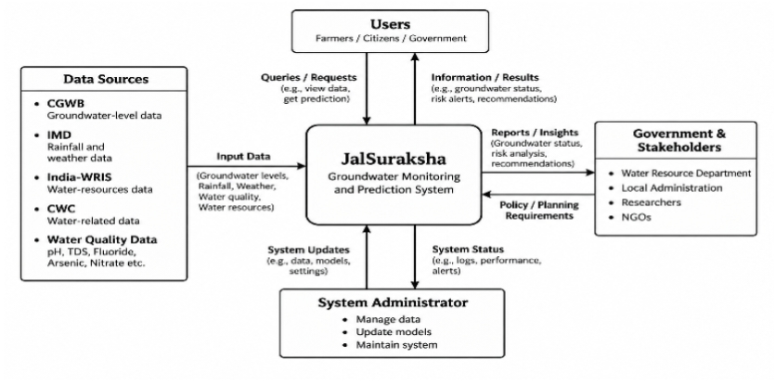
Figure A.1: Context Diagram (DFD Level 0) - JalSuraksha Groundwater Intelligence System

Appendix B
Entity-Relationship Diagram (ERD)
(Mandatory)
The Entity-Relationship Diagram (ERD) presented in Figure B.1 establishes the conceptual and logical data model underpinning JalSuraksha. The schema organizes multi-district administrative hierarchies (DISTRICT), spatial monitoring coordinates (LOCATION), edge telemetry devices (SENSOR), environmental and chemical measurements (MEASUREMENT), machine learning forecasting outputs (PREDICTION), intervention advisories (RECOMMENDATION), and system credentials (USER). Foreign key constraints ensure strict referential integrity across temporal series and spatial units.
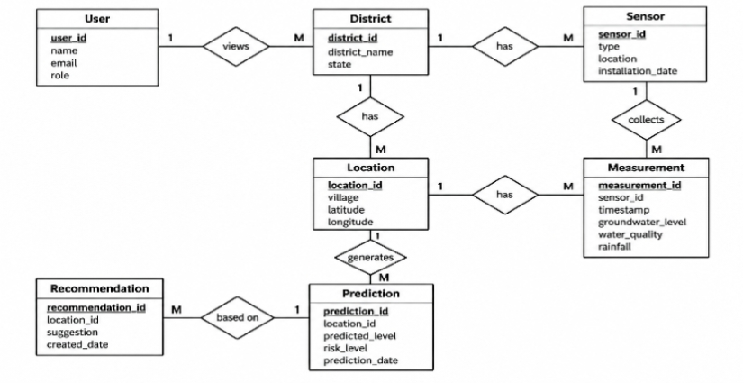
Figure B.1: Entity-Relationship Diagram (ERD) - JalSuraksha Hydrological Data Model

Appendix C
Use-Case Diagram (UCD)
(Optional)
The Use-Case Diagram (UCD) depicted in Figure C.1 delineates the functional interactions between the four primary system actors and the JalSuraksha platform. Actors comprise Water Resource Officials, Regional Planners, Farmers & Citizens, and Hydrological Researchers. Use cases encompass real-time aquifer monitoring, water quality compliance evaluation against BIS 10500 standards, ML groundwater depth forecasting, SHAP explainability inspection, HG-CF recharge structure recommendation, rooftop rainwater harvesting sizing, and 75-district comparative CSV data exports.
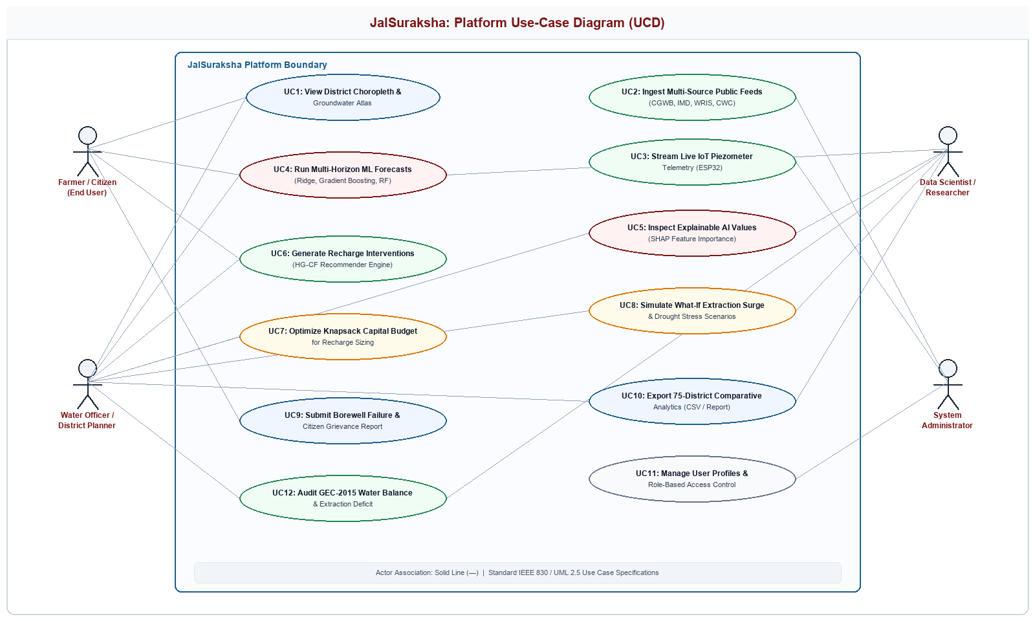
Figure C.1: Use-Case Diagram (UCD) - Core Functional Workflows and Stakeholder Roles

Appendix D
Data Dictionary (DD)
(Mandatory)
The Data Dictionary defines the relational schemas, data types, nullability constraints, and functional descriptions of the core entities implemented in the JalSuraksha database architecture.

Table D.1: DISTRICT Table (Entity: Administrative Assessment Units)
Fields | Data type | Description
DIST-ID | Integer (PK) | Unique administrative district identifier code (Census/LGD).
DIST-State-Name | Varchar(100) | Name of State or Union Territory (36 States/UTs).
DIST-Name | Varchar(100) | Official district administrative name (700+ districts).
DIST-Total-Area-SqKm | Float | Total geographic surface area of the district in square kilometers.
DIST-Over-Exploited-Status | Varchar(30) | CGWB classification (Safe, Semi-Critical, Critical, Over-Exploited).
DIST-Baseline-Depth-mbgl | Float | Long-term historical baseline depth to water table in mbgl.

Table D.2: LOCATION Table (Entity: Spatial Monitoring Points)
Fields | Data type | Description
LOC-ID | Integer (PK) | Unique geographical monitoring station identifier.
LOC-DIST-ID | Integer (FK) | Foreign key referencing parent DISTRICT record.
LOC-Latitude | Numeric(9,6) | WGS84 geospatial latitude coordinate in decimal degrees.
LOC-Longitude | Numeric(9,6) | WGS84 geospatial longitude coordinate in decimal degrees.
LOC-Hydrogeology-Zone | Varchar(100) | Aquifer formation type (Alluvial, Hard Rock, Basaltic, Limestone).
LOC-Soil-Type | Varchar(80) | Dominant soil taxonomy and surface infiltration group.

Table D.3: SENSOR Table (Entity: Edge IoT Telemetry Hardware)
Fields | Data type | Description
SENS-ID | Integer (PK) | Unique physical hardware sensor identifier.
SENS-LOC-ID | Integer (FK) | Foreign key referencing installed monitoring LOCATION.
SENS-Device-EUI | Varchar(64) | Unique hardware MAC / EUI address of ESP32 microcontroller.
SENS-Firmware-Version | Varchar(20) | Current embedded firmware version string.
SENS-Battery-Level-Pct | Float | Current telemetry battery charge state percentage (0-100%).
SENS-Installation-Date | Date | Calendar date of physical borehole sensor commissioning.

Table D.4: MEASUREMENT Table (Entity: Hydrological Time-Series & Water Quality)
Fields | Data type | Description
MEAS-ID | BigInt (PK) | Unique high-frequency time-series measurement identifier.
MEAS-LOC-ID | Integer (FK) | Foreign key referencing monitoring station LOCATION.
MEAS-Timestamp-UTC | Timestamp (Hypertable) | UTC timestamp of reading collection.
MEAS-Water-Level-mbgl | Float | Observed depth to groundwater table in meters below ground level.
MEAS-Rainfall-mm | Float | Precipitation recorded during measurement window in millimeters.
MEAS-pH | Float | Measured water acidity/alkalinity level (BIS 10500 standard: 6.5 - 8.5).
MEAS-EC-uS-cm | Float | Electrical conductivity measured in microSiemens per centimeter.
MEAS-TDS-mg-L | Float | Total dissolved solids concentration in milligrams per liter.
MEAS-Fluoride-mg-L | Float | Fluoride chemical assay concentration (BIS 10500 limit: 1.0 - 1.5 mg/L).
MEAS-Arsenic-mg-L | Float | Arsenic chemical assay concentration (BIS 10500 limit: 0.01 mg/L).
MEAS-Nitrate-mg-L | Float | Nitrate chemical assay concentration (BIS 10500 limit: 45.0 mg/L).

Table D.5: PREDICTION Table (Entity: Machine Learning Forecast Records)
Fields | Data type | Description
PRED-ID | BigInt (PK) | Unique machine learning forecast execution identifier.
PRED-DIST-ID | Integer (FK) | Foreign key referencing target administrative DISTRICT.
PRED-Model-Type | Varchar(50) | Applied ML algorithm (Ridge Regression, Gradient Boosting, Random Forest).
PRED-Horizon-Months | Integer | Forward forecasting duration window (3, 6, or 12 months).
PRED-Depth-mbgl | Float | Predicted depth to groundwater table in meters below ground level.
PRED-RMSE-Bound | Float | Validated error margin bound (benchmark ±4.35 m).
PRED-SHAP-Summary | Text | Serialized top-3 feature driving impacts explaining the forecast.

Table D.6: RECOMMENDATION Table (Entity: Recharge & Conservation Interventions)
Fields | Data type | Description
REC-ID | BigInt (PK) | Unique intervention recommendation advisory identifier.
REC-DIST-ID | Integer (FK) | Foreign key referencing recipient target DISTRICT.
REC-Intervention-Type | Varchar(100) | Recommended MAR structure (Check Dam, Percolation Tank, Recharge Shaft).
REC-Priority-Rank | Integer | Calculated suitability priority ranking (Rank 1 through 5).
REC-Recharge-m3-yr | Float | Estimated annual volumetric recharge potential in cubic meters/year.
REC-Cost-INR | Numeric(14,2) | Estimated bill-of-quantities construction budget in INR.
REC-NDCG-Score | Float | Collaborative filtering recommendation confidence score (NDCG@5: 0.437).

Table D.7: USER Table (Entity: System Authentication & Roles)
Fields | Data type | Description
USER-ID | Integer (PK) | Unique user account identifier code.
USER-Username | Varchar(80) | Unique system login handle or email address.
USER-Role | Varchar(40) | Access role (Official, Planner, Researcher, Farmer, Citizen).
USER-Organization | Varchar(150) | Affiliated government department, agency, or institution.
USER-District-Scope | Varchar(100) | Permitted administrative territorial scope or All-India access.
USER-Created-At | Timestamp | Calendar timestamp of account provisioning.

Appendix E
Screen Shots
The screenshots presented in Figures E.1, E.2, and E.3 depict the operational interfaces of the JalSuraksha platform, illustrating the interactive Dynamic Map Atlas, the Super Intelligence Lab with AI benchmarking and SHAP explanations, and the District Canvas with historical-versus-predicted groundwater depth trajectories.
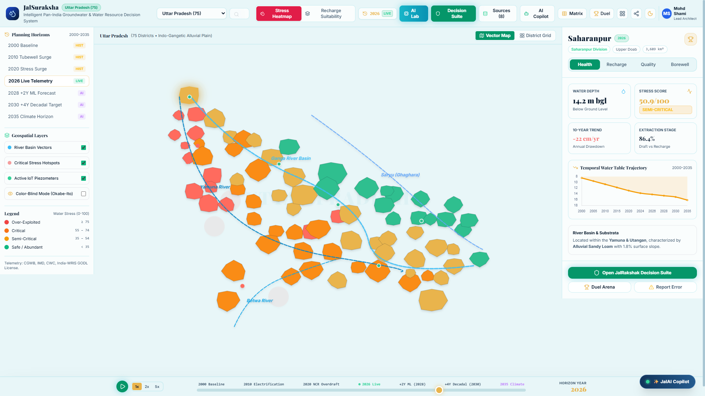
Figure E.1: JalSuraksha Dynamic Map Atlas - Real-time Aquifer Monitoring across 700+ Districts

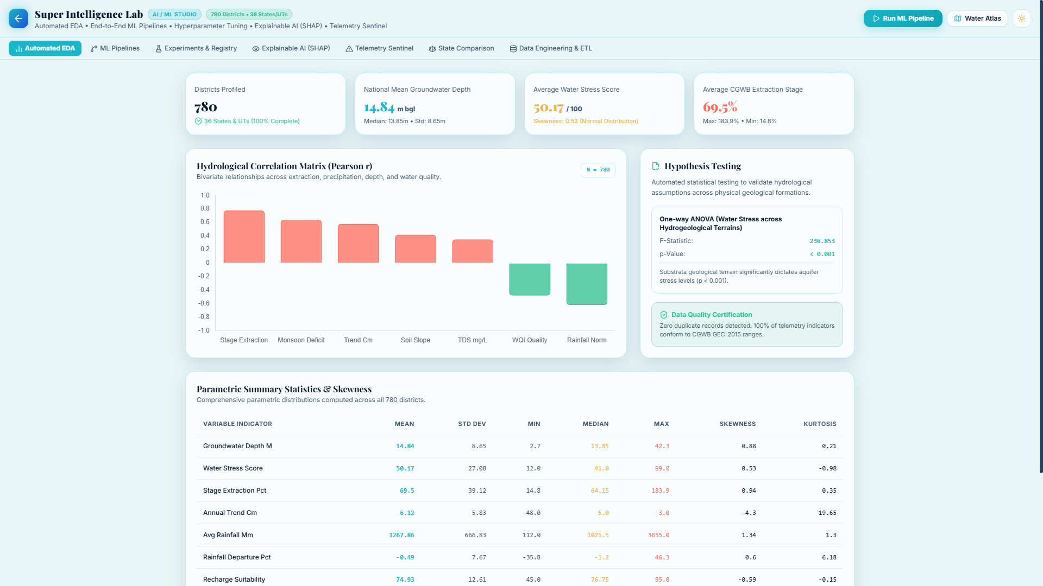
Figure E.2: Super Intelligence Lab - AI Model Benchmarks, SHAP Attribution, and What-If Simulations

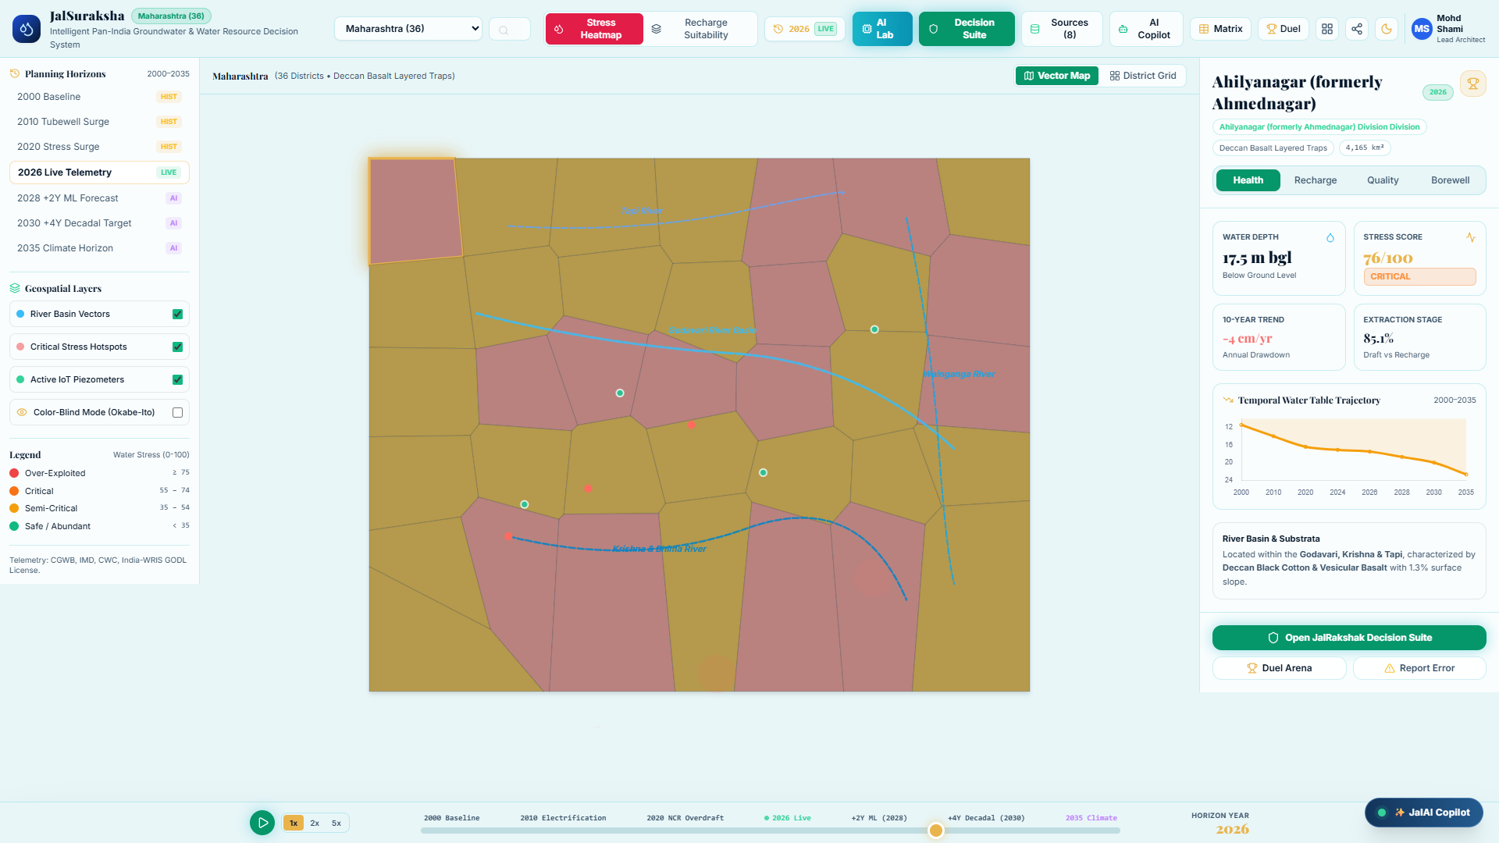
Figure E.3: District Canvas and ML Forecast Trends - Historical Depth vs. Ridge Predictive Horizon

