Cryptography – CTF Solutions

**Q1) Pigpen Cipher**

CIPHER TEXT –



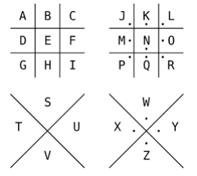

**Flag= FLAG{YIAXSAOWBRYUKPVLEHUUYHETENXRBC}**

**Q2) Bacon Cipher**

Cipher Text -AABABABABBAAAAAAABBA{BBAAABABBBBBAAA2ABABBAABBAABBBB4BBAAAABABBABBB BAAABBABABBBABABAABBB4AAABAAAABABABBBBABBA9AAABB8BAABBAABBAAAABBABB AA8AAABBBABBB}

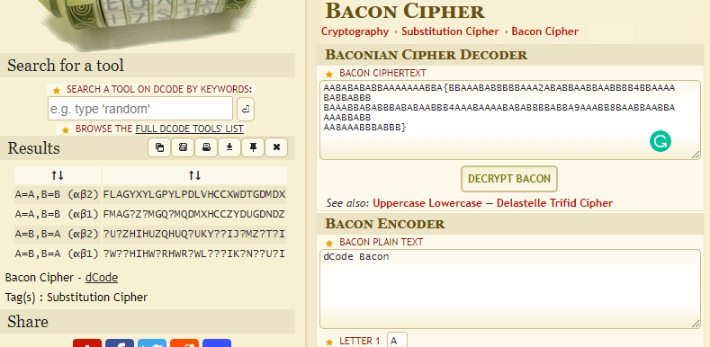

**Flag= FLAG{YXYLGPYLPDLVHCCXWDTGDMDX}**

**Q3) Bifid Cipher**

Cipher Text

HBTG{r2zQ92IpAwEecAABVVDIX9YaAbRaSk}

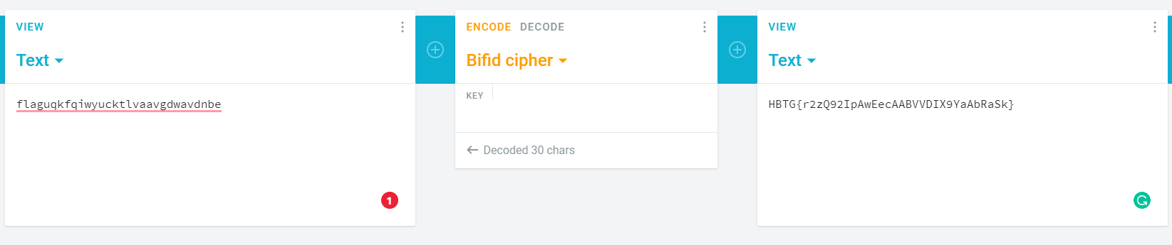

**Flag=FLAG{uqkfqiwyucktlvaavgdwavdnbe}**

**Q4) Gold-Bug Cipher**

Cipher Text-



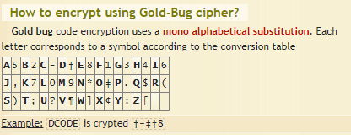

**Flag=FLAG{CUOWCTATDFPXDJTZRCRADXETFTJW}**

**Q5) Conversions**

Cipher text: 51 55 32 53 51 32 52 56 32 50 97 32 51 99 32 52 56 32 53 57 32 53 50 32 53 51 32 50 50 32 52 50 32 51 53 32 54 56 32 54 102 32 53 100 32 52 48 32 55 49 32 52 48 32 55 50 32 53 48 32 51 49 32 52 56 32 51 55 32 52 48 32 50 102 32 52 52 32 50 57 32 51 102 32 50 52 32 50 54 32 51 98 32 50 97 32 54 100 32 50 97 32 52 48 32 52 49 32 52 102 32 52 49 32 52 57 32 52 101 32 51 54 32 53 97 32 52 48 32 51 51 32 55 51

-decimal to hex

-hex to Base84

-base84 to string

**Flag=FLAG{jrSgpsFceAz388jm4kMQB4WeC9KCpv}**