《科学计算可视化》实验报告

实验题目： 二维标量场可视化

姓名 杨文轩
学号 3013216080
专业 计算机
班级 2013级3班

天津大学计算机科学与技术学院
2015 年 10月 22日

一、实验内容
在visual studio 6.0 的环境下实现科学计算可视化的二维标量场可视化，实验共分为四个部分，其代码分别在四个工程drawing 1-4中，四个工程分别实现了不同程度的计算可视化。
1、用网格序列法生成P103页中等值为4.5的等值线
2、用三角剖分法生成上述等值线
3、生成随机等高线
- 生成分辨率大于50Χ50的网格
- 在网格顶点进行随机数赋值，且在区间[0,1]范围内
- 利用网格序列法实现等值线生成（等值为0.4,0.6，结果用不同颜色的线标示）
4、用三角剖分法优化上述结果

二、主要技术及实现
该实验的主要的实验基础是计算可视化的二维标量场的可视化方法，二维标量场可看成是位于某二维面上的一维标量函数F(x,y).基本上是以规整格网或非规整格网表示某二维面,二维面网格上每 一点有二维空间坐标(x,y),在网格点或网格拓扑单元上附属有 标量数据。二维标量场的可视化主要任务是把二维面上的标量数据的分布特征，表现出来。主要有等值线法和区域填充法。该实验中我使用的是等值线的网格序列法。
下面是我具体使用的方法理论：
等值线是由F(xi,yi) == Ft的所有点(xi,yi)组成。这些点 按一定顺序连接组成函数F(x,y)的值为Ft时的等值线，基本思想是按网格单元的排列次序,逐个处理每一个单元,寻找每 一单元内相应的等值线段。在处理完所有单元后,就自然生成了该 网格中的等值线分布。
也就是说该算法主要分为三个阶段
1、逐个计算每一网格单元与等值线的交点;
2、连接该单元内等值线的交点,生成在该单元中的一等值线线段;
3、由一系列单元内的等值线线段构成该网格中的等值线。
在具体代码实现的时候我们只需要对一个二维的平面先画出网格，然后用一个二层的循环遍历每一个小方格，然后对于每一个小方格都做相同的操作:寻找方格边界上的等值点，然后把等值点用直线段相连接。所有的小方格自然会构成一个完整的等高线。
（1）一个简化：
在计算的时候首先把所有的数值先生成出来存在一个二维数组中，然后将这个矩阵A减去value值，（value为我们等高线的数值）
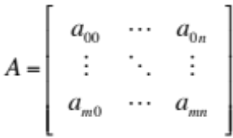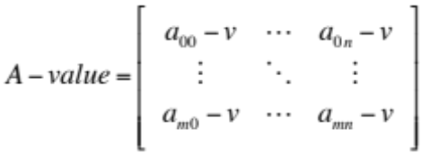
得到一个只有包含负数的矩阵，可以简化后续的过程，我们要得到的等高线即0值等高线
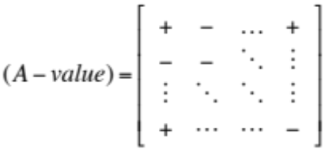
（2）分情况讨论
对于一个方格来说，等值线的划分有三种情况：
- 三正一负，相邻两边连线
- 两正两负且相对的两边连线
- 两正两负且相邻的两边连线

而第三种情况会产生歧义，也就是说存在4个等值点，可能是以正对角线的方式连，也有可能是以负对角线的方式来连线。原因是该等值线应当是双曲线的两支，而不是直线。通过求该双曲线两条渐近线交点处的函数值来判定线的走向。如果为正，说明和正的两个点的连线方向是连续的，所以抛物线的方向应与连线方向呈90度。由此确定了歧义。
三角优化的方法，为了克服歧义，我们可以通过把每一个正方形再细分成三角形，这样就可以消除歧义，同时这样的划分会使得等值线的精度更高，同时又相对减少了多余的计算。代码得到优化。
三、实验结果
下面是实验的截图：
1-1 网格序列法等高线
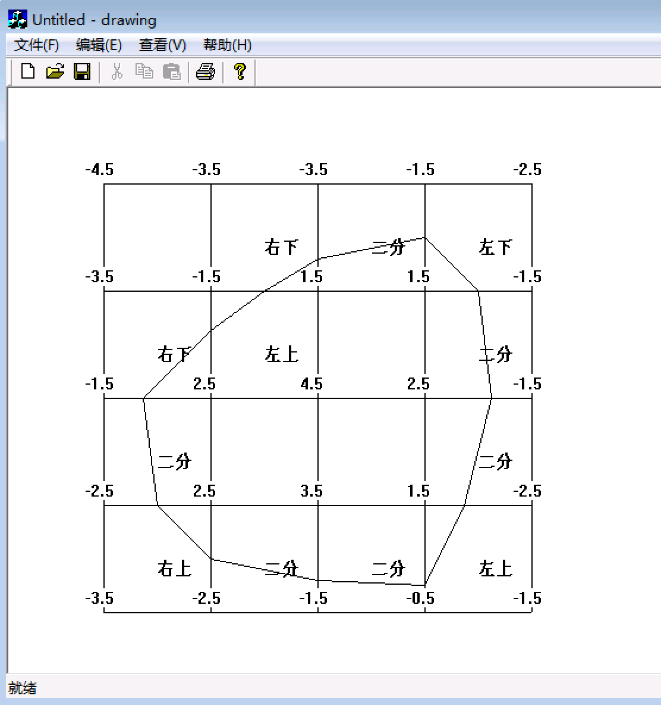
1-2三角优化
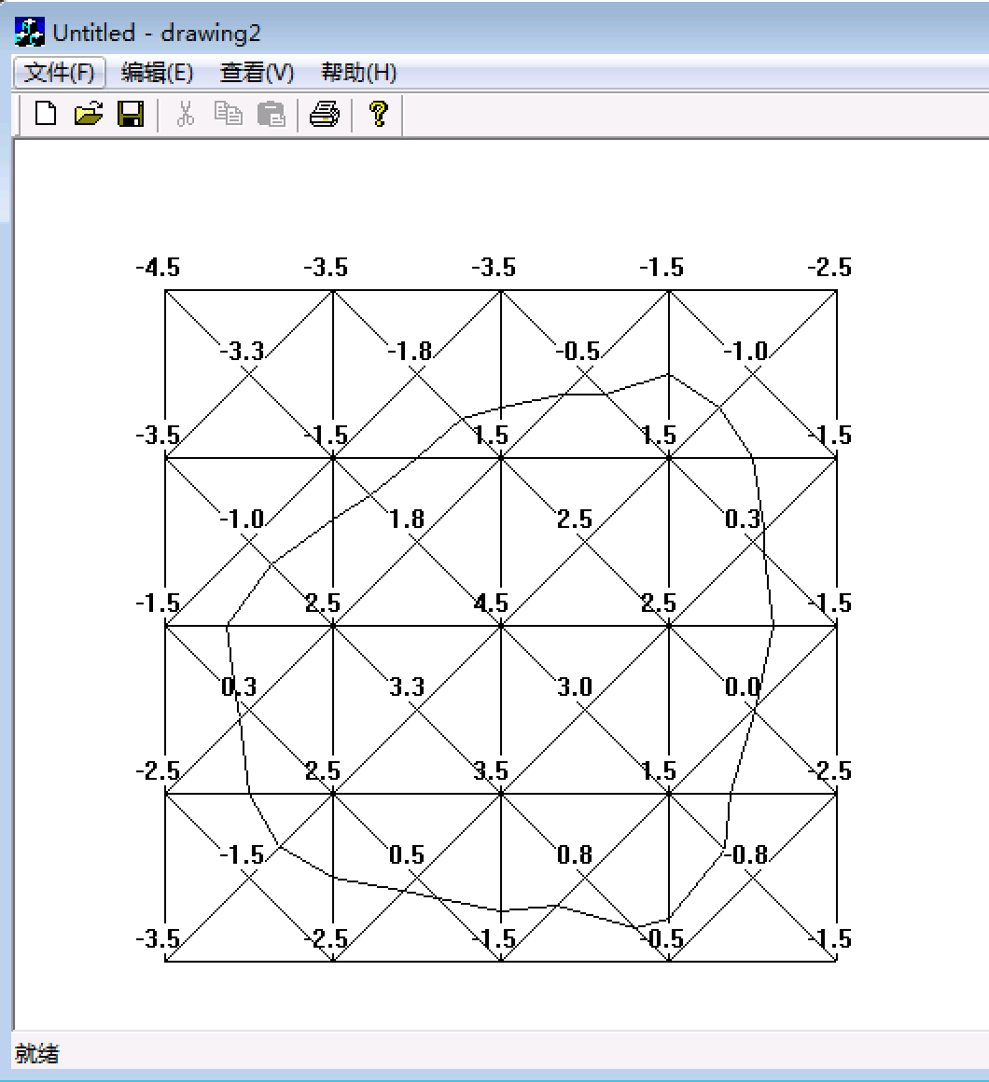
2-1随机大规模多值等高线（蓝色等高线为0.4，红色等高线为0.6）
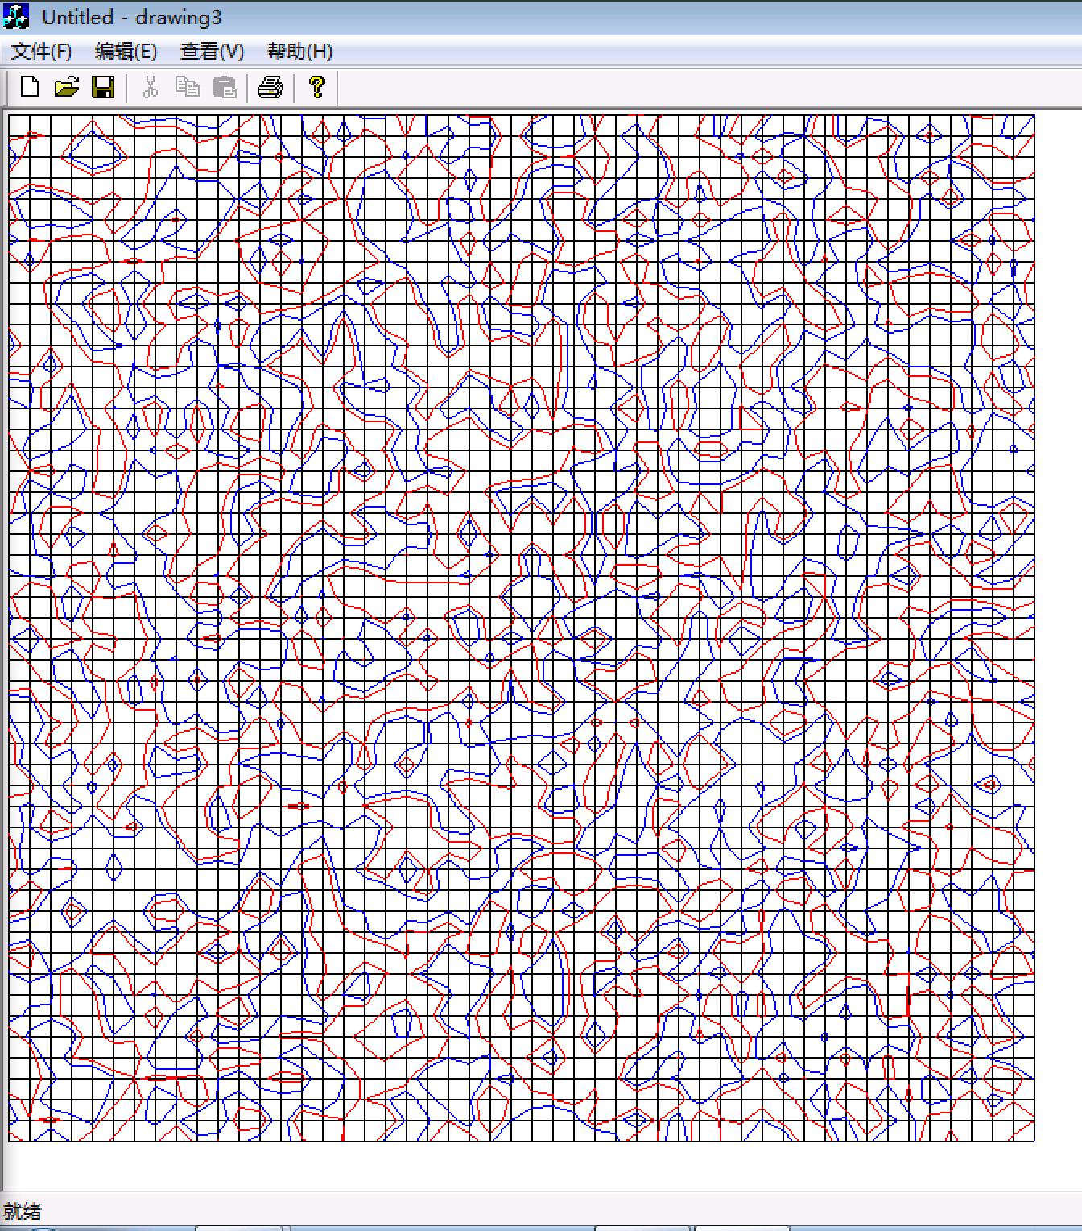
2-2三角优化
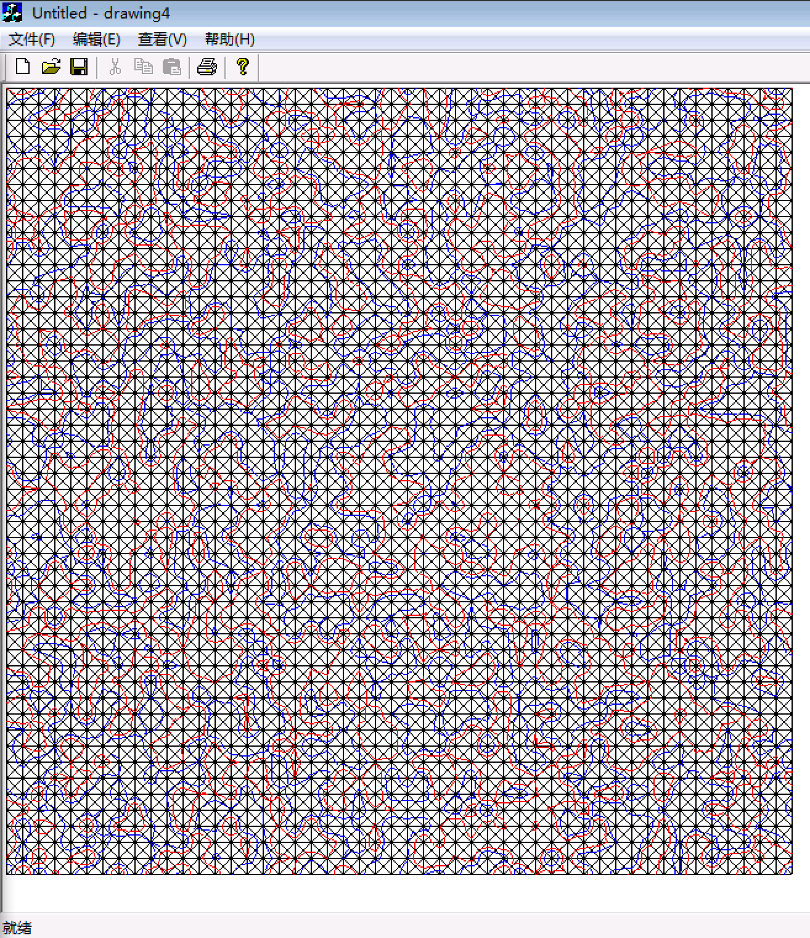
四、实验分析和总结
根据这次实验所得的结果，可以看出实验的最终结果与预期一致，尤其是随机生成等高线，画的完整且用不同颜色突出了不同的数值。
在实验的过程中我针对每一种情况都编写了代码，所以代码中有冗余，这样做虽然使得代码量增大，但是却方便了阅读和debug，还可以采用把不同的部分比如加减，变量，都存在一个数组中，然后判断符合那一种情况，就调用数组中的该情况的变量和运算。

五、核心源代码
1-1代码
// drawingView.cpp : implementation of the CDrawingView class
//

#include "stdafx.h"
#include "drawing.h"

#include "drawingDoc.h"
#include "drawingView.h"

#include <iostream>

#include <conio.h>

using namespace std;
#ifdef _DEBUG
#define new DEBUG_NEW
#undef THIS_FILE
static char THIS_FILE[] = __FILE__;
#endif

/////////////////////////////////////////////////////////////////////////////
// CDrawingView

IMPLEMENT_DYNCREATE(CDrawingView, CView)

BEGIN_MESSAGE_MAP(CDrawingView, CView)
//{{AFX_MSG_MAP(CDrawingView)
// NOTE - the ClassWizard will add and remove mapping macros here.
// DO NOT EDIT what you see in these blocks of generated code!
//}}AFX_MSG_MAP
// Standard printing commands
ON_COMMAND(ID_FILE_PRINT, CView::OnFilePrint)
ON_COMMAND(ID_FILE_PRINT_DIRECT, CView::OnFilePrint)
ON_COMMAND(ID_FILE_PRINT_PREVIEW, CView::OnFilePrintPreview)
END_MESSAGE_MAP()

/////////////////////////////////////////////////////////////////////////////
// CDrawingView construction/destruction

CDrawingView::CDrawingView()
{
// TODO: add construction code here

}

CDrawingView::~CDrawingView()
{
}

BOOL CDrawingView::PreCreateWindow(CREATESTRUCT& cs)
{
// TODO: Modify the Window class or styles here by modifying
// the CREATESTRUCT cs

return CView::PreCreateWindow(cs);
}

/////////////////////////////////////////////////////////////////////////////
// CDrawingView drawing

void CDrawingView::OnDraw(CDC* pDC)
{
CDrawingDoc* pDoc = GetDocument();
ASSERT_VALID(pDoc);
// TODO: add draw code for native data here
//=============

int gridwidth=90;
int gridx=80;
int gridy=80;

//draw the grid
int i=0;
for( i=0;i<5;i++){
drawline(gridx+i*gridwidth,gridy,gridx+i*gridwidth,gridy+4*gridwidth,pDC);//vertical
drawline(gridx,gridy+i*gridwidth,gridx+4*gridwidth,gridy+i*gridwidth,pDC);//horizontal
}

double mat[5][5]={
{0,1,1,3,2},
{1,3,6,6,3},
{3,7,9,7,3},
{2,7,8,6,2},
{1,2,3,4,3}
};

int j,k;

/* CString str;
for( j=0;j<5;j++)
{
for( k=0;k<5;k++)
{
str.Format("%.1f",mat[j][k]);
//TextOut(pDC->GetSafeHdc(),100,100,str,2);
pDC->TextOut(gridx-15+k*gridwidth,gridy-20+j*gridwidth,str);
}
}
*/

double value=4.5;

for(j=0;j<5;j++)
{
for( k=0;k<5;k++)
{
mat[j][k]-=value;
}
}

CString str;
for( j=0;j<5;j++)
{
for( k=0;k<5;k++)
{
str.Format("%.1f",mat[j][k]);
//TextOut(pDC->GetSafeHdc(),100,100,str,2);
pDC->TextOut(gridx-15+k*gridwidth,gridy-20+j*gridwidth,str);
}
}

for( j=0;j<4;j++)
{
for( k=0;k<4;k++)
{
int cnt=0;
if(mat[j][k]>0) cnt++;
if(mat[j+1][k]>0) cnt++;
if(mat[j][k+1]>0) cnt++;
if(mat[j+1][k+1]>0) cnt++;

if(cnt==0||cnt==4) continue;

if(cnt==1||cnt==3){

if(mat[j][k]*mat[j+1][k+1]>0){
if(mat[j][k+1]*mat[j][k]>0){
//左下
CString str;
//str.Format("左下：%.1f*%.1f=%.1f_j=%d_k=%d",mat[j][k+1],mat[j][k],mat[j][k+1]*mat[j][k],j,k);
pDC->TextOut(gridx+(k+0.5)*gridwidth,gridy+(j+0.5)*gridwidth,"左下");
int x1=gridx+gridwidth*k;
int y1=gridy+gridwidth*j;
int x2=x1;
int y2=y1+gridwidth;

double ratio=-1*mat[j][k]/mat[j+1][k];
double percent=ratio/(ratio+1);
y1+=gridwidth*percent;

double ratio2=-1*mat[j+1][k]/mat[j+1][k+1];
double percent2=ratio2/(ratio2+1);
x2+=gridwidth*percent2;

drawline(x1,y1,x2,y2,pDC);
}
else{
//右上
pDC->TextOut(gridx+(k+0.5)*gridwidth,gridy+(j+0.5)*gridwidth,"右上");

int x1=gridx+gridwidth*k;
int y1=gridy+gridwidth*j;
int x2=x1+gridwidth;
int y2=y1;

double ratio=-1*mat[j][k]/mat[j][k+1];
double percent=ratio/(ratio+1);
x1+=gridwidth*percent;

double ratio2=-1*mat[j][k+1]/mat[j+1][k+1];
double percent2=ratio2/(ratio2+1);
y2+=gridwidth*percent2;

drawline(x1,y1,x2,y2,pDC);

}
}
else{
if(mat[j][k]*mat[j][k+1]>0){
//右下
pDC->TextOut(gridx+(k+0.5)*gridwidth,gridy+(j+0.5)*gridwidth,"右下");

int x1=gridx+gridwidth*(k+1);
int y1=gridy+gridwidth*j;
int x2=x1;
int y2=y1+gridwidth;

double ratio=-1*mat[j][k+1]/mat[j+1][k+1];
double percent=ratio/(ratio+1);
y1+=gridwidth*percent;

double ratio2=-1*mat[j+1][k+1]/mat[j+1][k];
double percent2=ratio2/(ratio2+1);
x2-=gridwidth*percent2;

drawline(x1,y1,x2,y2,pDC);
}
else{
//左上
pDC->TextOut(gridx+(k+0.5)*gridwidth,gridy+(j+0.5)*gridwidth,"左上");

int x1=gridx+gridwidth*k;
int y1=gridy+gridwidth*j;
int x2=x1;
int y2=y1+gridwidth;

double ratio=-1*mat[j][k]/mat[j][k+1];
double percent=ratio/(ratio+1);
x1+=gridwidth*percent;

double ratio2=-1*mat[j+1][k]/mat[j][k];
double percent2=ratio2/(ratio2+1);
y2-=gridwidth*percent2;

drawline(x1,y1,x2,y2,pDC);
}
}

}
if(cnt==2){

if(mat[j][k]*mat[j+1][k+1]>0){
pDC->TextOut(gridx+(k+0.5)*gridwidth,gridy+(j+0.5)*gridwidth,"歧义");
double mid=(mat[j][k]+mat[j][k+1]+mat[j+1][k]+mat[j+1][k+1])/4;
if(mid*mat[j][k]>0)//正斜线
{
//line one
int x1=gridx+gridwidth*k;
int y1=gridy+gridwidth*j;
int x2=x1;
int y2=y1+gridwidth;

double ratio=-1*mat[j][k]/mat[j+1][k];
double percent=ratio/(ratio+1);
y1+=gridwidth*percent;

double ratio2=-1*mat[j+1][k]/mat[j+1][k+1];
double percent2=ratio2/(ratio2+1);
x2+=gridwidth*percent2;

drawline(x1,y1,x2,y2,pDC);

//line two
int x3=gridx+gridwidth*k;
int y3=gridy+gridwidth*j;
int x4=x3+gridwidth;
int y4=y3;

double ratio3=-1*mat[j][k]/mat[j][k+1];
double percent3=ratio3/(ratio3+1);
x3+=gridwidth*percent3;

double ratio4=-1*mat[j][k+1]/mat[j+1][k+1];
double percent4=ratio4/(ratio4+1);
y4+=gridwidth*percent4;

drawline(x3,y3,x4,y4,pDC);
}
else{//反斜线
//line one
int x1=gridx+gridwidth*k;
int y1=gridy+gridwidth*j;
int x2=x1;
int y2=y1+gridwidth;

double ratio=-1*mat[j][k]/mat[j][k+1];
double percent=ratio/(ratio+1);
x1+=gridwidth*percent;

double ratio2=-1*mat[j+1][k]/mat[j][k];
double percent2=ratio2/(ratio2+1);
y2-=gridwidth*percent2;

drawline(x1,y1,x2,y2,pDC);

//line two
int x3=gridx+gridwidth*(k+1);
int y3=gridy+gridwidth*j;
int x4=x3;
int y4=y3+gridwidth;

double ratio3=-1*mat[j][k+1]/mat[j+1][k+1];
double percent3=ratio3/(ratio3+1);
y3+=gridwidth*percent3;

double ratio4=-1*mat[j+1][k+1]/mat[j+1][k];
double percent4=ratio4/(ratio4+1);
x4-=gridwidth*percent4;

drawline(x3,y3,x4,y4,pDC);
}
}
else{
pDC->TextOut(gridx+(k+0.5)*gridwidth,gridy+(j+0.5)*gridwidth,"二分");
if(mat[j][k]*mat[j][k+1]>0)//horizontal
{
int x1=gridx+gridwidth*k;
int y1=gridy+gridwidth*j;
int x2=x1+gridwidth;
int y2=y1;

double ratio=-1*mat[j][k]/mat[j+1][k];
double percent=ratio/(ratio+1);
y1+=gridwidth*percent;

double ratio2=-1*mat[j][k+1]/mat[j+1][k+1];
double percent2=ratio2/(ratio2+1);
y2+=gridwidth*percent2;

drawline(x1,y1,x2,y2,pDC);
}
else//vertical
{
int x1=gridx+gridwidth*k;
int y1=gridy+gridwidth*j;
int x2=x1;
int y2=y1+gridwidth;

double ratio=-1*mat[j][k]/mat[j][k+1];
double percent=ratio/(ratio+1);
x1+=gridwidth*percent;

double ratio2=-1*mat[j+1][k]/mat[j+1][k+1];
double percent2=ratio2/(ratio2+1);
x2+=gridwidth*percent2;

drawline(x1,y1,x2,y2,pDC);
}

}
}
}
}

//===========
}

void CDrawingView::drawline(int x1,int y1,int x2, int y2,CDC* pDC){
CPen myPen2;
myPen2.CreatePen(PS_SOLID,1,RGB(0,0,0));
CPen *pOldPen=pDC->SelectObject(&myPen2);
pDC->MoveTo(x1,y1);
pDC->LineTo(x2,y2);
}

/////////////////////////////////////////////////////////////////////////////
// CDrawingView printing

BOOL CDrawingView::OnPreparePrinting(CPrintInfo* pInfo)
{
// default preparation
return DoPreparePrinting(pInfo);
}

void CDrawingView::OnBeginPrinting(CDC* /*pDC*/, CPrintInfo* /*pInfo*/)
{
// TODO: add extra initialization before printing
}

void CDrawingView::OnEndPrinting(CDC* /*pDC*/, CPrintInfo* /*pInfo*/)
{
// TODO: add cleanup after printing
}

/////////////////////////////////////////////////////////////////////////////
// CDrawingView diagnostics

#ifdef _DEBUG
void CDrawingView::AssertValid() const
{
CView::AssertValid();
}

void CDrawingView::Dump(CDumpContext& dc) const
{
CView::Dump(dc);
}

CDrawingDoc* CDrawingView::GetDocument() // non-debug version is inline
{
ASSERT(m_pDocument->IsKindOf(RUNTIME_CLASS(CDrawingDoc)));
return (CDrawingDoc*)m_pDocument;
}
#endif //_DEBUG

/////////////////////////////////////////////////////////////////////////////
// CDrawingView message handlers

1-2
// drawing2View.cpp : implementation of the CDrawing2View class
//
#include "stdafx.h"
#include "drawing2.h"
#include "drawing2Doc.h"
#include "drawing2View.h"
#include <math.h>
#ifdef _DEBUG
#define new DEBUG_NEW
#undef THIS_FILE
static char THIS_FILE[] = __FILE__;
#endif
/////////////////////////////////////////////////////////////////////////////
// CDrawing2View
IMPLEMENT_DYNCREATE(CDrawing2View, CView)
BEGIN_MESSAGE_MAP(CDrawing2View, CView)
//{{AFX_MSG_MAP(CDrawing2View)
// NOTE - the ClassWizard will add and remove mapping macros here.
// DO NOT EDIT what you see in these blocks of generated code!
//}}AFX_MSG_MAP
// Standard printing commands
ON_COMMAND(ID_FILE_PRINT, CView::OnFilePrint)
ON_COMMAND(ID_FILE_PRINT_DIRECT, CView::OnFilePrint)
ON_COMMAND(ID_FILE_PRINT_PREVIEW, CView::OnFilePrintPreview)
END_MESSAGE_MAP()
/////////////////////////////////////////////////////////////////////////////
// CDrawing2View construction/destruction
CDrawing2View::CDrawing2View()
{
// TODO: add construction code here
}
CDrawing2View::~CDrawing2View()
{
}
BOOL CDrawing2View::PreCreateWindow(CREATESTRUCT& cs)
{
// TODO: Modify the Window class or styles here by modifying
// the CREATESTRUCT cs
return CView::PreCreateWindow(cs);
}
/////////////////////////////////////////////////////////////////////////////
// CDrawing2View drawing
void CDrawing2View::OnDraw(CDC* pDC)
{
CDrawing2Doc* pDoc = GetDocument();
ASSERT_VALID(pDoc);
// TODO: add draw code for native data here
int gridwidth=90;
int gridx=80;
int gridy=80;
//draw the grid
int i=0;
for( i=0;i<5;i++){
drawline(gridx+i*gridwidth,gridy,gridx+i*gridwidth,gridy+4*gridwidth,pDC);//vertical
drawline(gridx,gridy+i*gridwidth,gridx+4*gridwidth,gridy+i*gridwidth,pDC);//horizontal
}
double mat[5][5]={
{0,1,1,3,2},
{1,3,6,6,3},
{3,7,9,7,3},
{2,7,8,6,2},
{1,2,3,4,3}
};
int j,k;
double value=4.5;
for(j=0;j<5;j++)
{
for( k=0;k<5;k++)
{
mat[j][k]-=value;
}
}
CString str;
for( j=0;j<5;j++)
{
for( k=0;k<5;k++)
{
str.Format("%.1f",mat[j][k]);
//TextOut(pDC->GetSafeHdc(),100,100,str,2);
pDC->TextOut(gridx-15+k*gridwidth,gridy-20+j*gridwidth,str);
}
}
double mid[4][4];
for( j=0;j<4;j++)
{
for( k=0;k<4;k++)
{
mid[j][k]=(mat[j][k]+mat[j+1][k]+mat[j][k+1]+mat[j+1][k+1])/4;
drawline(gridx+gridwidth*k,gridy+gridwidth*j,gridx+gridwidth*(k+1),gridy+gridwidth*(j+1),pDC);
drawline(gridx+gridwidth*(k+1),gridy+gridwidth*j,gridx+gridwidth*k,gridy+gridwidth*(j+1),pDC);
CString str;
str.Format("%.1f",mid[j][k]);
pDC->TextOut(gridx-15+(k+0.5)*gridwidth,gridy-20+(j+0.5)*gridwidth,str);
mid[2][3]+=0.1;//防止除零错误
int cnt=0;
if(mat[j][k]>0) cnt++;
if(mat[j][k+1]>0) cnt++;
if(mid[j][k]>0) cnt++;
if(cnt==1||cnt==2){
if(mat[j][k]*mid[j][k]>0){//右底角
int x1=gridx+gridwidth*k;
int y1=gridy+gridwidth*j;
int x2=x1+gridwidth;
int y2=y1;
double ratio=-1*mat[j][k]/mat[j][k+1];
double percent=ratio/(ratio+1);
x1+=gridwidth*percent;
double ratio2=-1*mat[j][k+1]/mid[j][k];
double percent2=ratio2/(ratio2+1);
x2-=gridwidth*percent2/2;
y2+=gridwidth*percent2/2;
drawline(x1,y1,x2,y2,pDC);
}
else if(mat[j][k+1]*mid[j][k]>0){//左底角
int x1=gridx+gridwidth*k;
int y1=gridy+gridwidth*j;
int x2=x1;
int y2=y1;
double ratio=-1*mat[j][k]/mat[j][k+1];
double percent=ratio/(ratio+1);
x1+=gridwidth*percent;
double ratio2=-1*mat[j][k]/mid[j][k];
double percent2=ratio2/(ratio2+1);
x2+=gridwidth*percent2/2;
y2+=gridwidth*percent2/2;
drawline(x1,y1,x2,y2,pDC);
}
else{//下顶角
int x1=gridx+gridwidth*k;
int y1=gridy+gridwidth*j;
int x2=x1+gridwidth;
int y2=y1;
double ratio=-1*mat[j][k]/mid[j][k];
double percent=ratio/(ratio+1);
x1+=gridwidth*percent/2;
y1+=gridwidth*percent/2;
double ratio2=-1*mat[j][k+1]/mid[j][k];
double percent2=ratio2/(ratio2+1);
x2-=gridwidth*percent2/2;
y2+=gridwidth*percent2/2;
drawline(x1,y1,x2,y2,pDC);
}
}
//2
int cnt2=0;
if(mat[j][k+1]>0) cnt2++;
if(mat[j+1][k+1]>0) cnt2++;
if(mid[j][k]>0) cnt2++;
if(cnt2==1||cnt2==2){
if(mat[j][k+1]*mid[j][k]>0){//下底角
//pDC->TextOut(gridx+(k+0.75)*gridwidth,gridy+(j+0.5)*gridwidth,"下底角");
int x1=gridx+gridwidth*(k+1);
int y1=gridy+gridwidth*j;
int x2=x1;
int y2=y1+gridwidth;
double ratio=-1*mat[j][k+1]/mat[j+1][k+1];
double percent=ratio/(ratio+1);
y1+=gridwidth*percent;
//pDC->TextOut(x1,y1,"□");
double ratio2=-1*mat[j+1][k+1]/mid[j][k];
double percent2=ratio2/(ratio2+1);
x2-=gridwidth*percent2/2;
y2-=gridwidth*percent2/2;
drawline(x1,y1,x2,y2,pDC);
}
else if(mat[j+1][k+1]*mid[j][k]>0){//上底角
int x1=gridx+gridwidth*(k+1);
int y1=gridy+gridwidth*j;
int x2=x1;
int y2=y1;
double ratio=-1*mat[j][k+1]/mat[j+1][k+1];
double percent=ratio/(ratio+1);
y1+=gridwidth*percent;
double ratio2=-1*mat[j][k+1]/mid[j][k];
double percent2=ratio2/(ratio2+1);
x2-=gridwidth*percent2/2;
y2+=gridwidth*percent2/2;
drawline(x1,y1,x2,y2,pDC);
}
else{//左顶角
int x1=gridx+gridwidth*(k+1);
int y1=gridy+gridwidth*j;
int x2=x1;
int y2=y1+gridwidth;
double ratio=-1*mat[j][k+1]/mid[j][k];
double percent=ratio/(ratio+1);
x1-=gridwidth*percent/2;
y1+=gridwidth*percent/2;
double ratio2=-1*mat[j+1][k+1]/mid[j][k];
double percent2=ratio2/(ratio2+1);
x2-=gridwidth*percent2/2;
y2-=gridwidth*percent2/2;
drawline(x1,y1,x2,y2,pDC);
}
}
//3
int cnt3=0;
if(mat[j+1][k+1]>0) cnt3++;
if(mat[j+1][k]>0) cnt3++;
if(mid[j][k]>0) cnt3++;
if(cnt3==1||cnt3==2){
/*CString s;
s.Format("%.1f",mat[j+1][k+1]*mid[j][k]);
pDC->TextOut(gridx+(k+0.5)*gridwidth,gridy+(j+0.75)*gridwidth,s);
*/
if(mat[j+1][k+1]*mid[j][k]>0){//左底角
CString s;
s.Format("左：%.1f",mat[j+1][k+1]*mid[j][k]);
//pDC->TextOut(gridx+(k+0.5)*gridwidth,gridy+(j+0.75)*gridwidth,s);
int x1=gridx+gridwidth*k;
int y1=gridy+gridwidth*(j+1);
int x2=x1;
int y2=y1;
double ratio=-1*mat[j+1][k]/mat[j+1][k+1];
double percent=ratio/(ratio+1);
x1+=gridwidth*percent;
//pDC->TextOut(x1,y1,"□");
double ratio2=-1*mat[j+1][k]/mid[j][k];
double percent2=ratio2/(ratio2+1);
x2+=gridwidth*percent2/2;
y2-=gridwidth*percent2/2;
drawline(x1,y1,x2,y2,pDC);
}
else if(mat[j+1][k]*mid[j][k]>0){//右底角
//pDC->TextOut(gridx+(k+0.5)*gridwidth,gridy+(j+0.75)*gridwidth,"右");
int x1=gridx+gridwidth*k;
int y1=gridy+gridwidth*(j+1);
int x2=x1+gridwidth;
int y2=y1;
double ratio=-1*mat[j+1][k]/mat[j+1][k+1];
double percent=ratio/(ratio+1);
x1+=gridwidth*percent;
double ratio2=-1*mat[j+1][k+1]/mid[j][k];
double percent2=ratio2/(ratio2+1);
x2-=gridwidth*percent2/2;
y2-=gridwidth*percent2/2;
drawline(x1,y1,x2,y2,pDC);
}
else{//上顶角
int x1=gridx+gridwidth*k;
int y1=gridy+gridwidth*(j+1);
int x2=x1+gridwidth;
int y2=y1;
double ratio=-1*mat[j+1][k]/mid[j][k];
double percent=ratio/(ratio+1);
x1+=gridwidth*percent/2;
y1-=gridwidth*percent/2;
double ratio2=-1*mat[j+1][k+1]/mid[j][k];
double percent2=ratio2/(ratio2+1);
x2-=gridwidth*percent2/2;
y2-=gridwidth*percent2/2;
drawline(x1,y1,x2,y2,pDC);
}
}
//4
int cnt4=0;
if(mat[j][k]>0) cnt4++;
if(mat[j+1][k]>0) cnt4++;
if(mid[j][k]>0) cnt4++;
if(cnt4==1||cnt4==2){
CString s;
s.Format("%d",cnt4);
//pDC->TextOut(gridx+(k+0.25)*gridwidth,gridy+(j+0.5)*gridwidth,s);
if(mat[j+1][k]*mid[j][k]>0){//上底角
CString s;
s.Format("左：%.1f",mat[j+1][k+1]*mid[j][k]);
//pDC->TextOut(gridx+(k+0.5)*gridwidth,gridy+(j+0.75)*gridwidth,s);
int x1=gridx+gridwidth*k;
int y1=gridy+gridwidth*j;
int x2=x1;
int y2=y1;
double ratio=-1*mat[j][k]/mat[j+1][k];
double percent=ratio/(ratio+1);
y1+=gridwidth*percent;
//pDC->TextOut(x1,y1,"□");
double ratio2=-1*mat[j][k]/mid[j][k];
double percent2=ratio2/(ratio2+1);
x2+=gridwidth*percent2/2;
y2+=gridwidth*percent2/2;
drawline(x1,y1,x2,y2,pDC);
}
else if(mat[j][k]*mid[j][k]>0){//下底角
//pDC->TextOut(gridx+(k+0.5)*gridwidth,gridy+(j+0.75)*gridwidth,"下");
int x1=gridx+gridwidth*k;
int y1=gridy+gridwidth*j;
int x2=x1;
int y2=y1+gridwidth;
double ratio=-1*mat[j][k]/mat[j+1][k];
double percent=ratio/(ratio+1);
y1+=gridwidth*percent;
double ratio2=-1*mat[j+1][k]/mid[j][k];
double percent2=ratio2/(ratio2+1);
x2+=gridwidth*percent2/2;
y2-=gridwidth*percent2/2;
drawline(x1,y1,x2,y2,pDC);
}
else{//右顶角
int x1=gridx+gridwidth*k;
int y1=gridy+gridwidth*j;
int x2=x1;
int y2=y1+gridwidth;
double ratio=-1*mat[j][k]/mid[j][k];
double percent=ratio/(ratio+1);
x1+=gridwidth*percent/2;
y1+=gridwidth*percent/2;
double ratio2=-1*mat[j+1][k]/mid[j][k];
double percent2=ratio2/(ratio2+1);
x2+=gridwidth*percent2/2;
y2-=gridwidth*percent2/2;
drawline(x1,y1,x2,y2,pDC);
}
}
}
}
}
void CDrawing2View::drawline(int x1,int y1,int x2, int y2,CDC* pDC){
CPen myPen2;
myPen2.CreatePen(PS_SOLID,1,RGB(0,0,0));
CPen *pOldPen=pDC->SelectObject(&myPen2);
pDC->MoveTo(x1,y1);
pDC->LineTo(x2,y2);
}
/////////////////////////////////////////////////////////////////////////////
// CDrawing2View printing
BOOL CDrawing2View::OnPreparePrinting(CPrintInfo* pInfo)
{
// default preparation
return DoPreparePrinting(pInfo);
}
void CDrawing2View::OnBeginPrinting(CDC* /*pDC*/, CPrintInfo* /*pInfo*/)
{
// TODO: add extra initialization before printing
}
void CDrawing2View::OnEndPrinting(CDC* /*pDC*/, CPrintInfo* /*pInfo*/)
{
// TODO: add cleanup after printing
}
/////////////////////////////////////////////////////////////////////////////
// CDrawing2View diagnostics
#ifdef _DEBUG
void CDrawing2View::AssertValid() const
{
CView::AssertValid();
}
void CDrawing2View::Dump(CDumpContext& dc) const
{
CView::Dump(dc);
}
CDrawing2Doc* CDrawing2View::GetDocument() // non-debug version is inline
{
ASSERT(m_pDocument->IsKindOf(RUNTIME_CLASS(CDrawing2Doc)));
return (CDrawing2Doc*)m_pDocument;
}
#endif //_DEBUG
/////////////////////////////////////////////////////////////////////////////
// CDrawing2View message handlers

1-3代码

// drawing3View.cpp : implementation of the CDrawing3View class
//
#include "stdafx.h"
#include "drawing3.h"
#include<time.h>
#include "drawing3Doc.h"
#include "drawing3View.h"
#ifdef _DEBUG
#define new DEBUG_NEW
#undef THIS_FILE
static char THIS_FILE[] = __FILE__;
#endif
/////////////////////////////////////////////////////////////////////////////
// CDrawing3View
IMPLEMENT_DYNCREATE(CDrawing3View, CView)
BEGIN_MESSAGE_MAP(CDrawing3View, CView)
//{{AFX_MSG_MAP(CDrawing3View)
// NOTE - the ClassWizard will add and remove mapping macros here.
// DO NOT EDIT what you see in these blocks of generated code!
//}}AFX_MSG_MAP
// Standard printing commands
ON_COMMAND(ID_FILE_PRINT, CView::OnFilePrint)
ON_COMMAND(ID_FILE_PRINT_DIRECT, CView::OnFilePrint)
ON_COMMAND(ID_FILE_PRINT_PREVIEW, CView::OnFilePrintPreview)
END_MESSAGE_MAP()
/////////////////////////////////////////////////////////////////////////////
// CDrawing3View construction/destruction
static const int r=50,c=50;
CDrawing3View::CDrawing3View():gridwidth(13),gridx(3),gridy(3)
{
// TODO: add construction code here
}
CDrawing3View::~CDrawing3View()
{
}
BOOL CDrawing3View::PreCreateWindow(CREATESTRUCT& cs)
{
// TODO: Modify the Window class or styles here by modifying
// the CREATESTRUCT cs
return CView::PreCreateWindow(cs);
}
/////////////////////////////////////////////////////////////////////////////
// CDrawing3View drawing
void CDrawing3View::OnDraw(CDC* pDC)
{
CDrawing3Doc* pDoc = GetDocument();
ASSERT_VALID(pDoc);
// TODO: add draw code for native data here
srand(time(0));
double matbak[r][c];
int ii,jj;
for(ii=0;ii<r;ii++){
for(jj=0;jj<c;jj++){
matbak[ii][jj]=(double)rand()/RAND_MAX;
}
}
//draw the grid
int i=0;
for( i=0;i<c;i++){
drawline(gridx+i*gridwidth,gridy,gridx+i*gridwidth,gridy+(r-1)*gridwidth,pDC,000);//vertical
}
for(i=0;i<r;i++){
drawline(gridx,gridy+i*gridwidth,gridx+(c-1)*gridwidth,gridy+i*gridwidth,pDC,000);//horizontal
}
int j,k;
/* CString str;
for( j=0;j<5;j++)
{
for( k=0;k<5;k++)
{
str.Format("%.1f",mat[j][k]);
//TextOut(pDC->GetSafeHdc(),100,100,str,2);
pDC->TextOut(gridx-15+k*gridwidth,gridy-20+j*gridwidth,str);
}
}
*/
int t=0;
double set[]={0.4,0.6};
int color[]={001,100};
for(t=0;t<2;t++){
double value=set[t];
double mat[r][c];
for(j=0;j<r;j++)
{
for( k=0;k<c;k++)
{
mat[j][k]=matbak[j][k]-value;
}
}
CString str;
for( j=0;j<r;j++)
{
for( k=0;k<c;k++)
{
str.Format("%.1f",mat[j][k]);
//TextOut(pDC->GetSafeHdc(),100,100,str,2);
// pDC->TextOut(gridx-15+k*gridwidth,gridy-20+j*gridwidth,str);
}
}
for( j=0;j<r-1;j++)
{
for( k=0;k<c-1;k++)
{
int cnt=0;
if(mat[j][k]>0) cnt++;
if(mat[j+1][k]>0) cnt++;
if(mat[j][k+1]>0) cnt++;
if(mat[j+1][k+1]>0) cnt++;
if(cnt==0||cnt==4) continue;
if(cnt==1||cnt==3){
if(mat[j][k]*mat[j+1][k+1]>0){
if(mat[j][k+1]*mat[j][k]>0){
//左下
CString str;
//pDC->TextOut(gridx+(k+0.5)*gridwidth,gridy+(j+0.5)*gridwidth,"左下");
int x1=gridx+gridwidth*k;
int y1=gridy+gridwidth*j;
int x2=x1;
int y2=y1+gridwidth;
double ratio=-1*mat[j][k]/mat[j+1][k];
double percent=ratio/(ratio+1);
y1+=gridwidth*percent;
double ratio2=-1*mat[j+1][k]/mat[j+1][k+1];
double percent2=ratio2/(ratio2+1);
x2+=gridwidth*percent2;
drawline(x1,y1,x2,y2,pDC,color[t]);
}
else{
//右上
//pDC->TextOut(gridx+(k+0.5)*gridwidth,gridy+(j+0.5)*gridwidth,"右上");
int x1=gridx+gridwidth*k;
int y1=gridy+gridwidth*j;
int x2=x1+gridwidth;
int y2=y1;
double ratio=-1*mat[j][k]/mat[j][k+1];
double percent=ratio/(ratio+1);
x1+=gridwidth*percent;
double ratio2=-1*mat[j][k+1]/mat[j+1][k+1];
double percent2=ratio2/(ratio2+1);
y2+=gridwidth*percent2;
drawline(x1,y1,x2,y2,pDC,color[t]);
}
}
else{
if(mat[j][k]*mat[j][k+1]>0){
//右下
//pDC->TextOut(gridx+(k+0.5)*gridwidth,gridy+(j+0.5)*gridwidth,"右下");
int x1=gridx+gridwidth*(k+1);
int y1=gridy+gridwidth*j;
int x2=x1;
int y2=y1+gridwidth;
double ratio=-1*mat[j][k+1]/mat[j+1][k+1];
double percent=ratio/(ratio+1);
y1+=gridwidth*percent;
double ratio2=-1*mat[j+1][k+1]/mat[j+1][k];
double percent2=ratio2/(ratio2+1);
x2-=gridwidth*percent2;
drawline(x1,y1,x2,y2,pDC,color[t]);
}
else{
//左上
// pDC->TextOut(gridx+(k+0.5)*gridwidth,gridy+(j+0.5)*gridwidth,"左上");
int x1=gridx+gridwidth*k;
int y1=gridy+gridwidth*j;
int x2=x1;
int y2=y1+gridwidth;
double ratio=-1*mat[j][k]/mat[j][k+1];
double percent=ratio/(ratio+1);
x1+=gridwidth*percent;
double ratio2=-1*mat[j+1][k]/mat[j][k];
double percent2=ratio2/(ratio2+1);
y2-=gridwidth*percent2;
drawline(x1,y1,x2,y2,pDC,color[t]);
}
}
}
if(cnt==2){
if(mat[j][k]*mat[j+1][k+1]>0){
//pDC->TextOut(gridx+(k+0.5)*gridwidth,gridy+(j+0.5)*gridwidth,"歧义");
double mid=(mat[j][k]+mat[j][k+1]+mat[j+1][k]+mat[j+1][k+1])/4;
if(mid*mat[j][k]>0)//正斜线
{
//line one
int x1=gridx+gridwidth*k;
int y1=gridy+gridwidth*j;
int x2=x1;
int y2=y1+gridwidth;
double ratio=-1*mat[j][k]/mat[j+1][k];
double percent=ratio/(ratio+1);
y1+=gridwidth*percent;
double ratio2=-1*mat[j+1][k]/mat[j+1][k+1];
double percent2=ratio2/(ratio2+1);
x2+=gridwidth*percent2;
drawline(x1,y1,x2,y2,pDC,color[t]);
//line two
int x3=gridx+gridwidth*k;
int y3=gridy+gridwidth*j;
int x4=x3+gridwidth;
int y4=y3;
double ratio3=-1*mat[j][k]/mat[j][k+1];
double percent3=ratio3/(ratio3+1);
x3+=gridwidth*percent3;
double ratio4=-1*mat[j][k+1]/mat[j+1][k+1];
double percent4=ratio4/(ratio4+1);
y4+=gridwidth*percent4;
drawline(x3,y3,x4,y4,pDC,color[t]);
}
else{//反斜线
//line one
int x1=gridx+gridwidth*k;
int y1=gridy+gridwidth*j;
int x2=x1;
int y2=y1+gridwidth;
double ratio=-1*mat[j][k]/mat[j][k+1];
double percent=ratio/(ratio+1);
x1+=gridwidth*percent;
double ratio2=-1*mat[j+1][k]/mat[j][k];
double percent2=ratio2/(ratio2+1);
y2-=gridwidth*percent2;
drawline(x1,y1,x2,y2,pDC,color[t]);
//line two
int x3=gridx+gridwidth*(k+1);
int y3=gridy+gridwidth*j;
int x4=x3;
int y4=y3+gridwidth;
double ratio3=-1*mat[j][k+1]/mat[j+1][k+1];
double percent3=ratio3/(ratio3+1);
y3+=gridwidth*percent3;
double ratio4=-1*mat[j+1][k+1]/mat[j+1][k];
double percent4=ratio4/(ratio4+1);
x4-=gridwidth*percent4;
drawline(x3,y3,x4,y4,pDC,color[t]);
}
}
else{
//pDC->TextOut(gridx+(k+0.5)*gridwidth,gridy+(j+0.5)*gridwidth,"二分");
if(mat[j][k]*mat[j][k+1]>0)//horizontal
{
int x1=gridx+gridwidth*k;
int y1=gridy+gridwidth*j;
int x2=x1+gridwidth;
int y2=y1;
double ratio=-1*mat[j][k]/mat[j+1][k];
double percent=ratio/(ratio+1);
y1+=gridwidth*percent;
double ratio2=-1*mat[j][k+1]/mat[j+1][k+1];
double percent2=ratio2/(ratio2+1);
y2+=gridwidth*percent2;
drawline(x1,y1,x2,y2,pDC,color[t]);
}
else//vertical
{
int x1=gridx+gridwidth*k;
int y1=gridy+gridwidth*j;
int x2=x1;
int y2=y1+gridwidth;
double ratio=-1*mat[j][k]/mat[j][k+1];
double percent=ratio/(ratio+1);
x1+=gridwidth*percent;
double ratio2=-1*mat[j+1][k]/mat[j+1][k+1];
double percent2=ratio2/(ratio2+1);
x2+=gridwidth*percent2;
drawline(x1,y1,x2,y2,pDC,color[t]);
}
}
}
}
}
}//2 loop
//===========
}
/*
void CDrawing3View::drawline(int x1,int y1,int x2, int y2,CDC* pDC){
CPen myPen2;
myPen2.CreatePen(PS_SOLID,1,RGB(0,0,0));
CPen *pOldPen=pDC->SelectObject(&myPen2);
pDC->MoveTo(x1,y1);
pDC->LineTo(x2,y2);
}
*/
void CDrawing3View::drawline(int x1,int y1,int x2, int y2,CDC* pDC,int RGB){
CPen myPen2;
switch(RGB){
case 100:
myPen2.CreatePen(PS_SOLID,1,RGB(255,0,0));
break;
case 010:
myPen2.CreatePen(PS_SOLID,1,RGB(0,255,0));
break;
case 001:
myPen2.CreatePen(PS_SOLID,1,RGB(0,0,255));
break;
case 000:
myPen2.CreatePen(PS_SOLID,1,RGB(0,0,0));
break;
};
CPen *pOldPen=pDC->SelectObject(&myPen2);
pDC->MoveTo(x1,y1);
pDC->LineTo(x2,y2);
}
/////////////////////////////////////////////////////////////////////////////
// CDrawing3View printing
BOOL CDrawing3View::OnPreparePrinting(CPrintInfo* pInfo)
{
// default preparation
return DoPreparePrinting(pInfo);
}
void CDrawing3View::OnBeginPrinting(CDC* /*pDC*/, CPrintInfo* /*pInfo*/)
{
// TODO: add extra initialization before printing
}
void CDrawing3View::OnEndPrinting(CDC* /*pDC*/, CPrintInfo* /*pInfo*/)
{
// TODO: add cleanup after printing
}
/////////////////////////////////////////////////////////////////////////////
// CDrawing3View diagnostics
#ifdef _DEBUG
void CDrawing3View::AssertValid() const
{
CView::AssertValid();
}
void CDrawing3View::Dump(CDumpContext& dc) const
{
CView::Dump(dc);
}
CDrawing3Doc* CDrawing3View::GetDocument() // non-debug version is inline
{
ASSERT(m_pDocument->IsKindOf(RUNTIME_CLASS(CDrawing3Doc)));
return (CDrawing3Doc*)m_pDocument;
}
#endif //_DEBUG
/////////////////////////////////////////////////////////////////////////////
// CDrawing3View message handlers

1-4代码
// drawing4View.cpp : implementation of the CDrawing4View class
//
#include "stdafx.h"
#include "drawing4.h"
#include<time.h>
#include "drawing4Doc.h"
#include "drawing4View.h"
#ifdef _DEBUG
#define new DEBUG_NEW
#undef THIS_FILE
static char THIS_FILE[] = __FILE__;
#endif
/////////////////////////////////////////////////////////////////////////////
// CDrawing4View
IMPLEMENT_DYNCREATE(CDrawing4View, CView)
BEGIN_MESSAGE_MAP(CDrawing4View, CView)
//{{AFX_MSG_MAP(CDrawing4View)
// NOTE - the ClassWizard will add and remove mapping macros here.
// DO NOT EDIT what you see in these blocks of generated code!
//}}AFX_MSG_MAP
// Standard printing commands
ON_COMMAND(ID_FILE_PRINT, CView::OnFilePrint)
ON_COMMAND(ID_FILE_PRINT_DIRECT, CView::OnFilePrint)
ON_COMMAND(ID_FILE_PRINT_PREVIEW, CView::OnFilePrintPreview)
END_MESSAGE_MAP()
/////////////////////////////////////////////////////////////////////////////
// CDrawing4View construction/destruction
static const int r=50,c=50;
CDrawing4View::CDrawing4View():gridwidth(13),gridx(3),gridy(3)
{
// TODO: add construction code here
}
CDrawing4View::~CDrawing4View()
{
}
BOOL CDrawing4View::PreCreateWindow(CREATESTRUCT& cs)
{
// TODO: Modify the Window class or styles here by modifying
// the CREATESTRUCT cs
return CView::PreCreateWindow(cs);
}
/////////////////////////////////////////////////////////////////////////////
// CDrawing4View drawing
void CDrawing4View::OnDraw(CDC* pDC)
{
CDrawing4Doc* pDoc = GetDocument();
ASSERT_VALID(pDoc);
// TODO: add draw code for native data here
//init the matbak
srand(time(0));
double matbak[r][c];
int ii,jj;
for(ii=0;ii<r;ii++){
for(jj=0;jj<c;jj++){
matbak[ii][jj]=(double)rand()/RAND_MAX;
}
}
//draw the grid(black)
int i=0;
for( i=0;i<c;i++){
drawline(gridx+i*gridwidth,gridy,gridx+i*gridwidth,gridy+(r-1)*gridwidth,pDC,000);//vertical
}
for(i=0;i<r;i++){
drawline(gridx,gridy+i*gridwidth,gridx+(c-1)*gridwidth,gridy+i*gridwidth,pDC,000);//horizontal
}
int t=0;
double set[]={0.4,0.6};
int color[]={001,100};
for(t=0;t<2;t++){
double value=set[t];
double mat[r][c];
int j,k;
for(j=0;j<r;j++)
{
for( k=0;k<c;k++)
{
mat[j][k]=matbak[j][k]-value;
}
}
//=====draw in a grid=======
double mid[r-1][c-1];
for( j=0;j<r-1;j++)
{
for( k=0;k<c-1;k++)
{
mid[j][k]=(mat[j][k]+mat[j+1][k]+mat[j][k+1]+mat[j+1][k+1])/4;
drawline(gridx+gridwidth*k,gridy+gridwidth*j,gridx+gridwidth*(k+1),gridy+gridwidth*(j+1),pDC,000);
drawline(gridx+gridwidth*(k+1),gridy+gridwidth*j,gridx+gridwidth*k,gridy+gridwidth*(j+1),pDC,000);
CString str;
str.Format("%.1f",mid[j][k]);
//pDC->TextOut(gridx-15+(k+0.5)*gridwidth,gridy-20+(j+0.5)*gridwidth,str);
//mid[2][3]+=0.1;//??????
//1
int cnt=0;
if(mat[j][k]>0) cnt++;
if(mat[j][k+1]>0) cnt++;
if(mid[j][k]>0) cnt++;
if(cnt==1||cnt==2){
if(mat[j][k]*mid[j][k]>0){//???
int x1=gridx+gridwidth*k;
int y1=gridy+gridwidth*j;
int x2=x1+gridwidth;
int y2=y1;
double ratio=-1*mat[j][k]/mat[j][k+1];
double percent=ratio/(ratio+1);
x1+=gridwidth*percent;
double ratio2=-1*mat[j][k+1]/mid[j][k];
double percent2=ratio2/(ratio2+1);
x2-=gridwidth*percent2/2;
y2+=gridwidth*percent2/2;
drawline(x1,y1,x2,y2,pDC,color[t]);
}
else if(mat[j][k+1]*mid[j][k]>0){//???
int x1=gridx+gridwidth*k;
int y1=gridy+gridwidth*j;
int x2=x1;
int y2=y1;
double ratio=-1*mat[j][k]/mat[j][k+1];
double percent=ratio/(ratio+1);
x1+=gridwidth*percent;
double ratio2=-1*mat[j][k]/mid[j][k];
double percent2=ratio2/(ratio2+1);
x2+=gridwidth*percent2/2;
y2+=gridwidth*percent2/2;
drawline(x1,y1,x2,y2,pDC,color[t]);
}
else{//???
int x1=gridx+gridwidth*k;
int y1=gridy+gridwidth*j;
int x2=x1+gridwidth;
int y2=y1;
double ratio=-1*mat[j][k]/mid[j][k];
double percent=ratio/(ratio+1);
x1+=gridwidth*percent/2;
y1+=gridwidth*percent/2;
double ratio2=-1*mat[j][k+1]/mid[j][k];
double percent2=ratio2/(ratio2+1);
x2-=gridwidth*percent2/2;
y2+=gridwidth*percent2/2;
drawline(x1,y1,x2,y2,pDC,color[t]);
}
}
//2
int cnt2=0;
if(mat[j][k+1]>0) cnt2++;
if(mat[j+1][k+1]>0) cnt2++;
if(mid[j][k]>0) cnt2++;
if(cnt2==1||cnt2==2){
if(mat[j][k+1]*mid[j][k]>0){//???
//pDC->TextOut(gridx+(k+0.75)*gridwidth,gridy+(j+0.5)*gridwidth,"???");
int x1=gridx+gridwidth*(k+1);
int y1=gridy+gridwidth*j;
int x2=x1;
int y2=y1+gridwidth;
double ratio=-1*mat[j][k+1]/mat[j+1][k+1];
double percent=ratio/(ratio+1);
y1+=gridwidth*percent;
//pDC->TextOut(x1,y1,"?");
double ratio2=-1*mat[j+1][k+1]/mid[j][k];
double percent2=ratio2/(ratio2+1);
x2-=gridwidth*percent2/2;
y2-=gridwidth*percent2/2;
drawline(x1,y1,x2,y2,pDC,color[t]);
}
else if(mat[j+1][k+1]*mid[j][k]>0){//???
int x1=gridx+gridwidth*(k+1);
int y1=gridy+gridwidth*j;
int x2=x1;
int y2=y1;
double ratio=-1*mat[j][k+1]/mat[j+1][k+1];
double percent=ratio/(ratio+1);
y1+=gridwidth*percent;
double ratio2=-1*mat[j][k+1]/mid[j][k];
double percent2=ratio2/(ratio2+1);
x2-=gridwidth*percent2/2;
y2+=gridwidth*percent2/2;
drawline(x1,y1,x2,y2,pDC,color[t]);
}
else{//???
int x1=gridx+gridwidth*(k+1);
int y1=gridy+gridwidth*j;
int x2=x1;
int y2=y1+gridwidth;
double ratio=-1*mat[j][k+1]/mid[j][k];
double percent=ratio/(ratio+1);
x1-=gridwidth*percent/2;
y1+=gridwidth*percent/2;
double ratio2=-1*mat[j+1][k+1]/mid[j][k];
double percent2=ratio2/(ratio2+1);
x2-=gridwidth*percent2/2;
y2-=gridwidth*percent2/2;
drawline(x1,y1,x2,y2,pDC,color[t]);
}
}
//3
int cnt3=0;
if(mat[j+1][k+1]>0) cnt3++;
if(mat[j+1][k]>0) cnt3++;
if(mid[j][k]>0) cnt3++;
if(cnt3==1||cnt3==2){
if(mat[j+1][k+1]*mid[j][k]>0){//???
CString s;
s.Format("??%.1f",mat[j+1][k+1]*mid[j][k]);
//pDC->TextOut(gridx+(k+0.5)*gridwidth,gridy+(j+0.75)*gridwidth,s);
int x1=gridx+gridwidth*k;
int y1=gridy+gridwidth*(j+1);
int x2=x1;
int y2=y1;
double ratio=-1*mat[j+1][k]/mat[j+1][k+1];
double percent=ratio/(ratio+1);
x1+=gridwidth*percent;
//pDC->TextOut(x1,y1,"?");
double ratio2=-1*mat[j+1][k]/mid[j][k];
double percent2=ratio2/(ratio2+1);
x2+=gridwidth*percent2/2;
y2-=gridwidth*percent2/2;
drawline(x1,y1,x2,y2,pDC,color[t]);
}
else if(mat[j+1][k]*mid[j][k]>0){//???
//pDC->TextOut(gridx+(k+0.5)*gridwidth,gridy+(j+0.75)*gridwidth,"?");
int x1=gridx+gridwidth*k;
int y1=gridy+gridwidth*(j+1);
int x2=x1+gridwidth;
int y2=y1;
double ratio=-1*mat[j+1][k]/mat[j+1][k+1];
double percent=ratio/(ratio+1);
x1+=gridwidth*percent;
double ratio2=-1*mat[j+1][k+1]/mid[j][k];
double percent2=ratio2/(ratio2+1);
x2-=gridwidth*percent2/2;
y2-=gridwidth*percent2/2;
drawline(x1,y1,x2,y2,pDC,color[t]);
}
else{//???
int x1=gridx+gridwidth*k;
int y1=gridy+gridwidth*(j+1);
int x2=x1+gridwidth;
int y2=y1;
double ratio=-1*mat[j+1][k]/mid[j][k];
double percent=ratio/(ratio+1);
x1+=gridwidth*percent/2;
y1-=gridwidth*percent/2;
double ratio2=-1*mat[j+1][k+1]/mid[j][k];
double percent2=ratio2/(ratio2+1);
x2-=gridwidth*percent2/2;
y2-=gridwidth*percent2/2;
drawline(x1,y1,x2,y2,pDC,color[t]);
}
}
//4
int cnt4=0;
if(mat[j][k]>0) cnt4++;
if(mat[j+1][k]>0) cnt4++;
if(mid[j][k]>0) cnt4++;
if(cnt4==1||cnt4==2){
CString s;
s.Format("%d",cnt4);
//pDC->TextOut(gridx+(k+0.25)*gridwidth,gridy+(j+0.5)*gridwidth,s);
if(mat[j+1][k]*mid[j][k]>0){//???
CString s;
s.Format("??%.1f",mat[j+1][k+1]*mid[j][k]);
//pDC->TextOut(gridx+(k+0.5)*gridwidth,gridy+(j+0.75)*gridwidth,s);
int x1=gridx+gridwidth*k;
int y1=gridy+gridwidth*j;
int x2=x1;
int y2=y1;
double ratio=-1*mat[j][k]/mat[j+1][k];
double percent=ratio/(ratio+1);
y1+=gridwidth*percent;
//pDC->TextOut(x1,y1,"?");
double ratio2=-1*mat[j][k]/mid[j][k];
double percent2=ratio2/(ratio2+1);
x2+=gridwidth*percent2/2;
y2+=gridwidth*percent2/2;
drawline(x1,y1,x2,y2,pDC,color[t]);
}
else if(mat[j][k]*mid[j][k]>0){//???
//pDC->TextOut(gridx+(k+0.5)*gridwidth,gridy+(j+0.75)*gridwidth,"?");
int x1=gridx+gridwidth*k;
int y1=gridy+gridwidth*j;
int x2=x1;
int y2=y1+gridwidth;
double ratio=-1*mat[j][k]/mat[j+1][k];
double percent=ratio/(ratio+1);
y1+=gridwidth*percent;
double ratio2=-1*mat[j+1][k]/mid[j][k];
double percent2=ratio2/(ratio2+1);
x2+=gridwidth*percent2/2;
y2-=gridwidth*percent2/2;
drawline(x1,y1,x2,y2,pDC,color[t]);
}
else{//???
int x1=gridx+gridwidth*k;
int y1=gridy+gridwidth*j;
int x2=x1;
int y2=y1+gridwidth;
double ratio=-1*mat[j][k]/mid[j][k];
double percent=ratio/(ratio+1);
x1+=gridwidth*percent/2;
y1+=gridwidth*percent/2;
double ratio2=-1*mat[j+1][k]/mid[j][k];
double percent2=ratio2/(ratio2+1);
x2+=gridwidth*percent2/2;
y2-=gridwidth*percent2/2;
drawline(x1,y1,x2,y2,pDC,color[t]);
}
}//4 end
}//loop k end
}//loop j end
}
}
void CDrawing4View::drawline(int x1,int y1,int x2, int y2,CDC* pDC,int RGB){
CPen myPen2;
switch(RGB){
case 100:
myPen2.CreatePen(PS_SOLID,1,RGB(255,0,0));
break;
case 010:
myPen2.CreatePen(PS_SOLID,1,RGB(0,255,0));
break;
case 001:
myPen2.CreatePen(PS_SOLID,1,RGB(0,0,255));
break;
case 000:
myPen2.CreatePen(PS_SOLID,1,RGB(0,0,0));
break;
};
CPen *pOldPen=pDC->SelectObject(&myPen2);
pDC->MoveTo(x1,y1);
pDC->LineTo(x2,y2);
}
/////////////////////////////////////////////////////////////////////////////
// CDrawing4View printing
BOOL CDrawing4View::OnPreparePrinting(CPrintInfo* pInfo)
{
// default preparation
return DoPreparePrinting(pInfo);
}
void CDrawing4View::OnBeginPrinting(CDC* /*pDC*/, CPrintInfo* /*pInfo*/)
{
// TODO: add extra initialization before printing
}
void CDrawing4View::OnEndPrinting(CDC* /*pDC*/, CPrintInfo* /*pInfo*/)
{
// TODO: add cleanup after printing
}
/////////////////////////////////////////////////////////////////////////////
// CDrawing4View diagnostics
#ifdef _DEBUG
void CDrawing4View::AssertValid() const
{
CView::AssertValid();
}
void CDrawing4View::Dump(CDumpContext& dc) const
{
CView::Dump(dc);
}
CDrawing4Doc* CDrawing4View::GetDocument() // non-debug version is inline
{
ASSERT(m_pDocument->IsKindOf(RUNTIME_CLASS(CDrawing4Doc)));
return (CDrawing4Doc*)m_pDocument;
}
#endif //_DEBUG
/////////////////////////////////////////////////////////////////////////////
// CDrawing4View message handlers

