***Pot Hole Detection on the roads using Transfer Learning (Resnet 50)***

As we all know how pot holes play a role in causing most of the minor and some major accidents actors the globe, having potholes on the roads are very dangerous in any climate, since it can cause a very serious damage to vehicle’s and even the drivers which can make the vehicle fall apart and causing serious injuries. So, here is a project which allows us to solve the problem of avoiding potholes where the model which we have generated using transfer learning i.e., Resnet50 is used to detect whether there are any pot holes or not on the roads, this model can be integrated with autopilot vehicle modes which allows the vehicle to avoid potholes.

***Base Paper***

1. https://www.researchgate.net/publication/357093620_Smart_Pothole_Detection_Using_Deep_Learning_Based_on_Dilated_Convolution

***Algorithm Description***

Resnet is a Transfer learning algorithm which is mainly known as Residual Neural Networks which helps us to solve the problem of vanishing gradients/exploding gradient descents which arises while training a neural network. Resnet50 is a 50-layer deep neural network using around 150+ layers to dig deep into the hole for the extensive training. The major breakthrough of this network is since the vanishing and exploding gradient descent problem occurs in a typical neural network due to concept of backpropagation for adjusting weights and bias, so in order to rectify this the authors have introduced this Residual network which uses Skip Connection solve the above problem.

***Steps to Run the code.***

**Note:** Make sure you have added path while installing the software’s.

<https://techieyantechnologies.com/2022/07/how-to-install-anaconda/>

<https://techieyantechnologies.com/2022/06/get-started-with-creating-new-environment-in-anaconda-configuring-jupyter-notebook-and-installing-libraries-using-requirements-txt-2/>

1. Install the prerequisites/software’s required to execute the code from reading the above blog which is provided in the link above.
2. Press windows key and type in anaconda prompt a terminal opens up.
3. Before executing the code, we need to create a specific environment which allows us to install the required libraries necessary for our project.

* Type conda create -name “env_name”, e.g.: conda create -name project_1
* Type conda activate “env_name, e.g.: conda activate project_1

1. Make sure you are in the correct path in your terminal, where you have saved your executable file/folder. E.g.: cd A:\project\AI\Completed\project_name, then press enter.
2. Install necessary libraries from requirements.txt file provided.
3. Run pip install -r requirements.txt or conda install requirements.txt (Requirements.txt is a text file consisting of all the necessary libraries required for executing this python file. If it gives any error while installing libraries, you might need to install them individually.)
4. Run main_resnet50.ipynb and make sure to change the path where your executable files are located and also the model path in the code, please follow the link on how to install and set up anaconda environment to execute files.

***Data Description***

The dataset used in this project was collected form the Kaggle data repository which is basically a hub for data scientists and all the enthusiasts who wants to do some exciting things with data. The dataset is basically divided into 2 classes, normal roads and roads with potholes. The data was already labelled and segregated into normal roads and pothole roads where each class consisting of about 350 normal road images and 329 pothole roads.

Normal road

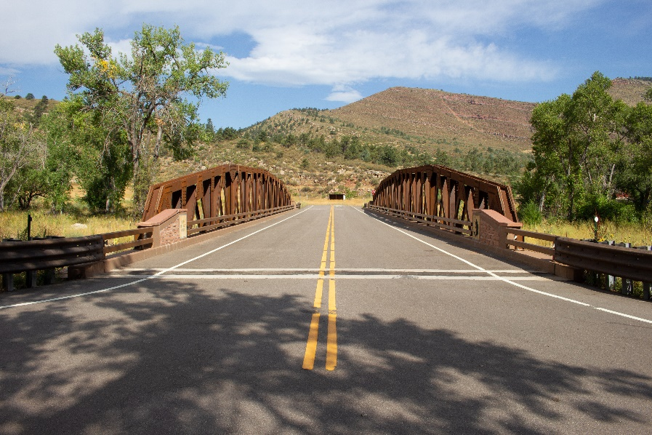

Pothole road

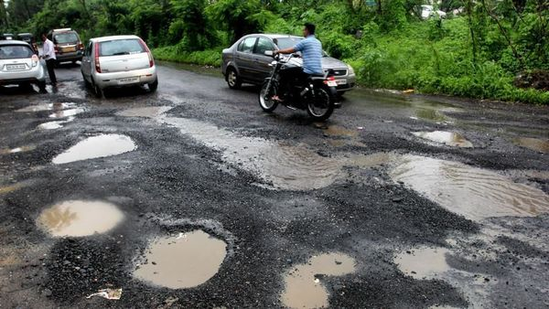

***Issues Faced.***

1. We might face an issue while installing specific libraries.

2. Make sure you have the latest version of python, since sometimes it might cause version mismatch.

3. Adding path to environment variables in order to run python files and anaconda environment in code editor, specifically in visual studio code.

4. Refer to the Below link to get more details on installing python and anaconda and how to configure it.

<https://techieyantechnologies.com/2022/06/get-started-with-creating-new-environment-in-anaconda-configuring-jupyter-notebook-and-installing-libraries-using-requirements-txt-2/>

5. Loading an understanding the transfer learning concept might be tricky at the start. Please refer to the algorithm description to learn more about transfer learning.

***Note:***

**All the required data hasn’t been provided over here. Please feel free to contact me for any issues.**

***Let’s Connect***

https://www.linkedin.com/in/abhinay-lingala-5a3ab7205/

***Yes, you now have more knowledge than yesterday, Keep Going.***

***Results***

**Normal Road**

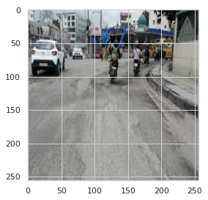

**Pothole Road**

