User Guide

# Introduction

The aim of this tool is to investigate the effects of weather on a construction project. It enables the building of a typical schedule – with activities and dependencies, however in addition the user can add a location and a climatic activity type to each activity. This allows for the calculation of a weather affected duration for each construction activity.

The effect of this weather aware calculation on the schedule can be viewed through several reports.

# Basic Workflow

To create a schedule the user must go through the following stages in this order:

* Create a new schedule
* Create the construction locations
* Create the activities, setting the location of each one
* Create the dependencies for each activity. This can stage can be skipped initially as a “Finish to Start” dependency will be assumed if one hasn’t been created.

# Schedule

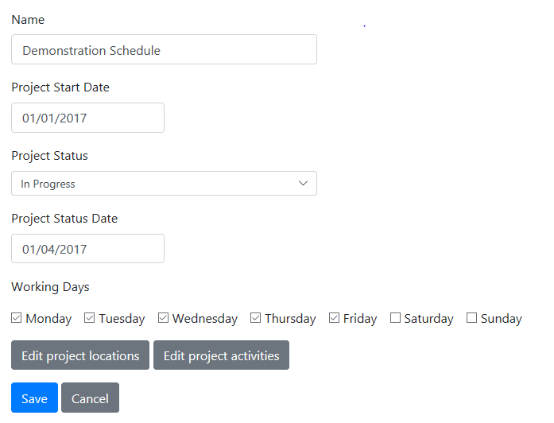

The important information when setting up a schedule is to create a name, construction start date and to select the working days that the construction will take place.

Once the schedule is created you can “Edit” it on the home screen and you will be able to manage construction locations, activities as well as run reports. The following sections will cover these screens.

#### Project Status

Changing “Project Status” in this dropdown indicates to what extent a project is in progress.

If you choose "Not Started", the project has not yet begun so all the activity durations are treated as estimates and they all will be increased by a weather affected duration when a report is run.

"Complete", will mean all the durations are actual so they will not be extended.

"In Progress" combined with typing a date into the “Project Status Date” box below means anything before that date is an actual duration and will not change, anything after is an estimate and will be extended.

## Locations

Selecting “Edit project locations”, will take you to the locations screen:

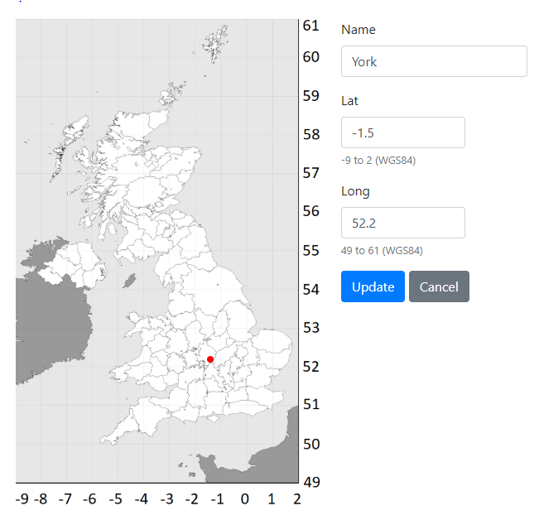

This is where the construction locations can be added that will be allocated to each activity. Click on “Add a new location” and the location can be specified either by clicking on the map or entering in coordinates in WGS84 format (up to 1 decimal place). Locations may be changed later and a new schedule can be calculated.

## Activities

From the schedule edit screen selecting “Edit project activities” will take you to the activities list, select “Add a new activity” to create a new one.

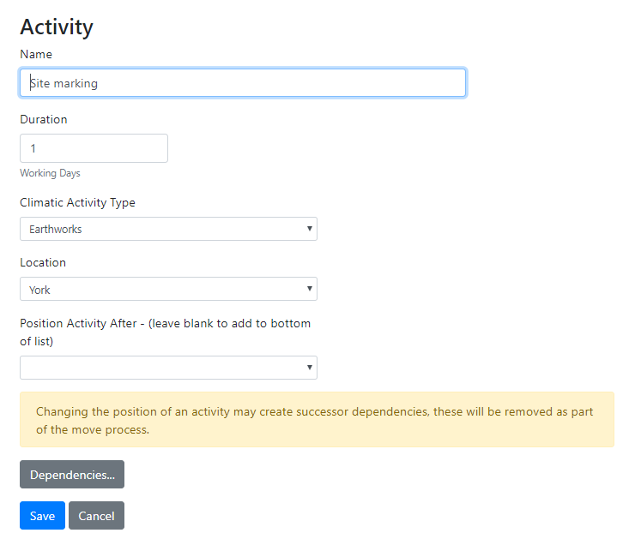

Enter a name and duration (in whole numbers).

Then specify a Climatic Activity Type, this will describe how this activity will be affected by the weather. This can be one of the following:

Earthworks

Concrete

Formworks

Steelworks

Outdoor paintings

Asphalt pavements

Unassigned

Unassigned will mean that the activity will not be extended when the report is calculated. It may be used for activities such as indoor work.

Finally choose the location where this activity will take place.

These last two fields will affect how the activity will be affected by the weather and how much its duration will be extended when the reports are run.

## Dependencies

Once an activity has been added you can then edit it and select “Dependencies” to setup how this activity is connected to others.

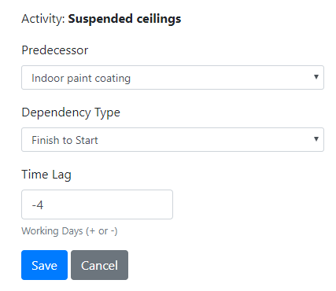

First select the predecessor activity, this is the only type of activity supported by the application, so the list will only contain those activities higher in position than the one you are editing in the activity list.

The dependency type can either be:

“Finish to Start”, the start of this activity is connected to the end of the predecessor activity.

“Start to Start”, the start of this activity is connected to the start of the predecessor activity.

Time lag is an offset from the above position in whole days and can either be positive or negative.

Multiple dependencies may also be created.

Also, no dependencies need to be created however when a report is run it will assume a dependency of finish to start with a zero time lag and will be connected to the previous activity in the list. When viewing the Gantt chart this activity will be positioned correctly but have no line showing the dependency.

# Reporting

At the bottom of the schedule edit screen is a reporting section for analysing the effects of the weather aware construction schedule.

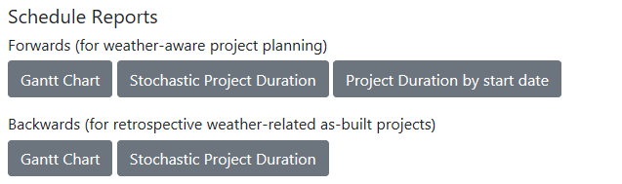

This is split into two sections:

Forwards looks at working from the estimated activity durations to a weather aware schedule.

Backwards reverses this process and calculate the estimates from an already built project affected by the weather.

## Gantt Chart

This shows a view of the planned and weather affected (actual) construction schedule.

Switch between these two views of the schedule via the radio buttons at the top of the report.

The “Type” column corresponds to the climatic activity type for the activity. This is defined as follows:

(E)arthworks

(C)oncrete

(F)ormworks

(S)teelworks

(O)utdoor paintings

(A)sphalt pavements

(U)nassigned

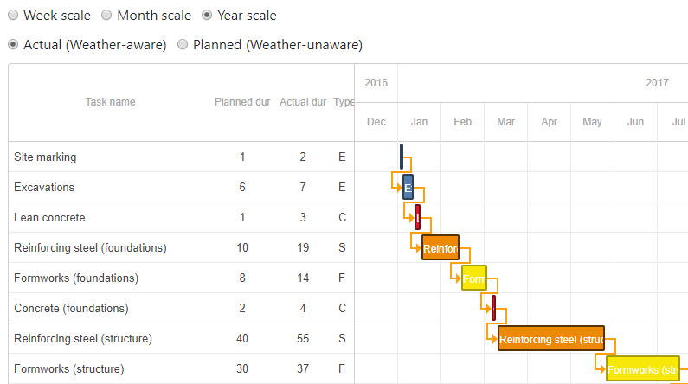

The reversed version of this report looks very similar however the Planned and Actual columns will be switched round. Despite the similarity this shows that the report has calculated the planned durations from the actual durations and is able to do it exactly.

## Stochastic Project Duration

This report uses the weather aware algorithm to calculate the project duration however with random variations that that effect the duration of each activity, this stochastic report is run 1000 times and the varying project lengths are then displayed against their probability.

The reversed version of this report is the same however it runs the reversed schedule for each of the 1000 runs.

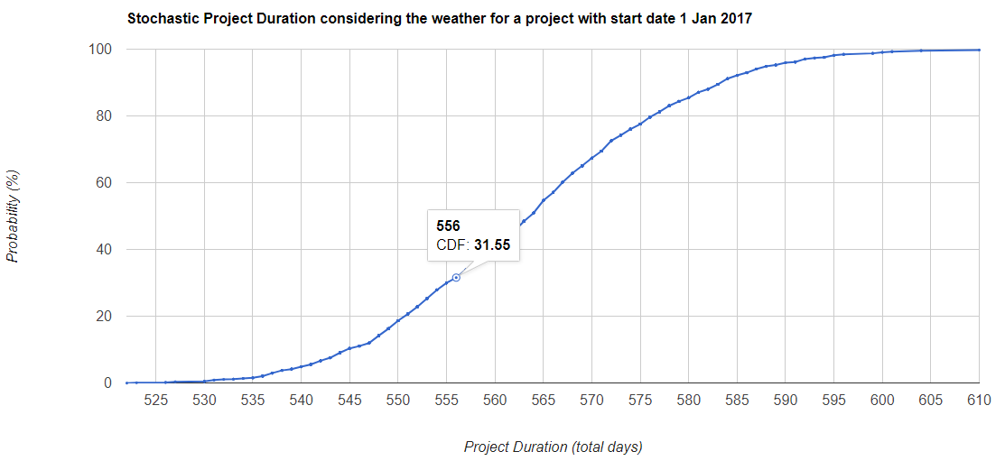

## Project Duration by start date

This report generates the weather aware schedule duration for a series of reports that start on every day of the year. The durations are then plotted against the day of year to enable the analysis of an ideal project start date.

