Movies Analytics using Azure Data Factory
Problem Statement
Use Azure Data Factory's visual authoring experience to create a pipeline that copies movie data stored to Azure Data Lake Storage Gen2 and then executes a Mapping Data Flow to transform and write the data to a Azure SQL Database.

Ingesting data into Azure Data Lake Storage Gen2
- Create a new azure data lake container with name as azure-project
- Upload the data into this container
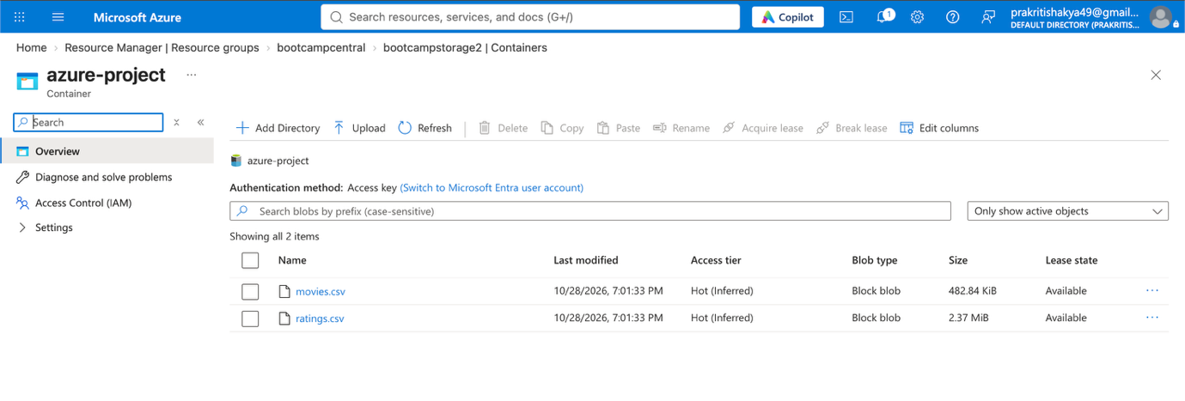
Create an ETL pipeline from data lake to sql db with following transformations.
- List down all unique genres and their number of occurrences for all those movies where rating is greater than 2.
select genres, count(*) as occurace
from movies m
join ratings r
on m.movieId = r.movieId
where rating>2
group by genres
- Write down these genres and count combinations into 2 column tables in azure sql db.
  - Schema = Test
  - Table Name = generes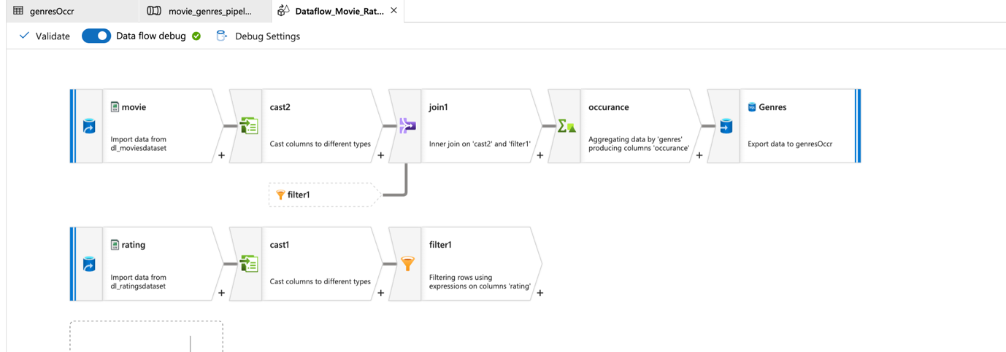
Submissions
You are supposed to submit the screenshots of all the activities like
- Creation of data lake container
- Creation of 2 linked services
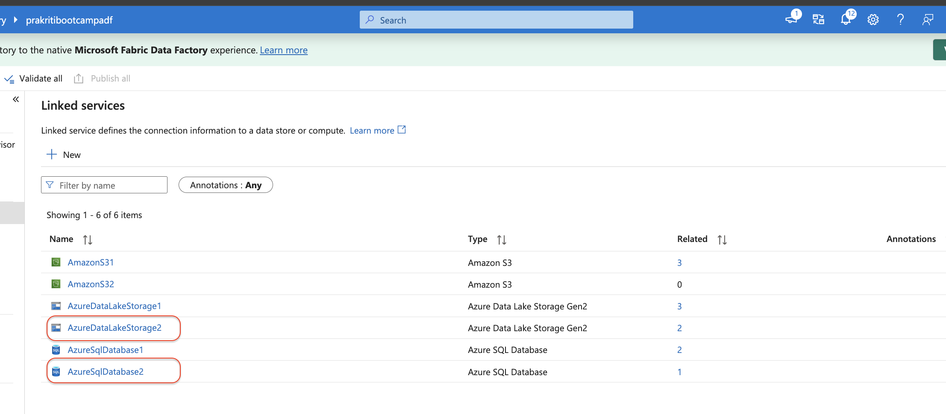
- Creation of datasets
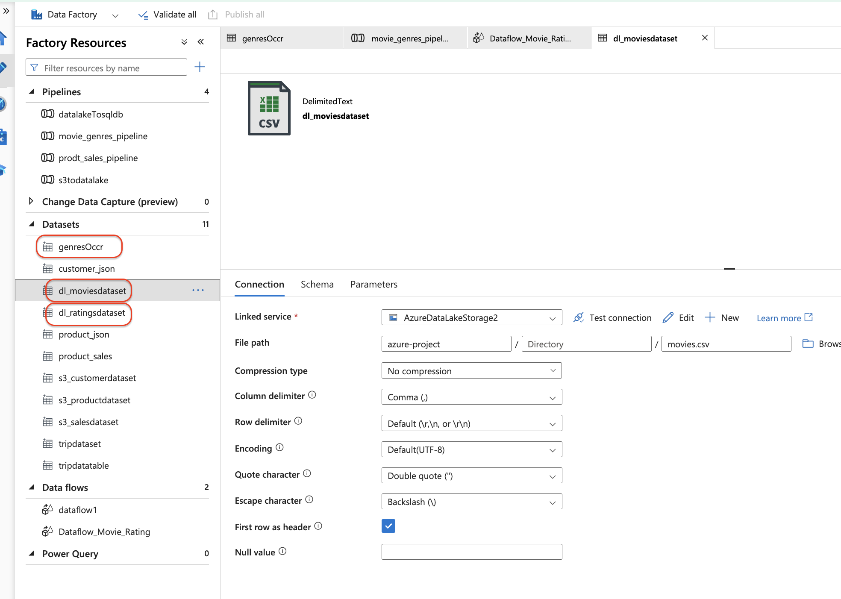
- Creation of dataflow
- Creation of pipeline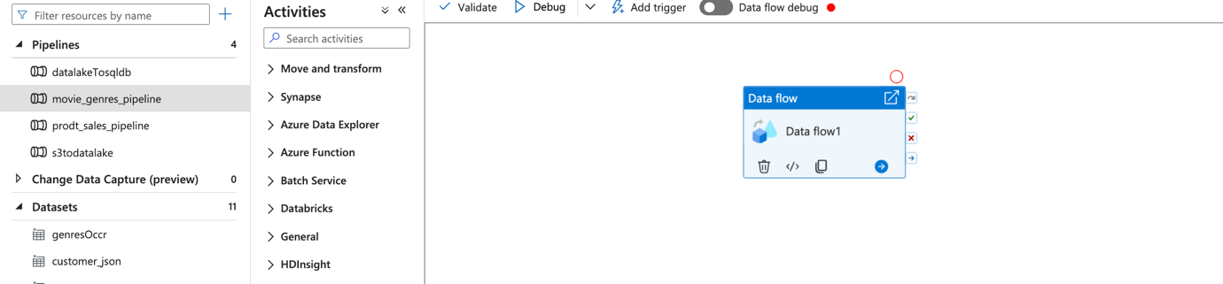
- aPreview output of final sql db table 

