1. **INTRODUCTION**

**1.1 PROJECT BACKGROUND**

In our daily lives we encounter lots of risks which result in fiscal losses. One of the excellent ways to safeguard these losses is through insurance. Insurance is basically a commercial means for relocating risks and covering fiscal losses.

The insurance management system is a complete solution for organizations which need to manage insurance for their vehicles, equipment, buildings, and many other resources. It aims at organizing and tracking insurance vendors and the policies provided under different coverage.

It is known to us that the insurance companies need to keep track of details of their target companies, agents, policy holders, their premium payments and the various products that are available with them; making them prone to error and under tremendous pressure in maintaining their day-to-day activities. Thus, usage of paper in the payment process leads to less efficiency, less accuracy and less productivity which in turn enlightens the requirement of a more effective management system of insurance service.

In the online insurance management system, if the user enters into the website, it will show the detail about insurance and other schemes of the policy through this online registration form thereby helping the customer to view their own insurance status. The system allows to see the logical elements from the physical components that it uses (computer, terminals and storage system).

**1.2 OBJECTIVE**

* To design a simple user friendly application that perfectly substitutes the existing system and makes it more efficient.
* To speed up the transactions.

1. **PROBLEM DEFINITION**

**2.1 APPLICATION OVERVIEW**

Online Insurance is a web application which is used to tracking the details about the insurance policy, customer details and company details. This project is useful for any kind of insurance company to manage the insurance details, to sanction the insurance for customer, process the insurance policy details and all kind of insurance process through online.

The proposed system is designed to eliminate the drawbacks of the existing system. It is designed by keeping to eliminate the drawbacks of the present system in order to provide a permanent solution to the problems. The primary aim of the new system is to speedup transactions.

**2.2 PROBLEM DESCRIPTION**

In this online process the user enter into the website it will show details about insurance and its types, also it will show the details about different duration schemes to the corresponding insurance type or insurance policy. In this process contains the user registration form which is used to apply for insurance policy through online. It also helps the customer to view their own insurance status information. The user has to register his insurance policy to this website, it will process that registration form. After submission of registration form the admin will process to verify that particular details registered by the customer and sanctioned the insurance policy.

If the policy holder wants to view the information about their own policy details, he/she login to policy status page by using the policy holder ID and password had already given by insurance company and view their own details.

1. **ANALYSIS AND DESIGN**

**3.1 ANALYSIS**

The development of a computer-based application includes a system’s analysis phase which produces or enhances the data model which itself is a precursor. There are a number of different approaches to system analysis. When a computer-based application is developed, system analysis (According to the Waterfall model) would constitute the following steps:

1. The development of a feasibility study, involving determining whether a project is economically, socially, technologically and organizationally feasible.
2. Conducting fact-finding measures, design to ascertain the requirements of the systems end-users. These typically span interviews, questionnaires, or visual observation of work on the existing system.
3. Gauging how the end-users would operate the system ( in terms of general experience in using computer hardware or software), what the system would be used for and so on.

Another view outlines a phased approach to the process. This approach breaks system analysis into 5 phases:

1. Scope definition.
2. Problem analysis
3. Requirements analysis
4. Logical design
5. Decision analysis

3.1.1 ER DIAGRAM:

In software engineering, an entity- relationship model(ER Model) is a data model for describing the data or information aspects of a business domain or its process requirements, in an abstract way that lends itself to ultimately being implemented in a database such as a relational database. The main components of ER models are entities (things) and the relationships that can exist among them.

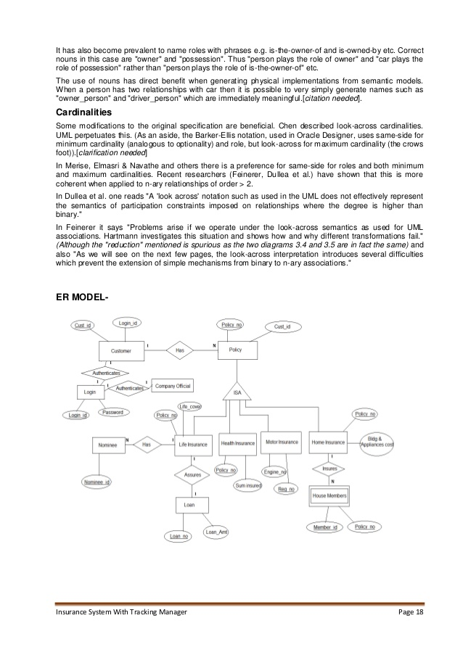

FIG. 3.1.1 ER DIAGRAM

The above diagram represents the Customer as an entity containing the Cust_id and Login_id attributes. Each Customer “Has”(relationship) a policy that he can obtain by logging into his registered account and this policy is generated by a Company Official.

3.1.2 USE CASE DIAGRAM:

Use cases are a widely used systems analysis modeling tool for identifying and expressing the functional requirements of a system. Each use case is a business scenario or event for which the system must provide a defined response. Use cases evolved out of the object-oriented analysis. However, their use as a modeling tool has become common in much other methodology.

Update Information Grant Policies

Approve Policies Grant Loans

View Profile

View Details

Administrator Login Company Officials

Pay Premium

Customer

FIG. 3.1.2 USE CASE DIAGRAM

Here, the customers, company officials and the administrator are represented as actors who have the authority to access their own respective use cases.

3.1.3 CLASS DIAGRAM:

In software engineering, a class diagram in the UML(Unified Modelling Language) is a type of static structure diagram that describes the structure of a system by showing the system’s classes, their attributes, operations (or methods), and the relationships among objects.

POLICY

Type

NextPremiumDate

PurchaseDate

PremiumAmount

Policy_Number

Policy_Expiry

Polcy_StartDate

ADMINISTRATOR

Login_id

Password

ViewPolicyDetails()

AddPolicyDetails()

ApprovePolicyDetails()

RemovePolicyDetails()

ModifyPolicyDetails()

CUSTOMER

Login_id

Password

Name

Date_Of_Birth

Address

Phone Number

Email_id

Gender

Country

City

Date

Pincode

Pay_Premium()

ViewPolicyDetails()

ViewProfile()

FIG. 3.1.3 CLASS DIAGRAM

* + 1. ACTIVITY DIAGRAM

The activity diagram shows the flow of interaction or sequence of interaction of the application.

Enter Username and Password

Verification of Username and Password

Not valid

Official Login

Administrator Login

User Login

Invalid Username and Password

valid

Go to Home Page

Login Successful

FIG. 3.1.4 ACTIVITY DIAGRAM

* + 1. OBJECT DIAGRAM:

An object diagram in the UML (Unified Modelling Language), is a diagram that shows a complete or partial view of the structure of a modelled system at a specific time.

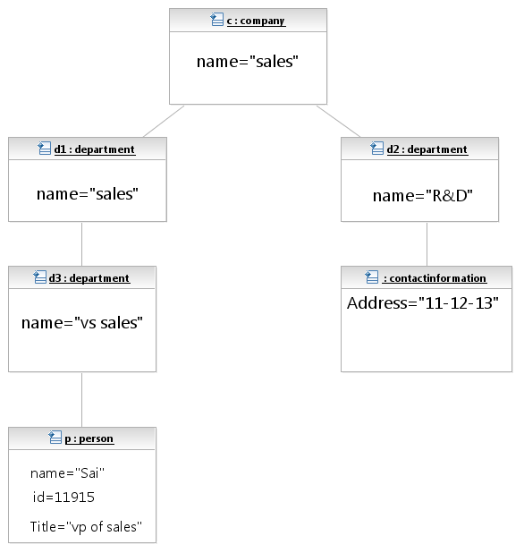

FIG. 3.1.5 OBJECT DIAGRAM

* + 1. STATE CHART DIAGRAM:

A state diagram is a type of diagram used in computer science and related fields to describe the behavior of systems. State diagrams require that the system described is composed of a finite number of states; sometime, this is indeed the case, while at other times this is a reasonable abstraction.

Initial State

Registered

View Policy Details

Not Registered: Register Now

Add Premium Details

Add Bank Details

Add Customer Details

Logout

Completion

FIG. 3.1.6 STATE CHART DIAGRAM

* + 1. SEQUENCE DIAGRAM:
       1. POLICY HOLDER/CUSTOMER:

A sequence diagram is an interaction diagram that shows how processes operate with one another and what their order is. A sequence diagram shows object interaction arranged in time sequence. It depicts the objects and classes involved in the scenario and the sequence of messages exchanged between the objects needed to carry out the functionality of the scenario.

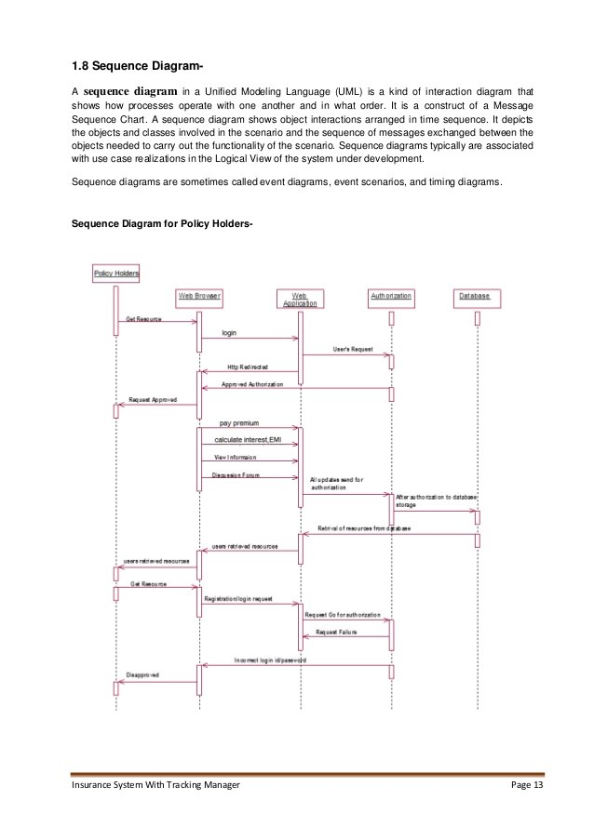

FIG. 3.1.7.1 SEQUENCE DIAGRAM ( POLICY HOLDER/CUSTOMER )

3.1.7.2 ADMINISTRATOR

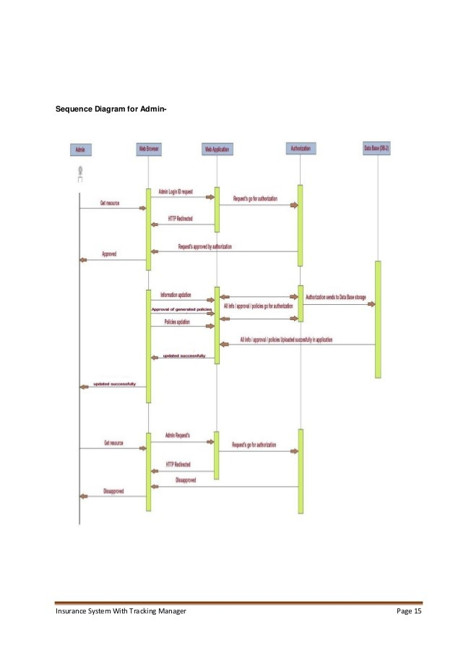

FIG. 3.1.7.2 SEQUENCE DIAGRAM (ADMINISTRATOR)

3.1.8 COLLABORATION DIAGRAM:

UML collaboration diagrams (Interaction Diagrams) illustrate the relationship and interaction between software objects. They require use cases, system operation contracts, and domain model to already exist. The collaboration diagram illustrates messages being sent between classes and objects (instances).

DATABASE

4. Verification Successful

7. Pay Premium

2. Request Insurance Approval

5. Register Details

3. Verify Details

6. Acknowledge Request

1. Add Details

CUSTOMER/POLICY HOLDER

ADMINISTRATOR

FIG. 3.1.8 COLLABORATION DIAGRAM

3.1.9 DEPLOYMENT DIAGRAM:

A deployment diagram in the UML models to the physical deployment of artifacts or nodes.

ONLINE INSURANCE MANAGEMENT SYSTEM

COMPANY OFFICIAL

POLICY HOLDER

ACCESS DATABASE

ADMIN

FIG. 3.1.9 DEPLOYMENT DIAGRAM

3.1.10 DATA FLOW DIAGRAM:

A data flow diagram is a graphically representation of the “flow” of data through an information system, modeling its process aspects. The DFDs describe the input-process-output view of the software. The level 0 DFD (Context DFD) shows the major external entities in application. The level 1 DFD refines the software system abstraction and describes the details of processing the input information to produce the output. Level 1 DFD is comparatively more descriptive form.

**Online Insurance**

**Admin**

**Policy Agent**

**Policy Holder**

**View Own Policy Details**

**Policy**

**Agent**

**Policy Holder**

**Add / Modify / Delete and View**

Operation

**View Own /Client Details**

**Data Base**

FIG. 3.1.10 DATA FLOW DIAGRAM

**3.2 DESIGN**

Systems design is the process of defining the architecture, components, modules, interfaces and data for a system to satisfy specified requirements. One could see it as the application of systems theory to product development. There is some overlap with the disciplines of systems analysis, systems architecture and systems engineering. If the broader topic of product development blends the perspective or marketing, design, and manufacturing into a single approach to product development, then design is the act of taking the marketing information and creating the design of the product to be manufactured.

1. Requirements Analysis- Analyses the needs of the end=users or customers.
2. Bench Marking- Is an effort to evaluate how current systems perform.
3. Systems Architecture- Creates a blueprint for the design with the necessary specification for the hardware, software, people and data resources.
4. Design- Designers will produce one or more ‘Models’ of what they see a system eventually looking like, with ideas from the analysis section either used or discarded. A document will be produced with the description of the system.

**4. SOFTWARE REQUIREMENTS AND SPECIFICATIONS**

**4.1 OVERVIEW:**

The requirements specification is a technical specification of requirements for the software products. It is the first step in the requirements analysis process it lists the requirements of a particular software system including functional, performance and security requirements. The requirements also provide usage scenarios from a user, an operational and an administrative perspective. The purpose of software requirements specification is to provide a detailed overview of the software project, its parameters and goals. This describes the project target audience and its user interface, hardware and software requirements. It defines how the client, team and audience see the project and its functionality.

**4.2 REQUIRED SOFTWARE**:

* Front End/Language: JSP
* Server: Apache Tomcat Web Server 8.0.9
* Back End/Database: Oracle 10g
* Browser: Internet Explorer/Google Chrome
* Operating System: WINDOWS (VERSION) XP/VISTA/ 7/ 8

**4.3 REQUIRED HARDWARE:**

* Processor PENTIUM IV 2.4 GHz
* RAM 512 MB
* Hard Disk 40 GB
* Cache Memory 11,011,968 Bytes
* Virtual Memory 32 MB
* Mouse Logitech Serial Mouse
* Keyboard Standard 104 Enhanced Keyboard

**5. IMPLEMENTATION**

After logging into the OIMS application, a customer can add and view his bank, personal and premium details. Meanwhile, the admin processes these details before saving it into the database on the back end. The admin can also reject few of the requests that the users make. The admin can view, add, remove and modify all the details available in the database.

**5.1 MODULE SPECIFICATION**

#### Policy Holder Registration form:

New Policy Holder gives their information like, Name, password, Ac no, bank, Organization, Occupation, age, gender, address, e-mail id.

#### Admin form:

Admin have provision to view all Agent, Policy, and Policy Holder information. First Admin enter their name and Id then only they can access. And also admin have the provision to view, Modify, Delete and insert the Policy, Policy Holder, and Agent.

1. **Policy Holder Form:**

This module is used to Policy Holders. They can view their own personal details when login into the Policy Holder module.

**6. RESULTS AND SCREENSHOTS**

This is the first page of the project where the interested company officials and customers have to sign up to avail the facilities. Already existing users and the admin can directly sign in by verifying their identity.

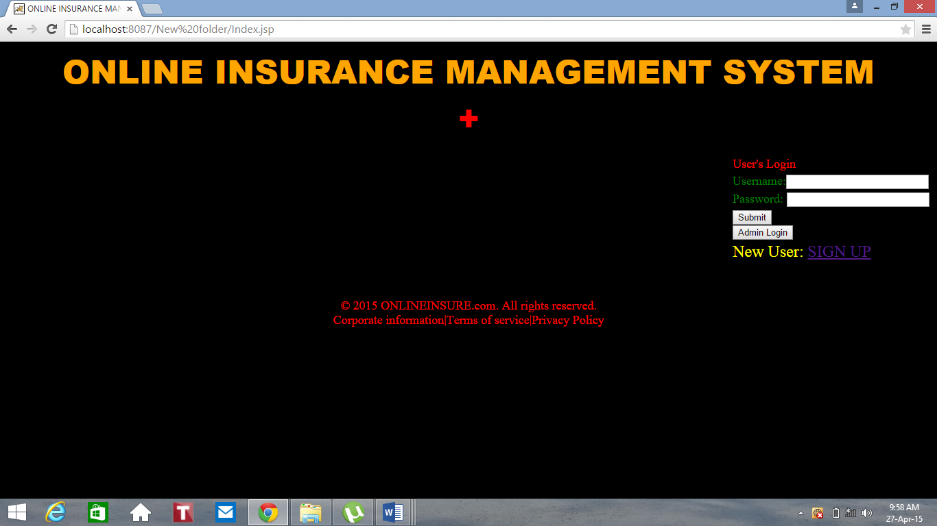

FIG. 6(a) Index Page

This is the sign up page for the users. The users have to fill all the required information before submitting and thereafter their entries will be saved in the database.

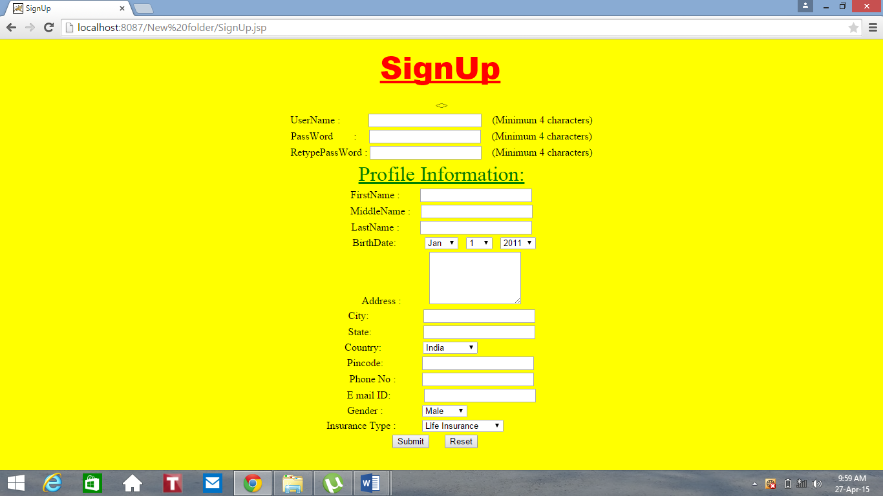

FIG. 6(b) Sign Up Page

This is the Home page for the users after they log into the site and their identity is verified. Here, they can view and add their details.

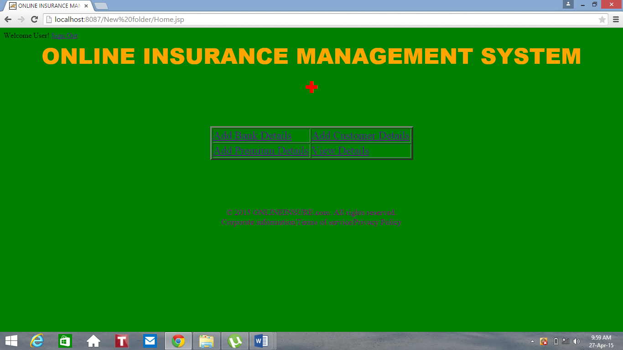

FIG. 6(c) User Home Page

This page contains entries related to the user’s bank and is checked by the admin after submitting before it is saved into the database.

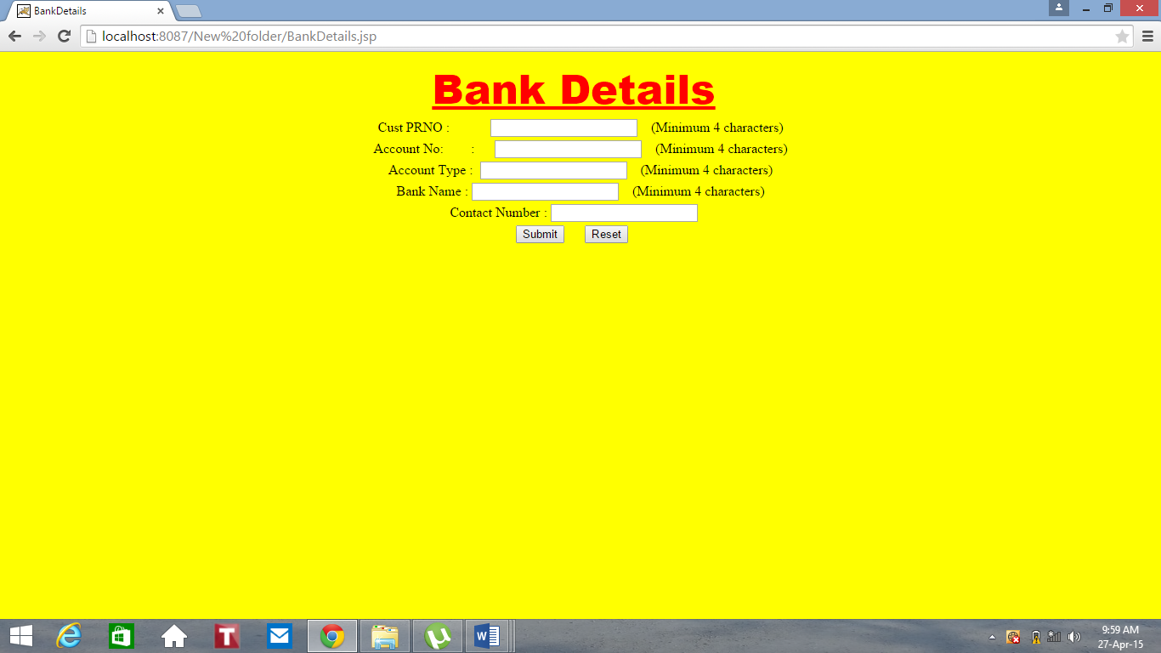

FIG. 6(d) User Bank Details

This page requires the users to provide their own personal details to store into the database.

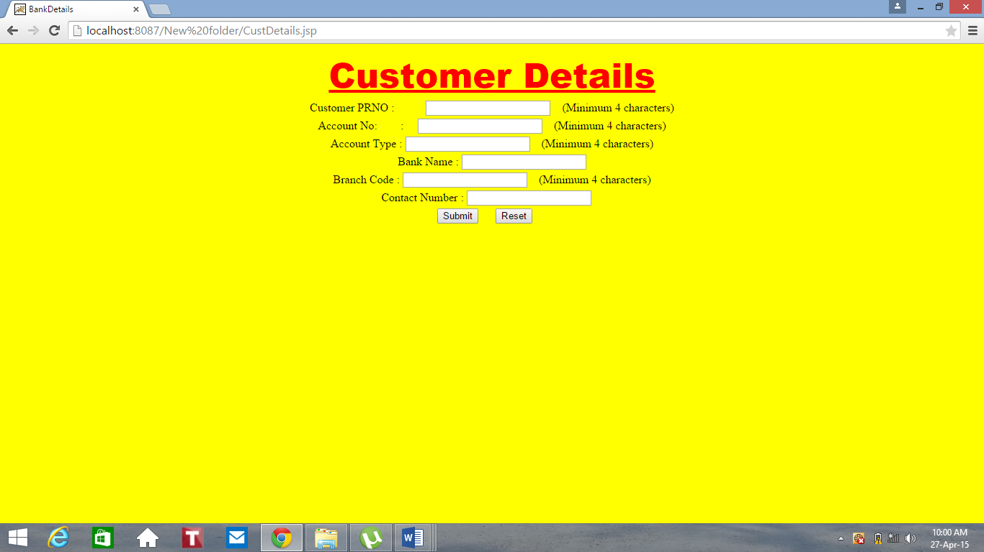

FIG. 6(e) Customer Details

This page requires the user to enter their premium details for calculating the premium amount to be paid on regular basis.

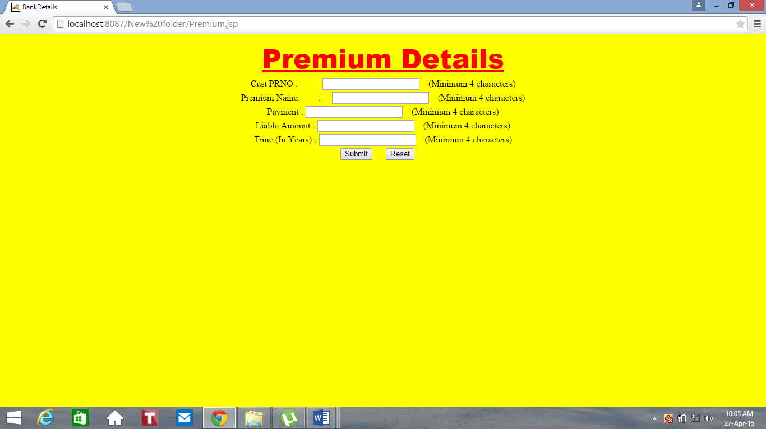

FIG. 6(f) User Premium Details

This is the admin login page where he can view all details of the users and modify them.

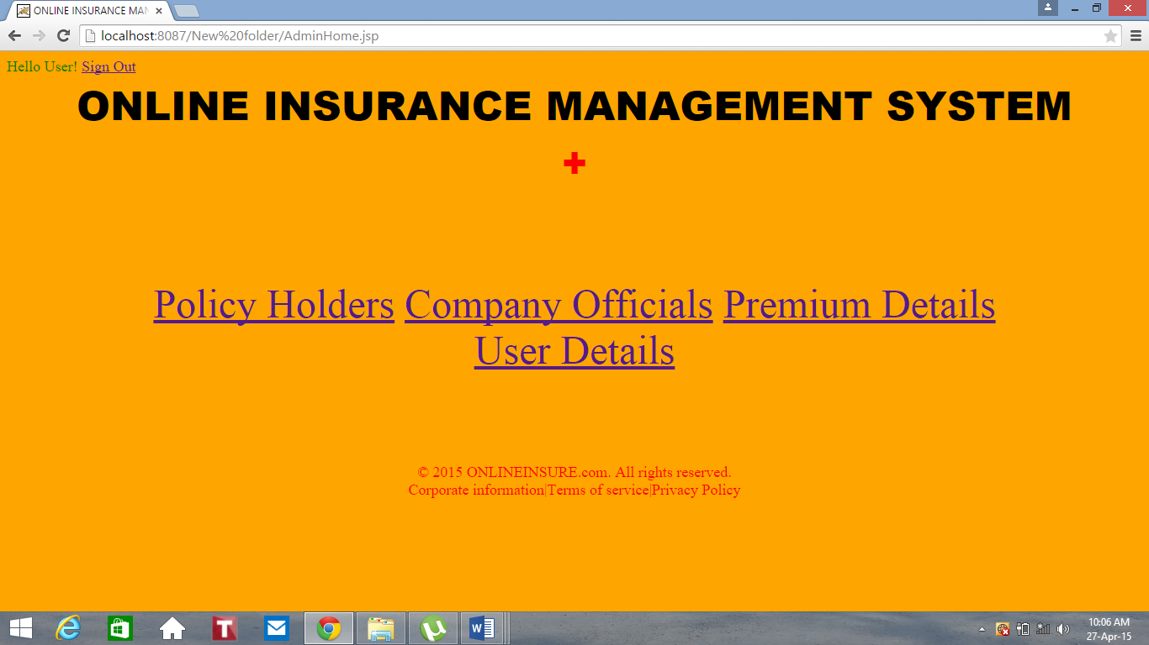

FIG. 6(g) Admin Home Page

This is the table that can be viewed by the admin containing information about the Customer Details.

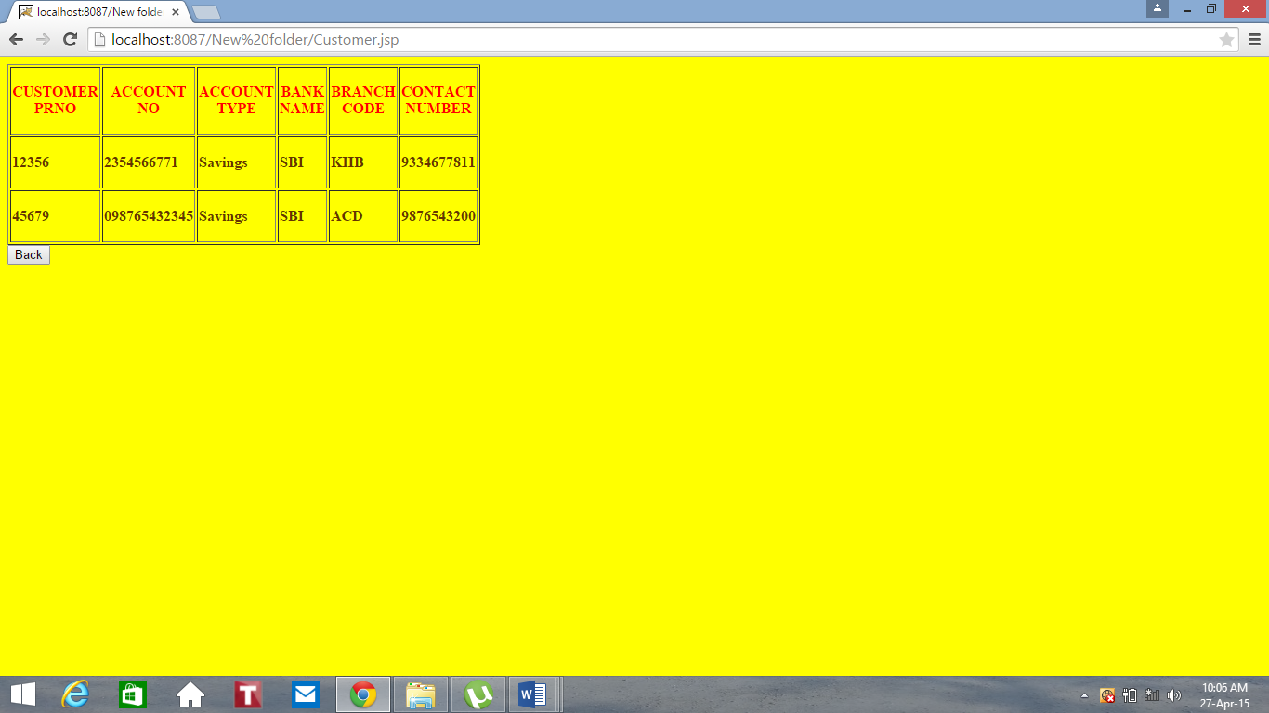

FIG. 6(h) Customer Table Page

This is the table that can be viewed by the admin containing information about the Company Officials.

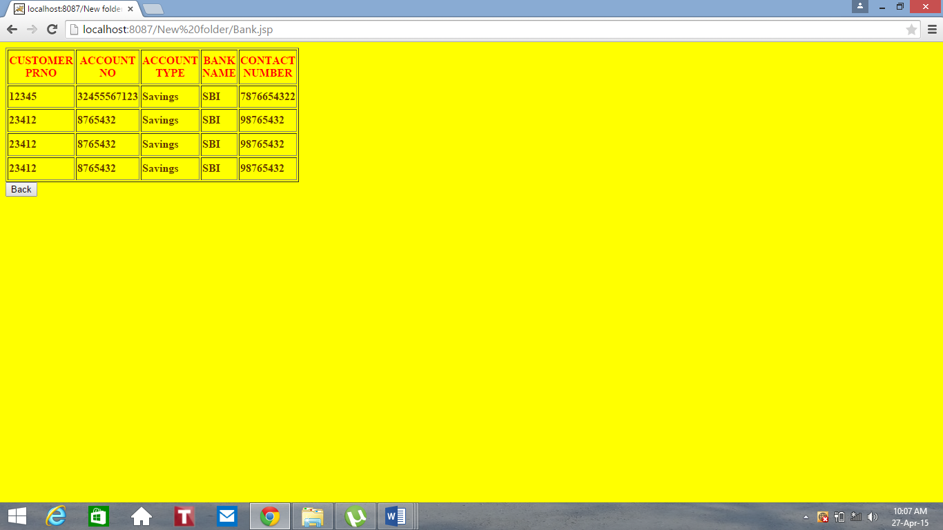

FIG. 6(i) Company Officials Table Page

This is the table that can be viewed by the admin containing information about the Premium.

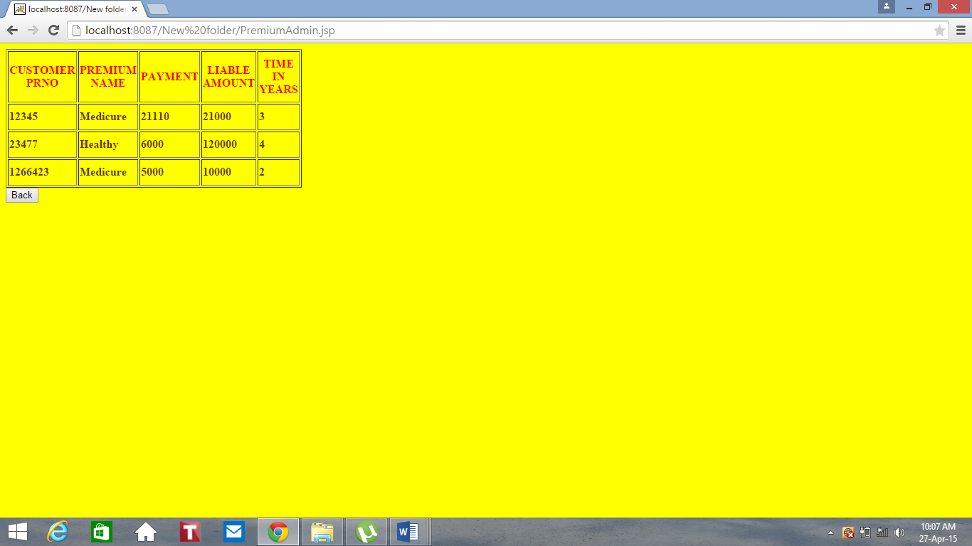

FIG. 6(j) Customer Premium Details Table Page

This is the table that can be viewed by the admin containing records of all the users who have signed up into the website.

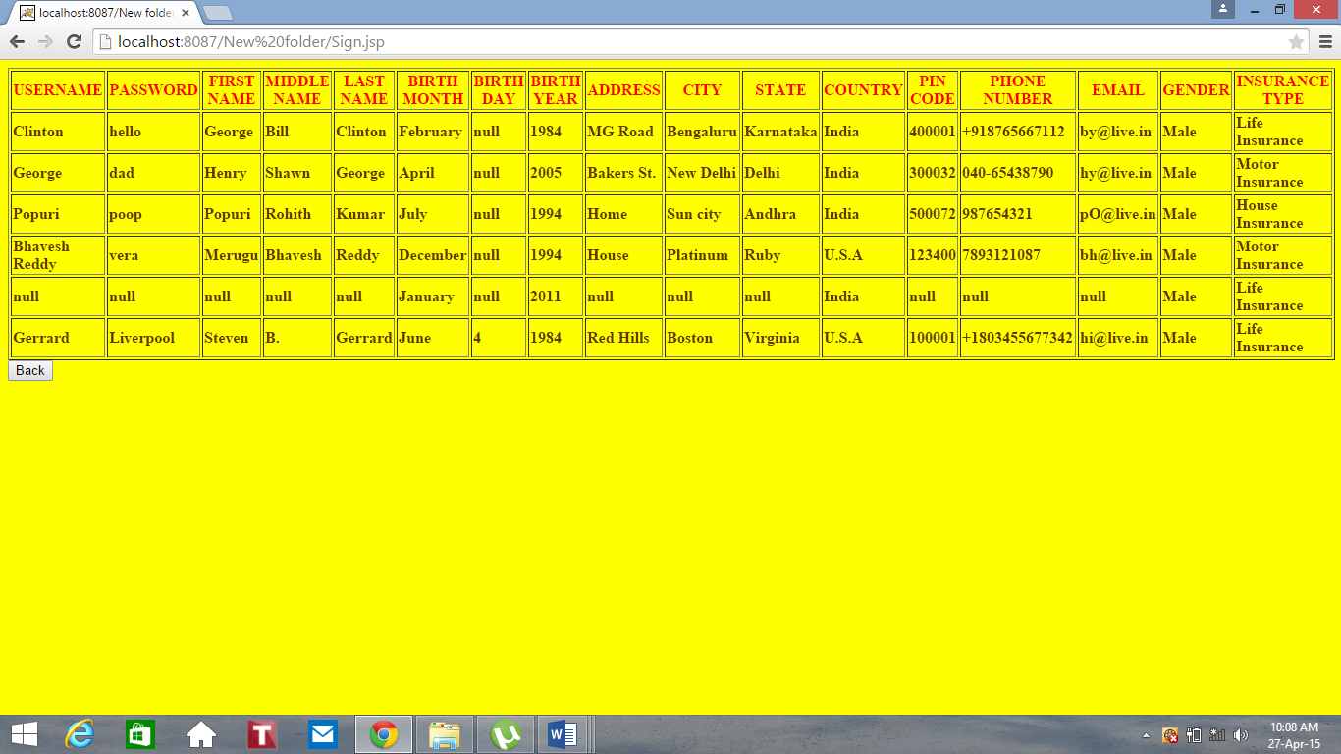

FIG. 6(k) User’s Information Page

**7. CONCLUSION**

In the present situation where the technology is the buzzword and has revolutionized the way we work and live, we would be the losers if we do not keep up with the changing world. Moreover, it makes a world of difference and a whole of sense to break-up from the age old work culture and embrace the effective, cost, and time saving ways of looking and working at things.

This is precisely where the Online Insurance supports and improves many of the core functionality of the insurance organization i.e. insurance project helps in quick easy monitoring of the reports that have been automatically generated as and when the admin and policy agent performs transactions in the system. Using such a system helps the organization in minimizing the time consumed in fulfilling the day-to-day functionality’s and cutting down the expenses incurred on the same.

**8. BIBLIOGRAPHY**

1. Brawner, L. B. "Insurance and Risk Management for Libraries/
2. Breighner, M., W. Payton and J. Drewes.  Risk and Insurance Management Manual for Libraries, 2012.
3. Clow, F. "Disaster Preparedness: Managing Library Liability."  Library Hi Tech Bibliography  No. 5 (2010?): 29-33.
4. Deshima, J. "Securing Museum Coverage." Best's Review (Property/Casualty Insurance Edition) (August 1992): 61-62, 98.
5. [www.tutorialspoint.com](http://www.tutorialspoint.com)
6. [www.wikipedia.org](http://www.wikipedia.org)
7. [www.google.com](http://www.google.com)