- The original waypoint data used for path following is very rugged, as shown below
Requires smoothing technique we used before to avoid this oscillation
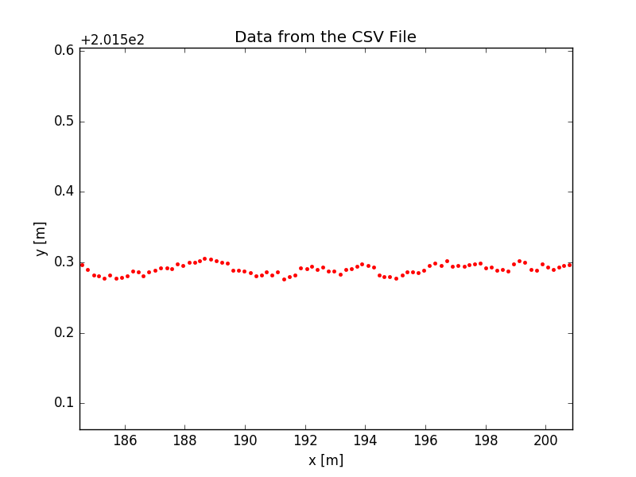
Figure 1: Zoom of Fig. 1
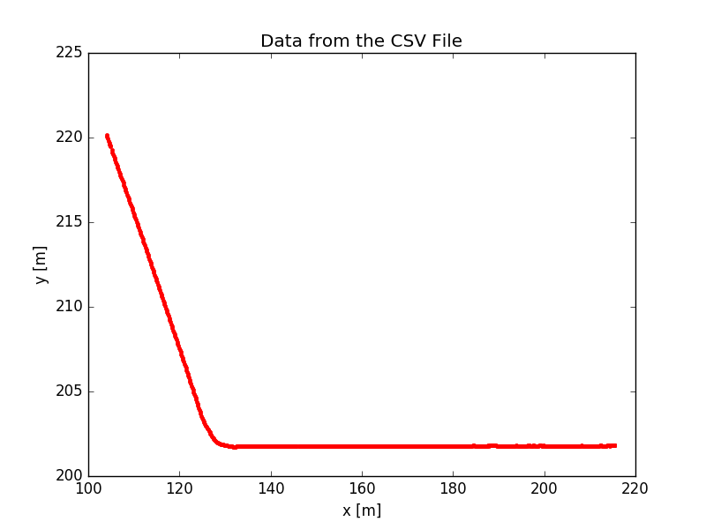
Figure 2: Waypoints (x, y)

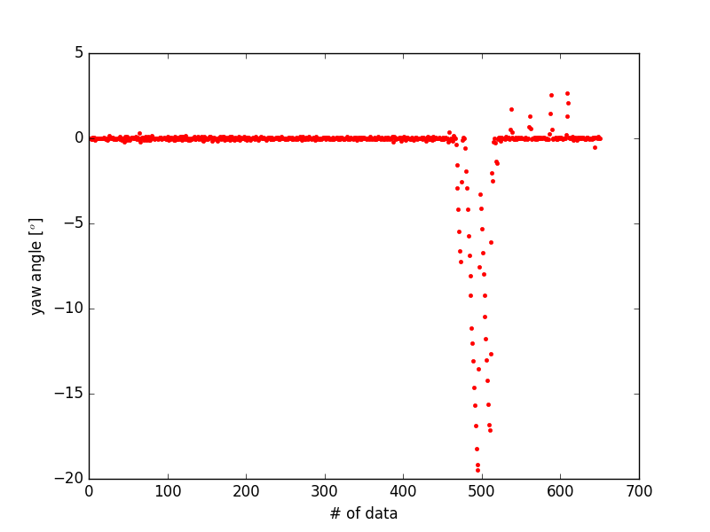
Figure 3: Yaw angle collected

- A python script “wpProcess.py” is written to preprocess the data. The waypoints are scattered to evenly distributed along a constant gap (default = 1 m). The program also creates a new csv file contained the processed result. The scattered result is as follows:

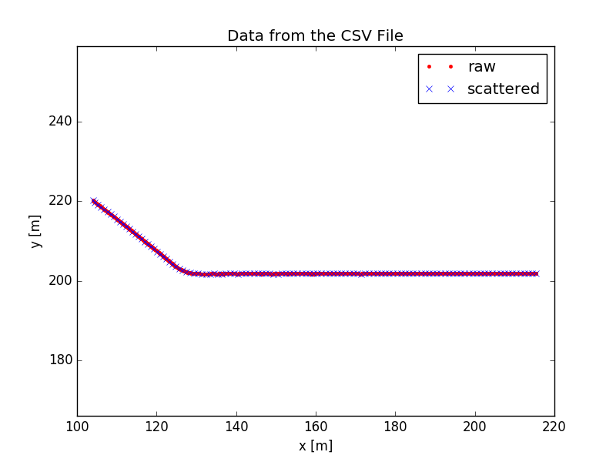
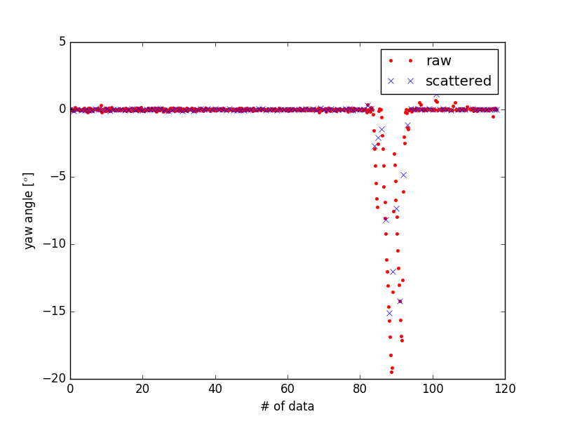
The scattered data of angles still can not be used for heading directly.
The angle heanding from neighbouring discrete waypoints are calculated and is shown below:
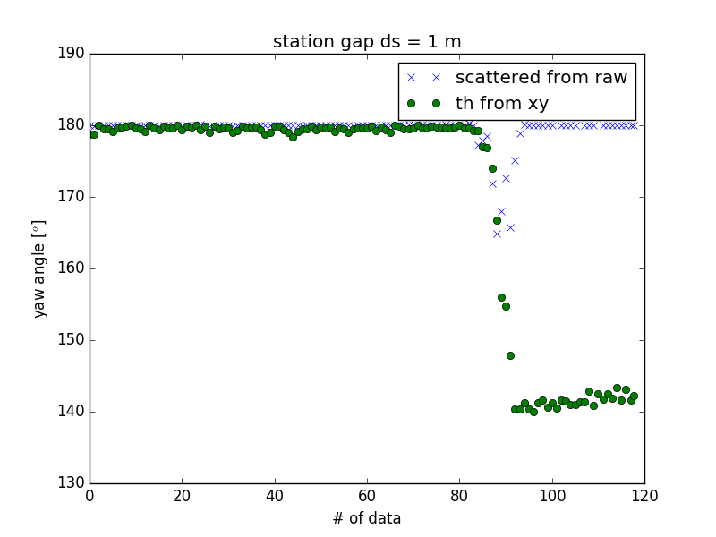

It appears that the raw heading data is wrong. The heading of the processed data still oscillates too much. This will creates oscillations in the steering wheel as well.

The scattered waypoints are still not satisfactory. We follow the paper (S. Thrun. Stanley: The Autonomous Car that Won the DARPA challenge) to modify the path.
Step 1: Evenly distribute the waypoints evenly, say every 1 m;
Step 2: Calculate the curvature and apply a Savitzky-Golay filter to smooth it, as shown below;
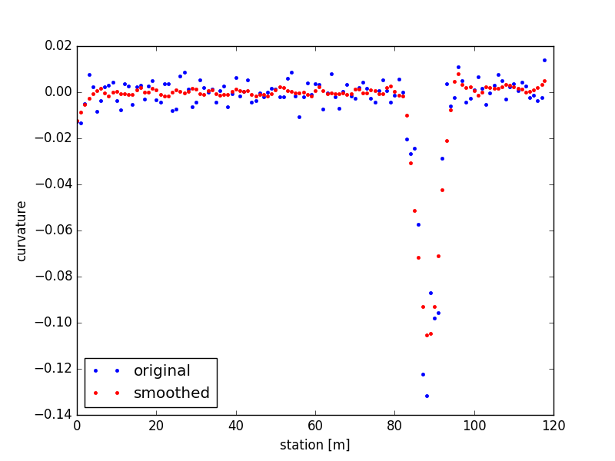

Step 3: redistribute the waypoints proportional to the curvature radius value. The idea is to start from one end, try the initial max length first, if in this range no curvature value exceeds the value matched for this length in the chart below, then take the new point and find the next one; otherwise use binary search until it’s satisfied.

The relationship: ds = limit 0.1*radius within [1, 10] m
curvature | >0.1 0.1 0.05 0.01 <0.01
radius [m] | <10 10 20 100 >100
ds [m] | 1 1 2 10 10
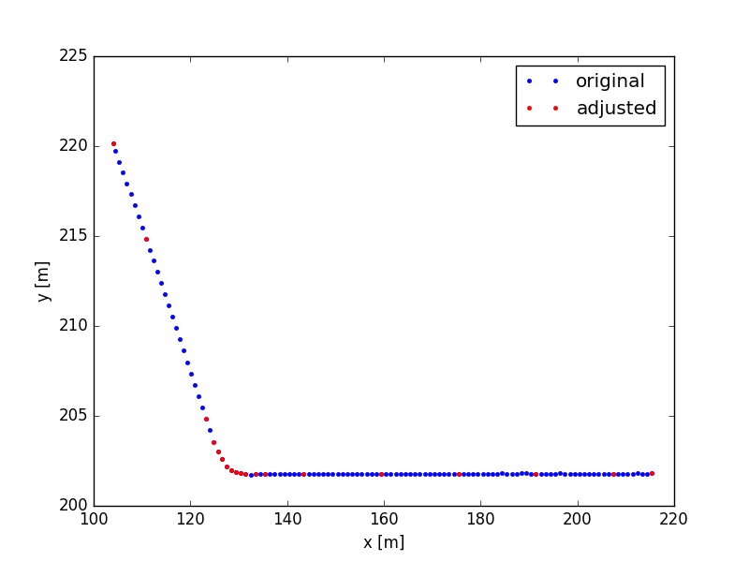
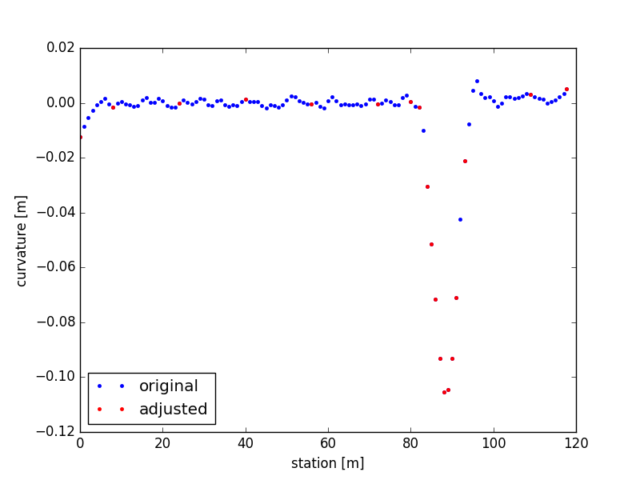

The length of each segment is printed out as below. It can be seen that the algorithm successfully distribute the waypoint numbers proportional to the curvature radius. And from the curvature plot from the above right plot, it appears appropriate of this re-distribution to better describe curvature and smoothness.
ds = 8.0
16.0
16.0
16.0
16.0
8.0
2.0
2.0
1.0
1.0
1.0
1.0
1.0
1.0
1.0
2.0
16.0
8.65849505794

Step 4: Readjust the waypoints’ positions from step 3 to reduce the heading changes in between neighboring waypoints.
Results are shown below. See how the heading angles are smoothed through this process.

Examples: beta = 100
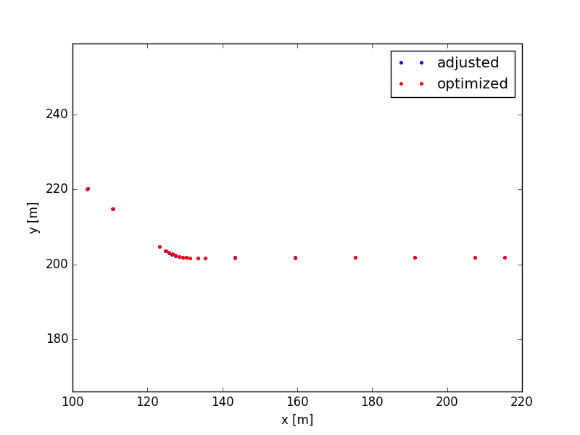
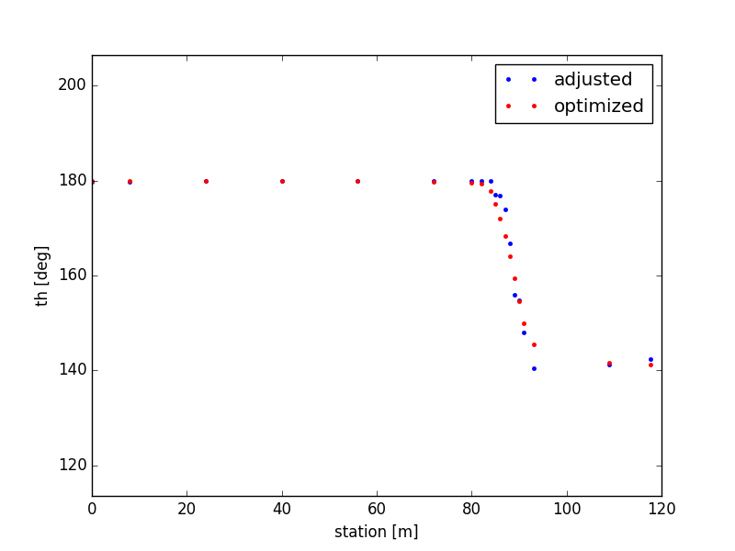
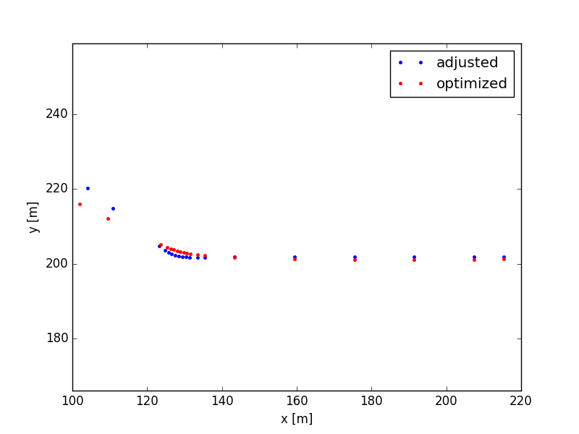
beta = 10000

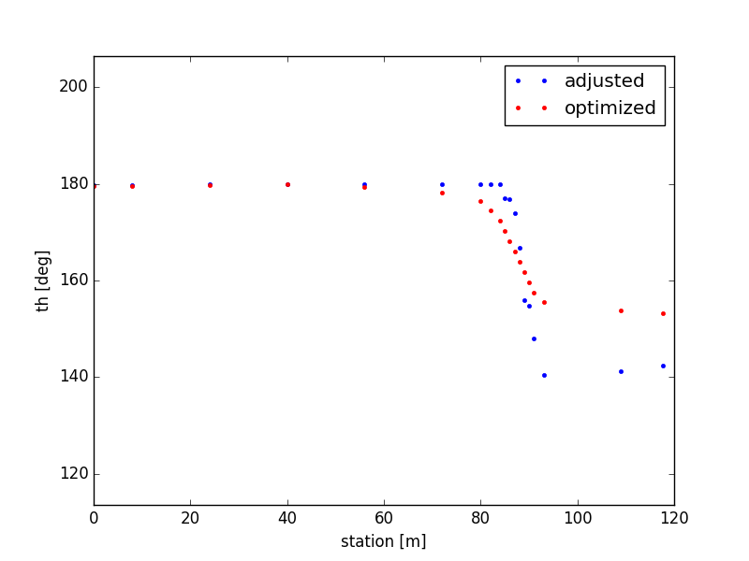

Visualize the waypoint update in rviz (in blue)
