Cody Kimmins

Fish Market Mini Report

The output of the fish market program has 300 types of seafood picked randomly. There are weights and prices assigned to each new object with prices being fixed. The weights are randomly chosen based on a realistic bound with fish allowed the highest value. Running the program outputs the index, type, weight, and price into a csv file. Opening the file results in the following:

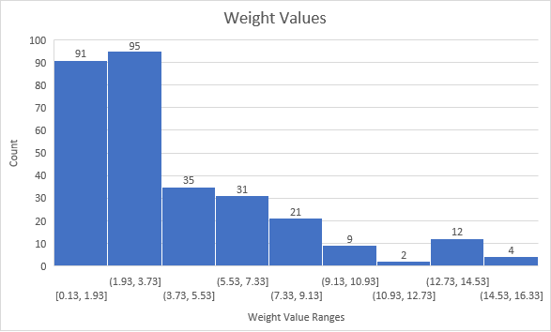The graph for all the weights from the program:

These results show that the most generated weight values are between 0.1 and 4.0. Out of all 300 seafood weights, only two of them are between 11 and 12.73. The larger the weight values are the least likely it will be chosen. Fish is the only seafood that can exceed 10 lbs. which is interesting when comparing this to the next graph.

The results showing the amount of seafood types selected is interesting. Knowing that a fish can have a weight ranging from 1 to 15, you would guess that Fish would be the least caught. The new graph that shows the count of the seafood types suggest otherwise. Fish was chosen 80 times while scallops and shrimp were at 74 each. To make it so Fish are caught even more I added more “weight” and the following graphs show the results.

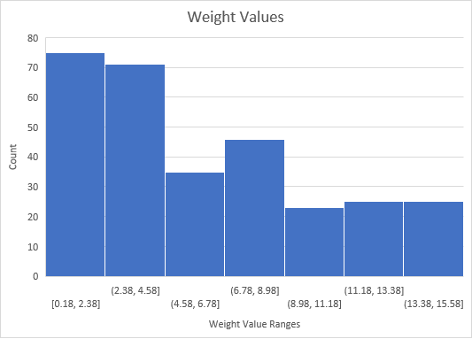

This graph shows the new weight values with the increased chance of catching fish. There is a lot more variety this time even though the lowest weights still make up the most. The count of the different types is shown in this graph:

In the simulation of the added weights to fish, it has doubled the amount from 74 to 142. Crab has stayed the same while scallops and shrimp have almost halved their original amount.