SQL Connectivity:

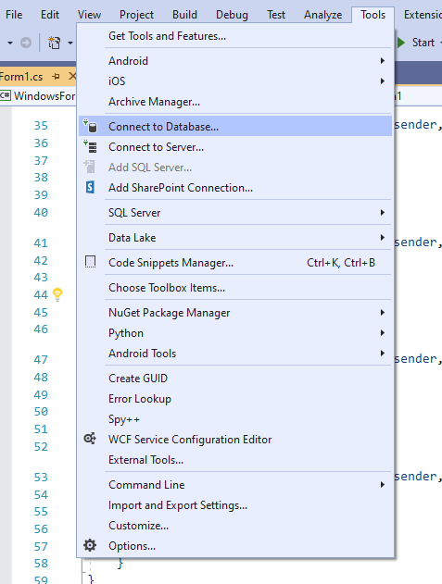

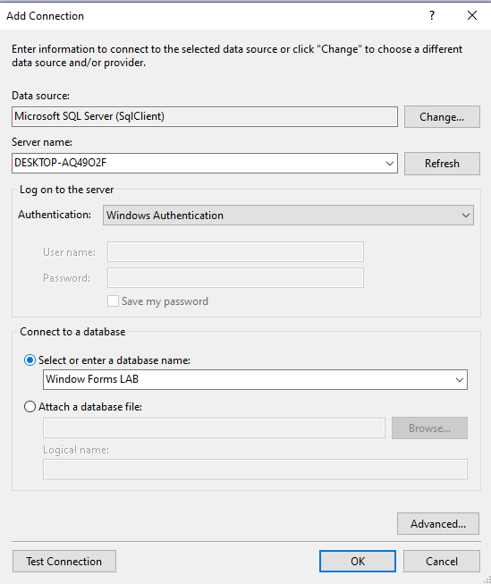

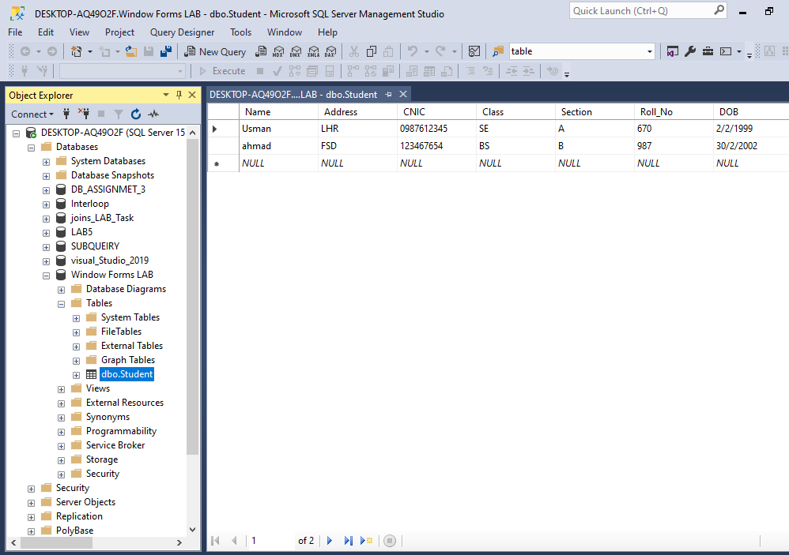

**Front End Development**

**Initial Window of App:**

This is the initial Screen of our software what ever you can select from this.

This is the initial screen where you can select any operation to operate and then get your result.

**Design:**

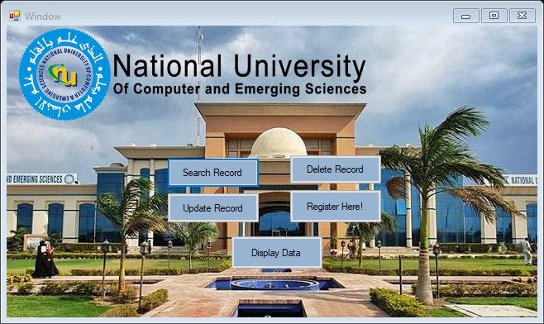

**Code:**

using System;

using System.Collections.Generic;

using System.ComponentModel;

using System.Data;

using System.Drawing;

using System.Linq;

using System.Text;

using System.Threading.Tasks;

using System.Windows.Forms;

using System.Data.SqlClient;

namespace WindowsFormsApp1

{

public partial class Form1 : Form

{

public Form1()

{

InitializeComponent();

}

private void button1_Click(object sender, EventArgs e)

{

Form3 f2 = new Form3();

f2.ShowDialog();

}

private void Form1_Load(object sender, EventArgs e){}

private void button2_Click(object sender, EventArgs e)

{

Form4 f2 = new Form4();

f2.ShowDialog();

}

private void button3_Click(object sender, EventArgs e)

{

Form2 f2 = new Form2();

f2.ShowDialog();

}

private void button4_Click(object sender, EventArgs e)

{

Form5 f2 = new Form5();

f2.ShowDialog();

}

private void button5_Click(object sender, EventArgs e)

{

Delete f2 = new Delete();

f2.ShowDialog();

}

}

}

**Search TAB:**

Here you can enter roll number to search for a record and then your result is display in given grid view.

**Design:**

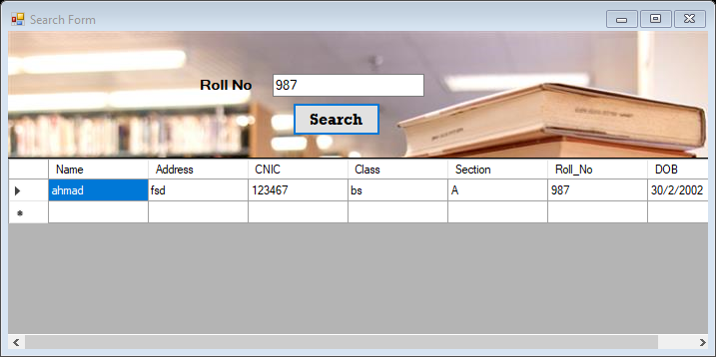

**Code:**

using System;

using System.Collections.Generic;

using System.ComponentModel;

using System.Data;

using System.Drawing;

using System.Linq;

using System.Text;

using System.Threading.Tasks;

using System.Windows.Forms;

using System.Data.SqlClient;

namespace WindowsFormsApp1

{

public partial class Form3 : Form

{

public Form3()

{

InitializeComponent();

}

SqlConnection con = new SqlConnection("Data Source=DESKTOP-AQ49O2F;Initial Catalog=Window Forms LAB;Integrated Security=True");

private void button1_Click(object sender, EventArgs e)

{

con.Open();

string q = "SELECT * FROM Student WHERE Roll_No = ('"+ textBox1.Text.ToString() +"')";

SqlDataAdapter SDA = new SqlDataAdapter(q, con);

DataTable dt = new DataTable();

SDA.Fill(dt);

dataGridView1.DataSource = dt;

con.Close();

}

private void Form3_Load(object sender, EventArgs e)

{

}

}

}

**Update Tab:**

This is the form where you can update your given record. To operate for an updating value to need to double click on any row and then you can update your data then enter Update record. Your record can be updated.

**Design:**

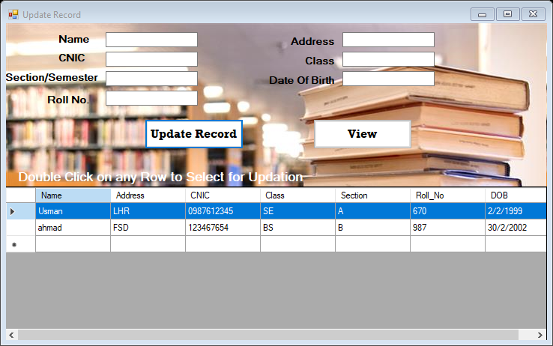

**Code:**

using System;

using System.Collections.Generic;

using System.ComponentModel;

using System.Data;

using System.Drawing;

using System.Linq;

using System.Text;

using System.Threading.Tasks;

using System.Windows.Forms;

using System.Data.SqlClient;

namespace WindowsFormsApp1

{

public partial class Form4 : Form

{

public Form4()

{

InitializeComponent();

}

SqlConnection con = new SqlConnection("Data Source=DESKTOP-AQ49O2F;Initial Catalog=Window Forms LAB;Integrated Security=True");

private void Form4_Load(object sender, EventArgs e)

{

con.Open();

string q = "SELECT * FROM Student";

SqlDataAdapter SDA = new SqlDataAdapter(q, con);

DataTable dt = new DataTable();

SDA.Fill(dt);

dataGridView1.DataSource = dt;

con.Close();

}

private void button1_Click(object sender, EventArgs e)

{

string name = name_box.Text.ToString();

string address = address_box.Text.ToString();

string cnic = cnic_box.Text.ToString();

string Class = class_box.Text.ToString();

string section = section_box.Text.ToString();

string roll = roll_box.Text.ToString();

string dob = dob_box.Text.ToString();

con.Open();

string q = "Update Student Set Name = '" + name + "',Address ='" + address + "', CNIC='" + cnic + "',Class='" + Class + "',section='" + section + "',Roll_No='" + roll + "',DOB='" + dob + "' Where Roll_No ='" + roll + "'";

SqlCommand cmd = new SqlCommand(q, con);

cmd.ExecuteNonQuery();

name_box.Clear();

section_box.Clear();

address_box.Clear();

cnic_box.Clear();

class_box.Clear();

roll_box.Clear();

dob_box.Clear();

con.Close();

MessageBox.Show("Data Update successfuly..!");

}

private void dataGridView1_MouseDoubleClick(object sender, MouseEventArgs e)

{

name_box.Text = dataGridView1.SelectedRows[0].Cells[0].Value.ToString();

address_box.Text = dataGridView1.SelectedRows[0].Cells[1].Value.ToString();

cnic_box.Text = dataGridView1.SelectedRows[0].Cells[2].Value.ToString();

class_box.Text = dataGridView1.SelectedRows[0].Cells[3].Value.ToString();

section_box.Text = dataGridView1.SelectedRows[0].Cells[4].Value.ToString();

roll_box.Text = dataGridView1.SelectedRows[0].Cells[5].Value.ToString();

dob_box.Text = dataGridView1.SelectedRows[0].Cells[6].Value.ToString();

}

private void button2_Click(object sender, EventArgs e)

{

con.Open();

string q = "SELECT * FROM Student";

SqlDataAdapter SDA = new SqlDataAdapter(q, con);

DataTable dt = new DataTable();

SDA.Fill(dt);

dataGridView1.DataSource = dt;

con.Close();

}

}

}

**Registration Form here:**

Here you can register yourself enter your data in given space and press Submit. Your data is saved in database.

**Design:**

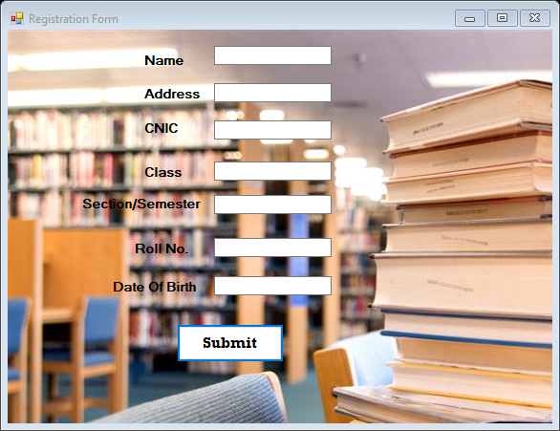

**Code:**

using System;

using System.Collections.Generic;

using System.ComponentModel;

using System.Data;

using System.Drawing;

using System.Linq;

using System.Text;

using System.Threading.Tasks;

using System.Windows.Forms;

using System.Data.SqlClient;

namespace WindowsFormsApp1

{

public partial class Form2 : Form

{

public Form2()

{

InitializeComponent();

}

public string conString = "Data Source=DESKTOP-AQ49O2F;Initial Catalog=Window Forms LAB;Integrated Security=True";

private void Form2_Load(object sender, EventArgs e)

{

}

private void button1_Click(object sender, EventArgs e)

{

SqlConnection con = new SqlConnection(conString);

con.Open();

if (con.State == System.Data.ConnectionState.Open)

{

string name = name_box.Text.ToString();

string address = address_box.Text.ToString();

string cnic = cnic_box.Text.ToString();

string Class = class_box.Text.ToString();

string section = section_box.Text.ToString();

string roll = roll_box.Text.ToString();

string dob = dob_box.Text.ToString();

string q = "insert into Student values ('" + name +"','" + address + "','"+cnic+"','"+Class+"','"+section+"','"+roll+"','"+dob+"')";

SqlCommand cmd = new SqlCommand(q, con);

cmd.ExecuteNonQuery();

name_box.Clear();

section_box.Clear();

address_box.Clear();

cnic_box.Clear();

class_box.Clear();

roll_box.Clear();

dob_box.Clear();

con.Close();

MessageBox.Show("Data insert successfuly..!");

}

}

}

}

**Delete Record Form:**

if you want to delete your record here you can double click on row of your data and then press Delete Record Button your data can be deleted in a second.

**Design:**

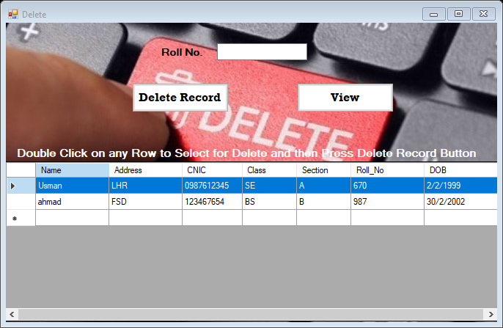

**Code:**

using System;

using System.Collections.Generic;

using System.ComponentModel;

using System.Data;

using System.Drawing;

using System.Linq;

using System.Text;

using System.Threading.Tasks;

using System.Windows.Forms;

using System.Data.SqlClient;

namespace WindowsFormsApp1

{

public partial class Delete : Form

{

public Delete()

{

InitializeComponent();

}

SqlConnection con = new SqlConnection("Data Source=DESKTOP-AQ49O2F;Initial Catalog=Window Forms LAB;Integrated Security=True");

private void Delete_Load(object sender, EventArgs e)

{

con.Open();

string q = "SELECT * FROM Student";

SqlDataAdapter SDA = new SqlDataAdapter(q, con);

DataTable dt = new DataTable();

SDA.Fill(dt);

dataGridView1.DataSource = dt;

con.Close();

}

private void dataGridView1_CellContentClick(object sender, DataGridViewCellEventArgs e)

{

}

private void button1_Click(object sender, EventArgs e)

{

con.Open();

string q = "Delete From Student where Roll_No='" + roll_box.Text.ToString() + "'";

SqlDataAdapter SDA = new SqlDataAdapter(q, con);

SDA.SelectCommand.ExecuteNonQuery();

con.Close();

MessageBox.Show("Record Deleted!!");

}

private void button2_Click(object sender, EventArgs e)

{

con.Open();

string q = "SELECT * FROM Student";

SqlDataAdapter SDA = new SqlDataAdapter(q, con);

DataTable dt = new DataTable();

SDA.Fill(dt);

dataGridView1.DataSource = dt;

con.Close();

}

private void dataGridView1_MouseDoubleClick(object sender, MouseEventArgs e)

{

roll_box.Text = dataGridView1.SelectedRows[0].Cells[5].Value.ToString();

}

}

}

**Display the record of all Student:**

If you want to display all record you can select Display record button from initial Window your record can be display here.

**Design:**

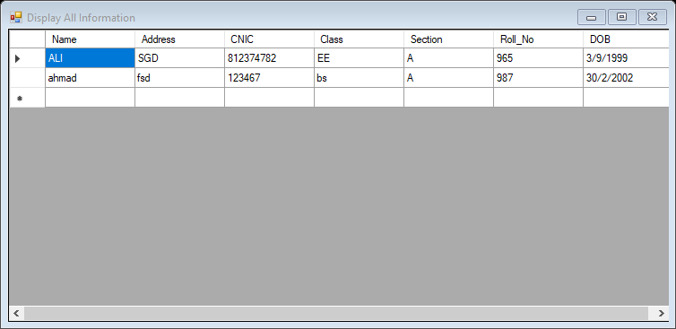

**Code:**

using System;

using System.Collections.Generic;

using System.ComponentModel;

using System.Data;

using System.Drawing;

using System.Linq;

using System.Text;

using System.Threading.Tasks;

using System.Windows.Forms;

using System.Data.SqlClient;

namespace WindowsFormsApp1

{

public partial class Form5 : Form

{

public Form5()

{

InitializeComponent();

}

SqlConnection con = new SqlConnection("Data Source=DESKTOP-AQ49O2F;Initial Catalog=Window Forms LAB;Integrated Security=True");

private void Form5_Load(object sender, EventArgs e)

{

con.Open();

string q = "SELECT * FROM Student";

SqlDataAdapter SDA = new SqlDataAdapter(q, con);

DataTable dt = new DataTable();

SDA.Fill(dt);

dataGridView1.DataSource = dt;

con.Close();

}

}

}