WorkingThroughCakes

4:00 p.m. call….

Jason helping Nina get the average thing running that we started

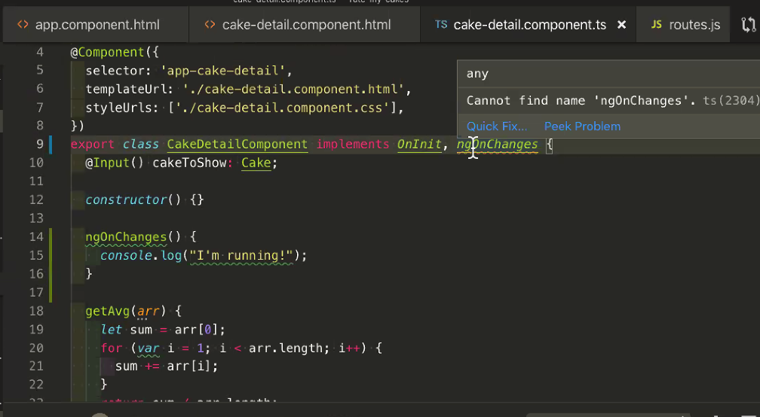

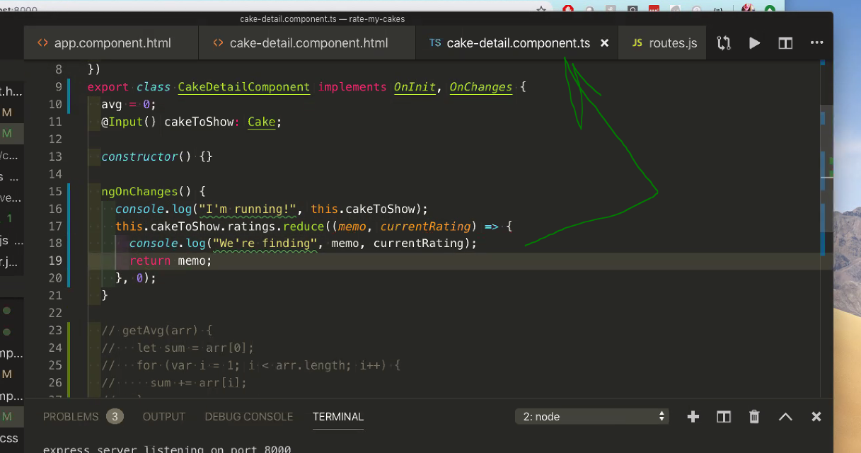

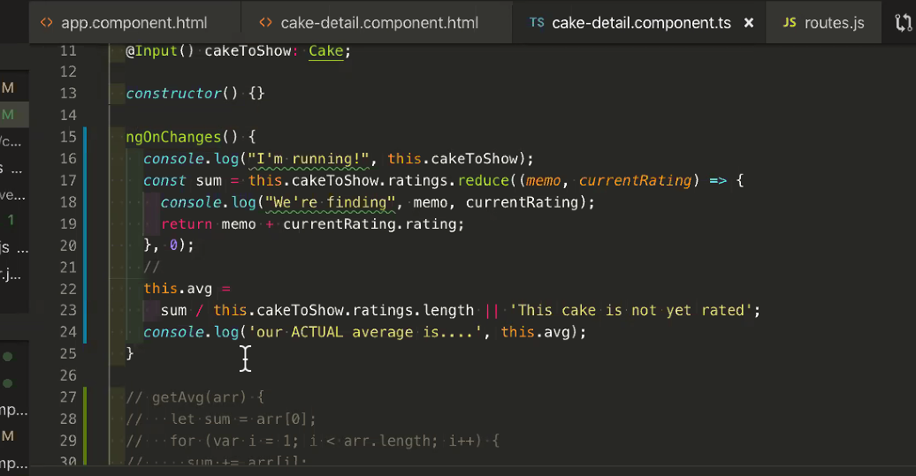

then he helped Alec, then me.

But to finish I need to copy her average rating code from yes - the files are cake-detail.component.ts and the cake-detail.component.html

Files checked:

* server.js
  + added two requires for database and routes
* scrolling up..
* deleted my cake.ts
* did ng generate service rating
* rating.service.ts
  + added several lines
* rating.service.spec.ts…no change
* cake.spec.ts..skipped it for now
* cake.service.ts
  + lots of additions
* cake.service.spec.ts
  + no change
* cake.model.ts.
  + mostly rename of cake.ts
  + adding the class Rating
* app.module.ts
  + add lots
* app.component.ts
  + copied lots with clip..might need revisit
* app.component.spec.ts
  + no changes
* app.component.html
  + clip copy
* app.component.css
  + no changes
* …under cake detail
* cake.detail.component.ts
  + copied in several including average method
* cake-detail.component.spec.ts
  + no changes
* cake-detail.component.html
  + clip copy
* ….under sever
* cake.models.js
  + clip copy
* controllers
  + two files drug
* routes.js
  + drug
* database.js
  + no changes

After 1:00 we kept working together without Jason until maybe 2:00

From the 5/23 Jason helping

--

discussion on how to do database including collections, tables, etc

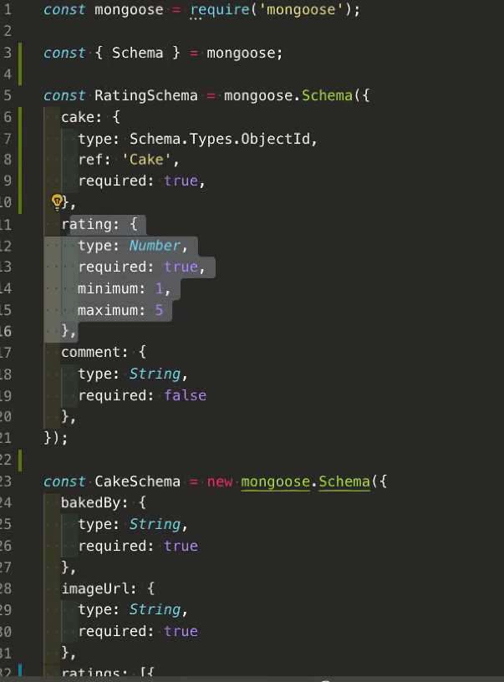

Jason said the above was the best way two collections with relationship not nested

and yes we need a class for cake and another for rating

assumes that when we call for cakes in server file..we re calling all cakes and will populate

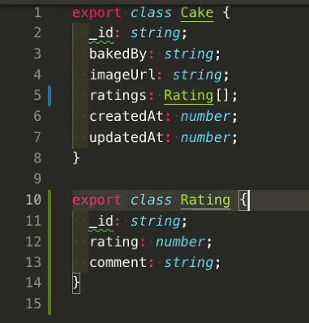

cake.model.ts should match cake.model.js

this relates to front end not knowing about backend

then talked about Nina's error

Alec said Nina needed to add this to her server.js

require('./server/config/routes')(app);require('./server/config/configuration');

and order matters…database should come first:

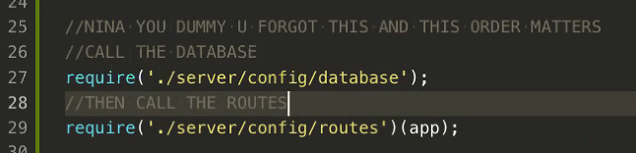

Yes, when we create a rating, we update the associated cake

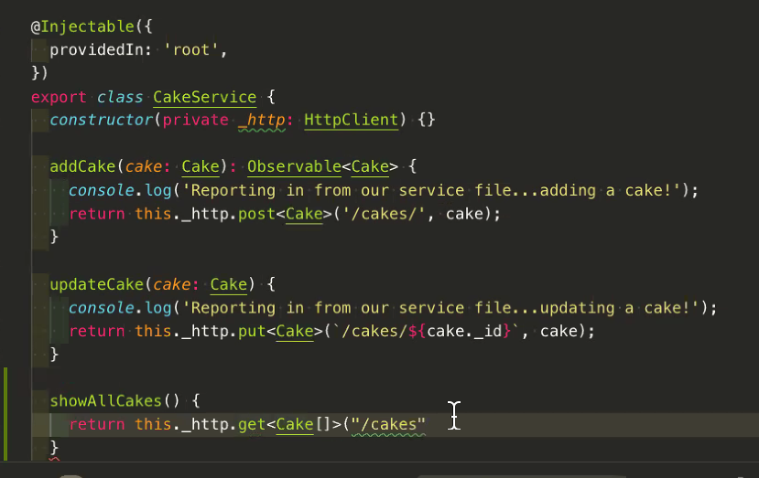

Jason recommends this for updating mongo databases

<https://robomongo.org/download>

Entire output:

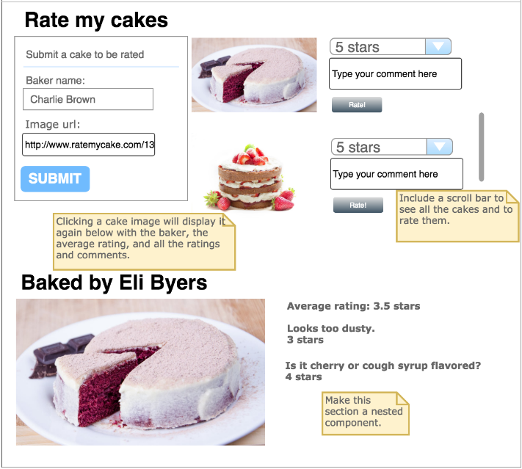

>>>>>>The components  
Even though I show alternatives below, I think the assignment calls for just two components: root and showCake and that is what I think we should do

cakeSubmission component for use with three component solution

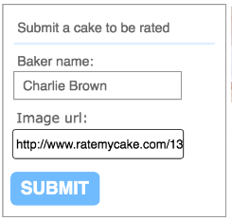

ratingSubmission component for use with three component solution

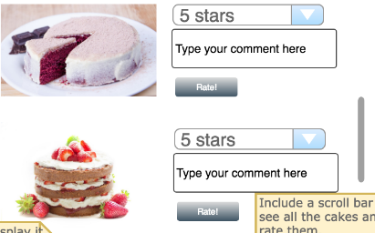

submission component for use with two component solution

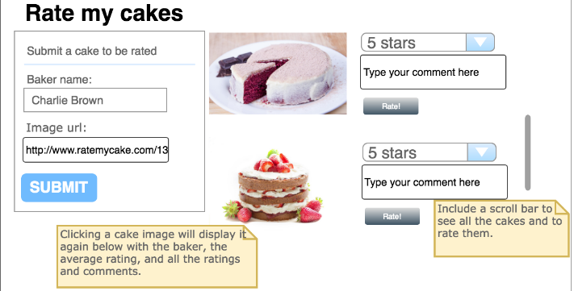

showCake component for both two and three component solutions

