CRUD:

questions for 0900

1

in below, what/why the event and taskForm:

form (submit)="onSubmitNew($event, taskForm)" #taskForm="ngForm" autocomplete="off">

2

My edit button is refreshing the page

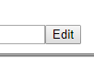

3

Error: in my fake task in onSubmitUpdate for dates: ERROR in src/app/app.component.ts(91,7): error TS2322: Type 'string' is not assignable to type 'number'. it says date is of type number

What's what

* what happens when Create Task is clicked?
* what populates Create Task initially…should be nothing?
* what clears Create Task after button is clicked?
* What should happen when 1st edit button is clicked…yes, show the form, but how?
* What happens when 2nd Edit button is clicked?
* What happens when Delete button is clicked?

deficiencies…besides not removing or updating anything with/to the database

* Edit task area shows all the time…not just when edit button is clicked

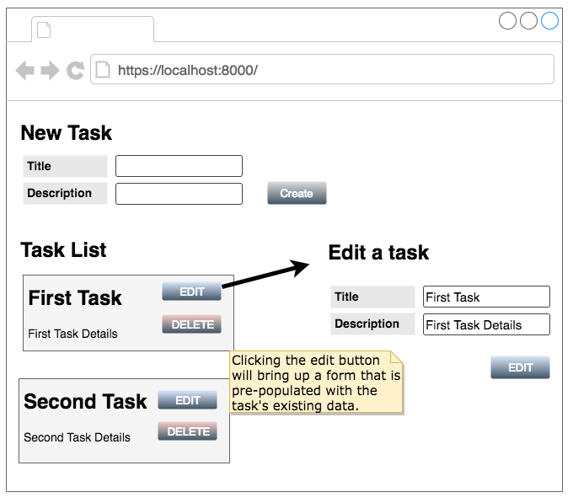

5/22/19 early am…changing text boxes changed json as typed

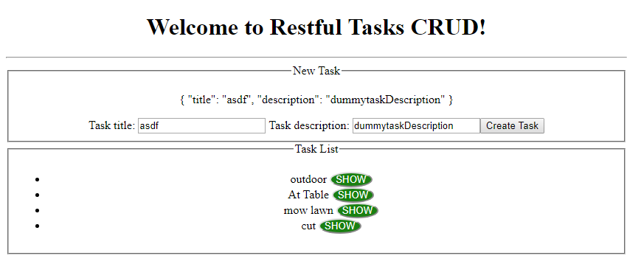

how to get the database items to show in output

Refreshing myself on how I even did database stuff like schema and CRUd:

* resttask.models.js has definition of shema and collections/tables of documents/fields
* restask.controller.js has db commands like findByIdAndUpdate…remove….create…findOne

I need to understand the

* service
* observables
* how to get database data to the html/css/( app.component.ts) via the service/http.service.ts

-------==================

Sunday with W

= data worked, but needed to get the red squiggles from under this.tasks

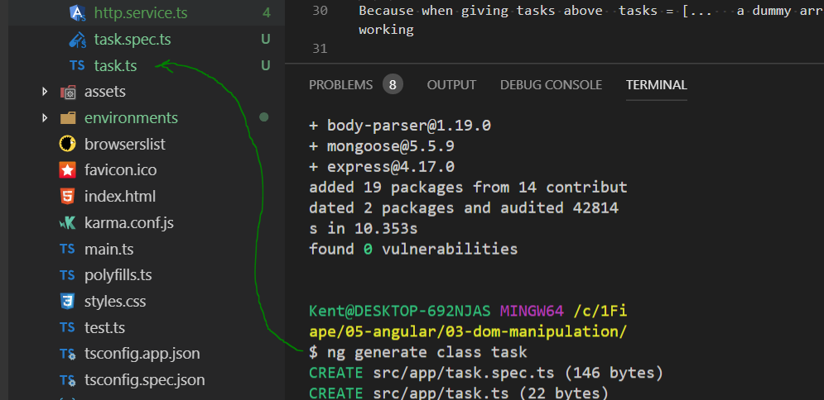

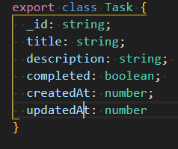

Added things in a few files marked with comments as //with Wes

Now go to service…

still had red squiggles, but then open and close app.component.ts solved

below are happening because trying to display before exists

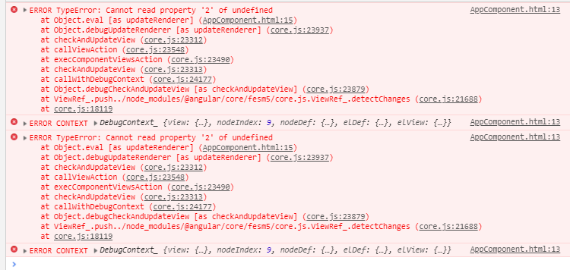

-----------==========

>>>>>Andre said (see bottom for complete, this is just salient parts):

do it in http.service.ts

service = http.service.ts

So in this assignment, they want you to instead of calling this.getTasks() in your service. you can

return this._http.get('/tasks');

and do

let tempObservable = this._httpService.getTasks();

observable.subscribe(data => {})

So in your service, you only return those calls. In your component.ts, you would make the observable call to your service methods

Below he is explaining the wording in the assignment

* root component meaning your app.component.ts You can call an observable in your app.component.ts to your service method
* What they want you to do is call your httpservice from your 'root' component which is your app.component.ts

>>>>>>Alec said:

**alec_m**

[8:37 PM](https://dojo.news/coding-dojo/pl/jjgiedmzjpre9cezc9bstejbmc)

You don't need postman

**kent_h**

[8:37 PM](https://dojo.news/coding-dojo/pl/mth3to6xxp8qfkgk1os8efsofw)

so if the goal is to get the below to show up, I think I can do that

**alec_m**

[8:37 PM](https://dojo.news/coding-dojo/pl/1qr557uenfg47x34oaqexyutda)

Yup that's the goal!

>>assignment said

* Continue building off your Restful Tasks assignment, which should currently have your service making all the get requests to your server. Now,
* have the root component [A: app.component.ts] invoke the methods in the service [http.service.ts] that make the requests to the server.
* have the root component[A: app.component.ts] subscribe to the observables that are returned. >>top of Observables tab
* have the root component[A: app.component.ts] store the data it receives in its own attributes.
* you are set up to use the data you have in the root component[A: app.component.ts] to manipulate the DOM. Use structural directives to display the data in the HTML.

Note: Googling, structural directives are this kind of thing: <div *[ngIf](https://angular.io/api/common/NgIf)="hero" class="name">{{hero.name}}</div>

>>>> >>platform teaching tabs said

* DOM/Service tab is the last before the DOM chapter plus it is the one Andre referenced…
* Service sends data to app.component.ts/controller then on to the view/html
* Amy says I need to
  + create service I did that with the "ng generate service http"
  + register service with app
  + need tool called http client
  + do dependency injection

Other resources:

<https://github.com/CodingDojoDallas/mean_may_2018/blob/master/andy_moon/Angular/restful_task_continued/client/src/app/app.component.ts>

I switched over to DM because I am embarrassed that I can't get this assignment...they are having us re-do the previous restful to make it "better"....the previous version I did with the instructor and all the requests were sent from Postman....do you think that will still be the case?

Before the responses/results just came back in Postman, but now they will come out of the web page in the broswer as below:

**Image Pasted at 2019-5-18 20-07.png**

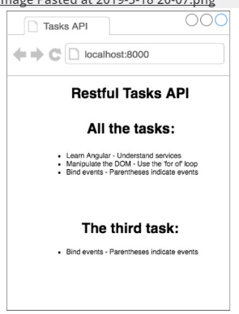

of the three below items in the checklist, I only understand the last one:

Have the root component invoke the requests to the server and receive the data Have the root component store the received data in its own attributes Display the received data in the html

But I will keep looking at the platform...I will look for words like "invoke the requests

I want to figure this out on my own, but it is hard for me to find the way

And I really don't understand Postman

**ta_andre**

[8:09 PM](https://dojo.news/coding-dojo/pl/ps1tepb5rbnzp8d6jiz8ps9cec)

root component meaning your app.component.ts

You can call an observable in your app.component.ts to your service method

**kent_h**

[8:10 PM](https://dojo.news/coding-dojo/pl/zz7ybr8ni3fiuegfkrc6sm97rr)

Would that replace what we did with Postaman before as below:

**Image Pasted at 2019-5-18 20-10.png**

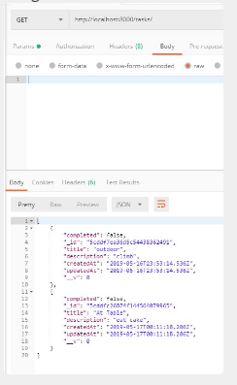

Before the instructor had me have Postman do the requests, so I don't know if now I am supposed to do the requests some other way

**ta_andre**

[8:12 PM](https://dojo.news/coding-dojo/pl/eg7j7hqd8fnk5mofo68keu585a)

You can still use postman. The reason for postman is so you can send http requests. Before you would send http requests with buttons and <a tags

You can do the same thing either way. Create a button in app.component.html to call an app.component.ts method that would call your httpService method to call your server

**kent_h**

[8:13 PM](https://dojo.news/coding-dojo/pl/njz9wrdtdtbuzmeaur5kp347da)

so I can send a request from Postman and and the result can show up as the output/component on browser?

**ta_andre**

[8:14 PM](https://dojo.news/coding-dojo/pl/ea4kbdu59pfotcz8keec771kjh)

Well if you want to use postman, that would call out to your server. Right now you want Angular's service to call your server

So in this case, ignore postman for now

What they want you to do is call your httpservice from your 'root' component

which is your app.component.ts

**kent_h**

[8:16 PM](https://dojo.news/coding-dojo/pl/p36x1rnwmj8ouyx7f3qq1ppffr)

Oh, I thought this was my root component:

**Image Pasted at 2019-5-18 20-16.png**

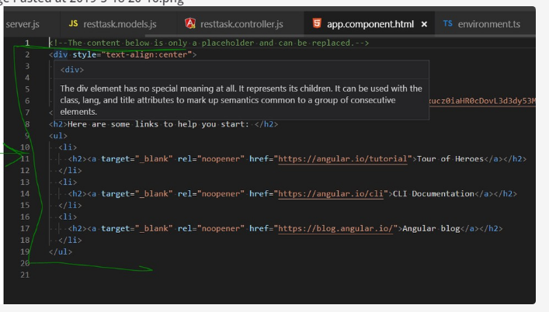

So, rather, is this the root component:

**Image Pasted at 2019-5-18 20-17.png**

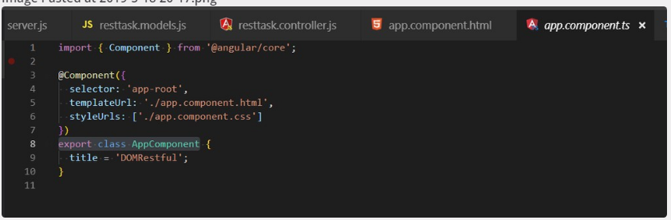

**ta_andre**

[8:17 PM](https://dojo.news/coding-dojo/pl/dfdwifmdgby998qem7ps4kg99y)

Yes that is correct

They are both your root component, but the ts file is where your logic goes

a root component can contain html, ts, css, etc files

**kent_h**

[8:19 PM](https://dojo.news/coding-dojo/pl/9zof9d7sdfyjimufijt17ezwec)

thanks...I will keep trying

1

**kent_h**

[8:45 PM](https://dojo.news/coding-dojo/pl/m5kxudwzcifuiy4cwp7gpoik9r)

Andre,

They said to make this output:

**Image Pasted at 2019-5-18 20-46.png**

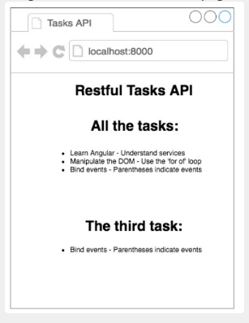

I can do that just by changing the below:

**Image Pasted at 2019-5-18 20-46.png**

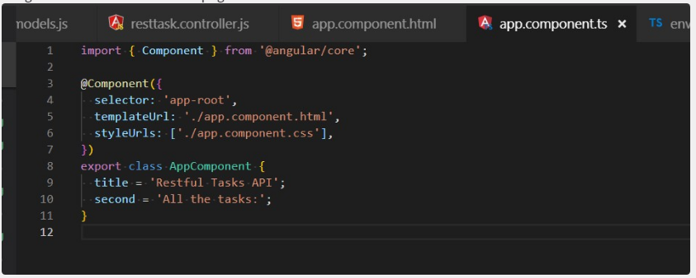

**Image Pasted at 2019-5-18 20-47.png**

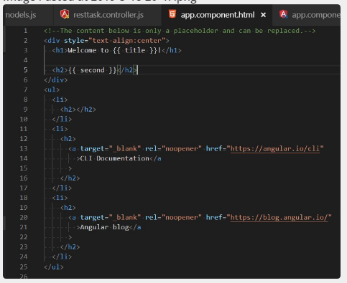

**Image Pasted at 2019-5-18 20-47.png**

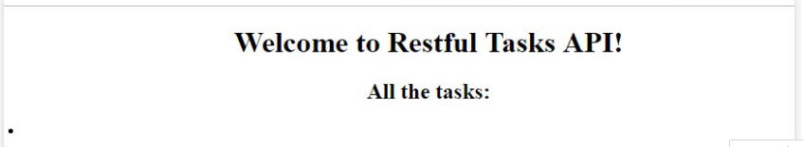

Does that seem right?

**ta_andre**

[8:47 PM](https://dojo.news/coding-dojo/pl/trqrdwituinh7djbs7n97wgi8o)

Yes

**kent_h**

[8:47 PM](https://dojo.news/coding-dojo/pl/gg8g4papxib77x8hadztpjshsa)

If so, that is a lot easier than I thought from the platforms wording

**ta_andre**

[8:48 PM](https://dojo.news/coding-dojo/pl/w44trejjf7yix8zjcycx93m5ma)

Now you just need to call your service.ts and call to your server to retrieve all of the data from the database

**kent_h**

[8:50 PM](https://dojo.news/coding-dojo/pl/1gr8hos3spn7mqhp9mcizenn8w)

I am worried because I see you go off duty in 10 minutes and I don't know how to do that

I don't have a service ts...I think I need to run another command to get it?

like this? ng generate service service-name

if so, what service name should I use?

Andre

**ta_andre**

[8:54 PM](https://dojo.news/coding-dojo/pl/f8izeranbtbedd6gp4b61nifzy)

Yes that is the command you use

There should've been an assignment/lecture before you call your service.ts file to your server

I would recommend you do that first

**kent_h**

[8:55 PM](https://dojo.news/coding-dojo/pl/ci5yzudnnby43marbxdf8wo99y)

I think so, too, but I have not found it

**ta_andre**

[8:56 PM](https://dojo.news/coding-dojo/pl/oy5phtccjfddxc4xhy61jtwnea)

It was the pictures you sent me earlier today

In groupchat

**Image Pasted at 2019-5-17 21-46.png**

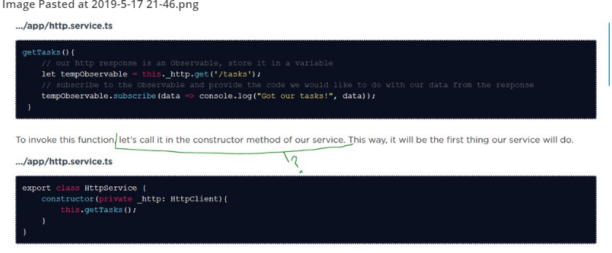

This is your http.service.ts where you call out to your server with '/tasks/ url

**kent_h**

[8:57 PM](https://dojo.news/coding-dojo/pl/c9gxzqe9m7fyzc1uny9cwg3bih)

okay

I will look there

Any other last suggestions before you go

and THANK YOU

**ta_andre**

[8:59 PM](https://dojo.news/coding-dojo/pl/e6zihe16spb6pfxxfrgcu37xko)

So in this assignment, they want you to instead of calling this.getTasks() in your service. you can

return this._http.get('/tasks');

and do

let tempObservable = this._httpService.getTasks(); observable.subscribe(data => {})

So in your service, you only return those calls. In your component.ts, you would make the observable call to your service methods

**kent_h**

[9:00 PM](https://dojo.news/coding-dojo/pl/mdp4pj7eapdrmq4kwjdqyik15e)

thanks

1

I don't want to keep you over...

Good night (I am in Texas)

**ta_andre**

[9:01 PM](https://dojo.news/coding-dojo/pl/nmeptht953gw7qsk65bz57x8wr)

No worries. Another student is asking a question right now as well. I'm glad I can help

**kent_h**

[9:02 PM](https://dojo.news/coding-dojo/pl/g4qsee93piys8nbk3ha8whkkjr)

btw, I found it..about creating that file.....they abbreviated and that threw me:

Create a service We'll set up our service by navigating to our Angular app in our terminal and running this line:

ng g s http

Here, we're naming our service 'http', but you may name it whatever you like. This gives us a file called http.service.ts. Open this file and you'll see that we are exporting a class called HttpService, which means another file can import it!

**ta_andre**

[9:03 PM](https://dojo.news/coding-dojo/pl/myybq79fwjg7ddxuksgsapo9fa)

**kent_h**

[9:04 PM](https://dojo.news/coding-dojo/pl/z9zdeko8wtrhffasike46oh3qo)

Oh, and where you say: So in your service, you only return those calls...."service" means the servicename.service.ts...I think?

**ta_andre**

[9:05 PM](https://dojo.news/coding-dojo/pl/7jcn68rweir7feprjdwf9tp9zr)

yes