Working through Tasks Nested

Details of selected task….

they called this component "task" using ng generate component task

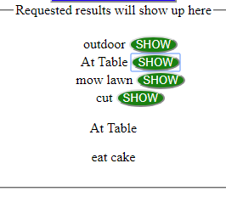

**...src/app/task/task.component.ts**

@Component({

selector: 'app-task',

templateUrl: './task.component.html',

styleUrls: ['./task.component.css']

})

to nest the task component within the root component, place the <app-task></app-task> tag in the html of the root component wherever we want it to appear.

Amy..what needs to be in there…

* ts needs to have: taskToShow
* Then html can use {{taskToShow.title}}

When I click the show button, it goes to a method maybe called selectedTask

in html of root component we should hae used selector…[see above]

* use attributes in selector to to pass data down
* as in: <app-task [taskToShow]='selectedTask'></app-task>

Must import Input into class file

then use @Input() taskToShow also in class file