JavaScript DOM
Basic
Bookstore & Reading Club
Task Instructions and Submissions:
- Create a new branch named EventsAndDOM.
- Follow the instructions.
- Commit your changes, push the branch to GitHub, and merge it into your main branch.
- Don’t forget to update the readme file and add the live URL to it.
- Submit final repository link.
EX3: Events and DOM
Problem domain :
- Up until now, your bookstore app ran automatically using prompt pop-ups and alert messages when the page loaded. Now, you will transform it into a real, interactive web application by adding HTML form inputs, handling browser events (like button clicks), and dynamically rendering the user data array directly onto the page layout.
Requirements:
HTML Structure Update:
- Update your index.html to include a clean input form with fields for Username, Membership Type (student or regular), Book Genre, and Book Title.
- Add a submit button and an empty container (e.g., a <div id="result-card">) where the user’s details will eventually appear.
Event Handling:
- In your app.js, select your button/form using DOM methods and attach an event listener
Functions & Arrays Integration:
- Inside your event handler function, read the values entered into the input fields.
- Run your validation logic (ensuring the membership type is correct) and store the validated data into your student array: [username, membershipType, bookGenre, bookTitle].
- Create a rendering function that loops through or extracts data from this array to dynamically create HTML elements (like paragraphs or list items) and injects them into your results container on the web page. (Replace alerts and console logs with actual visual updates on the page!).

JavaScript Dom
Exercises 01
Add a label to each of the input fields: username, password, confirm password
Exercise 02
Add a required validation to each input that shows an error message next to the entry if it does not have any text entered.
Exercise 03
Add a further validation to check if the user input in the password and confirm password inputs match. Show an error message if they do not.
Exercise 04
Ensure the ‘Register’ button is disabled until the user has entered valid data into all the input fields. Once they have, the registration button should then be enabled.
Exercise 05
When the user clicks the ‘Register’ button, a message should be displayed informing them of a successful user registration.
Mid
Exercise 06
Add a required validation to each input that shows an error message next to the entry if it does not have any text entered.
Result :
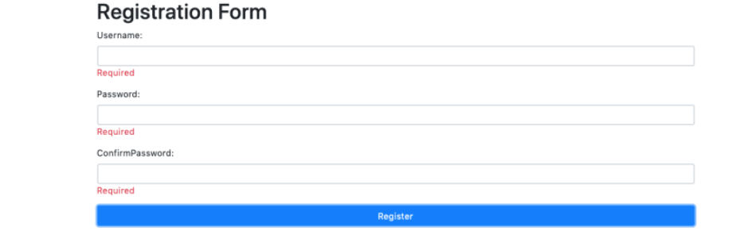
Exercise 01
-----------
Highlight all of the words over 8 characters long in the paragraph text (with a yellow background for example)
Exercise 02
-----------
Add a link back to the source of the text after the paragraph tag.
(https://google.com/)
Exercise 03
-----------
Split each new sentence on to a separate line in the paragraph text.
A sentence can be assumed to be a string of text terminated with a period (.)
Exercise 04
-----------
Count the number of words in the paragraph tag and display the count afer the heading.
You can assume that all words are separated by one singular whitespace.
Result :
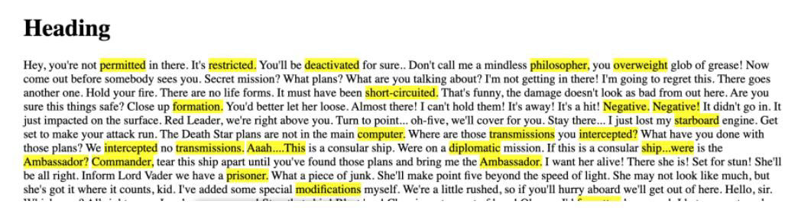
Advanced
3-Create a simple shopping list application that allows adding items to the list by inputting them into a form and clicking a button.
When an item is added, it should appear on the list and have a button next to it to delete it.
The form input should be cleared and focused after each item is added.
Output:
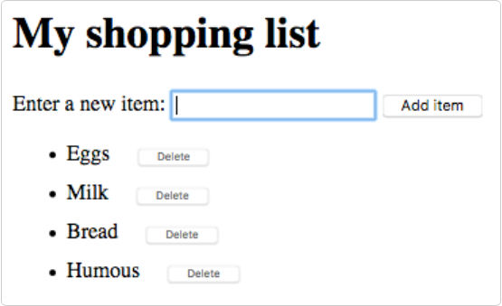
4-In this exercise, you’ll work with an array and you’ll add nodes to the DOM to display the Results and the Scores.
Output:
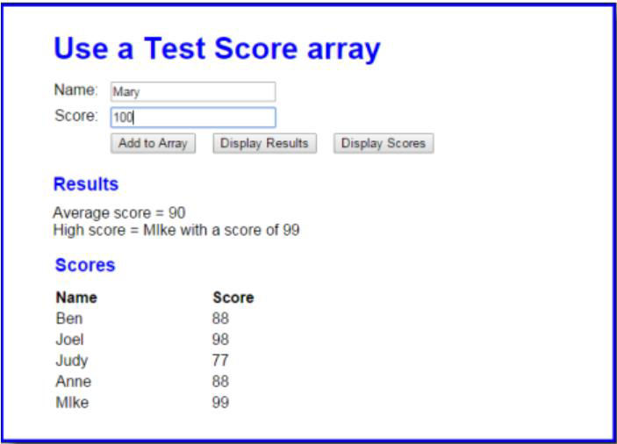
1. Open the HTML and JavaScript files Then, run the application to see the user interface shown above, although that interface won’t do anything until you develop the JavaScript for it.
2. At the start of the JavaScript file, you’ll see the declarations for two arrays: one for names and one for scores, and each array contains four elements. You’ll also see the code for the $ function as well as an onload event handler that attaches three functions named addScore(), displayResults(), and displayScores() to the click events of the buttons.
3. Write the displayResults function(). It should derive the average score and the highest score from the arrays and then display the results in the div element with “results” as its id, as shown above. To display the results, you need to add nodes to the DOM with the heading as an h2 element and the average and highest scores as elements. The easiest way to do that is to use the innerHTML property as shown in figure 6-13.
4. Write the displayScores() function. It should get the names and scores from the arrays and display them as rows in the HTML table element with “scores_table” as its id, as shown above.
5. Write the addScore() function. It should add a name and score to the two arrays. To test whether this works, you can click the Display Scores button and see if the new name and score have been added to the table.
6. If you haven’t already done it, add data validation to addScore() function. The Name entry must not be empty and the Score entry must be a positive number from 0 through 100. If either entry is invalid, use the alert() method to display this error message: “You must enter a name and a valid score”.
7. Make sure that your application moves the cursor to the Name field when the application starts and after a name and score have been added to the array.

DOM & Events Task: Interactive Text Editor
Task Description
Build an interactive web interface that allows users to format a specific block of text using JavaScript DOM manipulation and Event Listeners.
Requirements
1. Target Element
- Create a display area (e.g., a <div>) containing the default text “HELLO”.
- The default styles should be: Cyan background, Dark Red text color, font size 47px, and “Georgia” font family.
2. Formatting Buttons
- Bold Button: Toggles the text font weight between bold and normal.
- Italic Button: Toggles the text font style between italic and normal.
3. Alignment Buttons
- Create three buttons for text alignment: Left, Center, and Right.
- Clicking these should update the textAlign property of the target text.
4. Text Case & Clear Buttons
- Upper Case: Converts all text to uppercase.
- Lower Case: Converts all text to lowercase.
- Capitalize: Capitalizes the first letter of each word.
- Clear Text: Completely removes the text inside the display area.
5. Color Pickers
- Create an input field to select the Text Color.
- Create an input field to select the Background Color.
- Hint: Use the input event so the colors change in real-time as the user picks them.
6. Font Options
- A number input to control the font size (default value: 47).
- A dropdown menu (<select>) to choose the font family (e.g., Georgia, Arial, Times New Roman).
Expected Final Result
The screenshot below shows the interface in its default state (before any interaction). Your implementation should match this appearance exactly.
