**PHP Advanced Tasks**

**PHP Form Validation**

Create simple Login and Sign up pages, you can use Bootstrap for styling your pages, you should follow the below design, and all the inputs should have **validation in the frontend [regex] and the backend on both sides**.

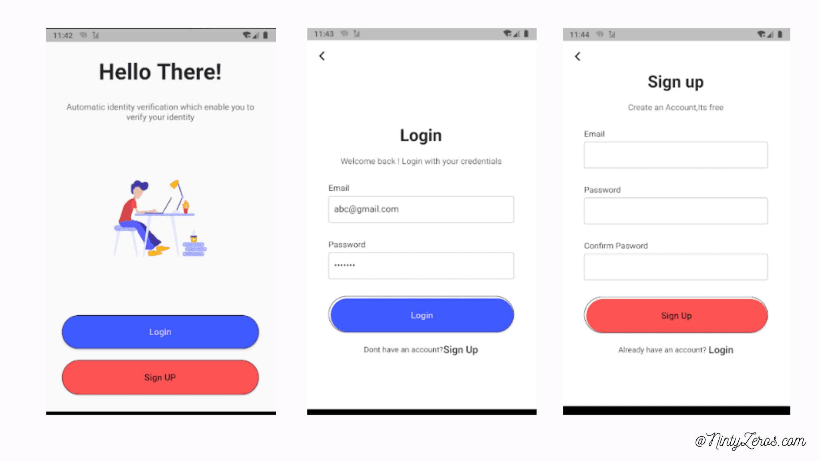

1. **Landing Page**

Your landing page will contain a welcoming message and two links one for the login page and the other one for the sign-up page

**2. Sign up Page**

Create a signup page containing the following input, all the inputs should be required and have validation as below:

* + Email: Should be an email input and follow the email pattern [regex] also the email is required
  + Mobile: Should be 10 digits also this field is required
  + Full name: Should be in 4 sections first name, middle name, last name, and family name validation must be done to make sure he entered a text
  + Password: The password should be at least 8 characters and this field is required and should cover password strength rules such as (upper case, lower case, numbers, special characters, and no spaces)
  + Password Confirmation: The password should match the above field [Password]

**3. Login**

After the user is registered his information should be stored in a database. The inserted information in the login form **must match** the signup, if all the information is validated the user should be redirected to the welcome page otherwise an alert message will be displayed. **you have two roles (Admin & User)**

**4. Welcome Page**

The user will be redirected to this page if his information is valid, this page will display the user’s email and user name and static welcoming message

**5. Admin Login:**

create a superuser, this admin can log in from the same login page after he logged, he can see this table:

|  |  |  |  |  |  |
| --- | --- | --- | --- | --- | --- |
| ID | User image | Name | Email | date created | Phone number |
|  |  |  |  |  |  |
|  |  |  |  |  |  |
|  |  |  |  |  |  |

The super admin can do all these functionalities:

1. View all registered users.
2. Add a new user.
3. Edit any of these users.
4. Delete any user.

**Hint:** **You can use all the topics you learned on PHP for the last two weeks.

**Note:** ** Don’t forget the sessions with login & signup