24/02/2024

1.Imagine your building a music streaming application like Spotify where you want to check a specific song present in database based on title of the song and author. Which data structure you use and why

25/2/2024 Assignment

1. Check and submit the behaviour when main class have return type other than void

Ans:

• IF you attempt to define the main() method with a return type other than void, you'll encounter a compilation error.

public class MainClass {

// Attempting to define main() with a return type other than void

public static int main(String[] args) {

System.out.println("Hello, World!");

return 0;

}

}

• As soon as the main() method terminates, the Java program terminates too. Hence, it doesn't make any sense to return from the main() method as JVM can't do anything with its return value of it.

•

2. Check and submit the behavior where main function should be empty but my program should display Java geek

Ans :

• it's not strictly necessary for the ‘main()’ method to contain any code.

public class JavaGeek {

public static void main(String[] args) {

System.out.println(Message.GREETING);

}

}

class Message {

static final String GREETING = "Java geek";

}

• This allows the main() method to be "empty" while still achieving the desired behavior.

3. Check and submit the behaviour when my main function is defined outside the class . And justify with your investigation

Ans :

• If you attempt to define the main() method outside of a class, you will encounter a compilation error.

•

// Attempting to define main() outside of a class

public static void main(String[] args) {

System.out.println("Hello, World!");

}

Main.java:1: error: '.class' expected

public static void main(String[] args) {

^

1 error

Reasons :

• it allows you to organize your code more logically.

• When the JVM starts, it searches for a class with a public static void main(String[] args) method, and upon finding it, executes the bytecode contained in the class file, resulting in the execution of the main() method and the start of the program.

• If you try to define the main() method outside of a class, the compiler will give you an error. This is because the JVM requires the main() method to be defined inside a class.

• main method highlights the first class to be executed by JVM. This class needs to be public/without any modifier (i.e. not private) , so that the jvm is able to access it.

4.What are OOPs Principal?

Ans : These four OOP principles—encapsulation, abstraction, inheritance, and polymorphism

5.What are Classes and Objects ?

Ans: a class in Java defines the blueprint for creating objects, while an object is an instance of a class that represents a specific entity with its own state and behavior.

26/02/2024

1.Type casting vs type conversion in simple words?

Type casting refers to explicitly changing the data type of a variable from one type to another.

double myDouble = 10.5;

int myInt = (int) myDouble; // Casting double to int

Type conversion refers to the automatic conversion of one data type to another by the programming language itself.

int myInt = 10;

double myDouble = myInt; // Implicit type conversion from int to double

27/02/2024

1. can I add a number without using the Addition Operator (+) in java?

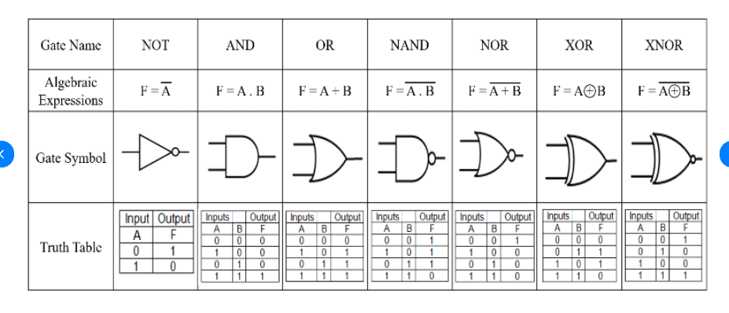

1. 2. can I Mul a number without using the Multiplication Operator (\*) in java?
2. 2. can I SWAP a number without using the Swap variable in java?