BLUE SENTINEL
Scaling Up the Marine Debris Detection System
Real-time alerts, ranking and cleanup decision support for ROV surveys | 3 October 2026

1. The idea
The current system detects underwater debris in an image and classifies it into 22 classes. A detector only lists objects. Blue Sentinel adds a decision layer on top: it watches ROV video, counts each object once, raises real-time alerts only for serious cases, ranks piles by how many objects they contain, remembers where things were, and compares surveyed areas for cleanup planning.
- Alerts: entangled animals, ghost gear and large piles alert in real time. Minor items such as a single bottle or a piece of cloth are logged but never alert.
- Ranking: the system counts the number of objects in each pile and ranks the piles, so cleanup effort goes to the larger pile first.
- Planning: a Cleanup Cost and Impact Optimizer compares surveyed areas and shows results as ranges.
- Users: ocean scientists first; cleanup contractors, environmental programs and port teams for the optimizer.

2. Pipeline
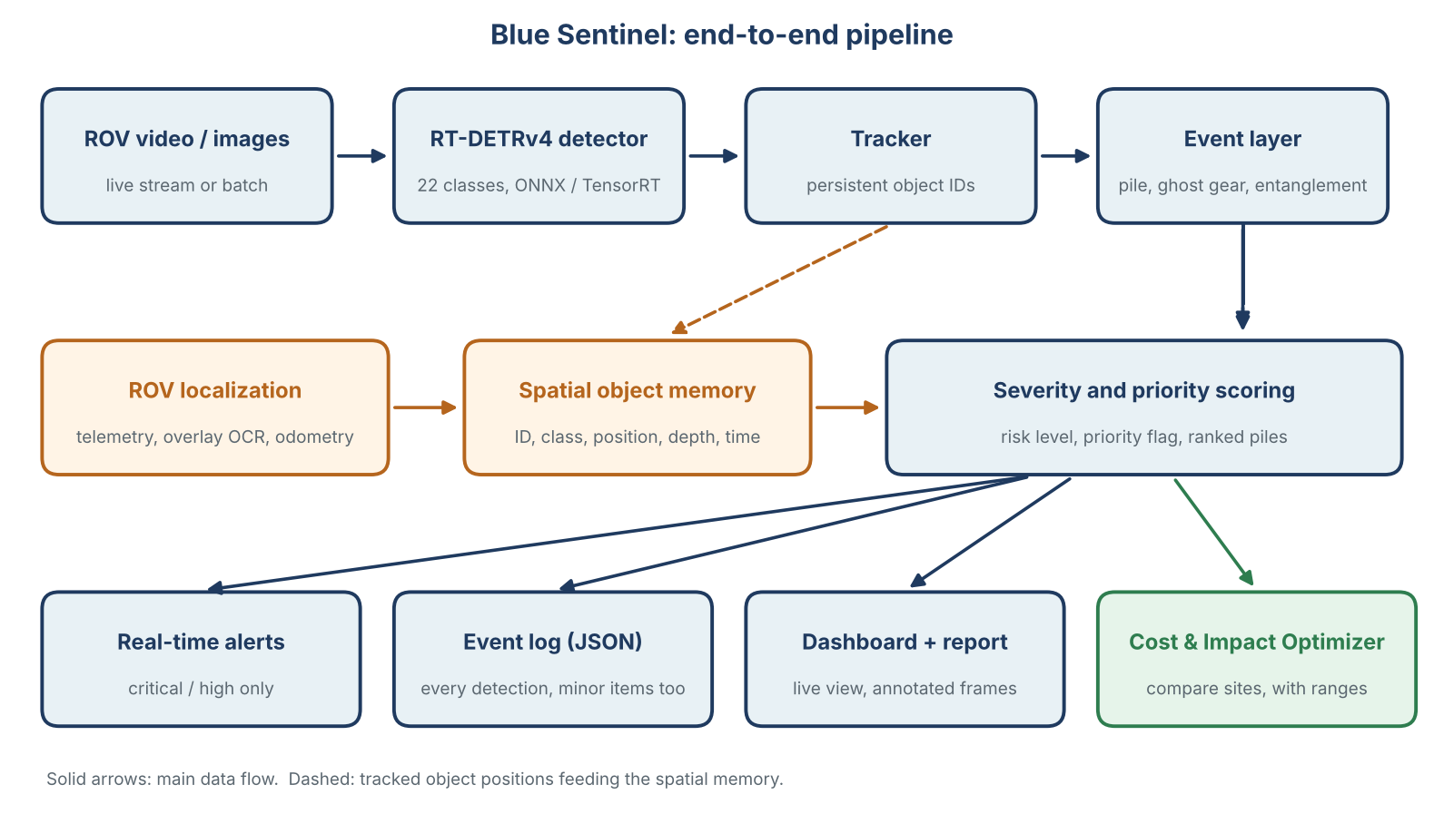

3. Core components
Component | What it does
Detection | Lightweight RT-DETR model, exported to ONNX, TensorRT and TorchScript. Runs frame by frame on video; no retraining is needed for video itself.
Tracking | Gives each object a persistent ID, so every object is counted once instead of once per frame.
Severity and risk | Severity score from object count, object types and density. Gives a risk level (Low, Medium, High, Critical) and a priority flag (Immediate Cleanup, Scheduled, Monitor). Output is JSON.
Location memory | Stores each object with depth, time and an approximate position. Depth and time come from the video overlay, a site anchor from the J-EDI dive record, and relative positions from visual odometry. Positions are approximate.
Dashboard and report | Streamlit or Gradio app with a live mode (fed by the simulator) and an analysis mode (upload video or images). Shows detections, severity, alerts and annotated frames, and downloads a PDF or HTML report.

3.1 Alert logic
Every detection goes into the log. Only the first three events below trigger a real-time cleanup alert, and each must persist across several frames before it fires.
Event | Rule (thresholds tuned on data) | Tier | Action
Entangled animal | Animal overlaps a net, line or debris, sustained over several frames | Critical | Real-time alert, Immediate Cleanup
Ghost gear | Net, rope or line above confidence and size thresholds | High | Real-time alert, Immediate Cleanup
Large pile | Object count in a small area above a pile threshold | High | Real-time alert, Immediate Cleanup
Small cluster | Several items, below the pile threshold | Medium | Logged, Scheduled
Single item | One bottle, cloth piece or similar | Low | Logged only, Monitor

Ranking piles: the system counts the number of objects in each pile and ranks the piles by that count. Class weights can be added so that fishing gear counts for more than cloth; any such weights are documented assumptions.

3.2 ROV simulator (the laptop plays the ROV's edge computer)
The simulator pretends to be the ROV's onboard computer, so the full system can be demonstrated without a vehicle.
- Runs the lightweight RT-DETR model, converted to ONNX, TensorRT and TorchScript.
- Runs on the laptop only.
- Processes recorded underwater videos frame by frame.
- Calculates detections and the severity score for each frame.
- Generates JSON results, which the dashboard receives as if they came from the vehicle.
TensorRT runs only on NVIDIA GPUs. If the laptop has none, the simulator uses ONNX or TorchScript. Report which format and hardware each FPS figure was measured on.

3.3 Cleanup Cost and Impact Optimizer
It helps a cleanup organization decide how to use limited money, equipment and staff. Example: three surveyed areas, budget to clean one this week. For each area it uses estimated debris quantities by class (as a range), expected crew hours from editable time-per-item assumptions, equipment requirements mapped from the class mix (cutters and lift bags for nets, sacks for small plastics), travel and operating costs, and the uncertainty in the survey results, which is carried through every calculation.
The output is a comparison per area with ranges, for example "crew hours 30 to 45 h" and "cost 900 to 1,300 cost units" (illustrative numbers), plus a note on which assumption changes the ranking most.
Validation rule. These estimates need operational data. Do not promise optimized or guaranteed cost savings until they are validated against real figures. Until then it is a comparison under stated assumptions.

4. How it will be evaluated
- Detection: mAP, precision and recall on stills and on video frames.
- Speed: FPS, latency and model size for each format, with the hardware stated.
- Counting: error against hand-counted clips.
- Alerts: precision, recall and false alerts per hour against moments marked by hand; minor items must stay quiet.
- Ranking: agreement with how 2 to 3 people rank pairs of piles.
- Optimizer: width of ranges and sensitivity of the ranking to each assumption.

5. Limitations to state openly
- Without a scale reference, pile size is a count and a relative area, and positions are approximate.
- Entanglement from bounding-box overlap is an approximation and can produce false alerts.
- It was not confirmed that a continuous ROV position file can be downloaded from J-EDI; check the dive pages and DARWIN, or ask JAMSTEC.
- Cost figures are assumptions until validated. The Jetson deployment is "TensorRT-ready" only, since no Jetson hardware is available.

6. Build order
- Evaluate and export the model (ONNX, TensorRT, TorchScript).
- Inference on video with tracking, then the alert logic and pile ranking.
- Severity score, risk level and JSON output.
- ROV simulator and dashboard, then the automated report.
- Test on clean, moderately polluted and heavily polluted videos, and record the metrics.
- If time allows: location memory, then the optimizer (a simple ranking demo on three example areas is enough to start).
Sources: J-EDI (godac.jamstec.go.jp/jedi), JAMSTEC DARWIN (godac.jamstec.go.jp/darwin), RT-DETRv4 (github.com/RT-DETRs/RT-DETRv4).

