**Proposal: Card Matching Game**

**Overview:**

**What is the problem we are trying to solve?**

I want to create an engaging and entertaining Card Matching Game using face cards to provide users with a fun and challenging experience. This game will help users improve their memory and cognitive skills while enjoying a classic card game. This will also help me to improve my web development skills so I can work on more complex projects in the future.

**Why are we doing this?**

The Card Matching Game is a popular and timeless pastime that can be enjoyed by people of all ages. By using face cards, we add a unique twist to the traditional card game, making it more appealing and relatable to a broader audience. This project also serves as an opportunity to demonstrate our development skills and creativity.

**Who is the audience?**

My target audience includes casual gamers, individuals looking for a mental challenge, and anyone seeking a fun and relaxing way to pass the time.

**Major Functions of the Application:**

1. **Card Deck:** Generate a deck of face cards (with suits like hearts, diamonds, clubs, and spades) shuffled randomly for the game and select cards based on the difficulty selected.
2. **Gameplay:** Implement the core card matching gameplay, allowing users to flip two cards at a time and check for matches.
3. **Scoring:** Track the player's score, keeping a record of their successful matches and attempts.
4. **Timer:** Include a timer to add a time-based challenge to the game.
5. **Win Condition:** Determine when the game is won, e.g., when all pairs have been matched.
6. **Animations:** Add animations for card flipping and matching to enhance the user experience.

**Wireframes:**

**Mobile View:**

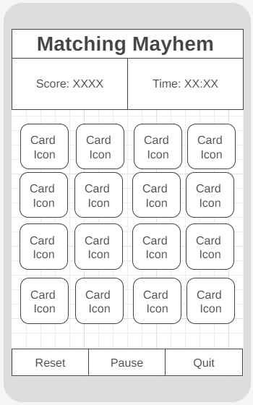

**Desktop View:**

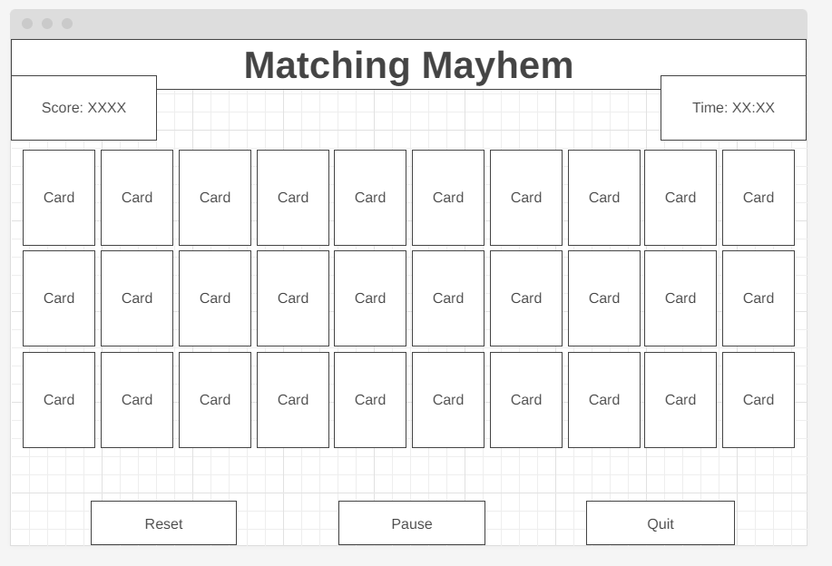

**Data Sources:**

I will be using this [API](https://deckofcardsapi.com/) for all the card information.

**Initial Module List:**

* **Card.js**: Define a Card class to represent each card in the game.
* **Deck.js**: Create a Deck class to manage the card deck and shuffling.
* **Game.js**: Implement the main game logic, including matching, scoring, and timer.
* **UI.js**: Handle the user interface, including card rendering, animations, and user interactions.

**Colors/Typography/Specific Element Styling:**

* **Colors:** I want to use red, black, and white to match the traditional card deck with green for the background.
* **Typography:** I will be using Gabarito & Comfortaa from google fonts.
* **Specific Element Styling:** Cards will have a realistic appearance with rounded corners with a traditional back.

**Schedule:**

To stay on target, I will try to stay to the following schedule.

* Week 1: Project setup, initial UI design, wireframing, and implement the card deck and basic gameplay functionality.
* Week 2: Add scoring, timer, win conditions and animations to the cards.
* Week 3: Testing, bug fixing, and final polish/submission.

**Trello Board:** <https://trello.com/b/ahPeBq8b/webdev-matching-game>