EBA-FFD: Adaptive Federated Fraud Detection under Differential Privacy and Concept Drift
1st Shlok Shah  Mukesh Patel School of Technology Management & Engineering, SVKM's NMIMS  Mumbai, India  shlokshah1310@gmail.com | 2nd Rajvi Mahidhar  Mukesh Patel School of Technology Management & Engineering, SVKM's  NMIMS  Mumbai, India  rnmahidhar@gmail.com | 3rd Swarnalata Bollavarapu  Mukesh Patel School of Technology Management & Engineering, SVKM's NMIMS  Mumbai, India  Swarnalata.B@nmims.edu

Abstract—Fraud detection can benefit from learning across multiple financial institutions, where different banks observe different transaction and fraud patterns. However, sensitive transaction data cannot be freely shared between institutions, limiting the ability to train a common fraud detection model. Federated learning enables collaborative training without centralizing raw transactions, but severe class imbalance, non-IID client data, and changing fraud patterns introduce additional challenges. We propose EBA-FFD, a privacy-preserving federated framework combining local KMeans-SMOTE/ENN balancing, differential privacy, and drift-aware adaptive aggregation. On the full-scale ULB European cardholder dataset, EBA-FFD achieves an F1-score of 0.7936 (PR-AUC 0.7261) under DP-SGD with RDP accounting (ε ≈ 3.0, δ ≤ 1×10⁻⁵; maximum realized ε = 3.014; SMOTE preprocessing and the drift signal lie outside this guarantee), compared with 0.8310 (PR-AUC 0.8563) for non-private centralized XGBoost (nominal p = 0.012) and 0.7689 (PR-AUC 0.7305) for a local-only baseline (nominal p = 0.034; neither survives multiple-comparison correction). The lower performance relative to centralized XGBoost cannot be attributed to privacy alone, since the non-private federated variant does not exceed the private system in F1 in our ablation, and the F1 advantage over local-only training is nominal while PR-AUC is comparable. All headline results use Focal Loss; an ablation measured on the test set and not used to select the reported system shows that plain BCE reaches F1 0.8170. Under injected label-flip drift on the largest client, adaptive aggregation achieves F1 = 0.6560 compared with 0.2276 for vanilla FedAvg, partially mitigating drift-induced degradation (three seeds, high variance). Overall, EBA-FFD suggests that privacy-preserving federated training can maintain effective fraud detection while addressing class imbalance and mitigating injected label-flip drift on one client.
Keywords—federated learning; differential privacy; concept drift; fraud detection; class imbalance; adaptive aggregation; non-IID data
I. INTRODUCTION
Payment-card fraud rarely stays confined to one bank, so cross-institution collaboration should help detect it. Regulations such as the General Data Protection Regulation (GDPR) [1], however, generally restrict banks from pooling raw transaction records. Federated learning (FL) [2] avoids this: each bank trains locally and only model updates, not raw data, leave its premises. Three properties of this setting are routinely under-addressed. First, client data is non-identically distributed (non-IID) across banks [3], so a fixed aggregation rule can be dominated by whichever bank is largest. Second, a privacy guarantee must be formal, not heuristic — trained models can themselves leak membership information about their training data [4], which is exactly what a rigorous differential privacy (DP) guarantee is designed to bound. Third, fraud tactics drift over time, and a bank whose update stream becomes corrupted should be down-weighted, not silently trusted. We propose EBA-FFD (Explainable, Balanced, and Adaptive Federated Fraud Detection) to address all three.
We also identify two measurement pitfalls that can invalidate a reported result if left undiagnosed: a validation metric whose decision threshold is re-optimized every round can tie across rounds, defaulting a naive "best round" selection to the first round tried; and under injected drift, any validation-based round selection structurally favors the pre-drift round, erasing the exact comparison a drift experiment is meant to make.
This paper's contributions are:
1) An adaptive, trust-weighted aggregation rule, using a Page-Hinkley (PH) drift statistic on each client's training loss, that damps rather than excludes a drifting bank, evaluated in a label-flip stress test on one client.
2) RDP-accounted, per-client differentially private stochastic gradient descent (DP-SGD), individually calibrated so banks of very different sizes reach approximately one shared privacy budget (scope of the guarantee stated in Section III).
3) An architecture right-sized for this DP-SGD noise regime — a plain multi-layer perceptron (MLP) — that at full scale matches or exceeds convolutional and recurrent alternatives in F1, plus a full-scale ablation finding that plain binary cross-entropy outperforms Focal Loss in this regime (measured on the test set and not used to tune the reported system).
4) A full-scale evaluation (100% data, 3 seeds, 4-32 banks), including ablations and negative results.
Section II reviews related work. Section III describes EBA-FFD's design. Section IV details the experimental setup. Section V reports results, Section VI discusses limitations, and Section VII concludes.
II. RELATED WORK
Federated averaging (FedAvg) [2] trains a global model by locally updating on each client and averaging the resulting weights in proportion to client dataset size. FedProx [5] adds a proximal term that restrains client drift under non-IID data, and is the aggregation-level baseline we compare against directly.
Non-federated fraud detection has a long history: Bhattacharyya et al. [6] compare logistic regression, support vector machines, and random forests on real transaction data, establishing tree-based ensembles as strong baselines — one motivation for our XGBoost comparison (Section IV.C). Within federated fraud detection specifically, Yang et al. [7] propose FFD, evaluated on large-scale real-world transaction data but without formal per-client DP accounting or explicit drift handling. Aljunaid et al. [8] combine FL with explainable-AI techniques for financial fraud detection; neither work validates a drift-robustness mechanism with an injected-drift evaluation harness, which is a central contribution here.
Differential privacy for deep learning is most commonly instantiated through DP-SGD [9], which clips per-sample gradients and adds calibrated Gaussian noise, with a Rényi differential privacy (RDP) [10] accountant composing the guarantee across steps. We use the Opacus library [11], which implements this mechanism for PyTorch; differentially private recurrent models have been trained at scale with related techniques [12]. Secure aggregation [13] is a complementary cryptographic technique — it hides individual updates from the server without bounding what the aggregate itself reveals — and is not used here, since our threat model is a DP-SGD guarantee (scoped in Section III) against exactly that aggregate-level leakage.
Class imbalance is typically addressed with synthetic oversampling: SMOTE [14] generates synthetic minority examples between existing neighbors, and KMeans-SMOTE [15] first clusters the data to avoid generating noisy synthetic points near class boundaries. We follow oversampling with Edited Nearest Neighbours (ENN) cleaning [16]. Focal Loss [17] down-weights easy examples during training; we found it net-harmful once KMeans-SMOTE/ENN already handles imbalance at full data scale (Section V).
Concept drift is surveyed by Gama et al. [18]; the Page-Hinkley (PH) test [19] it catalogues is our drift-detection mechanism, chosen because it consumes only the training loss already returned each round, although that release is not itself covered by the DP guarantee (Section III). Blanchard et al. [20] propose Krum, a Byzantine-robust aggregation rule that selects a single client update per round and discards the rest — in contrast, our rule damps a drifting client's weight without full exclusion. Other robust aggregation rules (e.g., coordinate-wise median and trimmed mean) are surveyed in [21]; we do not compare against Krum or these rules (Section VI).
III. SYSTEM DESIGN
EBA-FFD combines five components — non-IID partitioning, local class balancing, a right-sized classifier, DP-SGD local training, and drift-aware adaptive aggregation — into one federated pipeline [22] rather than five independent add-ons. Fig. 1 shows the resulting per-round architecture: each bank balances and trains locally under DP-SGD and reports its updated weights and mean training loss; the server runs a PH test on each client's loss to compute a trust score, aggregates updates weighted by dataset size times trust, and broadcasts the updated global model back for the next round. This architecture is designed so that every stage a bank's data passes through — balancing, training, and the only values that ever leave the bank (its DP-noised weight update and scalar loss) — stays inside that bank's own boundary. The weight update carries EBA-FFD's (ε, δ)-DP-SGD accounting (subject to the preprocessing caveat in Section III.B); the scalar training loss used for drift detection is computed from real, un-noised local batches, and its release is not itself covered by that guarantee, a scoping we return to in Section VI.
Privacy scope and threat model. We assume an honest-but-curious server that observes every bank's released update, and the DP unit is a single training record at one bank (record-level DP). The quantities a bank releases are its noised weight update, its un-noised scalar training loss, and its sample count n_k; the server additionally computes the trust scores that enter aggregation. The KMeans-SMOTE/ENN preprocessing, and threshold, round, architecture, and loss-function selection on validation data, are not privacy-accounted, and the validation and test sets are global splits held by the server rather than by the banks. The drift scenario we evaluate is a label-corruption stress test on one client, not an adversarial attacker model. For privacy-process considerations see [23].
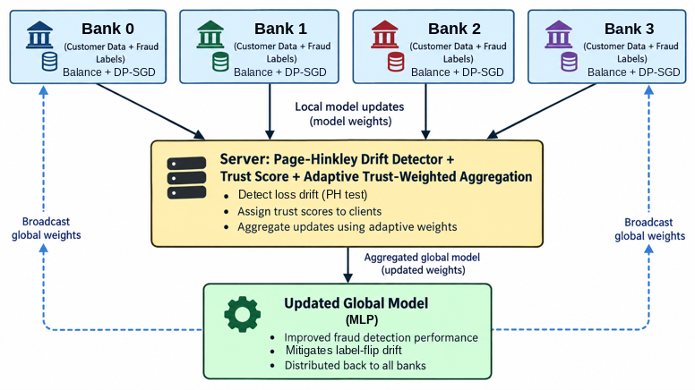
Fig. 1. EBA-FFD system architecture: per-round federated control flow.
A. Non-IID Data Partitioning
Transactions are partitioned across simulated banks using a Dirichlet distribution (concentration α = 0.5) over class labels, producing clients with heterogeneous fraud incidence and dataset size. A minimum fraud-per-client floor tops up any client that would otherwise receive too few fraud examples to train or evaluate meaningfully. The floor reassigns (moves, rather than copies) fraud records from fraud-rich clients, and the global validation and test sets are split from the raw dataset before partitioning, so neither the floor nor the balancing below touches them.
B. Local Class Balancing
Each client independently balances its local training data once, before federated training begins, using KMeans-SMOTE, falling back to plain SMOTE for clients whose cluster structure is too small, followed by ENN cleaning. This step never leaves the client and does not touch the DP-SGD privacy budget. It does not, however, automatically preserve DP-SGD's per-example sensitivity assumption: SMOTE-style oversampling interpolates between real neighbors, so a single original record can influence more than one synthetic training example, and we have not formally re-derived per-sample sensitivity bounds under this data-dependent transformation (Section VI).
C. Right-Sized Classifier
An initial capacity sweep at matched ε = 3.0 compared a convolutional neural network (CNN)-only design against a CNN plus bidirectional long short-term memory (BiLSTM) design and found the recurrent block cost 0.12-0.15 F1, which we hypothesize is because a BiLSTM's per-timestep, per-sample gradients accumulate DP-SGD noise faster than a CNN's. A follow-up check confirmed at three seeds that a plain MLP head, with no convolutional or recurrent block, consistently beats CNN-only (F1 0.7416 vs 0.7159, 0.8042 vs 0.7812, 0.7978 vs 0.7771). EBA-FFD uses this MLP classifier; the CNN-only and CNN+BiLSTM variants are retained as ablation arms (Table III). The full-scale evaluation shows the same ordering in F1, with a narrower margin (ΔF1 −0.008 for CNN-only vs the MLP default, within one standard deviation; the CNN variant scores higher on ROC-AUC and PR-AUC in Table III).
D. Loss Function
Training uses Focal Loss (α = 0.25, γ = 2.0) by default, and every result in Sections IV-V other than this ablation arm reflects that choice. At full scale, this ablation shows plain BCE outperforming Focal Loss (F1 0.8170 vs 0.7936, recall 0.7891 vs 0.7483) — the largest gain in the entire ablation table. We interpret this as KMeans-SMOTE/ENN balancing already handling the imbalance problem Focal Loss was meant to address once enough real data is available. Based on this finding, plain BCE appears preferable to Focal Loss in this regime. This ablation was measured on the test set and was not used to select or tune the system reported in Tables I, IV, and V, which all use Focal Loss and were not re-run with BCE; under BCE the F1 gap to centralized XGBoost would be smaller (about 0.014), but this was not tested for significance.
E. Differentially Private Local Training
Each client trains under DP-SGD via Opacus [11]: per-sample gradients are clipped to norm C = 1.0 and summed gradients are perturbed with Gaussian noise, with an RDP accountant [10] composing the realized (ε, δ) guarantee across every step and round. Mini-batches are drawn by Poisson sampling, which the RDP amplification bound requires, at sampling rate q_k over the client's post-balancing local training set. Each client's noise multiplier σₖ is individually solved for so every client reaches the same target budget (ε = 3.0, δ_k = min(1/n_k, 1×10⁻⁵)) within solver tolerance despite differing dataset sizes and step counts. Table II reports the resulting per-bank calibration.
F. Drift Detection and Adaptive Aggregation
Each client's mean local training loss is fed into a per-client PH statistic [19]. A client whose cumulative deviation from its running mean loss exceeds a threshold (PH tolerance 0.005, threshold 0.05, forgetting factor 0.9999) is flagged as drifting, and its aggregation weight is scaled by a trust factor that decays smoothly with drift severity (steepness β = 2.0) but never falls below a floor (trust_min = 0.20). With every client's trust fixed at 1.0, this rule reduces exactly to vanilla FedAvg, which is therefore both the no-adaptation ablation arm and an independent baseline.
G. Drift Injection Evaluation Harness
We inject drift mid-training, at round 5, as a label-flip (flip probability 0.75, drift level 1.5) on the federation's largest client (by sample count, determined per seed), rather than a covariate shift, since a covariate-shift injection was found to be neutralized by the classifier's normalization layer before it reaches the loss, which also illustrates that a PH statistic on training loss cannot detect shifts that do not change the loss. We target the largest client, not a fixed index, since a fixed index can land on a near-empty client under some Dirichlet partitions, making drift injection a no-op. This is a label-corruption stress test on one client rather than a model of gradual fraud-pattern change.
IV. EXPERIMENTAL SETUP
A. Dataset
Experiments use the ULB European cardholder credit-card transaction dataset [24]: 284,807 transactions, of which 492 (0.173%) are fraudulent, with 28 PCA-anonymized principal components plus Time and Amount. We selected this dataset over alternatives (synthetic fraud simulators, or proprietary bank datasets unavailable for academic publication) on three criteria: it is real transaction data rather than a synthetic approximation of fraud behavior; it is a commonly used public fraud benchmark [24], although we do not reproduce the federated fraud detection methods of [7], [8] on it, so no direct numerical comparison to prior work is made; and its extreme, realistic class imbalance (0.173% fraud) directly matches the imbalance-handling problem this paper addresses. We did not conduct a formal empirical comparison against alternative datasets — this is a stated selection rationale, not a rejection study.
B. Full-Scale Configuration
Results in Section V are from a full-scale run on a GPU cluster (Altair Access, NVIDIA H100): 100% of the dataset, ten communication rounds, three local epochs per round, three seeds ({42, 43, 44}), and federation sizes of 4, 8, 16, and 32 simulated banks (Dirichlet α = 0.5). Data are split approximately 70% train, 10% validation, and 20% test before any partitioning; the validation and test sets are global, held by the server, and never partitioned to banks. The expected local batch size is 256 (implied by q_k in Table II). Centralized XGBoost uses 300 trees (maximum depth 6, learning rate 0.1, subsample 0.8, column subsample 0.8); local-only XGBoost uses 150 trees (maximum depth 5); logistic regression uses balanced class weights; the non-federated baselines do not use SMOTE and rely on class weighting instead.
C. Baselines
EBA-FFD is compared against XGBoost (eXtreme Gradient Boosting) [25] and Logistic Regression trained centrally on pooled data, a centralized CNN, a local-only XGBoost model trained independently on each bank's data with no collaboration and averaged across banks, vanilla FedAvg under the same DP-SGD configuration, and FedProx under the same configuration. Methods with no privacy guarantee (marked † in Table I) quantify the utility cost of privacy and non-IID collaboration rather than competing directly with EBA-FFD (the local-only model additionally serves as the reference for the benefit of collaboration); FedProx at matched ε is the like-for-like federated comparison.
D. Metrics and Model Selection Protocol
We report Precision, Recall, F1, area under the receiver operating characteristic curve (ROC-AUC), and area under the precision-recall curve (PR-AUC). PR-AUC is emphasized over ROC-AUC for this task, since PR curves are more informative than ROC curves when evaluating classifiers on severely imbalanced data such as this dataset's 0.173% fraud rate [26]. The decision threshold is calibrated every round on the server-held global validation split (never partitioned to banks), and the reported round is selected by validation PR-AUC, never by test-set performance or by validation F1 (Section I). Under injected drift (Table IV) we instead report the final round's metrics, reflecting sustained drift-regime performance rather than a pre-drift snapshot.
E. Statistical Protocol
Every configuration runs across three seeds, controlling both data partition and model initialization. Table I reports mean ± standard deviation with a paired t-test on F1 against EBA-FFD as reference. The p-values are uncorrected; applying Holm correction across the five comparisons in Table I gives adjusted p = 0.060 (XGBoost), 0.136 (local-only), 0.408 (logistic regression), 0.846 (FedProx), and 0.930 (centralized CNN), so no difference remains significant at 0.05. We use the t-test rather than the Wilcoxon signed-rank test because an exact Wilcoxon test at n = 3 cannot produce a two-sided p-value below 0.25 regardless of effect size, making it uninformative at this sample size; we also computed Wilcoxon statistics internally and confirmed they were, as expected, non-significant throughout. Three seeds is the minimum for a non-degenerate paired test, the t-test's normality assumption cannot itself be verified at this sample size, and the reported p-values should be read as an initial significance signal rather than a definitive test.

V. RESULTS
A. Performance Relative to Baselines
As shown in Table I, EBA-FFD attains F1 = 0.7936 under DP-SGD accounting (ε ≈ 3.0, δ ≤ 1×10⁻⁵). At full scale this is below centralized XGBoost (F1 = 0.8310, PR-AUC = 0.8563; nominal p = 0.012, Holm-adjusted p = 0.060) — a gap that our ablation cannot attribute to privacy alone, since the non-private federated variant in Table III does not exceed the private system in F1, and which may largely reflect model class (gradient-boosted trees versus neural networks on tabular data). On PR-AUC, which we emphasize, EBA-FFD (0.7261) is lower than centralized XGBoost (0.8563), centralized CNN (0.8263), local-only (0.7305), and logistic regression (0.7334), so F1 alone understates the gap to the centralized models. EBA-FFD attains higher F1 than the local-only baseline averaged across banks (F1 = 0.7689, nominal p = 0.034, Holm-adjusted p = 0.136), although PR-AUC is comparable, and no significant difference from FedProx at matched ε was detected (p = 0.423; n = 3 cannot establish equivalence). EBA-FFD and FedAvg+DP report identical numbers in Table I, consistent with every client's trust score remaining at 1 absent injected drift, in which case the adaptive aggregation rule reduces exactly to vanilla FedAvg (Section III.F).
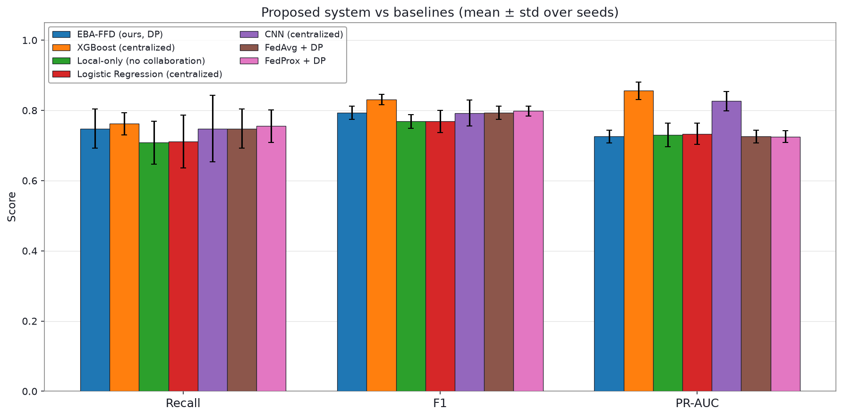
Fig. 2. Recall, F1, and PR-AUC across methods (full scale, 3 seeds).
TABLE I: COMPARISON AGAINST BASELINES
Method | Precision | Recall | F1 | ROC-AUC | PR-AUC | p (F1)
EBA-FFD (ours, DP) | 0.8484 ± 0.0312 | 0.7483 ± 0.0562 | 0.7936 ± 0.0190 | 0.9730 ± 0.0103 | 0.7261 ± 0.0181 | ref
XGBoost (centralized)† | 0.9148 ± 0.0177 | 0.7619 ± 0.0312 | 0.8310 ± 0.0146 | 0.9825 ± 0.0055 | 0.8563 ± 0.0250 | 0.012
Local-only (no collab.)† | 0.8478 ± 0.0502 | 0.7083 ± 0.0612 | 0.7689 ± 0.0193 | 0.9678 ± 0.0093 | 0.7305 ± 0.0337 | 0.034
Logistic Regression† | 0.8437 ± 0.0501 | 0.7109 ± 0.0752 | 0.7687 ± 0.0314 | 0.9699 ± 0.0109 | 0.7334 ± 0.0306 | 0.136
CNN (centralized)† | 0.8515 ± 0.0454 | 0.7483 ± 0.0948 | 0.7922 ± 0.0369 | 0.9725 ± 0.0104 | 0.8263 ± 0.0271 | 0.930
FedAvg + DP | 0.8484 ± 0.0312 | 0.7483 ± 0.0562 | 0.7936 ± 0.0190 | 0.9730 ± 0.0103 | 0.7261 ± 0.0181 | —
FedProx + DP | 0.8494 ± 0.0328 | 0.7551 ± 0.0468 | 0.7982 ± 0.0141 | 0.9735 ± 0.0101 | 0.7254 ± 0.0167 | 0.423
† No privacy guarantee (raw data pooled or privacy ignored) — utility upper bound, not a competing system (the local-only row additionally serves as the reference for the benefit of collaboration). FedProx at matched ε is the like-for-like federated comparison. p-values are uncorrected paired t-tests on F1 (n = 3).
Table II reports per-bank privacy calibration for seed 42, with n_k and q_k referring to each bank's post-balancing local training set. Bank sizes are markedly skewed (Bank 3 holds 218,467 of the 258,424 post-balancing training rows, about 84.5% of the federation's training data), and smaller banks (Bank 0, 2,212 samples) require a larger noise multiplier for the same target ε. Because aggregation weights scale with n_k, the global model is largely determined by the largest bank; we hypothesize that this contributes to the small F1 effect of DP noise and federation size reported below, but we did not test it. Bank 1's realized ε = 3.014 slightly exceeds the 3.0 target because Opacus's noise-multiplier search satisfies the target within a small tolerance rather than exactly, not because of an accounting error; the maximum realized ε is therefore 3.014. Bank 3's δ is 4.6×10⁻⁶ because δ_k = min(1/n_k, 1×10⁻⁵).
TABLE II: PER-BANK DIFFERENTIAL PRIVACY CALIBRATION (SEED 42)
Bank | n_k | q_k | Steps | σ_k | δ_k | ε spent
0 | 2,212 | 0.11573 | 270 | 3.0273 | 1.0e-05 | 2.859
1 | 23,789 | 0.01076 | 2790 | 1.1133 | 1.0e-05 | 3.014
2 | 13,956 | 0.01834 | 1650 | 1.3477 | 1.0e-05 | 2.969
3 | 218,467 | 0.00117 | 25620 | 0.6934 | 4.6e-06 | 2.998
B. Component-Wise Ablation Analysis
Removing KMeans-SMOTE/ENN balancing drops F1 from 0.7936 to 0.7353 (ΔF1 −0.0583). Architecture ordering from Section III.C holds in F1, with a narrow margin (within one standard deviation). The only positive finding is the loss-function result: adding Focal Loss back costs 0.0234 F1, although removing KMeans-SMOTE/ENN balancing (−0.0583) and adding the CNN and BiLSTM blocks (−0.0612) have larger effects. The − Differential privacy row shows a small negative effect (ΔF1 −0.0112), attributed to high variance in that arm (three seeds) rather than a stable effect, so removing DP does not improve F1 here; on PR-AUC, however, the non-private variant is higher (0.8045 vs 0.7261), indicating a ranking-quality cost of DP that F1 at a re-calibrated threshold does not show. Adaptive aggregation shows ΔF1 = 0.0000 here since, absent drift, it is identical to vanilla FedAvg in these runs, so this row duplicates the reference row. These component-level results are summarized in Table III.
TABLE III: COMPONENT ABLATION (STATIONARY)
Variant | Precision | Recall | F1 | ROC-AUC | PR-AUC | ΔF1
Full system (MLP, no CNN/BiLSTM, Focal Loss) | 0.8484 ± 0.0312 | 0.7483 ± 0.0562 | 0.7936 ± 0.0190 | 0.9730 ± 0.0103 | 0.7261 ± 0.0181 | ref
+ CNN block (discarded) | 0.8287 ± 0.0441 | 0.7483 ± 0.0460 | 0.7855 ± 0.0310 | 0.9771 ± 0.0075 | 0.7323 ± 0.0147 | −0.0080
+ CNN and BiLSTM blocks (discarded) | 0.7787 ± 0.0477 | 0.6939 ± 0.0468 | 0.7324 ± 0.0252 | 0.9513 ± 0.0113 | 0.6472 ± 0.0109 | −0.0612
+ BiLSTM only (no CNN) | 0.8193 ± 0.0538 | 0.7517 ± 0.0328 | 0.7825 ± 0.0096 | 0.9478 ± 0.0041 | 0.7022 ± 0.0724 | −0.0111
− KMeans-SMOTE/ENN balancing | 0.8329 ± 0.0443 | 0.6633 ± 0.0890 | 0.7353 ± 0.0478 | 0.8479 ± 0.0107 | 0.6343 ± 0.0490 | −0.0583
− Focal Loss (plain BCE) | 0.8492 ± 0.0418 | 0.7891 ± 0.0312 | 0.8170 ± 0.0045 | 0.9759 ± 0.0061 | 0.7398 ± 0.0167 | +0.0234*
− Differential privacy† | 0.8568 ± 0.0622 | 0.7279 ± 0.0850 | 0.7824 ± 0.0268 | 0.9661 ± 0.0113 | 0.8045 ± 0.0072 | −0.0112
− Adaptive aggregation (vanilla FedAvg) | 0.8484 ± 0.0312 | 0.7483 ± 0.0562 | 0.7936 ± 0.0190 | 0.9730 ± 0.0103 | 0.7261 ± 0.0181 | +0.0000
* Reference row uses Focal Loss (Section III.D), the loss function actually reflected in Tables I, III (reference row), IV, and V; a positive ΔF1 here means removing it in favor of plain BCE improves F1. This ablation was measured on the test set and was not used to select the system in this paper's other reported tables. † No privacy guarantee.
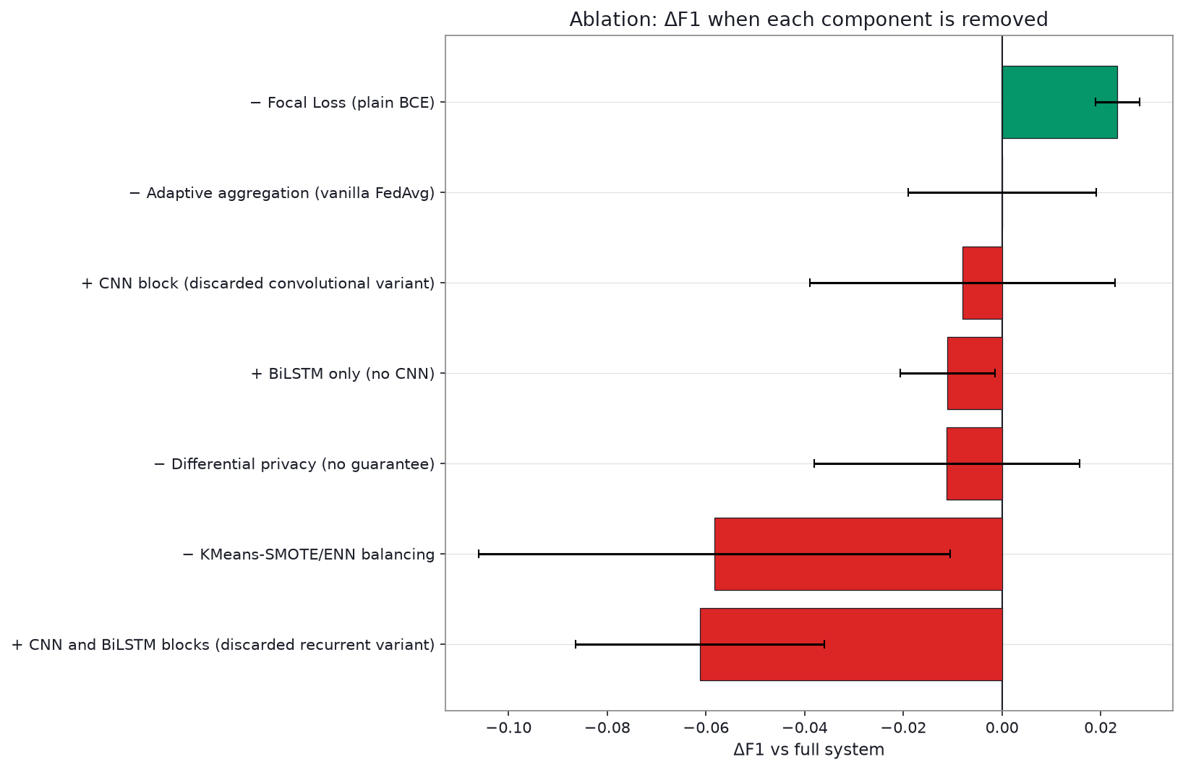
Fig. 3. ΔF1 relative to the full system for each ablated or added component (full scale; error bars are each arm's own standard deviation, not the paired difference).
C. Adaptive Aggregation Under an Injected Label-Flip Stress Test
Under drift injection, vanilla FedAvg collapses (F1 = 0.2276) while adaptive aggregation holds substantially better (F1 = 0.6560; ΔF1 = +0.4285). This is directionally consistent with a protective effect at full scale; adaptive aggregation partially mitigates but does not eliminate drift damage. The reported mean and standard deviation of vanilla FedAvg's F1 (0.2276 ± 0.3942) are consistent with complete collapse (F1 ≈ 0) in two of the three seeds and little degradation in the third. No significance test is reported for this comparison.
Both arms show very large standard deviations (0.19-0.53), attributed to extreme bank-size skew: the client targeted by drift is, by design, the federation's largest, and how dominant it is varies by which random partition each seed draws. We report this as a real, directionally consistent effect, while flagging the variance as a genuine limitation (Section VI). The full results are reported in Table IV.
TABLE IV: ADAPTIVE AGGREGATION UNDER INJECTED LABEL-FLIP DRIFT
Variant | Precision | Recall | F1 | ROC-AUC | PR-AUC | ΔF1
Full system (adaptive aggregation) | 0.6800 ± 0.1928 | 0.6361 ± 0.1852 | 0.6560 ± 0.1842 | 0.8678 ± 0.1356 | 0.5805 ± 0.2489 | ref
− Adaptive aggregation (vanilla FedAvg) | 0.2152 ± 0.3727 | 0.2415 ± 0.4183 | 0.2276 ± 0.3942 | 0.3792 ± 0.5297 | 0.2233 ± 0.3851 | −0.4285
D. Scalability
F1 is highest at 4 banks (0.7936) and roughly flat from 8-32 banks (0.7596, 0.7803, 0.7699). Mean DP noise increases steadily with bank count (σ̄: 1.695 → 3.487), and per-round wall-clock time decreases (19.9s → 13.0s; simulation wall-clock time with sequentially simulated clients, excluding communication cost) since each bank's local workload shrinks as data is split more ways. The complete scalability results are reported in Table V.
TABLE V: SCALABILITY
Banks | Precision | Recall | F1 | ROC-AUC | PR-AUC | σ̄ | s/round
4 | 0.8484 ± 0.0312 | 0.7483 ± 0.0562 | 0.7936 ± 0.0190 | 0.9730 ± 0.0103 | 0.7261 ± 0.0181 | 1.695 | 19.9
8 | 0.8389 ± 0.0329 | 0.6973 ± 0.0679 | 0.7596 ± 0.0321 | 0.9716 ± 0.0081 | 0.7133 ± 0.0215 | 2.459 | 15.9
16 | 0.8383 ± 0.0414 | 0.7313 ± 0.0386 | 0.7803 ± 0.0228 | 0.9752 ± 0.0061 | 0.7172 ± 0.0458 | 3.265 | 14.1
32 | 0.8451 ± 0.0286 | 0.7109 ± 0.0752 | 0.7699 ± 0.0333 | 0.9658 ± 0.0157 | 0.7114 ± 0.0333 | 3.487 | 13.0
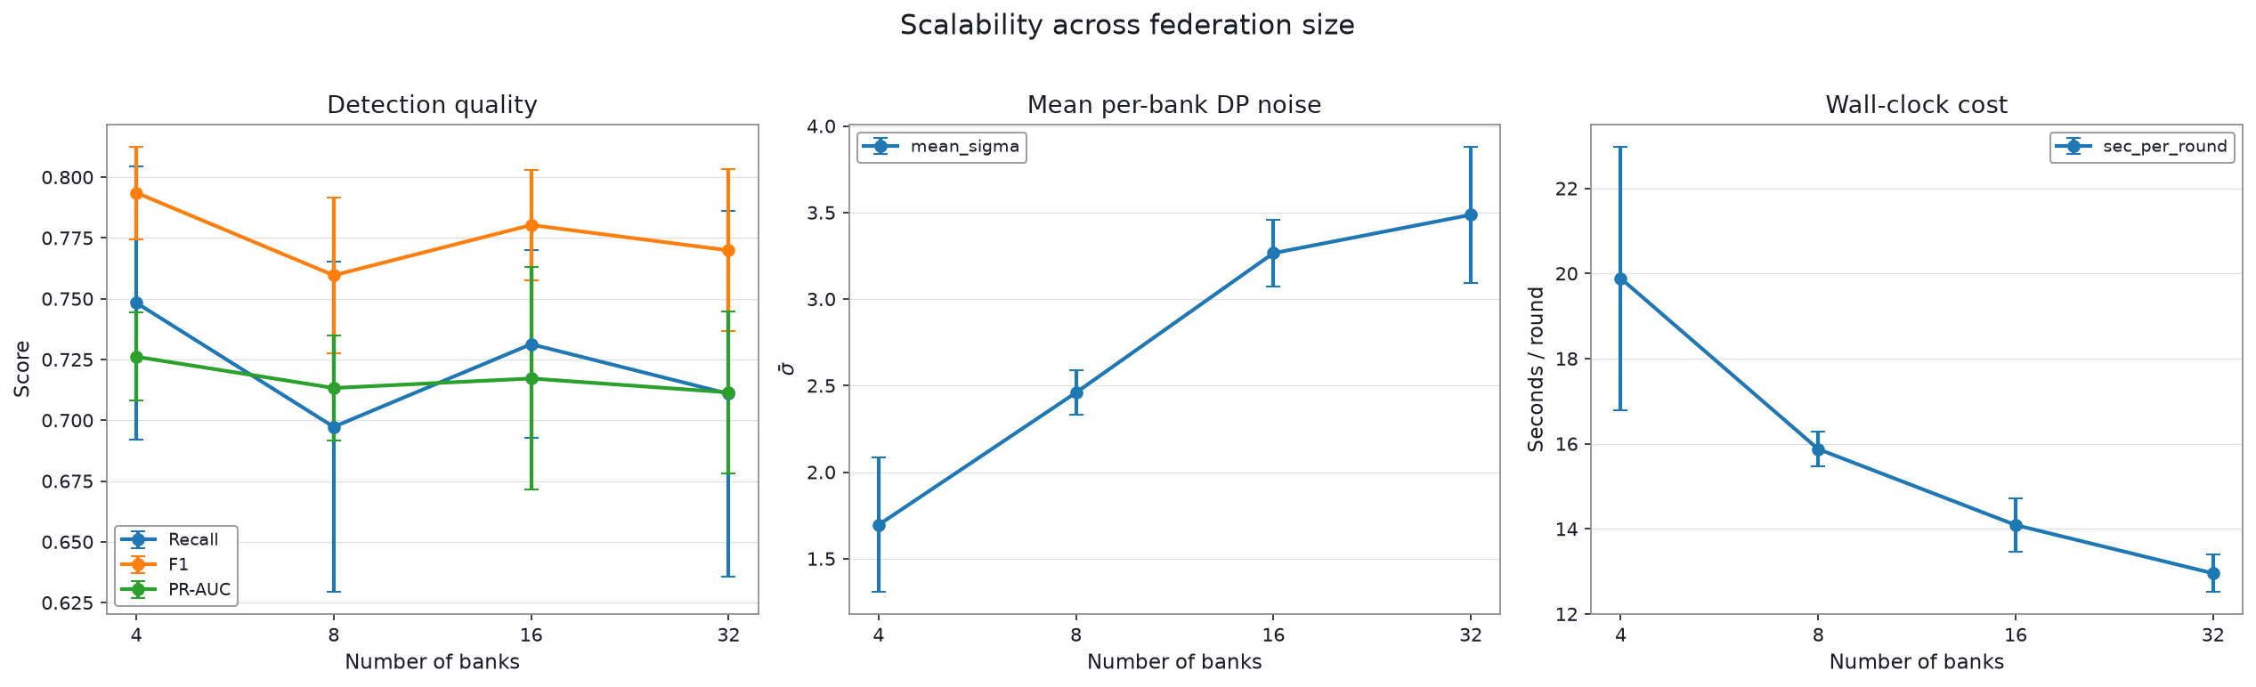
Fig. 4. Recall, F1, PR-AUC, mean DP noise, and wall-clock time per round as federation size increases (full scale, 4-32 banks).

VI. DISCUSSION AND LIMITATIONS
The most consequential findings are that the gap to centralized XGBoost is not attributable to privacy alone, that the F1 advantage over local-only training is nominal once multiple comparisons are accounted for, and that the headline results use a loss function that our own ablation found inferior.
At full scale, adaptive aggregation outperforms vanilla FedAvg under drift, but is not close to fully immune, with far more seed-to-seed variance than any stationary result. We trace this to extreme bank-size skew. A more precise estimate would need more seeds for this condition, or a partitioning scheme bounding how dominant one bank can become. With trust_min = 0.20 and the partition in Table II, a fully damped Bank 3 (218,467 × 0.20 ≈ 43,700) would still carry roughly 52% of the aggregation weight against about 39,960 for the other three banks combined, which may limit how much damage adaptive aggregation can remove; we did not test whether full exclusion would perform better.
The loss-function finding shows that the reported system is not the best-performing configuration we measured: the headline results use Focal Loss, and Tables I, IV, and V were not re-run with plain BCE. Two limitations remain: three seeds is the minimum for a non-degenerate paired test, and a wider seed count would sharpen every number here, particularly the drift result; and all results remain on one public dataset (Section IV.A), so while the systems-level findings are not dataset-specific claims, they have not been checked against a second dataset.
Further limitations are as follows. The p-values are uncorrected paired t-tests at n = 3 and do not remain significant after Holm correction. One bank holds about 84.5% of the post-balancing training data, so the federation behaves largely like that single bank. The DP guarantee excludes the SMOTE/ENN preprocessing, the un-noised loss used for drift detection, and validation-based selection, and the validation and test sets are held centrally by the server, which departs from a strictly federated setting. The drift evaluation is a label-flip stress test on one client rather than general concept drift, compares only against vanilla FedAvg, and does not include Byzantine-robust aggregators (for example Krum, trimmed mean, or median) or a full-exclusion baseline. Clients are simulated sequentially, and communication cost is not measured.
VII. CONCLUSION AND FUTURE WORK
We presented EBA-FFD, combining a right-sized MLP classifier with Focal Loss, local class balancing, RDP-accounted DP-SGD, and PH-driven adaptive aggregation that damps drifting clients without excluding them. At full scale, EBA-FFD reaches F1 = 0.7936 under DP-SGD accounting — below a non-private centralized XGBoost and above local-only training in F1 (nominal p = 0.012 and 0.034), although neither difference remains significant after multiple-comparison correction — and under an injected label-flip, adaptive aggregation partially mitigates, though does not eliminate, the damage a corrupted client causes.
Two design decisions were examined in full-scale ablations: architecture (MLP matched or exceeded CNN-only in F1, within one standard deviation) and loss function (a full-scale ablation shows plain BCE outperforming Focal Loss, which is not incorporated into the results above). Future work includes re-running all tables with plain BCE, a second independent fraud dataset, additional seeds for the high-variance drift condition, robust-aggregator baselines, less skewed partitions, and an adversarial drift-injection threat model.
Acknowledgment
The authors thank the institution's GPU computing facility for providing access to the NVIDIA H100 cluster (via Altair Access) used for the full-scale evaluation reported in this paper.
References
[1] European Parliament and Council of the European Union, “Regulation (EU) 2016/679 (General Data Protection Regulation),” Official J. Eur. Union, vol. L119, pp. 1–88, 2016.
[2] B. McMahan, E. Moore, D. Ramage, S. Hampson, and B. A. y Arcas, “Communication-efficient learning of deep networks from decentralized data,” in Proc. 20th Int. Conf. Artif. Intell. Statist. (AISTATS), PMLR, vol. 54, 2017, pp. 1273–1282.
[3] H. Zhu, J. Xu, S. Liu, and Y. Jin, “Federated learning on non-IID data: A survey,” Neurocomputing, vol. 465, pp. 371–390, 2021, doi: 10.1016/j.neucom.2021.07.098.
[4] R. Shokri, M. Stronati, C. Song, and V. Shmatikov, “Membership inference attacks against machine learning models,” in Proc. IEEE Symp. Secur. Privacy (SP), 2017, pp. 3–18, doi: 10.1109/SP.2017.41.
[5] T. Li, A. K. Sahu, M. Zaheer, M. Sanjabi, A. Talwalkar, and V. Smith, “Federated optimization in heterogeneous networks,” in Proc. Mach. Learn. Syst., vol. 2, 2020, pp. 429–450.
[6] S. Bhattacharyya, S. Jha, K. Tharakunnel, and J. C. Westland, “Data mining for credit card fraud: A comparative study,” Decis. Support Syst., vol. 50, no. 3, pp. 602–613, 2011, doi: 10.1016/j.dss.2010.08.008.
[7] W. Yang, Y. Zhang, K. Ye, L. Li, and C.-Z. Xu, “FFD: A federated learning based method for credit card fraud detection,” in Proc. IEEE Int. Congr. Big Data (BigData), 2019.
[8] S. K. Aljunaid, S. J. Almheiri, H. Dawood, and M. A. Khan, “Secure and transparent banking: Explainable AI-driven federated learning model for financial fraud detection,” J. Risk Financial Manag., vol. 18, no. 4, Art. no. 179, 2025, doi: 10.3390/jrfm18040179.
[9] M. Abadi et al., “Deep learning with differential privacy,” in Proc. ACM SIGSAC Conf. Comput. Commun. Secur. (CCS), 2016, pp. 308–318.
[10] I. Mironov, “Rényi differential privacy,” in Proc. IEEE Comput. Secur. Found. Symp. (CSF), 2017, pp. 263–275.
[11] A. Yousefpour et al., “Opacus: User-friendly differential privacy library in PyTorch,” arXiv, 2021. [Online]. Available: https://arxiv.org/abs/2109.12298
[12] H. B. McMahan, D. Ramage, K. Talwar, and L. Zhang, “Learning differentially private recurrent language models,” in Proc. Int. Conf. Learn. Represent. (ICLR), 2018.
[13] K. Bonawitz et al., “Practical secure aggregation for privacy-preserving machine learning,” in Proc. ACM SIGSAC Conf. Comput. Commun. Secur. (CCS), 2017, pp. 1175–1191.
[14] N. V. Chawla, K. W. Bowyer, L. O. Hall, and W. P. Kegelmeyer, “SMOTE: Synthetic minority over-sampling technique,” J. Artif. Intell. Res., vol. 16, no. 1, pp. 321–357, 2002, doi: 10.1613/jair.953.
[15] F. Last, G. Douzas, and F. Bacao, “Oversampling for imbalanced learning based on k-means and SMOTE,” arXiv, 2017. [Online]. Available: https://arxiv.org/abs/1711.00837
[16] D. L. Wilson, “Asymptotic properties of nearest neighbor rules using edited data,” IEEE Trans. Syst., Man, Cybern., vol. 2, no. 3, pp. 408–421, 1972, doi: 10.1109/TSMC.1972.4309137.
[17] T.-Y. Lin, P. Goyal, R. Girshick, K. He, and P. Dollár, “Focal loss for dense object detection,” in Proc. IEEE Int. Conf. Comput. Vis. (ICCV), 2017, pp. 2999–3007.
[18] J. Gama, I. Žliobaitė, A. Bifet, M. Pechenizkiy, and A. Bouchachia, “A survey on concept drift adaptation,” ACM Comput. Surv., vol. 46, no. 4, Art. no. 44, pp. 1–37, 2014, doi: 10.1145/2523813.
[19] E. S. Page, “Continuous inspection schemes,” Biometrika, vol. 41, no. 1/2, pp. 100–115, 1954, doi: 10.1093/biomet/41.1-2.100.
[20] P. Blanchard, E. M. El Mhamdi, R. Guerraoui, and J. Stainer, “Machine learning with adversaries: Byzantine tolerant gradient descent,” in Adv. Neural Inf. Process. Syst. 30 (NeurIPS), 2017, pp. 119–129.
[21] P. Kairouz, H. B. McMahan et al., “Advances and open problems in federated learning,” Found. Trends Mach. Learn., vol. 14, no. 1–2, pp. 1–210, 2021, doi: 10.1561/2200000083.
[22] IEEE Guide for Architectural Framework and Application of Federated Machine Learning, IEEE Std 3652.1-2020, IEEE Standards Association, 2020.
[23] IEEE Standard for Data Privacy Process, IEEE Std 7002-2022, IEEE Standards Association, 2022.
[24] A. Dal Pozzolo, O. Caelen, R. A. Johnson, and G. Bontempi, “Calibrating probability with undersampling for unbalanced classification,” in Proc. IEEE Symp. Comput. Intell. Data Mining (CIDM), 2015.
[25] T. Chen and C. Guestrin, “XGBoost: A scalable tree boosting system,” in Proc. 22nd ACM SIGKDD Int. Conf. Knowl. Discov. Data Mining (KDD), 2016, pp. 785–794.
[26] T. Saito and M. Rehmsmeier, “The precision-recall plot is more informative than the ROC plot when evaluating binary classifiers on imbalanced datasets,” PLOS ONE, vol. 10, no. 3, Art. no. e0118432, 2015, doi: 10.1371/journal.pone.0118432.

