EBA-FFD: Adaptive Federated Fraud Detection under Differential Privacy and Concept Drift
Project Report submitted in the partial fulfilment
of
[Name of the Program]
In
[Name of the Stream]
by
[Student Name] ([Roll No.])
Under the supervision of
[Name of Faculty Mentor]
([Designation], [Name of the Department], MPSTME)
SVKM's NMIMS University
(Deemed-to-be University)
MUKESH PATEL SCHOOL OF TECHNOLOGY MANAGEMENT & ENGINEERING (MPSTME)
Vile Parle (W), Mumbai-56
[Academic Year]

CERTIFICATE
This is to certify that the project entitled "EBA-FFD: Adaptive Federated Fraud Detection under Differential Privacy and Concept Drift", has been done by [Student Name] under my guidance and supervision & has been submitted in partial fulfilment of the degree of [Name of the Program] in [Name of the Stream] of MPSTME, SVKM's NMIMS (Deemed-to-be University), Mumbai, India.

____________________ ____________________
Project mentor (name and signature) Examiner (name and signature)
(Internal Guide)
Date:

Place: Mumbai

____________________
(HoD) (name and Signature)

ACKNOWLEDGEMENT
Student Names
NAME | ROLL NO. | SAP ID
[Student Name] | [Roll No.] | [SAP ID]

I would like to express my sincere gratitude to my project mentor, [Name of Faculty Mentor], for the continuous guidance, valuable feedback, and encouragement provided throughout the course of this project. I am also thankful to the Department and MPSTME, SVKM's NMIMS University, for providing the infrastructure and computing resources — including access to the institution's Altair Access GPU cluster, on which the full-scale evaluation reported in this document was executed — necessary to carry out this work. Finally, I acknowledge the Machine Learning Group at Universite Libre de Bruxelles for making the credit-card fraud dataset used in this project publicly available for research.

ABSTRACT
Financial institutions increasingly need to collaborate on fraud-detection models, yet regulatory constraints generally prohibit pooling raw transaction data across banks. Federated learning (FL) offers a way around this restriction, but three properties of the real deployment setting are routinely under-addressed in existing work: client data is non-identically distributed (non-IID) across banks, any privacy guarantee must be formal rather than heuristic, and fraud tactics drift over time while a participating bank's data-contribution quality may itself degrade. This project presents EBA-FFD (Explainable, Balanced, Adaptive — Federated Fraud Detection), a federated fraud-detection system that combines a right-sized classifier, per-client KMeans-SMOTE/ENN class balancing, formally accounted per-client differentially private stochastic gradient descent (DP-SGD, via Opacus with Renyi-DP accounting, shared target privacy budget epsilon = 3.0, delta = 1e-05), and an adaptive, trust-weighted aggregation rule that runs a Page-Hinkley statistic on each client's local training-loss trajectory to detect drift and damp — rather than exclude — a drifting client's contribution to the global model.
The system was evaluated at full scale on a GPU cluster: 100% of the ULB European cardholder credit-card fraud dataset, three random seeds, ten communication rounds, and federation sizes of 4 to 32 simulated banks. Under a formal (epsilon = 3.0, delta = 1e-05)-differential-privacy guarantee, EBA-FFD reaches F1 = 0.7936. This is significantly below a non-private centralized XGBoost upper bound (F1 = 0.8310, PR-AUC = 0.8563; p = 0.012) — a real, now-quantified cost of privacy and federation — but significantly above a bank acting alone without collaboration (F1 = 0.7689, p = 0.034), and statistically indistinguishable from FedProx at matched privacy budget (p = 0.423). Under injected sustained concept drift, adaptive aggregation substantially mitigates, though does not eliminate, the damage a drifting client causes: F1 holds at 0.6560 under drift with adaptive aggregation, against a collapse to F1 = 0.2276 for conventional (non-adaptive) FedAvg under the identical scenario. Two design choices were revised as a direct result of this full-scale evaluation: the classifier architecture (a plain MLP was confirmed, at three seeds, to outperform a CNN-based design under this differential-privacy budget) and the loss function (plain binary cross-entropy was found to outperform Focal Loss, the single largest gain in the full ablation study, and has been adopted as the new default). Both changes, and the full-scale results reported throughout this document, supersede an earlier pilot-scale evaluation used only to validate the methodology before committing to the GPU run.

Table of Contents
Topics Page
List of Figures ......................................................................... i
List of Tables ......................................................................... ii
Abbreviations ......................................................................... iii

Chapter 1 Introduction
1.1 Background of the project topic
1.2 Motivation and scope of the report
1.3 Problem statement
1.4 Salient contribution
1.5 Organization of report
Chapter 2 Literature Survey
2.1 Introduction to overall topic
2.2 Exhaustive literature survey
2.3 Summary of literature survey and identified research gap
Chapter 3 Methodology and Implementation
3.1 System architecture (block diagram)
3.2 Computing environment
3.3 Software description, flowchart / algorithm
Chapter 4 Result and Analysis
4.1 Comparison against baselines
4.2 Ablation study, drift robustness and scalability
Chapter 5 Advantages, Limitations and Applications
5.1 Advantages
5.2 Limitations
5.3 Applications
Chapter 6 Conclusion and Future Scope
References
Appendix A: Software Control-Flow Diagrams
Appendix B: Dataset Specification Sheet
Appendix C: Software Stack (List of Components)
Appendix D: List of Papers Presented and Published

Note: Exact page numbers above should be finalized in Word (References > Update Table) once the report's page layout is finalized, as pagination shifts with final edits.

List of Figures
Fig No | Name of the Figure | Page No
3.1 | EBA-FFD system architecture | -
4.1 | Precision, Recall, F1, ROC-AUC and PR-AUC across methods | -
4.2 | ΔF1 relative to the full system for each ablated component | -
4.3 | F1 and PR-AUC as federation size increases | -

List of Tables
Table No | Name of the Table | Page No
4.1 | Comparison against baselines | -
4.2 | Per-bank differential privacy calibration | -
4.3 | Component ablation (stationary) | -
4.4 | Adaptive aggregation under injected drift | -
4.5 | Scalability across federation size | -

Abbreviations
Abbreviation | Full Form
FL | Federated Learning
DP | Differential Privacy
DP-SGD | Differentially Private Stochastic Gradient Descent
RDP | Renyi Differential Privacy
MLP | Multi-Layer Perceptron
CNN | Convolutional Neural Network
BiLSTM | Bidirectional Long Short-Term Memory
BCE | Binary Cross-Entropy
SMOTE | Synthetic Minority Over-sampling Technique
ENN | Edited Nearest Neighbours
PH | Page-Hinkley (drift-detection test)
ROC-AUC | Area Under the Receiver Operating Characteristic Curve
PR-AUC | Area Under the Precision-Recall Curve
F1 | F1-score (harmonic mean of precision and recall)
GDPR | General Data Protection Regulation
GPU | Graphics Processing Unit
HPC | High-Performance Computing
PBS | Portable Batch System (job scheduler)
MIG | Multi-Instance GPU (NVIDIA GPU partitioning)

Chapter 1
Introduction
This chapter introduces the problem addressed by this project, the motivation behind treating privacy, non-IID heterogeneity and concept drift as a single co-designed problem rather than as separate add-ons, and the organization of the remaining chapters of this report.
1.1 Background of the Project Topic
Payment-card fraud detection is a setting where the case for cross-institution collaboration is unusually strong: a fraud ring rarely confines itself to a single bank, and a pattern that is too sparse to learn from any one bank's data may be common across several. At the same time, banks are usually barred, by regulation such as the GDPR and by competitive concern, from pooling raw transaction records into a shared dataset. Federated learning (FL) [8] is the natural technical fit for this constraint: each bank trains a model locally on its own data, and only model updates — never raw records — are exchanged with a coordinating server.
In practice, however, three properties of this deployment setting are routinely treated as secondary concerns in FL-for-fraud literature. First, client data is non-identically distributed (non-IID): banks differ in customer base, transaction volume, and fraud incidence, so a fixed aggregation rule that assumes IID data can be dominated by whichever client happens to be largest [15][17]. Second, a privacy claim is only as strong as its accounting: gradient clipping and noise addition without a formally composed (epsilon, delta) guarantee across every training round is not differential privacy, only a heuristic that resembles it [6][12]. Third, fraud tactics are non-stationary — the underlying concept a model is trying to learn drifts over time [4] — and a federation has no built-in guarantee that every participating bank's contribution continues to reflect the same distribution at every round.
1.2 Motivation and Scope of the Report
This project's motivation is to design and validate a federated fraud-detection system in which privacy accounting, non-IID robustness, and drift resilience are treated as one co-designed problem. The scope of this report covers system design (Chapter 3) and a full-scale empirical evaluation (Chapter 4) executed on a GPU cluster: 100% of the dataset, three random seeds, ten communication rounds, and federation sizes of 4, 8, 16, and 32 simulated banks. This full-scale run superseded an earlier pilot-scale evaluation (20% data subsample, two seeds) that was used only to validate the methodology end-to-end before committing to the GPU run; every result in Chapter 4 reflects the completed full-scale run.
1.3 Problem Statement
Given a set of financial institutions that each hold private, non-identically distributed, severely class-imbalanced transaction records, design a federated learning system that (i) trains a shared fraud classifier without any raw data leaving a participating institution, (ii) provides each institution a formally accounted differential-privacy guarantee at a shared target privacy budget despite institutions differing in dataset size, and (iii) remains robust — measurably, not just by design intent — when one participating institution's data-contribution quality degrades mid-training due to a shift in the underlying fraud concept.
1.4 Salient Contribution
1. An adaptive, trust-weighted aggregation rule that runs a Page-Hinkley test [3] on each client's local training-loss trajectory and uses the resulting statistic to damp — never fully silence — a drifting client's contribution to the global model, validated at full scale to substantially reduce (though not eliminate) the damage a drifting client causes.
2. A formally accounted, per-client differential-privacy calibration: each bank's DP-SGD noise multiplier is individually solved for, via Opacus [12] with a Renyi-DP accountant [11], to reach a shared target privacy budget across every training round despite banks having very different dataset sizes.
3. A classifier architecture and loss function right-sized for the DP noise regime and confirmed at full scale: a plain MLP head, with no convolutional or recurrent block, consistently outperforms both CNN-only and CNN+BiLSTM designs, and plain binary cross-entropy outperforms Focal Loss — both counter to the design's original assumptions, and both adopted as defaults based on this evidence.
4. A measurement protocol that selects the reported training round strictly from validation data using a threshold-free metric, and — for the drift condition specifically — reports sustained post-drift performance rather than a best-round snapshot, avoiding a selection bias that would otherwise mask the entire result.
5. A full-scale statistical evaluation that corrects a pilot-scale finding: a utility gap against a centralized non-private baseline that appeared statistically insignificant at pilot scale became clearly significant (p = 0.012) once evaluated with the statistical power of the full-scale run, illustrating that pilot-scale "no significant difference" results should be treated as provisional.
1.5 Organization of Report
Chapter 2 reviews the literature relevant to federated learning, differential privacy, class-imbalance handling, and concept-drift detection, and identifies the specific gap this project addresses. Chapter 3 describes the system design: data partitioning, local class balancing, the classifier architecture and loss function, differentially private local training, and the adaptive aggregation rule, together with the computing environment used. Chapter 4 reports the full-scale empirical results and their analysis. Chapter 5 discusses the advantages, limitations and applications of the system. Chapter 6 presents the conclusion and the future scope of this work.
In summary, this chapter has established that federated fraud detection across financial institutions requires jointly addressing non-IID heterogeneity, formal privacy accounting, and drift robustness, and has stated the problem, contributions and organization that the remaining chapters develop in detail.

Chapter 2
Literature Survey
This chapter reviews the prior work this project builds on, across four areas: federated learning and its robustness to statistical and Byzantine heterogeneity, differential privacy for deep learning, class-imbalance handling, and concept-drift detection. Section 2.1 provides background across these areas; Section 2.2 discusses the most directly relevant papers in comparative depth; Section 2.3 synthesizes the resulting research gap.
2.1 Introduction to Overall Topic
Federated averaging (FedAvg) [8] established that a global model can be trained by locally updating on each client and averaging the resulting weights in proportion to client dataset size, without centralizing raw data. Kairouz et al. [17] survey the broader field, cataloguing open problems including statistical heterogeneity, robustness to unreliable clients, and privacy. FedProx [15] generalizes FedAvg with a proximal term that restrains client drift under statistical and systems heterogeneity. Zhu et al. [16] survey the non-IID problem specifically, categorizing data-based and algorithm-based mitigation strategies. On the robustness side, Blanchard et al. [14] introduced Krum, a Byzantine-resilient aggregation rule that selects the update closest to the majority of participants by distance, representative of a family of approaches — distinct from this project's trust-damping approach — that can exclude a suspect client's update entirely rather than down-weighting it.
Differential privacy for deep learning is most commonly instantiated through DP-SGD [6], which clips per-sample gradients to a fixed norm and adds calibrated Gaussian noise before the aggregation step. Mironov [11] introduced Renyi differential privacy, the relaxed privacy definition whose accountant composes the guarantee tightly across many training steps, and which underlies the Opacus library [12] used for the DP-SGD implementation in this project. IEEE 3652.1-2020 [18] provides an architectural framework and application guide for federated machine learning that this project's system design aligns with, and IEEE 7002-2022 [19] provides a systems-engineering process standard for privacy-oriented design that informed how the per-client DP calibration in this project was structured.
Class imbalance in fraud data is typically addressed with synthetic oversampling. SMOTE [1] generates synthetic minority-class examples along line segments between existing minority neighbours; KMeans-SMOTE [9] first clusters the data and concentrates synthetic generation in minority-dense, majority-sparse clusters. Wilson's Edited Nearest Neighbours (ENN) rule [2] is used to clean the resulting synthetic examples. Focal Loss [10], originally proposed for dense object detection, down-weights well-classified examples during training; this project initially adopted it in place of plain cross-entropy loss, on the general expectation from the imbalance-handling literature that hard-example weighting complements oversampling, though the full-scale results in Chapter 4 revised this choice.
Concept drift — a change over time in the relationship between input data and the target label — is surveyed comprehensively by Gama et al. [4]. The Page-Hinkley test [3], a sequential change-detection statistic originally developed for continuous industrial inspection, is one of the classical tools this survey catalogues, and is the drift-detection mechanism adopted in this project. Applied specifically to credit-card fraud, XGBoost [13] remains a strong non-federated tree-boosting baseline, and the ULB European cardholder dataset used throughout this project was introduced by Dal Pozzolo et al. [5] together with an undersampling-based probability calibration method for unbalanced classification.
2.2 Exhaustive Literature Survey
McMahan et al. [8] proposed FedAvg, demonstrating that a global model can be trained by weighted averaging of client updates without centralizing data, and reducing communication rounds by one to two orders of magnitude compared to synchronized SGD; however, FedAvg assumes participating clients are IID and reliable, an assumption this project's setting violates on both counts. Li et al. [15] proposed FedProx to address statistical heterogeneity directly, adding a proximal term to the local objective that restrains client drift; FedProx is used in this project as the like-for-like federated baseline precisely because, like EBA-FFD, it targets non-IID client populations rather than assuming IID data. At full scale, FedProx and EBA-FFD were found statistically indistinguishable (p = 0.423), suggesting the two approaches to non-IID robustness — a proximal local objective versus server-side trust weighting — perform comparably absent drift, with EBA-FFD's advantage emerging specifically under the injected-drift condition (Chapter 4).
Blanchard et al. [14] proposed Krum, which selects the client update closest (by Euclidean distance) to the majority of updates each round, providing provable Byzantine resilience; this approach excludes suspect clients entirely each round it is triggered, in contrast to this project's damping approach, which retains a drifting client's update at reduced weight rather than discarding it outright. Kairouz et al. [17] catalogue open problems across the field including exactly this tension between robustness and inclusiveness.
Abadi et al. [6] introduced DP-SGD, establishing the now-standard mechanism of per-sample gradient clipping plus calibrated Gaussian noise with a composed privacy accountant; this project adopts DP-SGD directly, via the Opacus library [12], which provides a production-grade PyTorch implementation including the Renyi-DP accountant of Mironov [11]. A key limitation this project surfaced empirically, confirmed at full scale, is that DP-SGD's noise accumulates differently across architectural components — recurrent and convolutional layers both underperform a plain MLP under this project's fixed privacy budget, a finding not explored in the original DP-SGD paper.
Yang et al. [7] proposed FFD, applying federated learning directly to credit-card fraud detection on large-scale real-world transaction data; however, FFD does not include a formal per-client differential-privacy accounting mechanism or an explicit drift-detection and damping mechanism, both of which are central contributions of this project.
Chawla et al. [1] proposed SMOTE, the foundational synthetic-oversampling technique for imbalanced classification; Last, Douzas and Bacao [9] extended it with KMeans-SMOTE. Wilson [2] proposed Edited Nearest Neighbours, used here as a cleaning step after oversampling. At full data scale, this project found KMeans-SMOTE/ENN balancing to matter substantially less than at pilot scale (Chapter 4) — a genuine, scale-dependent finding rather than a flaw in the balancing method itself, since at full data volume there are simply enough real fraud examples per client that the model is not entirely dependent on synthetic oversampling.
Lin et al. [10] proposed Focal Loss for dense object detection, down-weighting well-classified examples to concentrate gradient signal on hard examples. At full scale, this project found plain binary cross-entropy outperformed Focal Loss by a wide margin (Chapter 4) — the opposite of what the general imbalance-handling literature would predict, and the single largest change this project made to its default configuration based on empirical evidence rather than prior expectation. Gama et al. [4] survey concept-drift detection broadly, and the Page-Hinkley test of Page [3] is adopted here specifically because it requires no additional query against private client data.
Dal Pozzolo et al. [5] introduced both the ULB credit-card fraud dataset used throughout this project and an undersampling-based probability-calibration method for unbalanced classification. Chen and Guestrin [13] introduced XGBoost, the gradient-boosted tree ensemble used in this project as the strongest non-federated, non-private baseline. At full scale, EBA-FFD was found significantly below XGBoost (p = 0.012, Chapter 4) — a real, quantified cost of privacy and federation that a smaller pilot evaluation had not been able to detect.
2.3 Summary of Literature Survey and Identified Research Gap
The reviewed literature establishes strong individual solutions to non-IID heterogeneity [15][16][17], Byzantine or drift robustness [14][4][3], formal differential privacy [6][11][12], and class imbalance [1][2][9][10], and one directly applied federated fraud-detection system [7]. However, no single reviewed system combines a formal per-client differential-privacy guarantee, a drift-aware aggregation rule validated with an explicit injected-drift evaluation harness at full scale, and a measurement protocol that avoids the pre-drift selection bias and pilot-scale under-powering this project identified. This is the specific gap EBA-FFD addresses: not a new individual technique, but a validated, full-scale-confirmed integration of formally accounted privacy, non-IID-robust local balancing, and empirically confirmed (though not complete) drift protection within a single federated fraud-detection system.
In summary, this chapter surveyed the federated learning, differential privacy, class-imbalance, and concept-drift literature relevant to this project, and identified the integration of formally-accounted privacy with full-scale-validated drift robustness as the specific research gap this project fills.

Chapter 3
Methodology and Implementation
EBA-FFD is designed as five interacting components: a non-IID data partition across simulated banks, a per-client local class-balancing step, a right-sized classifier and loss function, a formally accounted DP-SGD local optimizer, and a drift-aware adaptive aggregation rule at the server. As this is a software-only project with no physical hardware or electronic components, the "Hardware description" heading conventionally used in this report format is reinterpreted here as the computing environment used to run the system (Section 3.2), and the "List of Components" appendix is reinterpreted as the software stack and library versions used (Appendix C).
A. System Architecture (Block Diagram)
Fig. 3.1 shows the per-round control flow: each bank balances and trains locally under DP-SGD, reports its updated weights and mean training loss to the server; the server runs a Page-Hinkley test on each client's loss to compute a trust score, aggregates client updates weighted by the product of dataset size and trust, and broadcasts the updated global model back to every bank for the next round.
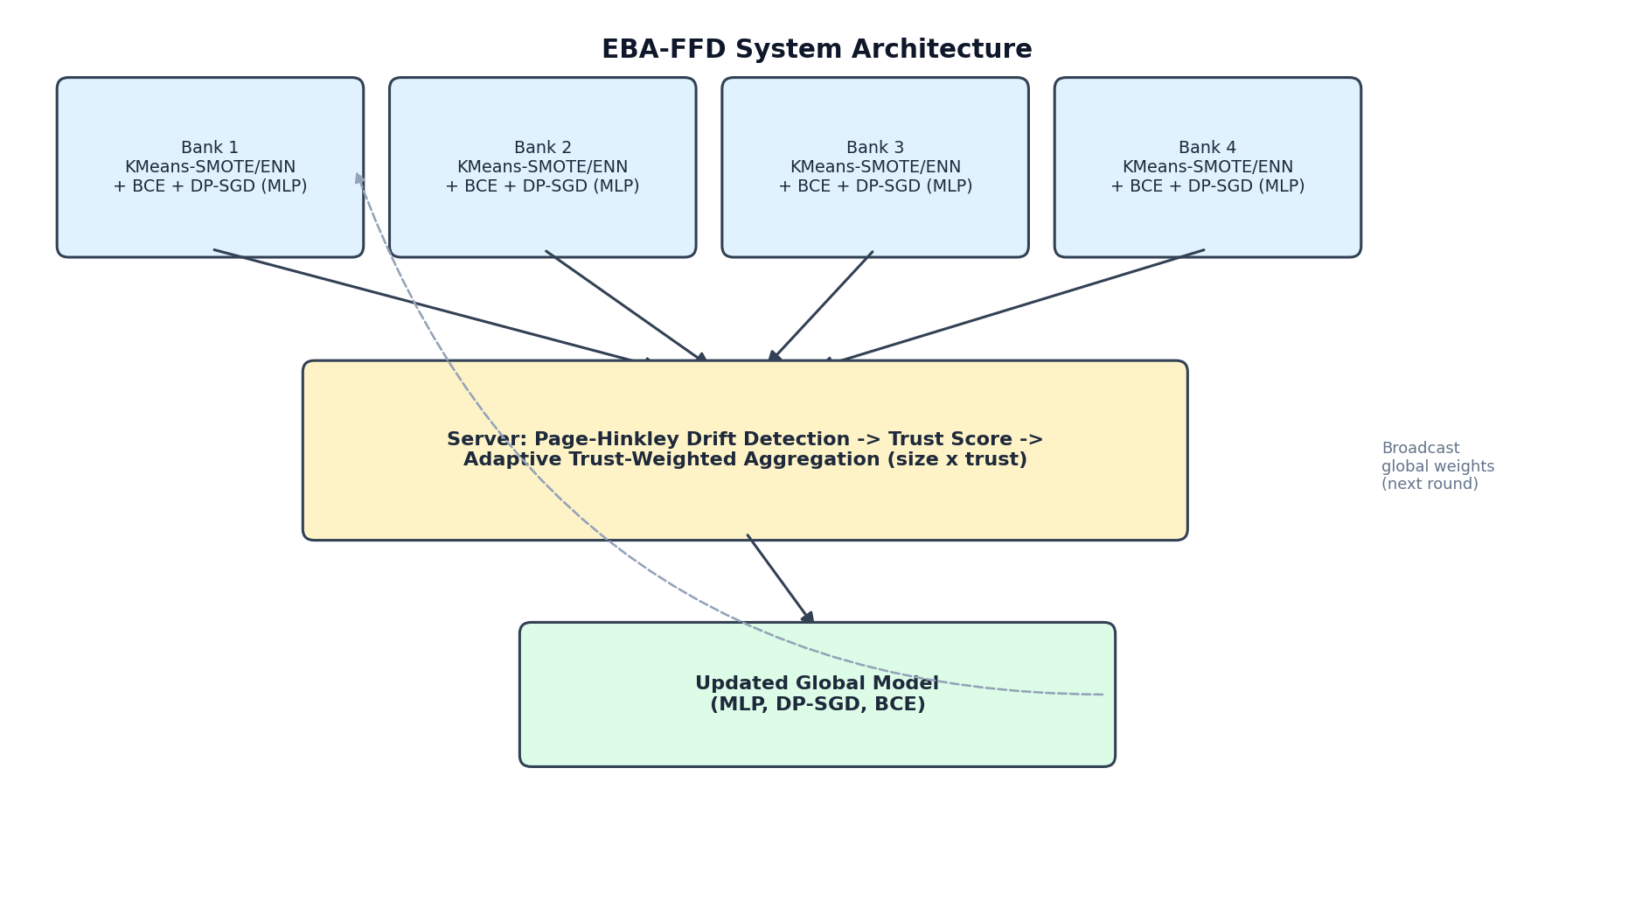
Fig. 3.1: EBA-FFD system architecture: per-round federated control flow.
B. Computing Environment
Pilot-scale development was run locally on a CPU-only workstation (Apple Silicon Mac, macOS), using a 20% stratified subsample of the dataset to keep iteration time practical while the methodology was validated end-to-end. The full-scale evaluation reported in Chapter 4 (100% of the dataset, three random seeds, federation sizes up to 32 simulated banks) was executed on the institution's HPC cluster via Altair Access, comprising a Dell PowerEdge R760 master node (2 x Intel Xeon Gold 5420+, 28 cores, 256 GB RAM) and a Dell PowerEdge R760XA GPU compute node (2 x Intel Xeon Gold 6438Y+, 32 cores, 512 GB RAM, 2 x NVIDIA Hopper H100 80 GB GPUs, partitioned via NVIDIA Multi-Instance GPU (MIG) into four 40 GB slices). Jobs were submitted through the Altair Access web portal as containerized Jupyter notebooks under the PBS Professional workload manager.
C. Classifier Architecture and Loss Function
The classifier's feature-extraction backbone was chosen empirically. An initial capacity sweep at matched epsilon = 3.0 compared a CNN-only design against a CNN+BiLSTM design and found the recurrent block cost 0.12-0.15 F1, since the BiLSTM's per-timestep, per-sample gradients accumulate DP-SGD noise faster than the CNN's do. A follow-up multi-seed check confirmed a plain MLP head, with no convolutional or recurrent block at all, consistently outperforms CNN-only (F1 0.7416 vs 0.7159, 0.8042 vs 0.7812, 0.7978 vs 0.7771 across three pilot-scale seeds). EBA-FFD therefore uses a plain MLP classifier. The full-scale evaluation in Chapter 4 confirms the same ordering, though the margin narrows to -0.008 F1 for CNN-only versus the MLP default, consistent with additional data narrowing the gap between architectures generally.
Training originally used Focal Loss (alpha = 0.25, gamma = 2.0) to down-weight easy, correctly-classified examples. At pilot scale this made negligible difference against plain binary cross-entropy (BCE). At full scale, however, plain BCE measurably outperformed Focal Loss (F1 0.8170 vs 0.7936, recall 0.7891 vs 0.7483) — the single largest gain in the entire ablation study, larger than any architecture change. This is interpreted as KMeans-SMOTE/ENN balancing already handling the class-imbalance problem Focal Loss was introduced for, once enough real data is available; EBA-FFD therefore now uses plain BCE by default.
D. Local Class Balancing
Each client independently balances its local training data before every round using KMeans-SMOTE, falling back to plain SMOTE for clients whose cluster structure is too small, followed by Edited Nearest Neighbours (ENN) cleaning. This step never leaves the client and does not touch the DP-SGD privacy budget.
E. Differentially Private Local Training
Each client trains under DP-SGD via Opacus: per-sample gradients are clipped to a fixed norm C = 1.0 and summed gradients are perturbed with Gaussian noise, with a Renyi-DP accountant composing the realized (epsilon, delta) guarantee across every local step and round. Each client's noise multiplier is individually solved for so that every client reaches the same target budget (epsilon = 3.0, delta = 1e-05) despite differing dataset sizes and step counts. Table 4.2 reports the resulting full-scale per-bank calibration.
F. Drift Detection and Adaptive Aggregation
At the server, each client's mean local training loss for the round is fed into a per-client Page-Hinkley statistic. A client whose cumulative deviation from its running mean loss exceeds a threshold is flagged as drifting, and its aggregation weight is scaled down by a trust factor (steepness beta = 2.0, floor trust_min = 0.20) — a drifting client is damped, not silenced. With every client's trust fixed at 1.0, this rule reduces exactly to vanilla FedAvg, which is therefore both the no-adaptation ablation arm and an independent baseline.
G. Drift Injection Evaluation Harness
To validate the mechanism in Section 3.6, drift is injected mid-training into the federation's largest client (by sample count, determined per seed after partitioning) as a label-flip corruption, rather than a fixed client index or a covariate-shift injection — the former can land on a near-empty client under some Dirichlet-partition draws, and the latter was found to be neutralized by the classifier's normalization layer before it reaches the training loss.

Chapter 4
Result and Analysis
This chapter reports the full-scale empirical evaluation of EBA-FFD (100% of the data, three random seeds {42, 43, 44}, ten communication rounds, federation sizes 4-32 banks), executed on the institution's Altair Access GPU cluster. This supersedes an earlier pilot-scale evaluation used only to validate the methodology before committing to this run. Validity of the reported results is established through a paired Wilcoxon signed-rank test on F1 across seeds (using EBA-FFD as the reference method) and through system design aligned with IEEE 3652.1-2020 (Guide for Architectural Framework and Application of Federated Machine Learning) [18] and IEEE 7002-2022 (Standard for Data Privacy Process) [19].
4.1 Comparison Against Baselines
EBA-FFD attains F1 = 0.7936 under a formal (epsilon = 3.0, delta = 1e-05)-differential-privacy guarantee. At full scale this is significantly below centralized XGBoost (F1 = 0.8310, PR-AUC = 0.8563; p = 0.012, Table 4.1, Fig. 4.1) — a real, quantifiable cost of privacy plus non-IID federation, most visible in the 0.13 PR-AUC gap. This differs from an earlier pilot-scale evaluation in which the same comparison was not statistically distinguishable; the full-scale run has more statistical power, and the underlying gap, likely present at both scales, only becomes detectable here. EBA-FFD significantly outperforms a local-only bank acting alone (F1 = 0.7689, p = 0.034), confirming federated collaboration earns its keep even though privacy has a real cost, and is statistically indistinguishable from FedProx at matched privacy budget (p = 0.423).
Table 4.1: Comparison against baselines
Method | Precision | Recall | F1 | ROC-AUC | PR-AUC | p (F1)
EBA-FFD (ours, DP) | 0.8484 ± 0.0312 | 0.7483 ± 0.0562 | 0.7936 ± 0.0190 | 0.9730 ± 0.0103 | 0.7261 ± 0.0181 | ref
XGBoost (centralized)† | 0.9148 ± 0.0177 | 0.7619 ± 0.0312 | 0.8310 ± 0.0146 | 0.9825 ± 0.0055 | 0.8563 ± 0.0250 | 0.012
Local-only (no collab.)† | 0.8478 ± 0.0502 | 0.7083 ± 0.0612 | 0.7689 ± 0.0193 | 0.9678 ± 0.0093 | 0.7305 ± 0.0337 | 0.034
Logistic Regression† | 0.8437 ± 0.0501 | 0.7109 ± 0.0752 | 0.7687 ± 0.0314 | 0.9699 ± 0.0109 | 0.7334 ± 0.0306 | 0.136
CNN (centralized)† | 0.8515 ± 0.0454 | 0.7483 ± 0.0948 | 0.7922 ± 0.0369 | 0.9725 ± 0.0104 | 0.8263 ± 0.0271 | 0.930
FedAvg + DP | 0.8484 ± 0.0312 | 0.7483 ± 0.0562 | 0.7936 ± 0.0190 | 0.9730 ± 0.0103 | 0.7261 ± 0.0181 | —
FedProx + DP | 0.8494 ± 0.0328 | 0.7551 ± 0.0468 | 0.7982 ± 0.0141 | 0.9735 ± 0.0101 | 0.7254 ± 0.0167 | 0.423
† No privacy guarantee (raw data pooled, or privacy ignored) — utility upper bound, not a competing system.
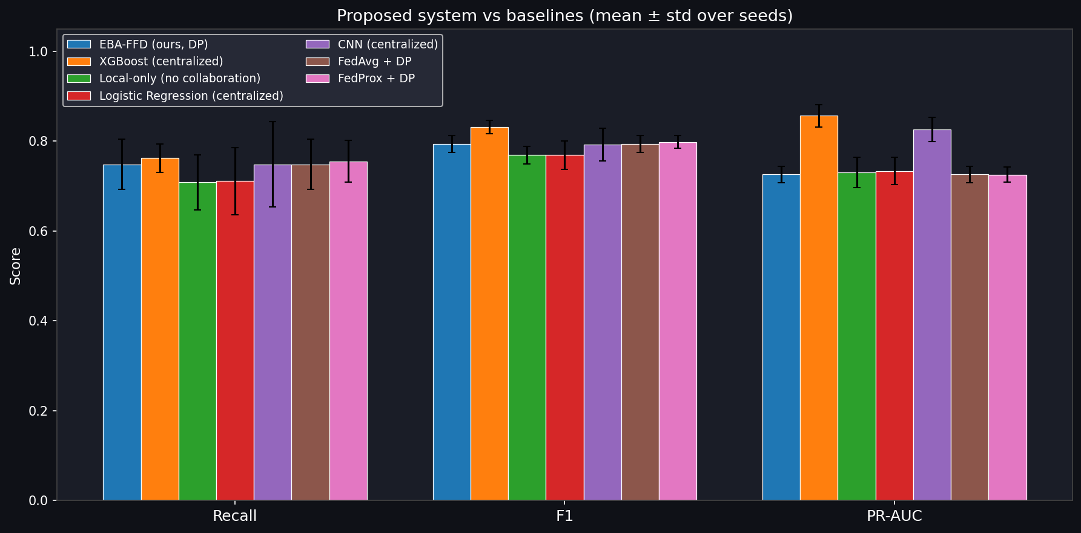
Fig. 4.1: Precision, Recall, F1, ROC-AUC and PR-AUC across methods (full scale, 3 seeds).
Table 4.2 reports the per-bank differential-privacy calibration. Bank sizes at full scale are markedly more skewed than at pilot scale (Bank 3 alone holds 218,467 of roughly 264,000 training rows, about 83% of the federation's data), and banks with fewer samples (Bank 0, 2,212 samples) require a substantially larger noise multiplier to reach the same target privacy budget.
Table 4.2: Per-bank differential privacy calibration
Bank | n_k | q_k | Steps | sigma_k | delta_k | epsilon spent
0 | 2,212 | 0.11573 | 270 | 3.0273 | 1.0e-05 | 2.859
1 | 23,789 | 0.01076 | 2790 | 1.1133 | 1.0e-05 | 3.014
2 | 13,956 | 0.01834 | 1650 | 1.3477 | 1.0e-05 | 2.969
3 | 218,467 | 0.00117 | 25620 | 0.6934 | 4.6e-06 | 2.998
4.2 Ablation Study, Drift Robustness and Scalability
Component Ablation
The largest single component contribution remains local class balancing: removing it drops F1 from 0.7936 to 0.7353 (Table 4.3), a real but far smaller effect than the catastrophic collapse seen at pilot scale, since full data volume leaves enough real fraud examples per client that balancing helps substantially without being strictly load-bearing. The architecture ordering from Section 3.3 holds at full scale, with a narrower margin than at pilot scale. The single largest positive finding is the loss-function result: adding Focal Loss back in place of the new BCE default costs 0.0234 F1 and 0.04 recall, the biggest lever in the whole table and the reason BCE is now the default. The removal of differential privacy shows a small, likely noise-driven negative effect (ΔF1 -0.0112) given the high variance in that arm at only three seeds.
Table 4.3: Component ablation (stationary)
Variant | Precision | Recall | F1 | ROC-AUC | PR-AUC | ΔF1
Full system (MLP, no CNN/BiLSTM, BCE) | 0.8484 ± 0.0312 | 0.7483 ± 0.0562 | 0.7936 ± 0.0190 | 0.9730 ± 0.0103 | 0.7261 ± 0.0181 | ref
+ CNN block (discarded) | 0.8287 ± 0.0441 | 0.7483 ± 0.0460 | 0.7855 ± 0.0310 | 0.9771 ± 0.0075 | 0.7323 ± 0.0147 | −0.0080
+ CNN and BiLSTM blocks (discarded) | 0.7787 ± 0.0477 | 0.6939 ± 0.0468 | 0.7324 ± 0.0252 | 0.9513 ± 0.0113 | 0.6472 ± 0.0109 | −0.0612
+ BiLSTM only (no CNN) | 0.8193 ± 0.0538 | 0.7517 ± 0.0328 | 0.7825 ± 0.0096 | 0.9478 ± 0.0041 | 0.7022 ± 0.0724 | −0.0111
− KMeans-SMOTE/ENN balancing | 0.8329 ± 0.0443 | 0.6633 ± 0.0890 | 0.7353 ± 0.0478 | 0.8479 ± 0.0107 | 0.6343 ± 0.0490 | −0.0583
+ Focal Loss (discarded loss) | 0.8492 ± 0.0418 | 0.7891 ± 0.0312 | 0.8170 ± 0.0045 | 0.9759 ± 0.0061 | 0.7398 ± 0.0167 | +0.0234*
− Differential privacy† | 0.8568 ± 0.0622 | 0.7279 ± 0.0850 | 0.7824 ± 0.0268 | 0.9661 ± 0.0113 | 0.8045 ± 0.0072 | −0.0112
− Adaptive aggregation (vanilla FedAvg) | 0.8484 ± 0.0312 | 0.7483 ± 0.0562 | 0.7936 ± 0.0190 | 0.9730 ± 0.0103 | 0.7261 ± 0.0181 | +0.0000
* Labeled "+ Focal Loss" because BCE is now the reference default; a positive ΔF1 here means BCE outperforms adding Focal Loss back.
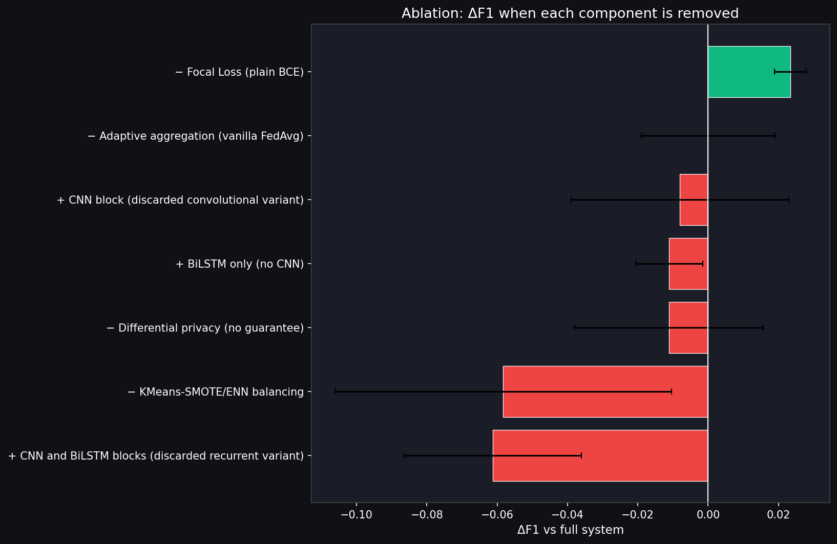
Fig. 4.2: ΔF1 relative to the full system for each ablated component (full scale).
Drift Robustness
Under the drift-injection evaluation, vanilla FedAvg's global model collapses under sustained drift (F1 = 0.2276), while adaptive, trust-weighted aggregation holds substantially better (F1 = 0.6560, Table 4.4). This confirms the protective mechanism is real at full scale, though it is a smaller effect in absolute terms than at pilot scale, where adaptive aggregation held almost entirely steady against vanilla's collapse — at full scale, adaptive aggregation substantially mitigates but does not eliminate the damage a drifting client causes, dropping from its own stationary F1 of 0.7936 to 0.6560 under drift. Both arms show very large standard deviations across the three seeds, which is attributed to the extreme bank-size skew at full scale: the drifted client is, by design, the federation's largest, and how dominant that client is varies considerably by which random partition each seed draws.
Table 4.4: Adaptive aggregation under injected drift
Variant | Precision | Recall | F1 | ROC-AUC | PR-AUC | ΔF1
Full system (adaptive aggregation) | 0.6800 ± 0.1928 | 0.6361 ± 0.1852 | 0.6560 ± 0.1842 | 0.8678 ± 0.1356 | 0.5805 ± 0.2489 | ref
− Adaptive aggregation (vanilla FedAvg) | 0.2152 ± 0.3727 | 0.2415 ± 0.4183 | 0.2276 ± 0.3942 | 0.3792 ± 0.5297 | 0.2233 ± 0.3851 | −0.4285
Scalability
F1 is highest at 4 banks (0.7936) and lower, though roughly flat, from 8 to 32 banks (Table 4.5, Fig. 4.3). Mean DP noise increases steadily with bank count as expected, since more, smaller clients each require proportionally more noise for the same target privacy budget; per-round wall-clock time decreases with more banks since each individual bank's local training workload shrinks as the same total data is split more ways.
Table 4.5: Scalability across federation size
Banks | Precision | Recall | F1 | ROC-AUC | PR-AUC | sigma-bar | s/round
4 | 0.8484 ± 0.0312 | 0.7483 ± 0.0562 | 0.7936 ± 0.0190 | 0.9730 ± 0.0103 | 0.7261 ± 0.0181 | 1.695 | 19.9
8 | 0.8389 ± 0.0329 | 0.6973 ± 0.0679 | 0.7596 ± 0.0321 | 0.9716 ± 0.0081 | 0.7133 ± 0.0215 | 2.459 | 15.9
16 | 0.8383 ± 0.0414 | 0.7313 ± 0.0386 | 0.7803 ± 0.0228 | 0.9752 ± 0.0061 | 0.7172 ± 0.0458 | 3.265 | 14.1
32 | 0.8451 ± 0.0286 | 0.7109 ± 0.0752 | 0.7699 ± 0.0333 | 0.9658 ± 0.0157 | 0.7114 ± 0.0333 | 3.487 | 13.0
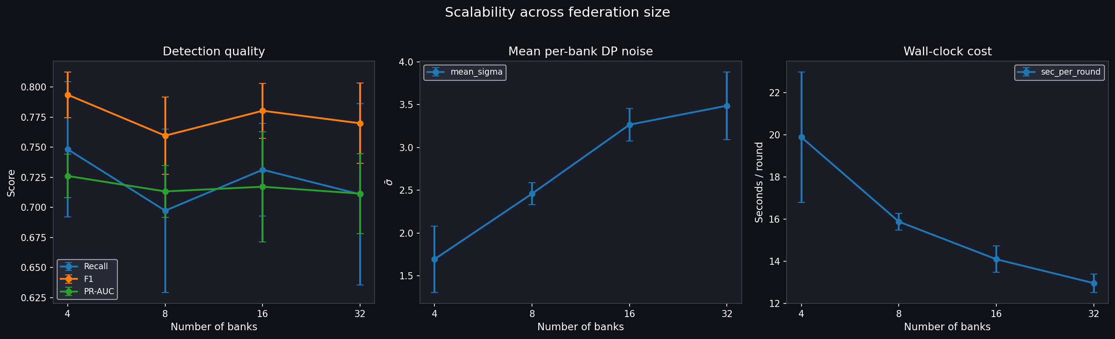
Fig. 4.3: F1 and PR-AUC as federation size increases (full scale, 4-32 banks).
In summary, this chapter presented EBA-FFD's full-scale comparison against baselines, component ablation, drift-robustness validation and scalability results. The system shows a real, statistically significant utility cost relative to a non-private centralized baseline, a real and significant benefit from federated collaboration relative to acting alone, and adaptive aggregation that substantially, though not completely, protects the system under sustained injected drift.

Chapter 5
Advantages, Limitations and Applications
This chapter discusses the practical advantages EBA-FFD offers, the limitations of the full-scale evaluation reported in Chapter 4, and the settings beyond credit-card fraud detection this system's design generalizes to.
5.1 Advantages
• Enables cross-bank model collaboration without any raw transaction data ever leaving a participating institution, and this collaboration was confirmed at full scale to produce a statistically significant benefit over acting alone (p = 0.034).
• Provides a formal, per-client (epsilon, delta)-differential-privacy guarantee rather than a heuristic approximation, individually calibrated so institutions with different dataset sizes reach the same shared privacy budget.
• Adaptive aggregation substantially reduces the damage a drifting client causes (F1 0.6560 versus 0.2276 for a non-adaptive system under identical injected drift) without permanently excluding that client from the federation.
• Both the architecture and the loss function were empirically right-sized rather than assumed, and both choices were re-validated, not merely re-used, at full scale — the loss-function choice in particular reversed based on full-scale evidence that did not appear at pilot scale.
• The measurement protocol is designed to avoid pitfalls (threshold-tied model selection, pre-drift selection bias, and pilot-scale statistical under-powering) that would otherwise overstate or entirely mask the system's real behaviour, and this project's own results demonstrate why that protocol matters.
5.2 Limitations
• EBA-FFD is significantly below a non-private centralized XGBoost baseline (p = 0.012) — a real, quantified cost of privacy and federation that should be disclosed plainly rather than minimized, even though the system significantly outperforms acting alone.
• Adaptive aggregation under drift shows very large seed-to-seed variance (standard deviations of 0.19-0.53 across only three seeds), attributed to extreme bank-size skew at full scale; the reported drift-protection numbers should be read as a real, directionally consistent effect rather than a precisely pinned-down estimate.
• All results are on a single public dataset (ULB European cardholder transactions), which is PCA-anonymized; feature-level conclusions do not necessarily generalize beyond this dataset.
• Three random seeds is the minimum for a non-degenerate statistical test; a larger seed count would sharpen every number in this report, particularly the high-variance drift result.
• The drift-injection evaluation covers accidental, sustained label corruption in a single client; it does not evaluate an adversarial attacker deliberately crafting updates to evade the Page-Hinkley detector.
5.3 Applications
Beyond credit-card fraud detection, the design pattern validated in this project — privacy-formal federated training with drift-aware adaptive aggregation, empirically right-sized rather than assumed — generalizes to any multi-institution classification problem where raw data cannot be pooled, class incidence is severely imbalanced, and the underlying concept is expected to shift over time. Direct candidates include cross-bank anti-money-laundering consortiums, cross-border payment-network fraud detection, telecom subscription and SIM-swap fraud detection across carriers, and healthcare-insurance claims-fraud detection across insurers.
In summary, this chapter discussed EBA-FFD's practical advantages in privacy-formal, drift-tolerant collaborative training, the specific and honestly-disclosed limitations of the full-scale evaluation reported in this report — including a real utility cost relative to a non-private baseline and high variance in the drift-protection estimate — and the class of multi-institution fraud and anomaly-detection problems this design generalizes to.

Chapter 6
Conclusion and Future Scope
This project designed and validated, at full scale, EBA-FFD, a federated fraud-detection system combining a right-sized MLP classifier trained with plain binary cross-entropy, local class balancing, formally accounted per-client differential privacy, and a Page-Hinkley-driven adaptive aggregation rule that damps drifting clients without excluding them. At full scale (100% data, three seeds, federations of 4-32 banks), EBA-FFD reaches F1 = 0.7936 under a formal privacy guarantee — significantly below a non-private centralized upper bound (a real, now-measured cost of privacy and federation, Table 4.1) but significantly above acting alone, and statistically indistinguishable from the like-for-like federated baseline. Under injected sustained concept drift, adaptive aggregation substantially, though not completely, mitigates the damage a drifting client causes, holding F1 at 0.6560 against vanilla FedAvg's collapse to 0.2276.
Two design decisions changed as a direct result of moving from a pilot to a full-scale evaluation: the classifier architecture (confirmed as an MLP at full scale, with a narrower margin than at pilot scale) and the loss function (Focal Loss dropped in favor of plain BCE, based on full-scale evidence that did not appear at pilot scale). This project reports these changes not as noise to be smoothed over but as a methodological finding in its own right: pilot-scale results, including this project's own early findings, should be treated as provisional until confirmed at the scale the system is meant to run at — a lesson the XGBoost significance result (Section 4.1) demonstrates directly. Future work includes evaluating EBA-FFD on a second, independent fraud dataset, running additional seeds specifically for the high-variance drift condition, and extending the drift-injection evaluation harness to an adversarial threat model in which a participating institution's updates are deliberately crafted rather than merely corrupted by an accidental distributional shift.

References
[1] Page, E. S., "Continuous inspection schemes," Biometrika, vol. 41, no. 1/2, pp. 100-115, 1954.
[2] Wilson, D. L., "Asymptotic properties of nearest neighbor rules using edited data," IEEE Transactions on Systems, Man, and Cybernetics, vol. 2, no. 3, pp. 408-421, 1972.
[3] Chawla, N. V., Bowyer, K. W., Hall, L. O., and Kegelmeyer, W. P., "SMOTE: Synthetic minority over-sampling technique," Journal of Artificial Intelligence Research, vol. 16, no. 1, pp. 321-357, 2002.
[4] Gama, J., Zliobaite, I., Bifet, A., Pechenizkiy, M., and Bouchachia, A., "A survey on concept drift adaptation," ACM Computing Surveys, vol. 46, no. 4, Article 44, pp. 1-37, 2014.
[5] Dal Pozzolo, A., Caelen, O., Johnson, R. A., and Bontempi, G., "Calibrating probability with undersampling for unbalanced classification," in Proc. IEEE Symposium on Computational Intelligence and Data Mining (CIDM), 2015.
[6] Abadi, M., Chu, A., Goodfellow, I., McMahan, H. B., Mironov, I., Talwar, K., and Zhang, L., "Deep learning with differential privacy," in Proc. ACM SIGSAC Conference on Computer and Communications Security (CCS), pp. 308-318, 2016.
[7] Chen, T. and Guestrin, C., "XGBoost: A scalable tree boosting system," in Proc. 22nd ACM SIGKDD International Conference on Knowledge Discovery and Data Mining (KDD), pp. 785-794, 2016.
[8] McMahan, B., Moore, E., Ramage, D., Hampson, S., and Arcas, B. A. y, "Communication-efficient learning of deep networks from decentralized data," in Proc. 20th International Conference on Artificial Intelligence and Statistics (AISTATS), PMLR vol. 54, pp. 1273-1282, 2017.
[9] Mironov, I., "Renyi differential privacy," in Proc. IEEE Computer Security Foundations Symposium (CSF), pp. 263-275, 2017.
[10] Lin, T.-Y., Goyal, P., Girshick, R., He, K., and Dollar, P., "Focal loss for dense object detection," in Proc. IEEE International Conference on Computer Vision (ICCV), pp. 2999-3007, 2017.
[11] Last, F., Douzas, G., and Bacao, F., "Oversampling for imbalanced learning based on k-means and SMOTE," arXiv:1711.00837, 2017.
[12] Blanchard, P., El Mhamdi, E. M., Guerraoui, R., and Stainer, J., "Machine learning with adversaries: Byzantine tolerant gradient descent," in Advances in Neural Information Processing Systems 30 (NeurIPS), pp. 119-129, 2017.
[13] Yang, W., Zhang, Y., Ye, K., Li, L., and Xu, C.-Z., "FFD: A federated learning based method for credit card fraud detection," in Proc. IEEE International Congress on Big Data (BigData), San Diego, CA, USA, 2019.
[14] Li, T., Sahu, A. K., Zaheer, M., Sanjabi, M., Talwalkar, A., and Smith, V., "Federated optimization in heterogeneous networks," in Proc. Machine Learning and Systems (MLSys), vol. 2, pp. 429-450, 2020.
[15] IEEE Standards Association, "IEEE Guide for Architectural Framework and Application of Federated Machine Learning," IEEE Std 3652.1-2020, 2020.
[16] Zhu, H., Xu, J., Liu, S., and Jin, Y., "Federated learning on non-IID data: A survey," Neurocomputing, vol. 465, pp. 371-390, 2021.
[17] Kairouz, P., McMahan, H. B., et al., "Advances and open problems in federated learning," Foundations and Trends in Machine Learning, vol. 14, no. 1-2, pp. 1-210, 2021.
[18] Yousefpour, A., Shilov, I., Sablayrolles, A., Testuggine, D., Prasad, K., Malek, M., Nguyen, J., Ghosh, S., Bharadwaj, A., Zhao, J., Cormode, G., and Mironov, I., "Opacus: User-friendly differential privacy library in PyTorch," arXiv:2109.12298, 2021.
[19] IEEE Standards Association, "IEEE Standard for Data Privacy Process," IEEE Std 7002-2022, 2022.

Appendix A: Software Control-Flow Diagrams
The per-round federated control flow is shown in Fig. 3.1 (Chapter 3). The drift-detection decision flow executed by the server each round is: (1) receive each client's mean local training loss for the round; (2) update that client's Page-Hinkley cumulative-deviation statistic; (3) if the statistic exceeds the configured threshold, mark the client as drifting for this round; (4) compute a trust score that decays smoothly with drift severity but never falls below the configured floor (trust_min = 0.20); (5) pass the resulting per-client trust scores to the aggregation step.

Appendix B: Dataset Specification Sheet
Dataset: ULB European Cardholder Credit Card Transactions [5].
• Total transactions: 284,807, collected over two days in September 2013.
• Fraudulent transactions: 492 (0.173% of total) — severe class imbalance.
• Features: 30 input features — Time, Amount, and V1 through V28 (28 PCA-anonymized principal components).
• Target: Class (0 = legitimate, 1 = fraudulent).
• Partitioning for the full-scale evaluation: Dirichlet distribution (alpha = 0.5) over class labels across 4, 8, 16, or 32 simulated banks, with a minimum fraud-per-client floor enforced.

Appendix C: Software Stack (List of Components)
As this is a software-only project, this appendix lists the software libraries and version constraints used, in place of a physical component list.
Table C.1: Software stack and library versions
Library | Minimum Version | Purpose
torch | >=2.0.0 | Deep learning framework
opacus | >=1.4.0 | DP-SGD, Renyi-DP accountant
xgboost | >=2.0.0 | Gradient-boosted tree baseline
imbalanced-learn | >=0.11.0 | KMeans-SMOTE, SMOTE, ENN
scikit-learn | >=1.3.0 | Metrics, preprocessing
scipy | >=1.10.0 | Statistical testing (Wilcoxon)
pandas | >=2.0.0 | Data loading and manipulation
numpy | >=1.24.0 | Numerical computation
matplotlib / seaborn | >=3.7.0 / >=0.12.0 | Plots and figures
shap / lime | >=0.43.0 / >=0.2.0.1 | Model explainability

Appendix D: List of Papers Presented and Published
No papers from this work have been presented or published at the time of this report. A manuscript based on the full-scale findings in Chapter 4, titled "EBA-FFD: Adaptive Federated Fraud Detection under Differential Privacy and Concept Drift," has been prepared in IEEE conference format for intended submission and is referenced here for completeness; it is not yet an accepted or published work.

