**<lecture6. user interfaces>**

**Single Page Applications**

Previously, if we wanted a website with multiple pages, we would accomplish that using different routes in our Django application. Now, we have the ability to load just a single page and then use JavaScript to manipulate the DOM. One major advantage of doing this is that we only need to modify the part of the page that is actually changing. For example, if we have a Nav Bar that doesn’t change based on your current page, we wouldn’t want to have to re-render that Nav Bar every time we switch to a new part of the page.

Let’s look at an example of how we could simulate page switching in JavaScript:

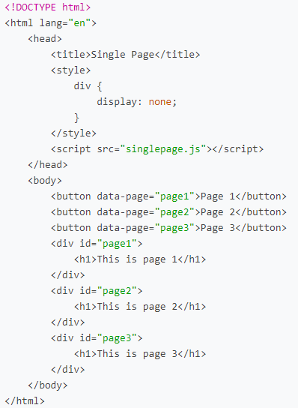

Notice in the HTML above that we have three buttons and three divs. At the moment, the divs contain only a small bit of text, but we could imagine each div containing the contents of one page on our site. Now, we’ll add some JavaScript that allows us to use the buttons to toggle between pages.

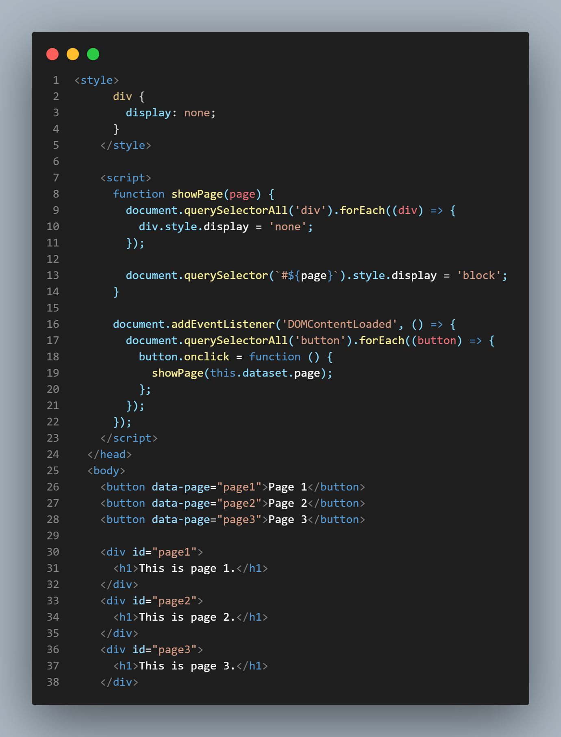

line9: forEach 돌면서 모든 div 태그 style을 display = 'none'으로 설정

line13: showPage의 parameter 'page'를 받아서 style을 display = 'block'으로 변경.

line17: querySelectorAll과 forEach로 모든 button 태그 선택하고 button.onclick 하면 showPage의 parameter로 dataset의 page를 불러옴.

결과적으로 각 button을 클릭하면 showPage(page1), showPage(page2), showPage(page3)가 실행되어 id = page{$}가 매겨진 div 내의 내용들이 보이게 됨.

**Single Page Applications in Django**

**# singlepage/urls.py**

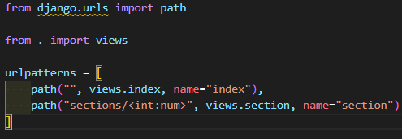

**# singlepage/views.py**

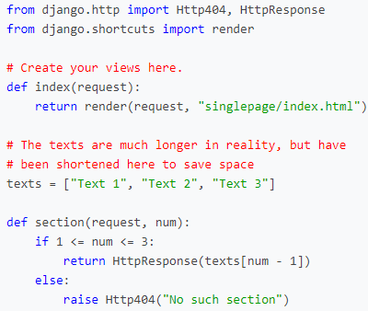

And two corresponding routes in views.py. Notice that the section route takes in an integer, and then returns a string of text based on that integer as an HTTP Response.

index.html 파일의 button 클릭을 통해 입력 받은 num값에 해당하는 array texts[num - 1]의 값을 반환.

**# templates/singlepage/index.html**

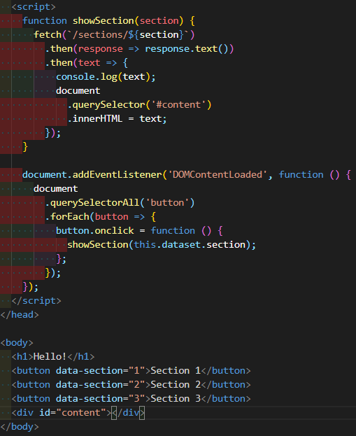

within our index.html file, we’ll take advantage of AJAX, which we learned about last lecture, to make a request to the server to gain the text of a particular section and display it on the screen.

각 버튼을 클릭할 때마다 dataset의 data를 showSection의 parameter로 집어넣고, showSection의 parameter가 /sections/${section}에 성공적으로 입력되면 text형식의 data를 반환하고, text형식의 data를 성공적으로 반환하면, #content의 innerHTML로 text를 반환.

**JavaScript History API**

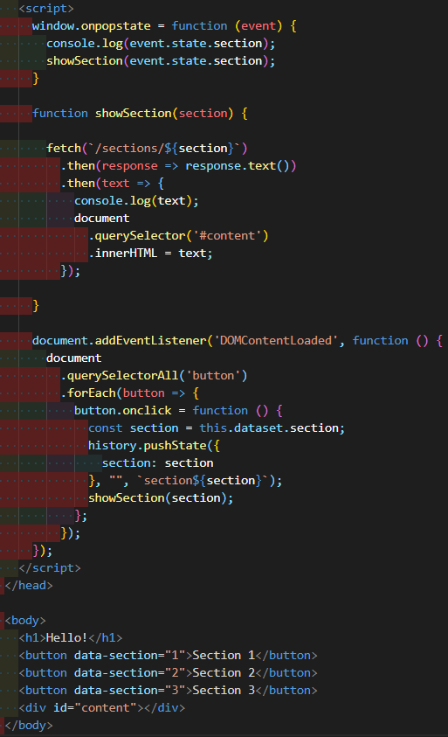

One disadvantage of our site though is that the URL is now less informative. You’ll notice in the video above that the URL remains the same even when we switch from section to section. We can solve this problem using the JavaScript History API. This API allows us to push information to our browser history and update the URL manually. Let’s take a look at how we can use this API. Imagine we have a Django project identical to the previous one, but this time we wish to alter our script to be employ the history API.

In the showSection function above, we employ the history.pushState function. This function adds a new element to our browsing history based on three arguments:

1. Any data associated with the state.
2. A title parameter ignored by most web browsers
3. What should be displayed in the URL
4. <https://developer.mozilla.org/ko/docs/Web/API/History/pushState>

The other change we make in the above JavaScript is in setting the onpopstate parameter, which specifies what we should do when the user clicks the back arrow. In this case, we want to show the previous section when the button is pressed. Now, the site looks a little more user-friendly:

history.pushState로써 세션 기록 항목에 state, title, url을 각각 저장함.

**Scroll**

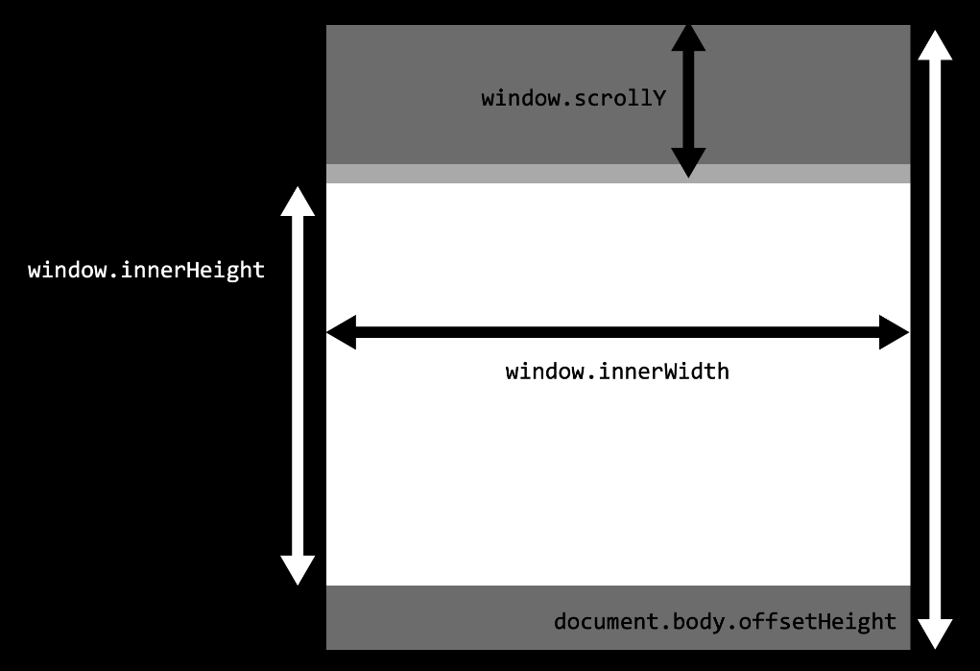

* window.innerWidth: Width of window in pixels
* window.innerHeight: Height of window in pixels
* window.scrollY: How many pixels we have scrolled from the top of the page
* document.body.offsetHeight: The height in pixels of the entire document.

The following code, for example, will change the backgroud color to green when we reach the bottom of a page:

**Infinite Scroll**

if you’re on a social media site, you don’t want to have to load all posts at once, you might want to load the first ten, and then when the user reaches the bottom, load the next ten.

**# urls.py**

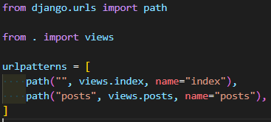

**# views.py**

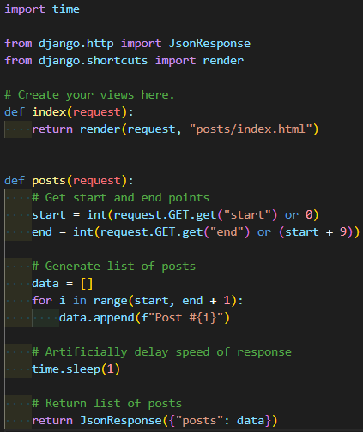

**# index.html**

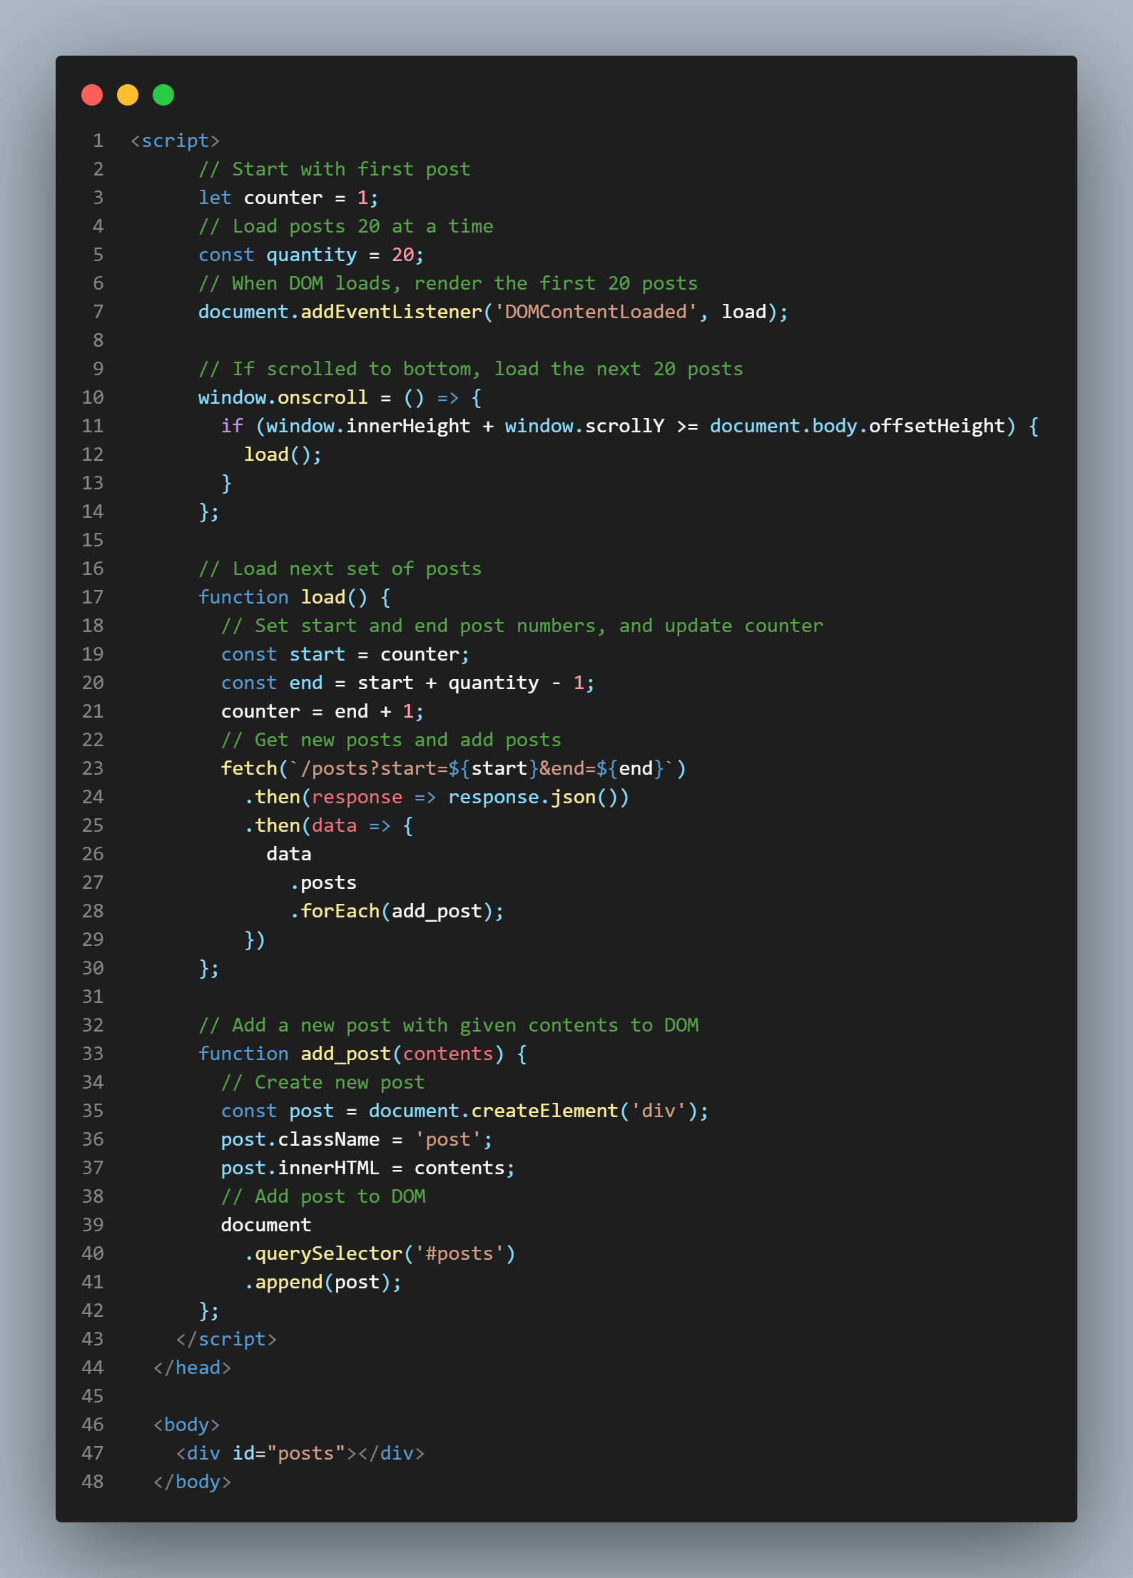

스크롤해서 scrollY 좌표가 window 최하단에 닿으면 새로운 post 생성.

Notice that the posts view requires two arguments: a start point and an end point. In this view, we’ve created our own API, which we can test out by visiting the url localhost:8000/posts?start=10&end=15, which returns the following JSON:

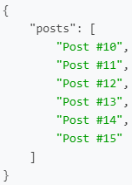

views.py와 index.html을 거치면 위처럼 json 형식의 data를 반환하여 post를 생성한다.

**Animation**

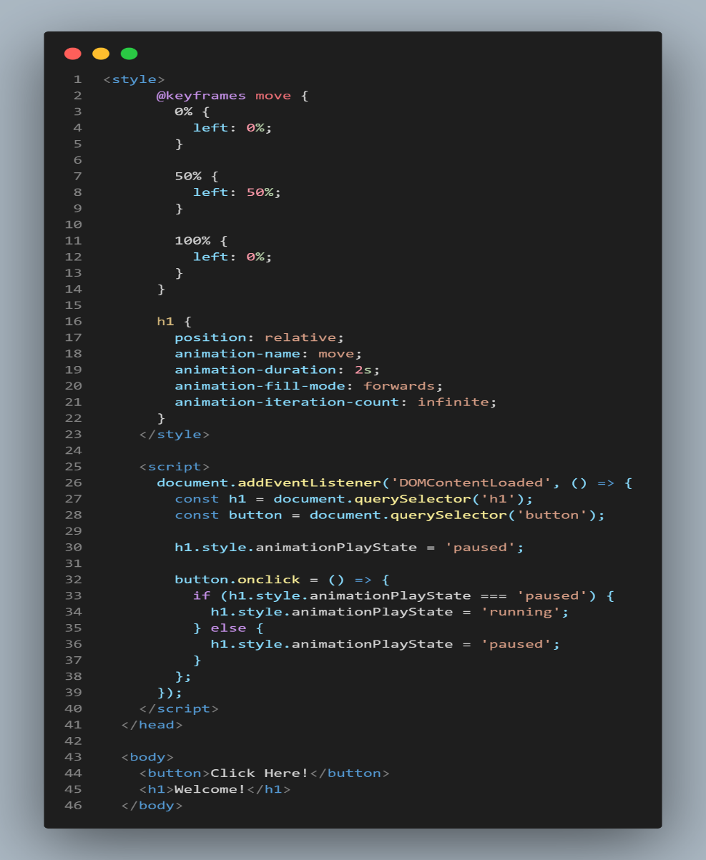

버튼 클릭하면 animation 작동. h1 좌우로 왔다갔다 함.

**# CSS in index.html**

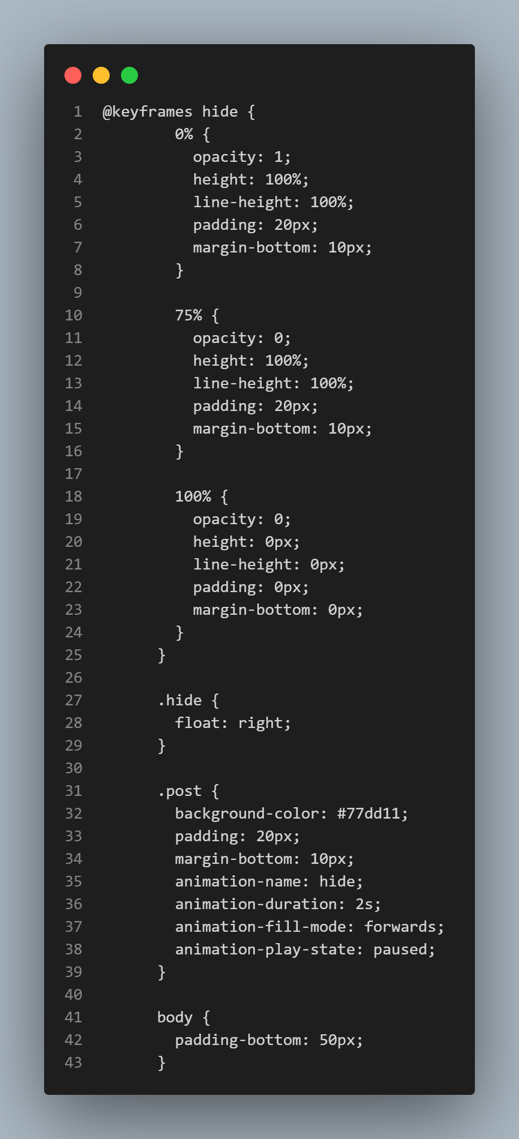

**# script in index.html**

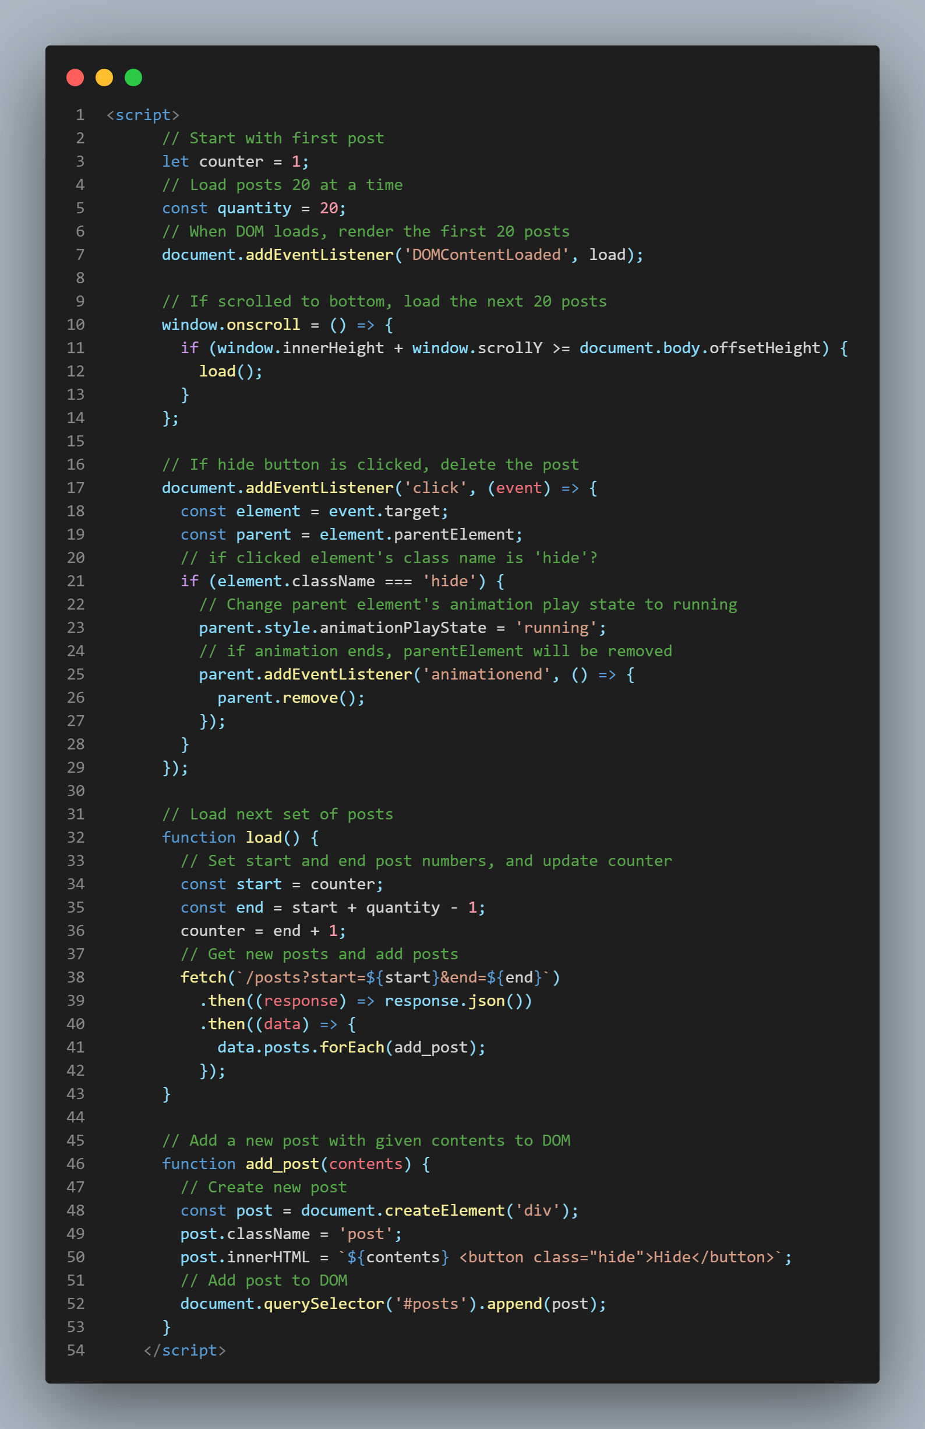

post 내 hide 버튼 누르면 animation 효과 주면서 사라짐.

**React**

**imperative programming vs declarative programming**

imperative programming methods, where we give the computer a set of statements to execute. For example, to update the counter in an HTML page we might have have code that looks like this:

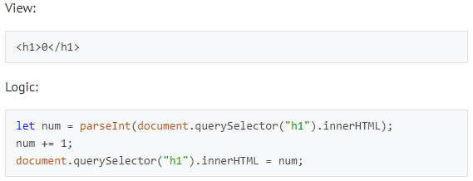

React allows us to use declarative programming, which will allow us to simply write code explaining what we wish to display and not worry about how we’re displaying it. In React, a counter might look a bit more like this:

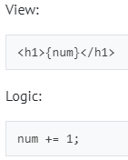

The beauty of React is that when the state changes, React will automatically change the DOM accordingly.

There are a number of ways to use React, (including the popular create-react-app command published by Facebook) but today we’ll focus on getting started directly in an HTML file. To do this, we’ll have to import three JavaScript Packages:

* React: Defines components and their behavior
* ReactDOM: Takes React components and inserts them into the DOM
* Babel: Translates from JSX, the language in which we’ll write in React, to plain JavaScript that our browsers can interpret. JSX is very similar to JavaScript, but with some additional features, including the ability to represent HTML inside of our code.

**# react.html**

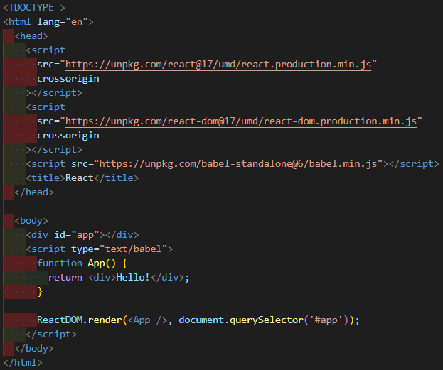

* In the body, we include a single div with an id of app. We almost always want to leave this empty, and fill it in our react code below.
* We include a script tag where we specify that type="text/babel". This signals to the browser that the following script needs to be translated using Babel.
* Next, we create a component called App. Components in React can be represented by JavaScript functions.
* Our component returns what we would like to render to the DOM. In this case, we simply return <div>Hello!</div>.
* The last line of our script employs the ReactDOM.render function, which takes two arguments:

1. A component to render
2. An element in the DOM inside of which the component should be rendered

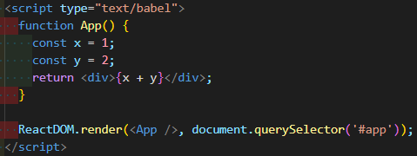

javascript에서 처럼 {}로 묶어서 변수 활용 가능.

**Render components with other components**

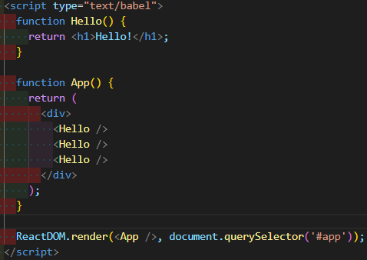

구조를 App() > Hello() * 3 라고 생각하면 됨.

**Props**

react에 쓰이는 components를 props를 추가하여 보다 flexible하게 쓸 수 있다.

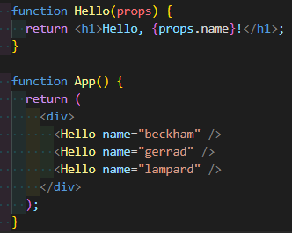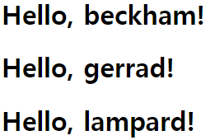

**useState**

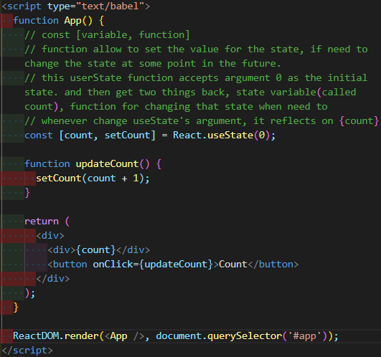

The **argument to** **useState** is the initial value of the state, which we’ll set to 0. The function returns both a variable representing the state and a function that allows us to update the state.

Now, we can work on what the function will render, where we’ll specify a header and a button. We’ll also add an event listener for when the button is clicked, which React handles using the **onClick** attribute.

Finally, let’s define the **updateCount** function. To do this, we’ll use the **setCount** function, which can take as argument a new value for the state.

**Create simple game by react useState and functions**

**# CSS in number_game.html**

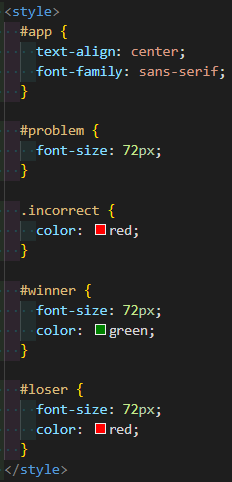

**# set useState in number_game.html**

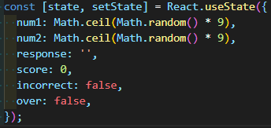

**# inputKeyPress() in number_game.html**

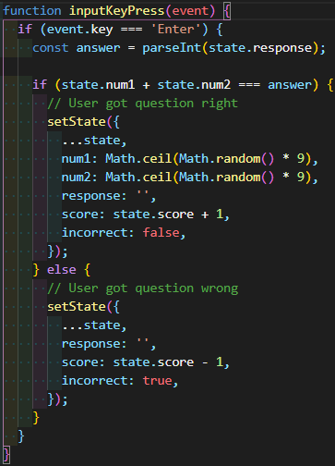

**# updateResponse() in number_game.html**

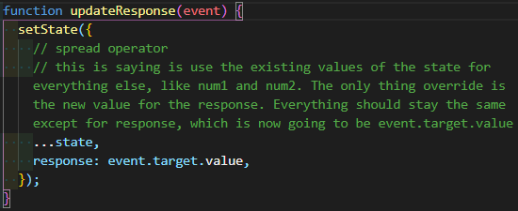

**# game end condition in number_game.html**

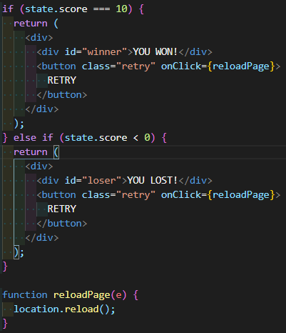

**# rendering sets of page in number_game.html**

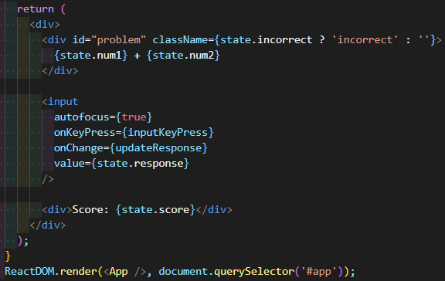

**<Project3. Mail>**

**Understanding**

The emails you’ll be sending and receiving in this project will be entirely stored in your database (they won’t actually be sent to real email servers)

How would you get access to such values in JavaScript? Recall that in JavaScript, you can use fetch to make a web request. Therefore, the following JavaScript code

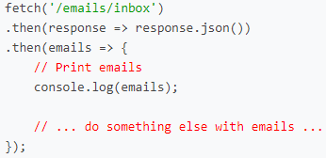

would make a GET request to /emails/inbox, convert the resulting response into JSON, and then provide to you the array of emails inside of the variable emails. You can print that value out to the browser’s console using console.log (if you don’t have any emails in your inbox, this will be an empty array), or do something else with that array.

Note also that if you request an invalid mailbox (anything other than inbox, sent, or archive), you’ll instead get back the JSON response {"error": "Invalid mailbox."}.

**API**

**GET /emails/<int:email_id>**

Sending a GET request to /emails/email_id where email_id is an integer id for an email will return a JSON representation of the email, like the below:

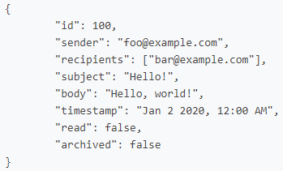

Note that if the email doesn’t exist, or if the user does not have access to the email, the route instead return a 404 Not Found error with a JSON response of {"error": "Email not found."}.

To get email number 100, for example, you might write JavaScript code like

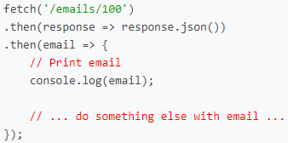

**POST /emails**

So far, we’ve seen how to get emails: either all of the emails in a mailbox, or just a single email. To send an email, you can send a POST request to the /emails route. The route requires three pieces of data to be submitted: a recipients value (a comma-separated string of all users to send an email to), a subject string, and a body string. For example, you could write JavaScript code like

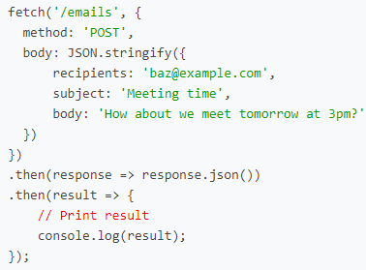

If the email is sent successfully, the route will respond with a 201 status code and a JSON response of {"message": "Email sent successfully."}.

**PUT /emails/<int:email_id>**

The final route that you’ll need is the ability to mark an email as read/unread or as archived/unarchived. To do so, send a PUT request (instead of a GET) request to /emails/<email_id> where email_id is the id of the email you’re trying to modify. For example, JavaScript code like

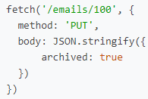

would mark email number 100 as archived. The body of the PUT request could also be {archived: false} to unarchive the message, and likewise could be either {read: true} or read: false} to mark the email as read or unread, respectively.

**Specifications**

Using JavaScript, HTML, and CSS, complete the implementation of your **single-page-app** email client inside of inbox.js (and not additional or other files; for grading purposes, we’re only going to be considering inbox.js!). You must fulfill the following requirements:

* Send Mail: When a user submits the email composition form, add JavaScript code to actually send the email.
  + You’ll likely want to make a POST request to /emails, passing in values for recipients, subject, and body.
  + Once the email has been sent, load the user’s sent mailbox.
* Mailbox: When a user visits their Inbox, Sent mailbox, or Archive, load the appropriate mailbox.
  + You’ll likely want to make a GET request to /emails/<mailbox> to request the emails for a particular mailbox.
  + When a mailbox is visited, the application should first query the API for the latest emails in that mailbox.
  + When a mailbox is visited, the name of the mailbox should appear at the top of the page (this part is done for you).
  + Each email should then be rendered in its own box (e.g. as a <div> with a border) that displays who the email is from, what the subject line is, and the timestamp of the email.
  + If the email is unread, it should appear with a white background. If the email has been read, it should appear with a gray background.
* View Email: When a user clicks on an email, the user should be taken to a view where they see the content of that email.
  + You’ll likely want to make a GET request to /emails/<email_id> to request the email.
  + Your application should show the email’s sender, recipients, subject, timestamp, and body.
  + You’ll likely want to add an additional div to inbox.html (in addition to emails-view and compose-view) for displaying the email. Be sure to update your code to hide and show the right views when navigation options are clicked.
  + See the hint in the Hints section about how to add an event listener to an HTML element that you’ve added to the DOM.
  + Once the email has been clicked on, you should mark the email as read. Recall that you can send a PUT request to /emails/<email_id> to update whether an email is read or not.
* Archive and Unarchive: Allow users to archive and unarchive emails that they have received.
  + When viewing an Inbox email, the user should be presented with a button that lets them archive the email. When viewing an Archive email, the user should be presented with a button that lets them unarchive the email. This requirement does not apply to emails in the Sent mailbox.
  + Recall that you can send a PUT request to /emails/<email_id> to mark an email as archived or unarchived.
  + Once an email has been archived or unarchived, load the user’s inbox.
* Reply: Allow users to reply to an email.
  + When viewing an email, the user should be presented with a “Reply” button that lets them reply to the email.
  + When the user clicks the “Reply” button, they should be taken to the email composition form.
  + Pre-fill the composition form with the recipient field set to whoever sent the original email.
  + Pre-fill the subject line. If the original email had a subject line of foo, the new subject line should be Re: foo. (If the subject line already begins with Re: , no need to add it again.)
  + Pre-fill the body of the email with a line like "On Jan 1 2020, 12:00 AM foo@example.com wrote:" followed by the original text of the email.

**Hints**

* To create an HTML element and add an event handler to it, you can use JavaScript code like the below:

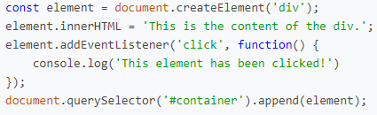

This code creates a new div element, sets its innerHTML, adds an event handler to run a particular function when that div is clicked on, and then adds it to an HTML element whose id is container (this code assumes that there is a HTML element whose id is container: you’ll likely want to change the argument to querySelector to be whichever element you’d like to add an element to).

* You may find it helpful to edit mail/static/mail/styles.css to add any CSS you need for the application.
* Recall that if you have a JavaScript array, you can loop over each element of that array using forEach.
* Recall that normally, for POST and PUT requests, Django requires a CSRF token to guard against potential cross-site request forgery attacks. For this project, we’ve intentionally made the API routes CSRF-exempt, so you won’t need a token. In a real-world project, though, always best to guard against such potential vulnerabilities!