**Name: Shubh Gangar**

**Roll No: 1911013**

**Batch: A1**

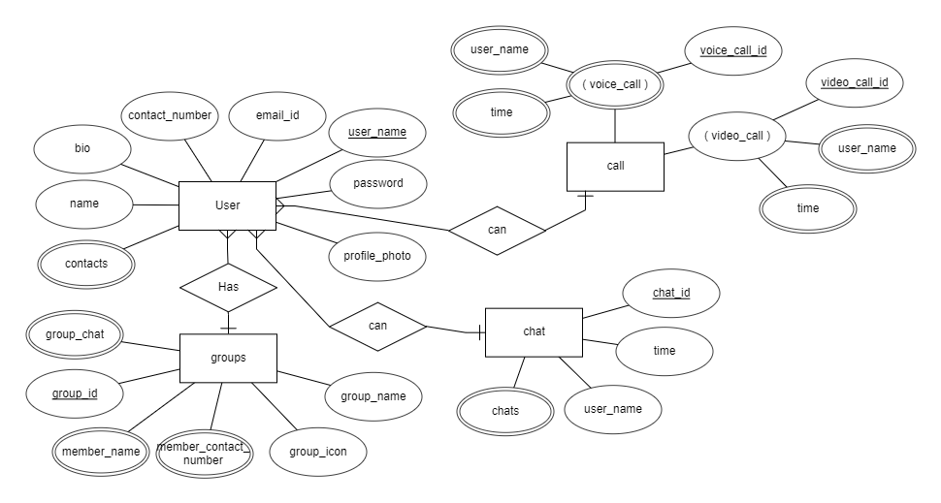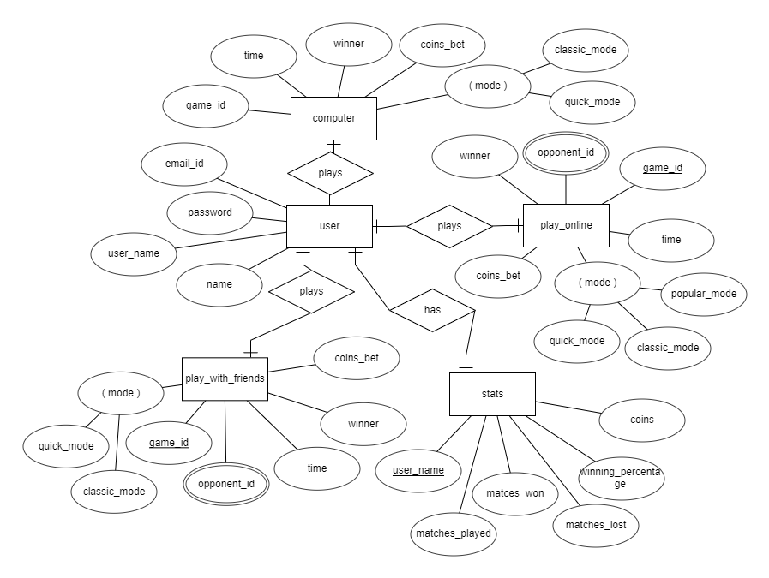**Question 2: Ludo King Application**

**Question 1) Telegram application**