**Code:**

import java.util.*;

public class Main

{

public static void main(String[] args) {

Scanner s=new Scanner(System.in);

System.out.println("Enter the number of elements");

int n=s.nextInt();

int[] arr=new int[n];

System.out.println("Enter the elements");

for(int i=0;i<n;i++)

{

arr[i]=s.nextInt();

}

for(int i=0;i<n-1;i++)

{

for(int j=i+1;j<n;j++)

{

if(arr[i]>arr[j])

{

int temp=arr[i];

arr[i]=arr[j];

arr[j]=temp;

}

}

}

System.out.println("After sorting:");

for(int i=0;i<n;i++)

{

System.out.print(arr[i]+" ");

}

}

}

**Output:**

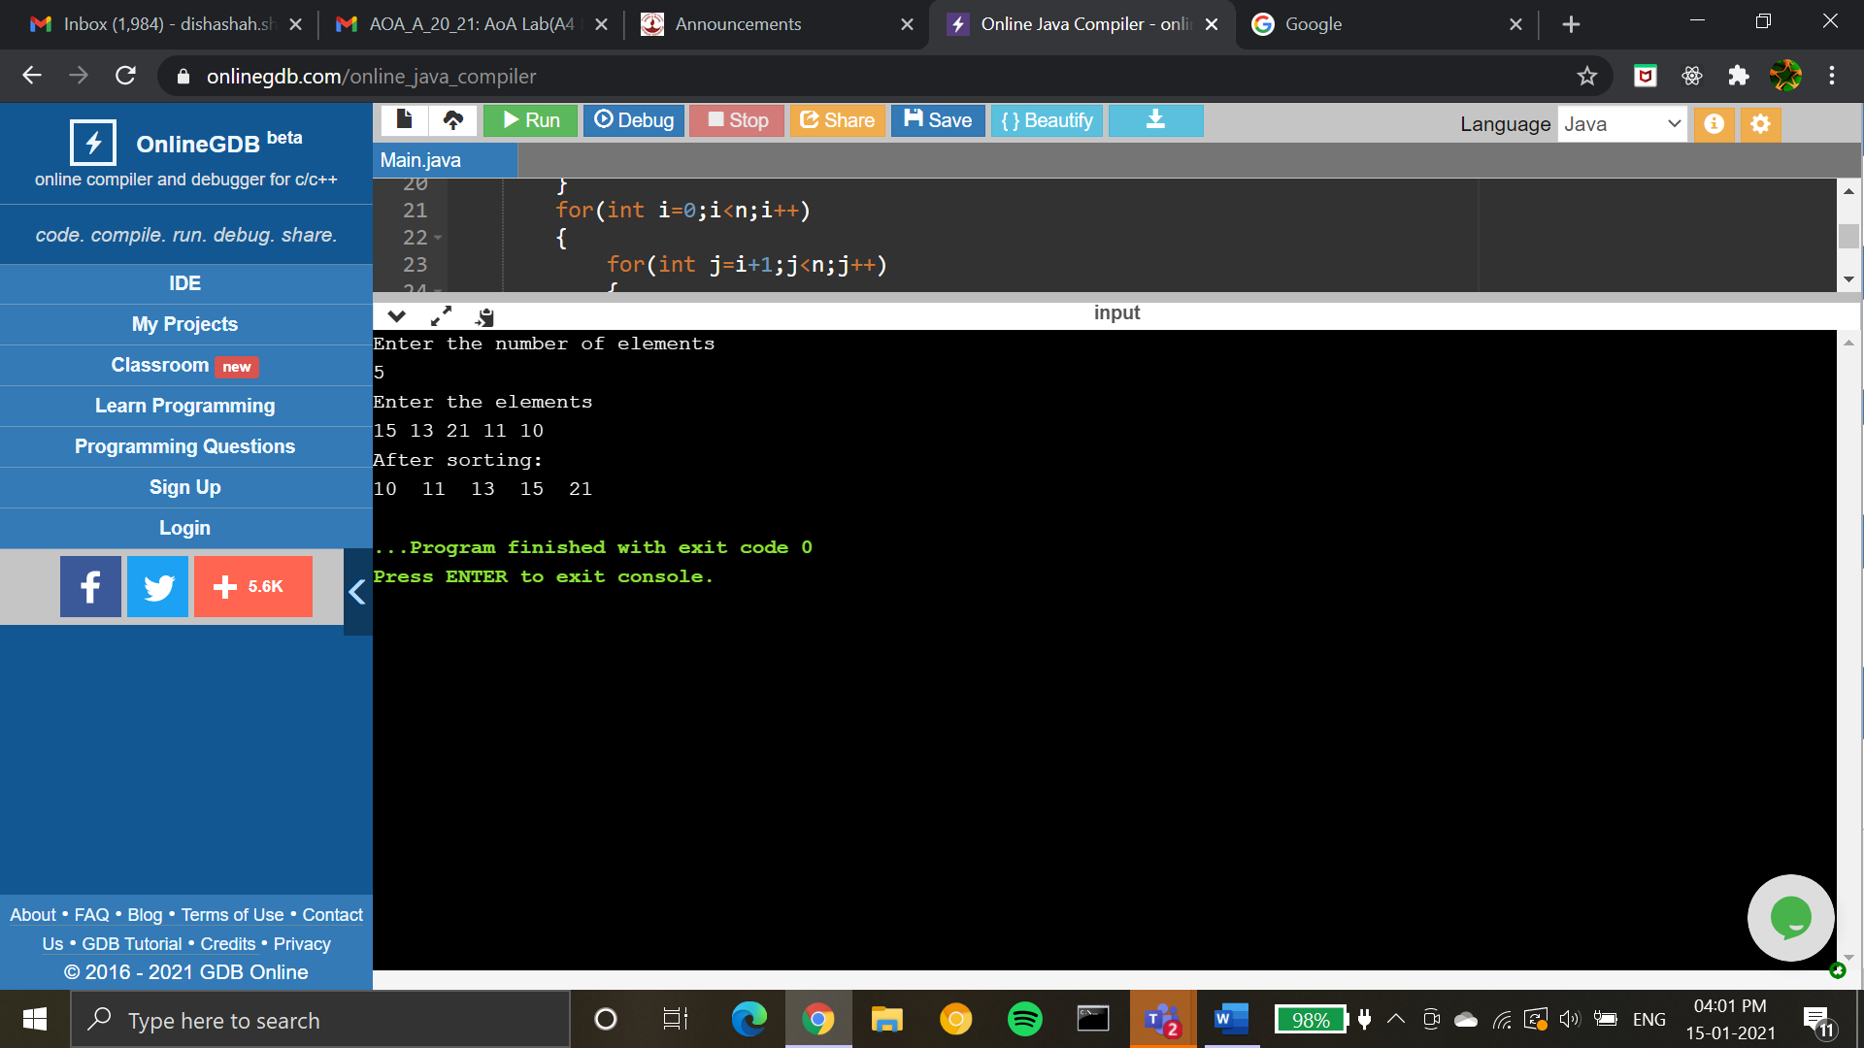

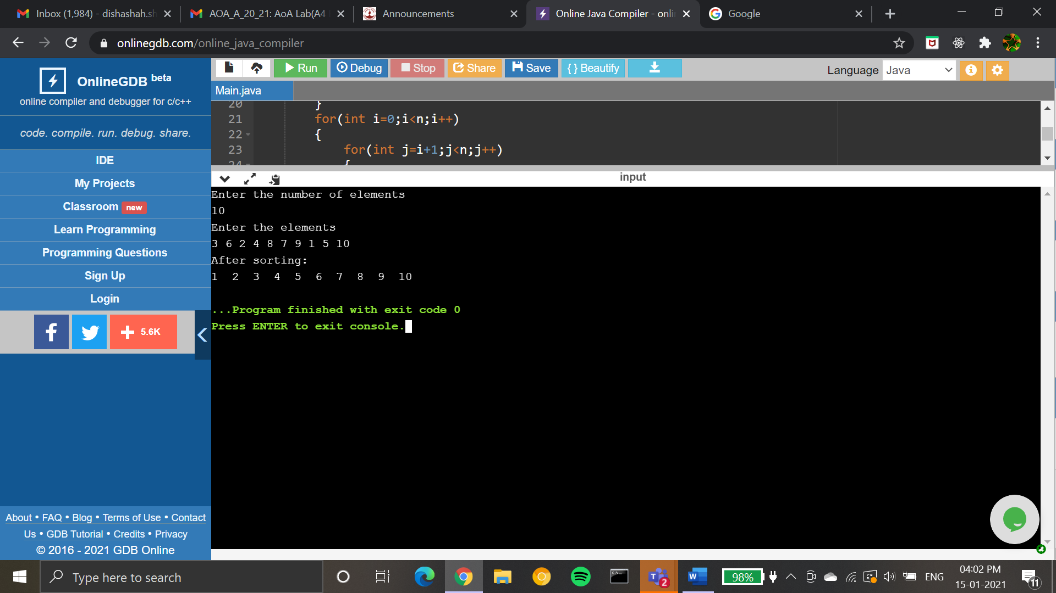

Time complexity and space complexity:

