Subject Homework

Jay Williams · 10GB · 20/09/2017

# JJ Thompson

The JJ Thompson model, also known as the plum pie model, got lots right and lots wrong. He knew that electrons were negatively charged and that the atom’s centre was positive. He devised a model in which the positively charged part of the atom was the “bread” of the atom and the electrons were the plum pieces



# John Dalton

John Dalton proposed that the smallest unit of matter was the atom. He said it was indivisible and small. He did not know about the nucleus or electrons. 

# Ernest Rutherford (1911)

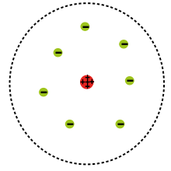Rutherford, in the famous Geiger-Marsden experiment, or the gold foil experiment, found that the atom had an area of high density and a cloud of low density electrons. He suggested that JJ Thompson’s model was incorrect.

# James Chadwick (1932)

James Chadwick discovered the neutron alongside Irene Curie. They discovered that when beryllium was bombarded with alpha particles a beam with high penetrating power was created. He found that it consisted of neutrons.

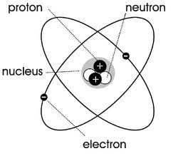

# Niels Bohr (1913)

The bohr model, what we rely on today, depicts the atom as a dense nucleus containing protons and neutrons and light electrons that orbit round the nucleus

