AI-POWERED MARKETING COMPANION FOR MARGINALIZED ARTISANS

A Major Project-I Report Submitted in Partial fulfillment for the award of Bachelor of Technology in Department of CSE
Submitted to
RAJIV GANDHI PROUDYOGIKI VISHWAVIDYALAYA BHOPAL (M.P)


MINOR PROJECT-I REPORT
Submitted by

Purnima Pandey[0103CS231305]
Under the supervision of Dr. Puneet Nema Professor


Department of CSE
Lakshmi Narain College of Technology, Bhopal (M.P.) Session
2025-26

LAKSHMI NARAIN COLLEGE OF TECHNOLOGY, BHOPAL

DEPARTMENT OF CSE

CERTIFICATE
This is to certify that the work embodied in this project work entitled “AI-Powered Marketing Companion for Marginalized Artisans” has been satisfactorily completed by Purnima Pandey[0103CS231305]. It is a Bonafide piece of work, carried out under the guidance in Department of CSE, Lakshmi Narain College of Technology, Bhopal for the partial fulfillment of the Bachelor of Technology during the academic year 2025-2026.

Guide By Approved By

Dr. Puneet Nema Dr. Vivek Richhariya Professor Professor & Head

LAKSHMI NARAIN COLLEGE OF TECHNOLOGY, BHOPAL

DEPARTMENT OF CSE ACKNOWLEDGEMENT
We express our deep sense of gratitude to Prof. Kritika Tiwari (Guide) department of CSE, L.N.C.T., Bhopal. Whose kindness valuable guidance and timely help encouraged me to complete this project.

A special thank goes to Dr. Vivek Richhariya (HOD) who helped me in completing this project work. He exchanged his interesting ideas & thoughts which made this project work successful.

We would also thank our institution and all the faculty members without whom this project work would have been a distant reality.

(Signature)

Purnima Pandey[0103CS231305]

INDEX

S.NO. | TOPICS | PAGES
1. | Problem Domain Description | 5-8
2. | Literature Survey | 9-13
3. | Major objective & scope of project | 14-19
4. | Problem Analysis and requirement specification | 20-24
5. | Detailed Design (Modeling and ERD/DFD) | 25-28
6. | Hardware/Software platform environment | 29-32
7. | Snapshots of Input & Output | 33-35
8. | Coding | 36-45
9. | Project limitation and Future scope | 46-49
10. | References | 50
 | Total 45

CHAPTER 1
PROBLEM DOMAIN DESCRIPTION

Background
Hostel management is an essential operational responsibility for educational institutions, especially colleges and universities where large numbers of students reside within campus accommodations. One of the most critical daily activities in hostels is maintaining resident attendance during night hours to ensure student safety, discipline, and accountability.
Traditionally, hostel attendance systems are managed manually by wardens using handwritten registers, verbal roll calls, or physical verification rounds. These methods are time-consuming, inefficient, and highly dependent on human effort. In many hostels, students must stand in queues while wardens manually mark attendance, creating inconvenience for both residents and management staff.

Manual systems also create opportunities for proxy attendance, where students attempt to mark attendance on behalf of absent residents. This compromises the reliability of hostel records and makes it difficult for wardens to accurately track student presence within the premises.
In addition, maintaining attendance records manually becomes increasingly difficult as hostel capacity grows. Large hostels often accommodate hundreds of students, making daily verification repetitive and prone to error. Wardens must also manage leave approvals, late entries, penalties, and absentee records alongside attendance tracking, which increases administrative workload significantly.

Modern students are highly dependent on smartphones and digital services, yet many hostel systems still rely on outdated paper-based processes. There is a growing need for an automated, secure, and scalable hostel attendance management solution that minimizes manual work while improving accuracy and transparency.

The proposed system addresses these issues through a mobile-based attendance mechanism integrated with facial recognition and Wi-Fi-based verification. Instead of requiring expensive surveillance infrastructure or biometric hardware, students can mark attendance directly from their own mobile devices while connected to the authorized hostel Wi-Fi network during a specified attendance window.

By combining face verification, network restrictions, attendance scheduling, and leave management into a single digital platform, the system aims to provide a practical and cost-effective solution suitable even for small and medium-sized hostels.

Challenges in Current Attendance Systems

Dependence on Manual Attendance Processes
Most hostels still rely on traditional attendance methods such as:
      - Physical registers
      - Manual roll calls
      - Warden rounds
      - Paper-based leave records
These methods require continuous human involvement and become inefficient when handling large numbers of students daily. Manual systems also consume valuable time during night attendance hours.

Possibility of Proxy Attendance
One of the major problems in conventional systems is proxy attendance, where:
      - Students answer on behalf of absent roommates
      - Friends attempt to manipulate attendance records
      - Wardens may unintentionally mark incorrect entries during busy hours This reduces the authenticity and reliability of hostel attendance data.

Lack of Real-Time Monitoring
In many hostels:
      - Wardens cannot instantly identify absent students
      - Attendance records are updated slowly
      - Leave information is maintained separately from attendance logs
As a result, hostel administration becomes fragmented and difficult to manage efficiently.

Difficulty Managing Leave Requests
Students frequently leave hostels temporarily for:
      - Medical reasons
      - Family visits
      - Academic activities
      - Emergencies
Traditional leave management involves handwritten applications or verbal approvals, making it difficult to:
      - Track approved leaves
      - Verify return dates
      - Maintain accurate attendance records
This creates confusion between authorized absence and actual absenteeism.

High Administrative Burden on Wardens
Hostel wardens are responsible for:
      - Monitoring resident attendance
      - Handling leave-requests

      - Managing penalties
      - Identifying absentees
      - Maintaining discipline
Performing all these tasks manually every day increases workload and reduces operational efficiency.

Why Technology is Needed Now

Increasing Hostel Population
Educational institutions are witnessing continuous growth in hostel admissions. Managing attendance manually for hundreds of students every night becomes impractical and difficult to scale.
A digital solution is necessary to streamline operations and reduce repetitive administrative work.

Growth of Smartphone Accessibility
Most students today possess smartphones with:
      - Internet connectivity
      - Front cameras
      - Notification support
      - Mobile application compatibility
This makes smartphone-based attendance systems both feasible and cost-effective without requiring specialized biometric hardware.

Availability of Affordable Face Recognition Technologies
Recent advancements in:
      - OpenCV
      - DeepFace
      - Mobile computing
      - Lightweight machine learning models
have made facial verification more accessible for academic and small-scale applications. Face recognition provides an additional layer of authentication compared to traditional attendance methods.

Need for Secure Attendance Verification
Simply marking attendance through a mobile application is insufficient because students may attempt to misuse the system remotely.
Therefore, additional verification mechanisms such as:
      - Hostel Wi-Fi restriction
      - Attendance time windows
      - Face verification
are necessary to ensure that attendance is marked only by authorized residents physically present within hostel premises.

Demand for Digital Record Management
Digital systems allow:
      - Automated attendance storage
      - Faster retrieval of records

      - Better transparency
      - Simplified monitoring
      - Reduced paperwork
They also help wardens generate attendance history and monitor resident activity more efficiently.

Need for an Automated Face Recognition and Wi-Fi Based Hostel Attendance System
The proposed system combines facial recognition and Wi-Fi-based validation to create a secure and practical attendance mechanism for hostel environments.
The system ensures that:
- Attendance can only be marked during the allowed time window
- Students must be connected to the authorized hostel Wi-Fi network
- Facial verification confirms the identity of the resident
- Leave requests are managed digitally
- Attendance records are stored automatically

Unlike expensive CCTV-based systems, the proposed solution does not require fixed camera installations throughout the hostel. Instead, students use their own mobile devices for attendance marking, making the system more affordable and deployable for smaller hostels.
The integration of leave management and attendance tracking into a unified platform also improves operational efficiency for hostel wardens by reducing manual paperwork and simplifying resident monitoring.
Thus, the proposed system provides:
- Improved attendance authenticity
- Reduced proxy attendance
- Lower administrative workload
- Better resident tracking
- Secure digital record maintenance
- Cost-effective hostel management automation

The project therefore addresses both operational and security-related challenges commonly faced in modern hostel environments.

CHAPTER 2
LITERATURE SURVEY

Existing Research Work

Smart Attendance Systems Using Face Recognition
Recent research in smart attendance systems has focused heavily on facial recognition due to its contactless nature and ability to reduce proxy attendance. Many institutions have adopted face-recognition-based attendance systems to automate traditional manual processes.
Most systems use deep learning models such as FaceNet, DeepFace, or CNN-based architectures for extracting facial embeddings and comparing them against stored data. These systems achieve high accuracy under controlled environments and reduce manual workload significantly.
However, many existing implementations are designed primarily for classrooms or office environments and often assume fixed camera setups. Such systems may not perform efficiently in hostel environments where students capture images using mobile devices under varying lighting conditions and angles.
Additionally, many studies focus only on recognition accuracy while overlooking practical hostel-specific concerns such as attendance timing restrictions, leave management, and administrative control.

Mobile-Based Attendance Verification Systems
Several modern attendance systems utilize smartphones to provide flexibility and portability. These systems allow users to mark attendance through mobile applications instead of relying on biometric hardware installed at fixed locations.
Research shows that mobile-based systems improve accessibility and reduce infrastructure cost. Features such as GPS verification, QR-code scanning, and internet-based authentication are commonly used to validate user presence.
Despite their convenience, these systems remain vulnerable to proxy attendance because location spoofing, QR sharing, or account misuse can occur easily. Most mobile attendance solutions lack strong identity verification mechanisms and therefore cannot guarantee authenticity in sensitive institutional environments such as hostels.

WiFi-Based Presence Authentication Systems
WiFi-based authentication has emerged as a lightweight method for verifying whether a user is physically present within a specific campus or building environment.
In many systems, attendance is allowed only when the user's device is connected to a predefined institutional WiFi network. This approach adds a location-based security layer without requiring GPS tracking.
Research indicates that WiFi-based systems are inexpensive and relatively easy to deploy compared to dedicated biometric hardware. However, WiFi authentication alone cannot verify the actual identity of the user. A student may still hand over their credentials or device to another person for proxy attendance. Therefore, WiFi verification is often more effective when combined with additional authentication methods such as face recognition or OTP validation.

Hostel Management Automation Systems
Several studies and software solutions have explored hostel management automation for handling resident records, room allocation, fee management, complaints, and attendance tracking.

Most hostel management systems focus on administrative convenience rather than secure attendance verification. Attendance is typically marked manually by wardens or through simple checkbox-based interfaces.
Research highlights that manual attendance systems consume significant time during night attendance hours and are prone to human error. In large hostels, maintaining accurate attendance records manually becomes increasingly difficult.
Existing hostel systems rarely integrate real-time facial verification, mobile-based attendance marking, or automated leave-freezing mechanisms.

Facial Recognition Challenges in Real-World Environments
Although facial recognition technology has advanced rapidly, several practical challenges still remain in real-world deployment.
Research literature identifies major issues such as:
      - Variations in lighting conditions
      - Poor image quality from mobile cameras
      - Occlusions caused by masks, spectacles, or low visibility
      - Different facial angles and expressions
      - Similar-looking individuals
Studies also highlight concerns regarding false positives and false negatives in recognition systems. Improper threshold selection may either reject legitimate users or incorrectly authenticate unauthorized individuals.
These challenges become more important in hostel environments because students capture images themselves through personal mobile devices rather than controlled biometric kiosks.

Role-Based Administrative Control Systems
Modern institutional systems increasingly implement role-based access control (RBAC) to separate permissions between administrators and normal users.
Research demonstrates that role separation improves security, accountability, and operational management. In attendance systems, administrators are often provided with privileges such as:
      - Managing attendance windows
      - Approving leave requests
      - Monitoring resident status
      - Viewing attendance reports
      - Controlling user access
However, many academic attendance systems still lack hostel-specific administrative workflows such as attendance freezing during leave periods or penalty handling after missed attendance.

Excerpts from Research Papers

Face Recognition Based Attendance Management Systems
“Face recognition technology enables automated attendance management without requiring physical interaction, thereby improving efficiency and reducing fraudulent attendance practices.”
This research highlights how facial recognition minimizes manual intervention and improves reliability compared to traditional attendance systems based on signatures or ID cards.

Mobile Attendance Systems Using Wireless Authentication
“Wireless network-based attendance systems reduce hardware dependency while enabling flexible and scalable deployment within institutional campuses.”
The paper discusses how Wi-Fi-based verification can act as an effective environmental authentication layer when integrated with mobile applications.

Smart Hostel Monitoring Systems
“Hostel management requires continuous monitoring of resident presence while balancing operational efficiency and student convenience.”
The study emphasizes the growing need for automated hostel monitoring systems due to increasing hostel capacities and administrative workload.

Deep Learning Approaches for Face Verification
“Embedding-based face verification methods provide efficient similarity comparison while reducing storage requirements compared to raw image storage.”
This work explains the importance of storing facial embeddings instead of raw facial images for improving efficiency and privacy.

Security Challenges in Attendance Systems
“Proxy attendance remains one of the most common vulnerabilities in digital attendance systems lacking biometric verification.”
The paper highlights that authentication systems relying solely on credentials or location verification remain insufficient in preventing misuse.

Practical Gaps

Lack of Hostel-Specific Attendance Solutions
Most existing attendance systems are designed for classrooms, offices, or workplaces rather than residential hostel environments.
Hostel attendance involves unique operational requirements such as:
      - Night attendance windows
      - Resident leave handling
      - Student return verification
      - Attendance freezing during approved leave
      - Warden monitoring and control
Existing systems rarely address these hostel-specific workflows comprehensively.
Gap: Lack of a dedicated hostel-oriented attendance management system combining identity verification, Wi-Fi authentication, and administrative control.

Inadequate Protection Against Proxy Attendance
Many attendance systems rely only on:
      - User credentials
      - GPS verification
      - QR scanning
      - Manual verification
These methods are vulnerable to misuse and cannot reliably prevent proxy attendance.

Gap: Need for a stronger attendance verification mechanism combining both face verification and institutional Wi-Fi authentication.

Dependence on Dedicated Hardware Infrastructure
Several biometric attendance systems require:
      - Fingerprint scanners
      - Dedicated facial recognition terminals
      - CCTV installations
      - Fixed biometric kiosks
Such infrastructure increases deployment cost and becomes impractical for smaller hostels.
Gap: Requirement for a low-cost, mobile-based attendance solution that utilizes students’ personal smartphones instead of expensive dedicated hardware.

Limited Administrative Automation
Most hostel attendance processes are still handled manually by wardens using paper registers or spreadsheets.
This creates problems such as:
      - Human error
      - Time consumption
      - Difficulty in monitoring large hostels
      - Lack of digital records
Gap: Need for an automated administrative dashboard supporting leave approval, attendance monitoring, and resident status management.

Absence of Integrated Leave Management
In many hostels, attendance and leave management operate independently. Students inform wardens manually about leaves, while attendance tracking remains separate.
This causes operational confusion and unnecessary manual coordination.
Gap: Need for an integrated leave management system where approved leave automatically affects attendance eligibility.

Poor User Convenience in Existing Systems
Many biometric systems require students to physically visit a common attendance terminal, leading to:
      - Queues
      - Delays
      - Congestion during attendance hours
Gap: Requirement for a mobile-first system allowing secure attendance marking directly from students’ personal devices while maintaining authentication reliability.

Why These Gaps Matter
Hostel attendance management directly affects student discipline, hostel security, and administrative efficiency. Manual systems become increasingly difficult to manage as hostel capacity grows.
Proxy attendance, missed attendance records, and inefficient leave handling reduce the reliability of existing processes and increase administrative burden on wardens.

At the same time, many available biometric solutions are expensive and infrastructure-dependent, making them unsuitable for smaller institutions and private hostels.
A mobile-based attendance system integrating:
- Face verification,
- Wi-Fi authentication,
- Leave management,
- Role-based administrative control, and
- Automated attendance records
can provide a practical, scalable, and cost-effective solution specifically tailored for hostel environments.
Therefore, the proposed system addresses not only technological challenges but also real operational problems faced by hostel administrators and residents in daily attendance management.

CHAPTER 3
MAJOR OBJECTIVE & SCOPE OF PROJECT

Objectives of the Project

Automate and Streamline Hostel Attendance Management
Traditional hostel attendance systems are mostly manual, time-consuming, and prone to errors. Wardens often maintain attendance registers manually, which increases workload and creates management difficulties in large hostels.
The primary objective of the proposed system is to automate hostel attendance management using facial recognition and Wi-Fi verification.
The system:
- Eliminates manual attendance registers
- Automates attendance marking
- Reduces administrative effort
- Provides faster and more efficient attendance handling
This improves operational efficiency and minimizes dependency on manual processes.

Prevent Proxy Attendance and Unauthorized Attendance Marking
One of the major problems in traditional hostel attendance systems is proxy attendance, where one student marks attendance on behalf of another.
The objective of the system is to prevent such fraudulent activities using:
- Facial recognition verification
- Wi-Fi-based authentication
- Secure user login
Attendance will only be marked when:
- The student’s face matches stored facial data
- The device is connected to the authorized hostel Wi-Fi network
- The attendance window is active
This ensures that only genuine residents can mark attendance.

Provide Real-Time Attendance Monitoring
The project aims to provide real-time attendance monitoring for hostel wardens and administrators. The system should:
- Instantly record attendance entries
- Update attendance status in real time
- Display student attendance records immediately
- Provide live monitoring through the dashboard
This helps hostel authorities track resident presence efficiently without delays.

Simplify Leave Management Process
In many hostels, leave requests are handled manually using paper applications or verbal communication.
The objective of the proposed system is to digitize and simplify the leave management process. The system allows students to:

- Apply for leave through the mobile application
- Specify leave reason and duration
- Track leave approval status Wardens can:
- Approve or reject leave requests
- Monitor leave history
- Automatically freeze attendance requirements during approved leave periods This reduces paperwork and improves administrative coordination.

Improve Administrative Efficiency
Hostel wardens often spend significant time maintaining records manually. The system aims to reduce administrative burden by providing:
- Automated attendance storage
- Attendance history tracking
- Student profile management
- Leave management dashboard
- Search and filtering options
This allows wardens to manage large numbers of students more efficiently.

Provide Attendance Analytics and Reports
The system aims to generate useful attendance insights and reports automatically. The project will provide:
- Student attendance percentage
- Attendance history
- Daily attendance records
- Missed attendance tracking
- Leave statistics
These analytics help administrators monitor hostel discipline and identify attendance irregularities.

Enhance Security and Reliability
Security is an important objective of the project because hostel attendance data contains sensitive resident information.
The system aims to ensure:
- Secure authentication using JWT tokens
- Role-based access control
- Protected APIs
- Secure facial data storage
- Restricted access for unauthorized users
This improves reliability and prevents misuse of the system.

Provide Mobile Accessibility and Convenience
The project aims to provide a mobile-first attendance solution that students can use conveniently from their smartphones.
Students can:
- Mark attendance
- Capture facial images
- Apply for leave

- View attendance history
- Access personal profile
This improves usability and removes the need for dedicated attendance hardware.

Support Scalable and Modular System Design
The system is designed using separate frontend and backend architecture to ensure scalability and future enhancement.
The objective is to support:
- Independent frontend and backend development
- API-based communication
- Future AI model upgrades
- Integration with hostel management systems
- Addition of new modules in future versions This makes the project flexible and easier to maintain.

Reduce Infrastructure Cost
Many biometric attendance systems require expensive dedicated hardware. The proposed system aims to reduce implementation cost by:
- Using students’ personal smartphones
- Utilizing hostel Wi-Fi infrastructure
- Using software-based face verification
- Eliminating dedicated biometric devices
This makes the solution more practical and affordable for educational institutions.

Scope of Project

System Modules Included in Scope
      - Student Mobile Application
The mobile application module allows hostel residents to:
        - Login securely
        - Register facial data
        - Mark attendance
        - Apply for leave
        - View attendance history
        - Access personal profile information The frontend is developed using Flutter.

      - Facial Recognition Module
The facial recognition module verifies student identity before attendance marking. The module performs:
        - Image capture using mobile camera
        - Face detection
        - Face embedding generation
        - Face comparison and verification
The module is implemented using OpenCV and facial recognition libraries in Python.

      - Wi-Fi Verification Module
Attendance marking is allowed only when the student device is connected to the authorized hostel Wi-Fi network.
This module:
        - Detects connected Wi-Fi SSID
        - Verifies hostel network connection
        - Restricts attendance marking outside hostel premises This adds an additional security layer against proxy attendance.

      - Backend API Module
The backend module handles all business logic and communication between frontend and database. The backend provides:
        - Authentication APIs
        - Attendance APIs
        - Leave management APIs
        - Warden dashboard APIs
        - Student profile APIs
        - Attendance history APIs
The backend is developed using FastAPI.

      - Database Module
The system uses a relational database to store application data securely. The database stores:
        - Student records
        - Attendance records
        - Leave applications
        - User credentials
        - Facial embeddings
        - Warden details
MySQL is used as the database management system.

      - Warden Dashboard Module
The warden dashboard provides administrative control and monitoring features. The dashboard allows wardens to:
        - View attendance records
        - Monitor student status
        - Approve or reject leave requests
        - Search resident records
        - Access attendance analytics
        - Manage hostel residents
This module improves hostel administration efficiency.

      - Authentication and Authorization Module
The system includes secure authentication and role-based authorization. Features include:
        - JWT-based login authentication
        - Separate roles for students and wardens
        - Protected API access

        - Secure session handling
This ensures controlled system access.

      - Attendance History and Analytics Module
The system stores attendance records and generates attendance-related insights. The module provides:
        - Daily attendance logs
        - Attendance percentages
        - Monthly attendance summaries
        - Attendance trends
        - Missed attendance records
This helps wardens monitor hostel discipline effectively.

What the Project Will Deliver
The proposed project will deliver:
- A fully functional hostel attendance management system
- Facial recognition-based attendance verification
- Wi-Fi authenticated attendance marking
- Student mobile application
- Warden management dashboard
- Leave management system
- Attendance analytics and reports
- Secure backend APIs
- Integrated database system
- Research documentation and project report

Target Users and Stakeholders
The proposed system is intended for:
- Hostel wardens
- Hostel administration
- Resident students
- Educational institutions
- System administrators
- Developers and maintainers
The project aims to improve hostel management efficiency while ensuring secure and reliable attendance monitoring.

Technologies Included in the Scope
The project utilizes the following technologies: Frontend
- Flutter
- Dart Backend
- FastAPI
- Python Database
- MySQL

AI and Image Processing
- OpenCV
- Face Recognition Libraries Authentication
- JWT Authentication Development Tools
- VS Code
- GitHub
- Swagger
These technologies collectively provide a scalable and efficient system architecture.

CHAPTER 4
PROBLEM ANALYSIS AND REQUIREMENT SPECIFICATION

Problem Analysis
A detailed problem analysis helps in understanding the limitations of the current hostel attendance system and identifying the exact requirements needed for an improved automated solution. The existing hostel attendance process in many institutions is still highly dependent on manual verification and physical registers, making it inefficient, insecure, and difficult to manage at scale.
The proposed system introduces facial recognition, Wi-Fi-based verification, and centralized digital attendance management to solve these problems through automation and real-time monitoring.

Existing System Overview
Most hostels currently rely on traditional attendance mechanisms such as:
- Manual attendance registers
- Signature-based verification
- Roll-call attendance by wardens
- Spreadsheet or paper-based record maintenance
- Manual checking of hostel entry and exit
These systems require students to physically report to hostel staff during attendance hours. Hostel wardens manually verify students and maintain records, which becomes difficult when handling a large number of students.
Although these methods are simple to implement, they suffer from several operational and security-related issues.

Limitations of the Existing System
      - Proxy Attendance and Manipulation
One of the biggest problems in manual hostel attendance systems is proxy attendance. Students may:
        - Sign attendance on behalf of others
        - Use fake signatures
        - Mark attendance for absent students
        - Manipulate paper records
Since manual verification relies heavily on trust and human observation, fraudulent attendance becomes difficult to prevent.

      - Time-Consuming Manual Process
Hostel attendance is usually conducted within a short time window during evening hours. Manual verification leads to:
        - Long queues of students
        - Delays in attendance completion
        - Increased workload on wardens
        - Wastage of time for both staff and students

For large hostels with hundreds of students, the process becomes inefficient and difficult to manage daily.
      - Lack of Accurate Verification
Traditional systems cannot reliably verify whether:
        - The actual student is present
        - The student is physically inside the hostel
        - Attendance was marked genuinely
Without biometric or digital verification, the authenticity of attendance records cannot be guaranteed.

      - Poor Record Management
Paper registers and spreadsheets create several management issues:
        - Attendance records can be lost or damaged
        - Manual searching of records is difficult
        - Generating reports requires extra effort
        - Errors may occur during data entry
        - Historical attendance analysis becomes complicated
This reduces operational efficiency and increases administrative burden.

      - No Real-Time Monitoring Most existing systems do not provide:
        - Real-time attendance status
        - Instant student verification
        - Live attendance tracking
        - Automated reports or analytics
Wardens must manually calculate attendance percentages and verify student records whenever needed.

      - Security Vulnerabilities
Manual systems provide weak security because:
        - Anyone can attempt proxy attendance
        - Unauthorized students may enter attendance areas
        - No identity verification mechanism exists
        - There is no digital proof of attendance This compromises hostel discipline and accountability.

Stakeholder Analysis
      - Students Students require:
        - Quick and smooth attendance marking
        - Minimal waiting time
        - Fair and transparent attendance records
        - Secure identity verification
They benefit from a faster and automated process without unnecessary manual procedures.

      - Hostel Wardens Wardens are responsible for:

        - Monitoring student presence
        - Maintaining hostel discipline
        - Managing attendance records
        - Handling leave applications They need:
        - Automated attendance management
        - Reduced manual workload
        - Reliable student verification
        - Real-time attendance monitoring

      - Hostel Administration The administration requires:
        - Accurate attendance data
        - Secure and tamper-proof records
        - Attendance analytics and reports
        - Centralized monitoring system
The system helps management improve operational efficiency and hostel security.

      - Institution Management Institution authorities require:
        - Improved discipline in hostels
        - Reliable student monitoring
        - Digital transformation of hostel operations
        - Better transparency and accountability
The proposed system supports institutional modernization and automation goals.

Identified Problems to be Solved
The proposed system aims to solve the following problems:
- Proxy attendance in hostels
- Manual and slow attendance processes
- Lack of secure identity verification
- Difficulty in maintaining attendance records
- Absence of real-time monitoring
- High dependency on manual work
- Lack of centralized attendance management
- No automated attendance analytics
- Weak hostel attendance security

Table 1. Problems and Their Impacts

PROBLEM | IMPACT
Manual attendance process | Time-consuming and inefficient
Proxy attendance | Inaccurate attendance records
No biometric verification | Weak security and misuse

PROBLEM | IMPACT
Paper-based records | Difficult management and storage
No real-time monitoring | Delayed tracking and reporting
High workload on wardens | Reduced operational efficiency
Lack of attendance analytics | Poor monitoring and decision-making

Requirement Specification
This section defines the functional and non-functional requirements necessary for the successful implementation of the Smart Hostel Attendance Management System.

Functional Requirements (FR)
      - User Authentication
Students and wardens must be able to log in securely JWT-based authentication must be implemented Unauthorized users must not access the system

      - Face Registration
Students must be able to register their face through the mobile app The system must capture and process face images
Face embeddings must be stored securely in database

      - Face Verification
The system must capture a live image during attendance marking It must compare the captured image with stored embeddings Attendance should be marked only if the face matches successfully

      - Wi-Fi Verification
Attendance must only be allowed within hostel Wi-Fi network The system must verify SSID before marking attendance Attendance outside hostel network must be rejected

      - Attendance Marking The system must:
Record attendance date and time Prevent duplicate attendance entries Store attendance securely in database Return success or failure messages

      - Attendance Monitoring Wardens must be able to:
View daily attendance records Monitor absent students Access attendance history

      - Leave Management

Students must be able to:
Apply for leave through the app View leave request status Wardens must be able to:
Approve or reject leave requests Monitor leave history

      - Settings Management
Wardens or administrators must be able to:
Configure attendance timing Configure hostel Wi-Fi SSID Manage attendance rules

Non-Functional Requirements (NFR)
      - Accuracy
Facial recognition accuracy should be high under normal lighting conditions False attendance marking should be minimized

      - Performance
Attendance verification should complete within a few seconds APIs should respond quickly during peak usage

      - Reliability
The system must operate continuously during attendance hours Attendance records must remain consistent and accurate

      - Security
Passwords must be encrypted
JWT authentication must be implemented Face embeddings must be stored securely Unauthorized API access must be restricted

      - Scalability
System should support increasing numbers of students Multiple hostels should be supportable in future versions

      - Usability
Mobile app interface should be simple and user-friendly Minimal technical knowledge should be required

      - Maintainability
Backend APIs should be modular and easy to update Database schema should support future expansion

      - Availability
System should remain available during hostel attendance hours, downtime being minimal

CHAPTER 5
DETAILED DESIGN (MODELLING AND ERD/DFD)

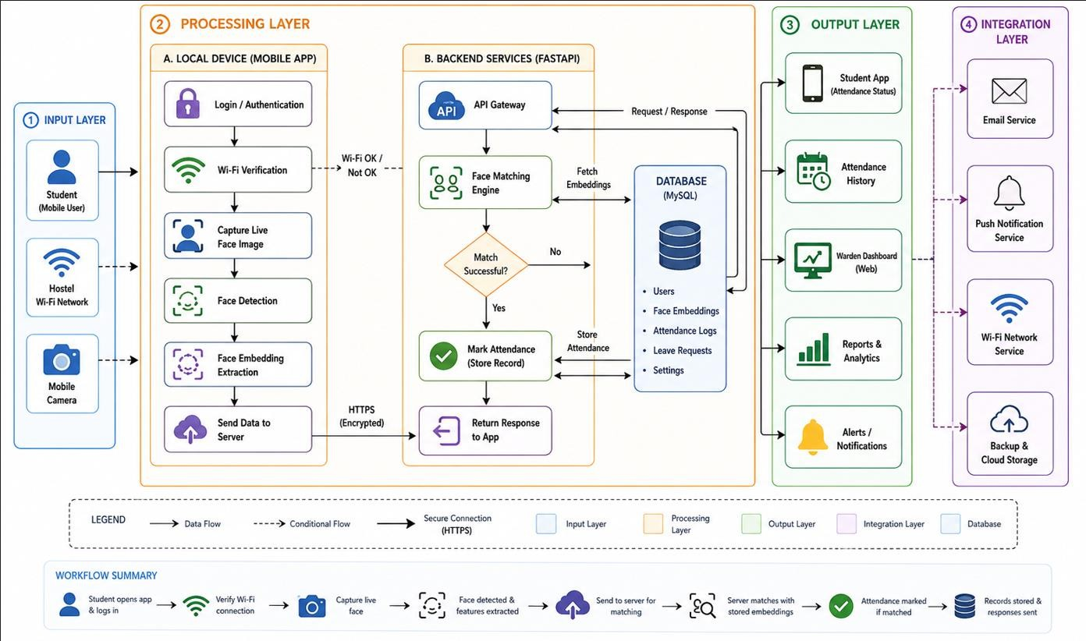
System Workflow

Step-by-Step Flow
      - Student Registration & Authentication
        - Students register/login using hostel credentials.
        - User data is securely stored in the backend database.
      - Wi-Fi Verification
        - Before attendance is marked, the app checks whether the student is connected to the authorized hostel Wi-Fi network.
        - This prevents attendance marking from outside the hostel premises.
      - Face Recognition Attendance
        - The student opens the attendance section and captures a live selfie.
        - The backend compares the captured face with the stored face dataset using OpenCV-based recognition.
      - Attendance Validation
        - Attendance is marked only if:
          - Face matches successfully
          - Student is connected to hostel Wi-Fi
          - Attendance has not already been marked for the day
      - Database Storage
        - Attendance records are stored in the MySQL database with date, time, and student details.
        - The system maintains daily attendance history automatically.
      - Leave Management
        - Students can apply for leave through the app.

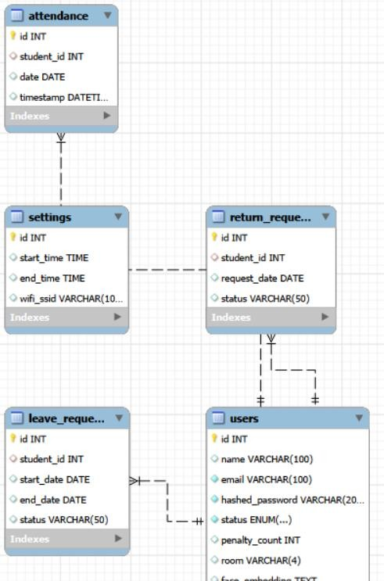
        - Leave requests are sent to the warden dashboard for approval or rejection.
      - Warden Dashboard Monitoring
        - Wardens can view student attendance records, pending leave requests, and hostel statistics.
        - They can approve/reject leave applications and monitor absentees in real time.
      - Attendance Analytics & Reports
        - The system generates attendance summaries and visual statistics such as:
- Present vs absent students
- Attendance percentage
- Daily/monthly attendance trends
        - Helps wardens analyse hostel discipline efficiently.

Entity Relationship Diagram

CHAPTER 6
HARDWARE/SOFTWARE IMPLEMENTATION PLATFORM

Hardware
The proposed Smart Hostel Attendance Management System requires moderate hardware resources for smooth execution of backend services, facial recognition processing, database management, and mobile application support.
The following hardware configuration is recommended:
- Computer/Laptop with Quad-Core Processor
- Minimum 8 GB RAM
- Minimum 15 GB free disk storage
- Webcam or smartphone camera for facial image capture
- Stable Wi-Fi network for attendance verification
- Android smartphone for running the Flutter application
- Optional GPU support (NVIDIA GTX 980 or equivalent) for faster facial recognition processing and AI computations
The system can also run on lower-end systems for small-scale deployment, though performance may reduce during simultaneous requests or intensive face-processing operations.

Software
The project uses modern software technologies and frameworks for frontend development, backend APIs, database management, and facial recognition processing.

Flutter
Flutter is an open-source UI software development toolkit developed by Google. It is used for building the mobile frontend application of the system.
Features of Flutter include:
      - Cross-platform mobile application development
      - Fast UI rendering
      - Rich widget library
      - Responsive and modern user interfaces
      - Support for Android application deployment
Flutter enables the development of a single codebase for mobile application functionality, reducing development time and improving maintainability.

Dart
Dart is the programming language used by Flutter for frontend application development. It provides:
      - Fast execution performance
      - Object-oriented programming support
      - Hot reload functionality
      - Easy integration with APIs and backend services Dart is used to implement:

      - Authentication screens
      - Attendance marking interfaces
      - Leave management pages
      - API communication services

Python 3
Python 3 is the primary programming language used for backend development and facial recognition functionalities.
Python is widely used in:
      - Artificial Intelligence
      - Machine Learning
      - Computer Vision
      - Backend API development The project uses Python because of:
      - Simplicity and readability
      - Large ecosystem of AI libraries
      - Strong FastAPI support
      - Efficient image processing capabilities

FastAPI
FastAPI is a modern Python web framework used to build REST APIs for the backend system. It provides:
      - High performance API handling
      - Asynchronous request support
      - Automatic API documentation
      - JWT authentication support
      - Easy integration with databases and AI modules FastAPI is used to implement:
      - Authentication APIs
      - Attendance APIs
      - Leave management APIs
      - Warden dashboard APIs
      - Face registration and verification endpoints

OpenCV
OpenCV (Open-Source Computer Vision Library) is used for image processing and facial recognition operations.
It supports:
      - Face detection
      - Image preprocessing
      - Facial feature extraction
      - Real-time computer vision tasks
OpenCV helps the system capture and process facial images during registration and attendance verification.

DeepFace / Face Recognition Libraries
The system uses facial recognition libraries for generating and comparing face embeddings.

These libraries provide:
      - Facial verification
      - Embedding generation
      - Face similarity comparison
      - AI-based identity matching
They improve the security and accuracy of attendance marking.

MySQL
MySQL is used as the relational database management system for storing application data. The database stores:
      - Student records
      - Attendance history
      - Leave applications
      - User credentials
      - Face embeddings
      - Hostel settings MySQL provides:
      - Structured data storage
      - Fast query execution
      - Reliable transaction handling
      - Scalability and maintainability

Android Studio
Android Studio is used as the primary development environment for Flutter application development and testing.
It provides:
      - Emulator support
      - Debugging tools
      - Flutter plugin integration
      - APK generation support

Visual Studio Code
Visual Studio Code (VS Code) is used for backend and frontend development. It offers:
      - Lightweight development environment
      - Python and Flutter extensions
      - Integrated terminal
      - Git support
      - Debugging and code formatting tools

Git and GitHub
Git is used for version control, while GitHub is used for project repository hosting and collaboration. They help in:
      - Source code management
      - Backup and recovery
      - Team collaboration
      - Version tracking and deployment management

Swagger
Swagger is used for API testing and debugging. It is used to:
      - Test backend endpoints
      - Verify request and response handling
      - Debug authentication and attendance APIs
      - Validate JSON responses

CHAPTER 7
SNAPSHOTS OF INPUT AND OUTPUT
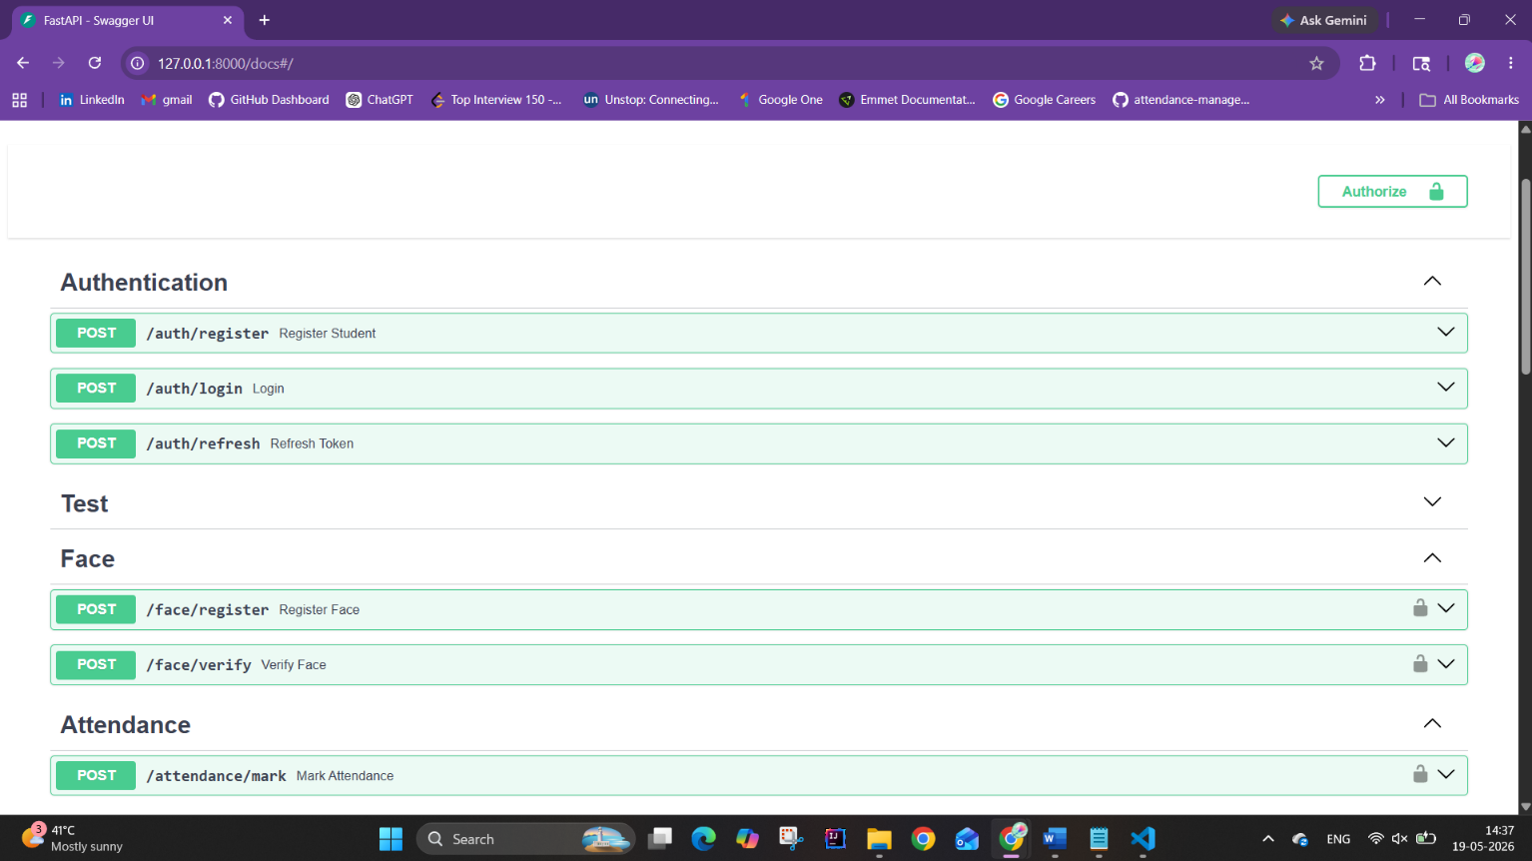

Fig. 7.1. Authentication, Registration and Attendance Routes on Swagger

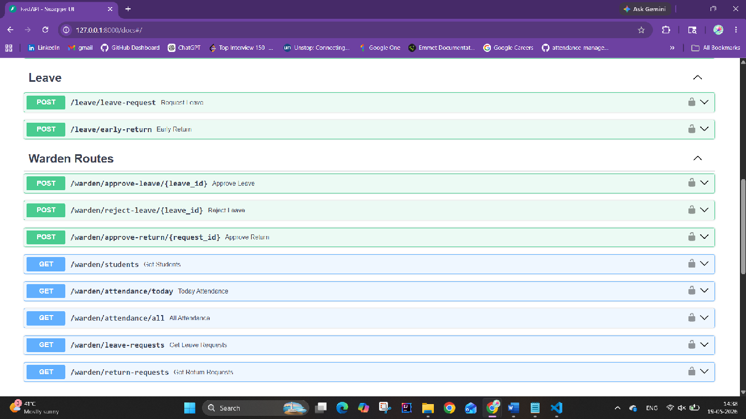

Fig. 7.2. Leave and Warden Routes on Swagger
31

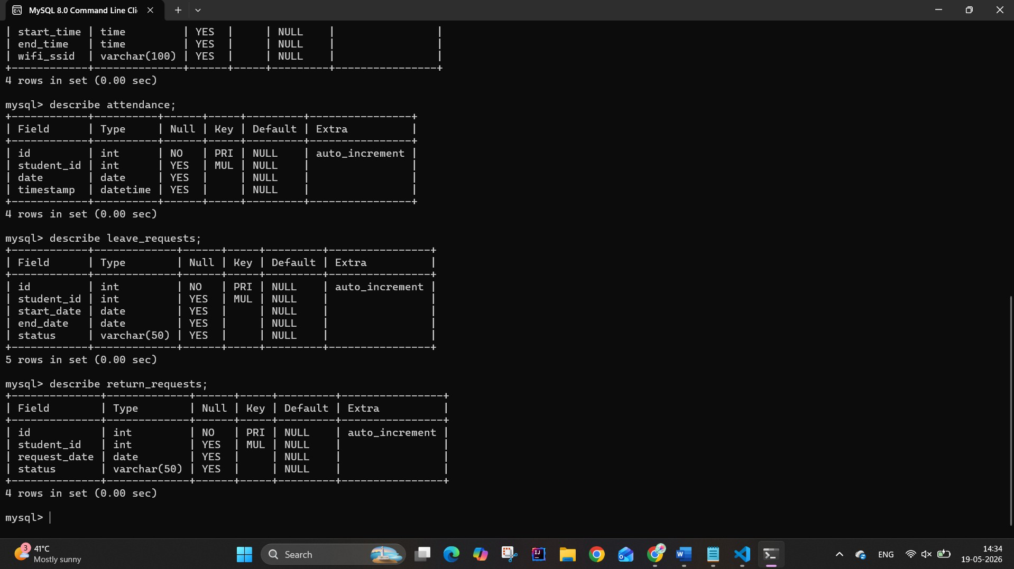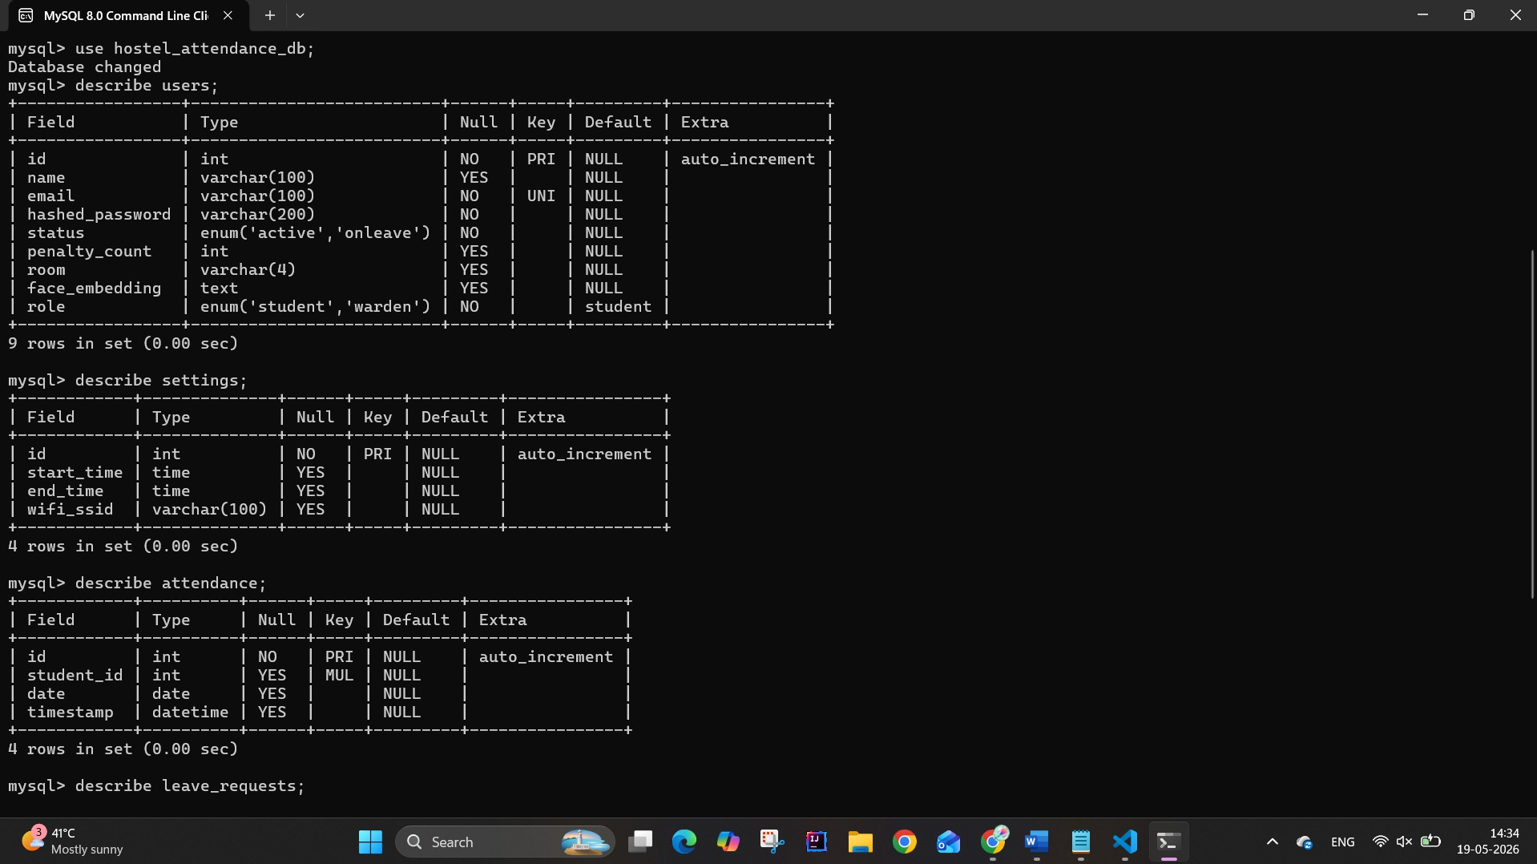
Fig. 7.3. Database Schema
Fig. 7.4. Database Schema

CHAPTER 8
CODING

Frontend Code

Authentication
import 'dart:convert';
import 'package:http/http.dart' as http;
import 'package:shared_preferences/shared_preferences.dart'; import 'api_service.dart';

class AuthService {
static String? _accessToken; static String? _refreshToken;

final String baseUrl = ApiService.baseUrl;
static bool get isLoggedIn => _accessToken != null; Future<void> loadTokens() async {
final prefs = await SharedPreferences.getInstance();
_accessToken = prefs.getString("access_token");
_refreshToken = prefs.getString("refresh_token");
}

Future<bool> register({ required String name, required String email, required String password, required String room,
}) async {
final response = await http.post( Uri.parse("$baseUrl/auth/register"),
headers: {"Content-Type": "application/json"}, body: jsonEncode({
"name": name,
"room": room, "email": email, "password": password,
}),
);

return response.statusCode == 201;
}

Future<Map<String, dynamic>?> login(String email, String password) async {

final response = await http.post( Uri.parse("$baseUrl/auth/login"),
headers: {"Content-Type": "application/json"},
body: jsonEncode({"email": email, "password": password}),
);

if (response.statusCode == 200) {
final data = jsonDecode(response.body); print("LOGIN RESPONSE: $data");
final accessToken = data["access_token"]; final refreshToken = data["refresh_token"];
final hasFace = data["user"]["has_face_registered"] == true; final prefs = await SharedPreferences.getInstance();
await prefs.setString("access_token", accessToken); await prefs.setString("refresh_token", refreshToken); await prefs.setBool("has_face", hasFace);

_accessToken = accessToken;
_refreshToken = refreshToken;

return data;
}

return null;
}

static Future<void> logout() async {
final prefs = await SharedPreferences.getInstance(); await prefs.clear();
_accessToken = null;
_refreshToken = null;
}

Future<String?> refreshAccessToken() async {
// use memory first
String? refreshToken = _refreshToken;

// fallback to storage
if (refreshToken == null) {
final prefs = await SharedPreferences.getInstance(); refreshToken = prefs.getString("refresh_token");
}

if (refreshToken == null) return null;

final response = await http.post( Uri.parse("$baseUrl/refresh"),
headers: {"Content-Type": "application/json"}, body: jsonEncode({"refresh_token": refreshToken}),
);

if (response.statusCode == 200) {
final data = jsonDecode(response.body);
final newAccessToken = data["access_token"];

final prefs = await SharedPreferences.getInstance(); await prefs.setString("access_token", newAccessToken);

// update memory
_accessToken = newAccessToken;

return newAccessToken;
}

return null;
}

Future<void> setHasFace(bool value) async {
final prefs = await SharedPreferences.getInstance(); await prefs.setBool('has_face', value);
}

Future<bool> getHasFace() async {
final prefs = await SharedPreferences.getInstance(); return prefs.getBool('has_face') ?? false;
}

// ================= GETTERS =================
static String? get accessToken => _accessToken; static String? get refreshToken => _refreshToken;
}

Attendance
import 'dart:io';
import 'package:network_info_plus/network_info_plus.dart'; import 'package:permission_handler/permission_handler.dart';

import 'package:flutter/material.dart';
import 'package:hostel_attendance_frontend/services/auth_service.dart';

import 'package:hostel_attendance_frontend/services/api_face_service.dart'; import 'package:image_picker/image_picker.dart';

class StudentHome extends StatefulWidget { const StudentHome({super.key}); @override
State<StudentHome> createState() => _StudentHomeState();
}

class _StudentHomeState extends State<StudentHome> { bool? hasFace;
final ImagePicker _picker = ImagePicker();

@override
void initState() { super.initState(); loadUserState();
}

Future<void> loadUserState() async {
final value = await AuthService().getHasFace(); setState(() {
hasFace = value;
});
}

Future<File?> captureImage() async {
final XFile? photo = await _picker.pickImage(source: ImageSource.camera); if (photo == null) return null;
return File(photo.path);
}

Future<void> handleRegisterFace() async { final image = await captureImage();
if (image == null) return;

final token = AuthService.accessToken!;

final result = await FaceService.registerFace( token: token,
imageFile: image,
);
// update UI after success if (result["success"]) {
await AuthService().setHasFace(true);

setState(() { hasFace = true;

});
ScaffoldMessenger.of( context,
).showSnackBar(SnackBar(content: Text("Face registered successfully")));
} else { ScaffoldMessenger.of( context,
).showSnackBar(SnackBar(content: Text(result["message"])));
}
}

Future<String> getCurrentSSID() async { try {
await Permission.location.request();
await Permission.nearbyWifiDevices.request(); final info = NetworkInfo();
String? ssid = await info.getWifiName(); print("RAW SSID: $ssid");

if (ssid == null) { return "";
}
ssid = ssid.replaceAll('"', '').trim();
if (ssid.toLowerCase().contains("unknown")) { return "";
}
return ssid;
} catch (e) {
print("SSID ERROR: $e"); return "";
}
}

Future<void> handleMarkAttendance() async { final image = await captureImage();
if (image == null) return;

final token = AuthService.accessToken!; final ssid = await getCurrentSSID(); print("CURRENT SSID: $ssid");

if (ssid.isEmpty) { ScaffoldMessenger.of(context).showSnackBar( const SnackBar(
content: Text("Could not detect WiFi network. Try reconnecting"),
),

);
return;
}

final result = await FaceService.markAttendance( token: token,
imageFile: image, ssid: ssid,
);

if (result["success"]) { ScaffoldMessenger.of(context).showSnackBar(
const SnackBar(content: Text("Attendance marked successfully")),
);
} else { ScaffoldMessenger.of( context,
).showSnackBar(SnackBar(content: Text(result["message"])));
}
}

@override
Widget build(BuildContext context) { if (hasFace == null) {
return const Scaffold(body: Center(child: CircularProgressIndicator()));
}

return Scaffold(
appBar: AppBar(title: Text("Home")), body: Center(
child: hasFace!
? ElevatedButton(
onPressed: handleMarkAttendance, child: const Text("Mark Attendance"),
)
: ElevatedButton(
onPressed: handleRegisterFace, child: const Text("Register Face"),
),
),
);
}
}

Backend Code

Authentication
from fastapi import APIRouter, Depends, HTTPException from sqlalchemy.orm import Session
from app.database import SessionLocal from app.models.user import User
from app.schemas.auth_schema import RegisterSchema, LoginSchema
from app.core.security import decode_refresh_token, hash_password, verify_password, create_access_token, create_refresh_token
from app.database import get_db router= APIRouter()
# REGISTER RESIDENT
@router.post("/register", status_code=201)
def register_student(user: RegisterSchema, db: Session= Depends(get_db)): existing= db.query(User).filter(User.email== user.email).first()
if existing:
raise HTTPException(status_code=400, detail='User exists already')

new_user= User(
# table attributes= parameters being passed by user in the format of Register schema name= user.name,
room= user.room, email= user.email,
hashed_password= hash_password(user.password)
)
db.add(new_user) db.commit()
return {"message": "Resident registered successfully"} # RESIDENT LOGIN
@router.post("/login")
def login(user: LoginSchema, db: Session= Depends(get_db)): db_user = db.query(User).filter(User.email == user.email).first()

if not db_user:
raise HTTPException(status_code= 401, detail="Invalid email")

# order of parameters matters
if not verify_password(user.password, db_user.hashed_password ): raise HTTPException(status_code= 401, detail="Invalid password")

access_token = create_access_token({"sub": db_user.email, "user_id": db_user.id, "role": db_user.role.value})
refresh_token= create_refresh_token({"sub": db_user.email, "user_id": db_user.id})

return {
"access_token": access_token, "refresh_token": refresh_token, "token_type": "bearer", "user":{
"id": db_user.id, "email": db_user.email, "role": db_user.role,
"has_face_registered": db_user.face_embedding is not None
}
}

# REFRESH REFRESH_TOKEN
@router.post("/refresh")
def refresh_token(refresh_token: str):
payload= decode_refresh_token(refresh_token) if not payload:
raise HTTPException(status_code=401, detail="Invalid refresh token")

new_access_token= create_access_token({ "sub": payload["sub"],
"user_id": payload["user_id"]
})

return{
"access_token": new_access_token, "token_type": "bearer"
}

Attendance
from fastapi import APIRouter, UploadFile, File, Depends, HTTPException, status, Form from sqlalchemy.orm import Session
from datetime import datetime, date import ast
import numpy as np

from app.database import get_db
from app.models.attendance import Attendance from app.models.settings import Settings
from app.core.security import get_current_user, require_resident from app.services.face_service import generate_embedding from app.models.enums import StudentStatusEnum

router = APIRouter(tags=["Attendance"], dependencies=[Depends(require_resident)])

THRESHOLD = 0.75
@router.post("/mark") async def mark_attendance(
file: UploadFile = File(...),
ssid: str = Form(...), # currently connected ssid coming from frontend later current_user = Depends(get_current_user),
db: Session = Depends(get_db)
):

# Check if already marked today today = date.today()

existing = db.query(Attendance).filter( Attendance.student_id == current_user.id, Attendance.date == today
).first()

if existing:
raise HTTPException( status_code=status.HTTP_409_CONFLICT, detail="Attendance already marked"
)

# Check student status
if current_user.status != StudentStatusEnum.active: raise HTTPException(
status_code=status.HTTP_403_FORBIDDEN, detail="Attendance not allowed"
)

# Get settings
settings = db.query(Settings).first()

if not settings:
raise HTTPException( status_code=status.HTTP_500_INTERNAL_SERVER_ERROR, detail="Settings not configured"
)

# Time check
now = datetime.now().time()
if not (settings.start_time <= now <= settings.end_time): raise HTTPException(
status_code=status.HTTP_403_FORBIDDEN, detail="Outside attendance time window"
)

# WiFi check
# temporarily include AndroidWifi allowed_ssids=[settings.wifi_ssid, "AndroidWifi"] if ssid not in allowed_ssids:
print("FRONTEND SSID:", repr(ssid)) print("DB SSID:", repr(settings.wifi_ssid)) raise HTTPException(
status_code=status.HTTP_403_FORBIDDEN, detail="Not connected to hostel WiFi"
)

# Face verification image_bytes = await file.read()
new_embedding = generate_embedding(image_bytes)

if new_embedding is None: raise HTTPException(
status_code=status.HTTP_400_BAD_REQUEST, detail="Face not detected"
)
stored_embedding = ast.literal_eval(current_user.face_embedding) emb1 = np.array(new_embedding)
emb2 = np.array(stored_embedding)
similarity = np.dot(emb1, emb2) / (np.linalg.norm(emb1) * np.linalg.norm(emb2)) if similarity < THRESHOLD:
raise HTTPException(
status_code=status.HTTP_401_UNAUTHORIZED, detail="Face does not match"
)

# Mark attendance new_attendance = Attendance(
student_id=current_user.id, date=today
)

db.add(new_attendance) db.commit()

return {
"message": "Attendance marked", "similarity": float(similarity)
}

CHAPTER 9
PROJECT LIMITATIONS AND FUTURE SCOPE

Project Limitations
Although the proposed Smart Hostel Attendance Management System using Face Recognition and Wi-Fi Verification improves attendance automation, security, and monitoring, the system still has certain practical and technical limitations. These limitations arise due to environmental conditions, hardware dependency, network reliability, and limitations of face-recognition technology.

Environmental Limitations
      - Lighting Conditions
        - Poor lighting may reduce facial recognition accuracy.
        - Extremely bright backgrounds or shadows can affect image clarity.
        - Night-time attendance verification may require additional lighting support.
      - Face Visibility Issues
        - Masks, caps, helmets, or partially covered faces can reduce recognition performance.
        - Extreme face angles or improper camera positioning may lead to failed verification.
        - Motion blur due to quick movement can affect image capture quality.

Facial Recognition Limitations
      - Similar Facial Features
        - Individuals with similar facial structures may occasionally produce incorrect matches.
        - Accuracy may vary depending on dataset quality and training conditions.
      - Changes in Appearance
        - Significant changes such as beard growth, hairstyle changes, spectacles, or facial accessories can reduce matching accuracy.
        - Injuries or facial obstructions may affect recognition results.
      - Single Face Registration Dependency
        - If the registered face image is unclear or captured improperly, future verification may fail.
        - Users may need to re-register their face after major appearance changes.

Technical Limitations
      - Hardware Dependency
        - Low-quality cameras reduce face detection and recognition accuracy.
        - Older systems with insufficient RAM or processing power may experience lag.
      - Processing Delays
        - Real-time facial verification requires continuous image processing.
        - Large numbers of simultaneous requests may increase response time.
      - Internet and Network Dependency
        - Wi-Fi verification depends on stable network connectivity.
        - Weak hostel Wi-Fi signals may prevent successful attendance marking.

System Limitations
      - Database Dependency
        - Incorrect student registration details may lead to attendance issues.
        - Missing or corrupted face encodings may prevent verification.
      - Single Device Limitation
        - Students may only be able to mark attendance through registered hostel networks and approved devices.
        - Device switching or MAC-address changes may require reconfiguration.
      - False Acceptance / Rejection
        - The system may occasionally:
          - Reject an authorized student
          - Accept an incorrect match under certain conditions
      - Privacy Concerns
        - Facial data is sensitive information.
        - Improper storage or unauthorized access may lead to privacy risks.

Operational Limitations
      - Staff Training Requirement
        - Hostel wardens and administrators must understand dashboard operations.
        - Basic technical training is required for managing attendance records and leave requests.
      - Maintenance Requirements
        - Cameras require periodic cleaning and calibration.
        - Face-recognition models and databases require regular updates.

Future Scope / Enhancements
The project has significant future expansion potential and can evolve into a fully intelligent hostel monitoring and attendance ecosystem.

Advanced Recognition Features
      - Anti-Spoof Detection
        - Detect fake attendance attempts using:
          - Photos
          - Videos
          - Screen replays
        - Improve system security using liveness detection.

      - Multi-Face Detection
        - Detect multiple students attempting attendance simultaneously.
        - Prevent proxy attendance attempts.

      - Continuous Facial Authentication
        - Periodically verify student identity during hostel entry/exit monitoring.

Enhanced AI & Camera Systems
      - CCTV Integration

        - Integrate hostel CCTV feeds directly into the system.
        - Automatically detect and log hostel entry and exit events.

      - Infrared / Night Vision Cameras
        - Improve face recognition accuracy during low-light conditions.

      - Edge AI Deployment
        - Deploy optimized AI models on:
          - Raspberry Pi
          - Jetson Nano
          - Edge TPU devices
        - Reduce server dependency and improve processing speed.

Software Enhancements
      - Mobile Application Expansion
        - Add complete hostel management features:
          - Attendance history
          - Leave tracking
          - Notifications
          - Complaints and notices

      - Attendance Analytics Dashboard
        - Display:
          - Attendance percentage
          - Weekly/monthly attendance trends
          - Defaulter analysis
          - Hostel occupancy insights

      - Automated Alerts
        - Notify wardens when:
          - Students miss attendance repeatedly
          - Attendance percentage drops below threshold
          - Suspicious login attempts occur

Security Improvements
      - End-to-End Encryption
        - Encrypt sensitive student and facial data during storage and transmission.

      - Backup and Recovery System
        - Automatic cloud backup of attendance records.
        - Recovery support during system crashes.

      - Offline Attendance Mode
        - Allow temporary offline attendance marking.
        - Synchronize data automatically when internet connectivity returns.

Expanded Use Cases

      - Classroom Attendance Integration
        - Extend the same face-recognition system for classroom attendance.

      - Campus Access Control
        - Restrict unauthorized hostel or campus entry using facial verification.

      - Multi-Hostel Deployment
        - Centralized monitoring for multiple hostels within the same institution.

Smart Monitoring Features
      - Hostel Entry/Exit Tracking
        - Automatically log student movement in and out of hostel premises.

      - Emergency Monitoring System
        - Detect unusual late-night movement or unauthorized entries.

      - AI-Based Behaviour Monitoring
        - Future AI systems may detect suspicious activities or unusual movement patterns around hostel premises.

CHAPTER 10
REFERENCES

- Geitgey, A. “Face Recognition.” GitHub Repository. Available at: https://github.com/ageitgey/face_recognition

- Bradski, G. “The OpenCV Library.” Dr. Dobb’s Journal of Software Tools, 2000.

- Viola, P., & Jones, M. “Rapid Object Detection using a Boosted Cascade of Simple Features.” Proceedings of the IEEE Conference on Computer Vision and Pattern Recognition, 2001.

- Deng, J., et al. “ImageNet: A Large-Scale Hierarchical Image Database.” IEEE Conference on Computer Vision and Pattern Recognition (CVPR), 2009.

- Abadi, M., et al. “TensorFlow: Large-Scale Machine Learning on Heterogeneous Systems.” 2015. Available at: https://www.tensorflow.org/

- Python Software Foundation. “Python Language Reference, version 3.x.” Available at: https://www.python.org/

- Flutter Documentation. Available at: https://flutter.dev/

- FastAPI Documentation. Available at: https://fastapi.tiangolo.com/

- MySQL Documentation. Available at: https://dev.mysql.com/doc/

- Redmon, J., et al. “YOLO: Real-Time Object Detection.” Available at: https://pjreddie.com/darknet/yolo/

- Beg, M., et al. “Using Jupyter for Reproducible Scientific Workflows.” Computing in Science & Engineering, 2021.

- Sandler, M., et al. “MobileNetV2: Inverted Residuals and Linear Bottlenecks.” CVPR, 2018.

- Howard, A., et al. “Searching for MobileNetV3.” ICCV, 2019.

- OpenCV Documentation. Available at: https://opencv.org/

- JWT Authentication Introduction. Available at: https://jwt.io/introduction/

