Introduction

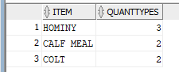So, before analyzing this database I made one small change because after running a query I found out that some items can use more than one quantity type to describe the quantity.

So, to fix this problem I converted the quantity types like bushel to lbs. using update statements.

Let’s say you hire someone else to analyze make sure you try to keep the quantity types consistent, so the DBA doesn't have to do it and saves time, and money. Also, for now to make things simpler I considered the receive column the same as the bought column.

Monthly Profit and How to increase margins

So, for a point of reference I have a made query to see how much the company is making so we get a sense of scale. *Pamount* is how much you guys pay people a month, B*amount* is how much you buy a month, and S*amount* is how much you sell amount, and *Profit* is sold-bought-paid. Also, I added the total profit.

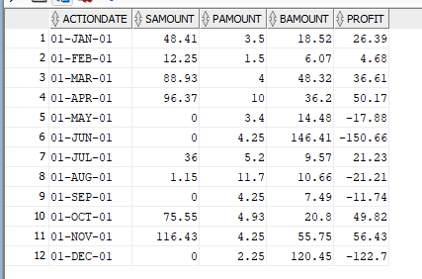

The major thing that stands out to me is you are in debt basically. So, a few interesting things to note on December, September, June, May, the store is not selling anything, and also August they go negative as well. So, the question is now how to reduce the negative profits?

Well I ran a second query which checks for each month how many times they paid someone to work

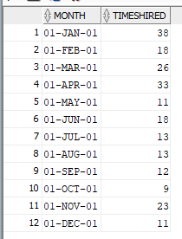

so, all the months marked are all the problem months that are negative. My recommendation for the future is maybe cut the amount of times you hire someone to do something in half. So instead of maybe hiring Dick jones 5 times a weak hire him twice a week. However, if it is imperative that you hire as much as your hiring there are alternatives. I have made a query that shows you who is offering the lowest average rates for the various jobs required. That way the company can save money on hiring for next year.

If we consider cutting in half the amount of days worked for people on the months we don’t sell anything. We end up cutting the amount paid by 8.48 dollars. Also lets just assume we hire the people with lower rates for next year some are offering to do the job for half the pay. So, let’s assume they will work as many hours, and any day we want. Then we can just cut the amount paid for the year in half, or maybe how about .4 we can get a cut of $18.032. That puts as now at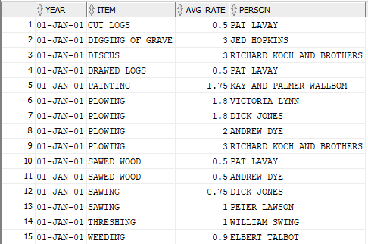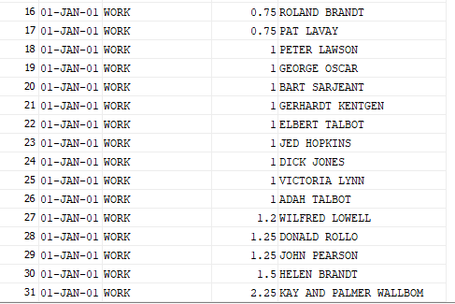 saving $26.512. So, the total is now $-52.348.

Also, I noticed that the bought category for June is 140 dollars and I’m wondering where that is coming from and what we can do about that so we can get closer to making profit.

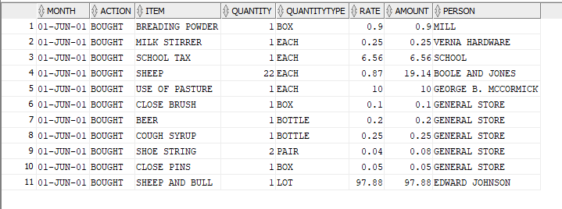

So, 97.88 was spent on farm animals in June.

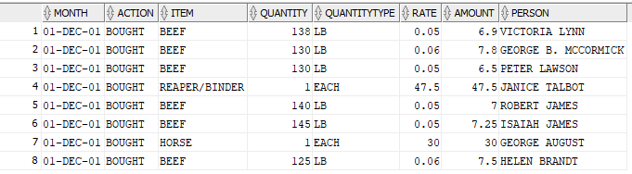Also, we got another large purchase of 47.5 in December. So, if we exclude all these big purchases assuming that maybe next year they'll pay off like selling the animals or getting milk from them, or breading them. Also, the reaper might be a one-time purchase as well. Then we'll be at $75 which is profit. We aren't done yet in optimizing the business. Let’s take a look at the items sold over the year.

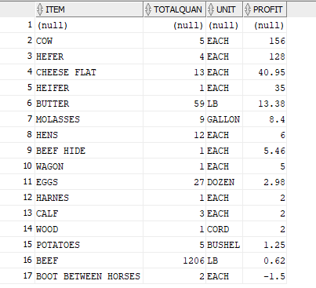So, one thing for selling 27 dozen eggs to only to make 2.98 something sounds off about that you're selling a dozen eggs for 11 cents. I don't care what year you're in maybe increase the price by half so now its .15. You just increased your profit by a dollar. Which in comparison could pay for an entire employee. Look at the number of cows sold a mere 5. Imagine a little price boost on the cows. 31.2 for each cow on average increase the price by a mere 20% not that crazy right? Rhetorical question that puts you at 37.44 per cow you just increased your revenue by $31.2. So now in total we are at $125.22. Keep in mind this is assuming everything stays the same, and we exclude those two big purchases, or assume that they pay for themselves. So, we are now greatly in profit territory compared to being -70. However, we aren't finished we have to talk about increasing margins on resale.

RESALE

So, after increasing are Profit margins we can go a little further by looking at items the business resells, and increase profit on that.

So, I made two views one which shows every kind of item you bought, and the total quantity you own over the course of the year, and its total value. Then every kind of item you sell, and then total quantity sold, and amount made.

ITEMS BOUGHT/RECEIVED ITEMS SOLD

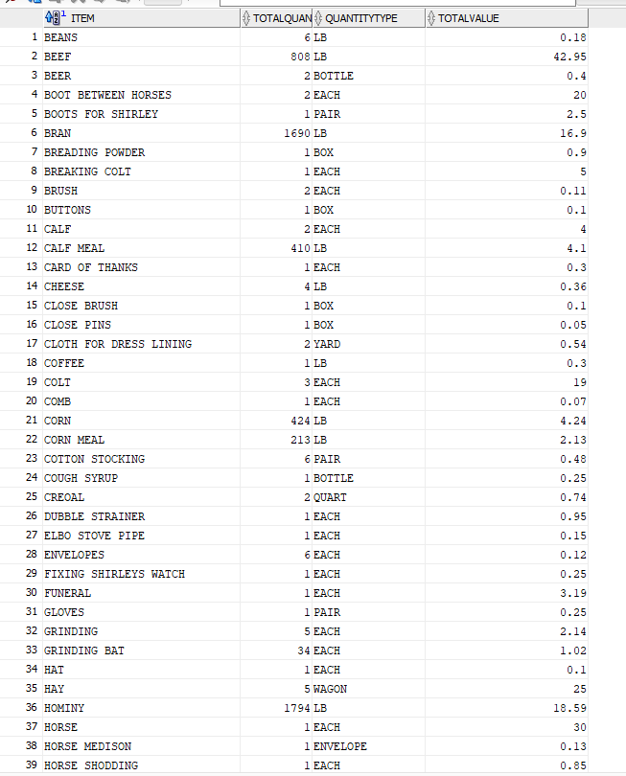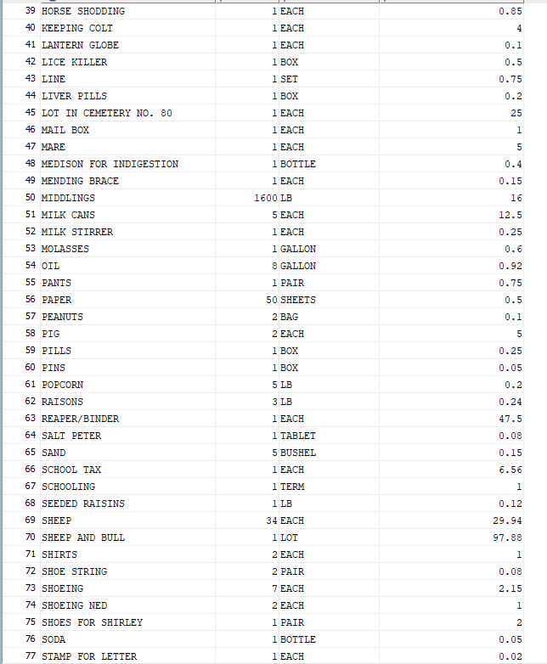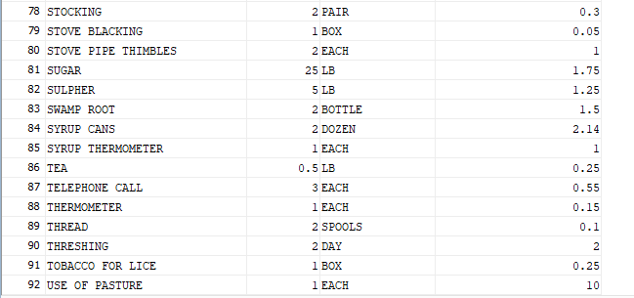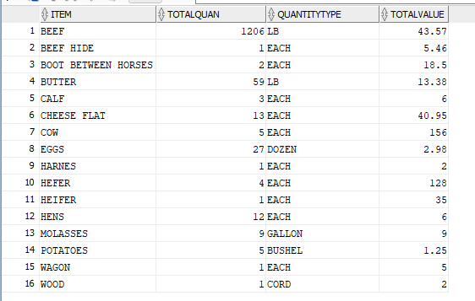

so, with these two tables here are the items that overlap, and the dollar amount sold, and bought.

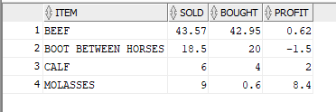 Total Profit

It shows the profit, but if we look a little more in depth, we can get some conclusive result here is a table of quantities bought and sold for the resale items.

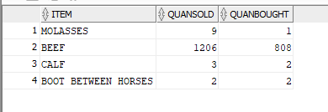

So maybe stock up a little more on molasses cause it seems to be very popular cause if we imagine for a second that if you bought the same amount of molasses, as you sold you'd be making a profit cause you bought it for .6 cents, and sold it for 1 dollar per gallon which is a pretty good margin because you are increasing the price by 100%. Then maybe cut out boots between horses because there is no profit margin on it or buy it cheaper or sell more. Now for the beef on average you are paying $.053, and you're selling it for $.036. why the business is selling it for less is beyond me. So, we are going to increase the price we are selling of beef per lb. by 100% of the price we bought cause that's what we are doing with the molasses. So now instead of a profit of .62 we get a profit of $41.69 on beef. So now on are running total we have now increased our profit to $166.91. We just turned one of our lousiest items into the second highest profiting item. Also, for the calves I’m not sure about the market so I am going to leave the price on those untouched, but if its anything close to the cows they should be selling for way more. Note this was all done without changing the price at which the company buys the items. I looked into the rates at which you are buying the items; however, everything is either being sold at the same rate, or only by one person.

SUMMARY

In the end we went from being down $-78.86, and in the future how to increase the profit to $166.91. We did this how, buy finding the workers with the cheapest rates, and reducing the days worked on months the company has no business. Also figuring out how to increase margins on items resold, and items just sold in general. Also, we looked at the items bought that put huge dents into the profit. We figured they would eventually pay for themselves like the sheep, bull. The bulls mate with the cows; you could sell more calves, cows, the sheep sells wool, goat sells milk, and etc. Also, the reaper/binder I’m assuming you only need one of and wouldn’t need next year. Before we rap this up a few things to note about all the items bought in general. Some of the things you are buying at absurd prices like milk cans; which I assume are a product for holding milk which costs $12.5 which is 7% of your profit. Also assuming this is a farm, or something of the sort things like cheese, hominy, corn, and milk your animals, and crop will be producing. So, I guess you could in theory you could subtract them from the profit, but I didn't. I only subtracted two very specific items that made sense. So, in the end we tried to our best to increase the profits without comprising the integrity because we could just say buy everything your buying at half the price, but I don’t think that’s possible. As well as me as the dba doesn’t know what you’re buying all these items for maybe you’re starting a second business, or you’re crafting stuff that you can sell in the future so I tried to keep it as strictly analytical as possible. Also I left the company with a lot of information like; all the items you have sold, how much of it you have sold, and how much has been bought. Just in case you need to know what items to restock on, and what not. With that my report is finished. Hopefully the company now knows what to do for the future, and is hopefully headed on a better trajectory now.