SupremeBot

OOP2 Hand-In project assignment

Nazmul Alam – t00152975

2014

# Introduction

SupremeBot is a java (swing) application that uses an artificial intelligence algorithm to have conversations with humans. It is created for OOP2 Java Project - to showcase the ability to re-use third party codes and understanding of OOP2 from the current curriculum. It is unique in the sense that it learns from humans, remembering words within its AI.

The user **first needs to login** to use the chat functionality. User will be **allowed to register** a new account as well if they are not registered into the system.

The program is divided into three parts

1. Dumb Bot
2. Bot versus Bot
3. Supreme Bot

**Dumb Bot** uses pre-coded, self-algorithm based program to answer to the questions, as suggested, the program is not as sophisticated as its counterpart.

**Bot versus Bot** functionality allows us to delve into how a computer talk against the computer. It should be fun how both AI responses work.

**Supreme Bot** functionality allows us to chat with the computer.

The history of the chat log are stored in the local directory, and can be restored by clicking ‘Load previous conversation’ from the menu.

**NB: The program needs to be able access the internet to function.**

# UML Class Diagram

# VOPC Diagram

LoginScreen

MainProgram

DumbBot

SupremeBot

ChatterBotThought

Dashboard

BotChattingBot

Utils

ChatterBotSession

User

GUICreation

RegistrationScreen

# Javadoc (Screenshots)

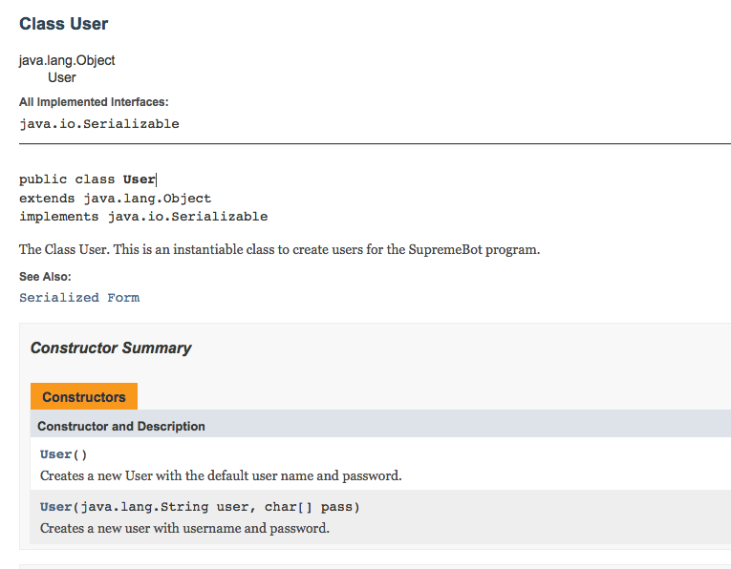

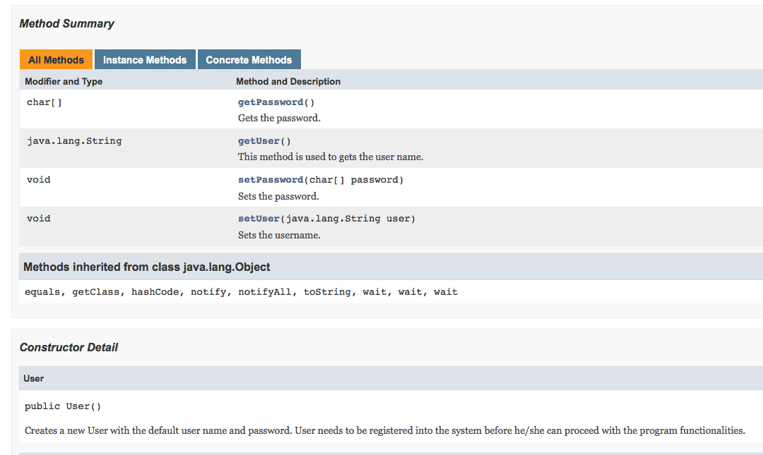

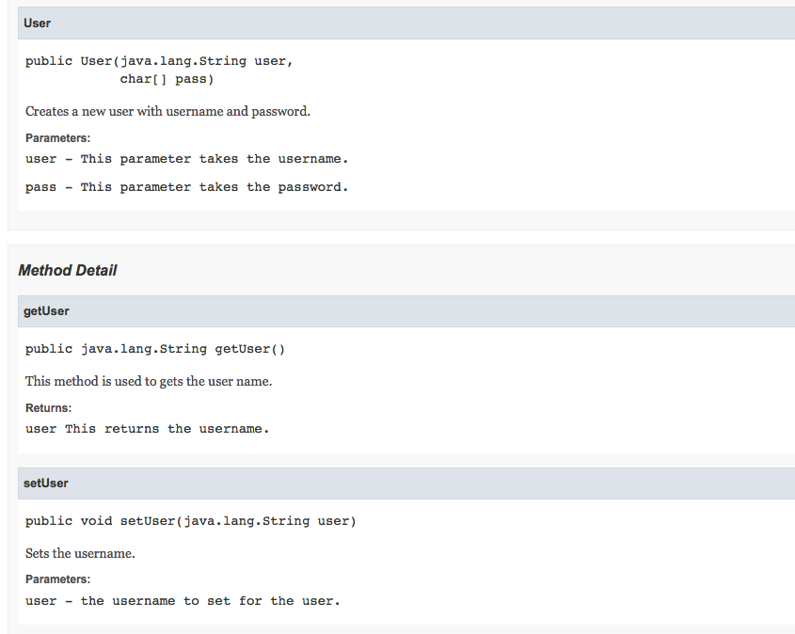

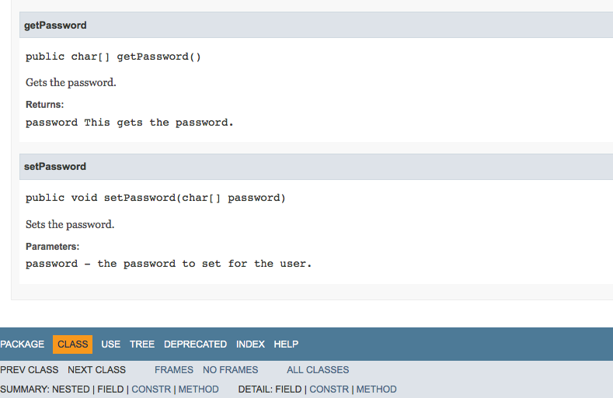

# Source Code