PracticeLab
User Guide — Coders and Auditors

Reading charts, coding and auditing assigned work, and sitting assessments
For: Coders and auditors
Version 1.0 · 21 September 2026

About this guide
Everything you need to use PracticeLab as a coder or an auditor. You will not see the Workspace or any trainer screen, and nothing here needs a password.

Before you start
PracticeLab is where you read clinical charts, practise coding them, and sit knowledge assessments. You do not need an account or a password. Your trainer gives you a code for each piece of assigned work.
You want to… | Go to | You need
Read a chart | The home screen | Nothing
Code assigned charts | Practice (right-hand side) | An access code, e.g. PRC-ABCD1234
Audit assigned charts | Practice (same place) | An audit code, e.g. AUD-ABCD1234
Sit an assessment | Assessment (right-hand side) | An Assessment ID, e.g. ASM-X7K2M9QP

Your code is personal
A code opens one person’s work. Do not share it and do not use anyone else’s. Your results are recorded against the name and employee ID the code was issued to.

The first time you open PracticeLab it asks your name. That name is stored in your browser only. It labels what you do; it is not a login.

Finding and reading charts
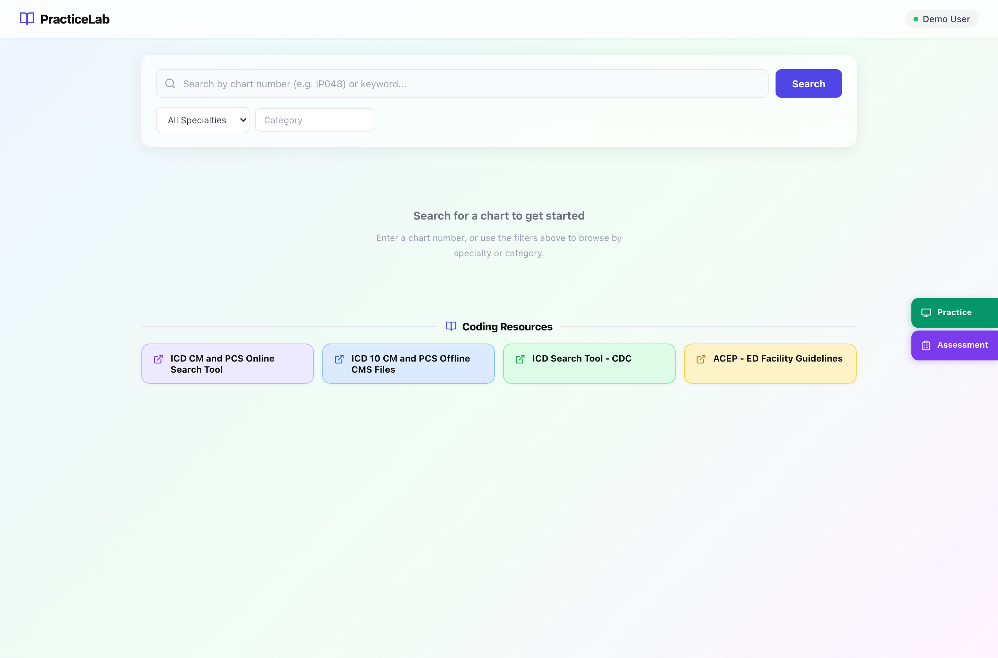
The home screen. Search sits at the top and Coding Resources below it; Recently Viewed appears once you have opened a few charts.
Section | What it is for
Search bar | Type a chart number (IP048) or a word. You can also leave it empty and search by specialty alone.
Specialty and Category | Narrow the list. Category options follow the specialty you pick.
Recently Viewed | The last charts this browser opened, for quick return.
Coding Resources | Reference links your trainers publish — guidelines, code books, policies.
Practice / Assessment | The two buttons on the right edge. This is where assigned work starts.

How to find a chart
- Type the chart number or a word, or pick a specialty.
- Press Search. Results list the chart number, specialty and category.
- Click a result to open it. Press the × in the search bar to clear the search and return to the home screen.
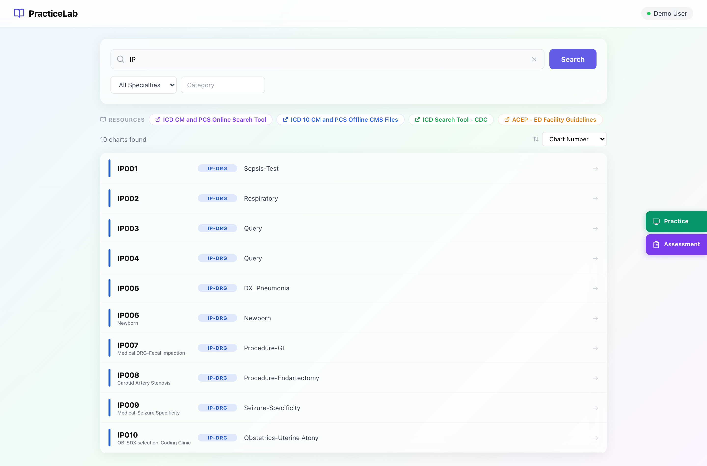
A search in progress. Resources move to a strip at the top while results are showing.

The chart viewer
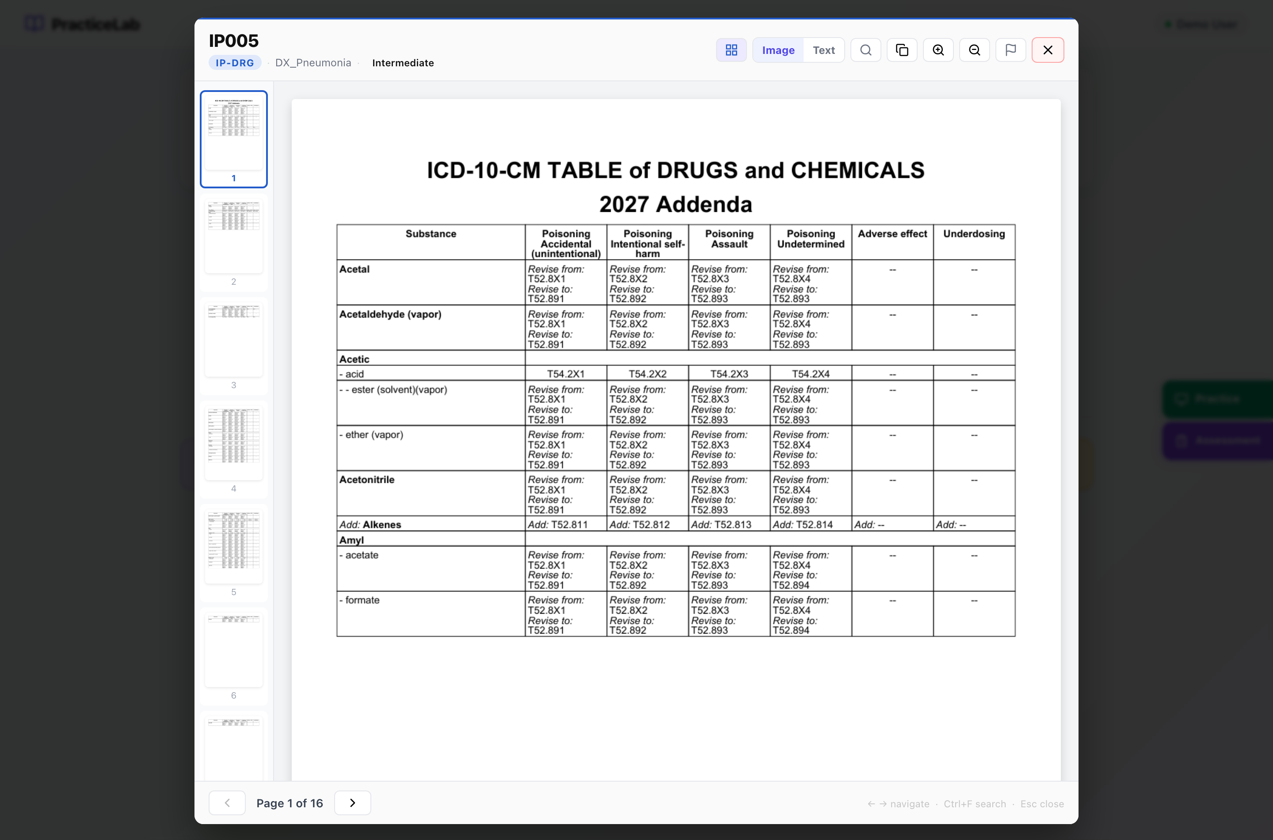
The viewer in Image mode — the pages exactly as scanned.
Control | What it does
Thumbnails (grid icon) | Show every page as a small preview; click one to jump to it.
Image / Text | Switch between the scanned page and its extracted text. Text is easier to search and select.
Search (magnifier, or Ctrl+F) | Find a word anywhere in the chart. Matches appear as page snippets with the word highlighted.
Copy | Copies the chart number.
Zoom in / out, Fit width, Fit page, Rotate | Adjust how the page sits on screen.
Flag | Report a problem with the chart — see below.
× or Esc | Close the viewer.
← → keys | Previous and next page.

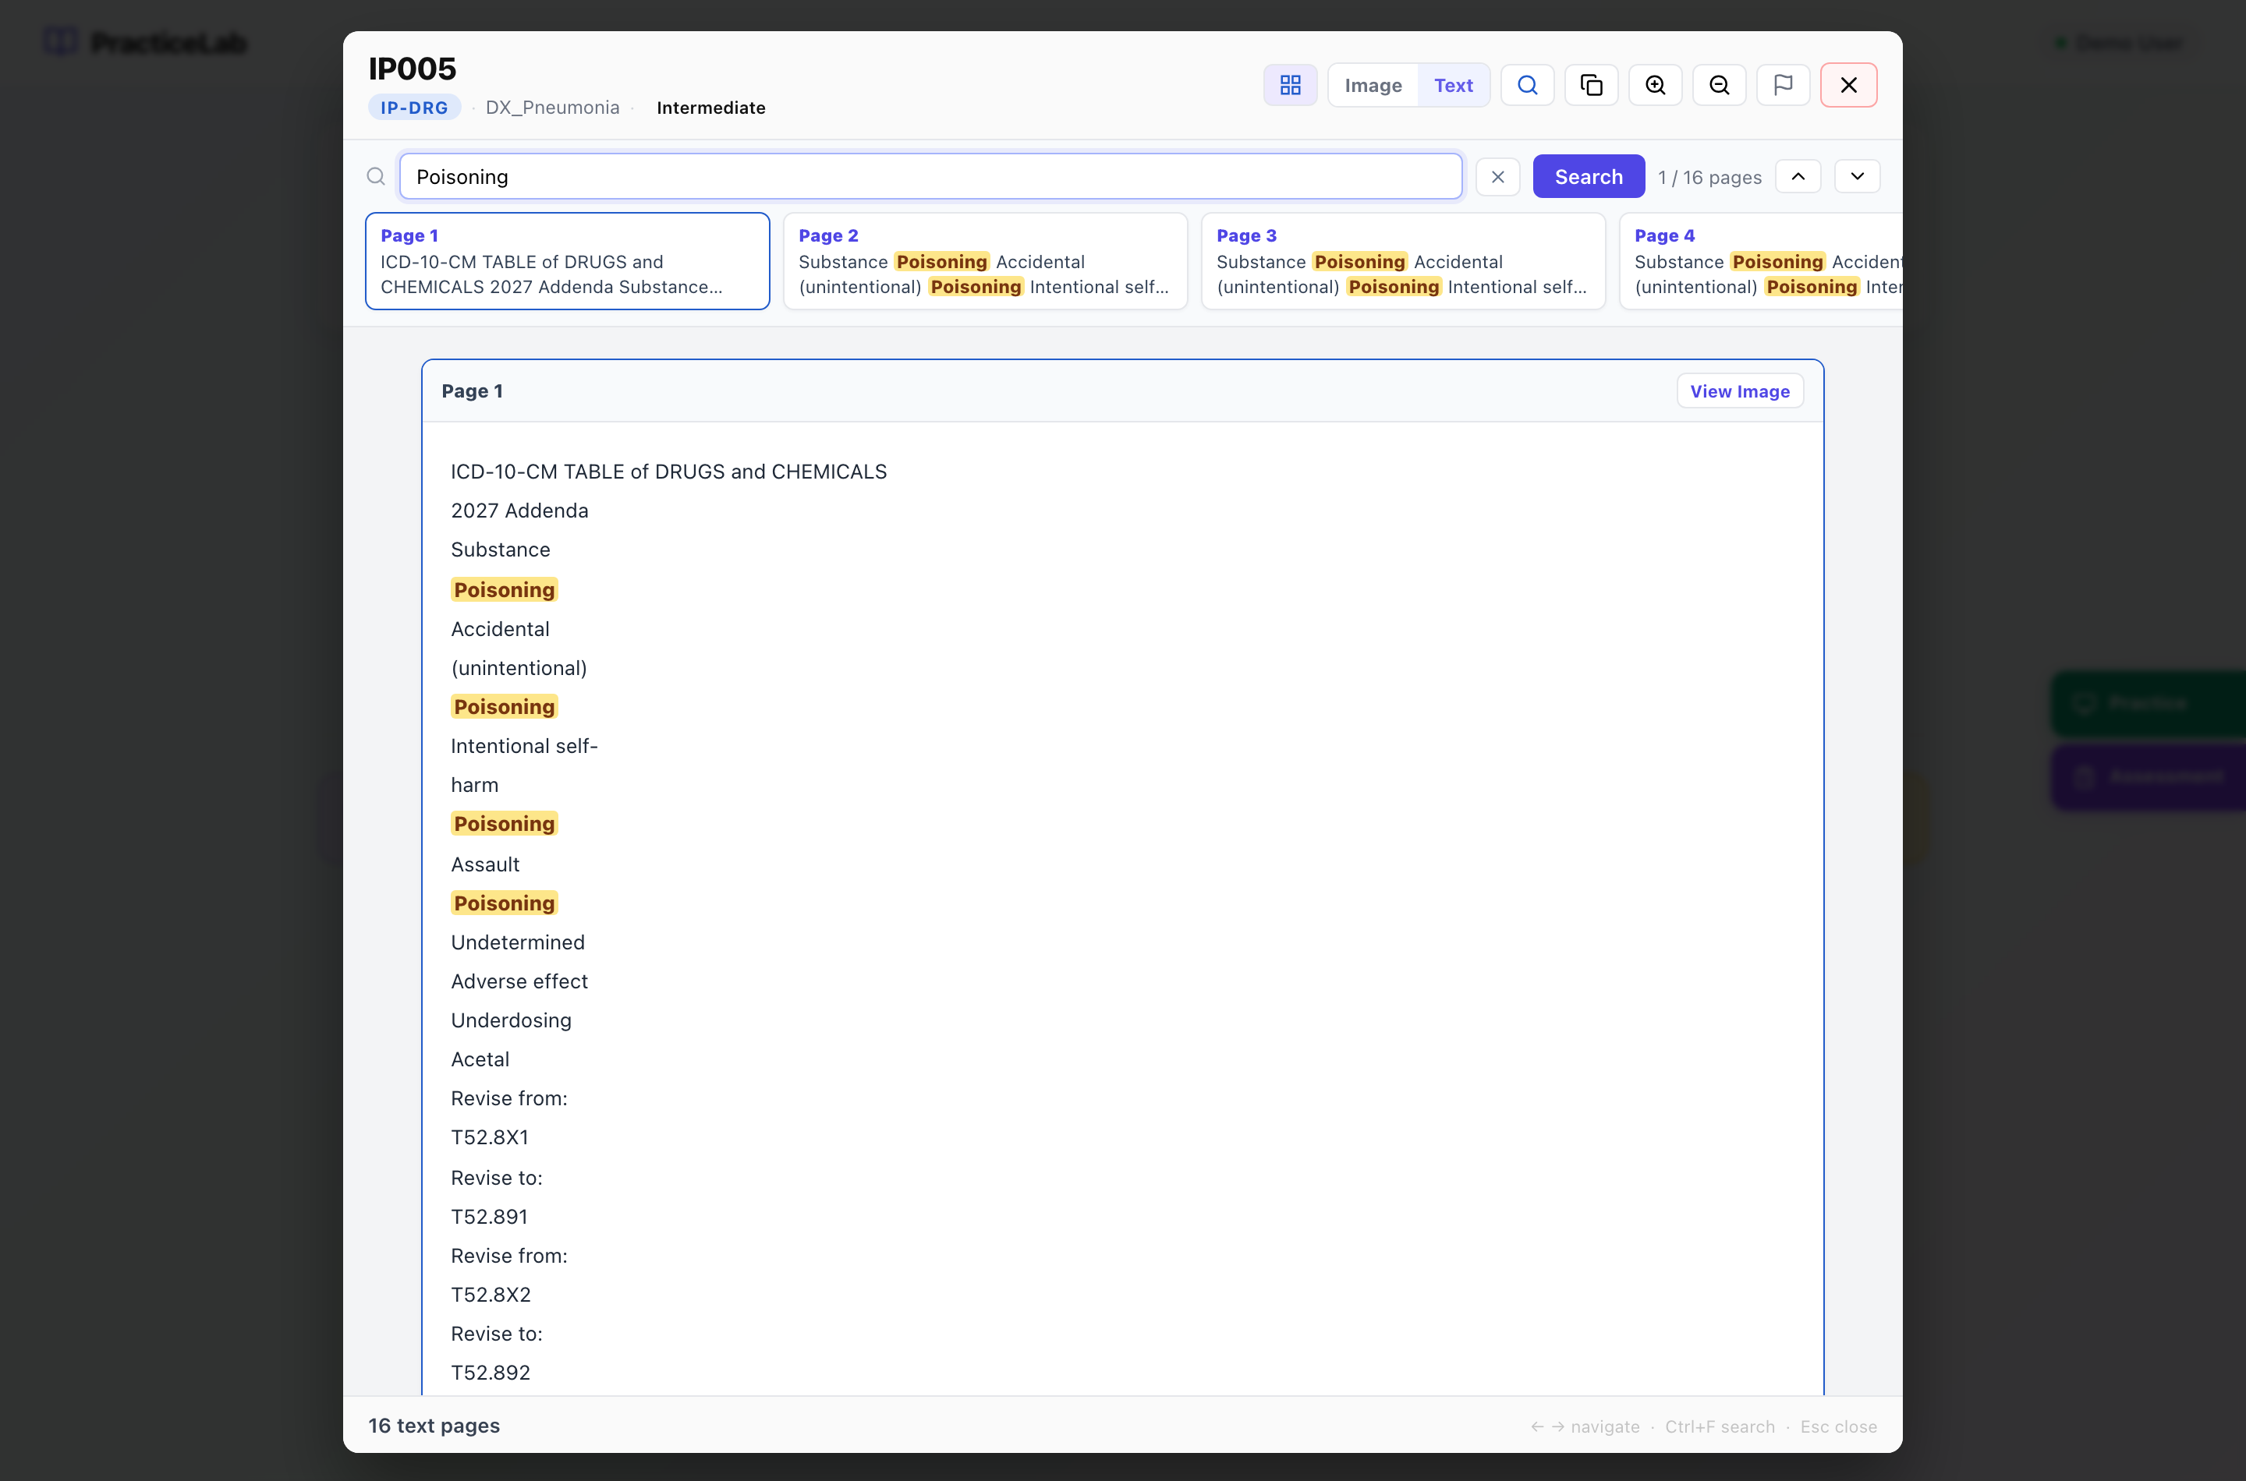
Text mode with a search running. Each snippet is a page with a match; the arrows step through them.

How to search inside a chart
- Press Ctrl+F (or the magnifier) and type a word.
- Press Search. The count shows how many pages matched.
- Click a snippet, or use the up and down arrows, to move between matches.
- Press × to clear. If a chart says text is not available, it was scanned without readable text — use Image mode.

Reporting a problem with a chart
Use the flag icon when a page is unreadable, a document is missing, or something on the page should not be there. Choose the problem, add a note if it helps, and send it. It goes straight to your trainers’ Feedback queue.

Coding assigned charts (Practice)
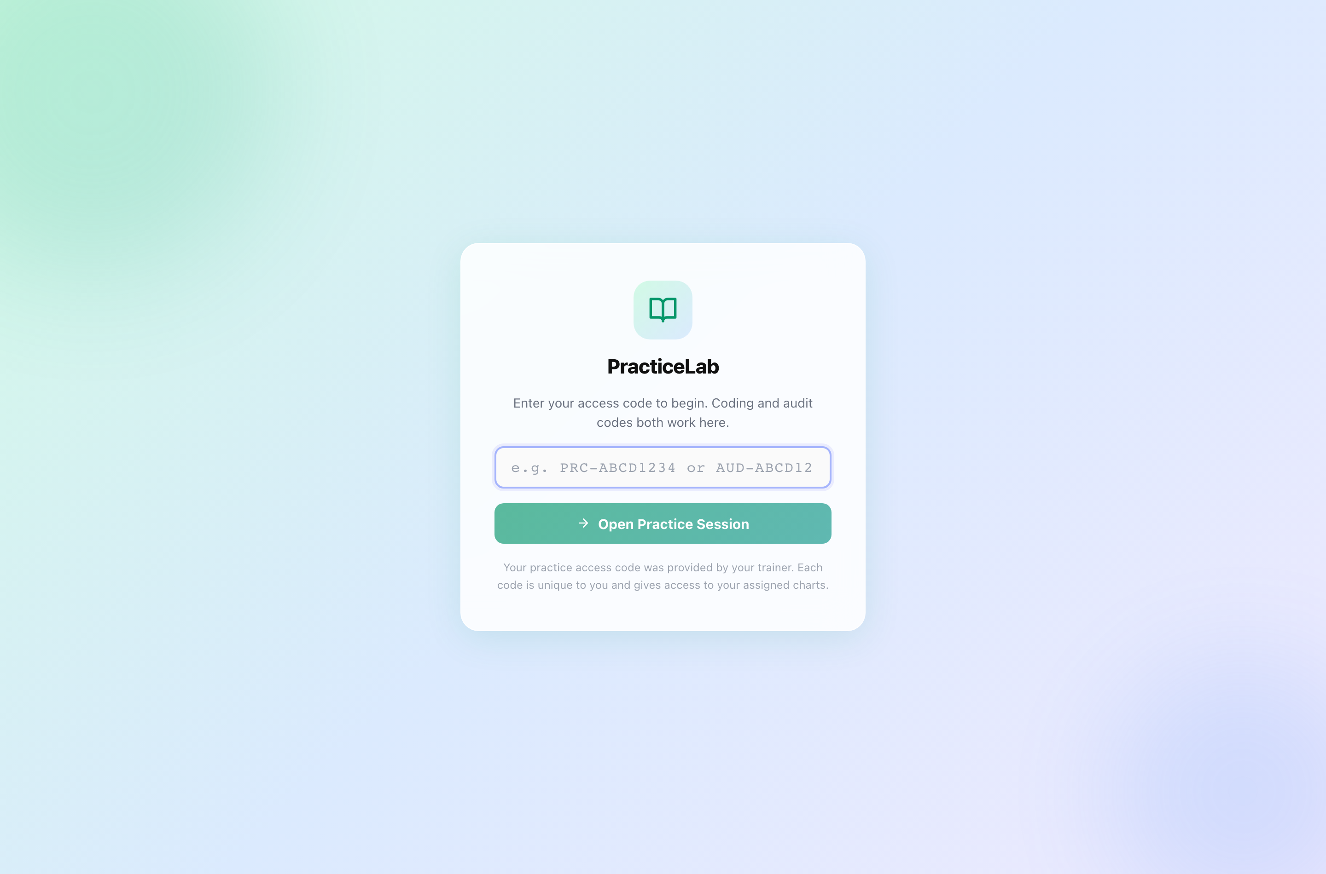
The Practice entry page. Coding codes and audit codes both work here.

How to start
- On the home screen, click Practice on the right edge.
- Enter the access code your trainer gave you and press Open Practice Session.
- Your charts appear in the left panel. Click one to open it and its coding form.

The screen
Section | What it is for
Left panel | Your assigned charts and their status — Not started, In progress, Complete — plus any you flagged.
Chart | The chart itself, with the same viewer controls as the home screen.
Coding form | The fields for this chart. They depend on its specialty — see below.
Save Progress / Submit All Charts | Save as you go; submit once, at the end, for everything.

What the form asks for, by specialty
Specialty | You enter
IP-DRG (inpatient) | Principal diagnosis and secondary diagnoses, each with a POA indicator, and ICD-10-PCS procedures.
ED Facility, ED Single Path, SDS, Surgery, Ancillary | First-listed and additional diagnoses, CPT procedures with modifiers, units and diagnosis pointers where the specialty uses them. No POA.
ED Profee | Diagnoses, the professional ED level, and procedure CPTs if applicable.
E/M | Patient type (new or established), the E/M code, and — when the visit is levelled by medical decision making — the three MDM sections: Problems (COPA), Data Review, and Risk.
Edits, Denials | No codes. You write your review, research, recommended resolution and final rationale.

POA indicators (inpatient only)
Value | Meaning
Y | Present at admission
N | Not present at admission
U | Documentation insufficient
W | Clinically undetermined
E | Exempt from POA reporting

Entering codes
- Type codes with or without the dot or spaces — J18.9 and J189 are both accepted.
- As you type, suggestions and descriptions appear for ICD-10-CM, ICD-10-PCS and HCPCS. CPT codes have no descriptions: that code set is licensed separately and is not in the system.
- Diagnosis pointers are numbers (1, 2, 3, 4), up to four per line.

Flags, notes and queries
- Flag — mark a chart you are unsure about. Your trainer sees the flag.
- Notes — anything you want your trainer to know about the chart. Only trainers see it.
- Query — where the documentation is unclear, answer “Yes — send for query” and write the question you would put to the physician. The query is then required, and your trainer reviews it.

Saving and submitting
- Work saves when you move to another chart. Press Save Progress any time to be sure.
- When every chart is done, press Submit All Charts.
- Review Before Submit lists each chart’s status and anything missing — for example a diagnosis without POA. Go back and fix it, or submit anyway.
- Confirm. Submission is final: you cannot change your codes afterwards.
- You see Submission Complete. If your trainer switched results on for this batch, your chart-by-chart feedback appears; otherwise your trainer shares it later.
Leaving part-way is safe
If you close the window before submitting, your work is kept. Open Practice with the same code later and carry on where you stopped.

Auditing assigned charts (for auditors)
Audit work is the reverse of coding. Each chart arrives already coded, as a claim. Some claims contain errors and some are correct. Your job is to find what is wrong and fix it — and to leave correct codes alone.

How to start
- Click Practice on the home screen, enter your audit code (it begins AUD-) and press Open Practice Session.
- Pick a chart from the left panel. The claim is shown section by section beside the chart.

What you can do to a claim
Action | How | Use it when
Keep | Do nothing | The code is correct as it stands.
Revise | Change the code or its POA, modifier or units in place | The code is on the claim but is wrong.
Delete | Press Delete on the line (Undo reverses it) | The code should not be on the claim at all.
Add | Press “Add a missing code” | A code the documentation supports is missing.

What counts
A finding counts only when you both spot it and correct it. Deleting a line or changing a code without putting the right one in its place does not score. And changing a correct code costs you — restraint is measured as carefully as detection.

Queries, notes and submitting
- Physician Query — if the documentation is unclear, answer “Yes — needs a query” and write what you need clarified.
- Notes — optional, for your trainer.
- Save progress as you go; press Submit Audit when every chart is reviewed. Review Before Submit shows what is left, and submitting is final.

Sitting an assessment
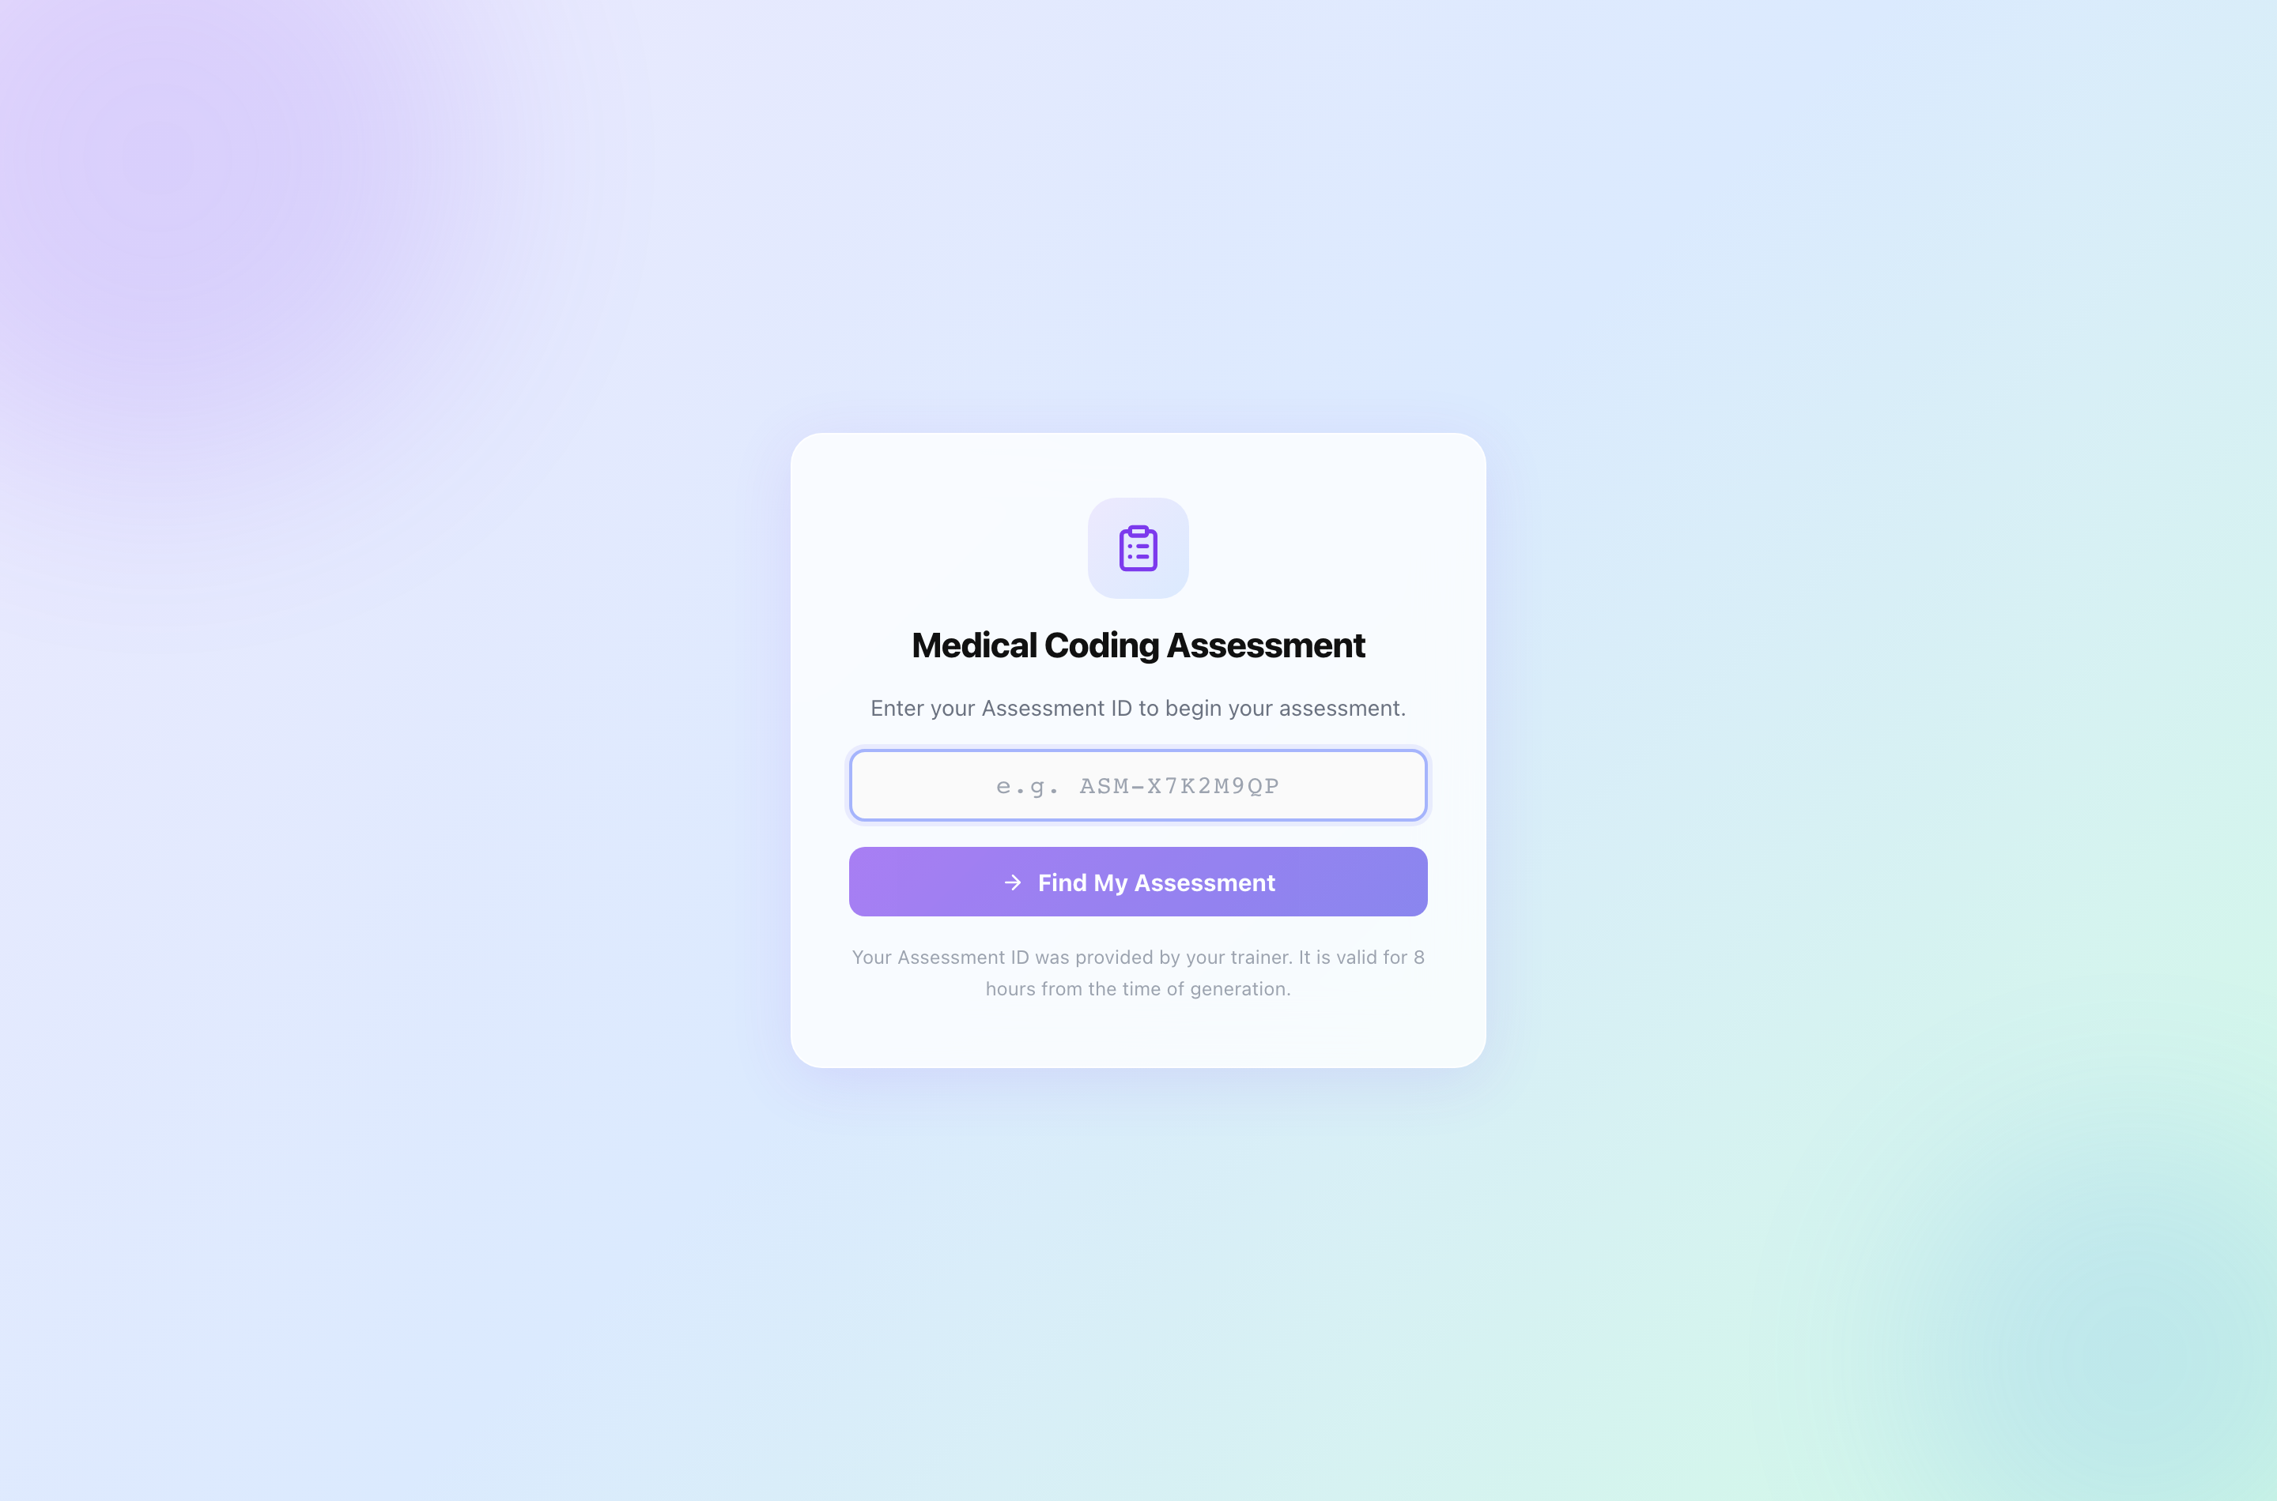
The assessment entry page.

How to sit it
- Click Assessment on the home screen, enter your Assessment ID and press Find My Assessment.
- Read the Ready to Begin screen — number of questions and time allowed. The clock starts when you press Start Assessment.
- Answer each question. Move freely between them from the question list; answers save as you go. Unanswered questions show as Skipped.
- Open Review & Submit to check what is left, then press Final Submit and confirm.
The clock does not stop
Closing the window does not pause it. When time runs out the paper submits itself with whatever you answered. A submitted paper cannot be reopened.
An Assessment ID is valid for 8 hours from when it was issued.

Afterwards you see either your result — score, pass mark, PASS or DID NOT PASS — or a message that your trainer will share it. Which one depends on how your trainer set up the assessment. You never see the questions again, because they are reused.

Good to know

One device at a time
A code can be open on only one browser at a time, so nobody else can work on your charts while you are. If you move computers, close PracticeLab on the first one before opening it on the second. If you forget, the hold releases itself after 90 minutes of inactivity, or your trainer can release it straight away.

When your batch closes
When your trainer closes a batch, you can no longer save or submit work in it. You can still open your code to read your own results and feedback.

Troubleshooting
What you see | What it means | What to do
“Access code not found” | The code was mistyped, or it is not a practice or audit code. | Check it character by character. Assessment IDs go in Assessment, not Practice.
“This access code is already open on another device” | Your code is open in another browser or on another computer. | Close it there and try again, or ask your trainer to release it.
“Could not save — check your connection” | The last save did not reach the server. | Check your connection and save again before leaving the chart.
Cannot submit; batch closed | Your trainer has closed the batch. | Contact your trainer. Your feedback is still readable.
“Some diagnoses are missing POA selection” | An inpatient diagnosis has no POA. | Choose a POA for each diagnosis.
Chart text not available | The chart was scanned without readable text. | Use Image mode.
“Assessment not found” | The Assessment ID is wrong or has expired. | Check it, or ask your trainer for a new one.

