PracticeLab
User Guide — Trainers

Running the chart library, batches, audits and assessments
For: Trainers
Version 1.0 · 21 September 2026

About this guide
How to run PracticeLab as a trainer. It covers every screen in the Workspace and the day-to-day work in each module.
What coders see is covered in the Coder guide — worth reading once, because most questions coders ask are answered there.

Your role
Trainers run the platform day to day: they manage the chart library and answer keys, run PracticeLab and audit batches, issue assessments, and read the results. Everything a trainer does happens in the Workspace, at /trainer.
Area | Coder | Trainer | Admin
Chart search and viewer | ✓ | ✓ | ✓
Practice, audit and assessment sessions (own code) | ✓ | — | —
Report a chart problem | ✓ | ✓ | ✓
Workspace and every trainer screen | — | ✓ | ✓
Chart Management, answer keys, batches, assessments, analytics | — | ✓ | ✓
Actions that need the master passphrase | — | — | ✓

Some actions need an Administrator
A small set of actions ask for the master passphrase: anything permanent, anything that changes a finished record, scoring changes that affect everyone, and bulk exports of answers. They are listed in the final chapter of this guide. If you need one done, ask an Administrator.

The Workspace
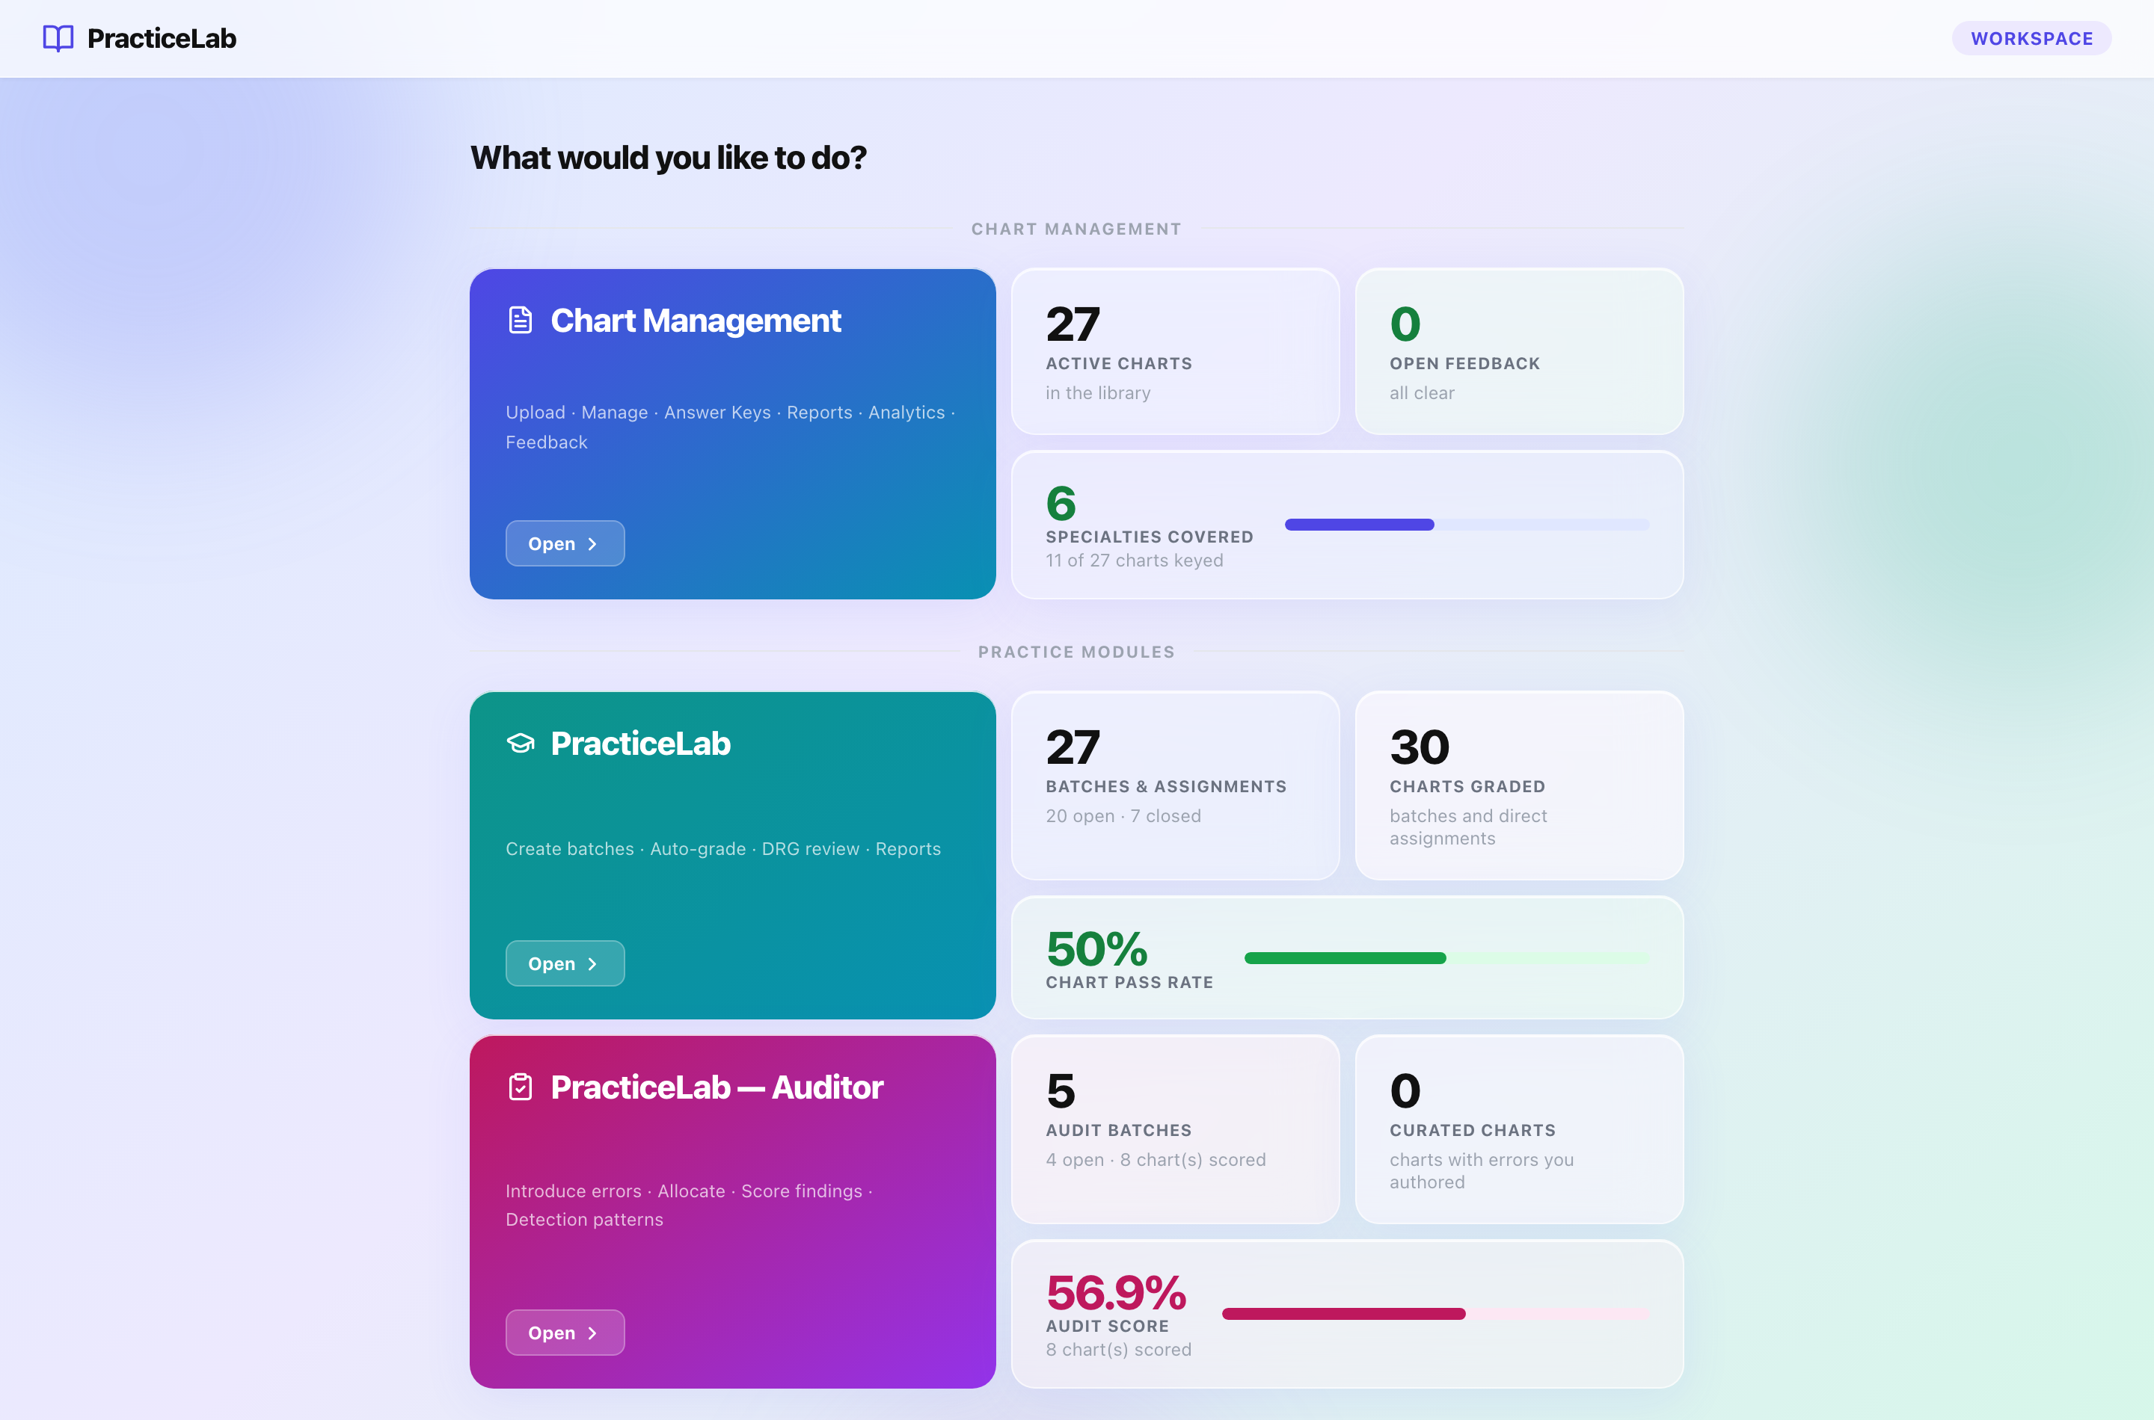
The Workspace. Each module card opens its area; the tiles beside it are live counts.
Section | What it is for
Chart Management | The chart library: upload, manage, reports, analytics, feedback.
PracticeLab | Coding batches, answer keys, scoring and analytics.
PracticeLab — Auditor | Audit batches, audit keys, audit scoring and analytics.
Assessments | The question bank, paper generation, sessions and analytics.

The tiles are worth a glance each morning: open feedback, charts without keys, open batches and the current pass rates are all here.

Chart Management
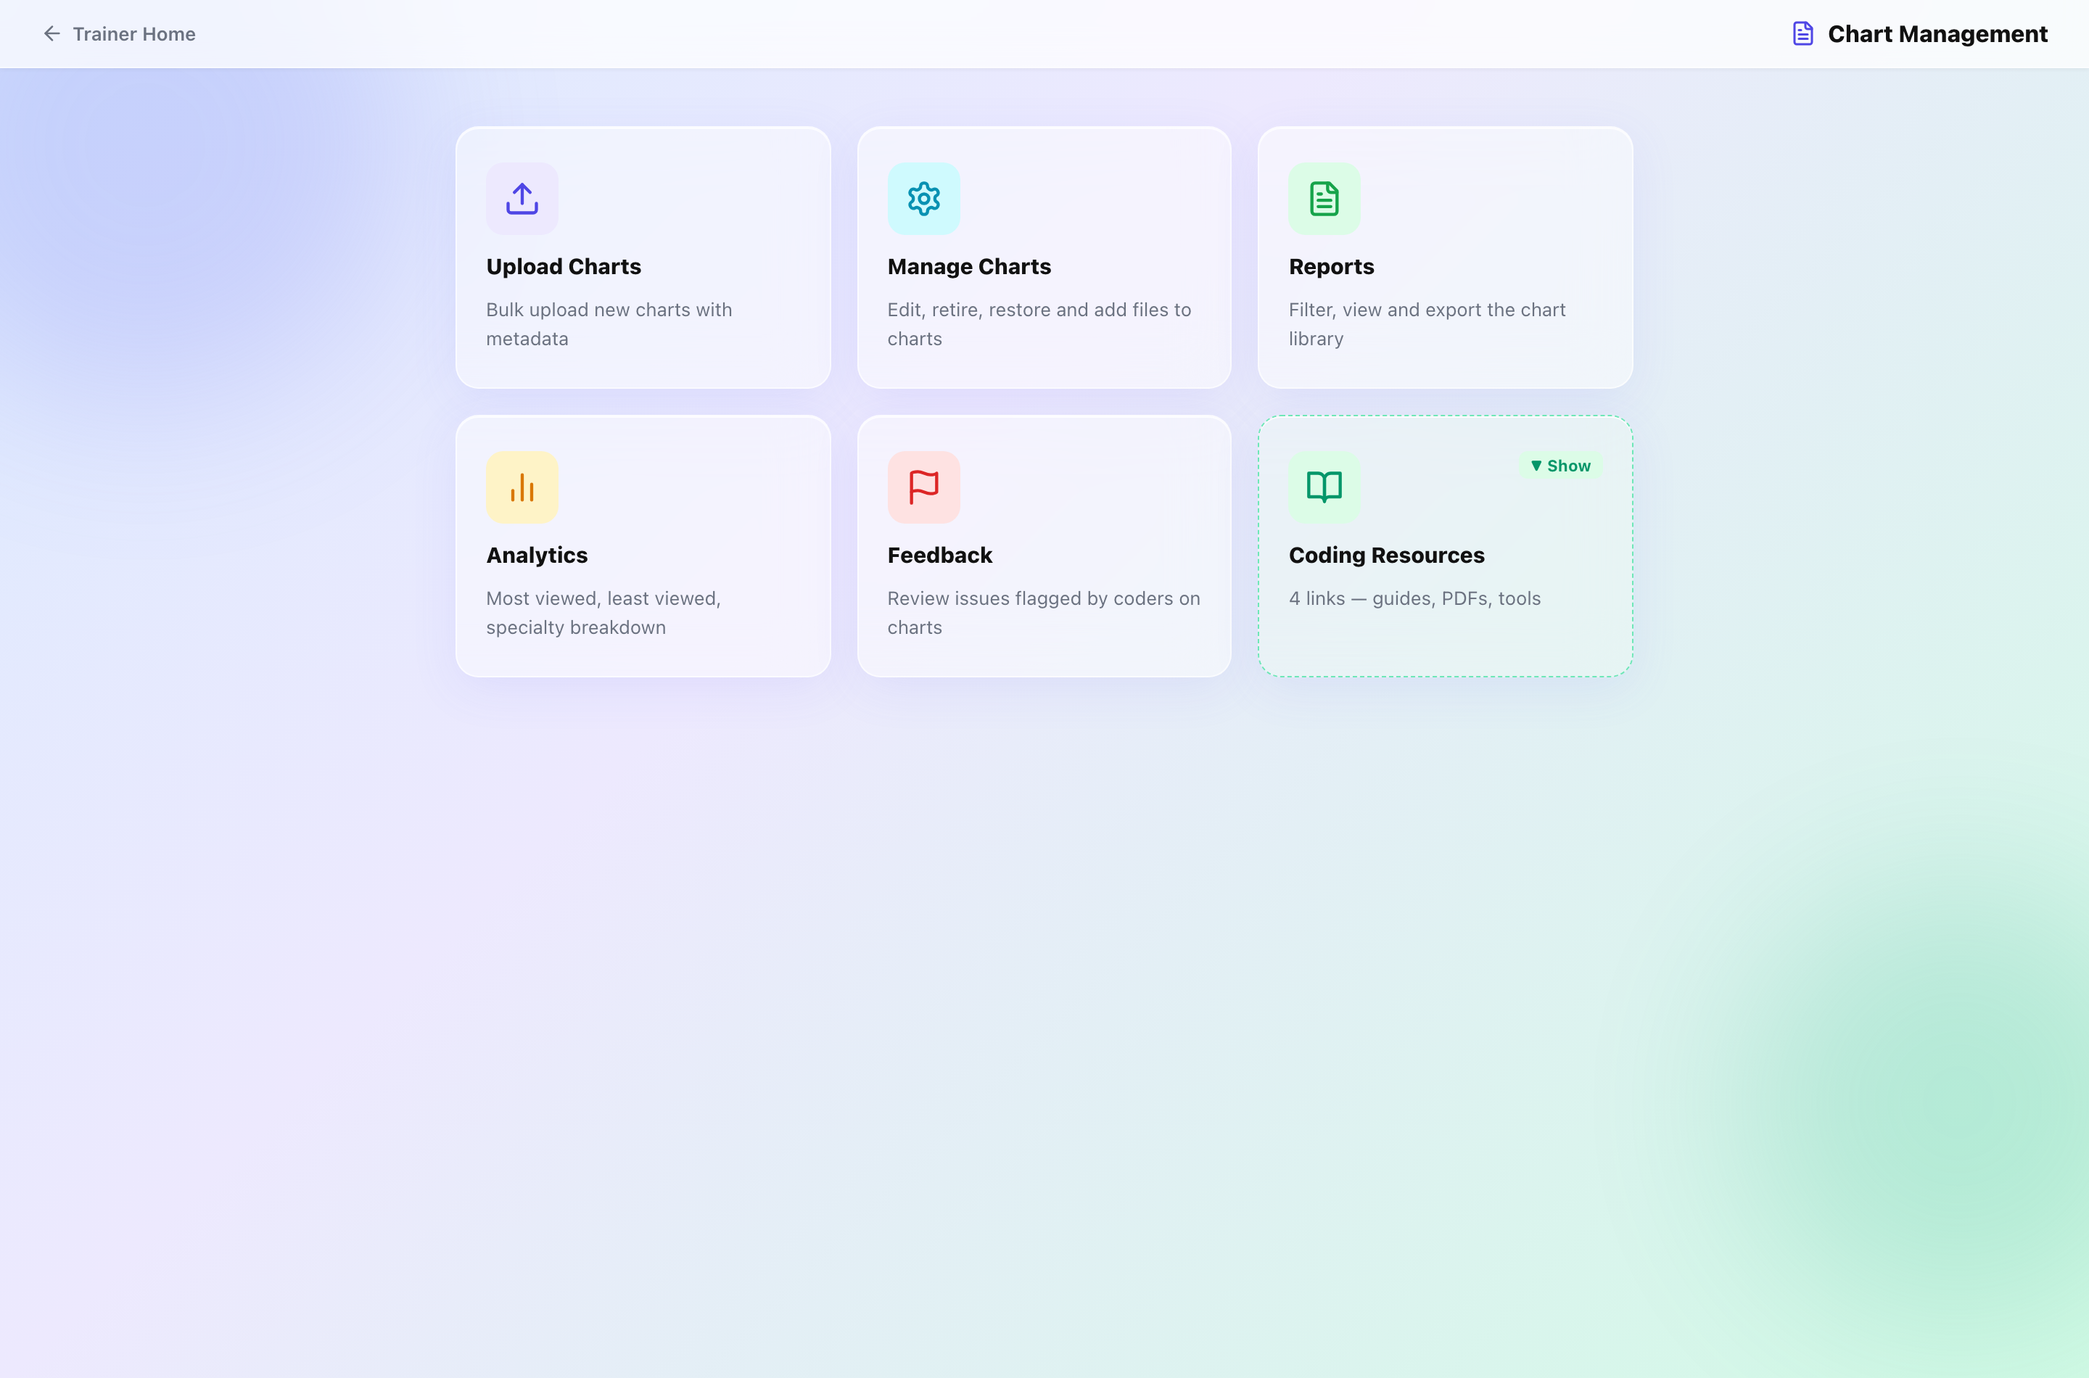
The Chart Management hub.
Section | What it is for
Upload Charts | Add charts. Numbers (IP001, SURG014) are assigned automatically per specialty.
Manage Charts | Search, edit details, retire and restore, add or replace pages.
Reports | Filter the library and export it to Excel.
Analytics | Charts by specialty, most and least viewed.
Feedback | Problems coders have reported, and their resolution.

How to upload charts
- Upload Charts → drag in PDFs or images (several at once is fine).
- Set specialty, category and difficulty for each.
- Preview to see the numbers that will be assigned, then Upload.
- Add answer keys for the new charts — until then they can be read but not graded.
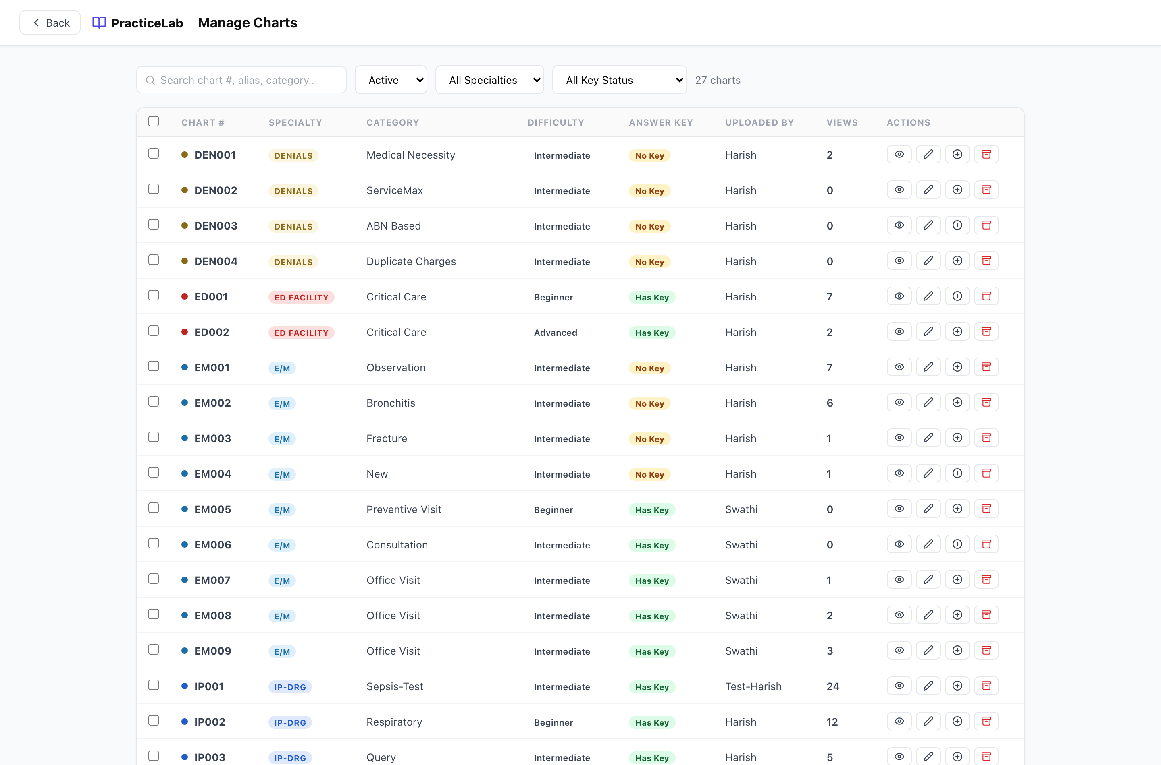
Manage Charts. The status filter includes Retired.

How to look after a chart
- Edit details — open the chart in Manage Charts and change category, difficulty or rationale.
- Retire — withdraws the chart from coders and breaks saved links, but keeps it, its key and its history. Restore brings it back. Use this instead of deleting.
- Replace pages — for a corrected copy, typically when a page shows information it should not. The chart keeps its number, key and results. You give a reason, which is recorded.
Your own charts
You can edit, retire, restore and replace pages on charts YOU uploaded. Doing any of these to a colleague’s chart needs an Administrator.

How to handle feedback
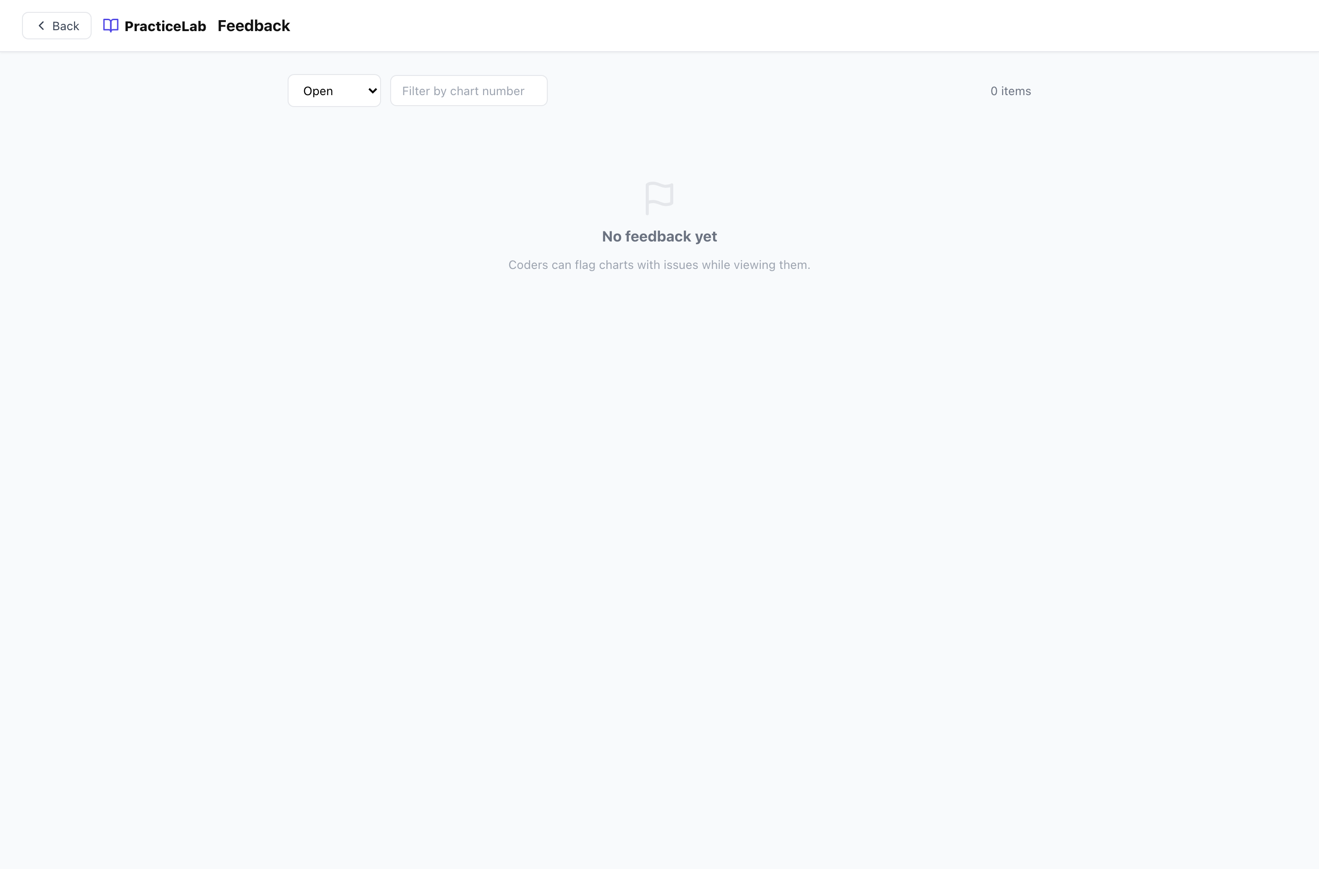
The Feedback queue.
- Open Feedback and read the report.
- Fix the chart if needed (often by replacing pages).
- Resolve the item. It can be reopened if the problem returns.

Coding Resources
The reference links coders see on the home screen. Add, reorder and remove them from Chart Management.

Answer keys
An answer key is the correct coding for one chart. A chart without one cannot be graded and is left out of graded batches automatically.
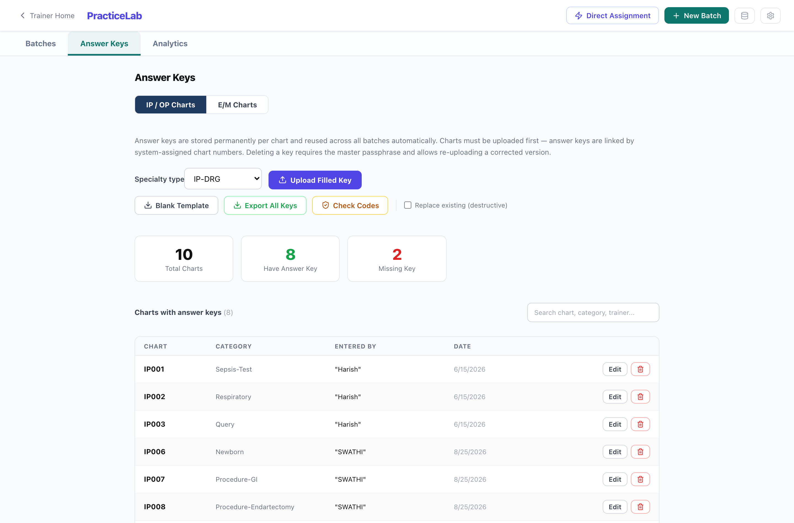
PracticeLab → Answer Keys. Filter by specialty and by whether a key exists.

Three ways to add a key
Method | Best for
Excel template — download, fill, upload | Many charts at once. The template is specific to each specialty; use the one for the charts you are keying.
Key editor — type it in on screen | One chart, or a quick correction. Code descriptions appear as you type, which makes it a check as well as an entry form.
E/M keys — separate template and screen | E/M and ED Profee charts, which are graded on medical decision making rather than code matching.

Check the key before a batch uses it
A wrong key is worse than a wrong answer: it silently grades every coder against it. Use the descriptions in the key editor to confirm each code says what you meant.

Adding keys is open to every trainer, and so is editing a key on a chart you uploaded. Editing an existing key on a colleague’s chart, replacing keys on upload, deleting a key and exporting all keys are Administrator actions.

PracticeLab — running coding batches
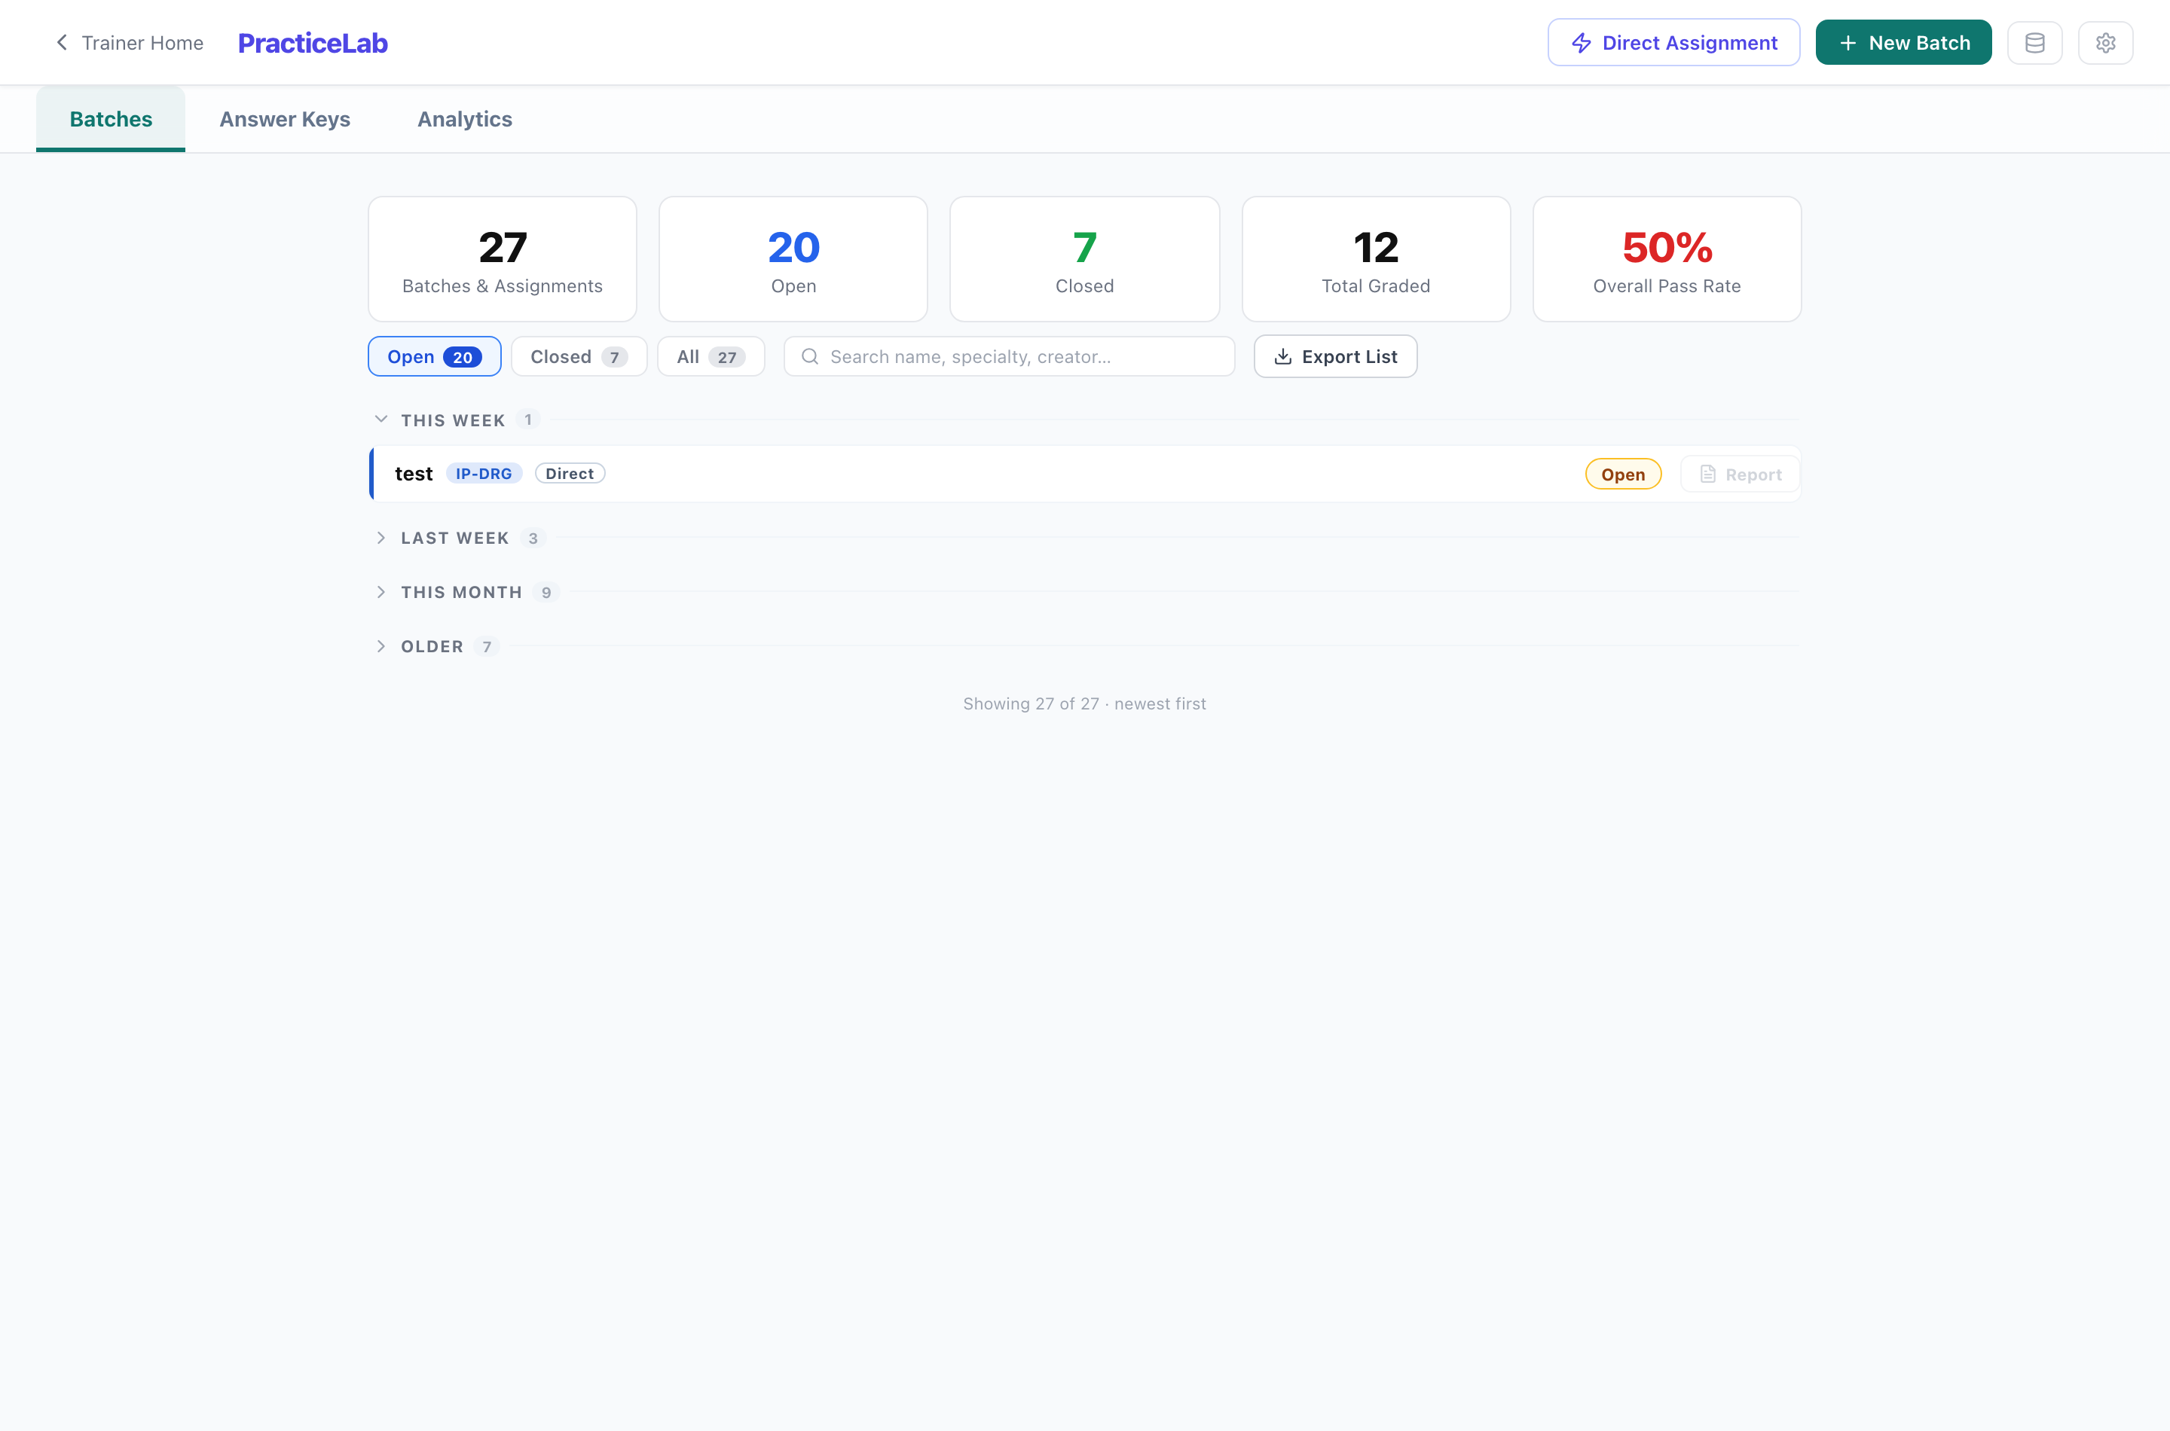
PracticeLab batches. The newest group opens by default.
Section | What it is for
Batches | Create, allocate, monitor, grade and close.
Answer Keys | The correct coding per chart.
Analytics | Ten views of performance — see the Analytics Guide.
Direct Assignment (button) | Give specific charts to specific people, outside a batch.

 | Batch | Direct assignment
Charts | Dealt by the system from a pool you filter | Picked by you
Suits | A cohort working through a pool over cycles | One person, one or a few charts
Analytics | Counted in cohort figures | Kept separate, and shown by the scope switch

How to run a batch
- New Batch — name, specialty, the filters that define the chart pool, charts per coder, and whether coders see their own results.
- Add coders (by name and employee ID, or from a file).
- Run Allocation. Each coder is dealt charts they have not seen, and gets an access code.
- Copy each access code and send it to its coder.
- Watch progress on the batch screen. Coders who joined late are included in the next allocation cycle.
- Grade what needs a person (below), then open View Results.
- Close the batch when the work is in. Scores become the record.
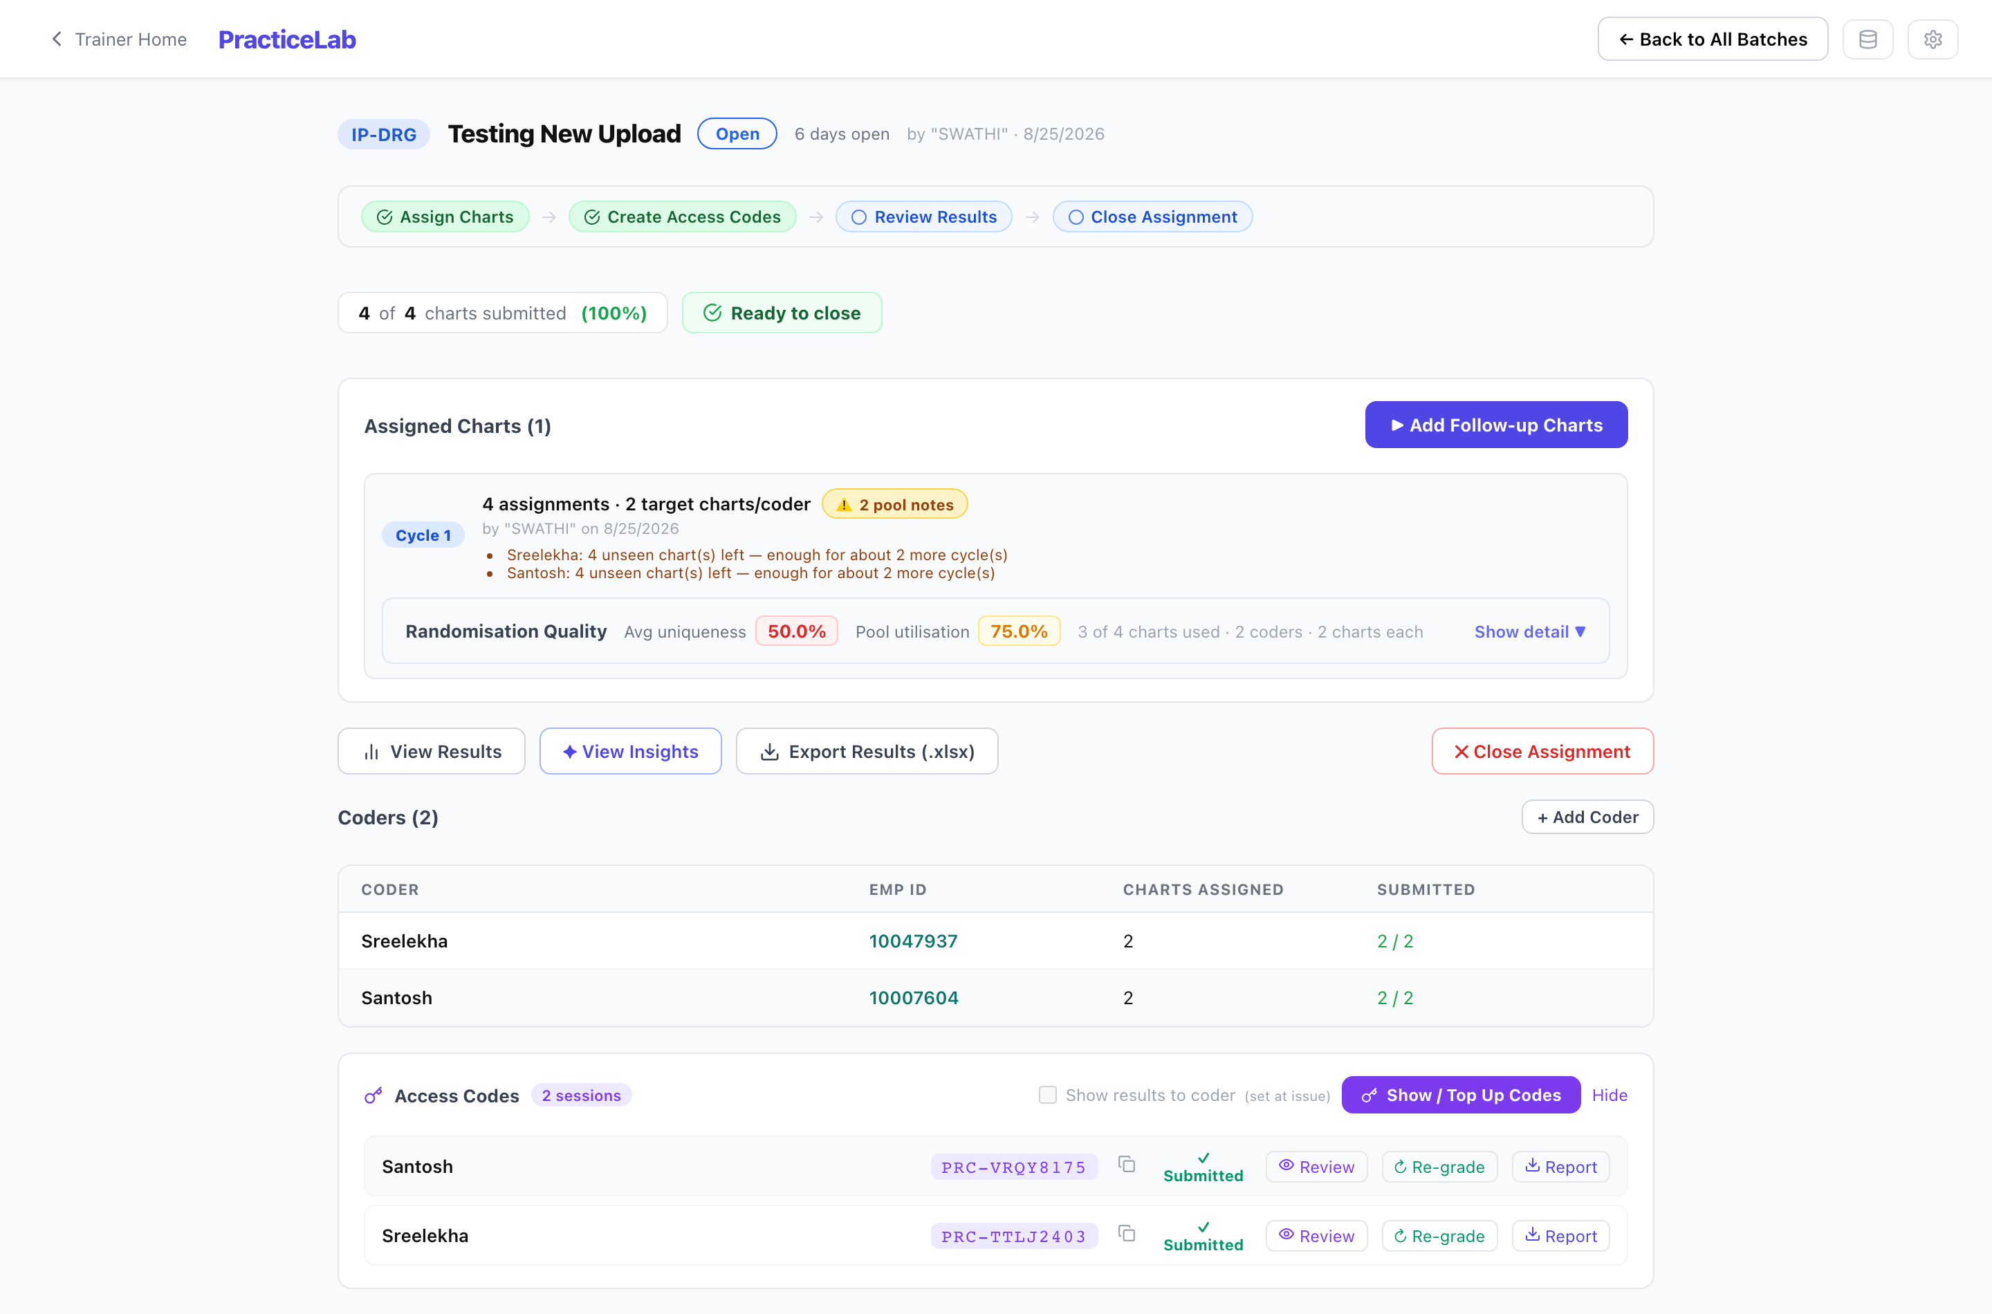
A batch in progress: cycles, coders, access codes and per-coder actions.

What needs a trainer’s judgement
Item | Where | What you decide
DRG Review | Inpatient charts flagged by grading | Whether a coding error changed the DRG. Marking it an error sets that chart’s DRG component to zero.
Query review | Charts where the coder raised a physician query | Whether the query was warranted, needs rewording, or was not warranted.
Grade Cases | Edits and Denials (written responses) | A rubric score for each part — Acceptable (5), Needs Improvement (3), Not Acceptable (0).

Other things on the batch screen
- Release — if a coder is locked out because their code is open on another device, release it and they can open it again straight away.
- Regrade — re-run grading for a session, for example after correcting its answer key.
- Notes — a running log for the batch.
- Results and Insights — per-coder and per-chart results, and what went wrong most. Exports to Excel and PDF.
- Accuracy (DPO) — per-area accuracy shown beside the score, if switched on for the batch. It is recorded either way, so switching it on later needs no regrade.
- Show results to coder — whether coders see chart-by-chart feedback when they submit. Off unless you turn it on.
Closing a batch
Closing ends submissions: coders can still read their feedback but cannot change or submit work. If some coders never started, the screen says so and offers “Close Unworked”. Reopening a closed batch, or force-closing one, is an Administrator action.

PracticeLab — Auditor
Audit batches work like coding batches, but the charts go out already coded with errors deliberately introduced, and the auditor finds and corrects them. Roughly a third of charts are left clean on purpose.
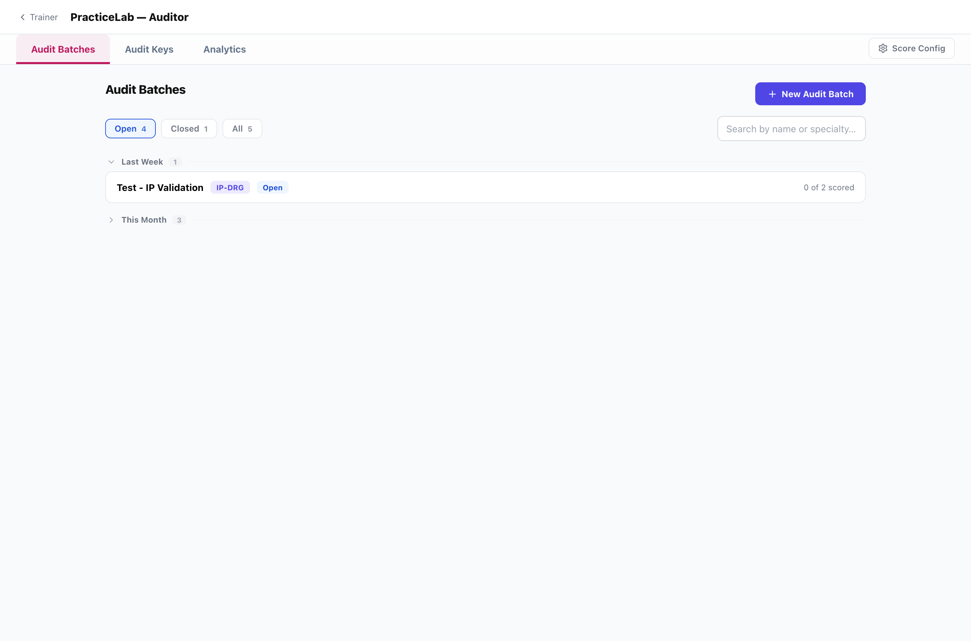
Audit batches.
Section | What it is for
Audit Batches | Create, allocate, monitor and close.
Audit Keys | Error sets authored by a trainer for a specific chart, instead of letting the system generate them.
Analytics | Audit Score, clean versus opportunity charts, what gets missed and what gets over-called.
Score Config | Scoring weights and the mix of error types. Administrator only.

How to run an audit batch
- New Audit Batch — specialty, filters, charts per auditor, and the allocation mode: Automatic, Guided (you set how many clean and authored charts), or Hand-picked (you choose the charts).
- Add auditors and Run Allocation. The claims are built and fixed at this point.
- Send each auditor their code (AUD-…).
- Watch progress on the batch row, for example “4 of 12 scored”. Regenerate an assignment if one needs rebuilding.
- Close the batch when the work is in.
Two rules to keep
Never tell auditors which charts are clean — the screen deliberately looks identical either way.
“Found” means found and corrected. Flagging alone scores nothing.

Creating, editing and deleting audit error sets, and exporting them, currently need the master passphrase, so they are done by an Administrator.

Assessments
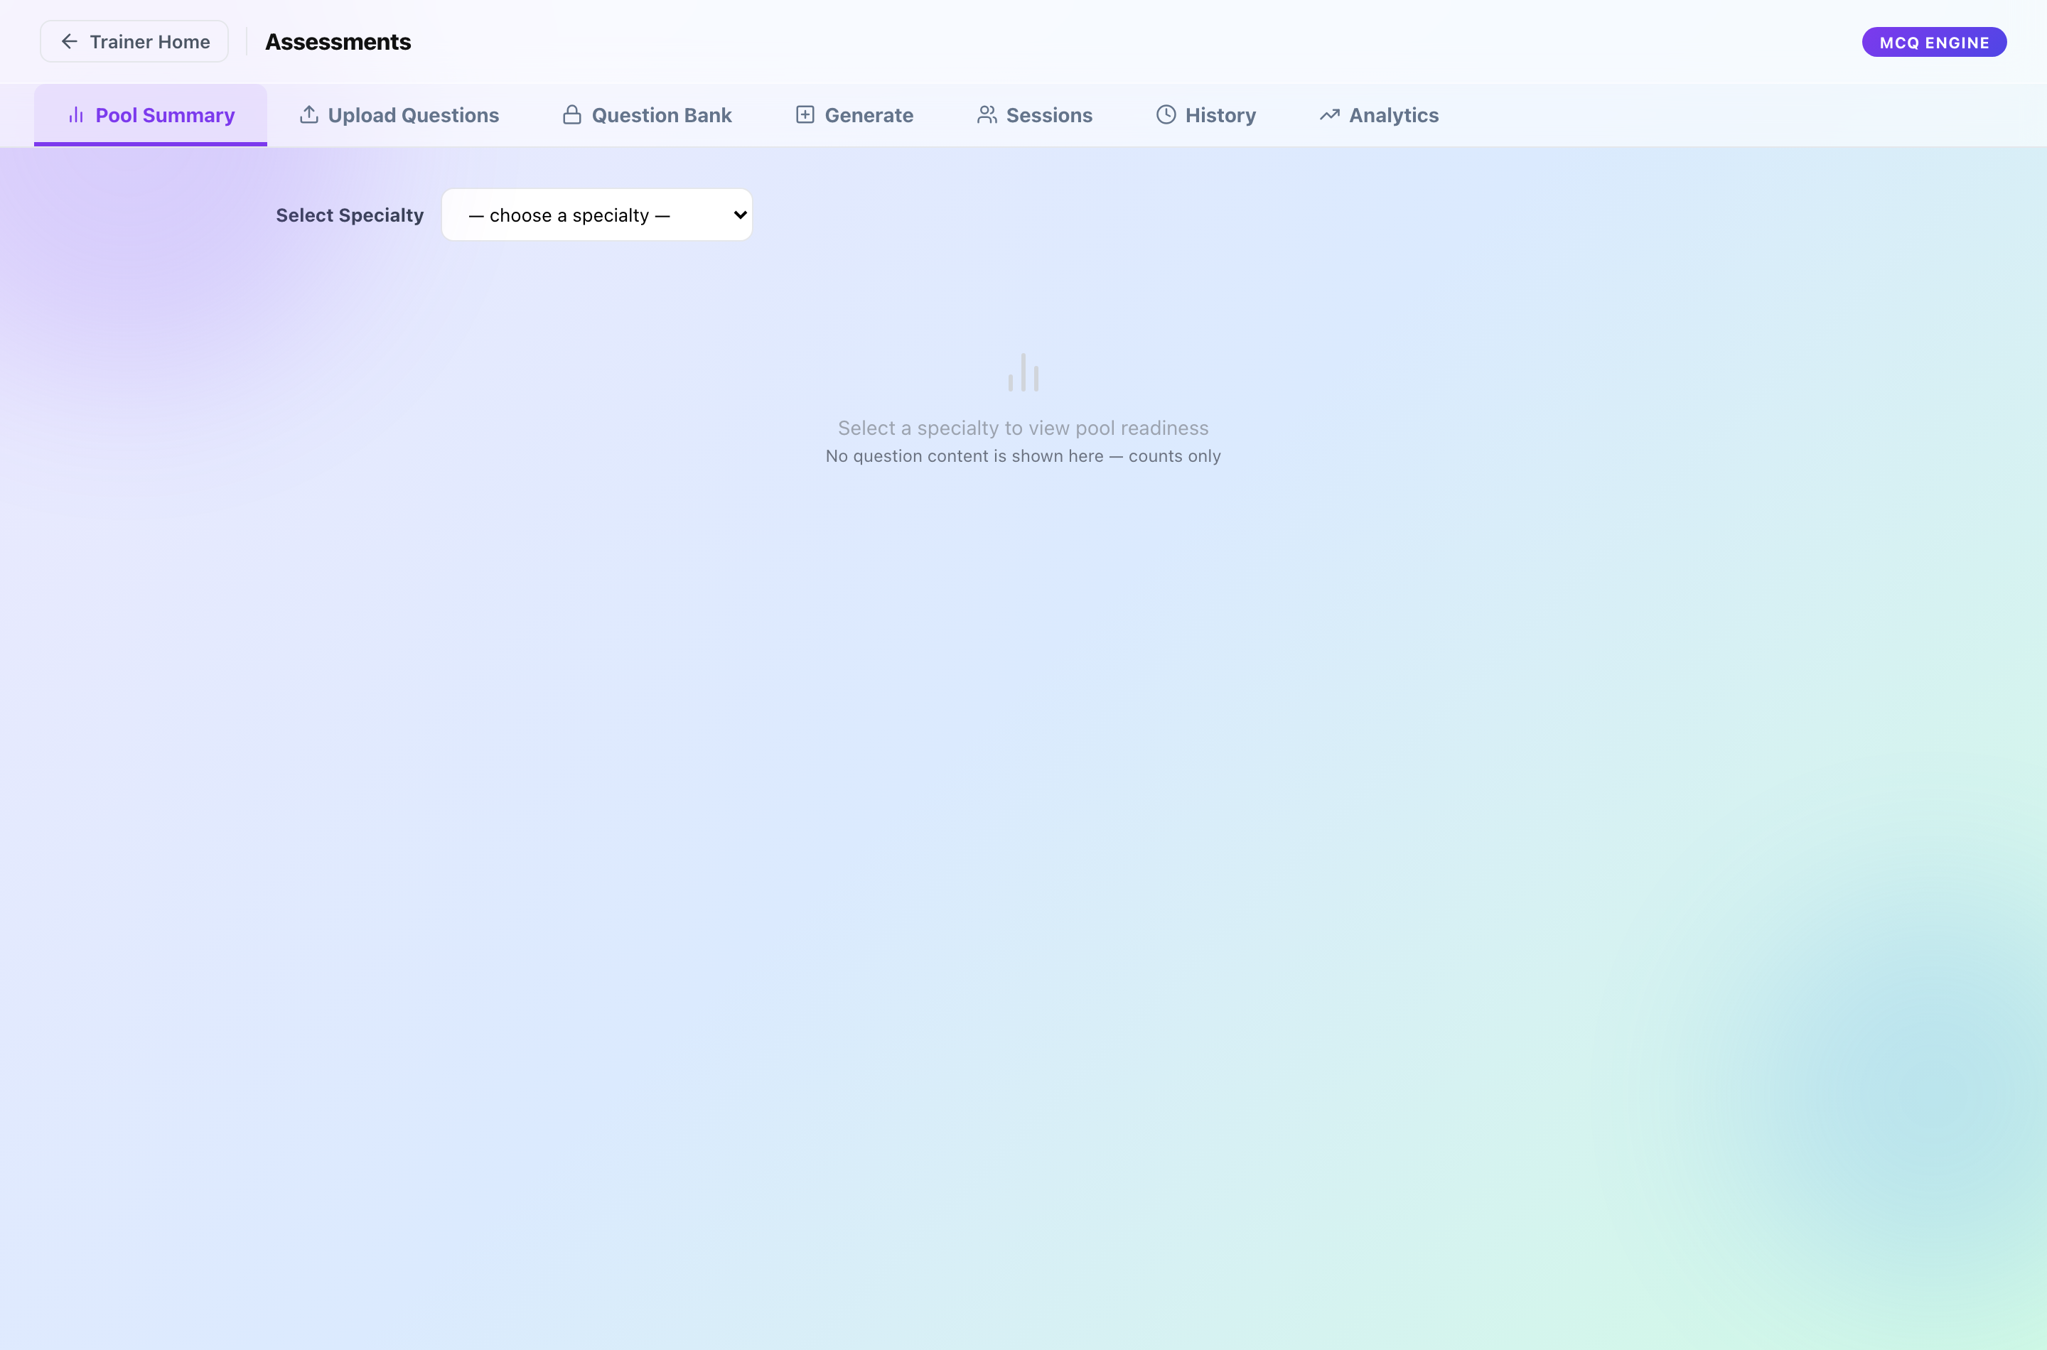
The Assessment module.
Section | What it is for
Pool Summary | How many questions the bank holds, by specialty and difficulty. Check before generating.
Upload Questions | Add questions from the Excel template.
Question Bank | Browse and edit questions. Administrator only.
Generate | Build papers and issue them to coders.
Sessions | Issued sittings, their IDs and status.
History | Papers already generated, with reports.
Analytics | Eight views of results — see the Analytics Guide.

How to issue an assessment
- Check Pool Summary: can the bank support the mix you want?
- Generate — choose the specialty mix, difficulty split, number of questions, time allowed and pass mark, whether coders see their score, and the coders.
- If the pool is short for any specialty, the screen lists the shortfall. Add questions, change the mix, or deliberately allow a short paper.
- Copy the Assessment IDs from Sessions and send them out. Each is valid for 8 hours.
- Read the results in Analytics, or download a batch report or per-coder reports from History.
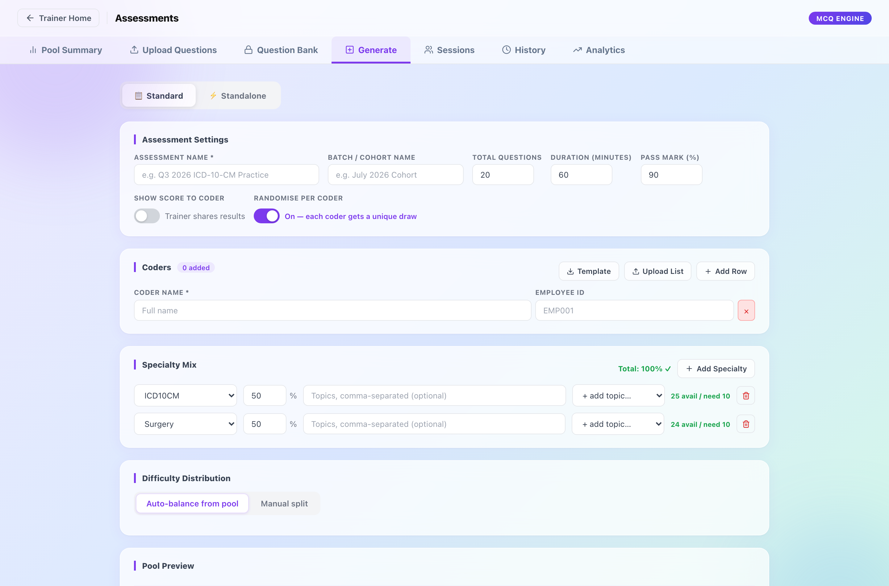
Generate. Each coder gets their own paper and their own Assessment ID.
- Each coder’s paper is drawn separately, and the order of the answer options is shuffled per person.
- Recently used questions are held back, so a group tested twice does not get the same paper.

Analytics and exports
PracticeLab, Auditor and Assessment each have an Analytics tab, and Chart Management has one more — 26 views in all. The PracticeLab Analytics Guide explains each one. Three rules matter before quoting any figure:
- A score (how well one chart was coded) and a pass rate (what share of charts or coders passed) are different numbers. Compare scores to the pass mark and pass rates to the 70% target.
- A batch is reported in coders; a coder is reported in charts. A coder passes by passing more than half their charts.
- NA means nothing to measure. It is not zero.
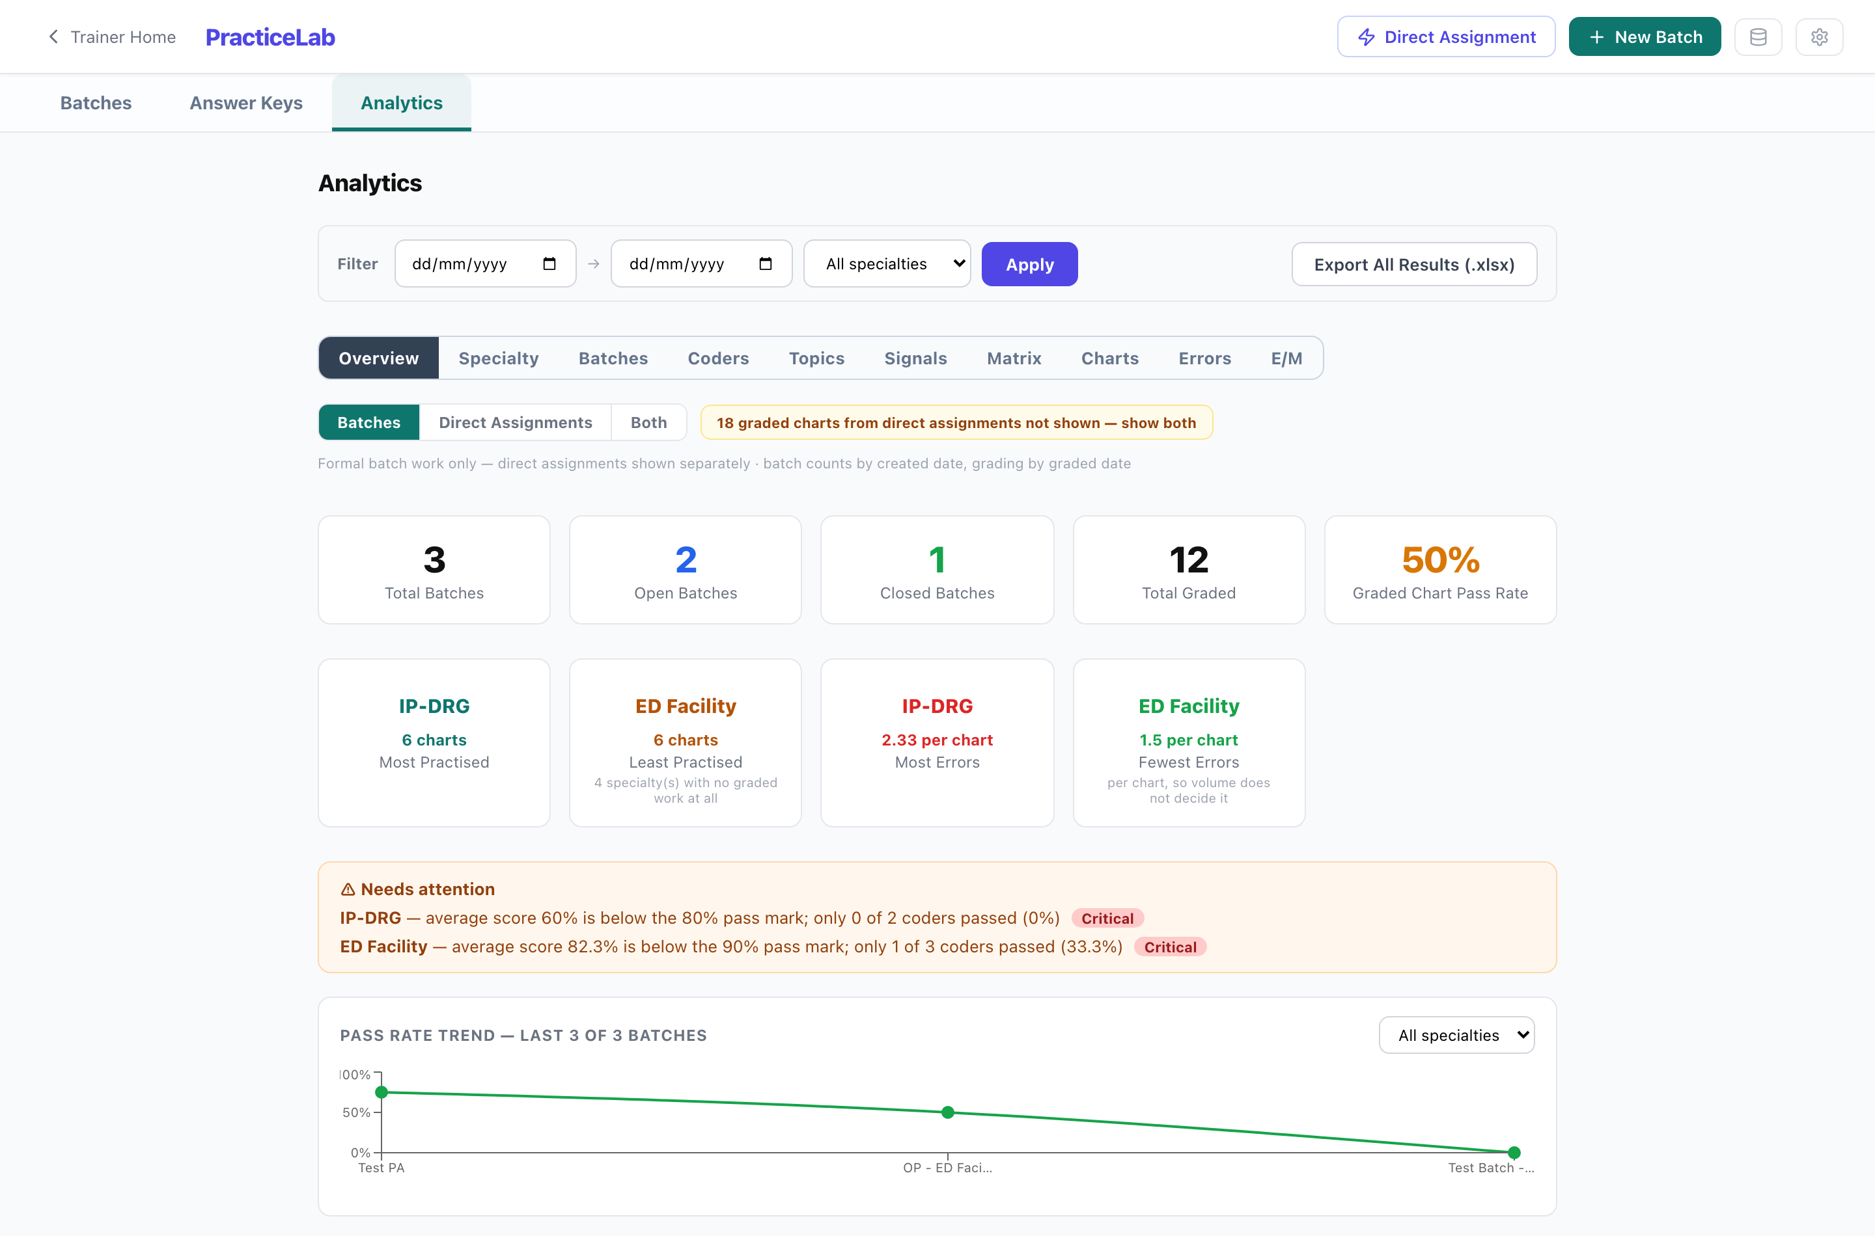
PracticeLab → Analytics.

Exports
Where | What
PracticeLab → Analytics | All results in the current filter (.xlsx)
A batch → Results | The batch’s results (.xlsx, .pdf)
Auditor → Analytics | The analytics workbook (.xlsx)
Assessment → History / Analytics | Batch report (.pdf), all coder reports (.zip), coder matrix (.xlsx)
Chart Management → Reports | The chart library (.xlsx)

Troubleshooting
What you see | What it means | What to do
A coder says their code is “already open on another device” | It is open in another browser. | Release it from the batch screen.
A chart cannot be added to a batch | It has no answer key. | Add a key, then allocate again.
Allocation deals fewer charts than expected | The filtered pool is too small for the number of coders and cycles. | Widen the filters or add charts. The batch screen reports how distinct the draws were.
“Passphrase required” | The action is an Administrator action. | Ask an Administrator.
Generate refuses to build a paper | The bank lacks questions for part of the mix. | Read the shortfall list; add questions or change the mix.
Code descriptions are blank | The reference code sets are not loaded in this environment. | Ask an Administrator to load them.
A coder cannot submit | The batch is closed. | Expected. An Administrator can reopen it if the closure was a mistake.

Actions that need an Administrator
These ask for the master passphrase. As a trainer, ask an Administrator when you need one.

Chart Management
Action | Coder | Trainer | Admin
Edit, retire or restore a chart you did not upload | — | — | ✓
Add or replace pages on a chart you did not upload | — | — | ✓
Purge a chart | — | — | ✓

Answer Keys
Action | Coder | Trainer | Admin
Edit an existing key on a chart you did not upload | — | — | ✓
Replace keys on upload | — | — | ✓
Upload E/M keys for charts you did not upload | — | — | ✓
Delete a key (standard or E/M) | — | — | ✓
Export all keys | — | — | ✓

PracticeLab
Action | Coder | Trainer | Admin
Reopen a closed batch | — | — | ✓
Force-close a batch | — | — | ✓
Scoring Config (standard and E/M) | — | — | ✓
View all open batches | — | — | ✓
Code Set Maintenance | — | — | ✓

Auditor
Action | Coder | Trainer | Admin
Reopen or force-close an audit batch | — | — | ✓
Audit Score Config | — | — | ✓
Create, edit or delete audit error sets; set the CC boundary | — | — | ✓
Export audit keys | — | — | ✓

Assessment
Action | Coder | Trainer | Admin
Question Bank — view, edit, change status, delete | — | — | ✓
Export questions | — | — | ✓
Override a coder’s response | — | — | ✓
Delete an assessment | — | — | ✓
Audit log | — | — | ✓

