PracticeLab
Database Schema Reference

32 tables · 448 columns · 32 foreign keys
Entity relationships, data dictionary and workflows
Version 1.0 · 12 August 2026

About this document
A reference for the PracticeLab database: every table, every column, how the tables relate, and the workflows that write them.
The contents were extracted from the schema the application itself builds, and the table descriptions from the model definitions in the source. Nothing here is transcribed by hand, so the document cannot drift from the code without the code changing first.
Companion document: PracticeLab — Data Architecture and Migration Specification covers the components, object storage and the migration procedure. This document covers the database alone.

How to read it
Section | Contents
1 Overview | Table count by domain, and the conventions used throughout
2 Entity relationships | Three diagrams, one per domain, showing every foreign key
3 Workflows | Two diagrams tracing which tables are written at each step of real use
4 Foreign key index | All 32 relationships in one list
5 Data dictionary | Every table and column, grouped by domain
6 Conventions and cautions | Patterns that recur, and the traps in them

1. Overview
The schema divides into five domains. Domain membership is a documentation convenience — the database enforces no such grouping — but it reflects how the tables are actually used and which move together.
Domain | Tables | Purpose
Chart Library | 6 | The clinical charts coders practise on, their page images and the audit trail
PracticeLab | 12 | Assigning charts to coders, answer keys, and the graded results
PracticeLab — E/M | 3 | Evaluation & Management grading, which uses a different scheme from other specialties
Practice sessions | 3 | Where coders actually work: access codes, drafts and submitted results
Assessment | 8 | Multiple-choice question papers, independent of charts

1.1 Conventions
- Primary keys are always a single integer column named id.
- Foreign keys are named <parent>_id — chart_id, batch_id, session_id.
- Timestamps are named created_at, updated_at or <verb>_at, and are stored with time zone under PostgreSQL.
- Repeating structures — lists of codes, per-coder question sets, warning lists — are stored in JSON columns rather than child tables. 19 columns across the schema are JSON.
- Deletion is avoided. Charts and questions are retired by setting a status column, so records already referencing them stay valid.
Types in this document are shown as declared by the application. Under PostgreSQL, JSON columns are native JSON and timestamps carry a time zone.

1.2 Where the schema comes from
The application has no schema file and no migration framework. It builds its own schema at startup: the ORM models create 26 tables, and a sequence of raw statements creates a further six and adds columns to existing ones.
Six tables have no ORM model
em_answer_keys, em_grading_results, em_scoring_configs, practice_sessions, practice_chart_drafts, practice_results
These exist only in the startup migration statements. A schema generated from the model definitions alone will appear complete and will be missing the entire E/M grading and practice-session subsystems — which is where every coder submission is recorded.

2. Entity relationships
Three diagrams, one per area. Arrows run from the child table to the parent it references — the direction a foreign key points.
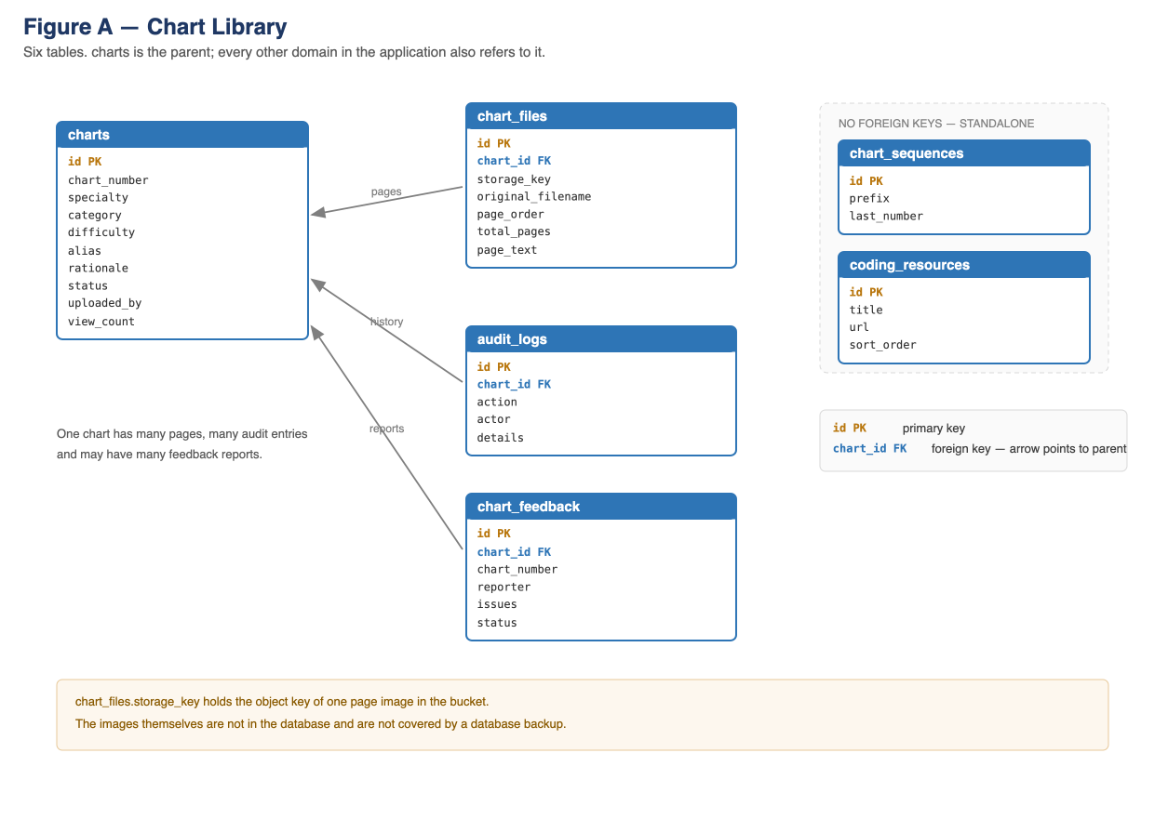
Figure A — Chart Library

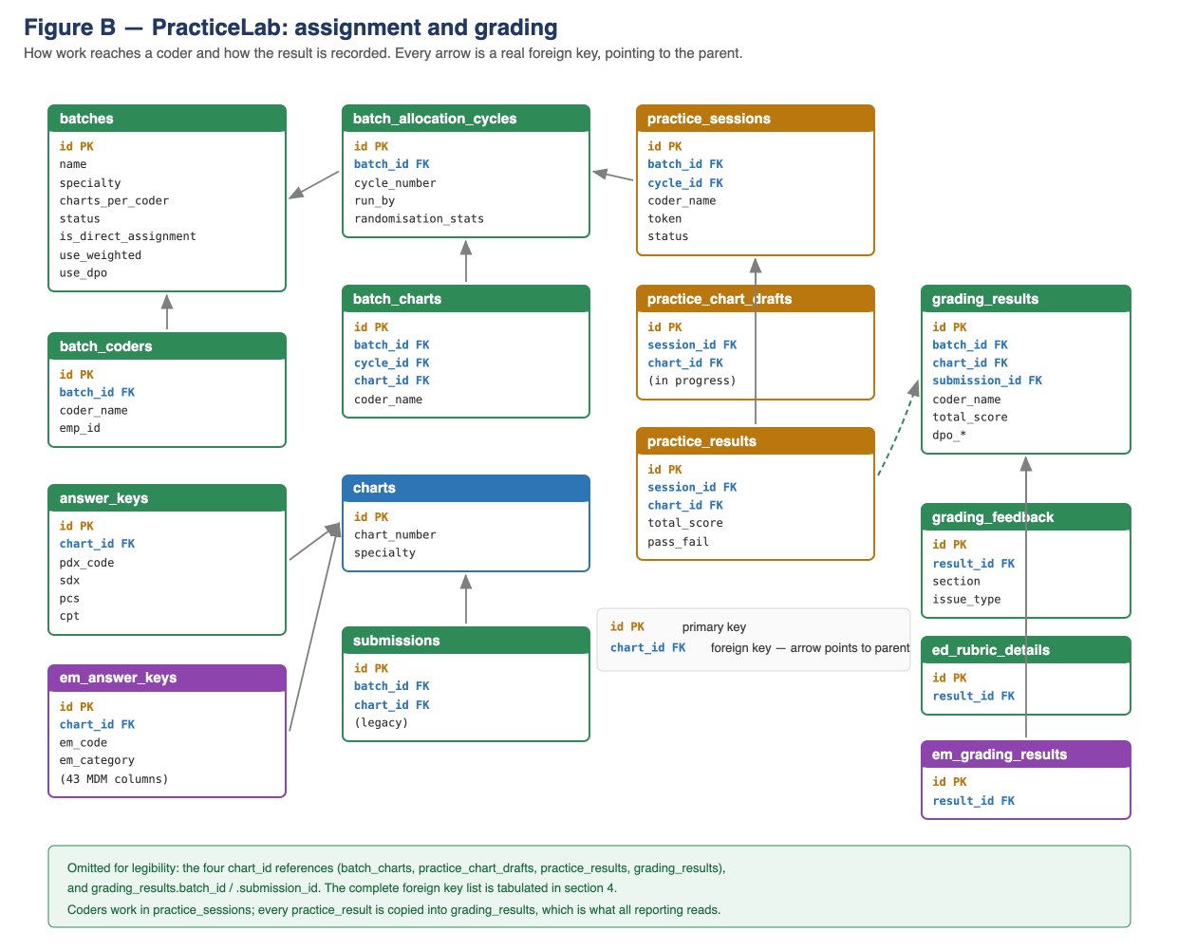
Figure B — PracticeLab: assignment and grading

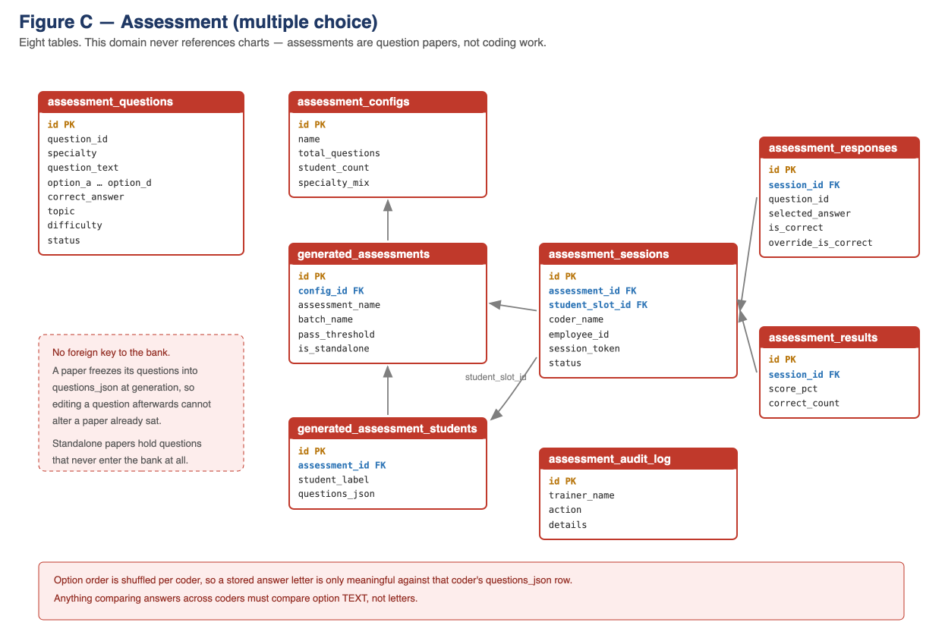
Figure C — Assessment

3. Workflows
Which tables are written, in what order, during the two things the application is used for.
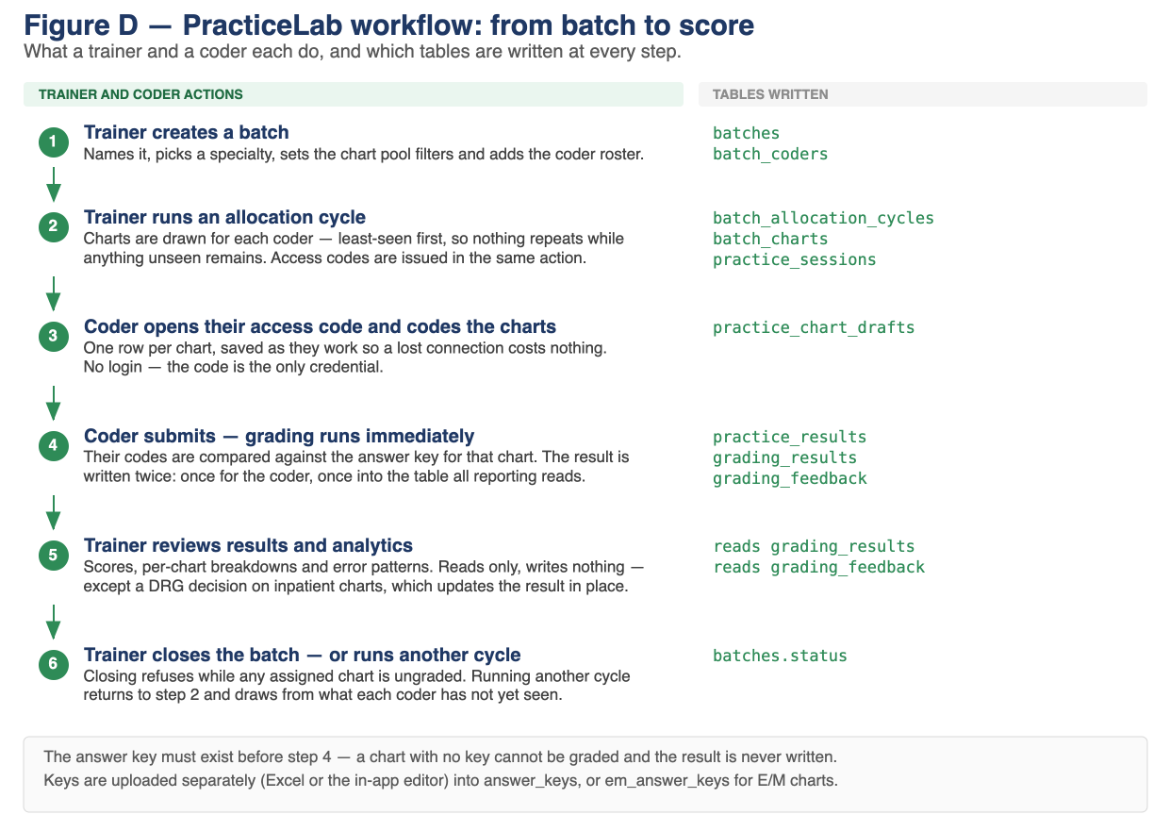
Figure D — PracticeLab: from batch to score

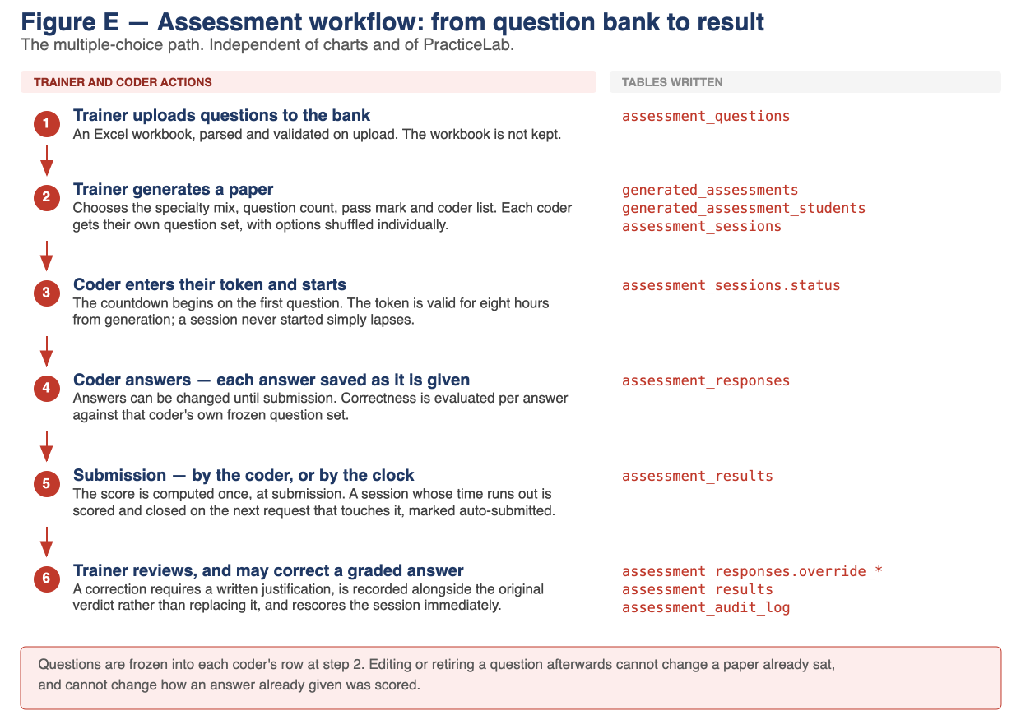
Figure E — Assessment: from question bank to result

4. Foreign key index
All 32 foreign keys, as read from the built schema.
Child table and column | References
answer_keys.chart_id | charts.id
assessment_responses.session_id | assessment_sessions.id
assessment_results.session_id | assessment_sessions.id
assessment_sessions.student_slot_id | generated_assessment_students.id
assessment_sessions.assessment_id | generated_assessments.id
audit_logs.chart_id | charts.id
batch_allocation_cycles.batch_id | batches.id
batch_charts.chart_id | charts.id
batch_charts.cycle_id | batch_allocation_cycles.id
batch_charts.batch_id | batches.id
batch_coders.batch_id | batches.id
chart_feedback.chart_id | charts.id
chart_files.chart_id | charts.id
ed_rubric_details.result_id | grading_results.id
em_answer_keys.chart_id | charts.id
em_grading_results.result_id | grading_results.id
generated_assessment_students.assessment_id | generated_assessments.id
generated_assessments.config_id | assessment_configs.id
grading_feedback.result_id | grading_results.id
grading_results.chart_id | charts.id
grading_results.submission_id | submissions.id
grading_results.batch_id | batches.id
practice_chart_drafts.chart_id | charts.id
practice_chart_drafts.session_id | practice_sessions.id
practice_results.chart_id | charts.id
practice_results.session_id | practice_sessions.id
practice_sessions.cycle_id | batch_allocation_cycles.id
practice_sessions.batch_id | batches.id
self_practice_results.chart_id | charts.id
self_practice_results.submission_id | self_practice_submissions.id
submissions.chart_id | charts.id
submissions.batch_id | batches.id
Ten tables hold no foreign key at all: they are either roots of a hierarchy or standalone configuration and logs.
assessment_audit_log, assessment_configs, assessment_questions, batches, chart_sequences, charts, coding_resources, em_scoring_configs, scoring_configs, self_practice_submissions

5. Data dictionary
Every table and column, grouped by domain. Descriptions are the ones carried in the source, so a change to either has to be made in both.

5.1 Chart Library
charts
A de-identified clinical chart that coders practise on.
Column | Type | Key · constraints
id | integer | primary key
chart_number | text(20) | required
specialty | text(14) | required
category | text(200) | required
difficulty | text(12) | required
alias | text(100)
rationale | text
status | text(7) | required
uploaded_by | text(100) | required
view_count | integer | required
created_at | timestamp | default CURRENT_TIMESTAMP
updated_at | timestamp
chart_files
One page of a chart.
Column | Type | Key · constraints
id | integer | primary key
chart_id | integer | → charts.id · required
storage_key | text(500) | required
original_filename | text(255) | required
page_order | integer | required
total_pages | integer | required
page_text | text
uploaded_by | text(100) | required
uploaded_at | timestamp | default CURRENT_TIMESTAMP
chart_sequences
Tracks the last used sequence number per specialty prefix.
Column | Type | Key · constraints
prefix | text(10) | primary key
last_number | integer | required
chart_feedback
A problem a coder reported with a chart — an unreadable page, a missing document, a chart that does not match its stated specialty.
Column | Type | Key · constraints
id | integer | primary key
chart_id | integer | → charts.id · required
chart_number | text(20) | required
reporter | text(100) | required
issues | text(500) | required
notes | text
status | text(8) | required
resolved_by | text(100)
resolved_at | timestamp
created_at | timestamp | default CURRENT_TIMESTAMP
audit_logs
What was done to a chart, by whom.
Column | Type | Key · constraints
id | integer | primary key
chart_id | integer | → charts.id · required
action | text(50) | required
actor | text(100) | required
details | text
created_at | timestamp | default CURRENT_TIMESTAMP
coding_resources
A reference link a trainer publishes to coders — guidelines, a coding manual, an internal policy page. Display order is manual via sort_order.
Column | Type | Key · constraints
id | integer | primary key
title | text(200) | required
description | text(500)
url | text(1000) | required
created_by | text(100) | required
sort_order | integer | required
created_at | timestamp | default CURRENT_TIMESTAMP

5.2 PracticeLab
batches
A unit of assigned coding work: a set of coders, a pool of charts, and the scoring rules to grade them by.
Column | Type | Key · constraints
id | integer | primary key
name | text(200) | required
specialty | text(14) | required
categories | JSON
difficulties | JSON
charts_per_coder | integer | required
created_by | text(100) | required
created_at | timestamp | default CURRENT_TIMESTAMP
status | text(6) | required
use_weighted | boolean | required
use_dpo | boolean | required
is_direct_assignment | boolean | required
closed_at | timestamp
closed_by | text(100)
force_closed | boolean | required
force_close_reason | text
notes | JSON
tags | JSON
batch_coders
A coder on a batch's roster.
Column | Type | Key · constraints
id | integer | primary key
batch_id | integer | → batches.id · required
coder_name | text(100) | required
emp_id | text(50)
batch_charts
One chart assigned to one coder, in one allocation cycle.
Column | Type | Key · constraints
id | integer | primary key
batch_id | integer | → batches.id · required
cycle_id | integer | → batch_allocation_cycles.id
coder_name | text(100) | required
chart_id | integer | → charts.id · required
submission_status | text(9) | required
batch_allocation_cycles
One round of chart randomization within an open batch.
Column | Type | Key · constraints
id | integer | primary key
batch_id | integer | → batches.id · required
cycle_number | integer | required
run_at | timestamp | default CURRENT_TIMESTAMP
run_by | text(100) | required
charts_per_coder | integer | required
notes | text(300)
randomisation_stats | JSON
warnings | JSON
coder_pool_notes | JSON
submissions
A coder's submitted codes for one chart, from the removed offline Excel workflow.
Column | Type | Key · constraints
id | integer | primary key
batch_id | integer | → batches.id · required
coder_name | text(100) | required
chart_id | integer | → charts.id · required
specialty | text(14) | required
pdx_code | text(20)
pdx_poa | text(5)
sdx | JSON
pcs | JSON
cpt | JSON
submitted_at | timestamp | default CURRENT_TIMESTAMP
grading_results
The score for one coder on one chart. The reporting table.
Column | Type | Key · constraints
id | integer | primary key
batch_id | integer | → batches.id · required
submission_id | integer | → submissions.id
coder_name | text(100) | required
emp_id | text(50)
chart_id | integer | → charts.id · required
specialty | text(14) | required
pdx_score | integer
sdx_score | integer
pcs_score | integer
cpt_score | integer
drg_score | integer
drg_flag | boolean
drg_reviewed | boolean
drg_override | text(5)
drg_reviewed_by | text(100)
drg_reviewed_at | timestamp
total_score | integer
pass_fail | text(4)
graded_at | timestamp | default CURRENT_TIMESTAMP
dpo_dx_accuracy | number
dpo_poa_accuracy | number
dpo_proc_accuracy | number
dpo_overall_accuracy | number
dpo_dx_correct | integer
dpo_dx_total | integer
dpo_poa_correct | integer
dpo_poa_total | integer
dpo_proc_correct | integer
dpo_proc_total | integer
grading_feedback
One specific mistake on one graded chart — what the key said, what the coder wrote, and which kind of error it was.
Column | Type | Key · constraints
id | integer | primary key
result_id | integer | → grading_results.id · required
section | text(3) | required
issue_type | text(14) | required
ak_code | text(50)
coder_code | text(50)
detail | text(200)
ed_rubric_details
Per-chart manual rubric grading record for Edits/Denials specialties.
Column | Type | Key · constraints
id | integer | primary key
result_id | integer | → grading_results.id · required
review_pass | boolean | required
research_coding_pass | boolean | required
research_payer_pass | boolean | required
research_nuances_pass | boolean | required
resolution_pass | boolean | required
rationale_tier | text(20) | required
trainer_note | text
graded_by | text(100) | required
graded_at | timestamp | default CURRENT_TIMESTAMP
answer_keys
Master answer key per chart — permanent, one per chart number.
Column | Type | Key · constraints
id | integer | primary key
chart_id | integer | → charts.id · required
specialty | text(14) | required
pdx_code | text(20)
pdx_poa | text(5)
sdx | JSON
pcs | JSON
cpt | JSON
facility_level | text(20)
profee_level | text(20)
entered_by | text(100) | required
created_at | timestamp | default CURRENT_TIMESTAMP
updated_at | timestamp
scoring_configs
How a specialty type is scored: component weights, pass mark and which scoring methods are enabled.
Column | Type | Key · constraints
id | integer | primary key
specialty_type | text(10) | required
pdx_weight | integer | required
sdx_weight | integer | required
pcs_weight | integer
drg_weight | integer
cpt_weight | integer
facility_level_weight | integer
profee_level_weight | integer
pass_threshold | integer | required
drg_triggers | JSON
overcoding_penalty | boolean | required
weighted_enabled | boolean | required
dpo_enabled | boolean | required
dpo_pass_threshold | number | required
updated_by | text(100)
updated_at | timestamp
self_practice_submissions
Coder-initiated or trainer standalone grading outside of any batch.
Column | Type | Key · constraints
id | integer | primary key
coder_name | text(100) | required
emp_id | text(50)
source | text(20) | required
status | text(20) | required
trainer_feedback | text
reviewed_by | text(100)
reviewed_at | timestamp
submitted_at | timestamp | default CURRENT_TIMESTAMP
self_practice_results
Per-chart grading result for a self-practice or standalone submission.
Column | Type | Key · constraints
id | integer | primary key
submission_id | integer | → self_practice_submissions.id · required
chart_id | integer | → charts.id
chart_number | text(20) | required
specialty | text(14)
weighted_score | integer
pass_fail | text(4)
dpo_dx_accuracy | number
dpo_poa_accuracy | number
dpo_proc_accuracy | number
dpo_overall_accuracy | number
error_message | text(300)
feedback_items | JSON

5.3 PracticeLab — E/M
em_answer_keys
The answer key for an Evaluation & Management chart. As well as codes, records the medical decision-making elements a coder should have identified — COPA, Data Review and Risk counts — and the complexity level each implies. em_category says which kind of encounter it is, because not every category is levelled by MDM.
Column | Type | Key · constraints
id | integer | primary key
chart_id | integer | → charts.id · required
copa_self_limited | integer | required · default 0
copa_stable_acute | integer | required · default 0
copa_stable_chronic | integer | required · default 0
copa_acute_uncomplicated | integer | required · default 0
copa_chronic_exacerbation | integer | required · default 0
copa_undiagnosed_new | integer | required · default 0
copa_acute_systemic | integer | required · default 0
copa_acute_complicated_injury | integer | required · default 0
copa_chronic_severe | integer | required · default 0
copa_threat_to_life | integer | required · default 0
copa_level | text(20) | required
copa_level_overridden | boolean | required · default FALSE
dr_prior_external_notes | integer | required · default 0
dr_review_test_results | integer | required · default 0
dr_order_tests | integer | required · default 0
dr_independent_historian | boolean | required · default FALSE
dr_independent_interpretation | boolean | required · default FALSE
dr_external_discussion | boolean | required · default FALSE
dr_level | text(20) | required
dr_level_overridden | boolean | required · default FALSE
risk_low | boolean | required · default FALSE
risk_prescription_drug_mgmt | boolean | required · default FALSE
risk_minor_surgery_with_factors | boolean | required · default FALSE
risk_elective_major_no_factors | boolean | required · default FALSE
risk_hospitalization | boolean | required · default FALSE
risk_sdoh | boolean | required · default FALSE
risk_drug_intensive_monitoring | boolean | required · default FALSE
risk_elective_major_with_factors | boolean | required · default FALSE
risk_emergency_major_surgery | boolean | required · default FALSE
risk_hospitalization_escalation | boolean | required · default FALSE
risk_dnr_deescalate | boolean | required · default FALSE
risk_parenteral_controlled | boolean | required · default FALSE
risk_level | text(20) | required
risk_level_overridden | boolean | required · default FALSE
em_code | text(10) | required
em_modifier | text(10)
dx_codes | text | required · default []
procedure_cpts | text | required · default []
entered_by | text(100) | required
entered_at | timestamp | default CURRENT_TIMESTAMP
patient_type | text | required · default NA
level_method | text | required · default MDM
total_time | integer
em_category | text
critical_care_minutes | integer
em_grading_results
The E/M breakdown behind one graded chart: what the coder submitted for each MDM element, the level derived from it, and the score per component. Linked one-to-one to the grading_results row carrying the headline score.
Column | Type | Key · constraints
id | integer | primary key
result_id | integer | → grading_results.id · required
sub_copa_self_limited | integer | required · default 0
sub_copa_stable_acute | integer | required · default 0
sub_copa_stable_chronic | integer | required · default 0
sub_copa_acute_uncomplicated | integer | required · default 0
sub_copa_chronic_exacerbation | integer | required · default 0
sub_copa_undiagnosed_new | integer | required · default 0
sub_copa_acute_systemic | integer | required · default 0
sub_copa_acute_complicated_injury | integer | required · default 0
sub_copa_chronic_severe | integer | required · default 0
sub_copa_threat_to_life | integer | required · default 0
sub_dr_prior_external_notes | integer | required · default 0
sub_dr_review_test_results | integer | required · default 0
sub_dr_order_tests | integer | required · default 0
sub_dr_independent_historian | boolean | required · default FALSE
sub_dr_independent_interpretation | boolean | required · default FALSE
sub_dr_external_discussion | boolean | required · default FALSE
sub_risk_low | boolean | required · default FALSE
sub_risk_prescription_drug_mgmt | boolean | required · default FALSE
sub_risk_minor_surgery_with_factors | boolean | required · default FALSE
sub_risk_elective_major_no_factors | boolean | required · default FALSE
sub_risk_hospitalization | boolean | required · default FALSE
sub_risk_sdoh | boolean | required · default FALSE
sub_risk_drug_intensive_monitoring | boolean | required · default FALSE
sub_risk_elective_major_with_factors | boolean | required · default FALSE
sub_risk_emergency_major_surgery | boolean | required · default FALSE
sub_risk_hospitalization_escalation | boolean | required · default FALSE
sub_risk_dnr_deescalate | boolean | required · default FALSE
sub_risk_parenteral_controlled | boolean | required · default FALSE
sub_em_code | text(10)
sub_em_modifier | text(10)
sub_dx_codes | text | required · default []
sub_procedure_cpts | text | required · default []
derived_copa_level | text(20)
derived_dr_level | text(20)
derived_risk_level | text(20)
em_level_score | number
cpt_score | number
dx_score | number
coding_accuracy_total | number
copa_element_score | number
dr_element_score | number
risk_element_score | number
reasoning_accuracy_total | number
sub_critical_care_minutes | integer
em_scoring_configs
Weights for E/M grading, held separately because the scheme differs: line 1 is coding accuracy, line 2 is reasoning accuracy. Whichever parts apply to a chart are renormalised to 100 at grading time.
Column | Type | Key · constraints
id | integer | primary key
line1_weight | number | required · default 70.0
line2_weight | number | required · default 30.0
em_level_weight | number | required · default 23.33
cpt_weight | number | required · default 23.33
dx_weight | number | required · default 23.34
copa_weight | number | required · default 10.0
dr_weight | number | required · default 10.0
risk_weight | number | required · default 10.0
pass_threshold | number | required · default 80.0
overcoding_penalty | boolean | required · default TRUE
updated_by | text(100)
updated_at | timestamp

5.4 Practice sessions
practice_sessions
One coder's access to one allocation cycle's charts. The token is the code a trainer hands out and the only credential a coder needs; there is no login. Keyed per cycle.
Column | Type | Key · constraints
id | integer | primary key
batch_id | integer | → batches.id
cycle_id | integer | → batch_allocation_cycles.id
coder_name | text(100) | required
specialty | text(50) | required
token | text(20) | required
chart_ids | text | required · default []
show_results_to_coder | boolean | required · default FALSE
status | text(20) | required · default pending
submitted_at | timestamp
created_at | timestamp | default CURRENT_TIMESTAMP
practice_chart_drafts
Work in progress on one chart: codes entered but not yet submitted. Saved as the coder types so a lost connection costs nothing. Superseded by practice_results on submission.
Column | Type | Key · constraints
id | integer | primary key
session_id | integer | → practice_sessions.id · required
chart_id | integer | → charts.id · required
pdx_code | text(20)
pdx_poa | text(5)
sdx | text | default []
pcs | text | default []
cpt | text | default []
ed_review | text
ed_research | text
ed_resolution | text
ed_rationale | text
flagged | boolean | default FALSE
coder_notes | text
updated_at | timestamp | default CURRENT_TIMESTAMP
em_data | text
facility_level | text
profee_level | text
critical_care_minutes | integer
practice_results
The graded outcome for one chart in one session, with the feedback shown to the coder. Every row is mirrored into grading_results, which is what all analytics and both PDF reports read.
Column | Type | Key · constraints
id | integer | primary key
session_id | integer | → practice_sessions.id · required
chart_id | integer | → charts.id · required
specialty | text(50)
total_score | integer
pass_fail | text(10)
drg_flag | boolean | default FALSE
feedback | text | default []
pdx_submitted | text(20)
pdx_answer_key | text(20)
pdx_correct | boolean
sdx_submitted | text | default []
sdx_answer_key | text | default []
pcs_submitted | text | default []
pcs_answer_key | text | default []
cpt_submitted | text | default []
cpt_answer_key | text | default []
ed_review | text
ed_research | text
ed_resolution | text
ed_rationale | text
ed_scored | boolean | default FALSE
ed_review_pass | boolean
ed_research_coding_pass | boolean
ed_research_payer_pass | boolean
ed_research_nuances_pass | boolean
ed_resolution_pass | boolean
ed_rationale_tier | text(30)
ed_trainer_note | text
ed_graded_by | text(100)
drg_reviewed | boolean | default FALSE
drg_override | text(20)
drg_reviewed_by | text(100)
drg_reviewed_at | timestamp
facility_level_submitted | text
facility_level_answer_key | text
profee_level_submitted | text
profee_level_answer_key | text

5.5 Assessment
assessment_questions
One multiple-choice question in the bank.
Column | Type | Key · constraints
id | integer | primary key
question_id | text(20) | required
specialty | text(50) | required
question_text | text | required
option_a | text | required
option_b | text | required
option_c | text | required
option_d | text | required
correct_answer | text(1) | required
difficulty | text(10) | required
topic | text(100)
question_type | text(20) | required
status | text(10) | required
shuffle_options | boolean | required
last_used_at | timestamp
uploaded_by | text(100)
created_at | timestamp | default CURRENT_TIMESTAMP
assessment_configs
A saved recipe for generating a paper: how many questions, how many coders, the specialty mix and how difficulty is distributed.
Column | Type | Key · constraints
id | integer | primary key
name | text(200) | required
total_questions | integer | required
student_count | integer | required
specialty_mix | JSON | required
difficulty_mode | text(10) | required
difficulty_mix | JSON
created_by | text(100) | required
created_at | timestamp | default CURRENT_TIMESTAMP
generated_assessments
One paper, issued to a named set of coders on a date.
Column | Type | Key · constraints
id | integer | primary key
config_id | integer | → assessment_configs.id
assessment_name | text(200) | required
batch_name | text(100)
student_count | integer | required
generated_by | text(100) | required
generated_at | timestamp | default CURRENT_TIMESTAMP
randomisation_stats | JSON
is_standalone | boolean | required
pass_threshold | integer
generated_assessment_students
One coder's individual paper, with their questions frozen at generation.
Column | Type | Key · constraints
id | integer | primary key
assessment_id | integer | → generated_assessments.id · required
student_label | text(50) | required
questions_json | JSON | required
assessment_sessions
One session = one coder taking one generated assessment.
Column | Type | Key · constraints
id | integer | primary key
session_token | text(20) | required
assessment_id | integer | → generated_assessments.id · required
coder_name | text(100) | required
employee_id | text(50)
duration_minutes | integer | required
expires_at | timestamp | required
student_slot_id | integer | → generated_assessment_students.id
started_at | timestamp
time_limit_ends_at | timestamp
submitted_at | timestamp
auto_submitted | boolean | required
status | text(20) | required
last_saved_at | timestamp
created_at | timestamp | default CURRENT_TIMESTAMP
assessment_responses
One row per question answered by a coder — upserted on each answer selection.
Column | Type | Key · constraints
id | integer | primary key
session_id | integer | → assessment_sessions.id · required
question_index | integer | required
question_id | text(20) | required
selected_answer | text(1)
is_correct | boolean
override_is_correct | boolean
override_reason | text
override_by | text(100)
override_at | timestamp
answered_at | timestamp
assessment_results
Computed once on final submission.
Column | Type | Key · constraints
id | integer | primary key
session_id | integer | → assessment_sessions.id · required
total_questions | integer | required
correct_count | integer | required
score_pct | number | required
time_taken_seconds | integer
submitted_at | timestamp | default CURRENT_TIMESTAMP
assessment_audit_log
Trainer actions on the assessment module that change a record or a result: deleting an assessment, correcting a graded answer, bulk question changes.
Column | Type | Key · constraints
id | integer | primary key
trainer_name | text(100) | required
action | text(50) | required
specialty | text(50)
details | text
created_at | timestamp | default CURRENT_TIMESTAMP

6. Conventions and cautions

6.1 Two scoring schemes sit side by side
grading_results carries both. total_score is the weighted score against the component weights in scoring_configs. The dpo_* columns are Diagnosis / POA / Procedure accuracy — the proportion of codes correct.
Both raw counts and percentages are stored. The counts exist so cumulative figures across many charts can be computed correctly, rather than by averaging percentages that each had a different denominator.

6.2 Results are written twice, on purpose
A coder submission writes practice_results and is then copied into grading_results. The copy is made in application code, not by a database constraint.
Every analytics endpoint and both PDF reports read grading_results. Without the copy, in-browser work would be invisible to all reporting. When investigating a discrepancy, grading_results is the reporting truth and practice_results is the record of what the coder was shown.

6.3 Answer letters are not comparable between coders
Assessment option order is shuffled per coder and frozen into generated_assessment_students.questions_json. A stored selected_answer of "B" means whatever B was for that coder.
Any query comparing answers across coders — distractor analysis, question quality — must resolve letters to option text through that row first.

6.4 Standalone question identifiers repeat
Questions created for a single paper without entering the bank are numbered SA-0001, SA-0002 by position within that paper. Two such papers both contain an SA-0001.
Anything keyed on question_id alone will merge unrelated questions. Pair it with the assessment.

6.5 Corrections are recorded, not applied over the original
A trainer correcting a graded answer writes assessment_responses.override_is_correct and leaves is_correct as the grader set it. The column is null when untouched, so an override to "incorrect" is distinguishable from never having been corrected.
Reporting must read the override where present and fall back to the original. Reading is_correct alone silently ignores every correction a trainer has made.

6.6 Vestigial columns
Column | Status
batch_charts.submission_status | Set only by the Edits/Denials rubric path. Graded work is determined from grading_results
submissions | Whole table retained for historical records from the removed offline Excel workflow; nothing writes to it
grading_results.submission_id | Null for all current work; populated only on those historical rows

6.7 Sequences
Three tables were originally created with INTEGER PRIMARY KEY and had PostgreSQL sequences attached by a later migration: practice_sessions, practice_chart_drafts, practice_results. After any restore, verify their sequence positions before accepting the environment — an incorrect position surfaces as a duplicate key error on the first insert, not at restore time.

