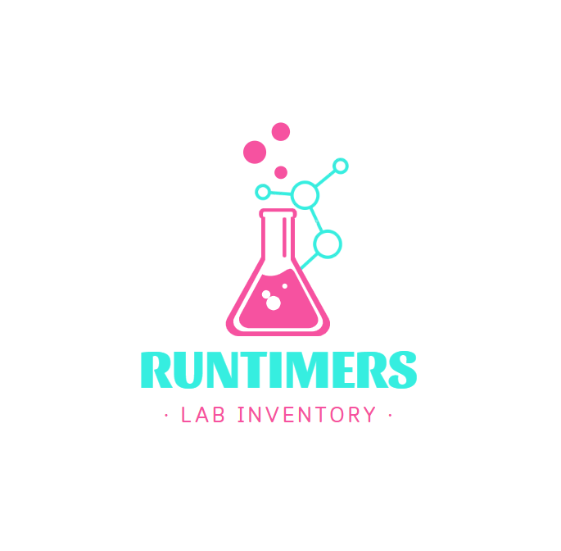

Table of Contents

1. ABOUT THE TEAM 3

2. INTRODUCTION 3

A. THE IDEA 3

B. MAIN STAGES OF DEVELOPMENT 4

C. USED TECHNOLOGIES 4

D. TABLE OF FUNCTIONS 5

E. BLOCK SCHEME 6

# ABOUT THE TEAM

|  |  |  |
| --- | --- | --- |
| TEAM MEMBER | ROLE WITHIN THE TEAM | GRADE |
| Zhaklin Yankova | Scrum trainer | 10B |
| Gabriela Encheva | Back - End developer | 10V |
| Nedyalko Libchev | Front - End developer | 10A |

# INTRODUCTION

### THE IDEA

Our idea was to create a "Lab Inventory Tracker" to help science labs stay organized and safe. The app allows lab workers to easily sort and organize chemicals by how much is left. It also lets users search for specific chemicals quickly, ensuring that important materials can be found without wasting time. The system keeps track of changes automatically whenever materials are used, making it easier to manage supplies without the hassle of counting or recording everything by hand. By building this app, we wanted to make lab work more efficient, reduce the risk of accidents from expired chemicals, and create a tool that could make scientific research safer and more effective.

### MAIN STAGES OF DEVELOPMENT

|  |  |
| --- | --- |
| WEEK | MAIN DUTIES |
| 1st Week | Creating logo and discussing ideas about the app. |
| 2nd Week | Making the design and implementation for our ideas through code. |
| 3rd Week | Developing the code |
| 4th Week | Developing the code |
| 5th Week | Creating the documentation and presentation. |

### USED TECHNOLOGIES

* C++ as the main programming language
* Microsoft Office 365 suite for documentation preparation
* Visual Studio 2022 as an integrated development environment.
* GitHub and Git as a cloud storage and control.
* Raylib as an external library for visualization
* Canva for design
* Aseprite for texture creator
* Teams as a communication point

### TABLE OF FUNCTIONS

|  |  |
| --- | --- |
| TYPE | NAME |
| int | main::windowInit() |
| void | displayStartingScreen() |
| void | displayHallway() |
| void | displayInventoryBg() |
| void | displayShelfInside() |
| void | displayChembenchZoomed() |
| bool | checkIfFileExists(const string& fileName); |
| void | saveInventoryFile(const string& fileName, vector<Chemical>& inventory) |
| void | randomSortInventory(vector<Chemical>& inventory) |
| void | sortInventory(vector<Chemical>& inventory) |
| void | handleElementClick(const string elementName, const int quantity) |
| void | displayArchive() |
| void | displayTablet() |
| vector<Chemical> | LoadInventoryFromFile(const string& fileName) |
| vector<Chemical> | searchInventory(const string& query, const vector<Chemical>& inventory) |

