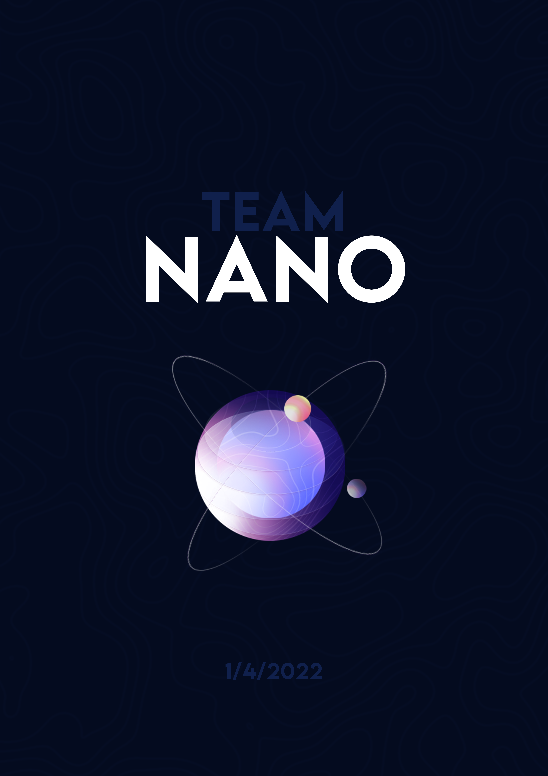

**Table of content**

**1.****Our team** 2

**2.****Recap** 2

**2.1** **Main goal** 2

**2.2** **Rules** 2

**2.3 Tasks** 2

**2.4 Realisation (Technologies that we used)** 3

**3.** **Structure** 4

# **Our team**

|  |  |  |
| --- | --- | --- |
| Name | Class | Roles |
| Kalin Chervenkov | 10 G | **Scrum Trainer** |
| Boris Savov | 10 A | **Front-end Developer** |
| Nikola Peshev | 10 V | **Front-end Developer** |
| Mario Berberov | 10 V | **QA Engineer** |

# **Recap**

## **Main goal**

Our goal is making fully customizable, interactive simulation of natural selection

## **Rules**

1. If an entity gets no food through the cycle, it dies
2. If an entity gets one food through the cycle, it stays alive
3. If an entity gets two foods through the cycle, it stays alive and reproduces
4. The cycle ends when all entities have gone back to their initial position or have died
5. If the energy of an entity is consumed all the way, it dies
6. If an entity reproduces, it always gets different traits of it’s parent

## **2.3 Tasks**

1. We assigned roles.
2. Front-end
3. Back-end
4. Connect front-end to back-end
5. Presentation, documentation and README.

## **2.4 Realisation (Technologies that we used)**

1. Software, that we used:

* **Teams** and **GitHub** for communication and organization.
* **Visual Studio** for writing the code.
* **Photoshop and Figma** for making all logos and designs
* **PowerPoint** and **Word** for the making of the presentation and documentation.

1. Fonts that we used:

* **Inter**

1. Technologies that we used:

* **C++23**
* **Doxygen** for the making of the QA documentation
* **RayLib** as a front-end engine
* **RayGui** as a front-end GUI
* **Clang-format** as a formatting tool
* **OpenGL** as a front-end API

# **Structure**

**3.1 Block scheme**

