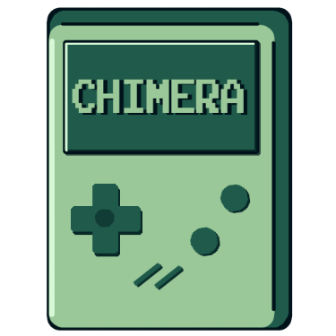



Chimera

Content

1. Our idea 3

2. Team 3

3. Stages of realization 3

3.1 Beginning 3

3.2 Planning 3

3.3 Final changes 3

4. Block scheme 3

5. Color scheme 4

6. Used technologies 4

7. Conclusion 4

7.1 Result 4

7.2 Future ideas 4

# 1. Our idea

Our idea is to create a game about a dog who works as a deliver in a city.

# 2. Team

* Hristo Kovachev – Scrum Trainer
* Yoan Gavrilov – QA Engineer
* Galq Ivanova – Backend Developer
* Konstantin Dinev – Backend Developer
* Hristiyan Petrov – Backend Developer
* Valeria Chavdarova – Frontend Developer
* Teodora Lozeva – Frontend Developer

# 3. Stages of realization

### 3.1 Beginning

First, we formed our team, assigned the roles and organized our meeting schedule.

Afterwards we discussed our ideas, combined them and got ready to start working.

### 3.2 Planning

We started our work using Teams as communication platforms. We discussed ideas, gave many different suggestions and shared how each of us sees the entire process. We allocated our tasks, each performing his assignments on time.

### 3.3 Final changes

After writing the whole code, our QA Engineer tested it multiple times and fixed some errors and bugs.

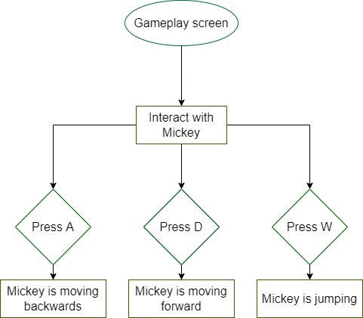

# 4. Block scheme

## 5. Color scheme

## 6. Used technologies

We made the graphical parts of the project on Figma and Krita.  
For the website we used Visual Studio Code, HTML5 & CSS3.   
To make we used C++, Visual Studio 2022 and Raylib.  
When we finally finished the game and the website, we made the presentation on Power Point, the documentation on Word and the QA documentation on Excel.

# 7. Conclusion

### 7.1 Result

We have created just a part of this unique game. We worked hard and learnt a variety of things. We improved our team work and increase knowledge in C++.

### 7.2 Future ideas

We will be working hard to improve our game. We are looking forward to make our product better by making it more accessible, adding more functions and last but not least make it even more entertaining.